**Student Management Portal**

**Team Members**

KMS hamim

Saidur

Zakir

Mintu

Tarif

**1. OBJECTIVES**

1. To know about HTML,CSS,JAVA SCRIPT etc.

2. To know about MYSQL.

3. To know how to use JAVA to connect with database.

4. To know how to manage database.

5. Implement all knowledge to build a student management website.

**2.BACKGROUND**

It is more efficient to manage students related data in website rather than hardcopy. Actually here website means database. Database is collection of data. In database we can perform various types of operation such as insert ,delete, modify, user create etc.

For the structure of the website normally HTML language will be used. HTML means hyper text markup language. It is actually not a language though called language. HTML is a collection of tags, attributes and attributes have value. We can change the structure by changing the attributes value.

For designing purpose CSS will be used . CSS means cascade style sheet. We can change color, border and other design through CSS.

We have to do various types of validation check such phone number, mail address etc. Those all are done by the Java Script . Javascript is a dynamic computer programming language. It is lightweight and most commonly used as a part of web pages, whose implementations allow client-side script to interact with the user and make dynamic pages. It is an interpreted programming language with object-oriented capabilities.

**MySQL** is an open source relational database management system (RDBMS) based on Structured Query Language (SQL). ... LAMP is a Web development platform that uses Linux as the operating system, Apache as the Web server, **MySQL** as the relational database management system and PHP as the object-oriented scripting language.

**Apache Tomcat** is used to deploy our Java Servlets and JSPs. So in our Java project we can build our WAR (short for Web ARchive) file, and just drop it in the deploy directory in **Tomcat**. So basically **Apache** is an HTTP Server, serving HTTP. **Tomcat** is a Servlet and JSP Server serving Java technologies.

**3.DESIGN CONSTRAINTS**

**Software Language Used**

The languages that shall be used for coding the Online Student Information Management System are Java Servlets, Java Server Pages (JSP), HTML, CSS, JQuery, JavaScript, and XML. For working on the coding phase of the Online Student Information Management System, the Internet Information Services (IIS) Server needs to be installed.

**Development Tools**

It will make use of the available Java Development Tool kits for working with Java Beans and Java Server Pages. Also will make use of the online references available for developing programs in HTML & XML and the scripting languages, JavaScript.

**HARDWARE INTERFACES**

* **Server Side**

The web application will be hosted on TOMCAT servers and connecting to one of the MySQL Database server. The web server is listening on the web standard port, port 8090.

* **Client Side**

The system is a web based application; clients are requiring using a modern web browser such as Mozilla Firebox 1.5, Internet Explorer 6 and Enable Cookies. The computer must have an Internet connection in order to be able to access the system.

**SOFTWARE INTERFACES**

* **Server Side**

The UOP already has the required software to host a Java web application. An Apache Webserver will accept all requests from the client and forward SUMS specific requests to Tomcat 5.5Servlet Container with J2EE 5.0. A development database will be hosted locally (using MySQL); the production database is hosted centrally (using MySQL).

* **Client Side**

An OS is capable of running a modern web browser which supports HTML version 3.2 or higher

**COMMUNICATIONS INTERFACES**

The HTTP protocol will be used to facilitate communications between the client and server.

**STEPS :**

1. Design the structure of the website using HTML.

2. After primary completing primary structure through HTML,use CSS to give more style.

3. Create register and login HTML page for student and teacher and also verify the valid data by using JavaScript.

4. Store all the registration data in database by using MySql.

Use Sketch Diagram

Fig 1. Use Sketch Diagram

Sequence Diagram

Student

Database

User Terminal

Registration

Check information and save to database

Registration Successful

Login

Check User

Change Password

Send Request

Login with new password

Update Profile

Send Request

Update Successful

View profile

Send request

Show data

View Academic Record

Send Request

Show data

Fig 2. Sequence Diagram for Student

Teacher

Database

User Terminal

Registration

Check information and save to database

Registration Successful

Login

Check User

Change Password

Send Request

Login with new password

Update Profile

Send Request

Update Successful

View profile

Send request

Show data

View Academic Record

Send Request

Show data

Fig 3. Sequence Diagram for teacher

Admin

Database

User Terminal

Registration

Check information and save to database

Registration Successful

Login

Check User

Add new student

Send Request

Update Successful

Add new teacher asdasdaasteacher

Add request

Successfully added

Add new class

Send Request

New class added successfully asdsusadsuccessfully

Fig 4. Sequence Diagram for Admin

ER DIagram

Student Management System

tbl_student

tbl_admin

tbl_teacher

Project Screen Shot

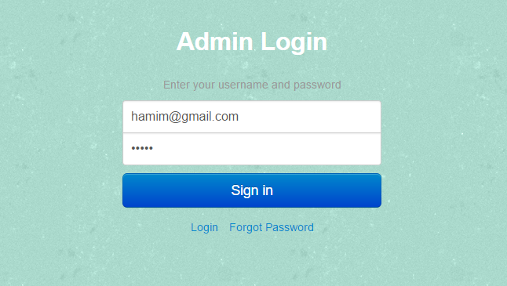

Admin Dashboard

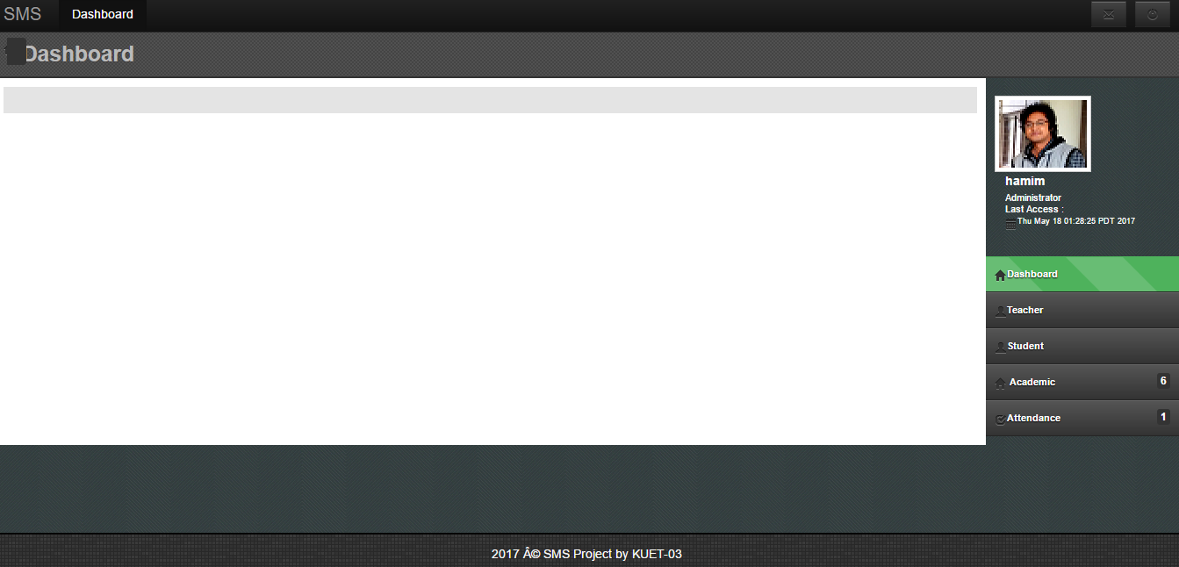

Add new Teacher

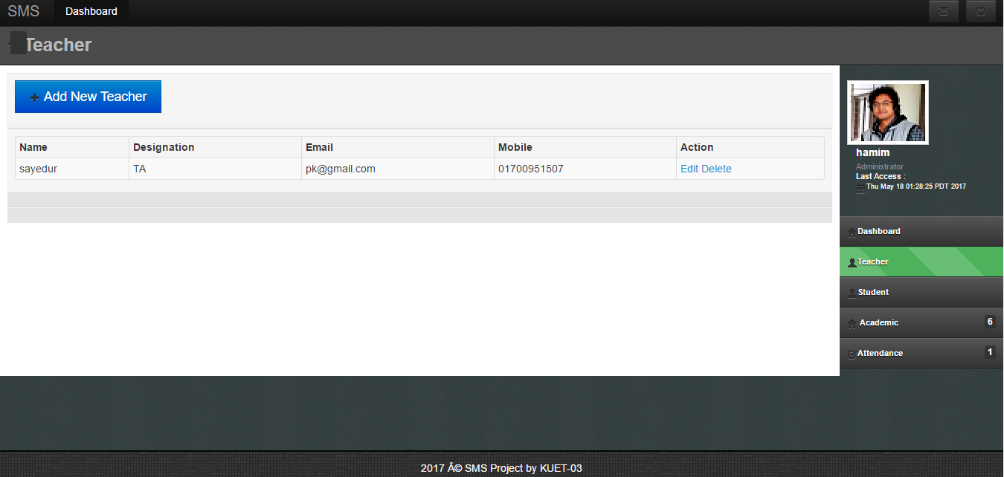

Data for New Teacher

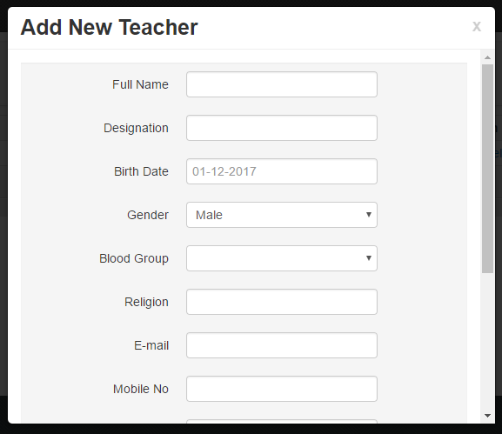

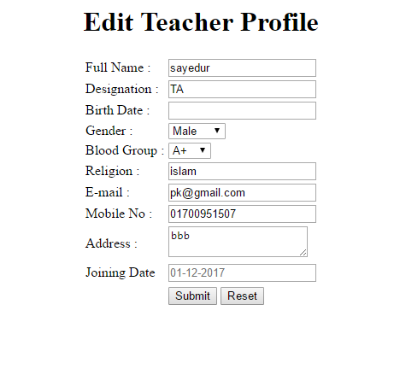

Add New Student

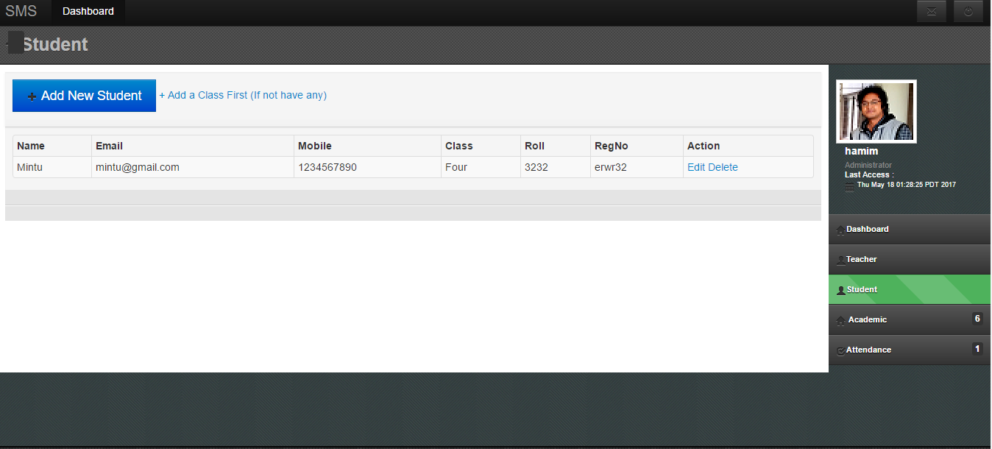

New Student Data Entry

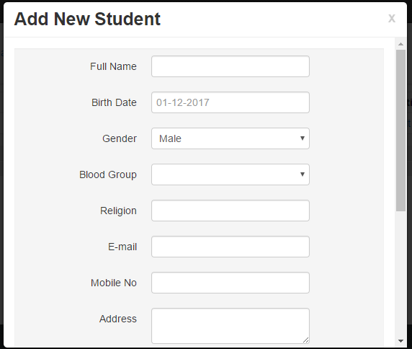 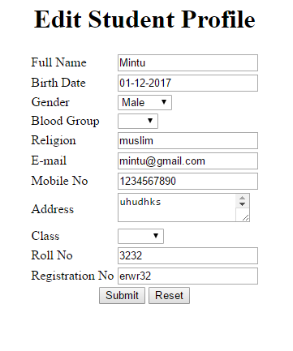

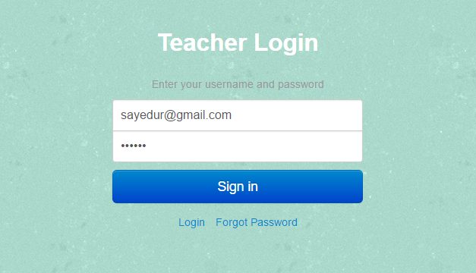

Teacher Profile

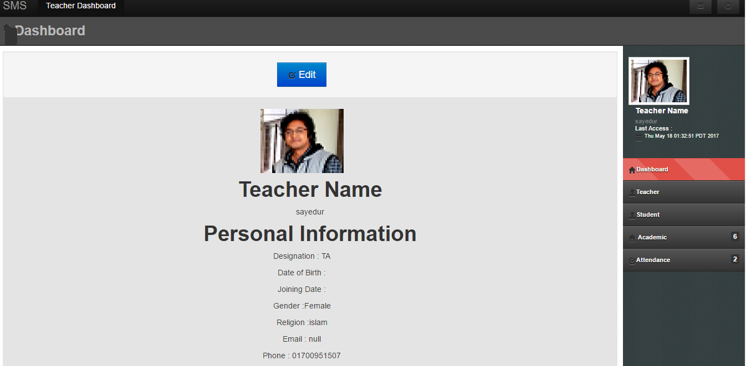

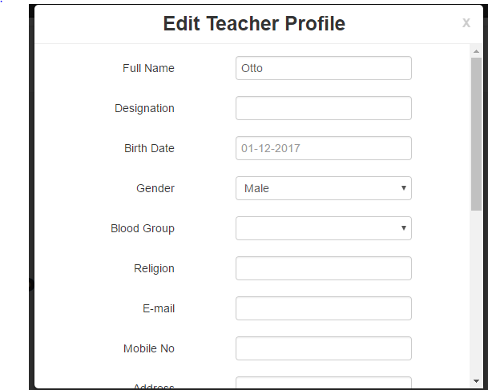

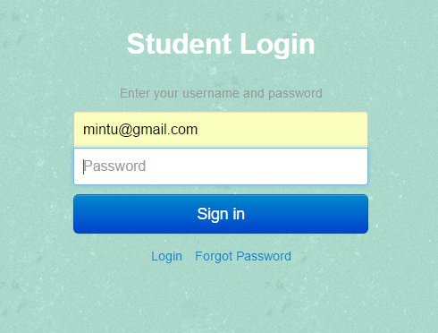

Student Profile

