Application_database

Courses_table

CREATE TABLE [dbo].[course_table] (
[id] | INT | NOT NULL, //as unique key
[name] | VARCHAR (50) NULL,
[age] | INT | NULL,
[email_id] | VARCHAR (50) NULL,
[profession] | VARCHAR (50) NULL,
[marks_12th] | INT | NULL,
[ug_degree] | VARCHAR (50) NULL,
[address] | VARCHAR (50) NULL,
[mobile_no] | INT | NULL,
[courses] | VARCHAR (50) NULL, //courses
PRIMARY KEY CLUSTERED ([id] ASC)

);

HomeController.cs

using System;
using System.Collections.Generic;

using System.Linq;
using System.Web;

using System.Web.Mvc;

namespace application_query.Controllers
{

public class HomeController : Controller
{

public ActionResult Index()
{

return View();
}

public ActionResult About()

{
ViewBag.Message = "Your application description page.";

return View();

}

public ActionResult Contact()
{

ViewBag.Message = "Your contact page.";

return View();
}

}
}

CourseTableController.cs //CRUD operation

using System;
using System.Collections.Generic;

using System.Data;
using System.Data.Entity;

using System.Linq;
using System.Net;

using System.Web;
using System.Web.Mvc;

using application_query.Models;

namespace application_query.Controllers
{

public class course_tableController : Controller
{

private application_databaseEntities db = new application_databaseEntities();

// GET: course_table
public ActionResult Index()

{
return View(db.course_table.ToList());

}

// GET: course_table/Details/5
[Authorize]

public ActionResult Details(int? id)

{

//form authorization for Viewing the data //Method for viewing the data

if (id == null)
{

return new HttpStatusCodeResult(HttpStatusCode.BadRequest);
}

course_table course_table = db.course_table.Find(id); if (course_table == null)

{
return HttpNotFound();

}
return View(course_table);

}

// GET: course_table/Create
public ActionResult Create() //HTTP method for creating the data

{
return View();

}

- POST: course_table/Create
- To protect from overposting attacks, enable the specific properties you want to bind to, for

- more details see https://go.microsoft.com/fwlink/?LinkId=317598.

[HttpPost]
[ValidateAntiForgeryToken]

public ActionResult Create([Bind(Include =
"id,name,age,email_id,profession,marks_12th,ug_degree,address,mobile_no,courses")]

course_table course_table)
{

if (ModelState.IsValid)
{

db.course_table.Add(course_table);
db.SaveChanges();

return RedirectToAction("Index");
}

return View(course_table);
}

// GET: course_table/Edit/5

public ActionResult Edit(int? id) //HTTP method for editing the data
{

if (id == null)
{

return new HttpStatusCodeResult(HttpStatusCode.BadRequest);
}

course_table course_table = db.course_table.Find(id);

if (course_table == null)
{

return HttpNotFound();
}

return View(course_table);
}

- POST: course_table/Edit/5

- To protect from overposting attacks, enable the specific properties you want to bind to, for

- more details see https://go.microsoft.com/fwlink/?LinkId=317598.
[HttpPost]

[ValidateAntiForgeryToken]
public ActionResult Edit([Bind(Include =

"id,name,age,email_id,profession,marks_12th,ug_degree,address,mobile_no,courses")]
course_table course_table)

{
if (ModelState.IsValid)

{
db.Entry(course_table).State = EntityState.Modified; db.SaveChanges();

return RedirectToAction("Index");

}
return View(course_table);

}

// GET: course_table/Delete/5

public ActionResult Delete(int? id) //HTTP method for deleting the data
{

if (id == null)
{

return new HttpStatusCodeResult(HttpStatusCode.BadRequest);
}

course_table course_table = db.course_table.Find(id); if (course_table == null)

{
return HttpNotFound();

}
return View(course_table);

}

// POST: course_table/Delete/5 [Authorize]

//Form authorization to Delete data user

must login

[HttpPost, ActionName("Delete")]

[ValidateAntiForgeryToken]
public ActionResult DeleteConfirmed(int id)

{
course_table course_table = db.course_table.Find(id); db.course_table.Remove(course_table); db.SaveChanges();

return RedirectToAction("Index");
}

protected override void Dispose(bool disposing)

{
if (disposing)

{
db.Dispose();

}
base.Dispose(disposing);

}
}

}

courses_table.cs

//------------------------------------------------------------------------------

- <auto-generated>
- This code was generated from a template.

- Manual changes to this file may cause unexpected behavior in your application.

- Manual changes to this file will be overwritten if the code is regenerated.
- </auto-generated>

//------------------------------------------------------------------------------

namespace application_query.Models
{

using System;
using System.Collections.Generic;

using System.ComponentModel.DataAnnotations;

using System.Web;
using System.Linq;

public partial class course_table

{
[Required(ErrorMessage = "ID is mandatory")] //form validation for mandatory fields public int id { get; set; }

[Required(ErrorMessage = "Name is mandatory")] //form validation for mandatory

fields
public string name { get; set; }

[Required(ErrorMessage = "Age is mandatory")] //form validation for mandatory fields public Nullable<int> age { get; set; }

[Required(ErrorMessage = "Email_id is mandatory")] //form validation for mandatory
fields

public string email_id { get; set; }
[Required(ErrorMessage = "Profession is mandatory")] //form validation for mandatory

fields
public string profession { get; set; }

[Required(ErrorMessage = "12 th marks is mandatory")] //form validation for mandatory fields

public Nullable<int> marks_12th { get; set; }
[Required(ErrorMessage = "Degree marks is mandatory")] //form validation for mandatory fields

public string ug_degree { get; set; }

[Required(ErrorMessage = "Address is mandatory")] //form validation for mandatory
fields

public string address { get; set; }
[Required(ErrorMessage = "Mobile_no is mandatory")] //form validation for mandatory

fields
public Nullable<int> mobile_no { get; set; } //Form validation for giving the list for the users

[Required(ErrorMessage = "Course name is mandatory Choose any one 1).ASP-XMl 2).Dotnet 3).JavaPro 4).Unix 5).C 6) C++")]

public string courses { get; set; }

}
}

Layout.cshtml
<!DOCTYPE html>

<html>
<head>

<meta charset="utf-8" />

<meta name="viewport" content="width=device-width, initial-scale=1.0">
<title>@ViewBag.Title - My ASP.NET Application</title>

@Styles.Render("~/Content/css")
@Scripts.Render("~/bundles/modernizr")

</head>

<body>
<div class="navbar navbar-inverse navbar-fixed-top"> <div class="container">

<div class="navbar-header">

<button type="button" class="navbar-toggle" data-toggle="collapse" data-target=".navbar-collapse">

<span class="icon-bar"></span>
<span class="icon-bar"></span>

<span class="icon-bar"></span>
</button>

@Html.ActionLink("Application name", "Index", "Home", new { area = "" }, new
{ @class = "navbar-brand" }) </div>

<div class="navbar-collapse collapse"> <ul class="nav navbar-nav">

<li>@Html.ActionLink("Home", "Index", "Home")</li> <li>@Html.ActionLink("About", "About", "Home")</li> <li>@Html.ActionLink("Contact", "Contact", "Home")</li> <li>@Html.ActionLink("Course", "Index", "course_table")</li>

</ul>

@Html.Partial("_LoginPartial") </div>

</div>
</div>

<div class="container body-content">
@RenderBody()

<hr />
<footer>

<p>&copy; @DateTime.Now.Year - My ASP.NET Application</p> </footer>

</div>

@Scripts.Render("~/bundles/jquery")
@Scripts.Render("~/bundles/bootstrap")

@RenderSection("scripts", required: false)
</body>

</html>

Startup.cs

using Microsoft.Owin;

using Owin;

[assembly: OwinStartupAttribute(typeof(application_query.Startup))] namespace application_query

{
public partial class Startup

{
public void Configuration(IAppBuilder app)

{
ConfigureAuth(app);

}
}

}

Testcases passed for validity

UnitTest1.cs

using Microsoft.VisualStudio.TestTools.UnitTesting; using System.Collections.Generic;

using System.Linq;
using System.Text;

using application_query;
using application_query.Controllers;

using application_query.Models;
using System.Web.Mvc;

namespace application_query_test

{
[TestClass]

public class UnitTest1
{

[TestMethod]
public void Index()

{
//arrange

HomeController controller = new HomeController();

//act
ViewResult result = controller.Index() as ViewResult;

//act

Assert.IsNotNull(result);
}

[TestMethod]

public void Contact()
{

//arrange
HomeController controller = new HomeController();

//act

ViewResult result = controller.Index() as ViewResult;

//act
Assert.IsNotNull(result);

}
[TestMethod]

public void About()
{

//arrange
HomeController controller = new HomeController();

//act

ViewResult result = controller.About() as ViewResult;

//act
Assert.AreEqual("Your application description page.",result.ViewBag.Message);

}
}

}

Output:
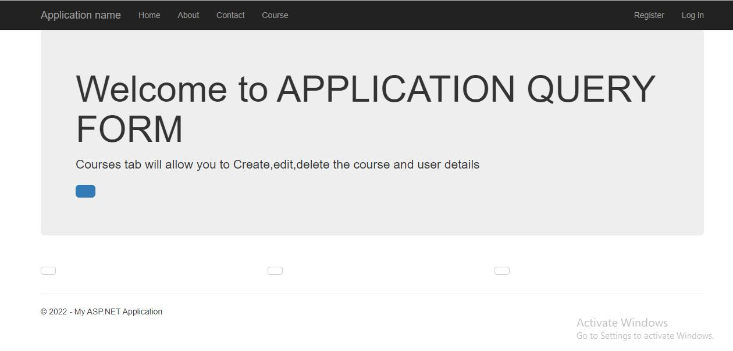

1)Creation of new data
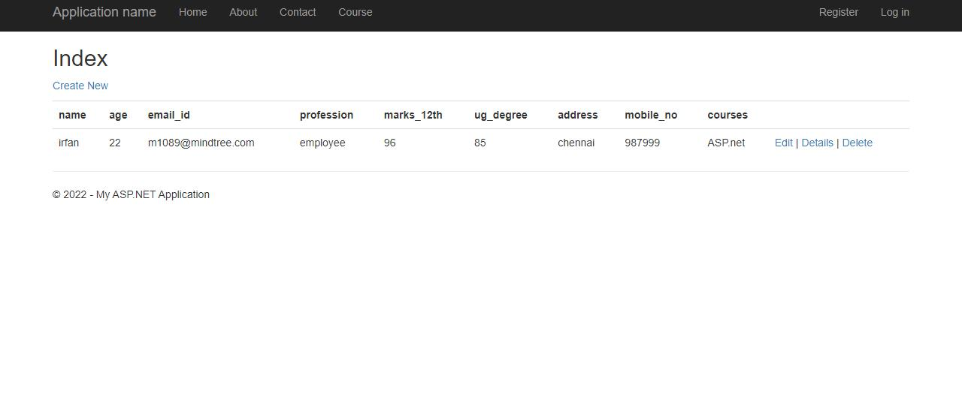

Form validation for mandatory fields

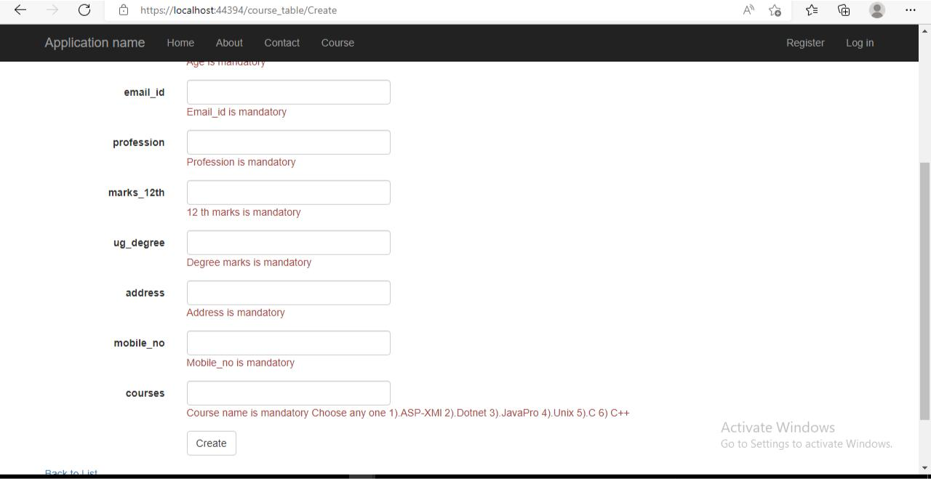

2).editing the existing data
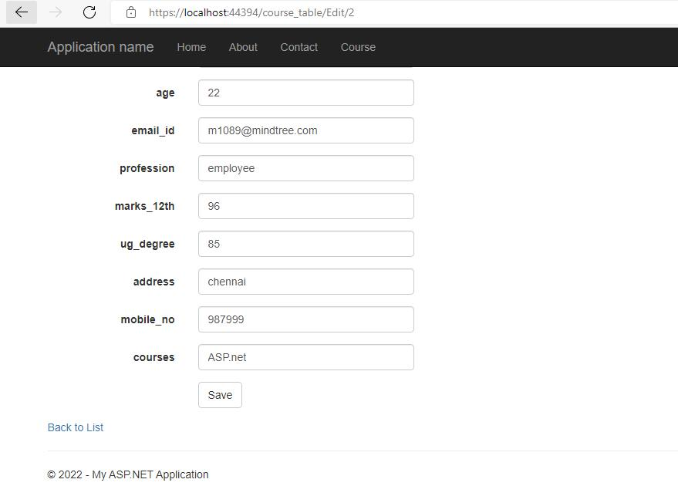

3).viewing the data

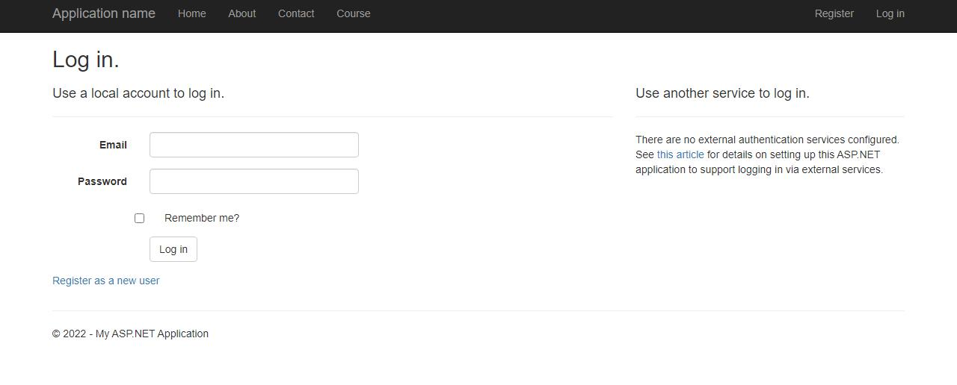

To view th e data it is mandatory to Register and Login
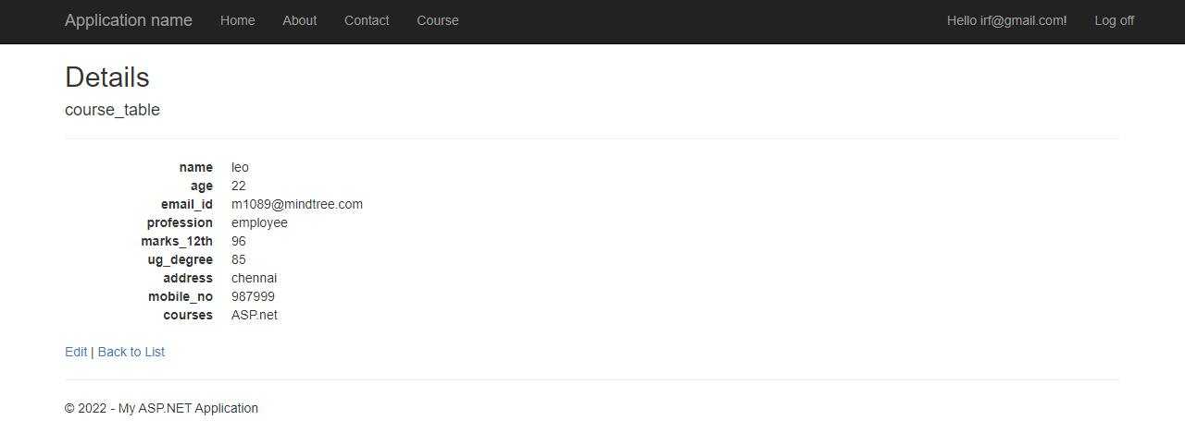

4).Delete Operation
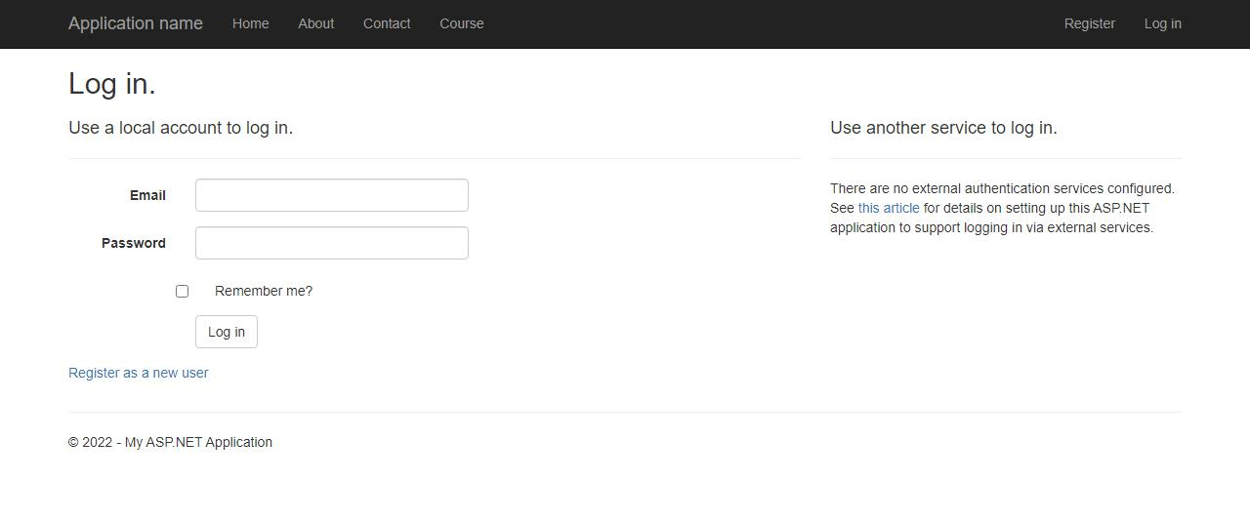

To delete the data it is necessary to Register and Login

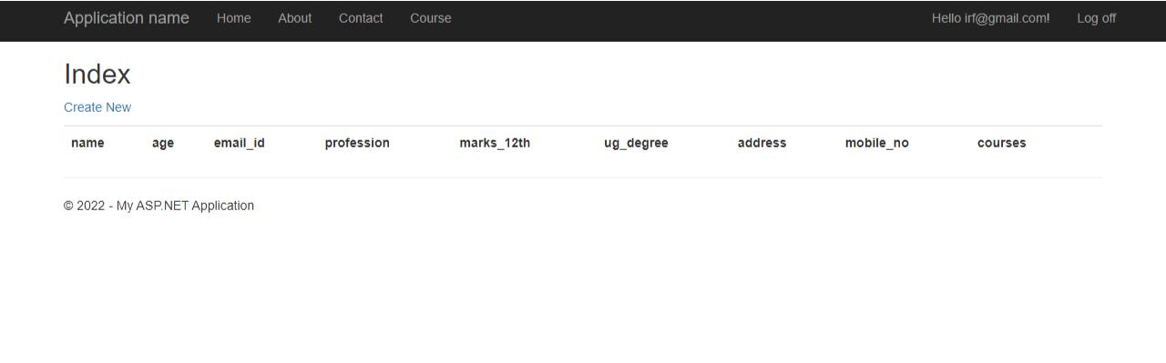

5).Database after deletion
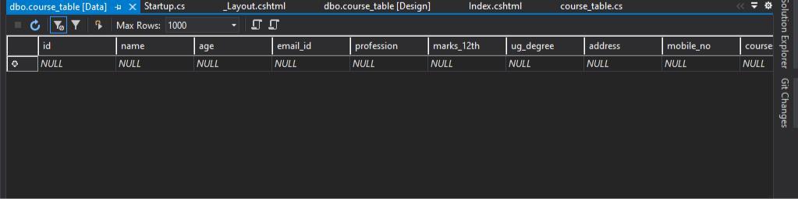

6)Database before deletion
