**Step by Step Guide**

*1)Setting up Remix IDE:*

-Go to <https://remix.ethereum.org/#optimize=false&runs=200&evmVersion=null>

-Create a new contract by pressing the button in the image below and give it any name you want.

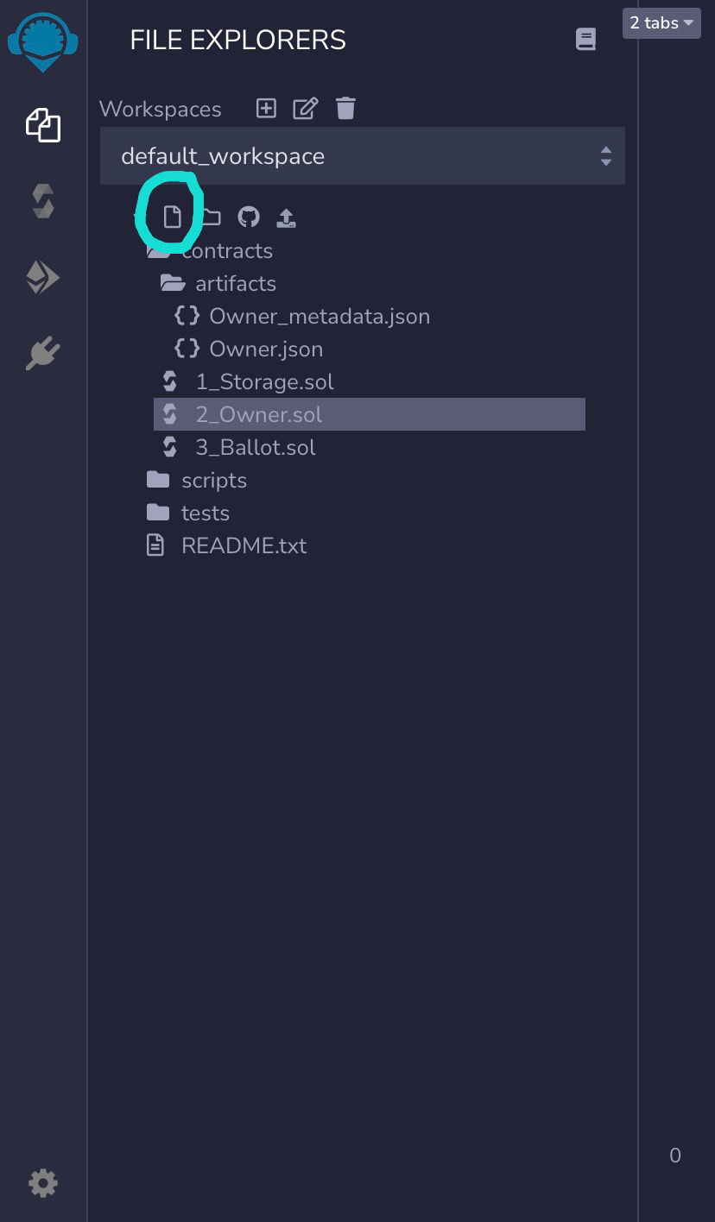

-Copy the contract I sent you (the .sol file) and paste it in this new contract you have created

-Go to the compiler screen by pressing the button on the left that is highlighted in the image below. After that change the compiler version to the one specified below and the check the box for Auto-Compile like in the image

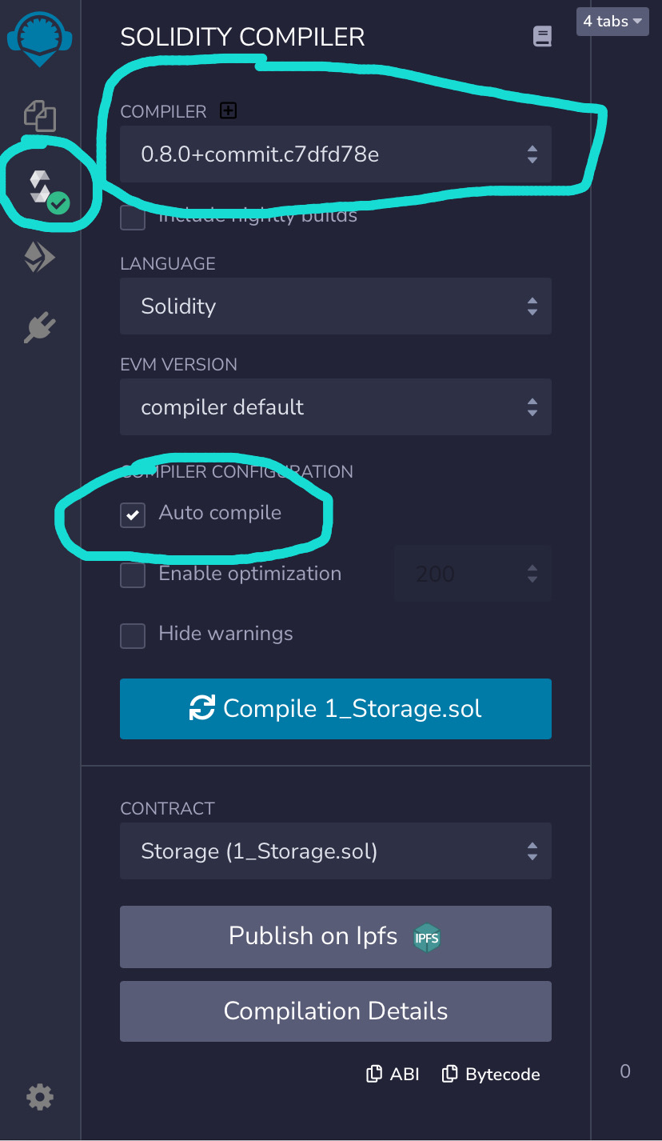

-Go to the deploy screen by clicking on the button on the left highlighted in the image below. After that change the environment to injectedweb3(will connect metamask). Finally, change the contract like highlighted in the image below to jetpack.

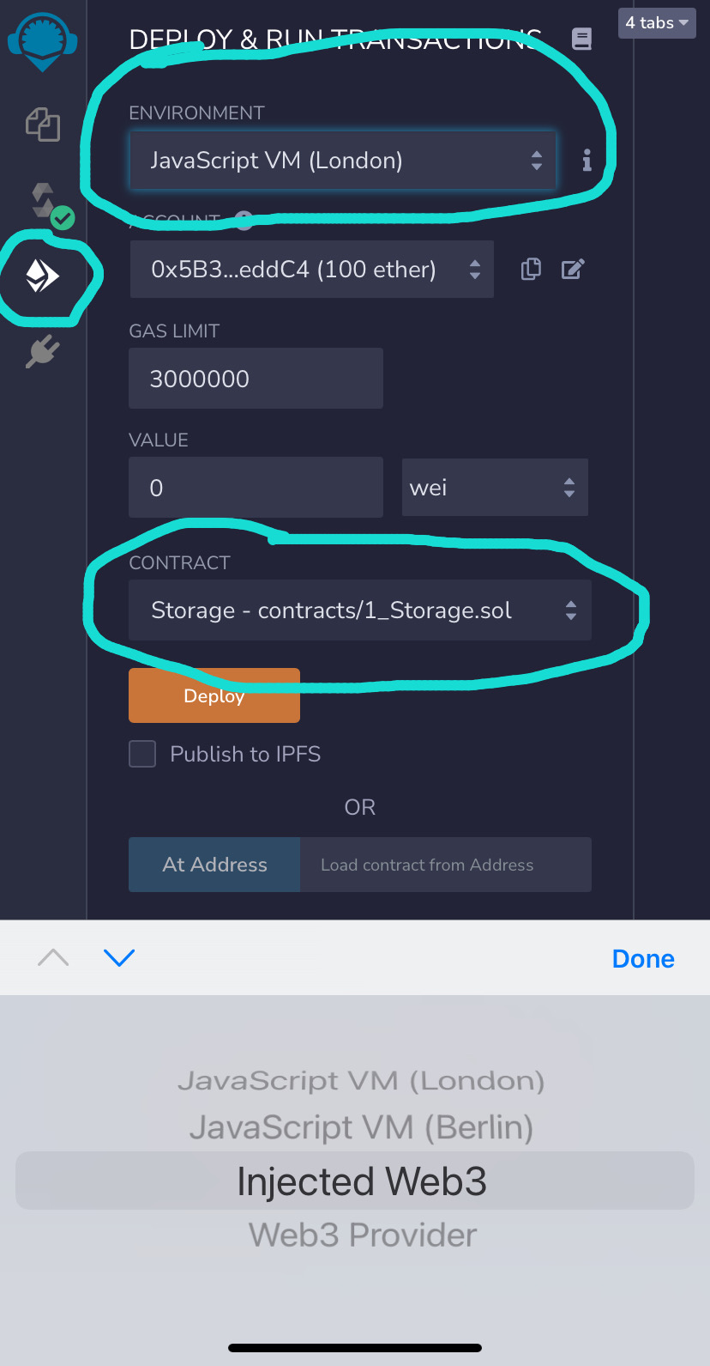

*2)Setting Mint Fee, Presale Start, Presale End, Public Sale Start*

-Go to lines 1859-1862 and modify the values.

Time is in unix (<https://www.unixtimestamp.com/>)

Mint fee is in wei (https://eth-converter.com/)

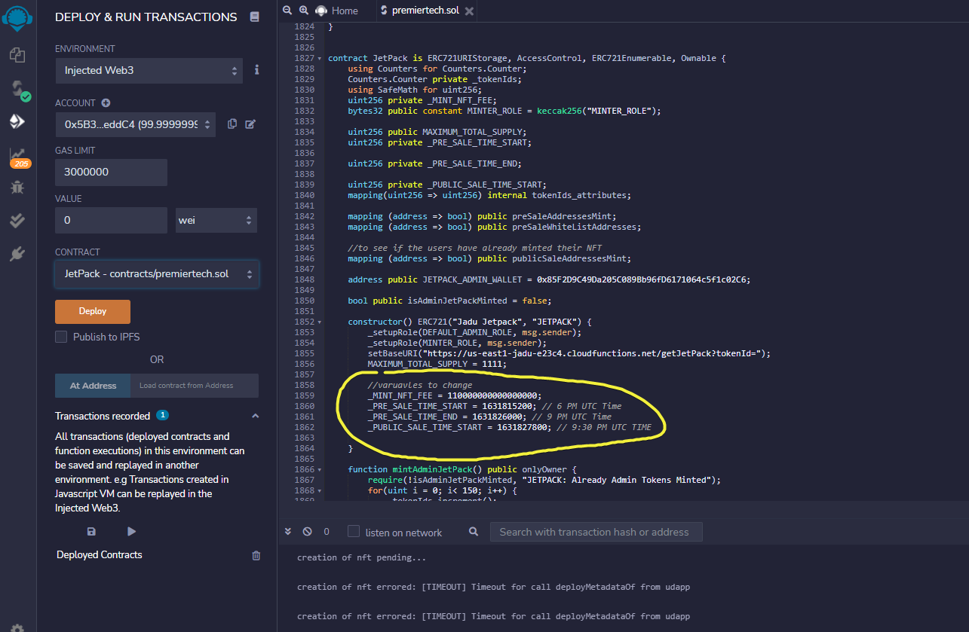

*3) Deploying Contract*

-Press deploy button after Remix configured correctly like mentioned in step 1

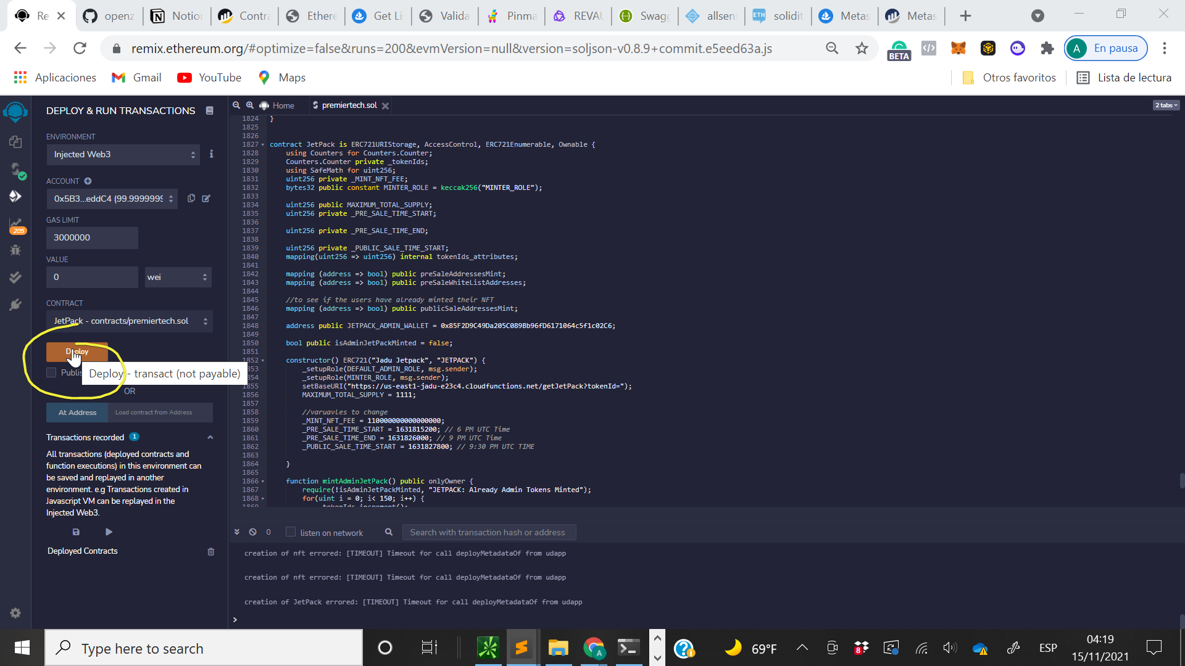

-Adding addresses to whitelist by calling the presaleWhitelistAddress function. The arguments passed to the function should be in this format ["0x318cBF186eB13C74533943b054959867eE44eFFE", “...”, “...”], [1, 1, 1, ....]

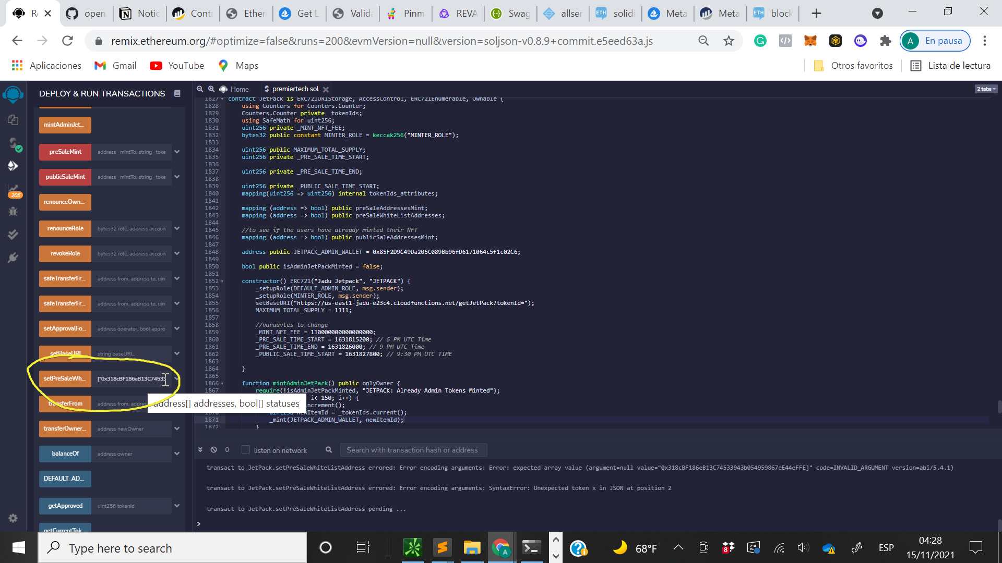

*4) Setting up UI*

-Get the deployed contracts address from remix and add it to html file

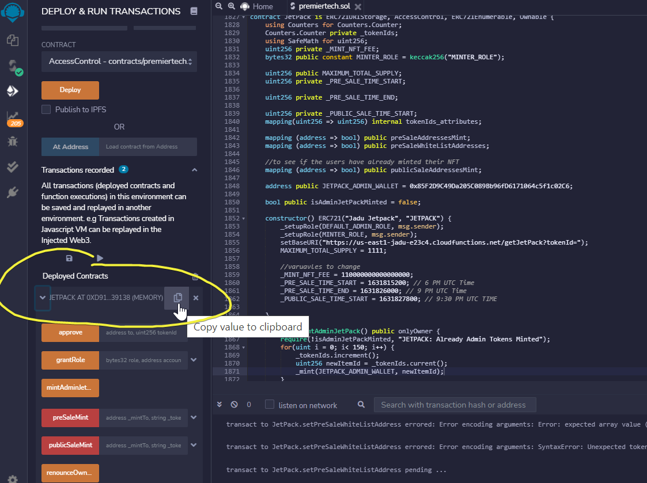

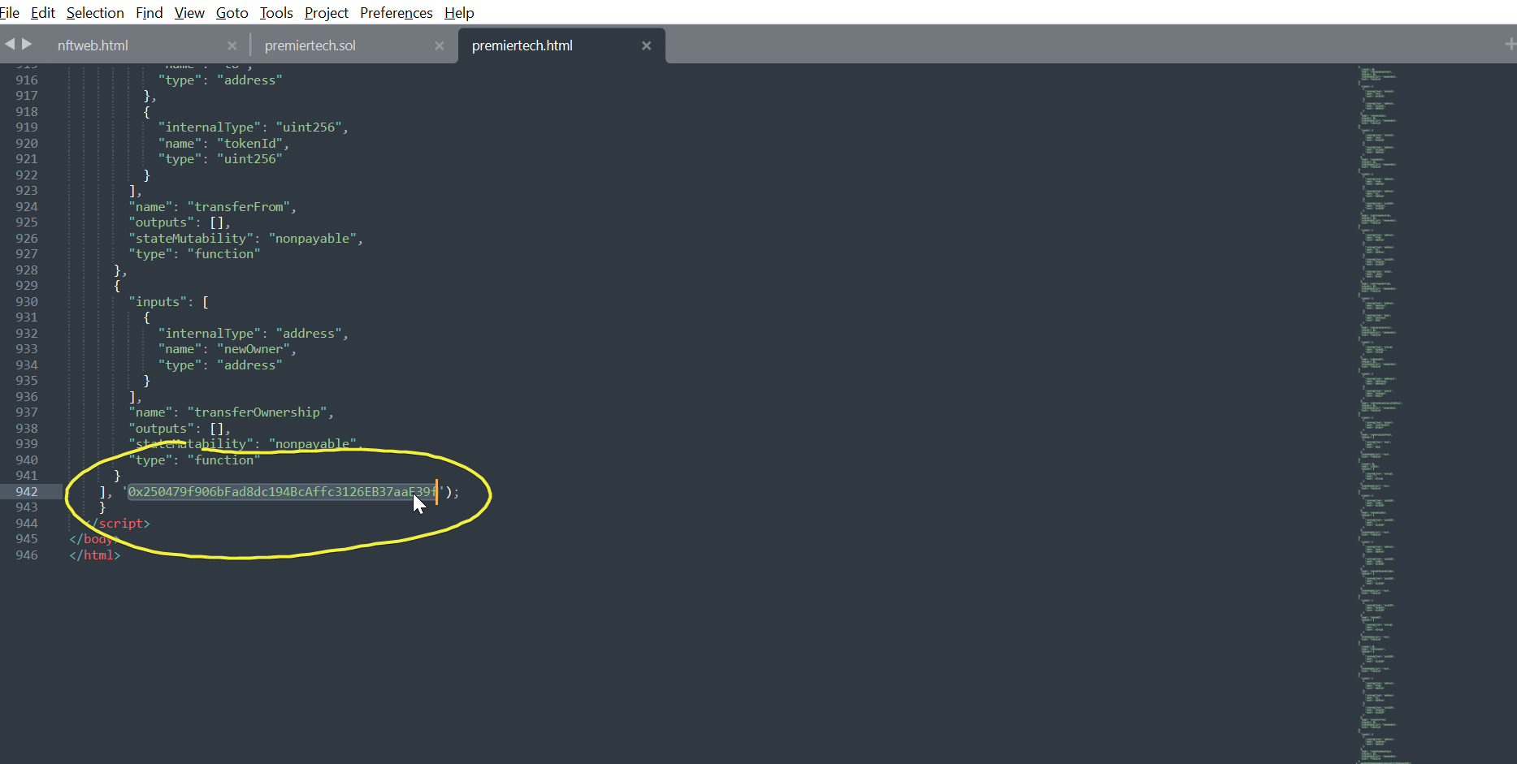

-From the cmd go inside the directory where you have the html file

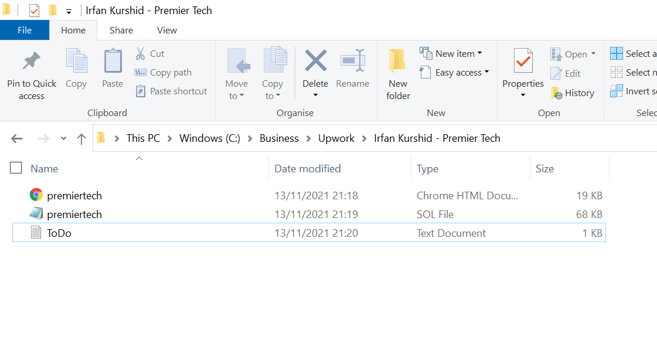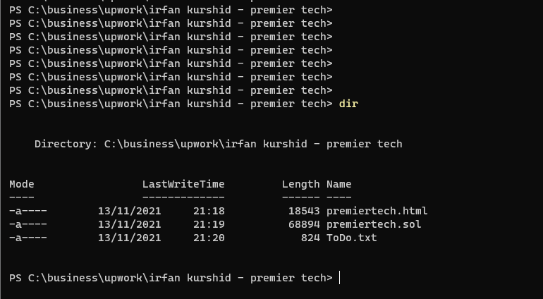

-Start an http server with npm , must have npm installed (<https://nodejs.org/en/download/>).

To start this server run these commands in cmd

**npm install http-server -g**

**Http-server**

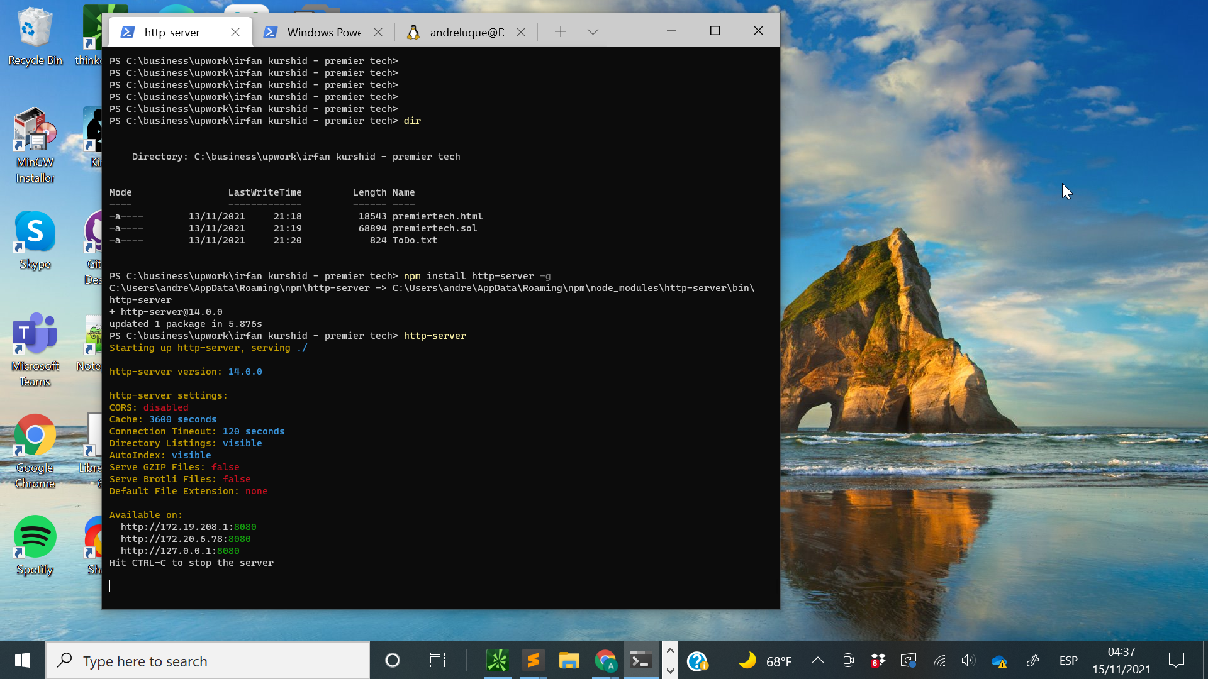

-Go to the browser and type http://localhost:8080/

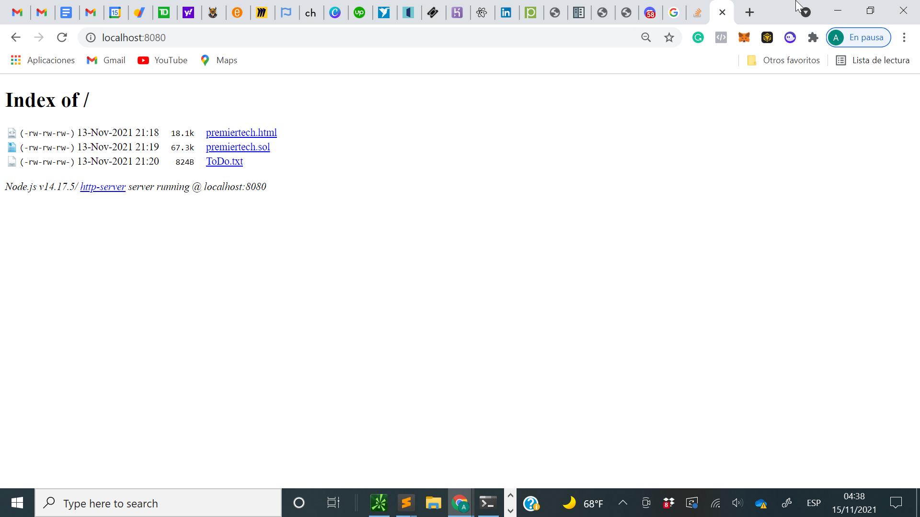

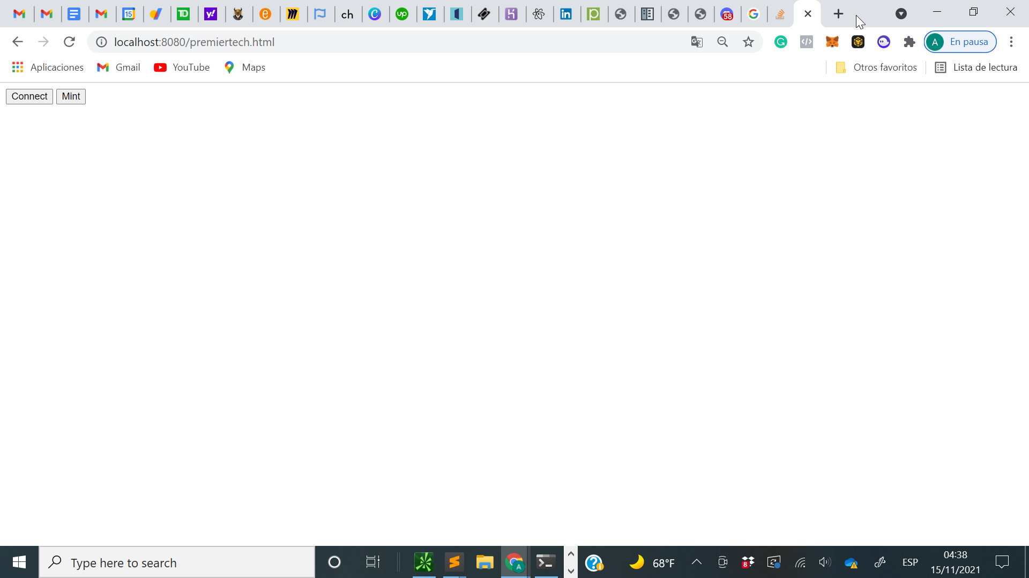

*5) Connecting to metamask and minting*

-Press the buttons in the website and if installed the metamask chrome extension will pop up and if your address is whitelisted and the presale or public sale has opened you will be able to mint

