# Malvertising Project

# Evaluation Results

The following observations were made from the data collected on Desktop and Mobile environment.

1. **Distribution of Time taken by websites to request Notification permission**

## Desktop :

The graph displayed is for 2980 websites. It can be observed that 95% cases take up to 3 minutes to request permission.

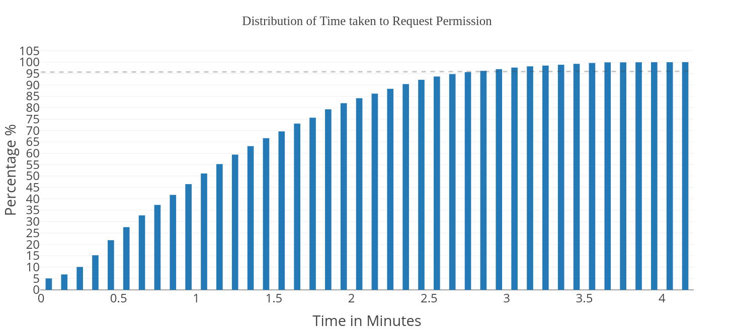

## Mobile :

The graph displayed is for 2980 websites. It can be observed that 95% cases take up to 3 minutes to request permission.

1. **Distribution of Time taken by websites to request Notification permission**