6 User Guide
This chapter provides the details of how to use this software.

  - JDK
This software is built using the JDK 1.4.2_3 so to use this software this version, or higher, of JDK must be installed on the operating system otherwise some features will not work properly.

6.1.1 Windows Installation
Down load the JDK version 1.4.2 from the website www.sun.java.com and install using the setup instructions. After installation, set the following environment variables using the advanced options in MyComputer->Properties->Advanced->Environment Variables.

Variable | Value
JAVA_HOME | d:\jdk1.4.2\j2sdk1.4.2
HYGRID | d:\HyGrid
CLASSPATH | .;.;%HyGrid%\mysql-java.jar;%JAVA_HOME%\lib;%HyGrid%
PATH | %PATH%;%JAVA_HOME%\bin
Table 6.1: Table of Environment variables for windows

6.1.2 Linux Installation
Download the JDK version 1.4.2_3, binary executable package, from the website www.sun.java.com and install using the setup instructions. After installation, set the following environment variables editing the file /etc/profile and define these environment variables.

Variable | Value
JAVA_HOME | /java/j2sdk1.4.2
HYGRID | /root/HyGrid
CLASSPATH | .:.:$HyGrid/mysql-java.jar:$JAVA_HOME/lib:$HyGrid:$CLASSPATH
PATH | $PATH:$JAVA_HOME\bin
Table 6.2: Table of Environment variables for linux

After setting these environment variables write at these commands at the end of the file.
EXPORT PATH CLASSPATH HYGRID JAVA_HOME.

  - MySQL
MySQL will be used to store database base records and it is must to run the HyGrid. Download MySQL version 4.2 for windows from the website www.mysql.com and install that using the install instructions. MySQL can be installed on the Linux plateform while installing the RedHat Linux using the custom install option. Choose the package of MySQL from the database server packages. Unzip the files data.zip provided with the HyGrid and unzip that file on to your local hard disk. Before starting the MySQL server copy the extracted files to the folder c:\mysql\data on the windows platform and /var/lib/mysql on the linux platform. After copying these files start the database server, the database will be started on the local machine.
You can also download a GUI tool for MySQL named MySQL control centre, available for download from www.mysql.com

  - System Information Files
Copy the files cpuusage.exe, processinfo.exe, and diskinfo.exe to the windows system32 directory on windows platform and the file atop.bin to /usr/bin directory on the linux platform. These files are must for HyGrid working because in the absence of these files the broker service will not work. These files are present in Windows_System_Programs_Exes folder.

6.4 Running Security Manager
Before running the security manager user has to provide the database connection information of the database to which security manager will connect to get and save information. Run the file DatabaseConfig.java to save the database connection information (This needed to be performed only once while running the security manager for the first time). After that run the rmiregistry from the base folder $HYGRID, using these command for windows and linux platforms repectively.
D:\HyGrid>start rmiregistry
root:HyGrid$]rmiregistry
To run the security manager use file “HyGridSecurityManager.java” and the command java HyGridSecurityManager 192.168.0.1 192.168.0.4. Here the addresses describe the scheduler and broker machine addresses respectively.

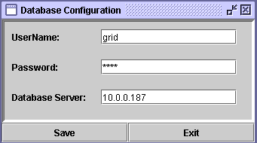
Figure 6.3: Saving Database Configurations

6.4.1 Machine Registration
To participate on the grid, a machine has to be registered with the security manager. To register a machine use the java file “RegisterMachines.java”. After successful operation the machine will not be registered instantaneously but the registration remains pending unless the administrator will not register it provides access rights. To accept register user and/or to give access rights the administrator will update the “machine” table. The same file would also be used to un-register the machines.

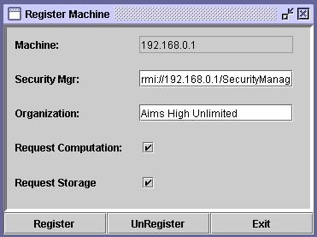
Figure 6.4: Sample Machine Registration screen

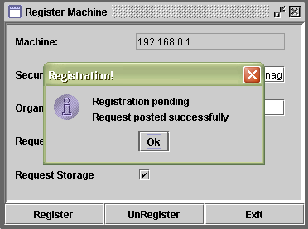
Figure 6.4: Sample Machine Registration screen

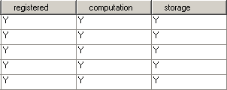
Update these fields to either 'Y' or 'N' to accept or reject

6.4.2 User Registration
To use the grid, a user has to be registered with the security manager. To register a user use the java file “RegisterUsers.java”. After successful operation the user will not be registered instantaneously but the user registration remains pending unless the administrator will not register the user and provide him access rights. To accept register user and/or to give access rights the administrator will update the “user” table. The same file would also be used to un-register the user.

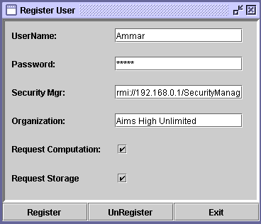
Figure 6.6: Sample User Registration screen

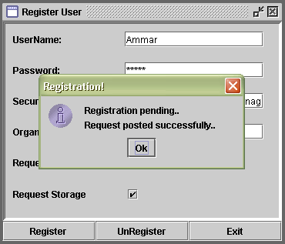
Figure 6.7: Sample User Registration screen

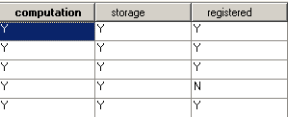
Update these fields to either 'Y' or 'N'

6.4.3 Login
After running the security manager and before running the other grid services user must have to login on to grid with the administrator user. The password of the administrator user is available in the “user” table of the database named “grid”, you can change that password for security reasons. Similarly before job submission the user must have to login to the grid using his/her user name and password .To run the login application use the java file “Login.java”.
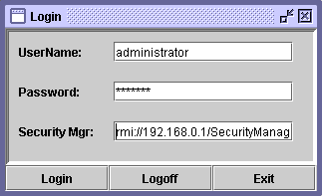
Figure 6.8: Sample Login screen

Here you have to provide the valid handle for the security manager, user name, and password otherwise it will prompt with an error message.
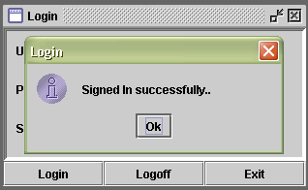
Figure 6.9: Sample Login screen

If all the entries would be valid then user will be logged in.

6.5 Running Broker
After logging on to grid, run the file “Broker.java” while providing the security manager’s address. Here you have to provide that security manager’s address which is currently managing the security for the grid and on which the user administrator is logged in.

    - Running Local Broker Service
Before running the broker service on the windows platform run the “CPUMemMonitor.exe” file to store the system information into a file.
To run the broker service on the local machine on the windows platform use the java file “WinBroker.java” and the file “LinuxBroker.java” on Linux platform. To run the local broker service you have to provide the main broker address and the file name to store the information on the local disk Use the following commands on windows and Linux platforms respectively.
c:\HyGrid>java WinBroker 192.168.0.1 d:/file.txt
root:HyGrid$]java LinuxBroker 192.168.0.1 /root/file.txt

6.6 Running Scheduler
To run the scheduler use file “Schedular.java”. This file requires the address of the security manager for managing security while scheduling jobs. 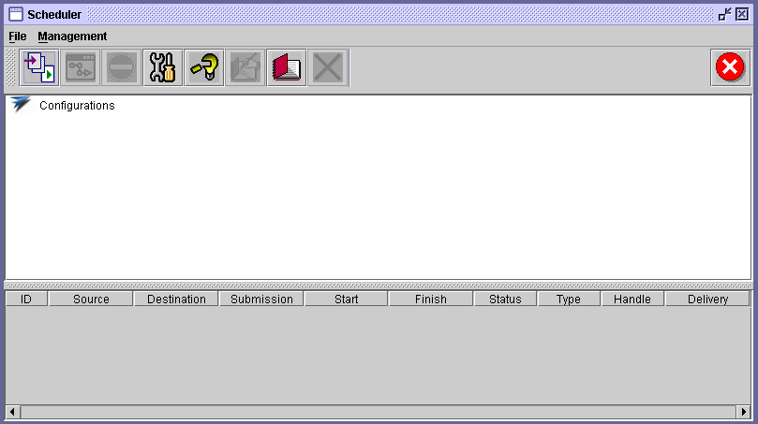
Figure 6.10: Main Scheduler UI

Scheduler user interface contains various options.
 This button is used to load a configuration file for this scheduler. Configuration file is the one which contains the names of the machines and the handles of the services running on those machines.
 This button is used to load the scheduler settings application which will be used to customize the scheduler settings, such as cpu, memory, disk thresholds etc.
 This button is used to create a new configuration file, or edit an existing file.
 This button is used to write the data in the table as a log file to the disk.
 This button is used to open the application for reading log files.
 This button is used to clear table data.
 This button is used to exit from the scheduler.
 This button is used to start the scheduler.
 This button is used to stop the scheduler
Scheduler UI also contains a table which shows the tabular information of the jobs and a tree to show the hierarchal view of the configuration file.

6 .6.1 Loading Configuration File
To load a configuration file the load file button will be used. It will show an open file dialog box, browse a .conf file created from the scheduler configuration editor.
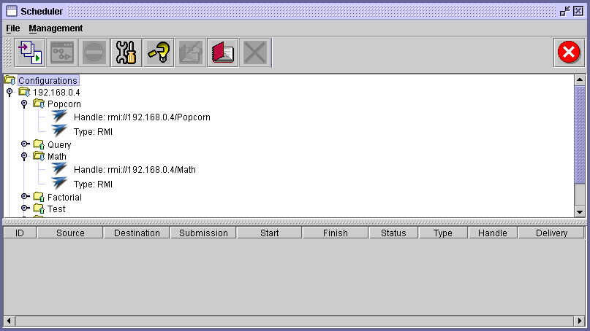
Figure 6.11: Configuration file is loaded

    - Loading Scheduler Settings
To load the scheduler settings use the scheduler settings button. It will open an application which will be used to customize the scheduler settings. Through this we can also save the settings into a file on the disk, so that to use previously saved settings.
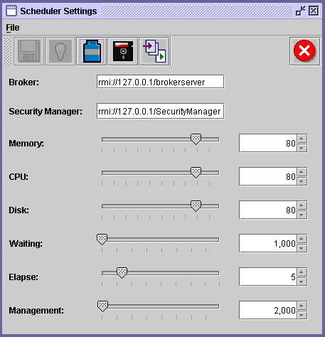
Figure 6.12: Scheduler settings screen

 This button is used to save settings which could be sent to the scheduler.
 This button is used to reset the recent changes done before save.
 This button is used to set the default settings.
 This button is used to save the settings in a file; the file extension must be .ssf
This button is used to load the settings from a file.
This button is used to exit the settings application.
There are 7 threshold values for various parts of scheduler.
Memory: Memory settings will restrict the scheduler to schedule jobs on a machine having % memory utilization greater than the set % value.
CPU: CPU settings will restrict the scheduler to schedule jobs on a machine having % CPU utilization greater than the set % value.
Disk: Disk settings will restrict the scheduler to schedule jobs on a machine having % Disk utilization greater than the set % value.
Waiting: Describes that after how many milliseconds the waiting thread will select a job from the waiting queue and try to reschedule that job.
Elapse: Describes the count that how many times the waiting thread will try to reschedule the job before the count less than or equal to the value set.
Management: Describes that after how many milliseconds the thread will perform housekeeping i.e. to start necessary threads, to stop unnecessary threads, and to get system information from the broker.
After loading the configuration file and the settings, the scheduler will be ready to be started. Both the steps must be completed before running the scheduler.

    - Scheduler Configuration Editor
Scheduler configuration editor is used to create and edit configuration files.
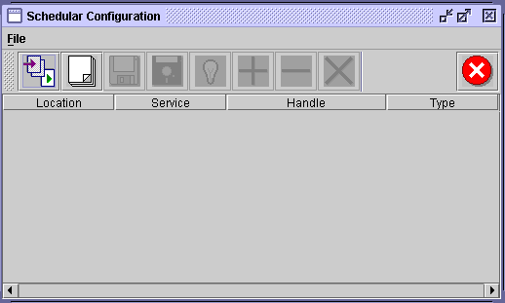
Figure 6.13: Scheduler Configuration Editor

It is simple and easily useable editor. It contains a table with four columns where we have to type the information and then save that information as a file whether we are creating a new file or editing another one.

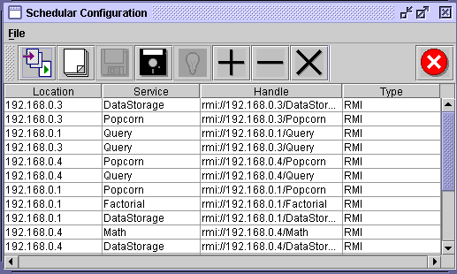
Figure 6.14: Configuration file is loaded

This button is used to load a configuration file.
 This button is used to create a new configuration file.
This button is used to save the current file.
 This button is used to save as file.
This button is used to reset the recent changes done before save.
This button is used to clear all table data.
This button is used to exit from the scheduler.
 This button is used to add a row to the table.
 This button is used to delete a row from the table.

  - Broker UI
Broker UI is a user interface used for monitoring the grid machines. It could be started with the file “BrokerUI.java” by providing the broker address.
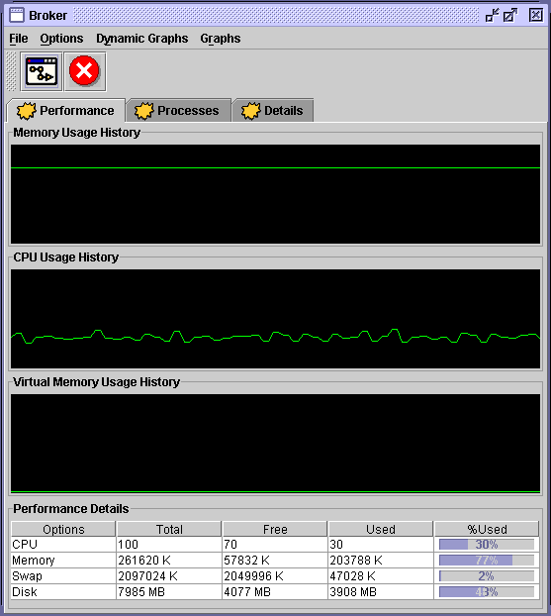
Figure 6.15: The main Broker UI

This button is used to select a machine for information display on the front panel.
This button is used to exit.
There are other options which are follows.

Processes: The tab page shows the process running on the machine selected.
Detailed Information: Displays the detailed information of a machine. It is available only on windows machines with windows xp or higher.

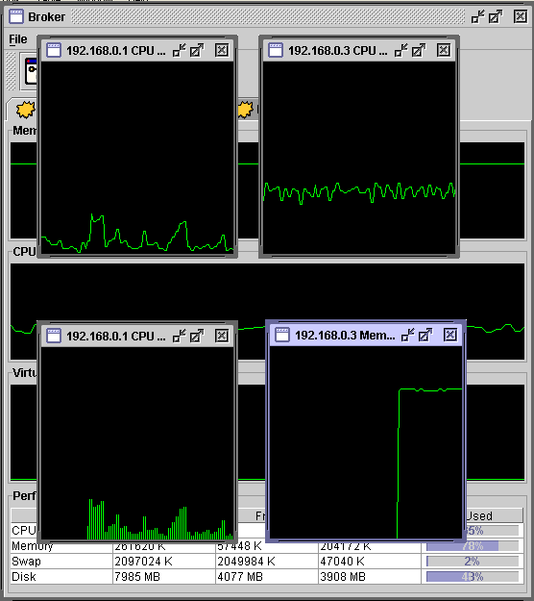
Figure 6.15: Broker with multithreaded dynamic graphs

Broker UI also provides various types of memory and CPU dynamic graphs. Graphs can be selected from the menu bar button “Dynamic Graphs”. Menu bar has other options of changing the type and orientation of graphs. At a single time multiple graphs can simultaneously display memory or CPU performance of multiple machines. Besides the dynamic graphs, it also provides the facility of 2D static graphs for displaying various system related information of CPU, memory, virtual memory, and hard disk.

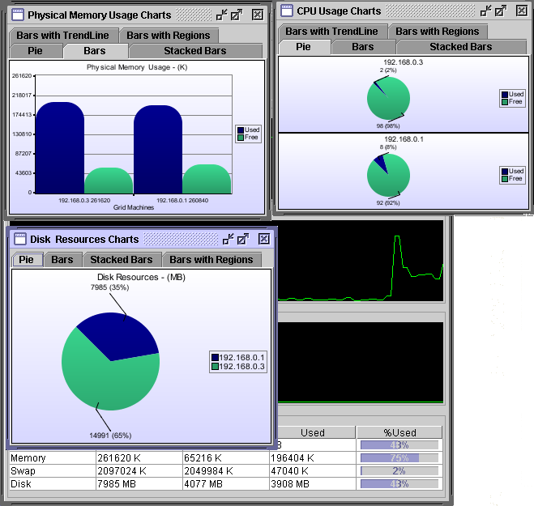
Figure 6.16: Broker with 2D Static graphs

6.8 Running Examples
6.8.1 Parallel Query Processor
To run the parallel query processor example we have to follow these steps.
- Run the services discussed above. Before running the scheduler service make sure that its config list contains the entry of the service “Query” for the machines on which the processing service would run.
- Run the file “QueryServer.java” by providing the scheduler address as a command line argument, on the machines whose list is given to the scheduler.
- Run the file “QueryApp.java” by providing the database address, query, scheduler address, and user name to the file. To provide the first two things you will have to edit the file.
- This is a computation intensive job so the user and machine must have the rights to access the computational resources. Further the user also has to log on to the grid (if not logged in earlier).

6.8.2 Popcorn Fractal
To run the popcorn fractal example we have to follow these steps.
- Run the services discussed above (if not running). Before running the scheduler service, or after running edit it to, make sure that its config list contains the entry of the service “Popcorn” for the machines on which the processing service would run.
- Run the file “PopcornServer.java” by providing the scheduler address as a command line argument, on the machines whose list is given to the scheduler.
- Run the file “popcorn.java” by providing the scheduler address, and user name to the file.
- This is a computation intensive job so the user and machine must have the rights to access the computational resources. Further the user also has to log on to the grid (if not logged in earlier).

6.8.3 Virtual Data Resource
To run the virtual data resource example we have to follow these steps.
- Run the services discussed above (if not running). Before running the scheduler service, or after running edit it to, make sure that its config list contains the entry of the service “DataStorage” for the machines on which the processing service would run.
- Run the file “DataStorageServer.java” by providing the scheduler & broker addresses as command line arguments, on the machines whose list is given to the scheduler.
- Run the file “SplitFile.java” by providing the scheduler & broker addresses, and user name to the file. You have to edit the file to provide the database address.
- This is a data intensive job so the user and machine must have the rights to access the storage resources. Further the user also has to log on to the grid (if not logged in earlier).

6.8.4 Large Number Factorial
To run the large number factorial example we have to follow these steps.
- Run the services discussed above (if not running). Before running the scheduler service, or after running edit it to, make sure that its config list contains the entry of the service “Factorial” for the machines on which the processing service would run.
- Run the file “FactorialServer.java” by providing the scheduler address as a command line argument, on the machines whose list is given to the scheduler.
- Run the file “Factorial.java” by providing the scheduler address, and user name to the file.
- This is a computation intensive job so the user and machine must have the rights to access the computational resources. Further the user also has to log on to the grid (if not logged in earlier).

6.9 Grid job, Application, Server
HyGrid provides two wizard classes “ClientWizard.java” and “ServerWizard.java” for creating a grid job, application, and server on the fly. These files could be used with the commands given below.
D:\HyGrid>ClientWizard Product Product
D:\HyGrid>ServerWizard Product
The above command will create two java files “Product.java” and “ProductServer.java” respectively and the classes created by the above two commands are.
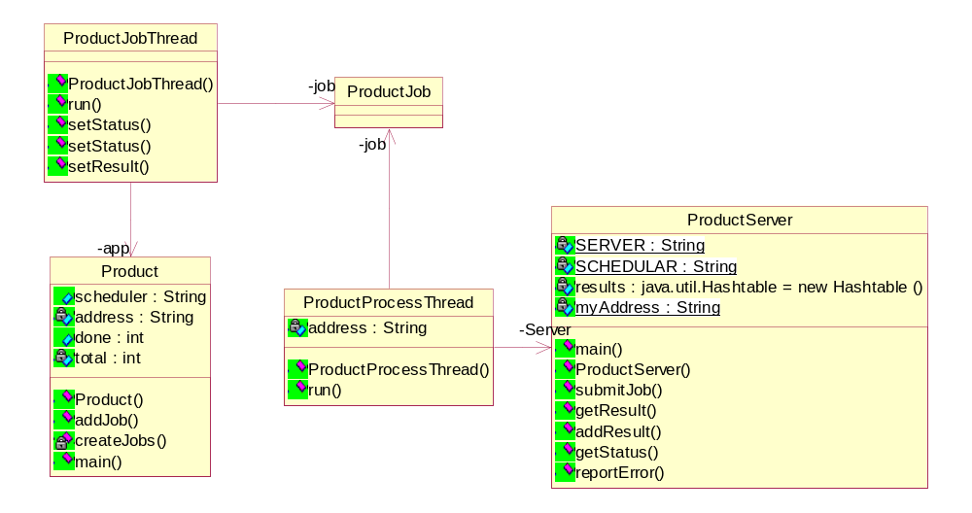

It is necessary to elaborate few methods and their usage; these include “createJobs”, “setResult”, and “addJobs”.
CreateJobs: CreateJobs is a method used to divide the logic into parts and creating subjobs for each division. While using this method some points should be kept under consideration.
- If the jobs are not so large and wouldn’t disturb the scheduling of other threads, especially the main thread, then the jobs could be created in this method.
- If the jobs are large and could effect the scheduling of the other threads, especially the main thread, then the jobs should be created in a separate thread so that the application’s response time wouldn’t be effected.
Add Result: “addResult” method is called by the “setResult” method of the job submission and retrieval thread to add the retrieved job in a data structure for future use or for processing the job spontaneously. Here again some point should be kept under consideration because the scheduler could st the client
uck due to these method calls if they won’t return the control back as early as possible.
- If the processing in the “addResult” method do not take higher CPU time then it is appropriate to process the job in that method .
- If the processing in the “addResult” method could consume more CPU time then it is appropriate to add the job in a data structure and process the jobs in a separate thread so that the control transfer to the scheduler quickly.
To have a practical look upon the above discussed cases you should see the files “SplitFile.java” and “QueryApp.java”.

