How to Run System Monitor

- On every machine, which you want to monitor, copy the windows system exe files to the system32 folder for the windows machine and install atop.bin (if not available) on the Linux machine.
- For windows machine run the file CPUMemMonitor to monitor the CPU and memory resources.
- Copy all the class files (System Monitor folder) of System Monitor on every machine which you want to monitor as well as on the machine which you want to make the central server (Broker Server).
- On a machine which you want make a central server (Broker Server), run the file Broker.class (java Broker). But before doing that run the rmiregistry from the base folder where all the System Monitor files are residing.
- On a machine, which you want to monitor, run the WinBroker.class (for windows machine, java WinBroker [Broker Server IP Address]) and/or LinuxBroker.class (for Linux machine, java LinuxBroker [Broker Server IP Address]). But before doing that run the rmiregistry from the base folder where all the System Monitor files are residing.
- On a machine from which you want to monitor all the machines, execute the file BrokerUI.class (java BrokerUI [Broker Server IP Address]). But before doing that run the rmiregistry from the base folder where all the System Monitor files are residing.

Broker UI
Broker UI is a user interface used for monitoring the grid machines. It could be started with the file “BrokerUI.java” by providing the broker address.
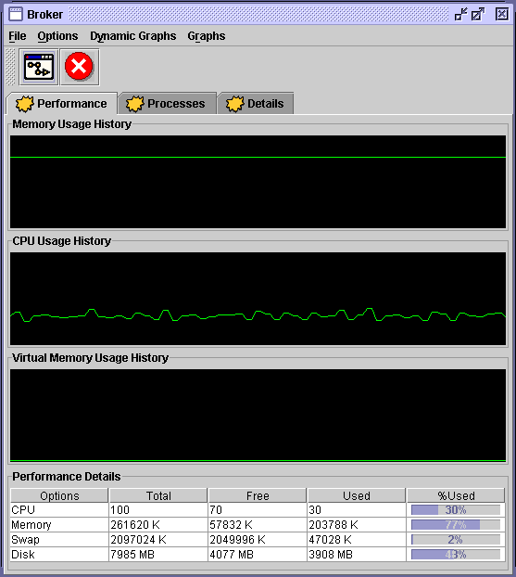

 This button is used to select a machine for information display on the front panel.
 This button is used to exit.
There are other options which are follows.

Processes: The tab page shows the process running on the machine selected.
Detailed Information: Displays the detailed information of a machine. It is available only on windows machines with windows xp or higher.

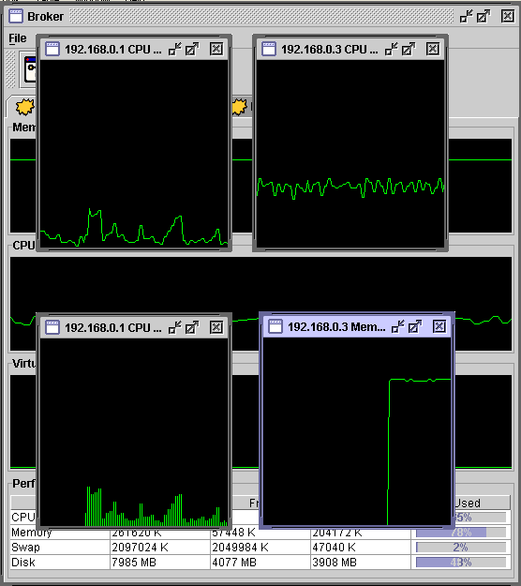

Broker UI also provides various types of memory and CPU dynamic graphs. Graphs can be selected from the menu bar button “Dynamic Graphs”. Menu bar has other options of changing the type and orientation of graphs. At a single time multiple graphs can simultaneously display memory or CPU performance of multiple machines. Besides the dynamic graphs, it also provides the facility of 2D static graphs for displaying various system related information of CPU, memory, virtual memory, and hard disk.

