* Implementation steps for the 2D CFAR process.

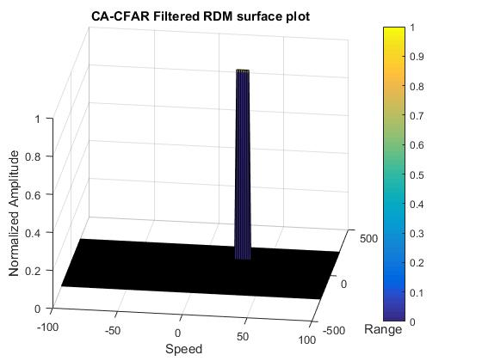

Steps:-

1. Choose number of training and guard cells
2. Choose the offset threshold
3. Loop through all cells and find average the noise and offset it to get the threshold value.
4. Check if CUT is above threshold and assign 1 if it is or 0 it is not

* Selection of Training, Guard cells and offset.
* To be honest, it was trail and error
* Steps taken to suppress the non-thresholded cells at the edges.
* All cells whose value were checked against the threshold would either have a 0 or a 1. Hence the border cells can be found be looking for cells that are neither 0 nor 1 and assigning 0