Sample JUITA Paper for A4 Page Size and Font Size of Times New Roman 24

First Author1, Second Author2, ..., Fifth Author5

*1,2,3,4,5Author’s affiliation (2 - 5 authors)*

1,2,3,4,5first.author@first-third.edu

**Abstract - This document provides formatting instructions for authors preparing articles for publication in the JUITA journal. Authors must follow the instructions given for the articles to be published. Authors can use this document both as an instruction set and as a template. Abstracts must be written in 100 -200 words, containing background information, objectives, methods, results, and conclusion. There should be no references/citations in the abstract.**

**Keywords: write 3-5 phrases**

1. INTRODUCTION

Manuscripts published in JUITA must be written by a minimum of 2 authors and a maximum of 5 authors. The systematics of the body of the manuscript consists of 1) introduction (containing research background along with support for previous studies and supported by relevant literature, problem formulations, and research objectives), 2) methods, 3) results and discussion, 4) conclusion (contains conclusions and suggestions).

1. PAGE LAYOUT

The manuscript page layout referred to in this document is regarding the page layout and the manuscript format as follows:

1. *Layout*

The paper size used in the manuscript is A4 210mm x 297mm (8.27"x 11.69"). Page margin limits are sized:

* Top = 19mm (0.75")
* Bottom = 43mm (1.69")
* Left = Right = 14.3mm (0.56")

1. *Manuscript Format*

Submissions must be in 1 column format with file type *.doc or *.docx.

1. WRITING OF THE TEXT

All the beginning of the paragraph is written indented. All sentences in a paragraph must be aligned right and left.

1. *Font Type*

The typeface used in the script is Times New Roman, except for the writing of e-mail accounts. Other fonts can be used if needed for certain purposes..

The required sizes and fonts are presented in Table I.

1. *Title and Author’s Name*

Writing the title using a 24pt regular font. The author’s name is written in 12pt font size. Author affiliation is written in 11pt font and italicized. The e-mail address is written in Courier Regular font size 10pt.

TABEL I  
FONT SIZE AND WRITING

| **Size** | **Times New Roman** | | |
| --- | --- | --- | --- |
| **Regular** | **Bold** | **Italic** |
| 10 | Table title, table content, figure title, references |  | References (partial) |
| 10 | Author’s email address (Courier) | abstract body |  |
| 11 | *level-1 heading*,  paragraph |  | *level-2 heading,*  *level-3 heading,*  author affiliation |
| 12 | Author’s name |  |  |
| 24 | Title |  |  |

All titles and author details must be written in 1 column and centered. Each word-initial in the title must be written in capital letters, except for the article, preposition, and conjunctions. The author’s name is written in full according to his real name. It may not be accompanied by an academic title, academic position, another title/position, or membership in any professional organization. Each affiliation must include the name of the department or company and the country’s name where the author is from (e.g., Informatics Engineering, Universitas Muhammadiyah Purwokerto, Indonesia).

1. *Headings*

The maximum level of headings used is 3 levels. All headings are written in 11pt font. Every word-initial in a heading must be written in capital letters except for certain words as in section III-B.

1. *Level-1 Heading: Level-1 heading* must be written using capital letters, centered, and numbered using capital Roman numerals. For example, “III. WRITING OF THE TEXT ”in this document. The two *level-1 headings* that are not numbered are “ACKNOWLEDGMENTS” and “REFERENCES”.
2. *Level-2 Heading: Level-2 heading* must be written italicized, aligned to the left, and numbered using uppercase (capital) letters followed by a “.” (period). For example, “*B. Title and Author’s Name*”.
3. *Level-3 Heading: Level-3 heading* must be written hanging (indent), italicized, and numbered with Arabic numerals followed by “)” (closing brackets). *Level-3 headings* must end with “:” (colon). The body of the *level-3* section is written as soon as the *level-3 heading* in the same paragraph. For example, this paragraph starts with a *level-3 heading*.
4. *Figure, Table, and Equation*

Figures and tables should be centered. Figure in graphic or other forms must be clearly legible and visible. Image coloring will greatly affect image clarity. An example of a figure in the form of a graphic is shown in Fig. 1, while a figure in the form of an image is presented in Fig. 2.

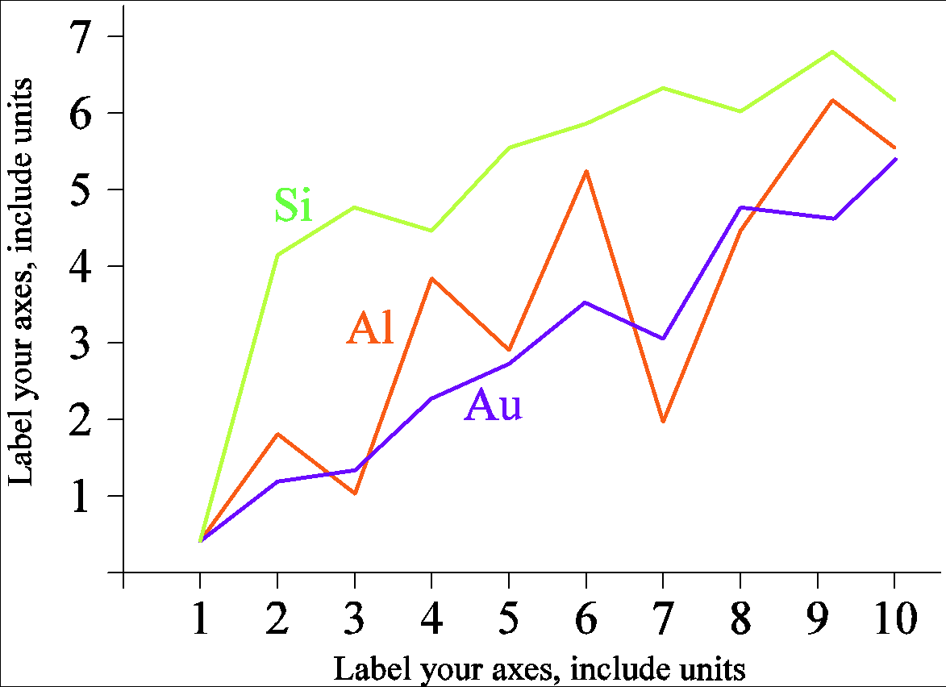

**Fig. 1 An example of a graphic figure**

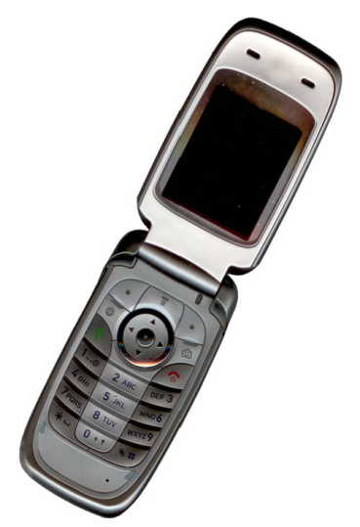

**Fig. 2 An example of a figure in the form of an image**

Fig. 1 and Fig. 2 as examples of figure presentation need to be considered and ensure that the use of colour must be clear and contrast, and all text labels in each figure must be clearly legible. Figures must be numbered using Arabic numerals. Figure title uses Bold 10pt font and is written centred to the figure. An image of a screen shot of a system or application, must be bordered.

Tables must be numbered using capital Roman numerals. The table title is placed on top of the table and is written in the centre of the table in 10pt capital Regular font, as in Table I. Tables are not allowed to be presented in the form of image.

The equations are an exception to the prescribed specifications of this template. You will need to determine whether or not your equation should be typed using either the Times New Roman or the Symbol font (please no other font). To create multileveled equations, it may be necessary to treat the equation as a graphic and insert it into the text after your paper is styled.

Number equations consecutively. Equation numbers, within parentheses, are to position flush right, as in (1), using a right tab stop. To make your equations more compact, you may use the solidus ( / ), the exp. function, or appropriate exponents. Italicize Roman symbols for quantities and variables, but not Greek symbols. Use a long dash rather than a hyphen for a minus sign. Punctuate equations with commas or periods when they are part of a sentence, as in (1).

$SM\left(\hat{e}, e_{i}\right)=\left\{SM\left(\hat{e}, e_{j}\right), e_{j}∈{Cl}_{i}\right\} ; i=1, 2, 3, …, k$

 

Note that the equation is centred with a right-aligned equation number. Be sure that the symbols or variables in your equation have been defined before or immediately following the equation. Use “(1)”, not “Eq. (1)” or “equation (1)”, except at the beginning of a sentence: “Equation (1) is . . .”

1. *Page Number, Headers, and Footers*

Page numbers, headers, and footers are not required in the manuscript submitted by the author.

1. *Links and Bookmarks*

All hypertext links and section bookmarks are not permitted in the manuscript. If you want to cite from the internet, it must be done using a citation system according to writing citations' rules.

1. *References*

The references section is not numbered. All references are written in 10pt regular font. Use the reference manager (suggestion: Mendeley) to write citations and bibliography. The manuscripts mostly use the IEEE model [1], likewise the citations. Some examples of library sources from books [2], journal paper [3], conference proceedings articles [4], and report [5] presented in this document.

1. CONCLUSION

The conclusion of the manuscript has no subsections. Conclusions and suggestions are written in one paragraph; they do not need to be separated.

ACKNOWLEDGEMENT

Like the references, the acknowledgment section is not numbered. An acknowledgment is written if there is one. Special thanks are addressed to funders for the research carried out or to people who are truly instrumental in carrying out the research.

REFERENCES

[1] IEEE, “Templates for IEEE Open Journals,” *https://journals.ieeeauthorcenter.ieee.org/create-your-ieee-journal-article/authoring-tools-and-templates/ieee-article-templates/templates-for-ieee-open-journals/*, 2018. [Online]. [Accessed: 10-Jun-2018].

[2] J. Heaton, *Artificial Intelligence for Humans, Volume 3: Neural Networks and Deep Learning*, 1.0. Chesterfield, USA: Heaton Research Inc., 2015.

[3] V. A. N. Fatimah, H. Mustafidah, and A. S. Fitri, “DIAMONT: a bilingual Android-based application to assist parents in the home-based management of childhood diarrhea–a concept,” *Bio-Algorithms and Med-Systems*, vol. 15, no. 4, pp. 1–11, 2019.

[4] H. Mustafidah, A. O. Yosi, A. S. Fitri, V. N. A. Fatimah, and Y. A. N. Fitriana, “Diet Calorie Determination System using Case-Based Reasoning,” *IOP Conf. Ser. Mater. Sci. Eng.*, vol. 771, no. 1, pp. 1–9, 2020.

[5] H. Mustafidah and S. Suwarsito, “Model Parameter Jaringan Syaraf Tiruan untuk Pemilihan Algoritma Pelatihan Jaringan Backpropagation yang Paling Optimal,” Purwokerto, Central Java, Indonesia, 2015.