 Faculty of Computer Science and Mathematics

Lab Exercise 1

Name: | MUHAMMAD IRFAN BIN A GHANI
Matric Num: | S79175


Overview:

This in-class exercise extends Lab Exercise 1. In addition to the basic tags you have practised (headings, paragraphs, lists, links and images), you will apply further HTML elements covered in Chapter 3: description lists, blockquote, special characters, e-mail links, relative links, proper nesting and HTML validation.
There are two problems. Your lecturer will assign one problem to you, or you may be asked to complete both.

Problem A: Local Business Web Page

A small local business near your campus (for example, a café, bookshop, laundry shop or printing shop) wants a simple one-page website to promote its services. You have been asked to build the first version of the page using HTML only (no CSS). You may use a real business as inspiration, or invent one.

Instructions
Create a file named lab1_ExerA.html that contains the following:
- A complete HTML5 structure: <!DOCTYPE html>, <html lang="en">, <head> with <meta charset="utf-8"> and a <title> showing the business name.
- An <h1> heading with the business name, followed by a short paragraph introducing the business. Use <strong> for the business slogan and <em> for at least one word that needs emphasis.
- An <h2> section “Our Menu / Services” using a description list (<dl>, <dt>, <dd>) with at least 4 items. Each <dt> is the item name and each <dd> gives a short description and price (e.g. RM 5.50).
- An <h2> section “How to Order” using an ordered list (<ol>) with 3–5 steps. 5. An <h2> section “Facilities” using an unordered list (<ul>) with at least 3 items.
6. An | <h2>
<blockquote>
section “What Our Customers Say” containing one customer review inside a element.
- An image related to the business using <img> with a meaningful alt attribute.
- Contact information that includes:
  - the business address, using <br> to separate address lines
  - an e-mail link using mailto:
  - an absolute link to a map or social media page that opens in a new tab (target="_blank").
- A footer line that uses at least two special characters, e.g. &copy; and &amp; (example: © 2026 Kopi & Roti Café).
- Comments (<!-- ... -->) explaining each section of your code.

Submission

Save the file as lab1_ExerA.html, validate it at https://validator.w3.org (Validate by File Upload), and submit it (Submit lab1_ExerA.html and Screenshot of validation) through Github

Lab1_ExerA.html (Screenshot of validation)
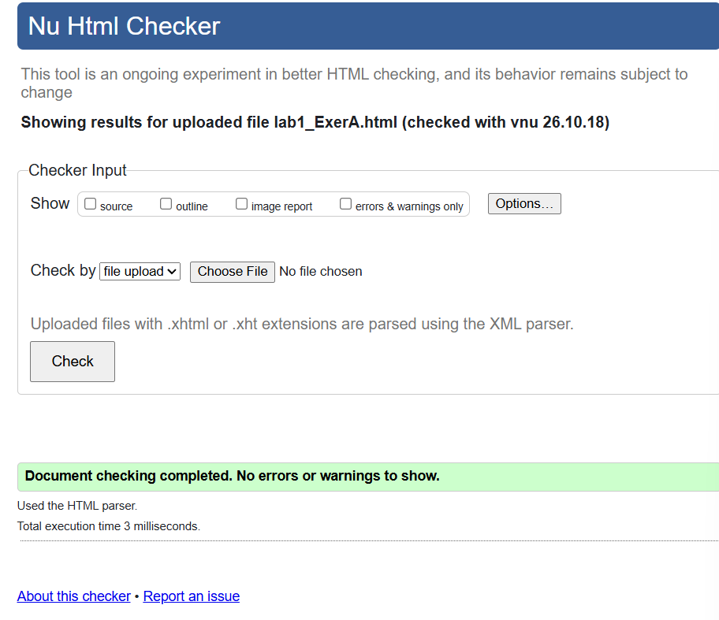

Lab1_ExerA.html code
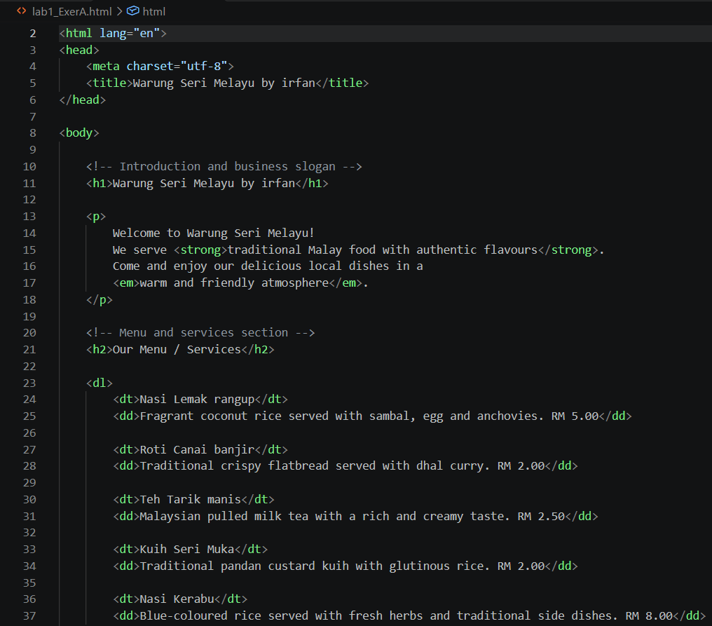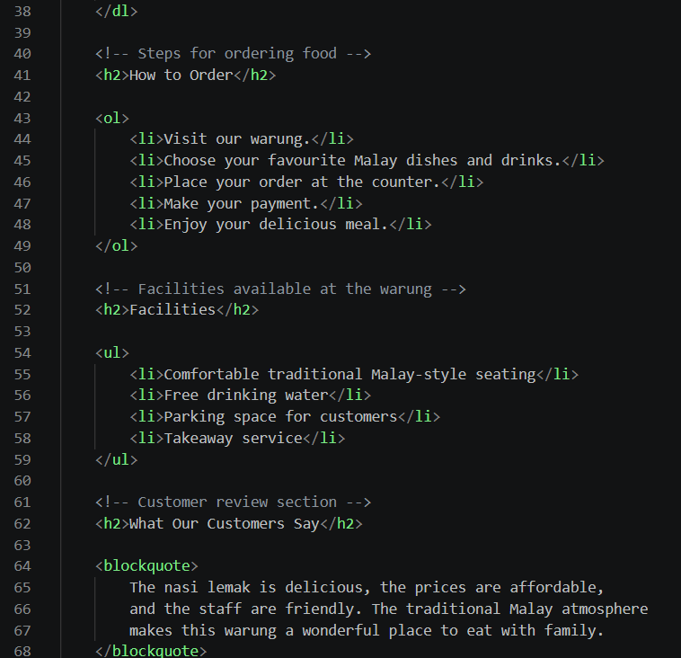
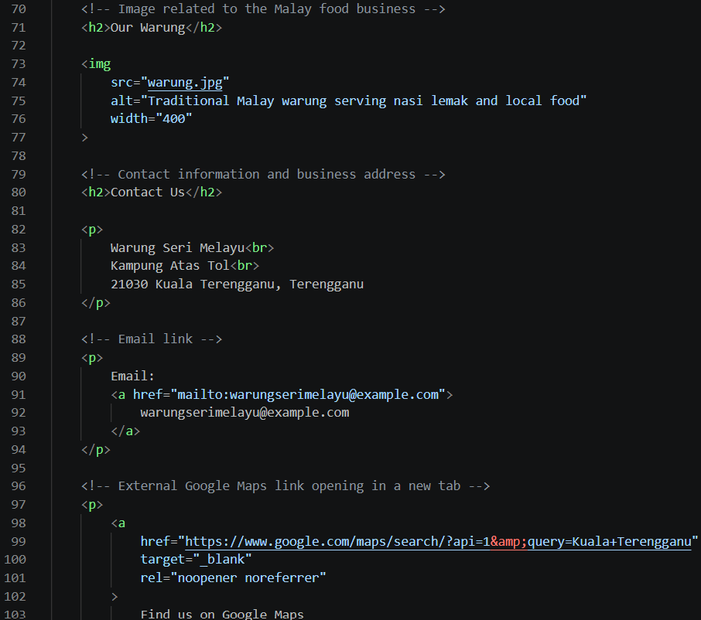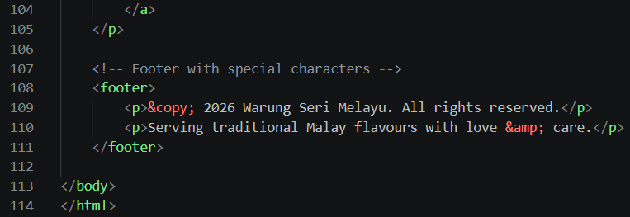

Output:
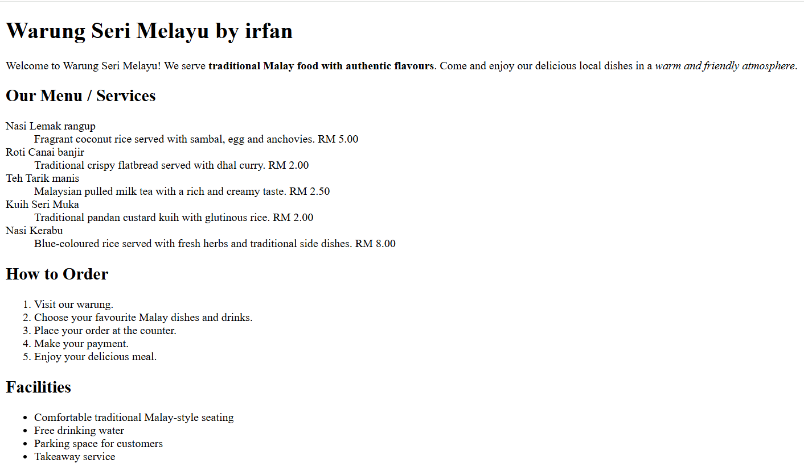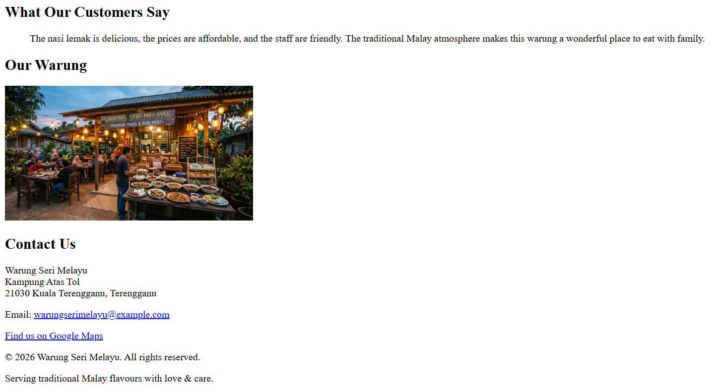

Problem B: Campus Club Mini Website (Debugging and Extend)

A junior committee member of the Campus Coding Club wrote the home page below, but it contains many mistakes. Some of them are still displayed by the browser, but the code is not valid HTML. Your tasks are to find and fix the errors, then extend the page into a small two-page website.

Given Code
- <html>
- <head>
- <title>Campus Coding Club
- <meta charset="utf-8">
- </head>
- <body>
- <h1>Welcome to Campus Coding Club</h2>
- <p>We meet every <strong><em>Wednesday</strong></em> at Lab 3.
- <h2>Our Activities<h2>
- <ul>
- <li>Weekly coding sessions
- <li>Hackathon</li>
- <li>Web design workshop</li>
- </ol>
- <p>Visit our university: <a href=www.umt.edu.my>UMT Website</a></p>
- <img src="club.jpg">
- <p>Copyright (c) 2026 Campus Coding Club & Friends</p> 18 </body>

Instructions

Part 1. Find and Fix the Errors
- Copy the given code into a new file named lab1_ExerB.html.
- Identify and correct all errors. At the top of the <body>, write an HTML comment listing each error and the line number, e.g. <!-- Error 1 (Line 1): missing <!DOCTYPE html> -->.
4. Validate your corrected file at https://validator.w3.org. Your final page must show “No errors or warnings to show”.

Part 2. Extend into a Two-Page Website
- Create a second page named contact.html with the same basic HTML5 structure and a suitable <title>.
- In contact.html, add an <h2> “Committee Members” section using a description list (<dl>): each <dt> is a position (President, Secretary, Treasurer, etc.) and each <dd> is the member’s name. Include at least 3 positions.
- Add an e-mail link using mailto: so visitors can contact the club.
- Add a navigation line at the top of BOTH pages using relative links, e.g. <a href="index.html">Home</a> | <a href="contact.html">Contact Us</a>. Clicking the links must move between the two pages.
- Add a short quote from the club advisor on index.html using <blockquote>.
- Use comments to explain each section of your code in both files.

Submission

Save the file as lab1_ExerB.html, validate it at https://validator.w3.org (Validate by File Upload), and submit it (Submit lab1_ExerB.html and Screenshot of validation) through Github
Lab1_ExerB.html (Screenshot of validation)
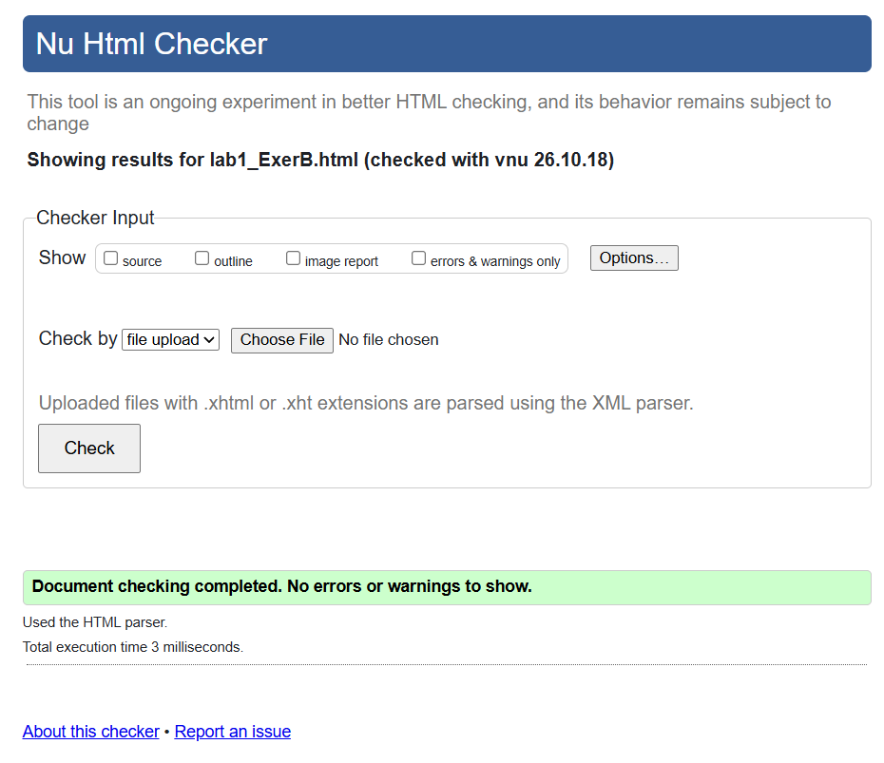

Contact.html (Screenshot of validation)
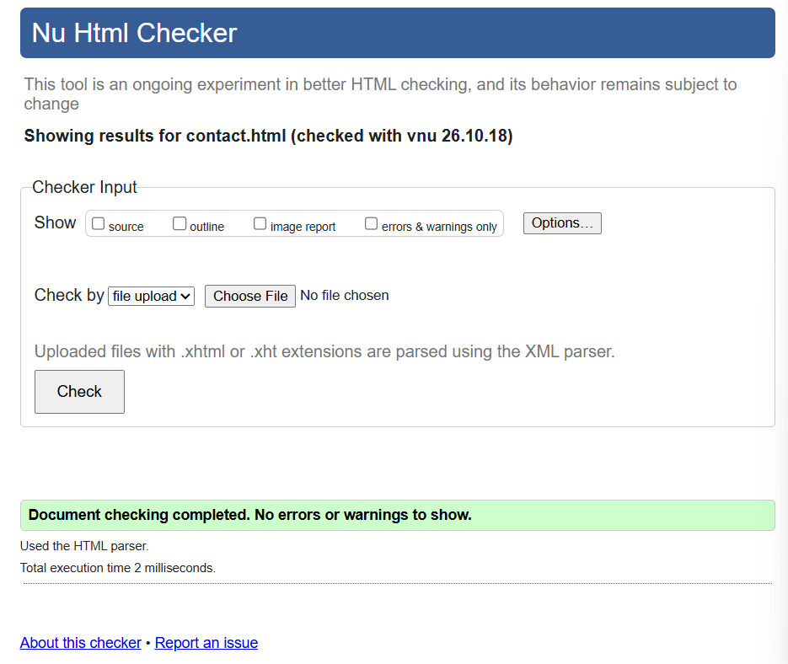

Lab1_ExerB.html code 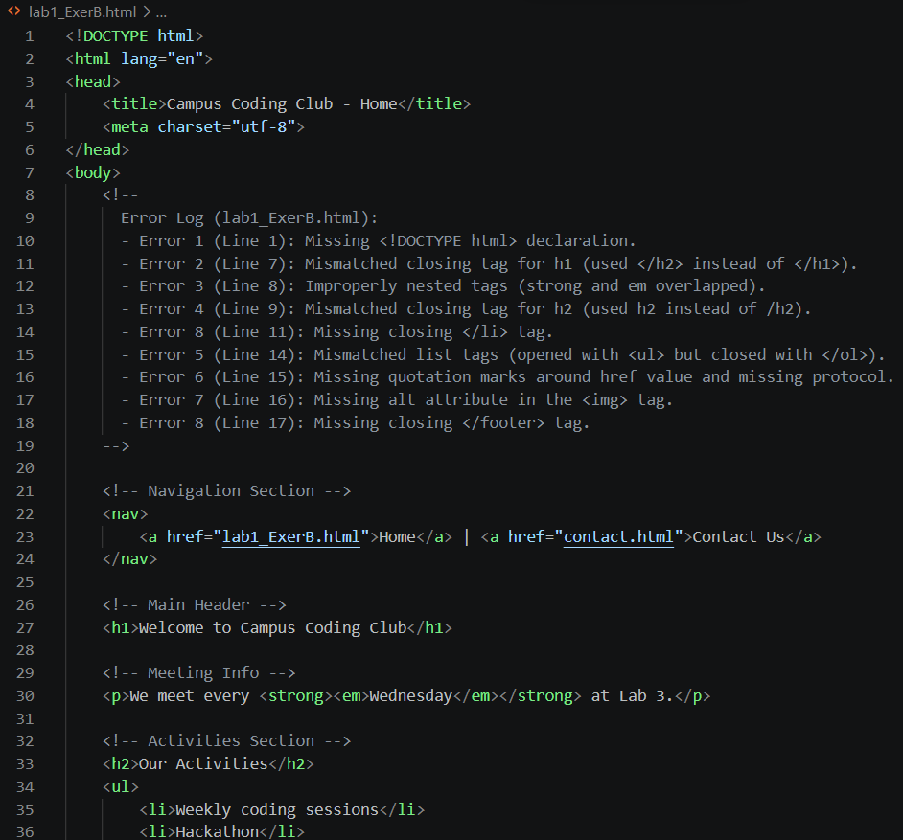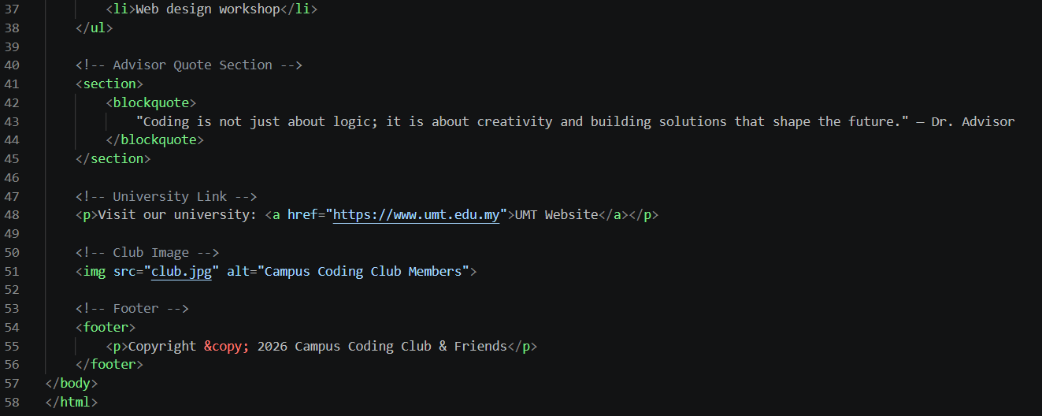

Contact.html code
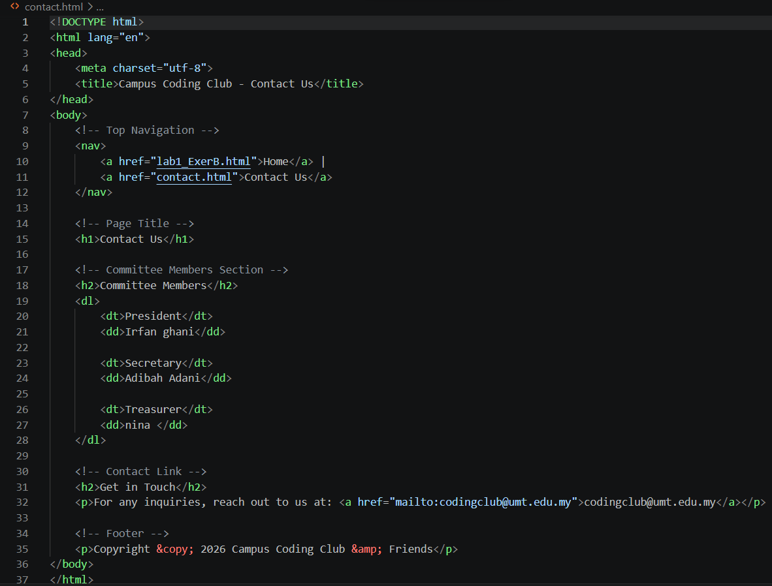

Output Lab1_ExerB.html
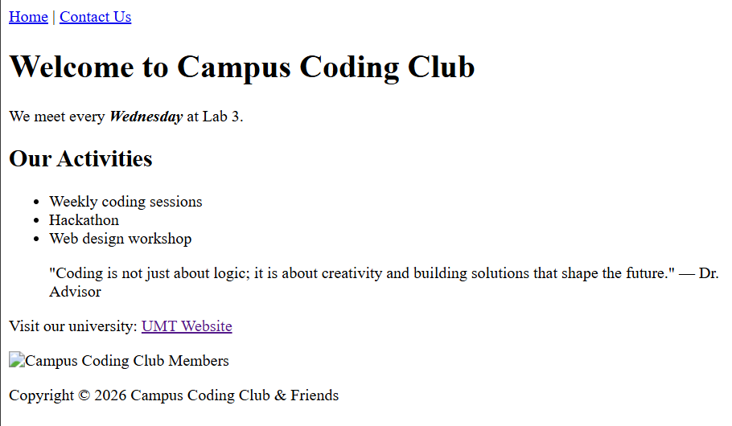
Output Contact.html
