Recommender Systems - Course Project Report
Cumulative report template - Parts 1, 2, and 3
Team | 9
Members | Irfan Khan, Reinis Gustavs Ignatjevs, Kaan Pide
For Part 3 track: select one | A / B / C
GitHub repository link | https://github.com/irfankhanai/movielens-recommender-system/tree/main

1. Part 1 - Data, Protocol and Baselines

1.1 Data characterization
Overall, the MovieLens 1M data contains 6040 users, 3883 movies (of which 3706 have ratings) and 1000209 ratings, giving a density of 4.26% or 4.47% when movies with no ratings are excluded. This means that the provided data is quite dense when compared to typical production data.
Additionally, we see that the data is quite top heavy. Examining user interactions (see figure b and c), the average number of ratings is 165.6, while the median is only 96. The top 15.71% of users are responsible for half of all ratings, while 28.9% of users have less than 50 ratings. Therefore, the data is quite heavy on a relatively smaller share of power users. It should also be noted that the provided data already filtered by the lowest activity users by removing anyone with less than 20 ratings.
Meanwhile, the movie rating distributions present a similar picture. A film receives 269.89 ratings on average, but only 123.5 at the median. The top 20 movies (0.54% of rated titles) account for 5% of all ratings and the top 452 (12.2%) for half of them, while 446 films (12.0%) have fewer than 10 ratings and 870 (23.5%) fewer than 30. Thus, the long tail effect is quite prominent in the provided data (see figure d and e).
Finally, the ratings themselves skew positive (see figure a), with the mean rating being 3.58 and the median being 4. Moreover, 57.5% of ratings are either 4 or 5, while only 16.4% of ratings are 1 or 2. From a temporal perspective, the ratings are very bursty (see figure f), with a single month, November 2000, accounting for 29.1% of all ratings. While from a user session perspective, most users do all their ratings within a single day (62.9%), meaning that for most users the data only captures their preferences at one point in time and not the evolution of their preferences over a longer time period.
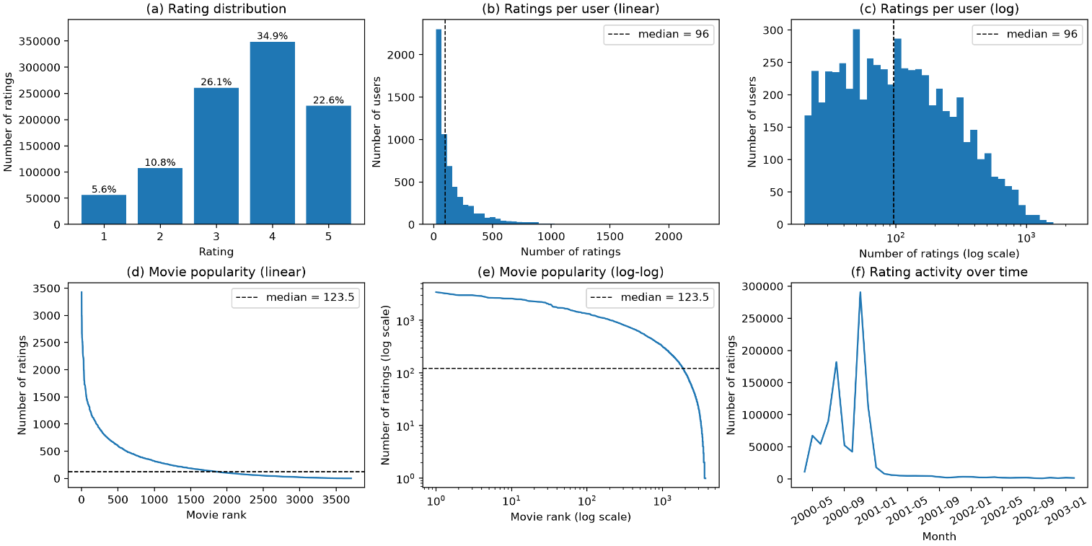

1.2 Preprocessing and feedback treatment
We loaded the data with pandas and did not clean or filter it any further, since there were no missing values or duplicates. Each user also has at least 20 ratings in the data set, so the lowest-activity users were already filtered out. For the catalogue, we kept the 177 movies that have no ratings. The baselines cannot recommend them, but some Part 2 models might, and the project requires ranking against the full catalogue.
For some of the baselines we applied a feedback treatment that turns ratings into binary feedback. We treated a rating of 4 or higher as positive and dropped the rest instead of using them as negative evidence. This cutoff balances two problems. A stricter cutoff (5 only) would keep just 22.6% of the data, while a looser one (3 or higher) would keep 83.6% and count lukewarm ratings as approval.
Although, it should be noted that a single fixed cutoff has a drawback, that it removes more of the ratings of users who rate low and over-represents users who rate high.
Overall, the treatment keeps 57.5% of the ratings as positive feedback. This lowers the interaction density over all movies from 4.26% to 2.45%. The median number of interactions per user falls from 96 to 58, and per movie from 123.5 to 44. The share of movies with fewer than 10 interactions doubles from 12% to 24.2%, and 350 movies have no positive feedback at all, including the 177 with no ratings.
The treatment is used by the item-kNN baseline and by one of the popularity baselines (Popular (Positive)), while Popular (All) counts the raw ratings. The same threshold defines relevance at evaluation for all models.

1.3 Train/validation/test split
We split the ratings globally time. Ratings were ordered by timestamp and cut at the 80th and 90th percentile of timestamps, so that the training set holds 80% of the ratings (25 Apr to 2 Dec 2000), validation holds the next 10% (2 to 29 Dec 2000) and the last 10% is held by test set (29 Dec 2000 to 28 Feb 2003). This split was validated so that all train ratings precede all validation ratings, which in turn precede the test ratings. The three splits hold 800’164, 100’024 and 100’021 ratings respectively.
We chose a global split to simulate deployment, where the model is fitted on the past and scores the future, and it keeps future ratings out of training. Meanwhile, a per user split would not, since one user’s test rating can predate other users training ratings.
The burstiness of the data makes the three sets very different. Training covers 221 days, validation 27 and test 791 days. The positive share of ratings (4 and 5 used for the feedback treatment) falls from 57.9% in training and 57.8% in validation to 54.4% in test.
Additionally, the burstiness in combination with the short timespans for users staying active means that many evaluated users are new. Of the 1103 validation users with a relevant rating, 611 (55.4%) have no positive training rating, against 197 of 1188 (16.6%) in test. For these users’ item-kNN has no profile and returns exactly the Popular (Positive) list, so we report our main results for users with at least one positive training rating (492 validation and 991 test users) and give all-user results alongside. In contrast, unseen movies hardly matter, only 0.02% (validation) and 0.10% (test) of ratings are on movies with no training rating, and 0.04% and 0.22% of relevant ratings are on movies with no positive training rating, so the recall ceiling from cold movies is negligible.

1.4 Evaluation protocol
Our evaluation protocol first retrieves only the relevant rankings from the datasets, either from the training, validation, or the testing sets. Then for each user, we run the recommending function (kNN or popular) and see if they have made a positive rating for those movies. Since this is a binary choice, making or not making a positive rating, the hits are stored as 1 and misses as 0. With this information in hand, we calculate the precision, recall, NDCG, and catalogue coverage for each user, and take the mean of all the statistics and return as evaluation.
With this evaluation metric, having perfect accuracy on precision or recall won’t help with the models we’re building, as the evaluation calculates with what the user has already rated for. The model should return most, if not all, items from unseen items. To determine if a given model is accurate or not, having a high accuracy metric is needed.

1.5 Baseline methods and settings
We have compared the item-based kNN, all-time popular, and positive rated movies. The baseline model is the all-time popular, that just chooses the most rated movies the user hadn’t made a review for. Positive rated movies method filters out the negative (1...3) ratings and then ranks them based on how much praise each movie got before returning the movies the user hadn’t made a review for. These two algorithms are very straightforward and establish a baseline for our models to compete with.
For the item-based kNN, we compare it against the baseline popular functions, as well as itself with differing parameters. Different sizes of k for kNN tune what we recommend, as having a small k makes for some noisy recommendations, easily skewed from some unorthodox choices from a single user, conversely having a large k makes for non-personalized enough recommendations, getting closer to positive rated movies algorithm. Choosing the similarity measure is also important. Both measures compare movies through the sets of users who liked them. Cosine similarity divides the number of users who liked both movies by the geometric mean of their like counts, whereas Jaccard similarity divides it by the number of users who liked either movie. Since we only use ratings of 4 or higher and treat them as binary positive feedback, the difference between a 4 and a 5 plays no role in either measure, so both are applicable, and they differ only in how they normalize for movie popularity.

1.6 Results and analysis
Based on the test results, item-based kNN outperforms both popularity baselines on all four measures, but only by a modest margin. For users with positive history it improves on Popular (Positive) by 9% in Precision@10 (0.198 against 0.182), 12% in Recall@10 and 10% in NDCG@10. The clearest difference is coverage: kNN recommends 6.6% of the catalogue against 3.3%, although both are low. Including the users without positive history narrows the NDCG@10 lead from 10% to 8%, since for these users kNN returns the popularity list. Counting only positive ratings also helps the popularity baseline, as Popular (Positive) beats Popular (All) by 5% in Precision@10.
On validation, cosine similarity with k = 40 performed best among the tuned settings, but only slightly better than Jaccard (NDCG@10 of 0.139 against 0.132, also at k = 40). Because our feedback is binary, cosine and Jaccard differ only in how they normalise the number of co-likes, so we do not read much into this gap. Without confidence intervals we treat the choice of cosine as tentative.
The k size of 40 shows us that having more neighbors yields a better model. The model can gather information from a greater sample and achieve higher accuracy. But the k size doesn’t scale infinitely, since k = 50 performs worse than k = 40. This demonstrates the importance of k size, since with a large k, the recommendation approaches the global mean, and with a small k, there isn’t any personalization.

2. Part 2 - Models and Honest Comparison

2.1 Models
Describe the additional models and paradigms. Clearly identify the self-implemented algorithm and explain its implementation.

2.2 Hyperparameter tuning and variability
Describe the validation-only tuning procedure, search spaces/budgets, random seeds, and confidence intervals or statistical testing.

2.3 Overall results
Present and discuss the main comparison. Explain important differences and avoid unsupported claims.

2.4 Disaggregated analysis
Report and interpret results broken down by at least two of the required dimensions: items with few vs. many training interactions, low- vs. high-activity users, popular vs. long-tail items, and early vs. late test period. Define any thresholds used and focus on findings that change or qualify the overall conclusions.

2.5 Sparsity ablation
Report and discuss the 100%, 50%, and 20% training-interaction experiments, including changes in the ranking between models.

3. Part 3 - Beyond Accuracy

3.1 Selected track and motivation
State Track A, B, or C and briefly motivate the selected intervention/extension.

3.2 Method
Describe only your selected track. The Track A/B/C guidance below is provided as instructions; delete the guidance for the two tracks you did not select before submission.

If Track A - Diversity and popularity bias
State the base recommender, selected re-ranking method, genre-vector item representation, trade-off parameter, and exact item-distance measure. Describe how the parameter was swept.

If Track B - Fairness
Define the release-decade provider proxy, report and justify the final decade boundaries and group sizes, state and justify the adopted fairness notion, describe the consumer groups based on MovieLens user attributes, and identify the stage and form of the mitigation.

If Track C - Group recommendations
State the selected synthetic group type and justify the chosen group size (3-5). Describe the three aggregation strategies. Identify which strategy was extended to the sequential scenario and explain how satisfaction is carried forward between recommendation rounds.

3.3 Results and trade-offs
Present the required track-specific results. Track A: report intra-list diversity, catalogue coverage, Gini and calibration error across the parameter sweep, and discuss the accuracy-diversity frontier. Track B: report position-weighted exposure against catalogue share, per-group consumer-side accuracy, and the fairness-performance frontier. Track C: compare group satisfaction, disagreement and minimum member satisfaction across the three aggregation strategies, then analyse how member and group satisfaction develop in the sequential scenario.

3.4 Cost and interpretation
State what is gained, what is lost, and who bears the cost where applicable. Explain what operating choice or strategy you would select and why.

3.5 "One number we cannot explain"
Identify one result you do not fully understand and describe how you would investigate it.

4. Discussion and Conclusions
Summarize the main findings across the project. Discuss limitations, failed approaches where relevant, and what the experiments support.

5. Contribution Statement
For each team member, provide two or three sentences describing their contribution.

6. Use of AI Assistants
State which AI tools were used and for what. If none were used, state that explicitly.
Claude was used to refactor and suggest some of the code used in the project, while Microsoft Copilot was used to polish some of the report text.

References
List references used in the report. References do not count toward the page limit.

