# How to access database of aws (rds)

1. Search rds in aws search bar and click on it (if you have already visited you will have following screen)
2. Click on RDS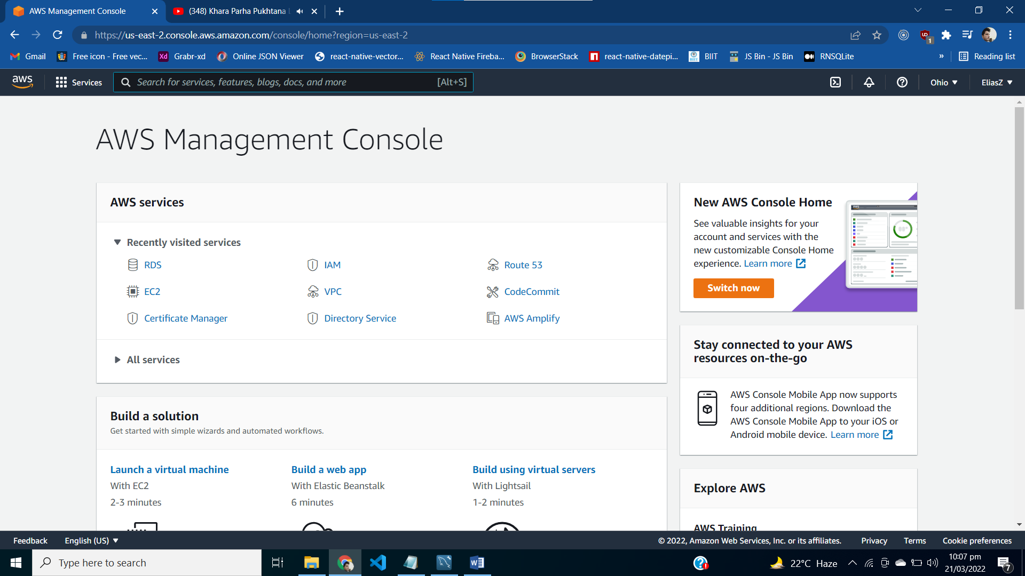
3. Click on db instance if you have created a database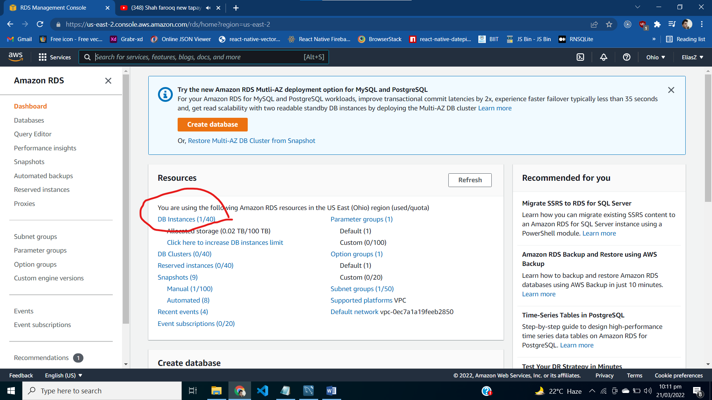
4. Then select your instance as given as: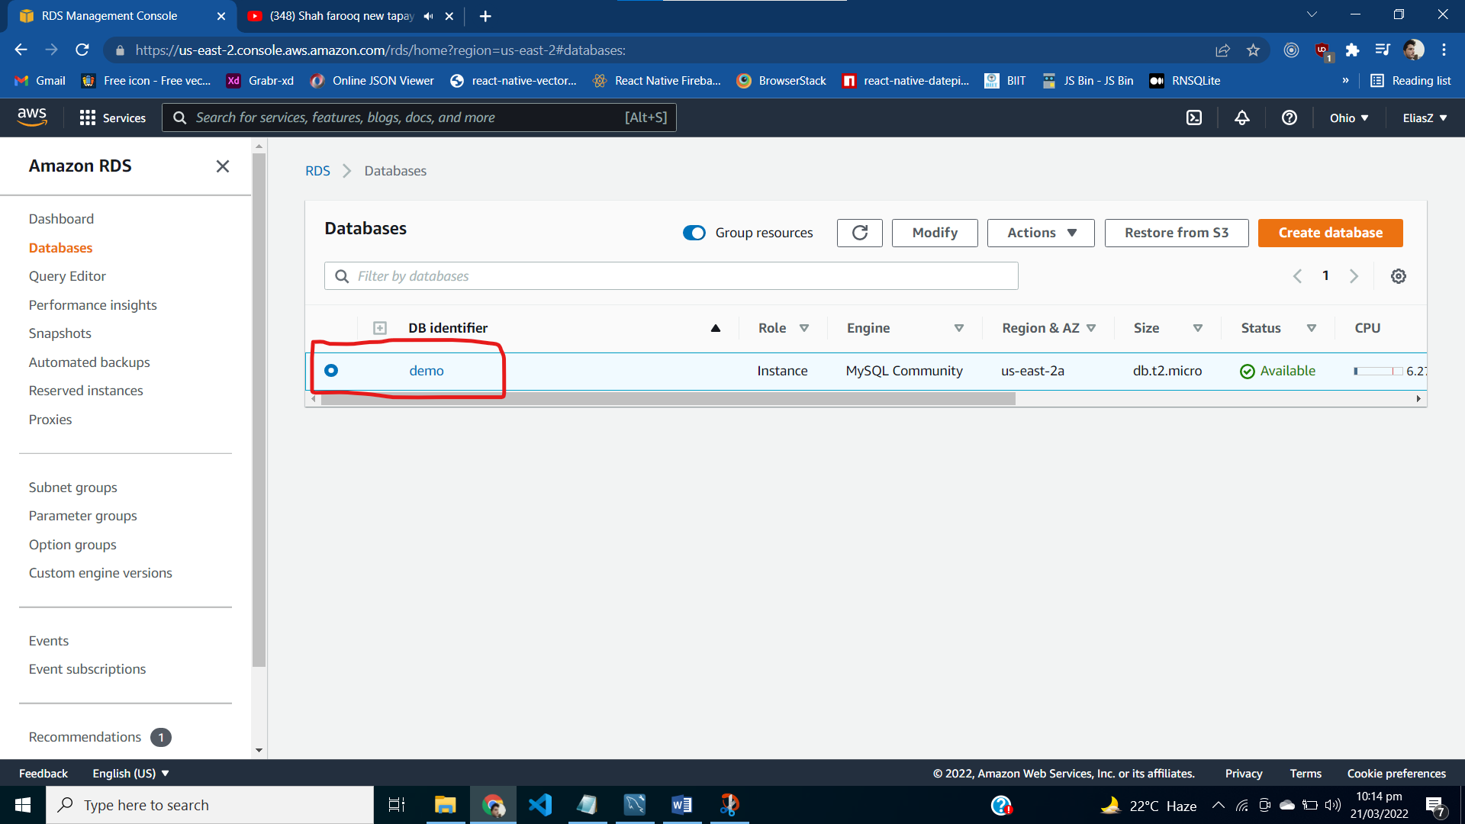
5. Copy the endpoint of your selected database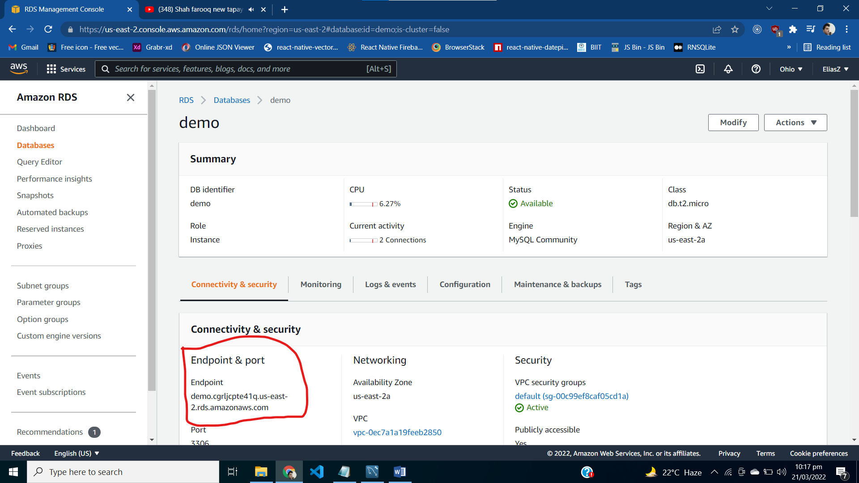
6. Edit in-bound rules for rds instance =>add rule of All traffic with source anywhere
7. Open workbench in your system and click on plus icon for new connection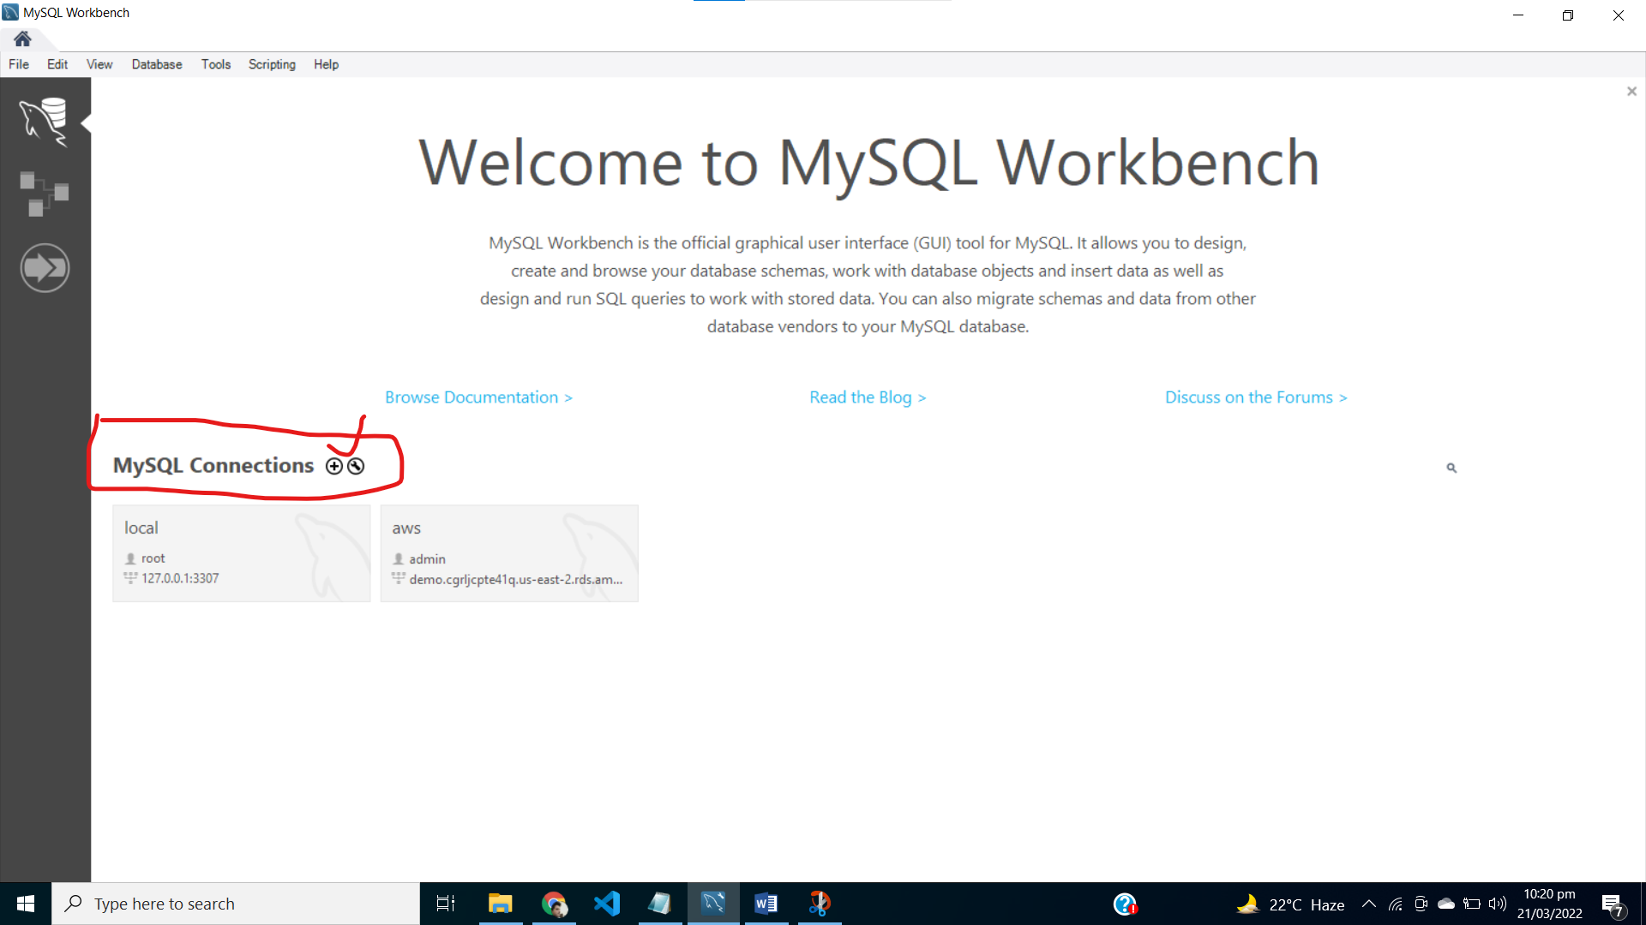
8. Fill the required fields like and put the password Khan@1234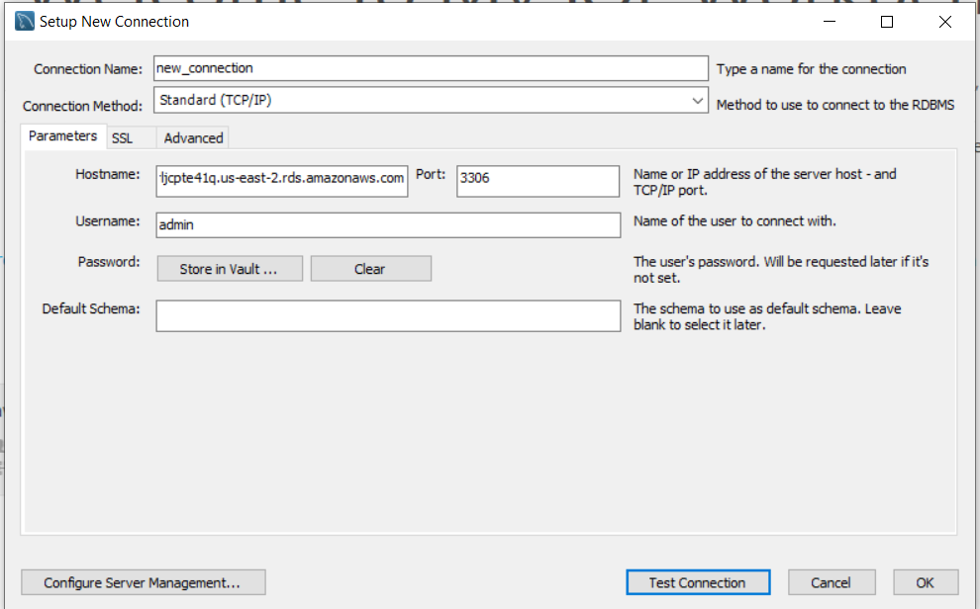
9. Click on test connection to test

# EC2 instance of aws

1. Search for ec2 instance and click on it. 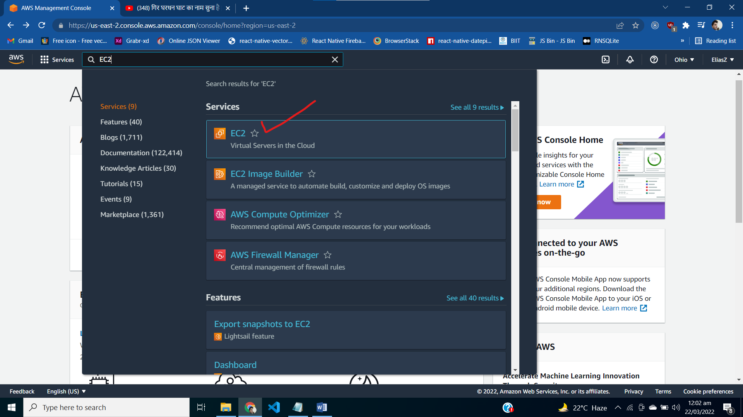
2. Select aws-instance and click on connect button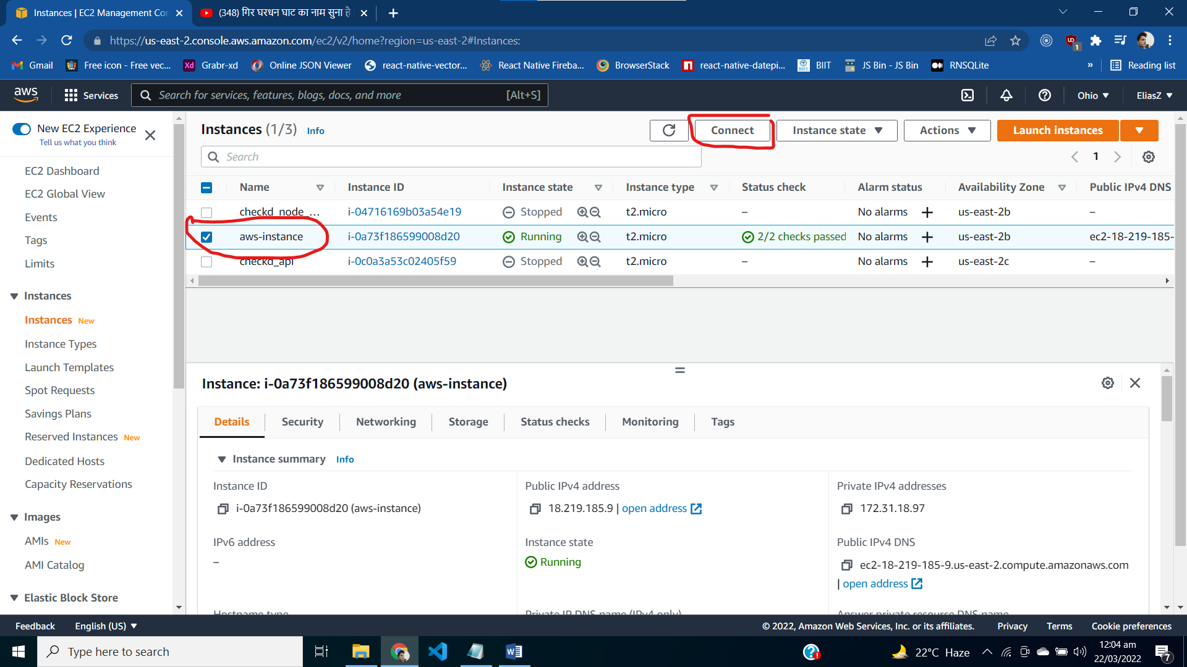
3. Click on connect button in below screen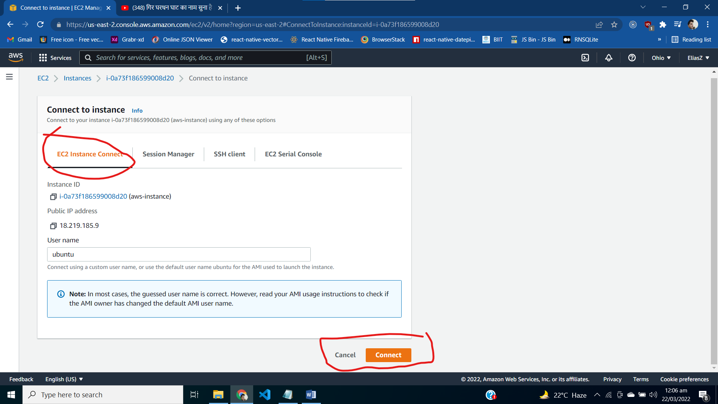
4. Cmd will appear in a new tab , you can see here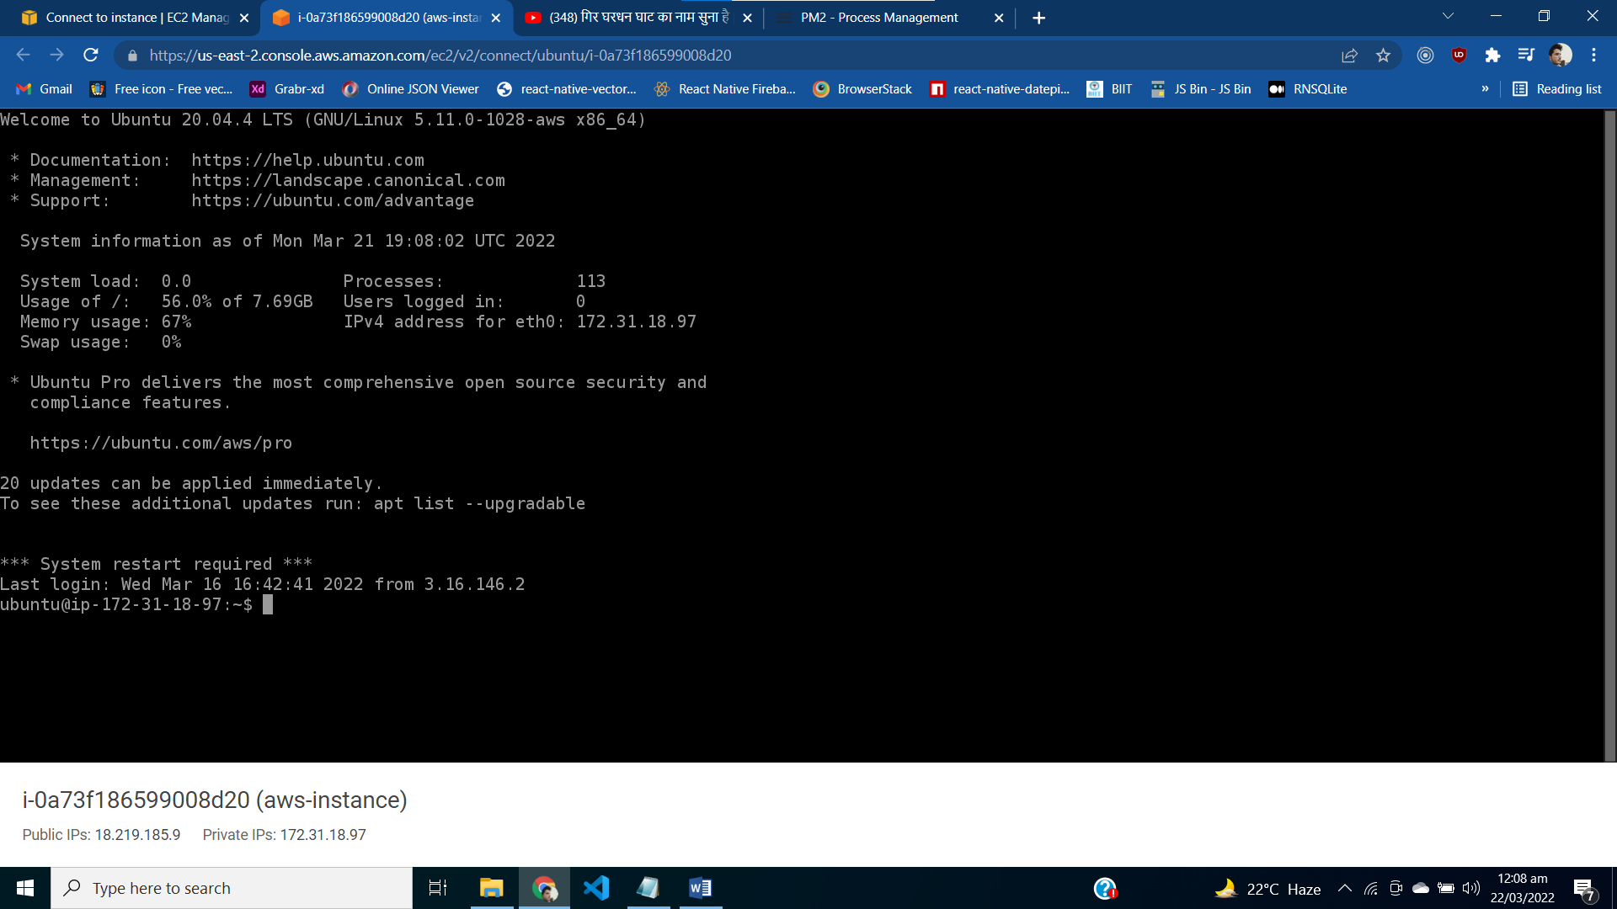
5. You can use commands to start ,stop server
6. pm2 stop server
7. pm2 start server
8. you can visit to for pm2 commands here
9. <https://pm2.keymetrics.io/docs/usage/process-management/>

# How to connect with EC2 instance

1. Search for ec2 instance and click on it. 
2. Select aws-instance and click on connect button
3. Goto security tab and then edit inbound rules

Following must be added

http

https

custom tcp

mysql/

and all source must be anywhere selected from dropdown

1. Copy ip address and user name as given 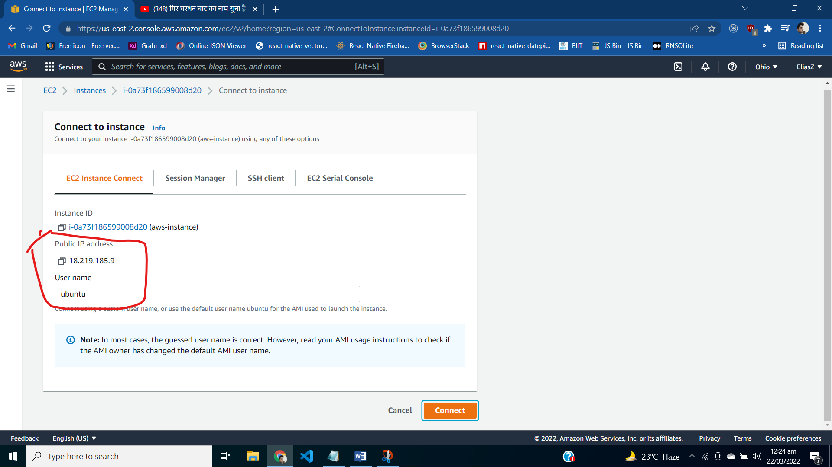
2. Open fileZilla on your system 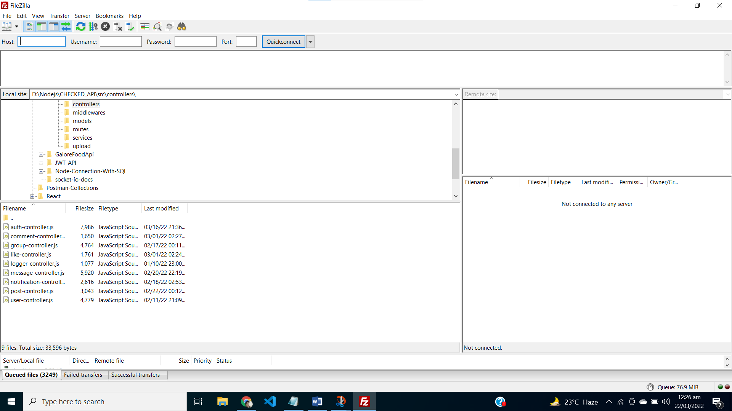
3. Put ip address (18.219.185.9) in host field and user-name with (ubuntu) and port number (22) and there is no need of password here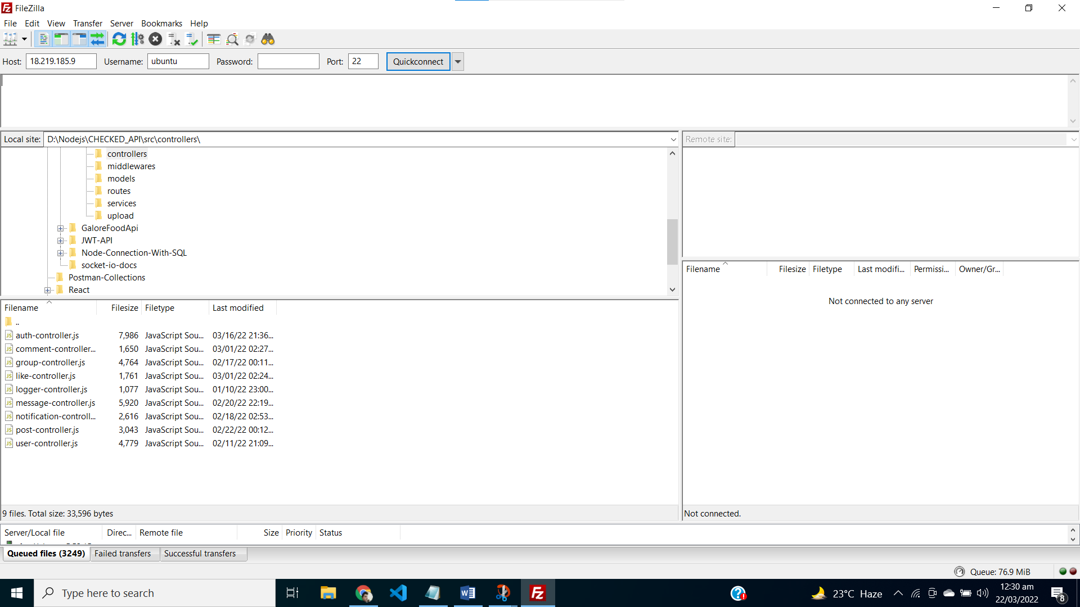
4. Click on edit then select setting from menu. Pop will appear as given and select SFTP and ac2 instance key named aws-key.ppk that I have placed in project folder named aws.rar then click on ok after selection of key file.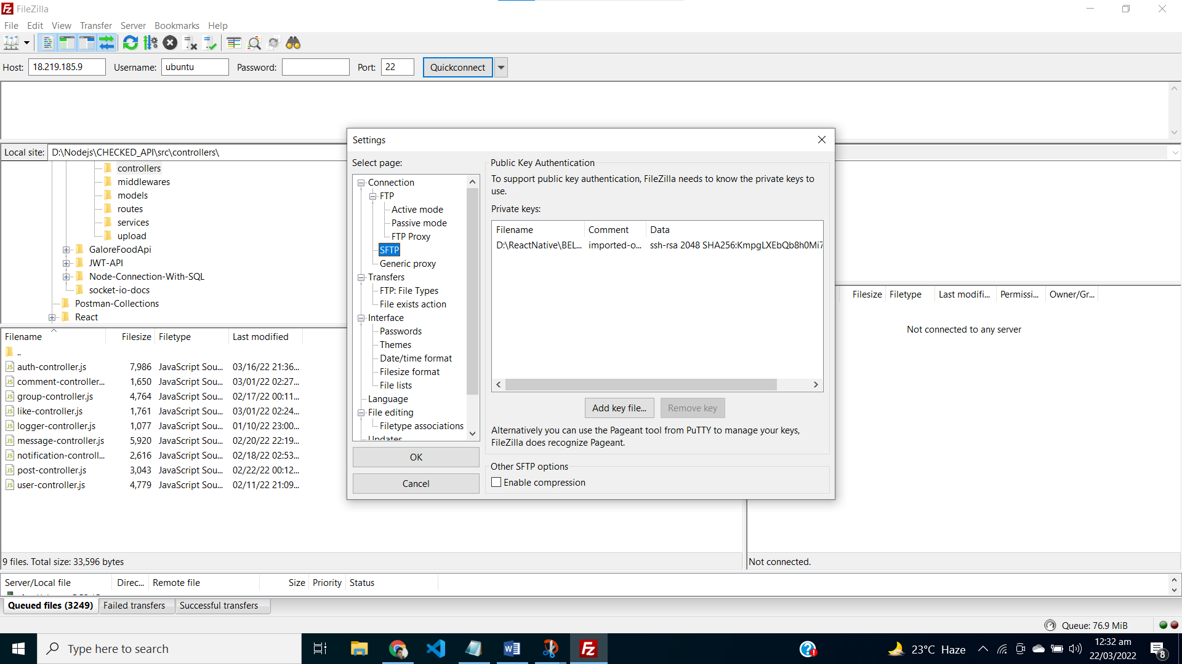
5. After successful connections you will see following screen 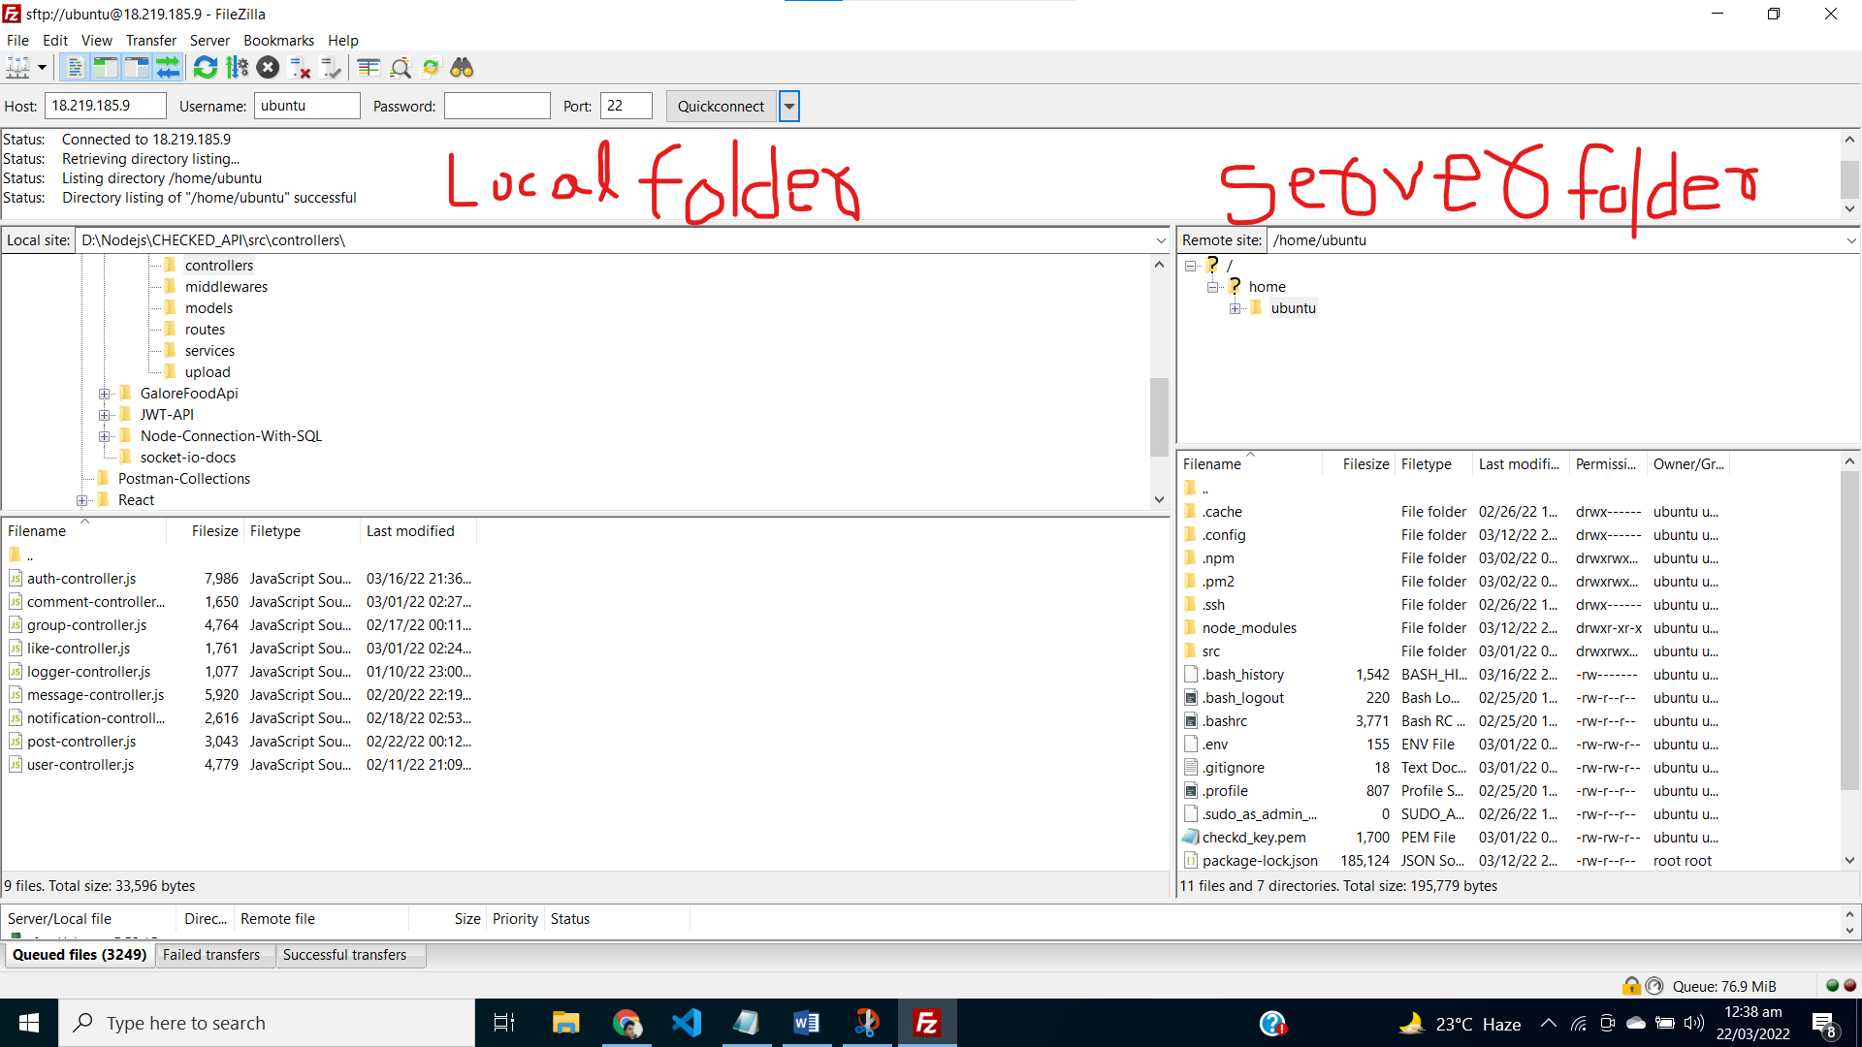
6. You can drag the files from local to server side that you want to update or change

Note

You should follow these steps to add or update files

After update/adding files, you should stop the ec2 intance by following command

**pm stop server**

then use start command to start the server again

**pm start server**

**run these command in cmd that we opened in above steps of** EC2 instance of aws