Banking System Simulator Project Report
IRFAN
L1F24BSCS0580
Object Oriented Programming (OOP)
University of Central Punjab

1. Introduction
This project is a console-based Banking System Simulator developed in C++. It demonstrates core Object-Oriented Programming concepts including encapsulation, inheritance and polymorphism. The system allows users to create accounts, authenticate using a PIN, deposit and withdraw money, perform balance inquiries, modify account details and check account status.

2. Objectives
- Implement Object-Oriented Programming concepts.
- Design reusable classes using inheritance.
- Protect account information using encapsulation.
- Provide secure PIN verification with account locking.
- Develop a menu-driven banking application.

3. Implemented Features
- Create Savings and Current Accounts
- Search Accounts
- Display All Accounts
- Deposit Money
- Withdraw Money
- Balance Inquiry
- Modify Account Information
- Automatic Account Lock after three incorrect PIN attempts
- Unlock Account using the correct PIN
- Input validation for names, PINs and numeric values

4. OOP Concepts Used

4.1 Encapsulation
Sensitive data such as account number, PIN, balance, wrongAttempts and locked status are private and accessed through public member functions.

4.2 Inheritance
SavingsAccount and CurrentAccount inherit from the Account base class.

4.3 Polymorphism
The Bank class stores Account pointers and invokes virtual functions such as display(), deposit() and withdraw() polymorphically.

5. Class Summary
Class | Responsibility
Account | Stores account information, verifies PIN, deposits, withdraws, displays details, locks/unlocks accounts.
SavingsAccount | Derived class representing a savings account.
CurrentAccount | Derived class representing a current account.
Bank | Creates, searches and manages accounts and banking operations.

6. UML Class Diagram
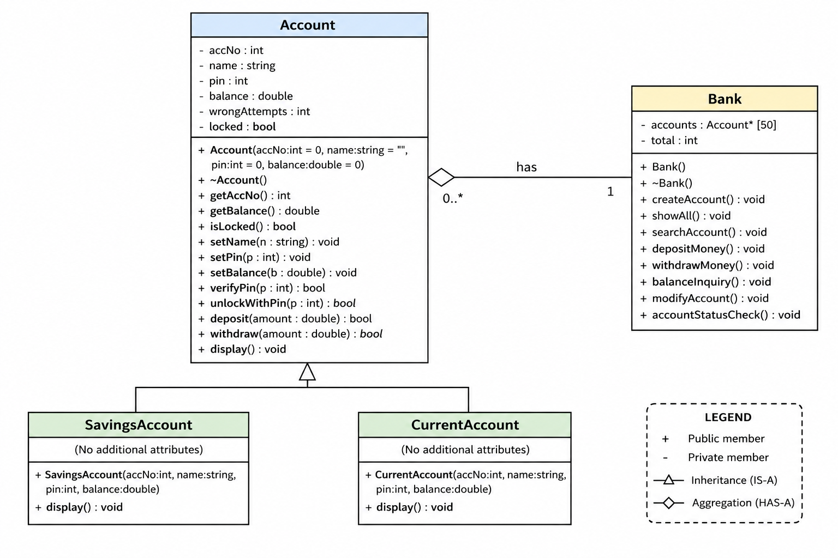
The UML diagram reflects the implemented classes: Account, SavingsAccount, CurrentAccount and Bank. SavingsAccount and CurrentAccount inherit from Account, while Bank aggregates multiple Account objects.

7. Security Features
- 4-digit PIN validation
- Account locks after three incorrect PIN attempts
- Unlock requires the correct PIN
- Validation of account names and numeric input

8. Future Enhancements
- Persistent file storage
- Transaction history
- Statement generation
- Interest calculation
- Graphical User Interface (GUI)
- Database integration

9. Conclusion
The Banking System Simulator successfully demonstrates the practical implementation of OOP concepts through a modular banking application. The project is suitable for academic submission and provides a solid foundation for future enhancements.

