SMART TRAFFIC CONTROL SYSTEM
Data Structures Semester Project Report
University of Central Punjab (UCP)
Developer: Irfan
Registration No: L1F24BSCS0580

1. Introduction
The Smart Traffic Control System is a C++ console application developed for the Data Structures course. It simulates traffic signal management at a four-way intersection. The project demonstrates the practical use of a Circular Linked List, Circular Queue, Array, Stack, and Binary Search Tree (BST).

2. Project Objectives
- Simulate traffic signal rotation.
- Manage vehicle counts in traffic lanes.
- Store recent system events using a Stack.
- Maintain registered vehicle records using a Binary Search Tree.
- Demonstrate practical implementation of multiple data structures in one system.

3. Data Structures Used
Data Structure | Purpose | Complexity
Circular Linked List | Connects traffic lanes | O(n) traversal
Circular Queue | Rotates active traffic signal | O(1)
Array | Direct lane lookup | O(1)
Stack | Stores recent logs | O(1)
Binary Search Tree | Vehicle registry | O(log n) average

4. System Working
The application initializes four traffic lanes (Northbound, Southbound, Eastbound, and Westbound). The first lane is activated with a green signal. During simulation, the active lane timer decreases every second and one vehicle passes every two simulated seconds while the signal is green. Users can manually update lane vehicle counts, view recent system logs, and manage vehicle records through BST insert, search, delete, and inorder display.

5. UML Class Diagram
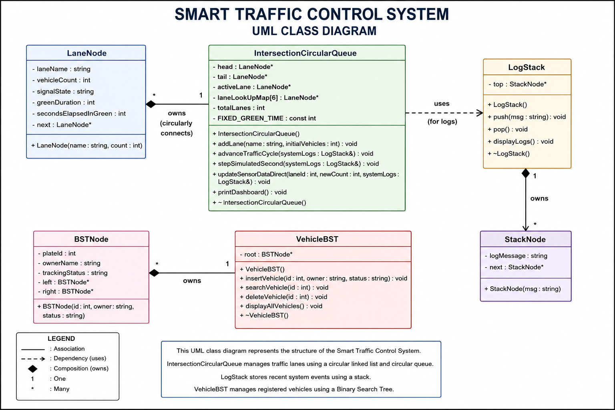
Relationship Explanation:
• IntersectionCircularQueue owns multiple LaneNode objects using composition.
• LogStack owns multiple StackNode objects using composition.
• VehicleBST owns multiple BSTNode objects using composition.
• IntersectionCircularQueue depends on LogStack to record traffic events.
• VehicleBST is managed independently from main.cpp and has no direct dependency on IntersectionCircularQueue.

6. Algorithms and Time Complexity
Operation | Complexity
Lane Lookup | O(1)
Traffic Signal Rotation | O(1)
Stack Push / Pop | O(1)
BST Insert | O(log n) average
BST Search | O(log n) average
BST Delete | O(log n) average
BST Inorder Traversal | O(n)

7. Conclusion
The Smart Traffic Control System fulfills the core requirements of the Data Structures course by integrating Arrays, Circular Linked List, Circular Queue, Stack, and Binary Search Tree into a single menu-driven application. The modular implementation makes the project easy to understand, maintain, and extend.

