DISTRIBUTED IoT
SENSOR ANALYTICS
Project Documentation
A Python-based coordinator–worker system for distributing sensor analytics tasks
Prepared: 30 October 2026
Implementation, reliability testing, live monitoring and performance evaluation

Executive summary
This project implements a small distributed processing system for analysing simulated IoT sensor data. A central coordinator receives batches of sensor readings, creates analytics tasks, assigns those tasks to available workers, records their results and tracks task execution. Two independent worker processes can execute tasks concurrently. A read-only Streamlit dashboard exposes worker status, task progress and the latest benchmark results.
The main performance experiment compared one worker with two workers while each task included approximately one second of artificial processing delay. Both runs processed the same workload of 20 tasks. The one-worker run took 20.242 seconds (0.988 tasks/second); the two-worker run took 10.112 seconds (1.978 tasks/second). This is approximately a 2.00× speedup under the tested delayed workload. The result demonstrates that the coordinator can distribute independent work across two workers. It should not be interpreted as a 2× improvement for the underlying lightweight analytics alone, because the artificial delay makes parallel execution easier to observe.

1. Project aim and scope
The aim was to build and test a working coordinator–worker application that demonstrates core distributed systems concepts: network communication, message framing, task scheduling, concurrent execution, persistent task state, worker failure handling, recovery and performance measurement.
The implementation is deliberately limited to a local, two-worker environment.
- Generate simulated sensor readings and submit them to a coordinator in batches.
- Create two analytics tasks per sensor batch: temperature statistics and anomaly detection.
- Distribute pending tasks among workers that are registered and ready.
- Persist task records and results in JSON so task progress can be inspected after execution.
- Recover unfinished tasks after coordinator restart and requeue tasks when a worker disconnects or times out.
- Measure throughput and task duration, and compare one-worker and two-worker execution.
- Display live operational state through a read-only dashboard.

2. System architecture
The system has three main runtime components. The sensor simulator produces input data; the coordinator manages the task queue and worker connections; and worker processes perform the requested analytics. The dashboard reads status and benchmark data but does not participate in task scheduling.
Component | Responsibility | Evidence/output
Sensor simulator | Generates readings and submits batches; signals when simulation input is complete. | SENSOR_BATCH and SIMULATION_DONE messages
Coordinator | Accepts worker connections, creates and schedules tasks, tracks state, handles results and failures. | Task records, worker state and benchmark summary
Workers 001 and 002 | Register with the coordinator, receive tasks, calculate results and return them. | Task results and worker completion counts
Streamlit dashboard | Reads persisted status and benchmark files and refreshes periodically. | Worker cards, task table, progress bar and benchmark metrics

3. Communication and task execution
The coordinator and workers communicate over TCP sockets. Messages are JSON-encoded and use a four-byte big-endian length prefix before the message body. The prefix allows the receiver to determine the complete message boundary because TCP is a byte stream and does not preserve application message boundaries.
The coordinator uses a selector-based event loop to monitor socket activity without dedicating a blocking read loop to every connection. Workers register with an identifier (001 or 002), receive assigned tasks, process them and send task results back.
The principal task lifecycle is:
PENDING → IN_PROGRESS → COMPLETED
A worker is tracked as READY when available and BUSY while executing a task. A task record contains details such as its identifier, operation, input readings, status, assigned worker, result and execution duration.

4. Analytics workload
Each simulated sensor batch creates two independent tasks. The temperature-statistics operation calculates summary values such as count, minimum, maximum and average temperature. The anomaly-detection operation checks readings against the configured thresholds used by this implementation (temperature at or above 40, or humidity at or above 90). The two operations provide separate units of work that can be scheduled on different workers.
The benchmark workload consisted of 20 tasks. In the performance runs, an approximately one-second artificial delay was added to task processing to make the effect of concurrent execution measurable.

5. Reliability and recovery tests
The screenshots document more than successful task completion. They also show a worker disconnecting while a task was in progress. The coordinator detected the disconnect, returned the unfinished task to PENDING, and assigned it to the remaining worker. The dashboard subsequently showed the task being completed and the workload reaching 100% completion.
A separate startup log shows the coordinator reporting that one task was recovered at startup. This is evidence of the recovery path for unfinished persisted work. The screenshot does not show the full task record before and after recovery, so it is presented as log evidence rather than a complete audit of the recovery state.
The implementation also includes task timeout handling. A timed-out task can be returned to the pending queue for reassignment. The screenshots included here directly demonstrate the worker-disconnection and startup-recovery paths; they should not be treated as a separate visual proof of every timeout scenario.

6. Performance evaluation
The one-worker and two-worker runs used the same total task count (20) and approximately the same average per-task execution time. The key difference was whether one or two workers could process tasks concurrently.
Configuration | Tasks | Duration | Throughput | Average task duration
One worker | 20 | 20.242 s | 0.988 tasks/s | 1.0068 s
Two workers | 20 | 10.112 s | 1.978 tasks/s | 1.0079 s
Calculated comparison: 20.242 ÷ 10.112 ≈ 2.00. The two-worker run therefore completed this workload in about half the elapsed time, with throughput almost twice that of the one-worker run. Average task duration remained close to one second in both runs, which is consistent with the artificial delay being applied per task while the two workers overlap their work.
The one-worker dashboard reports all 20 tasks completed by worker 001, with worker 002 disconnected. The two-worker dashboard reports 10 completions by each worker. These completion counts corroborate that the two-worker run actually used both workers rather than merely displaying two connected processes.

7. Interpretation and limitations
- The benchmark provides evidence of concurrent task execution and effective task distribution across two workers.
- The measured near-2× speedup applies to this 20-task workload with approximately one second of artificial delay.
- The benchmark does not establish that the raw temperature-statistics or anomaly-detection calculations are twice as fast with two workers.
- The workload is small and local. It does not measure performance across machines, variable network latency, large sensor streams or production-scale failure rates.
- The dashboard is read-only and local; it is an observability aid, not a production monitoring or control plane.
A stronger future evaluation could repeat each configuration several times, report the median and spread, and benchmark both the lightweight analytics workload without artificial delay and a larger workload. Those extensions are not required to support the result shown in this report.

8. Reproducibility and project artefacts
The principal project files are:
- coordinator.py — TCP coordinator, worker management, scheduling, task lifecycle, recovery and benchmark reporting.
- worker.py — worker registration, task execution and result submission.
- sensor_simulator.py — generation and submission of sensor batches.
- task_record.json — persisted task records and results.
- worker_state.json — persisted or exposed worker state, where used by the current implementation.
- benchmark_summary.json — latest benchmark summary consumed by the dashboard.
- dashboard.py — read-only Streamlit dashboard with periodic refresh.
To reproduce a run, start the coordinator, start either one worker or both workers, then run the sensor simulator. Use the same task workload and artificial-delay setting for both configurations. Wait until all 20 tasks are completed and the benchmark summary is saved. The dashboard can be opened during execution to observe worker status and task progress, and after execution to inspect the final benchmark.

9. Screenshot evidence and explanation
The figures below are arranged in the order supplied. The first group captures a two-worker run in progress and a worker failure; the next figures show successful completion and the two-worker benchmark; the final group records the one-worker comparison and supporting recovery/worker logs.

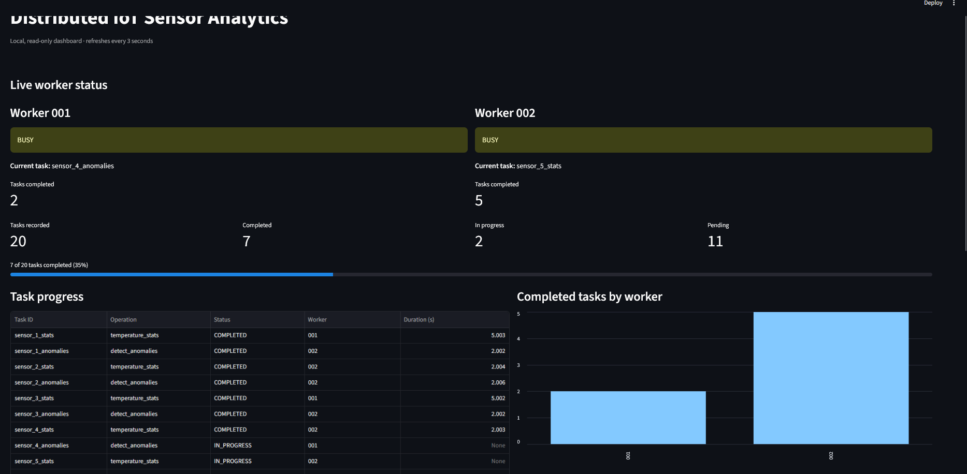
Figure 1. Two-worker execution in progress. Workers 001 and 002 are both BUSY on separate tasks. The dashboard shows 20 tasks recorded, 7 completed, 2 in progress and 11 pending (35% complete). This captures live scheduling rather than a final result.
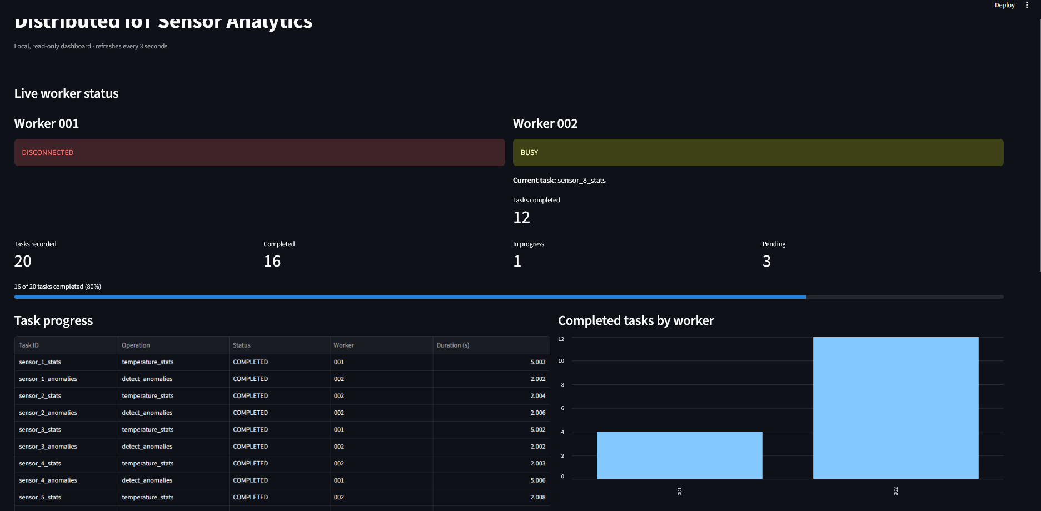
Figure 2. Worker failure during the same workload. Worker 001 is shown as DISCONNECTED while worker 002 continues processing. Sixteen of the 20 tasks are complete, with one in progress and three pending. This is the dashboard view of the failure scenario.
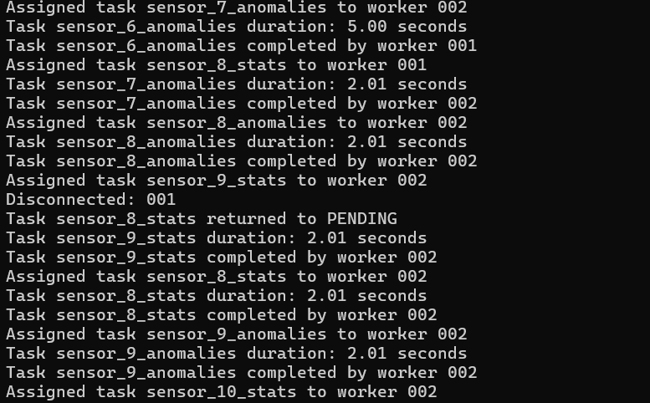
Figure 3. Coordinator log showing failure handling. The coordinator detects that worker 001 disconnected, returns sensor_8_stats to PENDING, and then assigns that task to worker 002, which completes it. This is direct evidence of task reassignment after a worker disconnect.

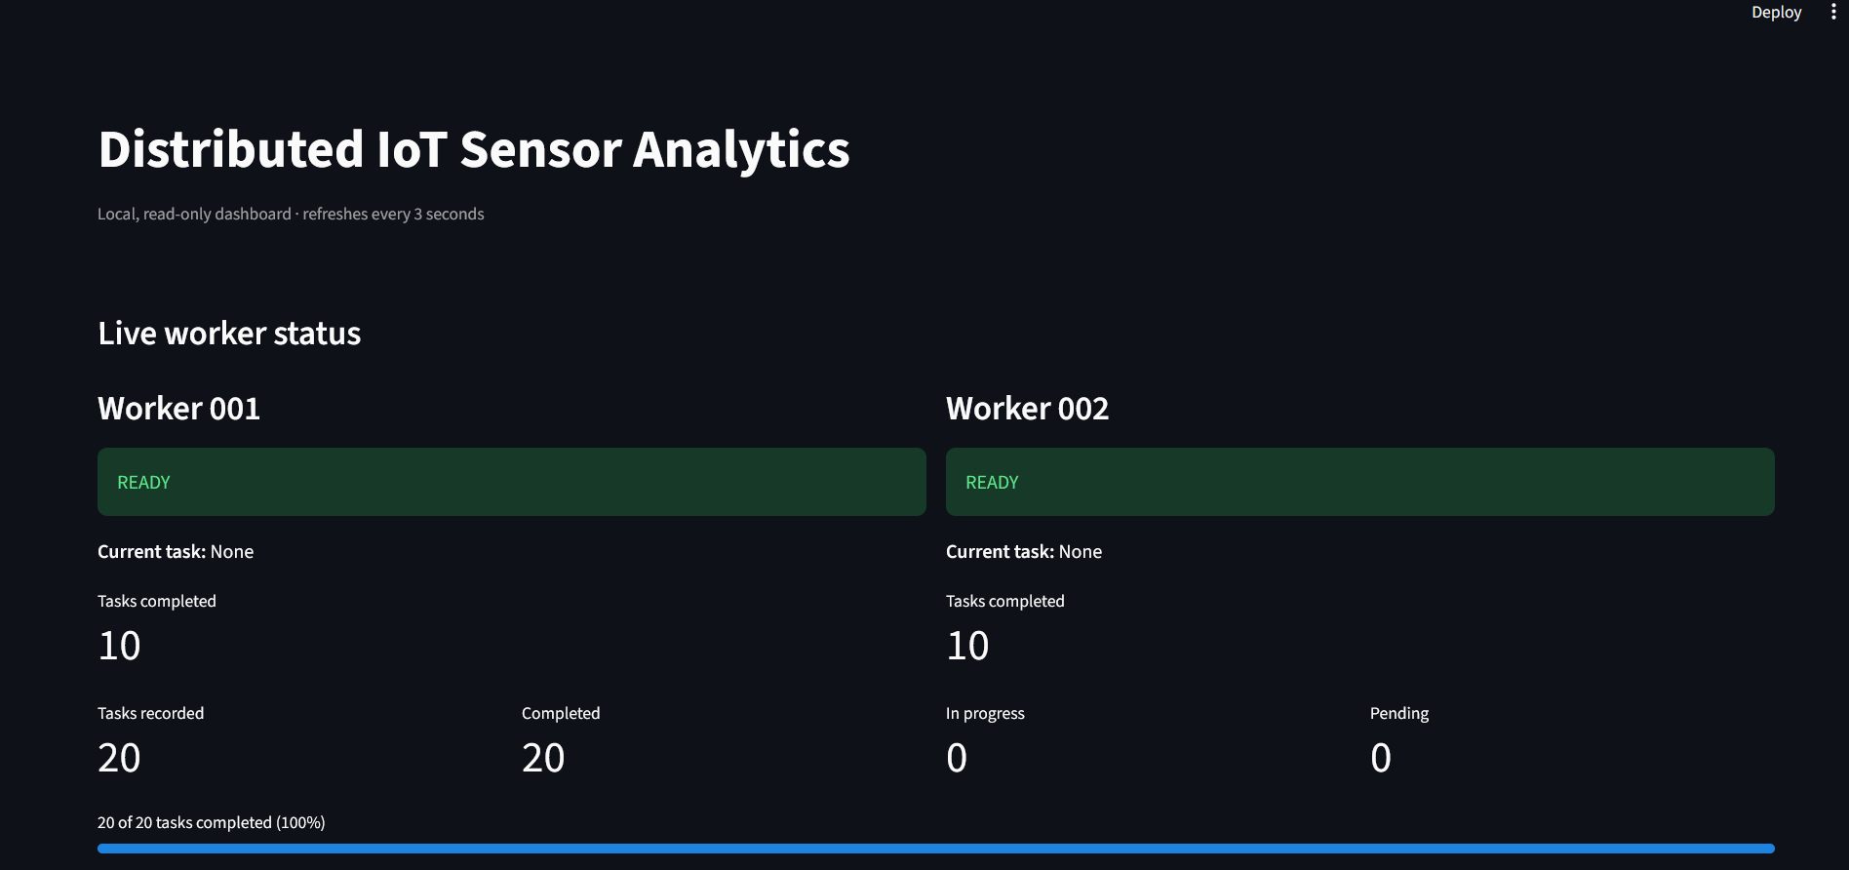
Figure 4. Successful completion with two workers. Both workers are READY, each has completed 10 tasks, and the dashboard shows 20 of 20 tasks completed with no tasks pending or in progress. This confirms the final distribution of work in the two-worker run.
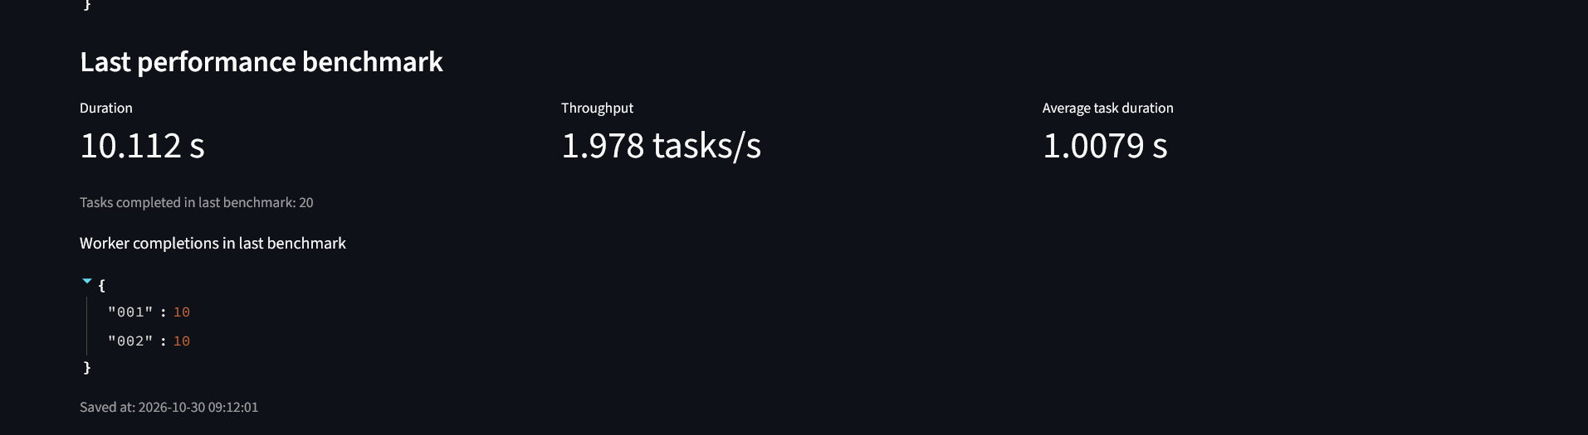
Figure 5. Two-worker benchmark result. The dashboard records 20 completed tasks in 10.112 seconds, throughput of 1.978 tasks/second and average task duration of 1.0079 seconds. The completion map shows 10 tasks handled by worker 001 and 10 by worker 002.

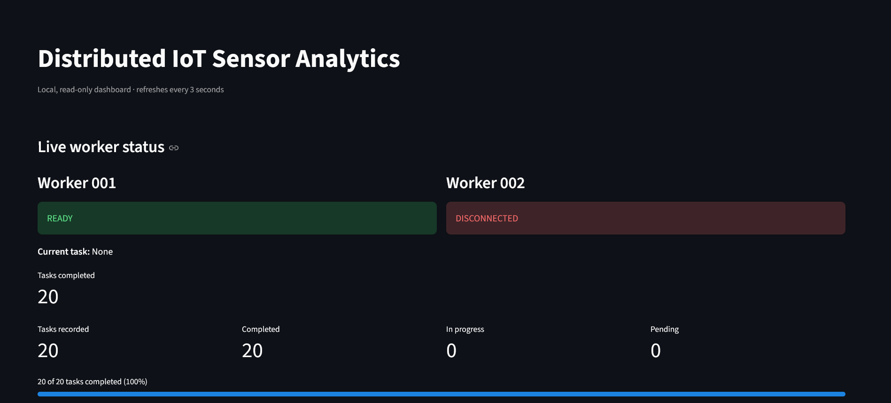
Figure 6. Successful one-worker run. Worker 001 is READY and worker 002 is DISCONNECTED. All 20 tasks are completed, and worker 001 reports 20 completions. This provides the single-worker comparison configuration.
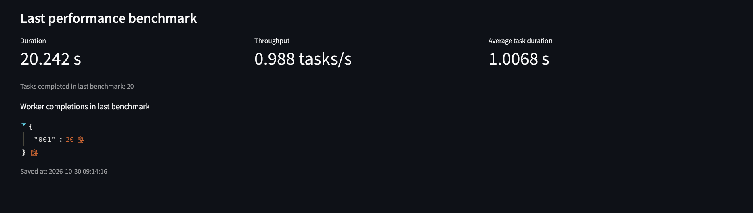
Figure 7. One-worker benchmark result. The 20-task workload took 20.242 seconds, with throughput of 0.988 tasks/second and average task duration of 1.0068 seconds. The completion map assigns all 20 tasks to worker 001.

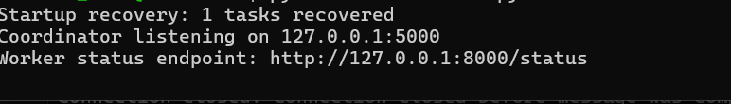
Figure 8. Coordinator startup and recovery log. On startup, the coordinator reports that one task was recovered before beginning to listen for worker connections. This supports the existence of the persisted-task recovery path.
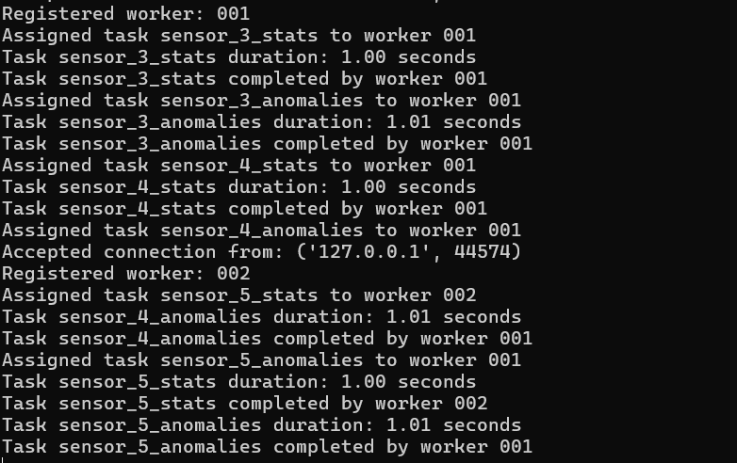
Figure 9. Worker registration and task execution log. The coordinator registers worker 001 and assigns it sensor analytics tasks; worker 002 subsequently connects and registers as well. The log illustrates worker discovery and task assignment during execution. It is supplementary operational evidence, not the one-worker benchmark result.

Conclusion
The project delivers a functioning local distributed task-processing pipeline for simulated IoT sensor analytics. It demonstrates framed TCP communication, coordinator-managed scheduling, two-worker parallel execution, persistent task records, worker-disconnection reassignment, startup recovery, benchmark reporting and a live read-only dashboard. In the controlled 20-task experiment, using two workers reduced elapsed time from 20.242 seconds to 10.112 seconds and increased measured throughput from 0.988 to 1.978 tasks per second. The result is a concrete demonstration of parallel task distribution under the tested workload, with the limitations of the artificial delay and local test environment stated explicitly.

End of report

