Date of publication xxxx 00, 0000, date of current version xxxx 00, 0000. Digital Object Identifier 10.1109/ACCESS.2026.0000000
Blockchain-Assisted Zero-Trust Architecture for Secure and Scalable Industrial Internet of Things (IIoT)
[Author Name(s)]
[Department, Institution, City, Country]
Corresponding author: [Name] (e-mail: [address]). This work was supported in part by [funding source and grant number].
ABSTRACT Industrial IoT (IIoT) networks need continuous, per-request verification, but placing a blockchain on the authentication path adds seconds of latency and saturates ledger capacity. We propose BC-ZTA, a three-tier blockchain-assisted zero-trust architecture in which edge policy enforcement points decide from cached, Merkle-verified ledger state, while identity, trust and audit updates are written asynchronously to a permissioned Hyperledger Besu (IBFT 2.0) network through four Solidity contracts. We implemented the policy enforcement point and five baselines, including real Keycloak and OpenLDAP services, and measured them end to end on a four-validator Besu network (five repetitions, seven cloud VMs). At 50 devices BC-ZTA answers in 5.4 ms on average, compared with 49.1 ms for a centralised directory with an injected 40 ms network delay and 1382 ms when every request is an on-chain transaction; the synchronous design answers only 40% of the requests at 200 devices, whereas BC-ZTA served 200 devices with no failures and about one on-chain write per second, and kept deciding while one of the four validators was stopped. Event-driven cache invalidation enforces a revocation in 1.3 s on average, and all 1750 forged, replayed, stale, unregistered, tampered or policy-violating requests were rejected. Merkle batch anchoring cuts audit gas per record by about 1351×. Against real Keycloak and OpenLDAP services, BC-ZTA decides 8× faster at 100 devices and keeps granting access when they are down, but revokes in 1.3 s rather than about 84 ms, and its ledger-independent latency (P95 ≤ 8 ms) holds when the ledger is flooded up to 1,200 tx/s. Limitations are the single cloud zone with injected network delay, single-node IAM products, a single-process PEP and the emulated device population.
INDEX TERMS Access control, blockchain, Hyperledger Besu, industrial Internet of Things, scalability, smart contracts, zero trust.

I. INTRODUCTION
A. IIoT Security Background
The Industrial Internet of Things (IIoT) interconnects programmable logic controllers, sensors, actuators, edge gateways and cloud analytics in smart manufacturing, energy and process-control plants. Historically these operational-technology (OT) networks relied on a hardened perimeter and implicit trust between devices on the same segment. As OT converges with IT and remote maintenance becomes routine, that perimeter dissolves, and a single compromised vendor laptop or sensor can become a foothold for lateral movement [1], [2]. Zero Trust Architecture (ZTA), formalised in NIST SP 800-207 [3], replaces location-based trust with per-request verification, and recent systematic reviews confirm its rapid uptake across domains [4]–[6].
B. Security Challenges
Four properties make IIoT hard to secure. (i) Constrained devices cannot run heavy cryptography or continuous agents; (ii) heterogeneity of protocols and vendors complicates uniform identity management [7], [8]; (iii) hard real-time budgets leave only milliseconds for a security decision; and (iv) scale, with thousands of devices that join, rotate keys and are revoked continuously. A centralised identity or policy server is both a single point of failure and a high-value target, and conventional logs held by that same operator are not independently trustworthy [5].
C. Zero-Trust Requirements
Following NIST SP 800-207 [3] and critical analyses of ZTA [9], an IIoT deployment needs: R1 strong, per-device cryptographic identity; R2 per-request authorisation by a policy decision point (PDP) enforced by a policy enforcement point (PEP); R3 least-privilege, short-lived sessions; R4 continuous trust assessment from behavioural and posture signals [10]; R5 micro-segmentation and containment; and R6 tamper-evident audit. R1–R5 must be satisfied within control-loop latency budgets.
D. Role of Blockchain
A permissioned blockchain offers a shared, tamper-evident source of truth among mutually distrusting plant, vendor and integrator domains: a decentralised identity registry, policy and reputation state governed by smart contracts, and an immutable audit trail. Prior work has applied it to zero-trust IoT access [11], [12], cross-domain digital-twin access [13], IIoT data protection [14] and contract-based access control [15], [16].
E. Research Gap
Despite this progress, three gaps remain. First, many designs place the ledger on the request path; a published Ethereum-based zero-trust framework, for instance, reports latency growing from 49.33 ms to 74.0 ms and throughput falling from 50 to 30.77 req/s [17]. Second, scalability is seldom evaluated for authentication and authorisation workloads, with notable exceptions that rely on sharding [18]; most studies evaluate accuracy or encryption cost [19], [20]. Third, continuous tamper-proof audit logging, repeatedly named as an open gap [5], is expensive when every event is written on-chain.
F. Research Objectives
We aim to (O1) design a blockchain-assisted ZTA whose per-request decisions do not wait for consensus; (O2) bound the resulting staleness of revocation and trust state; (O3) make audit anchoring cost sub-linear in the event rate; and (O4) evaluate latency, on-chain load, gas cost and revocation delay against three baselines.
G. Contributions
• Architecture. A three-tier BC-ZTA in which the PEP/PDP decide from edge-cached, Merkle-verified ledger state, so the blockchain is off the request path (Section III).
• Smart contracts. Four Solidity contracts (identity registry with epoch commitments, quorum-based trust reputation, ABAC access control, audit log with Merkle batch anchoring), compiled and unit-tested with 15 passing tests.
• End-to-end prototype and measurements. A running PEP/PDP service, three baselines (centralised PKI-IAM, local ABAC, blockchain-synchronous) and a load generator, evaluated on a seven-VM Google Cloud deployment with a four-validator Hyperledger Besu IBFT 2.0 network in five repetitions: latency and goodput up to 200 devices, revocation delay, security tests, a validator-failure test and gas (Sections 5–6).
• Bounded-staleness analysis. Event-driven invalidation reduces mean revocation delay from 6.6 s to 1.3 s (Section VI-F).
The remainder of the paper reviews related work (Section II), presents the architecture (Section III), the use case and threat model (Section IV), the methodology (Section V), results (Section VI) and conclusions (Section VII).
II. RELATED WORK
A. Blockchain-Based IIoT Security
Essaid and Ju combine blockchain, edge computing and smart contracts for IIoT data integrity and threat detection [14]. Hyper-IIoT proposes a smart-contract-inspired access-control scheme for resource-constrained devices [15], and formal model checking of IoT access-control contracts has been explored [16]. Lightweight authentication using blockchain and Chebyshev chaotic maps targets cross-domain IIoT [21]. For identity, Asim et al. use epoch-based batch registration with sparse Merkle trees to support up to 7,000 devices over 20 fog nodes with under 5 MB on-chain overhead [8], and IOTA-based decentralised identifiers have been prototyped on Raspberry Pi 4 devices, with CPU load peaking during DID generation [22]. DAG ledgers have been proposed for scalability and privacy in intelligent buildings [23], and a smart-city trust framework reports 450–500 tps with a lightweight adaptive PoS [24].
B. Zero-Trust IIoT Security
Federici et al. design a zero-trust remote-access architecture for IIoT [1], and Zanasi et al. a flexible architecture combining micro-segmentation, SDN and a central policy layer [2]. Ma and Chiu propose a risk-based access-control engine with continuous neighbour-trust assessment for IoT [10]; Mthethwa et al. address non-human identities [7]. Broader treatments include a ZTA framework for next-generation IoT [25], trust-driven adaptive edge resource management that lowers latency by 28.7% against cloud processing [26], and zero-trust foundation models for IoT AI [27]. Surveys summarise applications and challenges [28].
C. Blockchain-Assisted Zero Trust
Aleisa couples blockchain-enabled ZTA with post-quantum and zero-knowledge techniques, reporting 98% privacy preservation [11]. Nie et al. use smart contracts and inner-product encryption for 6G IoT access control, with 14% higher encryption efficiency and 18% lower access latency [12]. Sharma et al. add federated transfer learning for Industry 5.0 [19], and Mishra et al. a zero-trust digital twin with hash-chained lightweight blockchain auditing and deep-learning intrusion detection [20]. Salim et al. reach 2,500 TPS at 700 nodes through DRL-driven sharding [18]. Domain variants exist for FinTech [17], clinical trials with T-PBFT [29] and FPGA supply chains [30].
D. Comparative Analysis
Table 1 compares representative works on four criteria taken from their reported content.
TABLE 1. COMPARISON OF RELATED WORK
Work | Blockchain | Zero trust | IIoT focus | Scale eval.
[18] | Yes | Yes | No | Yes
[11] | Yes | Yes | No | No
[12] | Yes | Yes | No | Part
[19] | Yes | Yes | Part | No
[20] | Yes | Yes | Yes | Part
[13] | Yes | Part | Yes | Part
[15] | Yes | No | Yes | No
[8] | Yes | No | Yes | Yes
[10] | No | Yes | No | No
[2] | No | Yes | Yes | No
This work | Yes | Yes | Yes | Yes
Yes = addressed; Part = partly; No = not addressed. Authors’ reading of each paper’s reported content; “Scale eval.” means device/node scaling reported.
Three observations follow. Most blockchain-based zero-trust designs target generic IoT rather than IIoT; only two of the listed works report device or node scaling [8], [18]; and none of the listed works both reports scaling and quantifies the staleness introduced by off-path state. The last point is where this paper concentrates its evaluation.
E. Research Gap
No surveyed work simultaneously (a) keeps the ledger off the per-request path, (b) quantifies the revocation-staleness this causes and how to bound it, and (c) amortises audit cost via Merkle anchoring for an IIoT workload. This paper targets that combination.
III. PROPOSED ARCHITECTURE
A. Design Objectives
D1 decisions from local state in milliseconds; D2 no single trusted party for identity, policy or logs; D3 bounded staleness of cached state; D4 write load that grows slower than the request rate; D5 compatibility with constrained devices (ECDSA signatures, hash proofs only).
B. Architecture Overview
Fig. 1 shows three tiers. Devices form Layer I (IIoT and edge). Layer II is the zero-trust security layer at the edge gateway, hosting the PEP, PDP and trust engine. Layer III is the permissioned blockchain, whose identity, trust, access-control and audit services are implemented as smart contracts. Gateways cache Layer III state, so Layer II never waits for consensus.
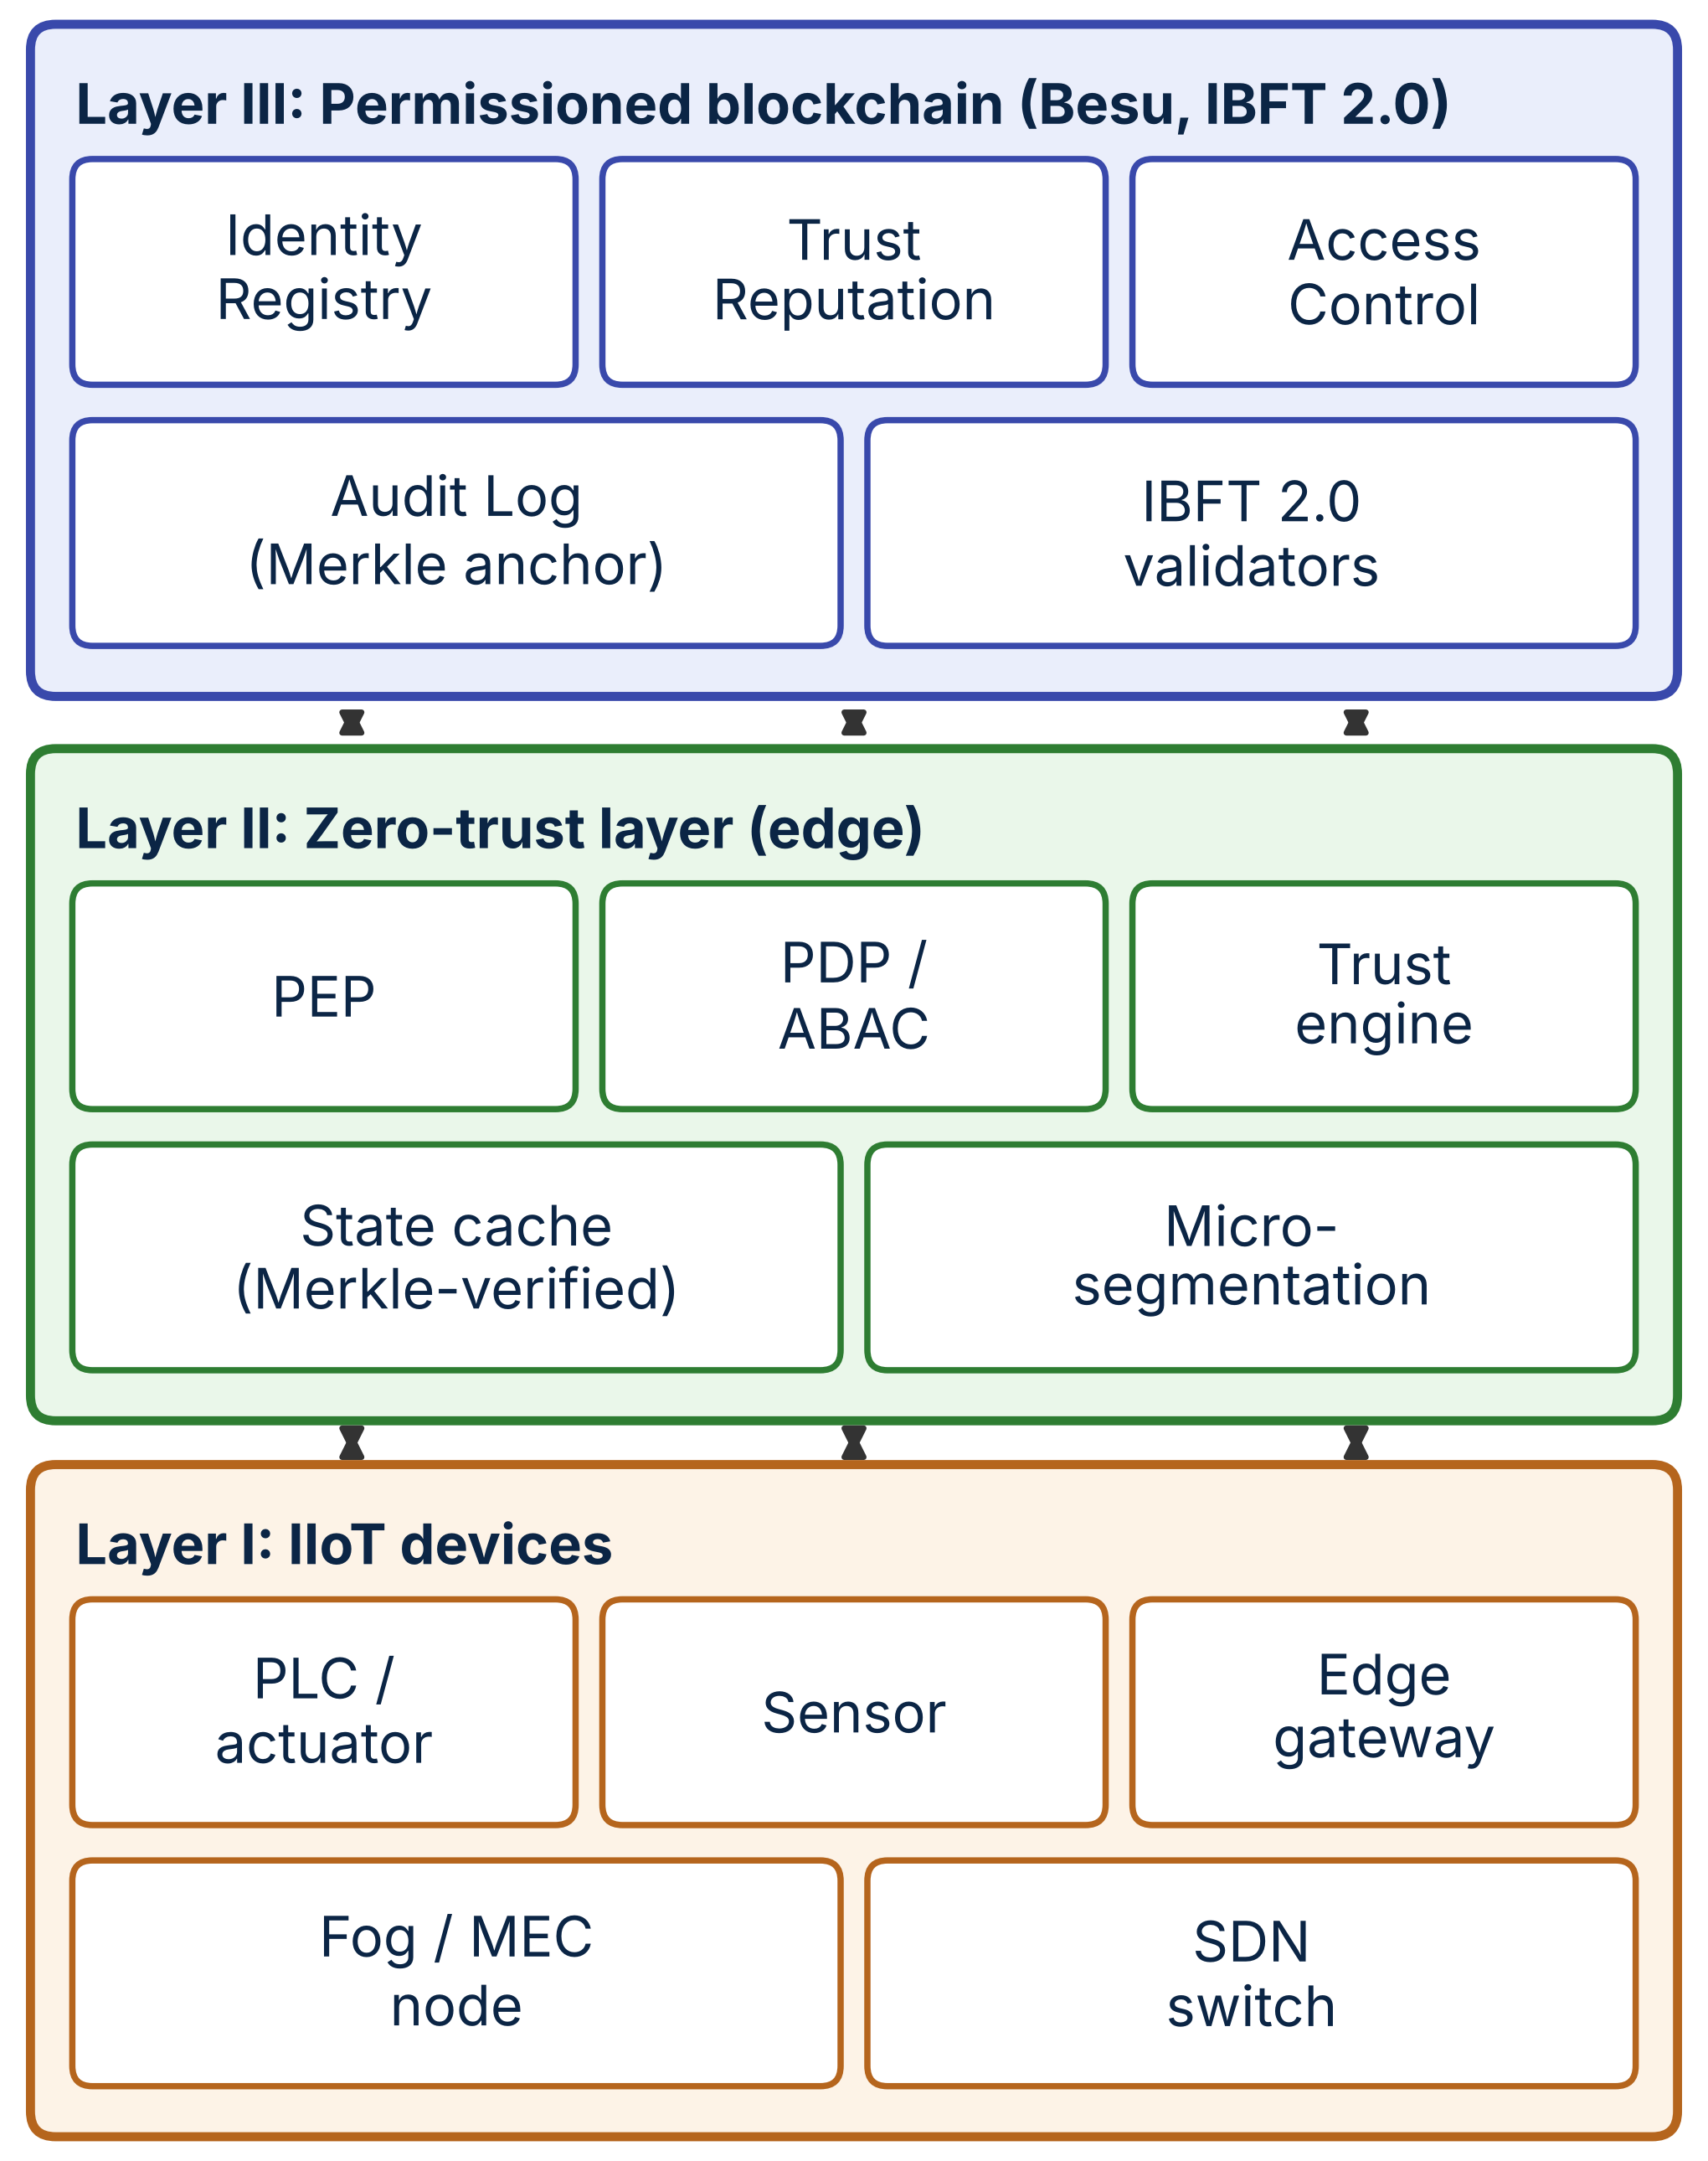
Fig. 1. Proposed BC-ZTA architecture: devices, edge/ZT layer, blockchain layer and contract services.
C. IIoT/Edge Layer
Sensors, actuators and PLCs hold an ECDSA key pair bound to a DID and sign each request with a timestamp and nonce. Edge gateways terminate sessions, host the PEP, keep a local cache of the identity, trust and policy state, and forward anomaly telemetry to the trust engine.
D. Zero-Trust Security Layer
The PEP intercepts every request. The PDP verifies the signature, checks the DID against a cached Merkle-verified registry entry, retrieves the trust score and policy, and returns allow/deny. Micro-segmentation is enforced by permitting only flows that hold a valid, unexpired session [2]. A trust engine converts behavioural features (rate, protocol conformance, firmware attestation) into score proposals.
E. Blockchain Layer
A permissioned Hyperledger Besu network with IBFT 2.0 consensus is operated by plant, integrator and vendor validators; with n validators it tolerates f = ⌊(n−1)/3⌋ Byzantine nodes. Gateways are read-only clients that subscribe to events; only authorised registrars, validators and the policy administrator send transactions.
F. Identity Management
Each device is a DID with a public-key hash and device class. Registrations are submitted by a plant-authorised registrar and may be grouped into epochs: the registrar commits a Merkle root of an epoch batch and devices later prove membership with a logarithmic-size proof, an approach inspired by epoch-based IIoT identity schemes [8]. Key rotation and revocation are single transactions that emit events.
G. Trust Management
Scores lie in [0,100] with an initial value of 70. A score changes only when a quorum of validators proposes the same value, and updates are rate-limited. An anomaly flag immediately subtracts 20 points (floored at 0) pending re-evaluation, giving fast conservative reaction.
H. Access Control
Policies are attribute-based: for each resource the administrator defines allowed device-class range, minimum trust score and session TTL. A request is granted iff the DID is active, the class is in range and the trust score meets the threshold; the grant yields a session identifier that expires after the TTL or on explicit revocation.
I. Smart Contracts
IdentityRegistry (register, update key, revoke, epoch commit, membership check); TrustReputation (quorum voting, anomaly flag); AccessControl (policy, evaluate, session grant/revoke); AuditLog (per-event log, Merkle batch anchor, inclusion verification). Table 2 lists the interfaces, and source and tests are in the accompanying package.
TABLE 2. SMART-CONTRACT INTERFACES
Contract | Main functions | Writer
IdentityRegistry | registerDID, updateKey, revokeDID, commitEpoch; verifyMembership, isActive (views) | Plant authority
TrustReputation | updateScore (quorum), flagAnomaly; getScore (view) | Validators
AccessControl | setPolicy, revokeSession; evaluateRequest (view), grantSession, isSessionValid | Admin; any caller
AuditLog | logEvent, anchorBatch; verifyInBatch, getAnchor (views) | Open in prototype
“Open in prototype” means the function has no caller restriction; a deployment would restrict it to gateway accounts.
J. Continuous Verification
Fig. 2 summarises the workflow. Verification does not end at login: every request is re-evaluated against current cached trust, sessions are short-lived, and the gateway refreshes cached entries every TTL seconds or immediately on a DIDRevoked or ScoreUpdated event. Audit records are hashed into a batch whose Merkle root is anchored on-chain asynchronously (step 7), so logging never delays the response.
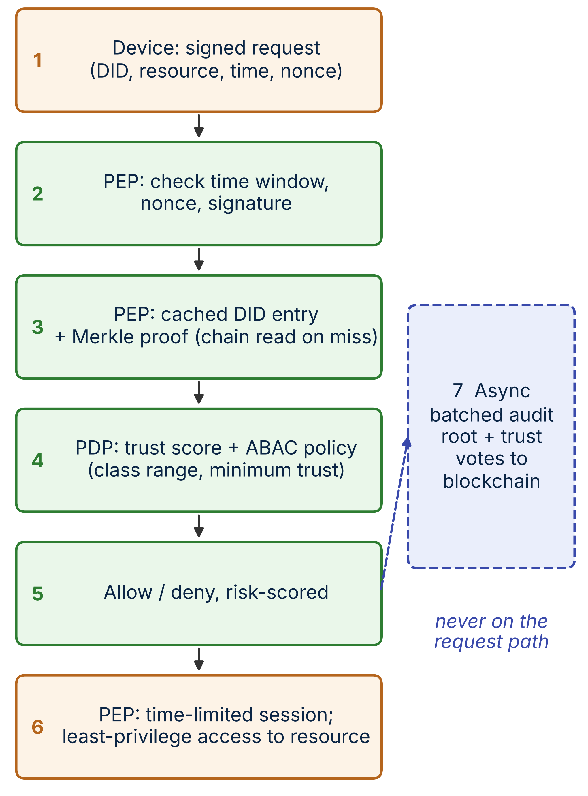
Fig. 2. Per-request verification workflow with cached state reads and asynchronous audit anchoring (step 7).
A request is r = (DID, resource, operation, t, n, σ), where t is a timestamp, n a nonce and σ the device’s ECDSA signature over the other fields. The PEP accepts r only if (i) |now − t| ≤ Δ and n has not been seen within Δ, which bounds replay; (ii) the DID is active in the cached registry, proved by a Merkle path against the latest committed epoch root or by a direct chain read on a cache miss; (iii) σ verifies under the public key whose hash is registered; and (iv) the PDP finds the trust score and policy satisfied. Otherwise the request is denied and an anomaly event is queued. As a fail-closed rule, a gateway whose cached state is older than 2·TTL because it lost contact with the ledger refuses new sessions, while existing sessions run to their own expiry.
IV. USE CASE AND THREAT MODEL
A. Use Case
A smart factory has several production cells, each with PLCs and sensors behind one edge gateway; a remote vendor engineer needs time-limited maintenance access to one PLC class; a SCADA historian consumes sensor data. Cells, vendor and integrator are separate administrative domains that jointly operate validators.
B. Assets and Trust Assumptions
Assets are device identities, policy and trust state, session tokens and audit records. We assume a majority-honest validator set (at most f Byzantine), secure device key storage, and gateways that are trusted for enforcement but may be compromised individually.
C. Adversary Model
A Dolev–Yao network adversary can eavesdrop, replay and inject messages; may compromise a subset of devices (including their keys) and one gateway; and may include an insider with administrative credentials in one domain but not in a validator quorum.
D. Threats and Countermeasures
Table 3 maps threats to mechanisms.
TABLE 3. THREATS AND COUNTERMEASURES
Threat | Attack | Countermeasure
Spoofing | Forged device identity | DID + ECDSA signature; Merkle-verified registry entry
Replay | Re-sent request | Timestamp + nonce window at PEP; session TTL
Lateral movement | Compromised device probes peers | Per-resource ABAC, micro-segmentation, short sessions
Insider / tamper | Admin edits policy or logs | On-chain policy and Merkle-anchored audit; validator quorum
Trust poisoning | False score votes | Quorum votes, rate limit; non-validators rejected
Stale state | Use of revoked identity | Event-driven cache invalidation, bounded TTL
Ledger DoS | Flooding the chain | Off-path reads; batched writes; non-validators cannot write trust

E. Security Goals
Authenticity of devices, least-privilege authorisation, revocation within a bounded delay, non-repudiable tamper-evident audit, and availability of access decisions during ledger congestion.
V. IMPLEMENTATION AND EXPERIMENTAL METHODOLOGY
A. Besu Blockchain Network
We deployed a four-validator Hyperledger Besu v26.9.0 IBFT 2.0 network (f = 1, block period 2 s, chain ID 2026, zero base fee, London EVM) with Docker on a GitHub-hosted 2-vCPU Linux runner for the contract-level micro-benchmark described below; all validators share that single host, so network delay is negligible and CPU is contended. The end-to-end experiments of Section V-C were run separately on a seven-VM Google Cloud deployment (Section V-G). A fresh network was started for each of 3 micro-benchmark repetitions. Contracts were compiled with Solidity 0.8.20 (optimizer 200 runs, EVM “london”). Five scenarios were run with pre-signed transactions from 8 worker wallets: S1 sequential write confirmation, S2 read latency (500 eth_call evaluations of AccessControl.evaluateRequest), S3 per-event logging at 10–200 tx/s offered for 20 s, S4 batch anchoring at 1 tx/s, and S5 revocation visibility. Block observation was polled every 25 ms. The benchmark scripts, contracts and raw results are available from the authors on request.
B. Smart Contracts
The four contracts total about 370 lines. A Hardhat/Chai suite of 15 tests passes and covers registration, duplicate and unauthorised registration, revocation, key update, quorum scoring, score floor, rate limiting, non-validator rejection, access grant/deny, session expiry, epoch Merkle membership and audit batch inclusion proofs.
C. End-to-End Prototype and Load Generator
Besides the contract-level tests, we implemented the complete request path as running software (Node.js 20): a PEP/PDP service, a load generator and the baselines of Section V-D. Each device owns a secp256k1 key and signs DID | resource | timestamp | nonce; its key hash and device class are registered on-chain and its DID is part of one Merkle epoch commitment. The PEP rejects stale timestamps (>5 s) and repeated nonces, recovers the signer, checks it against the registered key hash, verifies the Merkle membership proof against the cached epoch root, and evaluates the ABAC policy (device class 0–1, trust score ≥ 50). In BC-ZTA, identity, trust and policy state are read from Besu with eth_call on a cache miss and cached for 30 s; a block-polling subscription (20 ms) invalidates an entry when a DIDRevoked, KeyUpdated or ScoreUpdated event is mined; every decision is hashed, and once per second the Merkle root of the pending batch is anchored with AuditLog.anchorBatch. The load generator emulates N = 10, 25, 50, 100, 200 devices, each sending one request per second with staggered phases, for 5 s of warm-up and a 20 s measurement window; requests are signed before the window so that the generator itself is not the bottleneck. In the end-to-end experiments the PEP, the directory server, the load generator and the four Besu validators run on separate machines (Section V-G).
D. Baselines
(B1) Centralised PKI-IAM: each request makes one lookup at a separate directory server, on a separate directory VM whose responses are delayed by 40 ms with Linux tc netem to model a remote central service (about 50 ms per lookup in total, Section VI-A). (B2) ABAC without blockchain: a local attribute store at the PEP. (B3) Blockchain-only (sync): for every request the PEP reads the state with eth_call and sends an AuditLog.logEvent transaction (eight sender accounts) and replies only after the block containing it is observed. (P) Proposed BC-ZTA as in Section V-C. All four use the same request format, signature check and policy, so differences come from where state is read and written.
E. Experimental Parameters
Table 4 lists the experimental parameters; the injected network delays are assumptions, the other values are configuration of the prototype.
TABLE 4. EXPERIMENTAL PARAMETERS
Parameter | Value
Ledger | Besu v26.9.0, IBFT 2.0, 4 validators
Block period | 2 s
Platform | Google Cloud, 7 VMs (Section V-G)
Devices; request rate | 10–200; 1 req/s each
Warm-up; window; runs | 5 s; 20 s; 5
Cache TTL; anchor interval | 30 s; 1 s
Directory delay (B1, netem) | 40 ms
Validator link delay (netem) | 5 ms
Freshness window; policy | 5 s; class 0–1, trust ≥ 50
Revocation tests | 8 devices × 5 runs per system; TTL 10 s
Network delay is injected with tc netem on the directory and validator VMs only; everything else is measured on running software.
F. Performance Metrics
(E1) End-to-end latency (mean, P95) from request send to decision, goodput (accepted requests per second), failures, and on-chain writes per second versus device count. (E2) Revocation enforcement delay: time from the revocation action until the PEP first denies the device. (E3) Security tests with 50 attempts each per run. (E4) Decision latency while the ledger is flooded with transactions. (E5) Decision latency, goodput and revocation enforcement while one of the four validators is stopped. Also gas per operation and, from the micro-benchmark, confirmation latency and ledger throughput.
G. Distributed Deployment
The end-to-end experiments E1–E5 ran on Google Cloud (zone us-central1-a) on seven separate virtual machines in one VPC without external addresses: four Besu validators (e2-medium, 2 vCPU, 4 GB; one validator each), one PEP/PDP host (e2-standard-2), one directory server for B1 (e2-small) and one controller (e2-standard-2) that runs the load generator and the experiment scripts and submits the on-chain transactions. Linux tc netem delays all outgoing traffic of each validator VM by 5 ms to represent a plant-local validator network, and the responses of the directory server by 40 ms to represent a remote central service; all other delay is the real VM-to-VM network delay. Each of the 5 repetitions started a freshly generated chain and restarted the PEP for every device count; the repetitions ran sequentially on the same VMs. The validator-failure test (E5) stops one validator container for 30 s while 50 devices are served. Cloud VMs in one zone approximate independent hosts better than a shared CI runner, but they are not an industrial network: devices are emulated by the load generator and co-tenancy in the cloud can add variance. The deployment scripts, configuration and raw results are available from the authors on request.
A second cloud run on the same seven VMs added Keycloak 26.4.0 (Docker, development mode, embedded H2 database, OIDC token introspection) and OpenLDAP slapd (Debian 12 package, one search per request) on the directory VM (B4 and B5), the PEP-cache variants of both, a revocation test, a 25 s outage test, an open-loop PEP capacity test and the ledger flood sweep of Section VI-I. Besu was started with a 2.5 GB heap for the flood sweep. The scripts, orchestration and raw results are in the code package.
VI. RESULTS AND DISCUSSION
A. Authentication
Table 5 and Fig. 3 show end-to-end latency (mean of 5 runs). At 50 devices BC-ZTA answers in 5.4 ms on average (P95 6.2 ms), versus 49.1 ms for the centralised PKI-IAM, 5.2 ms for the ledger-free ABAC store and 1382 ms for the synchronous blockchain. BC-ZTA is therefore 89% faster than the centralised baseline, costs about 0.2 ms more than a local store (Merkle verification, hashing and audit bookkeeping), and is about 255× faster than checking every request on-chain. Even at 10 devices, where the ledger is not saturated, the synchronous design needs 1172 ms because each request waits for a block.
TABLE 5. END-TO-END LATENCY (MS, MEAN OF 5 RUNS)
System | Mean 50 | P95 50 | Mean 200 | P95 200
PKI-IAM | 49.1 | 50.0 | 49.0 | 50.9
ABAC | 5.2 | 6.0 | 4.1 | 5.1
BC-only | 1382 | 2272 | 12094 | 20757
BC-ZTA | 5.4 | 6.2 | 4.6 | 5.8
Columns give the number of devices; PKI-IAM responses are delayed by 40 ms (netem).
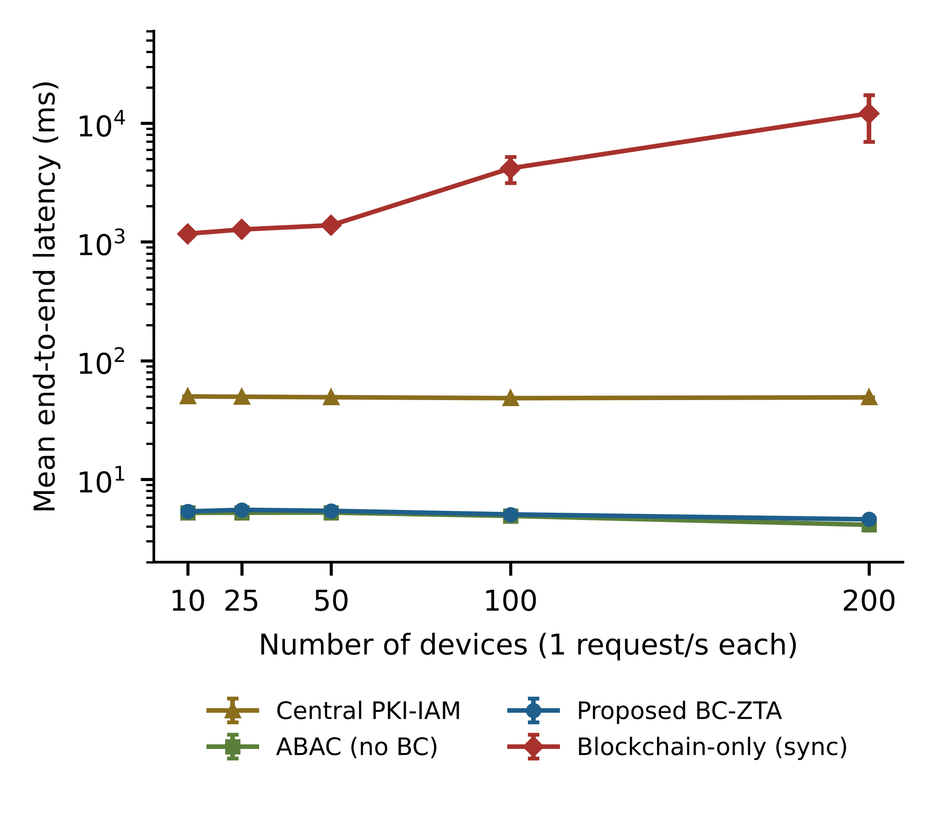
Fig. 3. Mean end-to-end latency versus number of devices (log scale; error bars: standard deviation of 5 runs).
B. Authorization
The proposed design makes policy decisions from the edge cache. The measured cache-hit ratio was 96% (one miss per device per 30 s TTL), so 50 devices caused only 50 chain reads for about 1,250 requests; each miss costs one batched eth_call of 5.4 ms in the micro-benchmark. The PEP used 0.29 CPU cores at 50 devices and 0.65 at 200, against 0.53 for the local store. Every decision is covered by the audit batch: in the 200-device runs about 5,000 decisions per run were anchored in roughly 25 transactions. On-chain evaluation costs 44,685 gas as an estimate, but because it is a read, no fee or block wait is incurred.
C. Blockchain Throughput
Table 6 summarises the Besu micro-benchmark. Write confirmation takes 1522 ms on average at 10 tx/s (P95 2439 ms), close to the 2 s block period; a transaction submitted just after a block, as in the phase-locked sequential tests S1/S5, waits about 1980 ms. Reads cost 5.4 ms (P95 10.9 ms). Committed throughput tracks the offered load up to 50 tx/s (46.5 tx/s) but saturates near 60 tx/s on this host: at 100 and 200 tx/s offered only 62.7 and 59.1 tx/s commit and 43% of transactions at 200 tx/s were not confirmed within 60 s. Batch anchoring at 1 tx/s confirmed all 60 anchors in 941 ms on average. Because all validators share one 2-vCPU host, 60 tx/s is a lower bound: on the seven-VM deployment the synchronous baseline committed up to 112 tx/s (Section VI-E), almost twice as much.
TABLE 6. MEASURED BESU RESULTS (SHARED CI HOST, 3 RUNS, MEAN)
Offered (tx/s) | Commit (tx/s) | Mean (ms) | P95 (ms) | Conf.
10 | 9.5 | 1522 | 2439 | 100%
25 | 23.3 | 1706 | 2659 | 100%
50 | 46.5 | 2330 | 3626 | 100%
100 | 62.7 | 11601 | 19753 | 100%
200 | 59.1 | 16424 | 27044 | 57%
Per-event logging (S3), four IBFT 2.0 validators on one shared 2-vCPU host; Conf. = confirmed fraction.
D. Resource Utilization
Measured gas per operation is listed in Table 7. Registering a device costs 55,682 gas, whereas committing an epoch root costs 75,469 gas independent of batch size. Logging one event on-chain costs 182,008 gas, while anchoring a batch costs 134,747 gas, i.e. about 135 gas per record for a 1,000-record batch (≈1351× cheaper). At 400 devices and 1 event/s the calculation gives 34.6 M events/day: 6636 MB/day of ledger growth with per-event logging (192 B/entry) versus 13.8 MB/day with batch anchoring. Device-side CPU and memory were not measured; prior IOTA-based DID work reports that DID generation can saturate a Raspberry Pi 4 CPU [22], which motivates our use of hash proofs only.
TABLE 7. MEASURED GAS PER CONTRACT OPERATION
Operation | Gas
IdentityRegistry.registerDID | 55,682
IdentityRegistry.commitEpoch | 75,469
IdentityRegistry.revokeDID | 49,550
AccessControl.setPolicy | 49,731
AccessControl.grantSession | 71,689
TrustReputation.updateScore (quorum) | 124,772
TrustReputation.flagAnomaly | 95,868
AuditLog.logEvent (per event) | 182,008
AuditLog.anchorBatch (per batch) | 134,747
Hardhat EVM (london), optimizer 200 runs; first-use storage costs included.
E. Scalability
Fig. 4 shows goodput and on-chain write load against device count. Central PKI-IAM, ABAC and BC-ZTA served every request up to 200 devices with no failures. The synchronous blockchain kept up to 50 devices (goodput 50 req/s, 1.4 s mean latency) and at 100 devices (100 req/s, 4.2 s), but at 200 devices only 40% of the requests were answered in time, goodput fell to 81 req/s and 4331 requests (summed over 5 runs) failed or timed out. Its on-chain write rate (100 tx/s at 100 and 112 tx/s at 200 devices) is the measured ledger ceiling of this deployment, whereas BC-ZTA writes about 1.0 tx/s regardless of the number of devices. The latency of BC-ZTA stays flat from 10 to 200 devices (5.4 to 4.6 ms mean, P95 at most 6.4 ms), and the PEP used 0.65 of its two vCPUs at 200 devices, so neither the ledger nor the PEP was the limit at this load; larger populations were not tested. For comparison, a sharded design reaches 2,500 TPS at 700 nodes [18]; our approach instead lowers the required write rate.
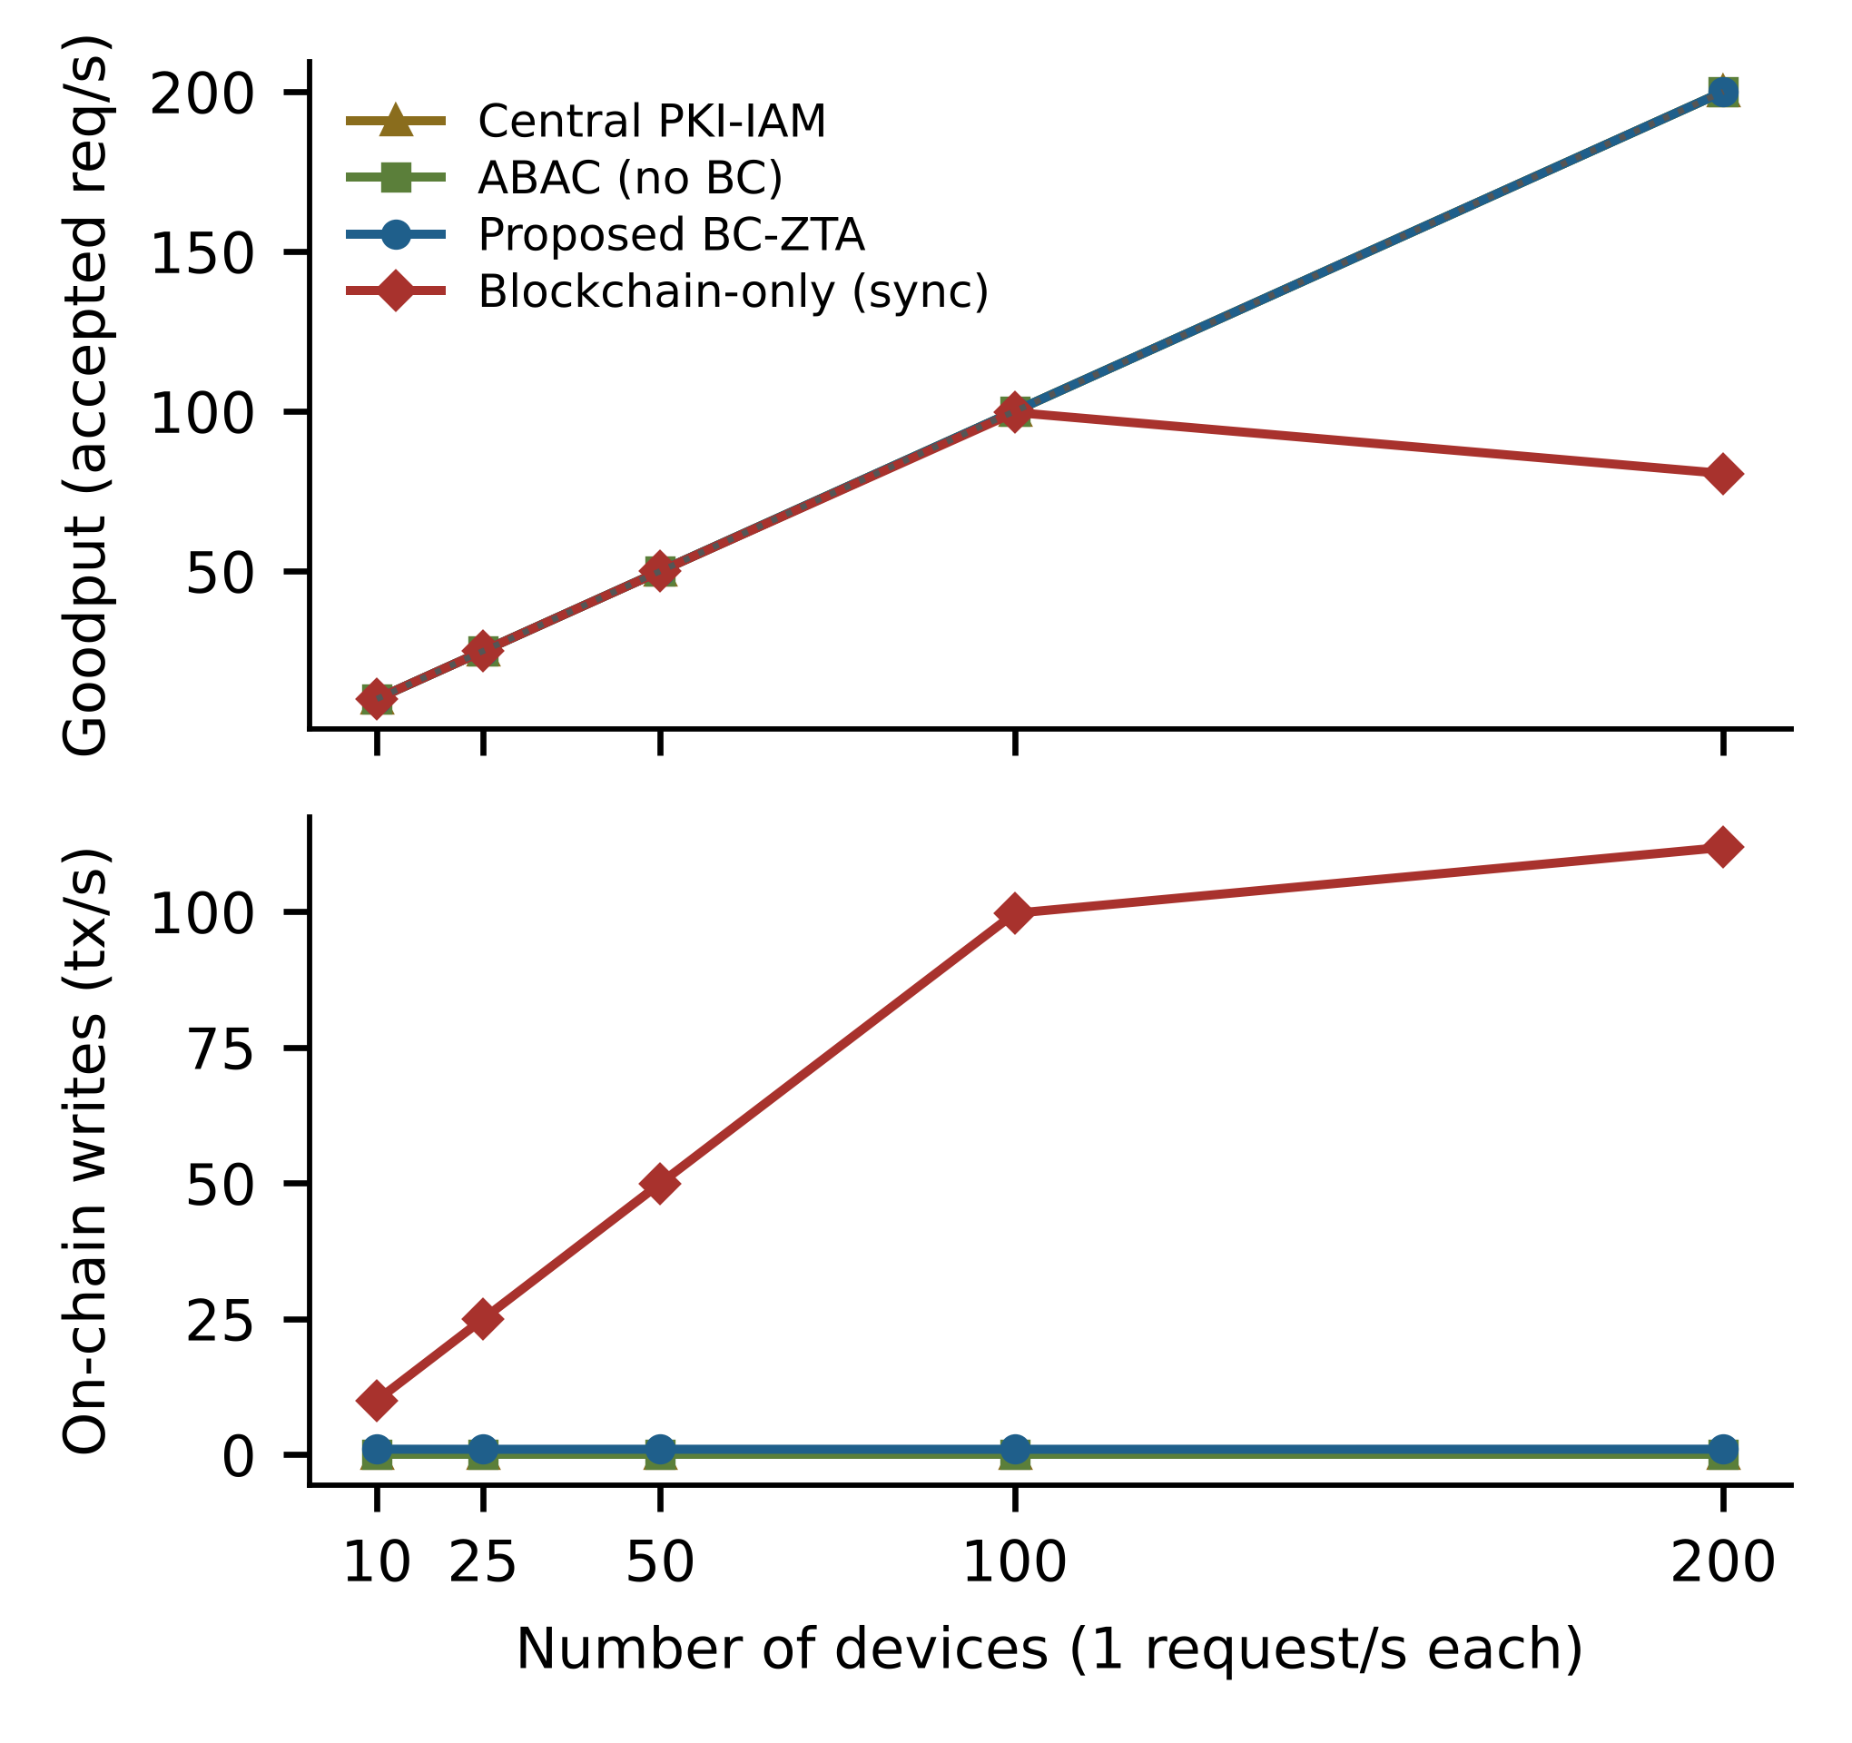
Fig. 4. Goodput (top) and on-chain writes per second (bottom) versus number of devices; dotted line: offered load.
F. Attack Resistance
Table 8 lists the security tests run against the BC-ZTA prototype (5 runs, 50 attempts per test and run). All legitimate requests were accepted (no false rejects), and none of the forged, replayed, stale, unregistered, tampered, class-violating or low-trust requests was accepted. For a revoked device, 0 requests were accepted after the revocation transaction was confirmed, and the first denial came 15 ms after confirmation or sooner. Fig. 5 shows the revocation enforcement delay of each system: with event-driven invalidation BC-ZTA enforces a revocation after 1.25 s on average (worst case 2.23 s), about one block period and independent of the TTL, whereas TTL-only refresh with a 10 s TTL needs 6.6 s on average (worst case 11.5 s). The centralised and local baselines revoke in 57 ms and 22 ms because they hold the state in one place (the ABAC samples are bimodal, about 7 ms or 57 ms; we did not isolate the cause, which lies in the probe path rather than in the store); the blockchain-only value (1.35 s) includes the request that was in flight when the revocation was issued.
TABLE 8. SECURITY TESTS ON THE BC-ZTA PROTOTYPE (5 RUNS)
Test | Attempts | Accepted
Legitimate requests (control) | 250 | 250
Forged signature | 250 | 0
Replayed request | 250 | 0
Stale timestamp | 250 | 0
Unregistered DID | 250 | 0
Tampered Merkle proof | 250 | 0
Class outside policy | 250 | 0
Trust score below threshold | 250 | 0
For the control row, Accepted is the desired outcome; for all other rows it must be 0.
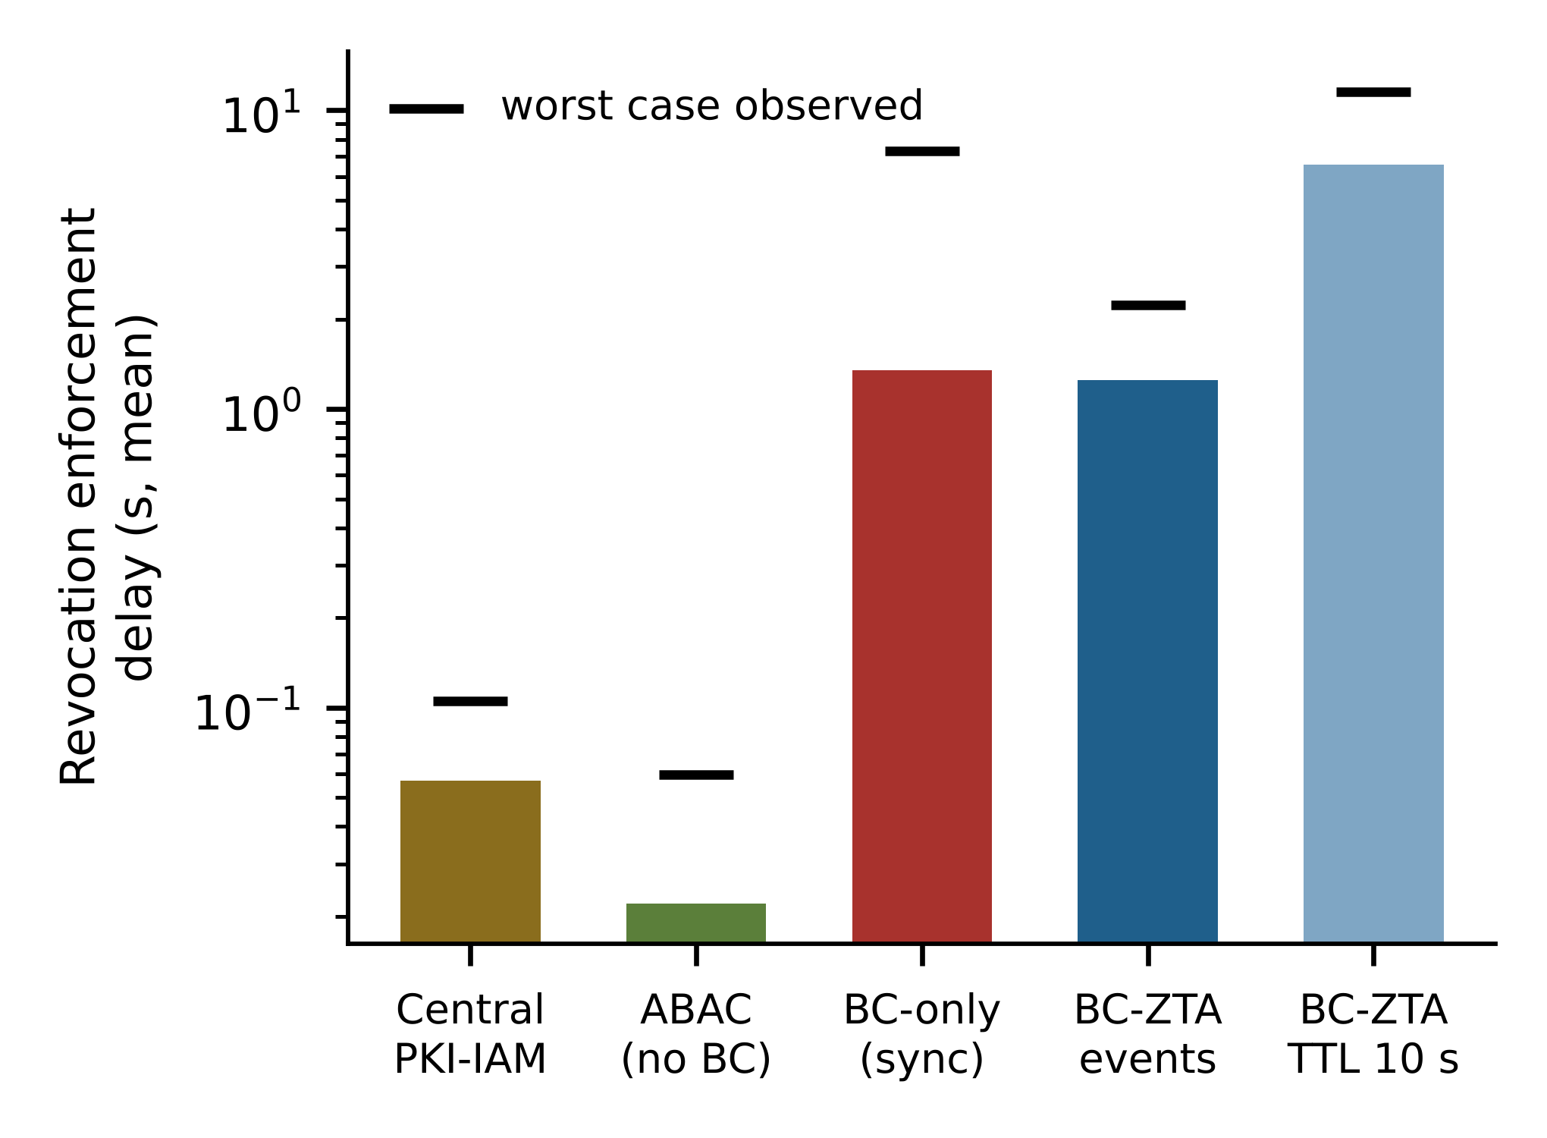
Fig. 5. Revocation enforcement delay (mean, log scale; marks: worst case observed).
G. Availability under Validator Failure and Ledger Flooding
E5 stops one of the four validators for 30 s while 50 devices are served and one device is revoked during the outage. IBFT 2.0 with four validators tolerates f = 1 faulty validator and the PEP decides from its cache, so decisions should be unaffected. Table 9 confirms this: all 3500 requests were answered and accepted (mean 5.4 ms, P95 6.8 ms, none late or failed), the revoked device was denied 1.76 s after the revocation was submitted, and the PEP kept anchoring audit batches (73 of 75 anchor transactions were confirmed when the statistics were read). Only one failure of one validator for 30 s was tested; network partitions, Byzantine validators and the loss of two validators were not.
TABLE 9. VALIDATOR-FAILURE TEST (E5, ONE RUN)
Measure | Value
Requests answered / accepted | 3500 / 3500
Mean / P95 latency (ms) | 5.4 / 6.8
Late or failed requests | 0 / 0
Revocation enforced (s) | 1.76
Anchors sent / confirmed | 75 / 73
One of four validators stopped for 30 s of a 70 s window; 50 devices at 1 req/s.
In E4 the ledger is flooded with 200 tx/s of audit-log transactions for 35 s while 50 devices are served. Besu accepted 3166 to 7000 of the 7000 flood transactions per run and rejected the rest (presumably a full transaction pool), so the accepted flood rate was 90 to 200 tx/s. In all 5 runs the PEP answered every request (success 100%), with mean latency 4.9–5.1 ms against 5.0–5.4 ms with an idle ledger. This is the intended effect of keeping the ledger off the request path. On the shared CI host the same flood had caused request failures, which we attribute to CPU contention between the PEP and the flooded validators and which the separate hosts removed.
H. Comparison with Production IAM Services
To replace the simple directory of B1 by real products, we added Keycloak 26.4 as an OpenID Connect token-introspection service [31] (B4) and OpenLDAP slapd as a directory queried once per request [32] (B5), each on the directory VM behind the same 40 ms netem delay, plus a variant of each with a 10 s decision cache at the PEP (“cached”). All five systems use the same PEP, signatures and policy. Table 10 gives the results (3 repetitions). At 25 and 100 devices the uncached products need 48.3 ms (Keycloak) and 46.8 ms (OpenLDAP) per decision because every request crosses the emulated WAN, against 6.3 ms for BC-ZTA, i.e. 8× and 7× faster. This advantage is mainly the removal of the WAN round trip: a PEP-side cache of the product's answer reaches 9.8–9.5 ms mean latency, and only its P95 (48 ms, one miss per device per TTL) remains WAN-bound. The decisive difference is therefore not the mean latency but what the cache costs: the cached products enforce a revocation only after the cache expires (mean 5.5 s, worst case 9.5 s for the 10 s TTL), whereas BC-ZTA’s event-driven invalidation enforces it in 1.2 s (worst case 2.2 s) at the same low latency. The uncached products are faster at revocation, 84 ms (Keycloak) and 72 ms (OpenLDAP), because the central service is consulted on every request; this is the price BC-ZTA pays for edge autonomy, and a plant that needs sub-second revocation must use the uncached products or a faster block period.
TABLE 10. PRODUCTION IAM BASELINES: LATENCY (MEAN / P95, MS) AND REVOCATION DELAY
System | 25 dev. | 100 dev. | 200 dev. | Revoc. (s)
Keycloak | 49.7 / 52 | 48.3 / 50 | 123.4 / 304 | 0.08
Keycloak, cached | 10.2 / 49 | 9.8 / 48 | 12.4 / 56 | 5.55
OpenLDAP | 47.3 / 49 | 46.8 / 49 | 77.2 / 243 | 0.07
OpenLDAP, cached | 10.1 / 47 | 9.5 / 47 | 10.6 / 50 | 5.20
BC-ZTA | 6.4 / 7 | 6.3 / 8 | 117.2 / 255 | 1.18
Mean of 3 repetitions; 40 ms netem delay on the IAM services; revocation: 8 devices per run, mean of 24; cache TTL 10 s.
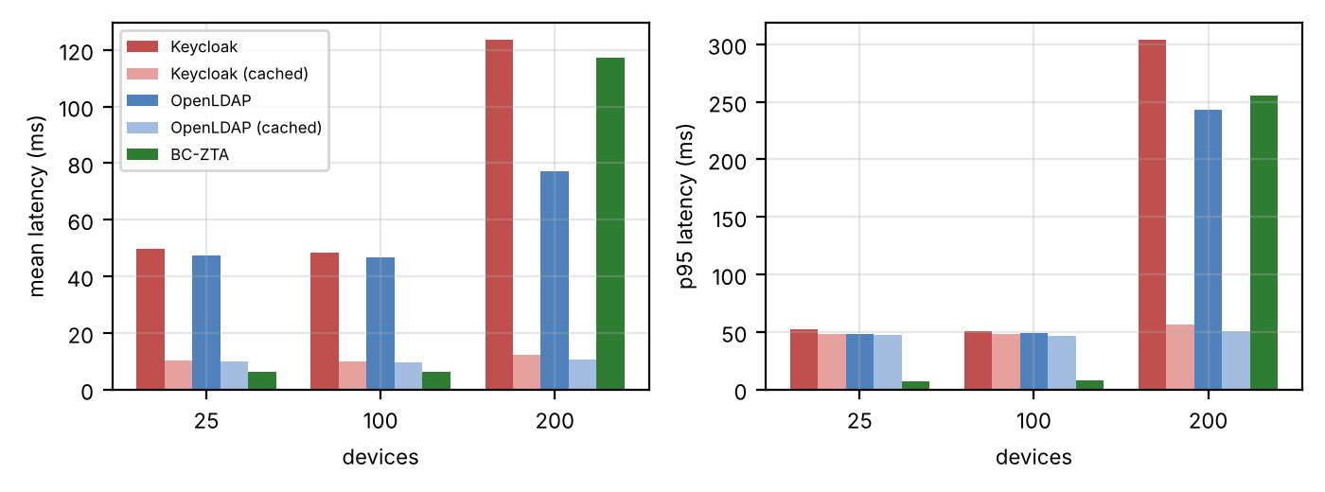
Fig. 6. Mean (left) and P95 (right) latency of Keycloak, OpenLDAP, their cached variants and BC-ZTA.
At 200 devices (one request per second each) the PEP, a single Node.js process on a 2-vCPU VM, approaches its own capacity: BC-ZTA (117 ms mean, 255 ms P95) and uncached Keycloak (123 ms) degrade similarly, while the cached products do not. In the earlier run of Section VI-A the same BC-ZTA configuration still decided in 4.6 ms at 200 devices, so this point lies at the saturation edge and is sensitive to run-to-run variation; we report it as a limit of our single-process PEP, not of the architecture, since PEPs are stateless and can be replicated per gateway. An open-loop capacity test (200–1,600 req/s, 3 repetitions) shows goodput saturating at about 246–291 req/s for all three systems, with P95 latency of several seconds beyond saturation; per-PEP capacity is therefore bounded by request signature verification and not by the choice of IAM backend.
Table 11 reports the outage test: the central service is stopped 20 s into a 100 s run with 100 devices and restarted at 45 s. Without Keycloak or OpenLDAP no new access decisions can be made: 0% of requests were granted during the outage for both uncached products, and 4% for the cached variants, whose entries expired within 2 s of the stop (they kept serving only until the 10 s TTL ran out and, because requests are spread over the TTL, most entries had already expired). Service resumed 1 s after restarting OpenLDAP and 14 s after restarting Keycloak (JVM start-up). BC-ZTA, whose PEP does not contact any central service, granted 100% throughout (Fig. 7). We did not test replicated or clustered Keycloak/OpenLDAP deployments, which would reduce this effect at the cost of operating them; the test shows the single-point-of-failure property that the architecture removes, not that central IAM cannot be made highly available.
TABLE 11. CENTRAL-SERVICE OUTAGE (25 s, 100 DEVICES, 3 RUNS)
System | Granted during outage (%) | Recovery after restart (s)
Keycloak | 0 | 14
Keycloak, cached | 4 | 14
OpenLDAP | 0 | 1
OpenLDAP, cached | 4 | 1
BC-ZTA | 100 | 0
Service stopped at 20 s and restarted at 45 s of a 100 s run; BC-ZTA has no central service (Keycloak was stopped on the directory VM, but BC-ZTA does not use it).
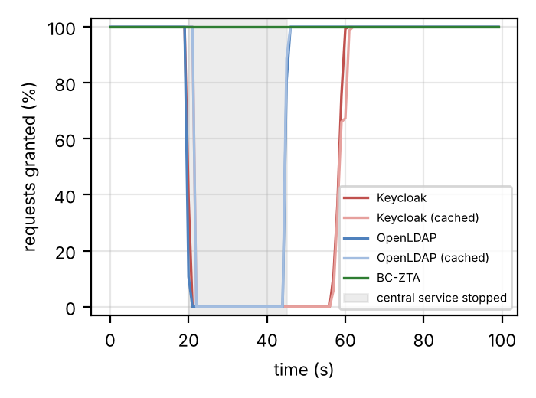
Fig. 7. Fraction of requests granted over time while the central IAM service is stopped (shaded) and restarted.
I. Ledger Flood Sweep
Section VI-G tested one flood rate. We therefore swept the offered rate of audit-log transactions from 0 to 1,200 tx/s (16 spam wallets, pre-signed transactions sent in nonce order, 20 s per rate after a 5 s warm-up, 50 devices at 1 request/s, 2 repetitions) once with BC-ZTA and once with the synchronous design, which writes each decision as a transaction on the same ledger (Table 12, Fig. 8). The committed rate saturates at about 193 tx/s for BC-ZTA and 215 tx/s for the synchronous design (peak at 200–400 tx/s offered) and then declines, to 106 and 152 tx/s at 1,200 offered, as Besu rejects most of the excess (“nonce too distant” and, at the highest rate, “transaction pool not enabled”; 50266 of 64802 submissions in the BC-ZTA run). BC-ZTA’s access latency does not follow: its mean stays at 5.8–6.3 ms and its P95 at no more than 7.9 ms with every request answered, because decisions never wait for the ledger. The synchronous design’s mean latency rises from 1.6 s with an idle ledger to 24 s at 1,200 tx/s (P95 30 s), and 7% of its requests fail at the highest rate. The flood therefore denies service to ledger-bound designs but only delays BC-ZTA’s own audit anchoring and revocation visibility, which we did not measure under flood.
TABLE 12. LEDGER FLOOD SWEEP (2 RUNS PER RATE)
Offered (tx/s) | Commit (tx/s) | BC-ZTA P95 (ms) | Sync. mean (s) | Sync. P95 (s)
0 | 1 | 6.9 | 1.6 | 2.5
100 | 97 | 6.6 | 2.9 | 4.5
200 | 184 | 6.5 | 10.2 | 14.7
400 | 193 | 6.8 | 18.4 | 24.6
800 | 162 | 6.9 | 24.2 | 31.4
1200 | 106 | 7.9 | 24.4 | 30.0
Commit = committed tx/s of the BC-ZTA run, from block data. Sync. = synchronous on-chain design.
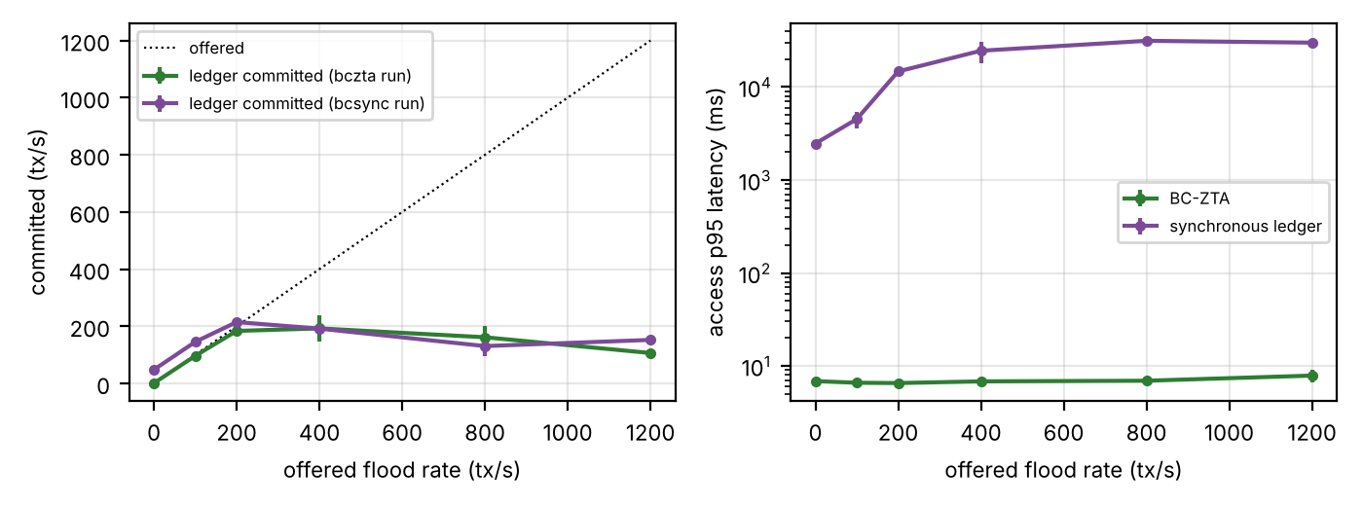
Fig. 8. Committed ledger rate (left) and access P95 latency (right) versus offered flood rate.
The flood generator targets the validator that the PEP also reads from, and the Besu heap was raised to 2.5 GB after a first attempt with the default 1 GB heap ran out of memory in the synchronous run at 400 tx/s; a flood against all validators, an attacker with more accounts, or a longer flood were not tested. The committed rate of 100–215 tx/s is specific to our four-validator, 2 s block, two-vCPU validator setup.
J. Comparison with Baselines
BC-ZTA is 0.2 ms slower than a ledger-free ABAC store at 50 devices but adds decentralised identity, shared policy and tamper-evident anchored audit that B2 lacks; against the centralised PKI-IAM it is 89% faster at 50 devices (with a 40 ms netem delay on the directory server) and removes the central directory; and against the synchronous blockchain it avoids ~1.4 s per decision at 50 devices and the ledger ceiling. Against real Keycloak and OpenLDAP services (Section VI-H) it is 8× and 7× faster at 100 devices and keeps granting access when they are down, but a PEP-side cache gives similar mean latency at the cost of stale revocations. Its price is revocation latency: about 1.3 s with events (one block) instead of about 84 ms for a central store. A reported Ethereum-based framework pays about 25 ms extra per request even at small scale [17], consistent with our finding that on-path consensus is the bottleneck.
K. Discussion and Limitations
The key trade-off is bounded revocation staleness for latency. Limitations: (i) the seven VMs sit in one zone of one cloud provider, so inter-VM delay is that of a data-centre network plus the injected netem delays, not a plant network or a WAN, and absolute latencies and throughput are specific to these VM sizes; (ii) B1–B3 are simple re-implementations; Keycloak ran in development mode (single node, embedded H2 database) and OpenLDAP as a single server, both behind an emulated 40 ms WAN, so production-tuned or clustered deployments may behave differently, particularly for availability; (iii) the device population is emulated by a load generator with up to 200 devices at 1 request/s: no physical devices, industrial protocols, secure elements, larger populations or bursty and churn-heavy workloads were used; (iv) one plant authority key issues registrations and revocations, so authority compromise is out of scope; (v) the availability tests are limited: the E4 flood was partly rejected by Besu (an accepted rate of 90–200 tx/s) and E5 stops one validator once for 30 s, with no network partition or Byzantine validator; (vi) each experiment has five repetitions (three for the IAM tests and two for the flood sweep) on the same VMs, the revocation tests use 8 devices per run, and a single-process PEP saturates at roughly 250–290 req/s, so larger sites need several PEPs; and (vii) trust scores are voted values, not yet learned from data. Comparisons with published numbers are indicative only, since workloads and testbeds differ.
Deployment considerations. First, validators must be run by independent parties (plant, integrator, vendor) for the Byzantine assumption to mean anything. Second, device keys should live in a secure element or TPM, because the architecture’s identity guarantees are only as strong as key custody. Third, on-chain records contain key hashes, scores and event hashes, not process data, which keeps operational data off the shared ledger. Fourth, in the prototype AuditLog and grantSession are callable by any account, and production deployments would restrict them to gateway identities. Fifth, the fail-closed rule of Section III-J trades availability for safety during ledger partitions and should be tuned against plant uptime requirements.
VII. CONCLUSION
We presented BC-ZTA, a blockchain-assisted zero-trust architecture that keeps consensus off the per-request path through edge-cached, Merkle-verified state and asynchronous batched anchoring. Four Solidity contracts pass 15 unit tests, and measured gas shows batch anchoring is about 1351× cheaper per record than per-event logging. In end-to-end tests on a seven-VM Google Cloud deployment with a four-validator Besu network, BC-ZTA decided in 5.4 ms on average at 50 devices and served 200 devices without failures with about one on-chain write per second, and kept deciding while one validator was stopped or the central IAM service was down, while the synchronous design needed 1.4 s at 50 devices and answered only 40% of the requests at 200 devices; the price is a revocation delay of about 1.3 s with event-driven invalidation. All forged, replayed, stale, unregistered, tampered and policy-violating requests were rejected. The evaluation used cloud VMs in a single zone with injected network delay and an emulated device population. Future work includes a multi-site Besu deployment with real network delay, physical devices and industrial protocols, clustered production IAM baselines, learning-based trust scoring and post-quantum signatures.
ACKNOWLEDGMENT
[Funding sources and acknowledgments to be added by the authors.]
REFERENCES
[1] F. Federici, D. Martintoni, and V. Senni, “A zero-trust architecture for remote access in industrial IoT infrastructures,” Electronics, vol. 12, no. 3, Art. no. 566, 2023, doi: 10.3390/electronics12030566.
[2] C. Zanasi, S. Russo, and M. Colajanni, “Flexible zero trust architecture for the cybersecurity of industrial IoT infrastructures,” Ad Hoc Netw., vol. 156, Art. no. 103414, 2024, doi: 10.1016/j.adhoc.2024.103414.
[3] S. Rose, O. Borchert, S. Mitchell, and S. Connelly, “Zero trust architecture,” Nat. Inst. Standards Technol., Gaithersburg, MD, USA, Spec. Publ. 800-207, Aug. 2020, doi: 10.6028/NIST.SP.800-207.
[4] M. L. Gambo and A. Almulhem, “Zero trust architecture: A systematic literature review,” J. Netw. Syst. Manage., vol. 34, Art. no. 25, 2026, doi: 10.1007/s10922-025-09998-x.
[5] S. Mushtaq, M. Mohsin, and M. M. Mushtaq, “A systematic literature review on the implementation and challenges of zero trust architecture across domains,” Sensors, vol. 25, no. 19, Art. no. 6118, 2025, doi: 10.3390/s25196118.
[6] M. A. Azad, S. Abdullah, J. Arshad, H. Lallie, and Y. H. Ahmed, “Verify and trust: A multidimensional survey of zero-trust security in the age of IoT,” Internet Things, vol. 27, Art. no. 101227, 2024, doi: 10.1016/j.iot.2024.101227.
[7] S. Mthethwa, M. T. Dlamini, and E. Jembere, “Zero trust for NHIs based on robust identity and access management for a resilient IoT future,” Sensors, vol. 26, no. 8, Art. no. 2392, 2026, doi: 10.3390/s26082392.
[8] M. Asim, N. Tariq, A. I. Awad, F. Waheed, S. Bukhari, A. Rafay, and H. H. Song, “Lightweight and privacy-aware decentralized identity management for Industrial Internet of Things applications,” Future Gener. Comput. Syst., vol. 186, Art. no. 108753, 2027 (online Aug. 2026), doi: 10.1016/j.future.2026.108753.
[9] E. B. Fernández and A. Brazhuk, “A critical analysis of zero trust architecture (ZTA),” Comput. Stand. Interfaces, vol. 89, Art. no. 103832, 2024, doi: 10.1016/j.csi.2024.103832.
[10] Y.-W. Ma and P.-H. Chiu, “A novel risk-based access control engine in zero trust architecture for IoT network,” Int. J. Inf. Secur., vol. 24, Art. no. 124, 2025, doi: 10.1007/s10207-025-01030-2.
[11] M. A. Aleisa, “Blockchain-enabled zero trust architecture for privacy-preserving cybersecurity in IoT environments,” IEEE Access, vol. 13, pp. 18660–18676, 2025, doi: 10.1109/ACCESS.2025.3529309.
[12] S. Nie, J. Ren, R. Wu, P. Han, Z. Han, and W. Wan, “Zero-trust access control mechanism based on blockchain and inner-product encryption in the Internet of Things in a 6G environment,” Sensors, vol. 25, no. 2, Art. no. 550, 2025, doi: 10.3390/s25020550.
[13] G. Ali, S. Shah, M. Elaffendi, and N. Ahmad, “Blockchain-based access management framework for interoperable digital twins in industrial IoT,” Front. Blockchain, vol. 8, Art. no. 1693926, 2025, doi: 10.3389/fbloc.2025.1693926.
[14] M. Essaid and H. Ju, “Blockchain solutions for enhancing security and privacy in Industrial IoT,” Appl. Sci., vol. 15, no. 12, Art. no. 6835, 2025, doi: 10.3390/app15126835.
[15] D. Li, H. Li, N. Crespi, R. Minerva, M. Li, W. Liang, and K. C. Li, “Hyper-IIoT: A smart contract-inspired access control scheme for resource-constrained Industrial Internet of Things,” IEEE Trans. Sustain. Comput., vol. 10, no. 5, pp. 820–829, 2025, doi: 10.1109/TSUSC.2025.3542466.
[16] Z. Guo, “Blockchain-enhanced smart contracts for formal verification of IoT access control mechanisms,” Alexandria Eng. J., vol. 118, pp. 315–324, 2025, doi: 10.1016/j.aej.2024.12.109.
[17] A. Singh, V. Pareek, and A. Sharma, “Blockchain-enabled zero trust framework for securing FinTech ecosystems against insider threats and cyber attacks,” arXiv:2507.19976, 2025.
[18] M. M. Salim, M. Kim, S. K. Singh, and J. H. Park, “Zero-trust blockchain-enabled framework for scalable and secure IoT networks,” Future Gener. Comput. Syst., vol. 175, Art. no. 108093, 2026, doi: 10.1016/j.future.2025.108093.
[19] A. Sharma, S. Rani, and W. Boulila, “Blockchain-based zero trust networks with federated transfer learning for IoT security in industry 5.0,” PLOS ONE, vol. 20, no. 6, Art. no. e0323241, 2025, doi: 10.1371/journal.pone.0323241.
[20] S. Mishra, T. S. M. Aldafas, and N. S. Alshammari, “A zero-trust digital twin framework for privacy-preserving multi-dataset intrusion detection in industrial IoT with lightweight blockchain auditing,” Sci. Rep., vol. 16, Art. no. 15236, 2026, doi: 10.1038/s41598-026-42041-w.
[21] Z. Zhai, J. Liu, X. Liu, Y. Mao, X. Zhang, J. Ma, and C. Jin, “A lightweight authentication method for Industrial Internet of Things based on blockchain and Chebyshev chaotic maps,” Future Internet, vol. 17, no. 8, Art. no. 338, 2025, doi: 10.3390/fi17080338.
[22] T. Ramírez-Gordillo, A. Maciá-Lillo, F. A. Pujol, N. García-D’Urso, J. Azorín-López, and H. Mora, “Decentralized identity management for Internet of Things (IoT) devices using IOTA blockchain technology,” Future Internet, vol. 17, no. 1, Art. no. 49, 2025, doi: 10.3390/fi17010049.
[23] S. I. R. Naqvi, Z. J. Bin, A. Mohsin, M. P. Akhter, and M. M. ur Rahman, “DBoT: Enhancing scalability and privacy in intelligent building spaces through a direct acyclic graph blockchain,” in Proc. 17th Int. Conf. Open Source Syst. Technol. (ICOSST), 2023, doi: 10.1109/ICOSST60641.2023.10414234.
[24] R. Islam, R. Bose, S. Roy, A. A. Khan, S. Sutradhar, S. Das, F. Ali, and A. A. AlZubi, “Decentralized trust framework for smart cities: A blockchain-enabled cybersecurity and data integrity model,” Sci. Rep., vol. 15, Art. no. 23454, 2025, doi: 10.1038/s41598-025-06405-y.
[25] P. Rani, “A zero-trust framework for securing next-generation Internet of Things network,” in New Trends and Applications in Internet of Things (IoT) and Big Data Analytics, vol. 2. Cham, Switzerland: Springer, 2026, pp. 213–225, doi: 10.1007/978-3-032-21753-0_12.
[26] B. Chellaprabha, D. Manohari, and J. J. Justus, “Scalable and secure IoT architecture using trust-driven adaptive resource management and edge intelligence,” in Expert Applications and Security (NICE-TEAS 2025), Lecture Notes in Networks and Systems, vol. 1823. Cham, Switzerland: Springer, 2026, pp. 444–461, doi: 10.1007/978-3-032-20114-0_40.
[27] K. Li et al., “Zero-trust foundation models: A new paradigm for secure and collaborative artificial intelligence for Internet of Things,” arXiv:2505.23792, 2025.
[28] S. Ghasemshirazi, G. Shirvani, and M. A. Alipour, “Zero trust: Applications, challenges, and opportunities,” arXiv:2309.03582, 2023.
[29] A. K. Peepliwal et al., “A prototype model of zero-trust architecture blockchain with EigenTrust-based practical Byzantine fault tolerance protocol to manage decentralized clinical trials,” arXiv:2408.16885, 2024.
[30] A. Kulkarni, N. A. Hazari, and M. Y. Niamat, “A zero trust-based framework employing blockchain technology and ring oscillator physical unclonable functions for security of field programmable gate array supply chain,” IEEE Access, vol. 12, pp. 89322–89338, 2024. [Online]. Available: https://scholars.utoledo.edu/display/pub-001262650600001
[31] J. Richer, Ed., “OAuth 2.0 token introspection,” Internet Eng. Task Force, RFC 7662, Oct. 2015. [Online]. Available: https://www.rfc-editor.org/rfc/rfc7662
[32] J. Sermersheim, Ed., “Lightweight Directory Access Protocol (LDAP): The protocol,” Internet Eng. Task Force, RFC 4511, Jun. 2006. [Online]. Available: https://www.rfc-editor.org/rfc/rfc4511
AUTHOR BIOGRAPHIES
[AUTHOR NAME] [Short biography, degrees, current position and research interests to be added; IEEE Access also requires a photo.]

