COMPLETE PROJECT OVERVIEW
• Content.
- BRD (Business Requirement Details)
- High level System Design
- ER Diagram
- Some UI Demo
- API Endpoints

1. Business Requirements Document (BRD)

Project Name: UrbanCart
Prepared by: Irfan(TL), Nagraj, Tanvi, Bhubaneswari, Mukunth
Course: BCA (Final Year)
College/University: SMSG Jain Degree College
Guide: Ms. Suchitra Mishra
1. INTRODUCTION .

1.1 Purpose
This document describes the business requirements for an online e-commerce platform that lets customers browse, search, and purchase products, and lets sellers and administrators manage products, orders, and users. It is the basis for the later SRS, design, and development phases.

1.2 Scope
The system is a web application with a customer storefront, a seller panel and an admin panel.
In scope: user registration and login, product catalogue and search, shopping cart, wishlist, checkout, simulated online payment, order tracking, reviews and ratings, seller product management, admin management and reports.
Out of scope (for this version): mobile native apps, real payment gateway with live money, logistics or courier API integration, multi-language and multi-currency support, AI recommendations.

2. Business Overview .

2.1 Background
Online shopping is now a primary way people buy goods. Small sellers often lack an affordable platform to reach customers, and customers want a single place to compare, buy, and track products. This project builds a simplified marketplace modelled on established platforms such as Amazon.

2.2 Problem Statement
Traditional shops are limited by location and opening hours, customers cannot easily compare products and prices, and small sellers lack a low-cost online presence. A web-based platform with product search, secure ordering, and order tracking addresses these gaps.

2.3 Business Objectives
- Provide a 24x7 online store for browsing and buying products.
- Allow multiple sellers to list and manage their products.
- Reduce manual order handling through automated cart, checkout, and order management.
- Give administrators clear control and visibility over users, products, and orders.
- Build a secure, scalable base that can be extended later.

2.4 Success Criteria
- A user can register, search, add to cart, check out, and see order status end to end.
- Pages load within 3 seconds under normal load.
- All core modules pass functional testing with no critical open defects.

- Stakeholders
  Stakeholder |  |   Role |   Interest
  Customer |  |   End user |   Easy browsing, safe payment, fast delivery tracking
  Seller |  |   Vendor |   List products, manage stock, receive orders
  Administrator |  |   System manager |   Control users, catalogue, orders, reports
  Project Guide |  |   Evaluator |   Quality of analysis, design, and implementation
  Developer (Student) |  |   Builder |   Deliver a working, documented system
 |  |  | .
4. Current System and Proposed System

4.1 Existing System
Purchases happen mainly in physical shops or through phone and messaging orders. Limitations: limited reach, manual record keeping, no automatic stock updates, no order history, and no easy price comparison.

4.2 Proposed System
A web platform where customers search and buy online, sellers manage their own listings, and admins oversee everything. Orders, stock, and payments are tracked automatically in a central database.

4.3 Advantages
- Available anytime, from anywhere
- Automatic stock and order tracking
- Faster, more accurate order processing
- Searchable, filterable catalogue
- Centralised reporting

4.4 Justification for the Project
Large e-commerce platforms already exist, so this project is justified by its purpose and focus, not by trying to replace them.
- Academic and skill value: E-commerce brings together authentication, role-based access, database design, transactions, payments, and security. Building it demonstrates the full software development lifecycle on a real-world problem.
- Support for small and local sellers: The platform gives small sellers a simple, low-cost way to list and sell products without the fees, competition, and complexity of the large marketplaces.
- Simpler and focused experience: A smaller catalogue and a cleaner workflow make browsing, ordering, and seller management easier than on a general-purpose giant.
- Full control and customisation: Because the platform is built in-house, features such as local-language support, local delivery rules, and custom reports can be added without depending on a third party.
- Proven demand, lower risk: Online shopping is a proven model with clear user needs, so the project can follow established practices while keeping its scope manageable for a student team.
- Extensible foundation: The modular design allows later additions such as a real payment gateway, recommendations, and a mobile app.
- User Roles, Permissions and Requirements .
  - Role and Permissions:
Role | Key Permissions
Guest | Browse products, search, view details
Customer | All guest rights plus cart, wishlist, checkout, orders, reviews, profile
Seller | Add, edit, delete, hide own products; manage stock; view and process own orders
Admin | Manage all users, sellers, categories, products, orders; approve sellers; view reports

  - User (Customer) Requirements:
These are the needs a customer must be able to meet on the platform; Section 6 turns them into detailed functional requirements.
ID | Requirement | Priority
UR-1 | Register and log in securely with email or phone and a password | Must
UR-2 | Reset a forgotten password through email verification | Must
UR-3 | Browse products by category and sub-category | Must
UR-4 | Search products by keyword and filter by price, category, and rating | Must
UR-5 | View full product details: images, price, description, stock status, reviews | Must
UR-6 | Add items to the cart, change quantities, and remove items | Must
UR-7 | Manage profile details and multiple delivery addresses | Must
UR-8 | Place an order and pay by Cash on Delivery or simulated online payment | Must
UR-9 | Receive an order confirmation and invoice | Must
UR-10 | View order history and track the current status of each order | Must
UR-11 | Use the site comfortably on mobile, tablet, and desktop | could
UR-12 | Save products to a wishlist for later | Should
UR-13 | Cancel an order before it is shipped | Should
UR-14 | Rate and review products they have purchased | Should
UR-15 | Receive email notifications about orders and account activity | Could
UR-16 | As a customer, I can request a return for a delivered item within 5 days of delivery, giving a reason. | Must
UR-17 | As a customer, I can see the status of my return and refund: requested, approved, rejected, shipped back, received, refunded or refund owed. | Should
Priority key: Must = needed for the first working version; Should = important, include if time allows; Could = optional extra.
5.3 Admin Requirements:
The administrator needs full control over users, catalogue, and orders, plus the information to run the platform.
ID | Requirement | Priority
AR-1 | Log in through a secure admin account that is separate from customer accounts | Must
AR-2 | See a dashboard with totals for users, orders, and sales | Must
AR-3 | View, block and unblock user accounts | Must
AR-4 | Add, edit, and delete categories and sub-categories | could
AR-5 | View, edit, and remove any product listing | could
AR-6 | View all orders and update their status | Must
AR-7 | Approve or reject seller registrations | Should
AR-8 | Monitor stock levels and get low-stock alerts | Should
AR-9 | Moderate reviews and remove inappropriate ones | Should
AR-10 | Reports: sales, top-selling products and categories and top sellers. | Should
AR-11 | Manage payment and refund records(simulated payments) | Could
AR-12 | Keep an audit log of important admin actions | Could
AR-13 | As an admin, I can view all returns and refunds, filtered by status. | Should
AR-14 | As an admin, I can mark a Cash on Delivery refund that was owed as paid | Could
5.4 Seller Requirements:
The seller needs to apply and be approved, list products, and process the orders for those products, while seeing only their own data.
ID | Requirement | Priority
SR-1 | Apply to become a seller with shop details, an ID proof, and a business proof | Must
SR-2 | Log in as a seller through the shared login page and see only their own products, orders, and sales | Must
SR-3 | Wait for admin approval, and see the reason and apply again if the application is rejected | Must
SR-4 | See a dashboard with active products, orders to process, and sales for the month | Must
SR-5 | Add, edit, and hide products with category, price, stock, description, and images, with low and out-of-stock products flagged | Must
SR-6 | View orders for their own products and update the status (confirmed, shipped, delivered) | Must
SR-7 | See the customer name, phone, delivery address, and payment type for each order | Must
SR-8 | Cancel an order before it is shipped | Must
SR-9 | See a sales summary and best-selling products | Should
SR-10 | Edit the shop profile: name, description, pickup address, and contact details | Should
SR-11 | As a seller, I can approve a return request, or reject it with a reason. | Must
SR-12 | As a seller, I can mark a returned item as received, which releases the refund and puts the item back into stock. | Must

- Functional Requirements .

6.1 User Management
- FR-1: Users shall register with name, email, phone, and password.
- FR-2: Users shall log in and log out securely.
- FR-3: Users shall reset a forgotten password via email verification.
- FR-4: Users shall view and edit their profile and manage multiple delivery addresses.

6.2 Product Catalogue and Search
- FR-5: The system shall display products organised by category and sub-category.
- FR-6: Each product page shall show images, title, price, description, stock status, and reviews.
- FR-7: Users shall search by keyword and filter by category, price range, and rating.
- FR-8: Users shall sort results by price, popularity, or newest.

6.3 Shopping Cart and Wishlist
- FR-9: Customers shall add, remove, and change quantity of items in the cart.
- FR-10: The cart shall show item totals, taxes, and the grand total.
- FR-11: Customers shall save products to a wishlist and move them to the cart.

6.4 Checkout and Payment
- FR-12: Customers shall select or add a delivery address at checkout.
- FR-13: The system shall support Cash on Delivery and a simulated online payment (test mode).
- FR-14: The system shall validate stock before confirming an order.
- FR-15: The system shall generate an order confirmation and an invoice.

6.5 Order Management
- FR-16: Customers shall view order history and current status (Placed, Confirmed, Shipped, Delivered, Cancelled).
- FR-17: Customers shall cancel an order before it is shipped.
- FR-18: Sellers shall update the status of orders for their products.

6.6 Reviews and Ratings
- FR-19: Customers who purchased a product shall rate and review it.
- FR-20: The product page shall show the average rating and individual reviews.
6.7 Seller Module
- FR-21: Sellers shall register with owner details, shop details, an ID proof, and a business proof, and await admin approval.
- FR-22: Sellers shall log in through the shared login page and be directed by status: approved sellers to the seller dashboard, pending or rejected sellers to a status page.
- FR-23: Rejected sellers shall see the admin’s reason and be able to update and resubmit the application.
- FR-24: Sellers shall see a dashboard with active products, orders to process, and sales for the month.
- FR-25: Approved sellers shall add, edit, and hide their own products with category, price, stock quantity, description, and images.
- FR-26: The system shall flag low-stock and out-of-stock products, and shall not let customers buy hidden or out-of-stock products.
- FR-27: Sellers shall view only the orders for their own products, with the customer name, phone, delivery address, and payment type.
- FR-28: Sellers shall cancel an order before it is shipped.
- FR-29: Sellers shall view sales summaries for 7 days, 30 days, or this year, and their best-selling products.
- FR-30: Sellers shall view and edit their shop profile: name, description, pickup address, contact details, and logo.

6.8 Admin Module
- FR-31: Admins shall have a login page.
- FR-32: Admins shall manage users, sellers, orders and sales.
- FR-33: Admins shall approve or reject seller applications.
- FR-34: Admins shall view and manage all orders.
- FR-35: Admins shall view reports: sales, top products, top categories.
- FR-36: Admins shall block and unblock user or seller.

6.9 Notifications (Not Important)
• FR-37: The system shall send email notifications for registration, order confirmation, and status changes and return updates.
6.10 Return and refund
- FR-38: Only delivered items can be returned, within 5 days of delivery, once per item, and a reason is required.
- FR-39: The seller approves the request, or rejects it with a mandatory reason.
- FR-40: After approval, the customer sends the item back to the seller, and the seller marks it received.
- FR-41: A returned item goes back into stock when the seller marks it received.
- FR-42: Item price plus its tax. The delivery charge is not refunded.
- FR-43: The refund is made only after the seller marks the returned item received.
- FR-44: Online payments are simulated (test-only). COD refunds are recorded as owed.
- FR-45: The customer sees the current status and timeline.
- FR-46: Admin access to the return and refund list with a status filter.

- Non-Functional Requirements .

Category | Requirement
Performance | Pages load in about 3 seconds or less under normal load; search results in under 2 seconds
Security | Passwords hashed (bcrypt), token-based authe (JWT), HTTPS, rolebased access control
Usability | Clean, intuitive interface; consistent navigation
Responsiveness | Works on desktop, tablet, and mobile browsers
Reliability | Database transactions keep orders and stock consistent; regular backups
Scalability | Modular design so features can be added without rewriting the system
Maintainability | Clean code structure, API documentation, version control (Git)


8. Business Rules .
  - BR-1: A product cannot be ordered if stock is zero.
  - BR-2: An order can be cancelled only before it is shipped.
  - BR-3: Only customers who bought a product may review it.
  - BR-4: Sellers can modify only their own products and orders.
  - BR-5: Seller accounts become active only after admin approval.
  - BR-6: Email addresses must be unique per account.
  - BR-7: Order status moves forward only: Placed, Confirmed, Shipped, Delivered.
  - BR-8: Stock goes back when an order is cancelled or a returned item is received.
  - BR-9: Blocked users cannot log in.
  - BR-10: An approved return must be sent back within 5 days.

9. Assumptions and Constraints .

9.1 Assumptions
- Users have internet access and a modern web browser.
- Payment is simulated; no real money is processed.
- Product data is entered by sellers or loaded as sample data.
- Sellers ship their own orders.

9.2 Constraints
- The project must be completed within the academic schedule.
- Only the approved technologies may be used.
- Developed by a single student (or small team) with limited budget.

10. Proposed Technology Stack .

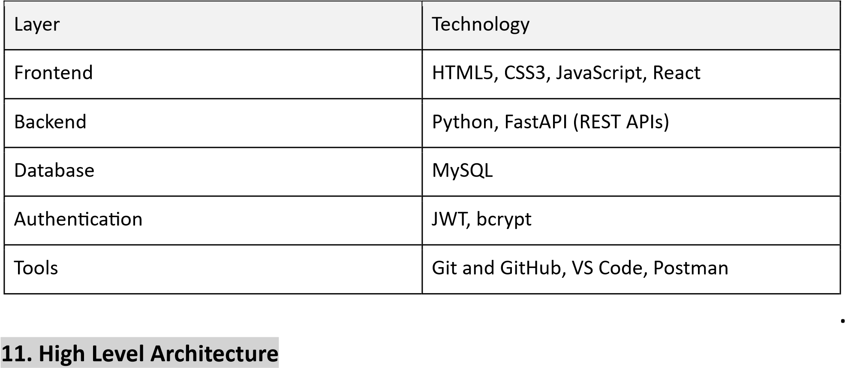

11. Major Modules .
- Authentication and User Management
- Product and Category Management
- Search and Filter
- Cart and Wishlist
- Checkout and Payment
- Order Management
- Reviews and Ratings
- Seller Panel
- Admin Panel

12. Future Enhancement .
- Real payment gateway integration (Razorpay or Stripe)
- Coupons and discounts
- Mobile Responsive
- Delivery partner integration and live tracking

13. Return and Refund .

Return Policy
- Only delivered items can be returned.
- A return must be requested within 5 days of delivery.
- Each item can be returned once.
- The customer must give a reason for the return.
- The seller approves the request, or rejects it and gives a reason.
- After approval, the customer sends the item back to the seller.
- Returned items go back into stock.
- Before an order ships, the customer cancels it instead of returning it.

Refund Policy
- The refund is made only after the seller marks the returned item received.
- The refund amount is the item price plus its tax. The delivery charge is not refunded.
- For online payments, the refund is simulated, because payments are test-only.
- For Cash on Delivery, the refund is recorded as owed, because no money was paid online.
- An order cancelled before it ships needs no refund, because no payment is due.

13. Business process flow .
The complete overview of the software application in the form of flowchart that represents how the application will work and how user and seller will interact with the application, how the orders will be fulfilled, how the refund and return will be happen and how the admin will use the application.

1. Customer Purchase
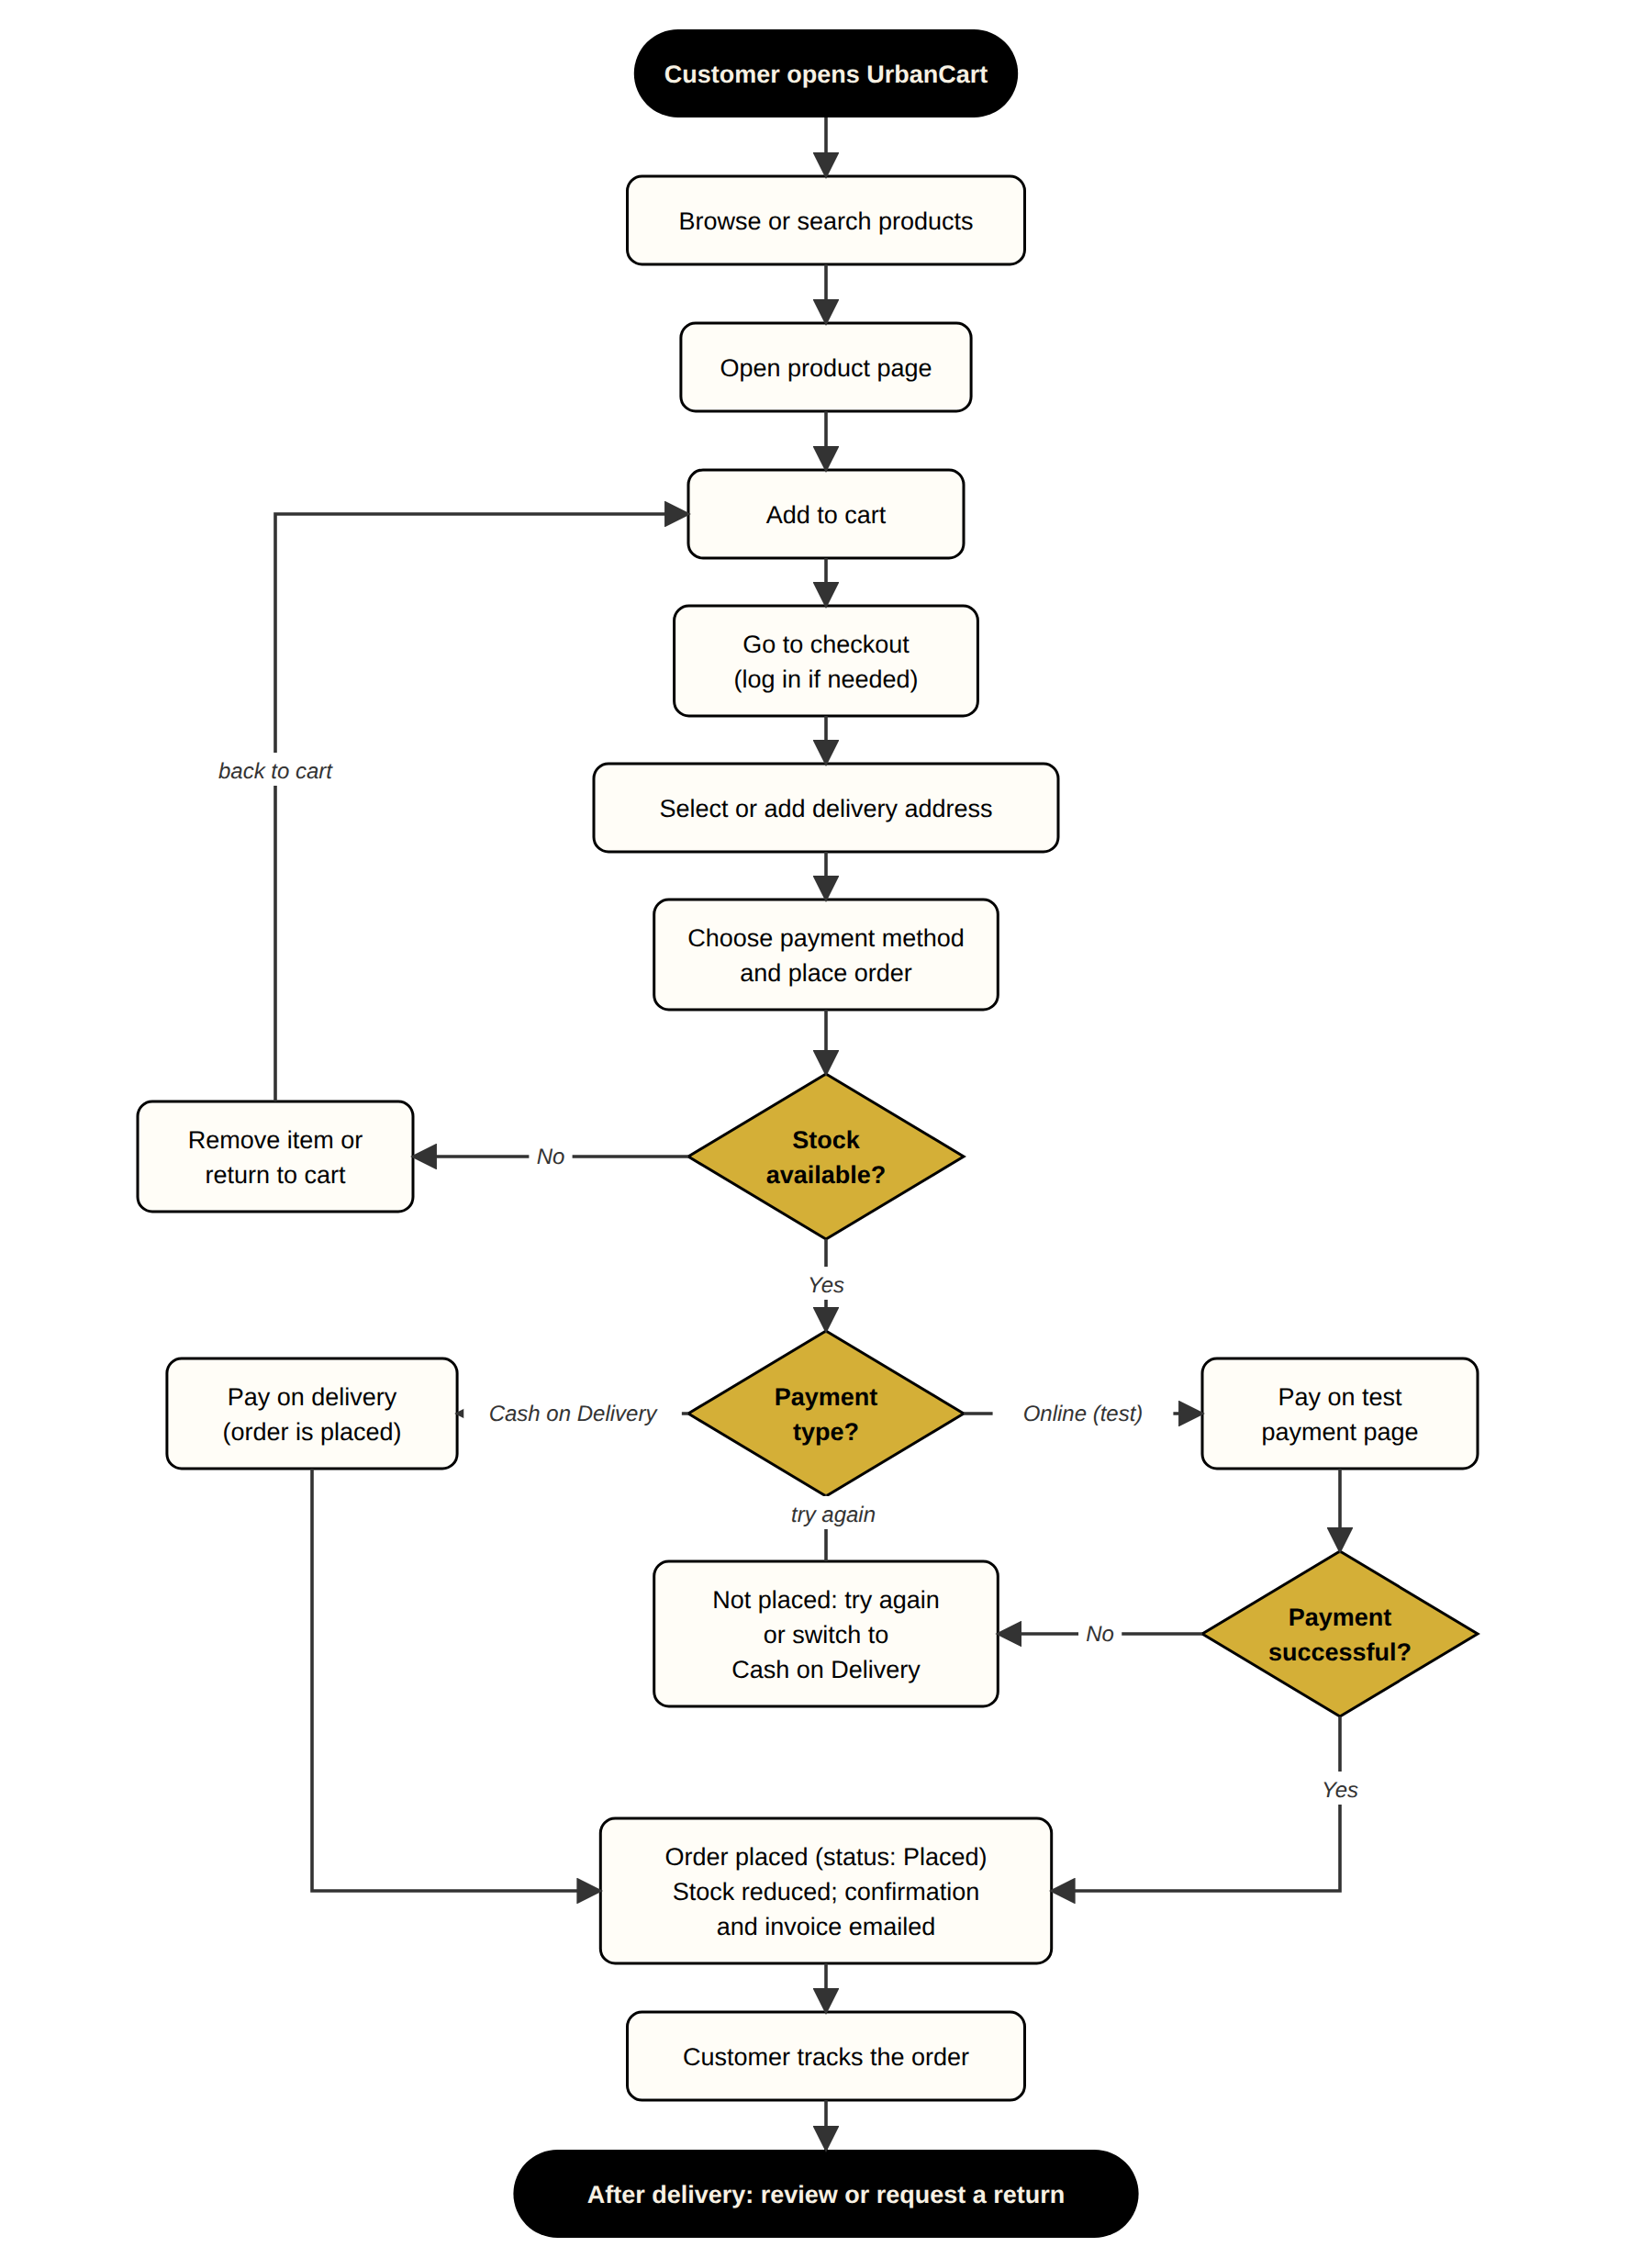
2. Seller Onboarding
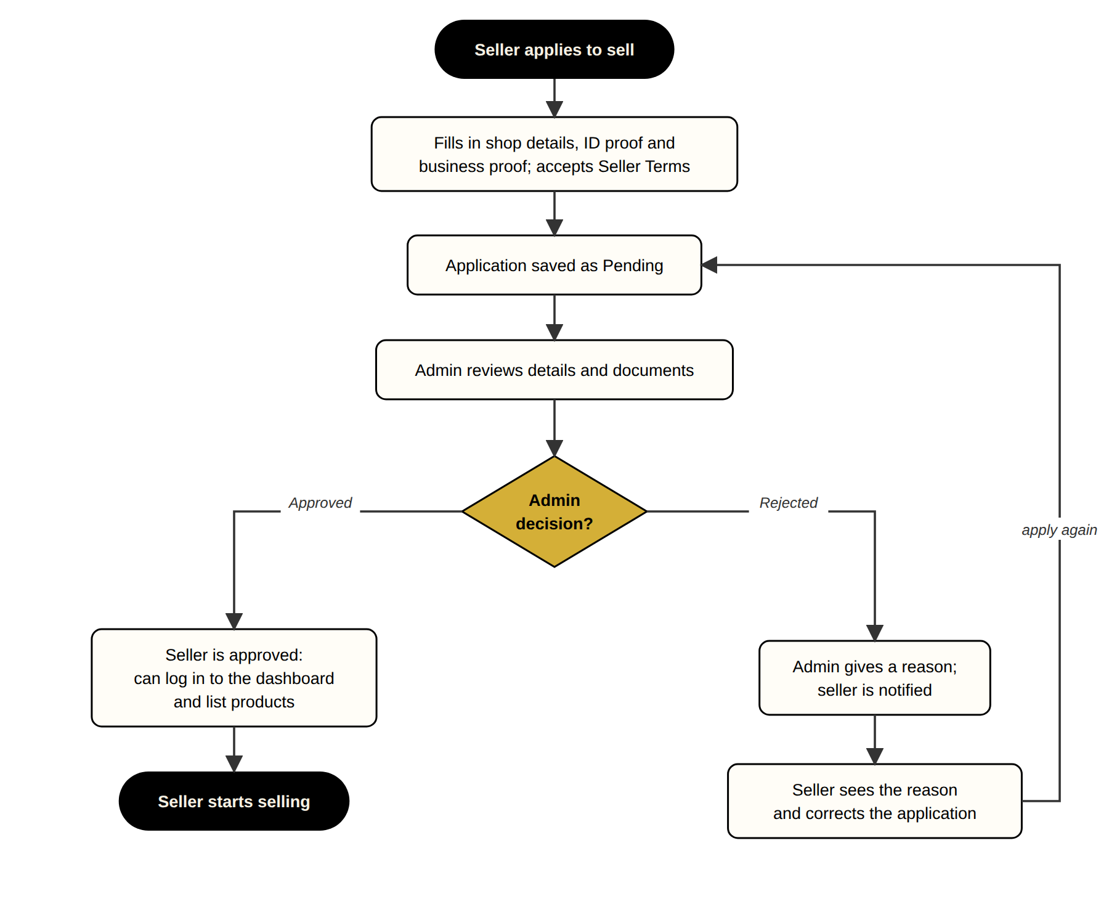

3. Admin

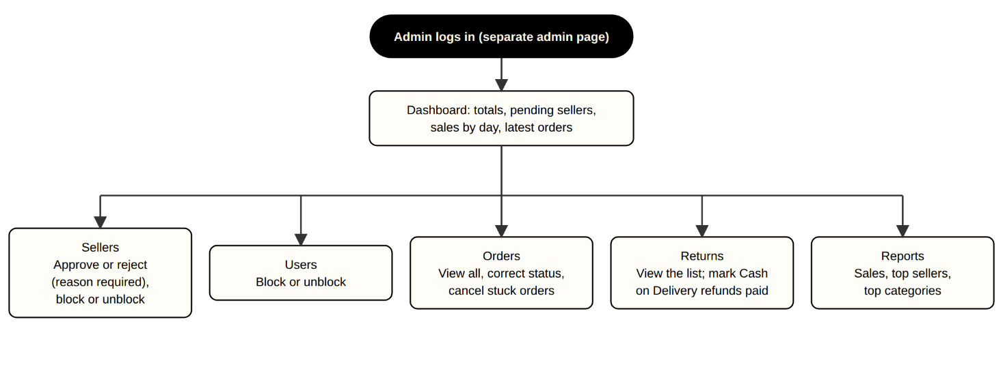

4.Order Fulfilment

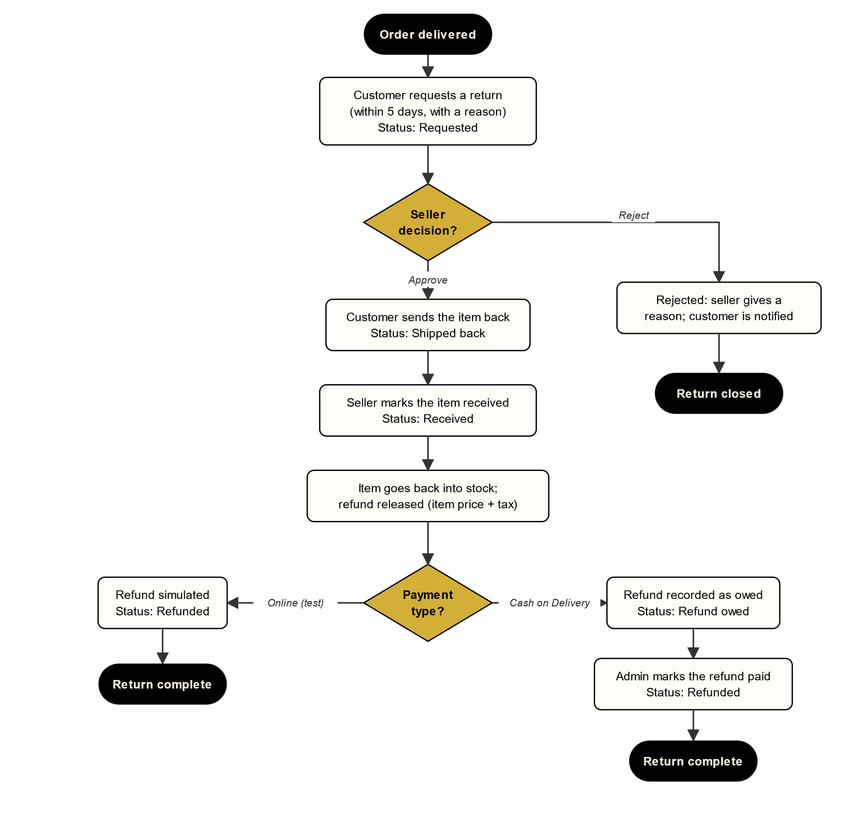

5. Return and Refund

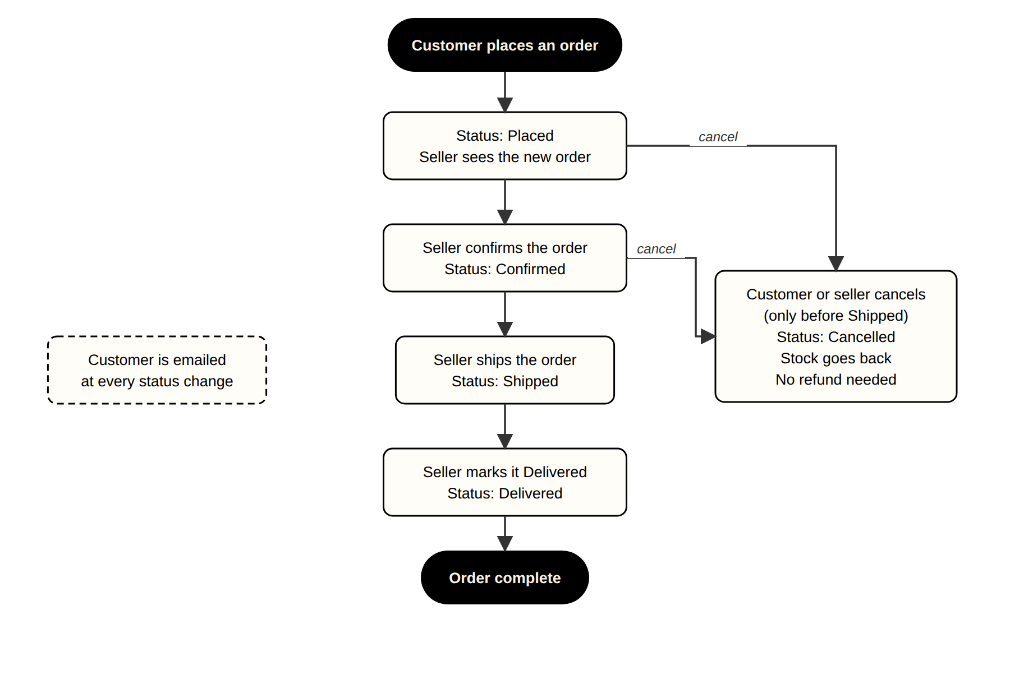

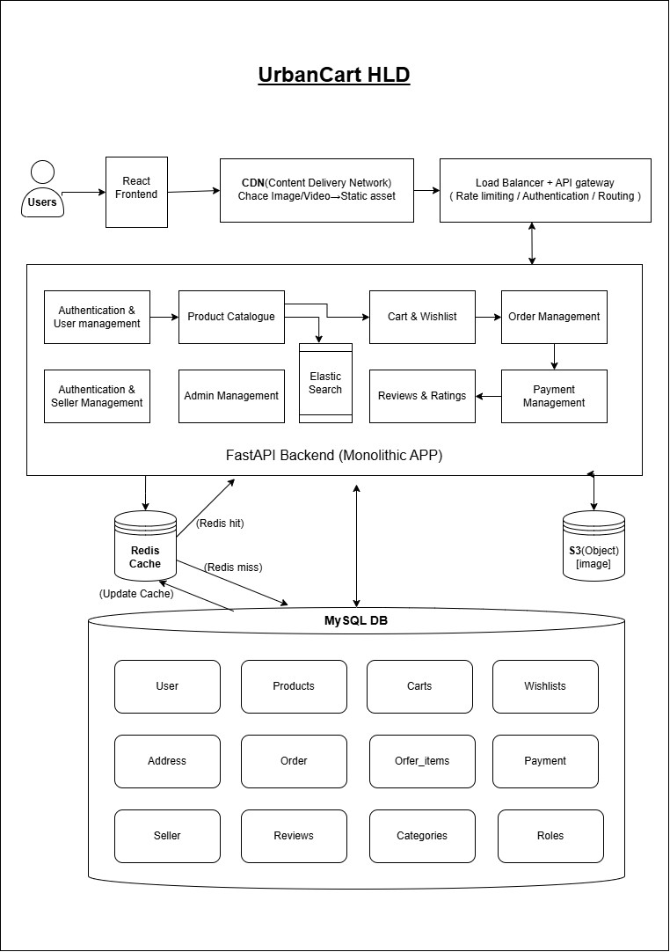

High Level Design

3.ER Diagram
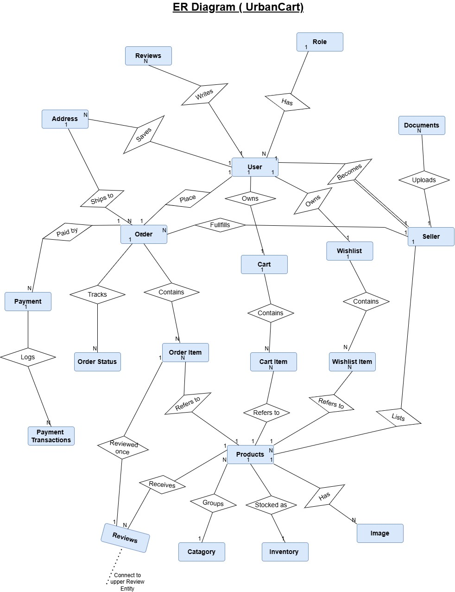
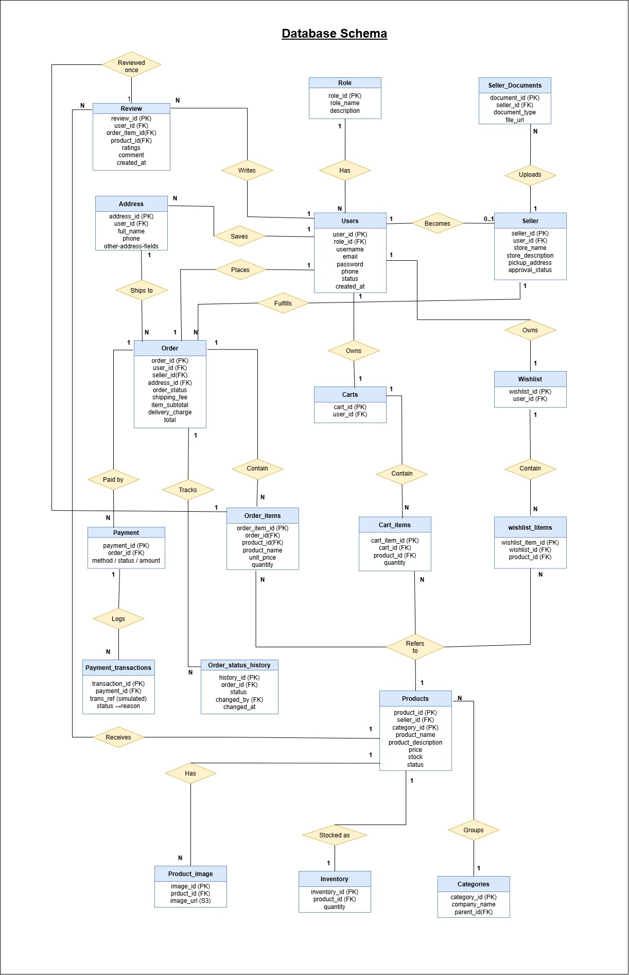

4. Some UI Demo

This is the login page customer and seller have different login section.
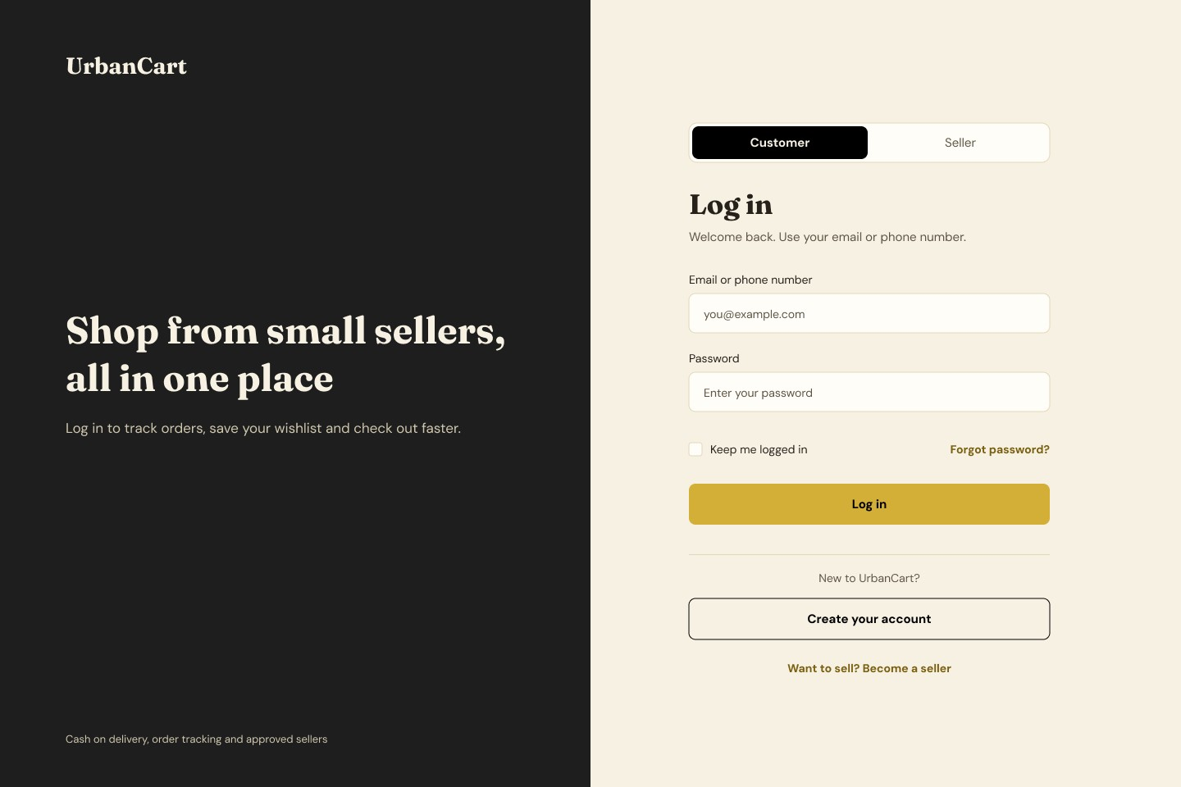

The below is the home page.
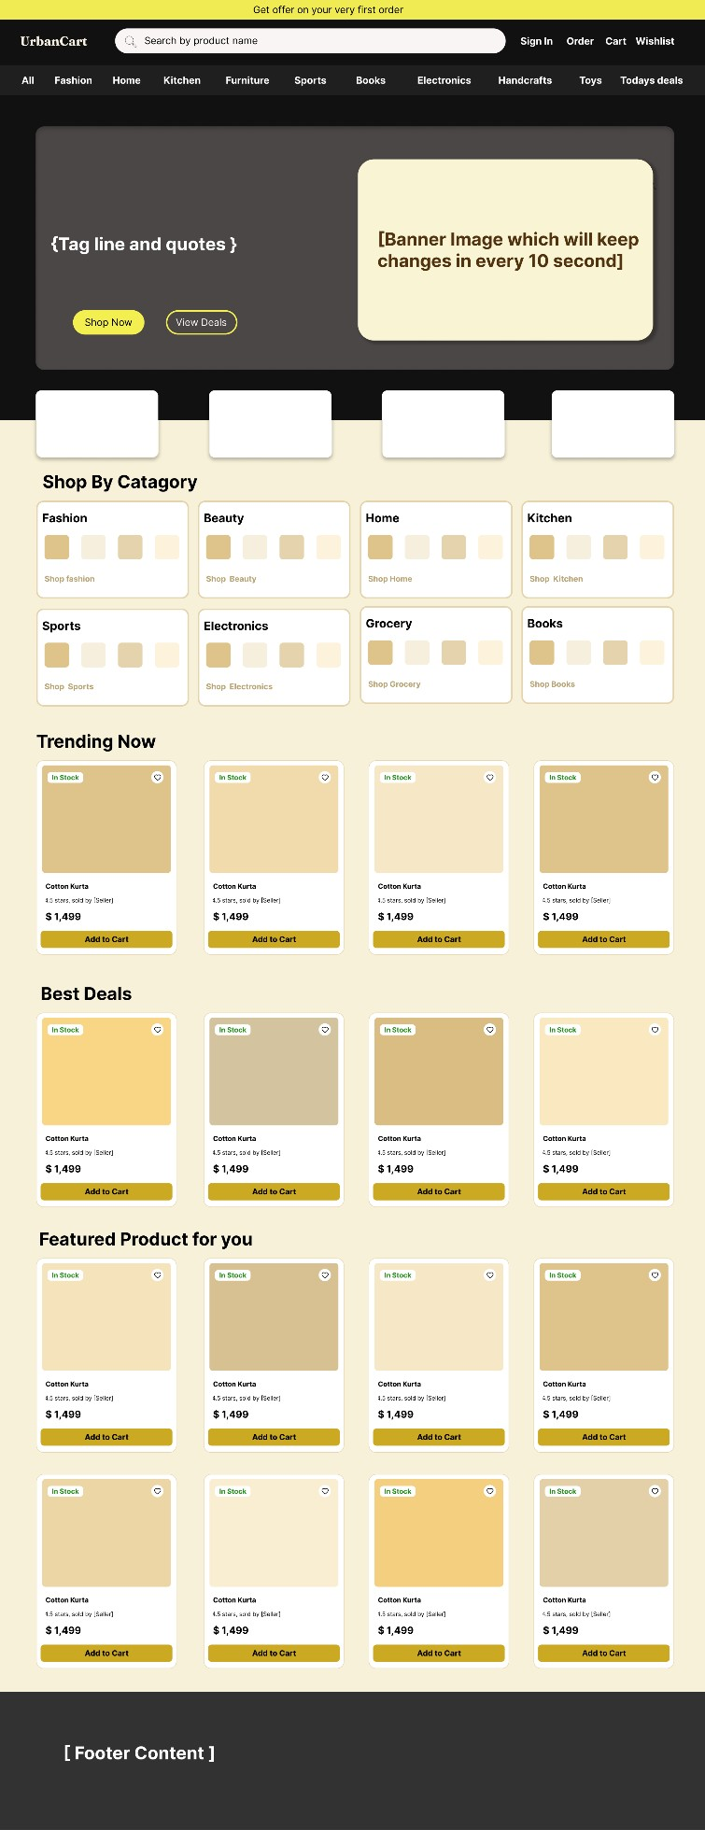

Specific Product section

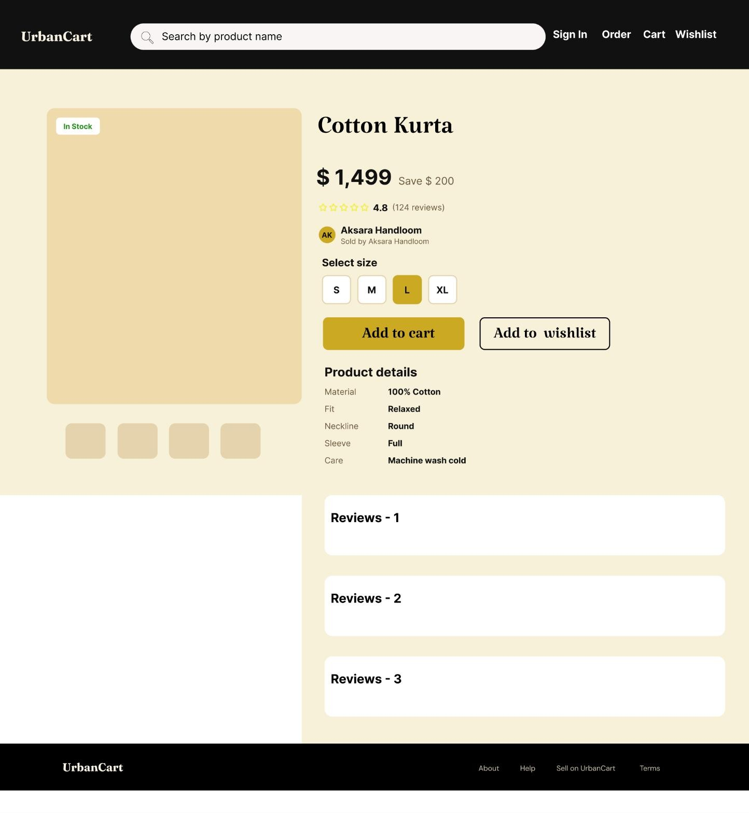

The checkout section

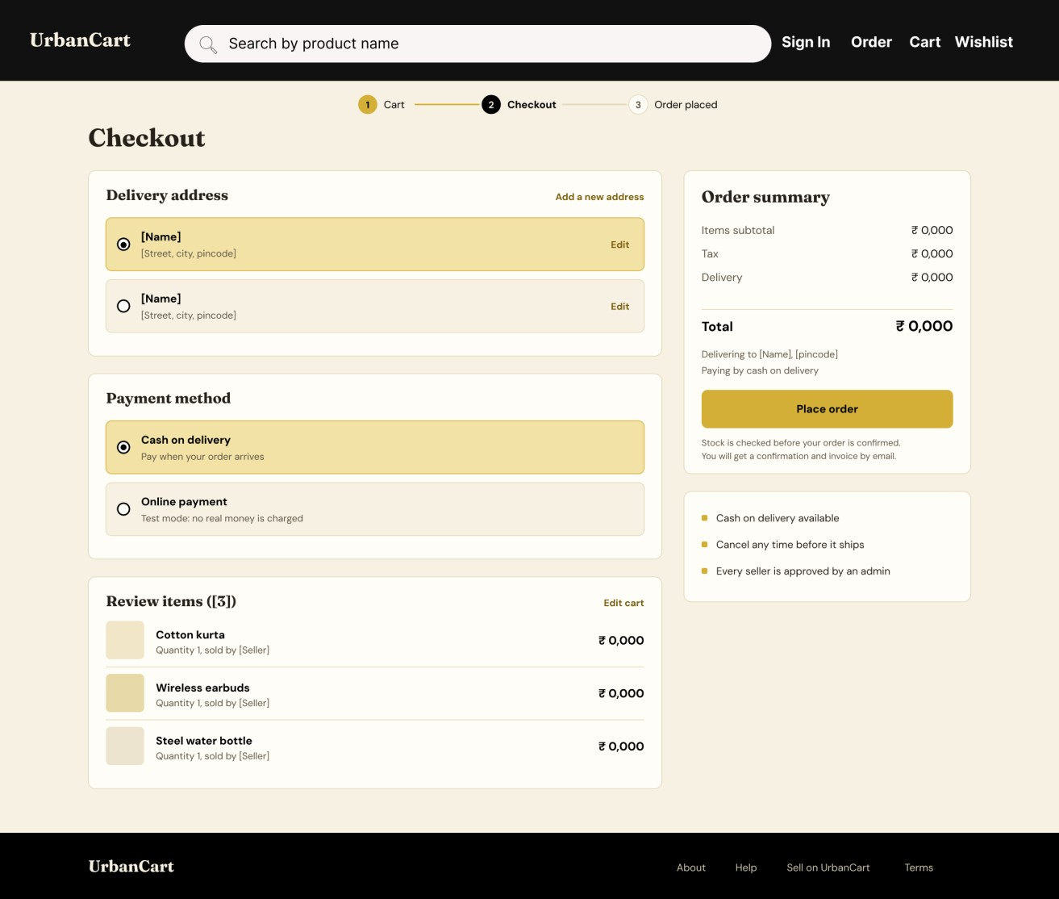

Product section (Seller)

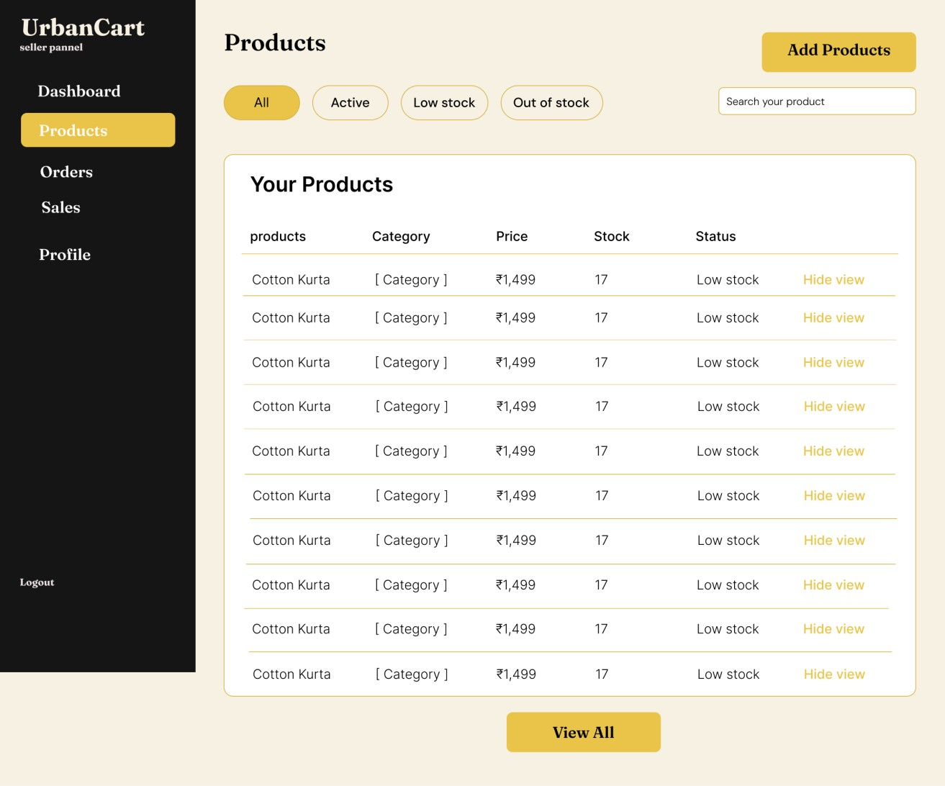

Overall order section(seller)

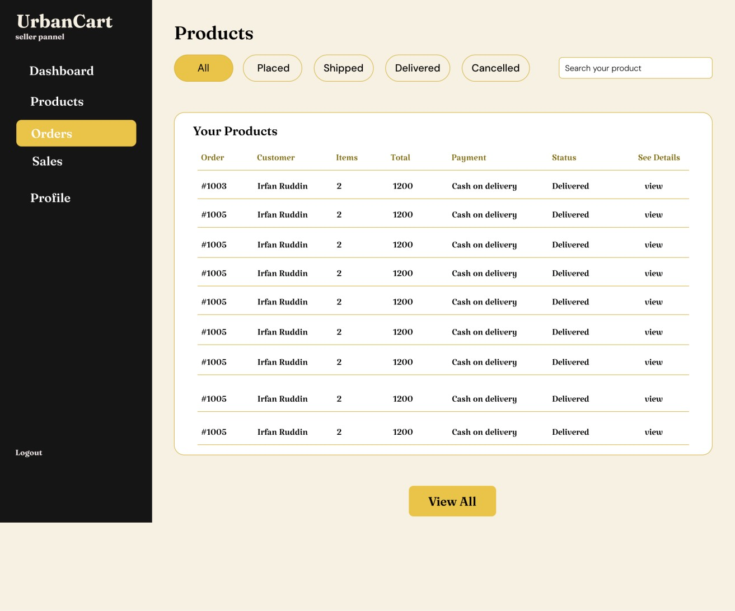

Specific user’s order(seller)

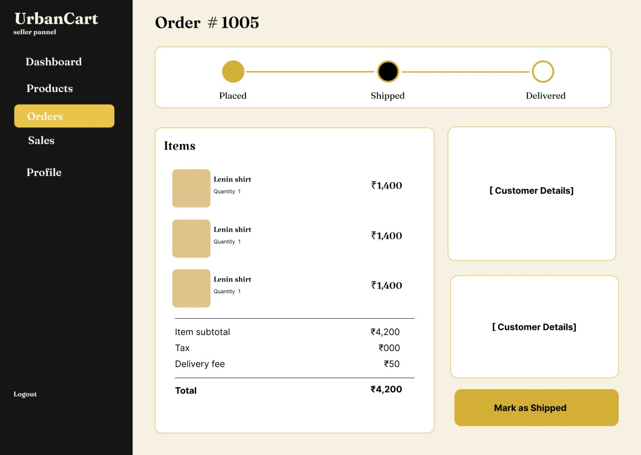

API Endpoint |  | Met hod | Description
/api/v1/auth/register | POST |  | Create a customer account with name,  email, phone and password.
/api/v1/auth/verify-email | POST |  | verify customer login email
/api/v1/auth/verify-email/resend | POST |  | resend the verification link
/api/v1/auth/login | POST |  | Log in as customer or seller. The choice is sent in the body.
/api/v1/auth/admin/login | POST |  | Log in as an administrator on the separate admin page.
/api/v1/auth/logout | POST |  | End the current session.
/api/v1/auth/me | GET |  | Return who is logged in: role and, for sellers, approval status.
/api/v1/auth/refresh | POST |  | Issue a new access token from a valid refresh token.
/api/v1/auth/password/forgot | POST |  | Email a reset link. Also used by Resend link.
/api/v1/auth/password/reset | POST |  | Set a new password using the emailed token.
/api/v1/auth/password/change | POST |  | Change password for the logged-in account.
/api/v1/users/me | GET |  | Return my profile.
/api/v1/users/me | PATCH |  | Update name, phone and other profile details.
/api/v1/users/me/addresses | GET |  | List my saved delivery addresses.
/api/v1/users/me/addresses | POST |  | Add a new address (from checkout or Saved addresses).
/api/v1/users/me/addresses/{address_id} | PUT |  | Edit a saved address.
/api/v1/users/me/addresses/{address_id} | DELETE |  | Remove a saved address.
/api/v1/users/me/addresses/  {address_id}/default | PUT |  | Make an address the default.
/api/v1/home | GET |  | Banner images, offer cards, trending, best deals and featured products.
/api/v1/categories | GET |  | Fixed list of categories with sub-categories.
/api/v1/products | GET |  | list products
/api/v1/products?q=&category=  &sort=&limit=&page=&  maxprice=&minprice | GET |  | Product list. Query: category, sub, q, min_price, max_price, rating, in_stock, sort, page, limit.
/api/v1/products/{product_id} | GET |  | Images, price, description, stock status, shop name and ratings.
/api/v1/products/{product_id}/reviews | GET |  | Reviews and avg rating for a product.
/api/v1/products/{product_id}  /reviews/{review_id} | PUT |  | Edit your own Review
/api/v1/products/{product_id}  /reviews/{review_id} | DELETE |  | Remove your Own review
/api/v1/delivery/check?pincode= | GET |  | Check whether delivery is available for a pincode.
/api/v1/cart | GET |  | Return my cart with item totals, tax and grand total.
/api/v1/cart/items | POST |  | Add a product to the cart.
/api/v1/cart/items/{item_id} | PUT |  | Change an item quantity.
/api/v1/cart/items/{item_id} | DELETE |  | Remove an item from the cart.
/api/v1/cart/items/{item_id}  /move-to-wishlist | POST |  | Move an item from cart to wishlist.
/api/v1/wishlist | GET |  | List my wishlist products.
/api/v1/wishlist/{product_id} | POST |  | Save a product (the heart).
/api/v1/wishlist/{product_id} | DELETE |  | Remove a product from the wishlist.
/api/v1/wishlist/{product_id}  /move-to-cart | POST |  | Move one wishlist product to cart.
/api/v1/wishlist/actions  /move-all-to-cart | POST |  | Move every wishlist product to cart.
/api/v1/checkout/validate | POST |  | Check stock and totals before placing the order; return unavailable items.
/api/v1/orders | POST |  | Place the order with address_id and payment_method
/api/v1/payments/{order_id}/test-pay | POST |  | Simulated online payment for an order; returns success or failed.
/api/v1/orders/{order_id}/invoice | GET |  | Download the invoice for an order.
/api/v1/orders | GET |  | My orders. Filter by status; search by order number.
/api/v1/orders/{order_id} | GET |  | Order detail with the status timeline (Track order).
/api/v1/orders/{order_id}/cancel | POST |  | Cancel before it ships, with an optional reason.
/api/v1/orders/{order_id}/return | POST |  | Customer can return once they received the order
/api/v1/products/{product_id}/reviews | POST |  | Post a rating, optional title and review text.
/api/v1/seller/apply | POST |  | Submit the seller application with documents.
/api/v1/seller/application | GET |  | Application status and the admin reason (pending  and rejected pages).
/api/v1/seller/application | PUT |  | Update and resubmit a rejected application.
/api/v1/seller/dashboard | GET |  | Active products, orders to process, month sales.
/api/v1/seller/products | GET |  | My products. Query: status (active, low, out), q.
/api/v1/seller/products | POST |  | Add a product with images.
/api/v1/seller/products/  {product_id}/images | POST |  | add the product image
/api/v1/seller/products/  {product_id}/images/{image_id} | DELETE |  | can remone any image of the product
/api/v1/seller/products/{product_id} | GET |  | One product, to fill the edit form.
/api/v1/seller/products/{product_id} | PUT |  | Edit a product.
/api/v1/seller/products/{product_id}  /visibility | PATCH |  | Hide or show a product without deleting it.
/api/v1/seller/orders | GET |  | Orders for my products. Query: status, q.
/api/v1/seller/orders/{order_id} | GET |  | Order detail with customer name, phone, address and payment type.
/api/v1/seller/orders/{order_id}/status | PATCH |  | Move to the next step: Confirmed, Shipped or Delivered.
/api/v1/seller/orders/{order_id}/cancel | POST |  | Cancel an order before it ships.
/api/v1/seller/sales?period= | GET |  | Sales summary, chart and best sellers. Period: 7d, 30d, year.
/api/v1/seller/profile | GET |  | Shop profile and approval status.
/api/v1/seller/profile | PUT |  | Edit shop name, description, pickup address and details.
/api/v1/seller/profile/logo | POST |  | Upload or change the shop logo.
/api/v1/admin/dashboard | GET |  | Totals, pending applications, sales by day, latest orders.
/api/v1/admin/users | GET |  | List customers. Query: status, q, page.
/api/v1/admin/users/{user_id}/status | PATCH |  | Block or unblock a customer.
/api/v1/admin/sellers | GET |  | List sellers. Query: status (pending, approved, blocked), q.
/api/v1/admin/sellers/{seller_id} | GET |  | Application details and document list.
/api/v1/admin/sellers/{seller_id}  /documents/{document_id} | GET |  | Open an uploaded ID or business proof.
/api/v1/admin/sellers/{seller_id}/approve | PATCH |  | Approve a seller application.
/api/v1/admin/sellers/{seller_id}/reject | PATCH |  | Reject a seller application. The body must include a reason.
/api/v1/admin/sellers/{seller_id}/status | PATCH |  | Block or unblock a seller; blocked seller products are hidden.
/api/v1/admin/orders | GET |  | All orders. Query: status, q, page.
/api/v1/admin/orders/{order_id} | GET |  | Order detail with seller and customer.
/api/v1/admin/orders/{order_id}/status | PATCH |  | Change an order status.
/api/v1/admin/orders/{order_id}/cancel | POST |  | Cancel a stuck or disputed order.
/api/v1/admin/reports?period= | GET |  | Sales by month, top sellers, top categories.

