User:
- User can register and log in
- Role based access. After register user saved to database.
- User can update their profile.
Assigning supervisor:
- There will be a page where supervisor can see the students who are under him. And student can see who their supervisor is. And there will be a head supervisor (can see the list of available supervisors and student) who will assign supervisors to students and then the assigned supervisors can see their students who are under control.
- Head supervisor can also reassign.
- Head supervisor can see all the student’s details, means there will be a page where all the student’s details will be available and there will be a search option where head supervisor can search by student id and get the student then can see the details.
- In application section there will be the details of the application or proposal(head supervisor section)
- Head supervisor can edit the progress list means he can add more check list items.

Search Project:
- The projects load from the database
- Can see the project details by clicking details button
- Student or supervisor can search the projects (Title).
Apply for a Project:
- Supervisor can create a project by filling necessary data and post it.
- Only student can apply for the available project once.
- Supervisor can check who applied for the project based on student id and details
- If same student applies more than once in a particular project, it will pop up a message “Already applied”
- One project can be chosen by only one student. If one user applies for this project, then other cannot apply need to choose another project.
- If supervisor try to apply it will show “Only student can apply”
- Without sign in or registration no one can apply for a project
- If supervisor accept the project, then the project remains booked. But if the project is rejected then it will again be available to the student
- If the project is rejected by the supervisor, then the supervisor needs to mention in field that why he rejects the project and this message will display in student dashboard action section.
- Student can only apply those projects that are posted by their assigned supervisor.
- They can apply for normal projects that are posted by their assigned supervisor and they need to fill up some fields before applying.
My posts:
- This feature only for supervisors. They can see their own posted projects. Can edit their post and delete. This also delete the corresponding application.
Post necessary documents:
- A dedicated page called Activity, there supervisor can upload necessary documents. And this same page will be different for students they can download those posted documents and submit necessary documents after completion.
Status Check:
- Students apply for a project. It will go to the supervisor, and they would update the status of the project if they interested.
- Updated status will appear in student dashboard as well.
Apply for own project:
- If student not interested to the posted projects, then they can create an application by filling project details and send it to supervisor. Then rest will be same.
- Student can edit their own proposal.
Project uniqueness test:
- A page where past completed projects stored. Then supervisor check the student proposal uniqueness by searching the proposals project title.
Activities:
- In activity page there will be option to make sections. For supervisor they can make activity (sections with section title then subsection like hierarchical. Section and subsection can be editable by supervisor only. Supervisors use sections for different purpose one section can use for only upload files and edit them and student can download the files. Then other section for submission, where student can see submission and submit.
- In Activity page it will be different for different supervisors. One supervisor can’t see other supervisor’s activities and tasks and submissions. And students can only see their assigned supervisors’ activities and task and submit to them only.
- Student can see their submission and can resubmit.

Progress Tracking:
- After student application accepted, in student side there will be a page named update your progress. Where there will be two sections, one for IP1 and another IP2.

In IP1 there will be updating fields like students need to update each task that they have finished like they need to check the boxes that they finished and the check boxes will be,
- Project Title
- Background
- Problem Statement
- Aims
- Objectives
- Justification
- Scope
- Approach and Deliverables
- Major Milestone with Gantt chart
- Constraints and Assumptions
- Resources
- External Bodies Involved
- Project Plan
- References (At least 3 related journals papers printed and attached)
For IP2 check boxes will be,
- UI/UX design done
- Backend logic and Database setup finished
- Backend APIs working properly
- Frontend connection with backend done
- Report writing Started
- Report writing done

And all these updates from the student will appear in supervisor side in new page called “Student Progress”. Where supervisor can see their assigned students progress like what they have done.

Announcement:
- Supervisors can post an announcement.

To be done
- Once the project is completed means all the list items of Ip1 and IP2 done then, in supervisor side in student progress page there will be a button called send completion form to student. And then this form will appear by clicking on submit project completion form in student sides “update your progress” page. The form fields will include the details that are shown in the picture. And student need to fill up those information and then click submit then the details will saved in completed projects collection and supervisor can see the project details in completed projects page
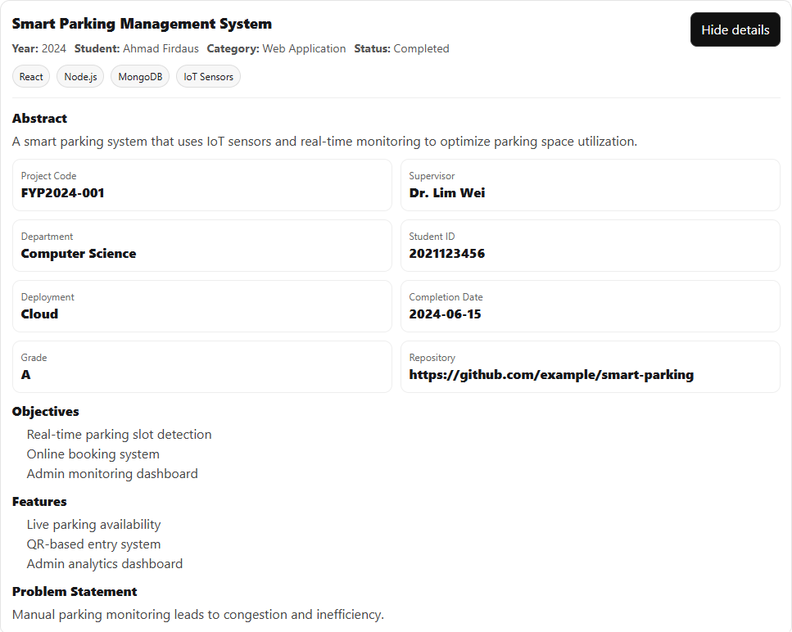

- For head supervisor the navbar will be different. The pages will be browsing projects, list of students, list of supervisors

