

Institute of Computer Science and Digital Innovation
Undergraduate Degree programme

B.Sc. (Hons.)

Computing

CC313/CC314
Project Formulation/
Project Design & Implementation

Student Weekly Logbook
Student Name: Hasna E Noor Rahman Irfan
Student ID: 1002370486
Academic Year: Year 3

Project Title: Final Year Project Management System (FYP portal)
Supervisor: Dr. Saleh Abdulalem Ali Mohammed
Supervisor email & telephone number: salehabdulalem@ucsiuniversity.edu.my
Second Marker: Dr. Ismail
Second Marker email & telephone number:

The Weekly Log Form
This form must be presented and signed at each meeting with the supervisor.
Meetings with the supervisor should be on a weekly basis. Generally such meetings will be a maximum of one hour in duration. Depending on progress they may be shorter. They must take place so that the supervisor can assess your progress.

Prior to each meeting you must complete the first 3 sections of the form:
Date and Time of Meeting
Brief description of work done since last meeting Number of hours spent on project since last meeting.

The other parts of the form must be completed at the meeting. After completing the form it must be signed by both parties.

Note:
The categories for progress are defined as:

very poor | no progress has been made on the project
Poor | very little of the work agreed has been undertaken  that which has been done is of a low quality
Satisfactory | the agreed work has been carried out but no further work attempted  the work is of a satisfactory standard
Good | the agreed work has been carried out and is of above satisfactory in quality or  the agreed work plus further work has been achieved all the work is of a satisfactory standard
very good | Far more than the agreed work has been carried out and all the work is of exceptional quality

Weekly Log: Week no. 3

Meeting Date |  |  | 9/2/2025
Meeting Time |  |  | 3pm-4pm
Brief description of work done since last meeting
This is the first meeting for IP2,
In this meeting I delivered my design of the system. Menas how the system looks like.

Number of hours spent on project since last meeting
Progress since last meeting |  | very poor |  | poor | satisfactory | good |  | very good
Agreed tasks for next meeting
- Start backend logic first, after finishing the design

Any other issues
None
Date and time of next meeting |  |  | 16/2/2025
Student signature | 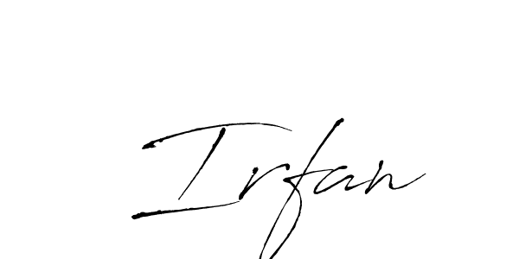
Supervisor signature

