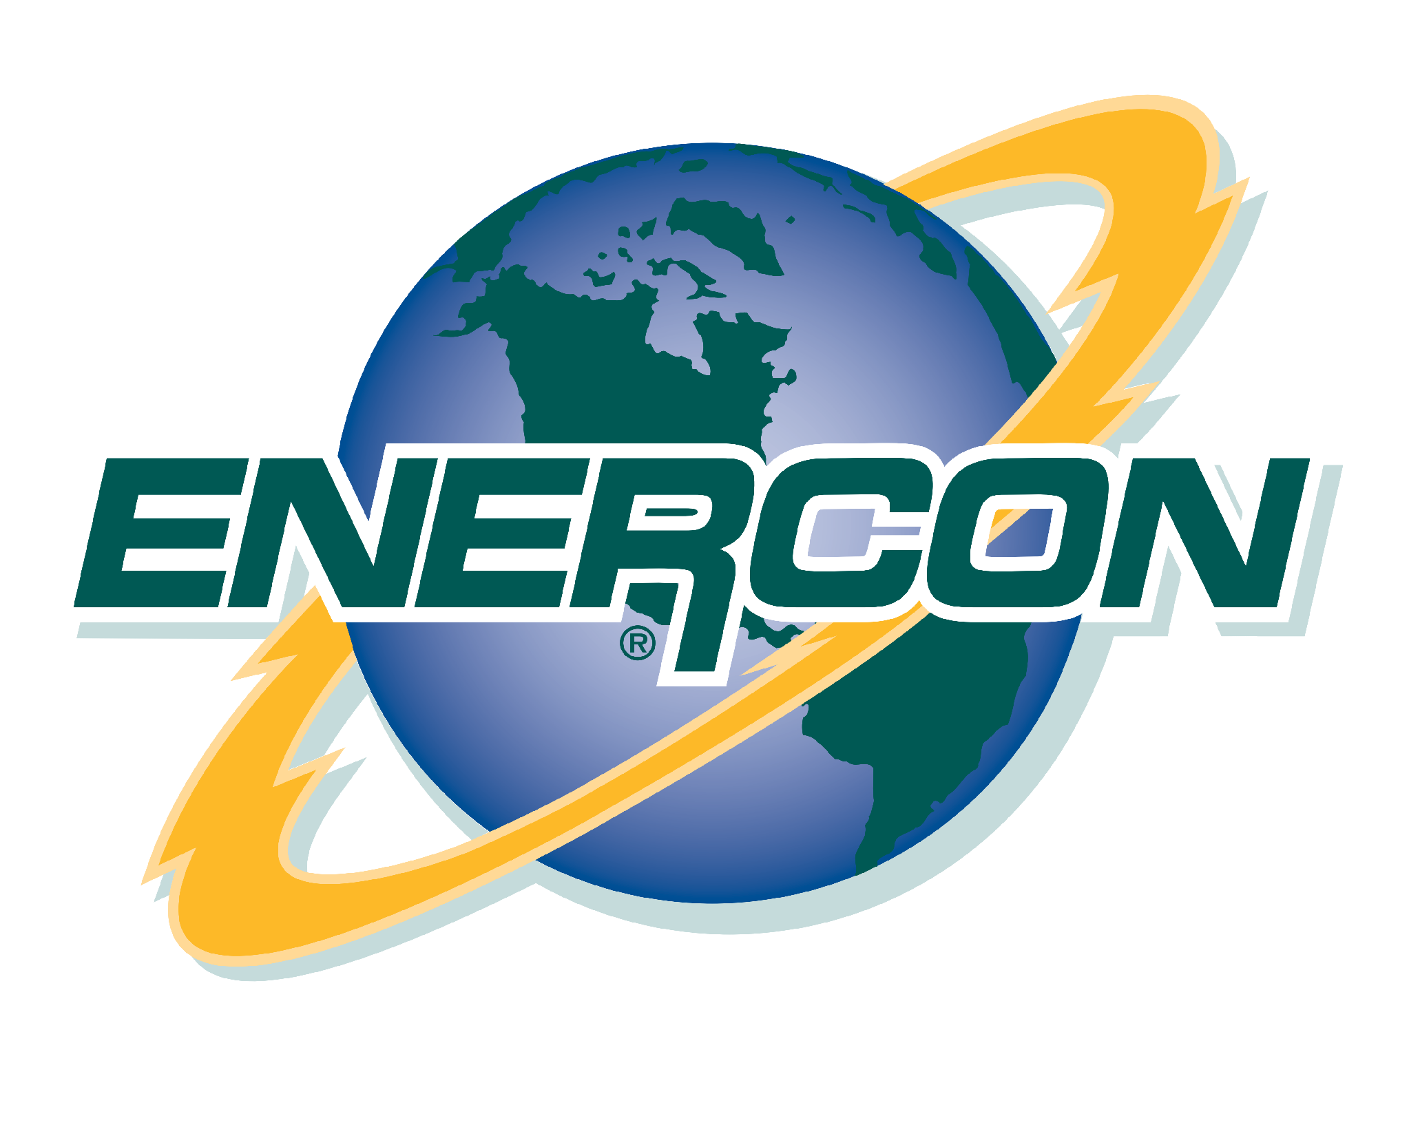
PT ENERCON POWER INDONESIA
Alamanda Tower, Unit A Lt. 22
Jl. TB Simatupang Kav. 23-24, Jakarta Selatan 12430
E-mail: sales@enercon.id

Date: {{date}}

To: {{customer_name}}
Attn: {{pic_name}}

Ref: {{pipeline_name}}
Enercon Quote : {{no_quote}}

Dear {{pic_name}},

Thank you very much for the opportunity to provide Enercon products and services. We are pleased to quote you the following:

QTY | DESCRIPTION | UNIT PRICE | TOTAL PRICE
TOTAL

Price is valid for {{price_validity_days}}. Tax excluded.
Delivery shall be {{delivery_weeks}} after purchase order
Payment Terms:
- {{payment_terms}}
As always, should you need further clarification, please do not hesitate to contact us.

Sincerely,
{{sales_name}}
PT ENERCON POWER INDONESIA

CLARIFICATIONS:
PT Enercon Power Indonesia’s Terms and Condition of Sale
- CONTRACT OF SALE: Enercon Engineering, Inc. (hereinafter called “Seller”) agrees to sell, and buyer agrees to purchase, the equipment described in this Proposal/ [Confirmation] [Invoice] pursuant to these terms and conditions, which shall constitute the entire contract of sale between buyer and seller. These terms and conditions supersede and take precedence over any and all terms, including, but not limited to, any contrary terms, in any documents (such as purchase orders) submitted by buyer to seller.
- ORDERS: Orders are subject to acceptance at home office of Seller.
- PRICES: Unless otherwise specified in writing, all prices are F.O.B. Seller’s plant, and all quotations automatically expire sixty (60) calendar days from date of issue unless communicated differently by the Seller. The price of any equipment scheduled for shipment on a date beyond a period of six (6) months from date of Seller’s order confirmation is subject to increase by Seller, unless otherwise agreed to in writing. All equipment will be suitably packed for domestic shipment, not suitable for long term storage, unless otherwise agreed to in writing.
- TERMS: Payment in IDR with normal payment terms are net cash thirty days from date of invoice. Payment schedule: follow as stated above in the quotation details.
- SHIPPING DATE: Seller shall not be responsible for any default or delay in shipping due to contingencies beyond its control, or the control of its suppliers, which prevents or interferes with Seller making delivery on the date specified, including but not limited to wars, or restraints affecting shipping, delivery of materials or credit as a result of strikes, lockouts, fires, floods, or any other contingency affecting the seller or its suppliers. The Seller shall have the right to cancel a contract of sale or to extend the shipping date in the event that any such contingencies prevent or delay shipments. Seller shall not be liable for any losses incurred by late delivery of equipment. Equipment held by Seller beyond scheduled delivery date for convenience of buyer will be invoiced on date of completion. Such equipment will be subject to charges for warehousing and other expenses incident to such delay.
DELAYS: In the event Buyer causes Seller to delay engineering, manufacturing, shipping, installation, or startup of equipment under this proposal, any additional costs incurred by the Seller shall be reimbursed by the Buyer. Seller shall not be responsible for delays in delivery caused by acts of God, government rulings, strikes, accidents, delays or default of Seller’s suppliers, delays caused by acts of the Buyer, or other causes outside of Seller’s reasonable control. Should the Buyer require the Seller to delay engineering, manufacturing, shipping, installation or startup by more than thirty (30) days, then Seller shall invoice the Buyer for a total of one hundred percent (100%) of the value of all work completed, and such invoice shall be due and payable net (15) fifteen days.
- ENERCON DESIGN: The design information contained herein is propriety and the sole property of Enercon Engineering, Inc. The pricing and equipment selections in this proposal are based on the interpretation of the information supplied to Enercon Engineering, Inc. The proposal is complete as presented herein. Any changes deviations or additions to the bill of materials as listed will require an adjustment to the price, and may require additional engineering and may adversely effect the delivery date. All software programs for PLC or touch screen are the Seller’s intellectual property. Should the project drawings or programs be amended by others without Enercon’s consent during the warranty period, Enercon will not be responsible for any mis-operations or damage caused by unauthorized changes.
- CHANGES: Should Seller make any changes at the request of the Buyer, or should changes in site conditions or installation requirements occur subsequent to this proposal, the parties shall re-negotiate the price and the time schedules quoted herein to reflect cost or schedule adjustments caused by said changes. Seller shall not be obligated to perform work on any changes without written agreement from the Buyer.
- CONFIDENTIALITY: Buyer shall keep confidential all prices, drawings, and technical information disclosed by the Seller as part of, or in conjunction with, this proposal or any resulting contract, including, but not limited to, information relating to the design, installation, materials of construction, operation repair, maintenance, or otherwise of the equipment or component parts thereof or other related items. Buyer may disclose said drawings and documents only to its authorized employees or contractors who agree to the terms of this paragraph and who agree not to use said information except for the installation, operation, and maintenance of the equipment for the Buyer only. Buyer shall return to Enercon Engineering all drawings and information, including that given to others by Buyer when contract is completed. Buyer shall return to Enercon Engineering all drawings and information, including that given to others by Buyer, if the job is not awarded to Enercon Engineering. This paragraph does not limit Buyer’s right to use this information if it is obtained from another source without restriction.
- INSTALLATION: Enercon Engineering, Inc shall not be responsible for any field installation. If after commissioning field service is required, please use our quoted per week rate. Pricing is based on complete electrical and mechanical integration performed by Enercon Engineering, Inc.
- CANCELLATION: Orders are not subject to cancellations or change in specifications, shipping schedules or other conditions originally agreed upon without Seller’s written consent, and then only upon agreement to compensate Seller for expenses incurred by such cancellation or changes. Cancellation schedule shall be as follows: 10% - Order received and entered on factory, work not started, material not ordered. 30% - Drawings for approval submitted. 60% - Approved drawings returned. Job released for manufacture. 80% - Material accumulated and production started. 100%- Manufacturing completed.
- TAXES: Any excise tax, sales tax, other taxes, or duty of any nature arising out of or assessed against equipment or orders shall be the sole and exclusive responsibility of buyer and shall be added to the prices quoted or invoiced and shall in all circumstances be paid by the buyer.
- INSURANCE AND RISK OF LOSS: The equipment manufactured by Enercon shall at all times after delivery to buyer, buyer’s agent or transportation company, whichever occurs first, be the sole responsibility of the buyer, and all loss or damage to said equipment or any part thereof shall be borne by the buyer (even if Seller has arranged for transportation), unless otherwise agreed in writing. Any equipment not manufactured by Enercon which is delivered by buyer or buyer’s agent to Enercon shall be the sole and exclusive responsibility of buyer. Buyer must maintain insurance on any such equipment delivered to Seller.
- LIMITED WARRANTY: Equipment manufactured by Enercon is warranted to be free from defects in material and workmanship under normal use, service, and indoor storage, for twelve (12) months after date of startup or eighteen (18) months after date of shipment from Seller’s plant, whichever occurs first, subject to the following provisions. This warranty is limited to repair, replacement or issuing of credit, as Seller may elect, and at Seller’s manufacturing plant, of such parts as shall appear to Seller, upon inspection, to have been defective in material or workmanship, but does not include any installation, labor or transportation costs. All warranty parts requests will require a Purchase Order. After evaluation, if deemed to be covered under warranty, the PO will not be charged. This warranty does not apply to normal maintenance or normal replacement of serviceable items. No warranty is made with respect to items manufactured by others. Seller shall in no event be liable for any special or consequential damages. Misapplication or revisions of equipment, without written approval by Enercon, will void the limited warranty. Replacement parts shall be warranted for six (6) months from date of shipment, subject to the terms and conditions as stated above for manufactured equipment. When the equipment reaches its final destination, the buyer must promptly notify the carrier of any damage, should the case arise. Otherwise, the buyer shall have no recourse against Enercon. Enercon Inspects parts returned for warranty claim for misapplication. Misuse of equipment will void this warranty. Enercon shall in no event be liable for any special or consequential charges for replacing or installation of warranty parts.
- LIMITATION OF REMEDIES AND DAMAGES: The Limited Warranty set forth in Section 13 above is in lieu of any and all other express and/or implied warranties. All other warranties, both express and/or implied, including but not limited to implied warranties of performance, merchantability or fitness for a particular purpose are expressly disclaimed and denied. Except for the remedy set forth in section 13 above, Seller shall not be liable to buyer or any third party under this contract, or for anything in any manner relating to or arising out of the subject matter of this contract, for any loss of business or profits or for any general, direct, indirect, special, consequential, exemplary, punitive, incidental or other damages, loss or expenses, even if Seller has been advised of the possibility of such damages, loss or expense. Seller is not responsible for any consequence of the use or application of the products by the buyer. Buyer shall indemnify and hold Seller, and its officers, directors, employees and agents harmless against any and all losses, claims, damages, judgments, liabilities, costs and expenses (including attorneys’ fees and expenses) arising out of or in any way related to the use of Seller’s products by buyer and/or any third party.
- VENUE: Any and all disputes, claims, or causes of action arising out of or in any way relating to any equipment manufactured by Enercon must be brought in the Circuit Court for the Tenth Judicial Circuit, Tazewell County, Illinois.
- FUEL SURCHARGE: Due to unexpected fluctuations of fuel prices tied to ever changing world events and subsequent market speculation, a fuel surcharge may be applied to any Engine Load Testing. The surcharge will be adjusted weekly based on the U.S. National Average Fuel Index of the current Monday publication minus on-road taxes. The fuel index, published by the Energy Information Administration of the U.S. Department of Energy, is available by telephone at 202-586-6966 or on the department's internet site: http://tonto.eia.doe.gov/oog/info/wohdp/diesel.asp

- EXCEPTIONS: Anything not specifically quoted above in lieu of any specification.

