A PENNY DREADFUL IN THREE ACTS
BLACKWOOD VALE
Design & Rules Bible — Handoff Manual
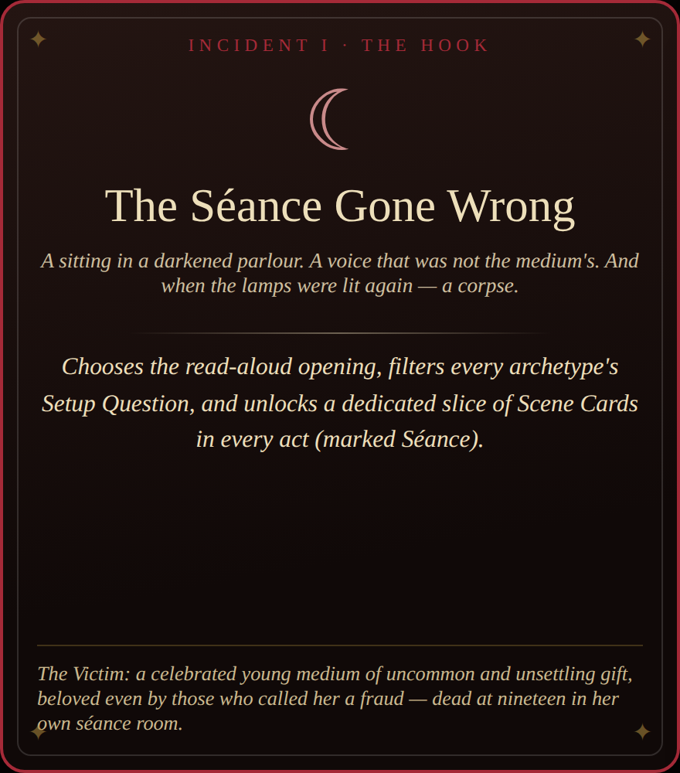
A gothic re-imagining after the design of Tall Pines by Miles Gaborit.
All card content, theming, and the browser implementation herein are original.
Prepared for the Blackwood Vale project team
Covers: theme & tone · full rules · card visual reference · complete content library · digital build notes · roadmap

Table of Contents
1 · Vision & Theme 3
The pitch, aesthetic pillars, Tone philosophy, and the Strike safety mechanic.
2 · The Incidents (Starting Hooks) 5
Both shipped Incidents in full: The Séance Gone Wrong and The Curse of the Manor.
3 · How to Play — Core Rules 7
Step-by-step procedure, adapted from the Tall Pines rulebook into Blackwood Vale terms.
4 · Card Type Reference 10
All six card types, shown as real screenshots from the shipped build, with anatomy notes.
5 · Content Library — Full Appendix 14
The complete card text, generated directly from the live game data.
5.1 · Archetypes 14
5.2 · Scene Cards (Acts I–III) 15
5.3 · Omens 21
5.4 · Hidden Sins 22
5.5 · Act Close Cards (Acts I–III) 23
6 · Digital Implementation Notes 25
How the browser build works: state model, screen flow, and how to extend the content.
7 · Roadmap / Open Threads 27
Sketched future Incidents, a Godot 4 port, and other open work.

1 · Vision & Theme

The Pitch
Blackwood Vale takes the bones of Tall Pines — a one-session, card-driven story game where a shared cast of Archetypes passes from player to player to unravel a single death across three acts — and re-skins every surface in Penny Dreadful gothic horror: cobblestone streets, gas-lamps, séances, occult corruption, and tragic family secrets. The mechanical skeleton is untouched; the mystery is no longer a Twin-Peaks-inflected mountain town but a fog-choked Victorian-adjacent town called Blackwood Vale, and the murder victim is discovered, mourned, and dissected through the same rhythm of scenes, symbols, tones, and secrets.
The browser build (Blackwood Vale, a single self-contained HTML file) is a faithful digital implementation of this redesign — no installation, exportable as a Chronicle at the end of play, playable hotseat around one screen or entirely solo.

Aesthetic Pillars
- Cobblestone & Gas-Light — every location reads as damp stone, weak lamplight, and fog that swallows sound. Even daylight scenes carry a held breath.
- The Séance & the Occult — mediums, omens, automatic writing, things that answer when called. The supernatural is never confirmed, only ever glimpsed sideways.
- Tragic, Inherited Secrets — guilt is generational. Houses remember. Families curse themselves quietly, over decades, long before the Victim was born.
- Symbol-Heavy, Serialized Storytelling — Tall Pines’ Symbol deck becomes the Omen deck: a recurring visual vocabulary (a stopped watch, a dead songbird, a second shadow) that accretes meaning across a single sitting, exactly as a penny-dreadful serial plants and repays its own imagery.
- Three Acts, One Sitting — the structure stays a half-hour-per-player, three-act tragedy with a formal Act Close, not an open-ended campaign.

Tone Philosophy
Tall Pines’ three Tones (Resolve, Shame, Understanding) become three gothic Tones that drive which secrets unlock and what each Act Close demands:
OBSESSION the need to know, to possess, to pursue the truth of the death past all decency and reason.
GUILT the weight of complicity — the urge to conceal, to atone, to keep the town’s shame behind its shutters.
DREAD the growing certainty that something is wrong here beyond murder — and that it is not finished.
Tones are never chosen deliberately — they ride along on whichever Scene Cards and Archetype faces are in play, and only become visible in aggregate: after a scene, after an act. The design intent is the same as the original game’s: tones should feel like an emergent mood, not a stat the players are optimizing.

Player Safety — The Strike
Tall Pines ships with the X-Card technique (Stavropoulos). Blackwood Vale keeps the same social contract under a period-appropriate name: the Strike. Any player may strike any element — an idea, a line of dialogue, an entire scene, a whole card once it’s in the Chronicle — at any time, with no explanation owed and no argument permitted. The stricken thing simply never happened. In the digital build this is literalized as a ☐ toggle on every Chronicle entry; the rulebook and in-app "Rules" overlay both state the norm before play begins. This is a load-bearing part of the design, not a footnote — the subject matter opens with a murdered teenager and is explicitly invited to go further.

2 · The Incidents (Starting Hooks)
Blackwood Vale ships with two Incidents — the equivalent of Tall Pines’ fixed premise, made selectable. Choosing an Incident at setup does three things mechanically: it swaps the read-aloud opening, it swaps every Archetype’s Setup Question (each Archetype has one question written for each Incident), and it unlocks that Incident’s dedicated slice of Scene Cards in every act, layered on top of a shared pool of universal cards. A group never sees the other Incident’s exclusive material in the same sitting — each Incident is a fully separate mystery wearing the same chassis.

2.1 · The Séance Gone Wrong
“A sitting in a darkened parlour. A voice that was not the medium’s. And when the lamps were lit again — a corpse.”
The Victim: a celebrated young medium of uncommon and unsettling gift, beloved even by those who called her a fraud, dead at nineteen in her own séance room.

Read-Aloud Introduction
A tragedy has struck the fog-bound town of Blackwood Vale. Its celebrated young medium — a spiritualist of uncommon gift, beloved even by those who called her a fraud — has been found dead in her own séance room. The circle was broken. The candles were drowned in their own wax. Every door was locked from within.
Together we will unravel what happened in that darkened parlour, what it means for our haunted little town — and what, if anything, came through when the circle broke. We may learn who is to blame. We may learn far more than we ever wished to know.


The Hook / Incident Card as it appears in the browser build (Séance example).

2.2 · The Curse of the Manor
“The east wing was sealed for a reason. The youngest heir found that reason on the eve of their inheritance.”
The Victim: the youngest heir of Blackwood Manor — kind-eyed, promising, the one the servants swore would finally be different — dead at eighteen in the sealed east wing.

Read-Aloud Introduction
A tragedy has struck Blackwood Manor, the great house that watches over the town of Blackwood Vale. The youngest heir — kind-eyed, promising, the one the servants swore would finally be different — has been found dead in the sealed east wing, on the very eve of their coming-of-age. Just as it happened to their uncle. Just as the curse has always said it must.
Together we will unravel the truth of their death, the sin at the root of the family tree, and what the house itself intends to do about it. We may learn who is to blame. We may learn far more than we ever wished to know.

3 · How to Play — Core Rules
What follows adapts the Tall Pines rulebook procedure for procedure into Blackwood Vale’s vocabulary. Where the two diverge, or where the digital build automates a step, it is called out explicitly.

What You Need
- One to six players (the digital build supports true solo play; the physical-table original wants three to six)
- About thirty minutes per player
- A way to jot names as they’re invented — the digital build does this for you automatically in the Chronicle
- Blackwood Vale (blackwood-vale.html) open in any modern browser, or a printed card set built from Section 5

Elements of the Game

The Victim
Established collaboratively before anything else. Their age, general likability, and vague connectedness to the six Archetypes are fixed by premise; every other fact — their name, their habits, their secrets — is generated by answering each Archetype’s Setup Question in turn. Naming the Victim happens last and is, per tradition, usually the hardest part.

The Archetypes
Six two-sided character roles, dealt (or in the digital build, always all six) at the start of play. No one owns an Archetype — they are picked up fresh by whoever leads a given scene. Each side carries a flip condition and a Tone; when the face-up condition is met at the end of a scene that Archetype appeared in, the card turns, changing both its available condition and its Tone going forward.

The Tones
Obsession, Guilt, and Dread (see Section 1). Every Scene Card and every Archetype face carries exactly one.

The Omens
The Symbol deck, renamed. Six Omens sit face-up in a row at all times; players read their imagery as literally, metaphorically, or obliquely as they like. An Omen played into a scene returns to its player afterward and can later be traded back onto the Omen deck to draw a fresh Scene Card — the game’s only way to refill a hand once dealt.

Hidden Sins
The Secret cards, renamed. Each player is dealt exactly one at setup (solo play deals two), keyed to a specific three-Tone combination. Nobody else may look at it. When a scene’s counted Tones contain that combination, the Sin unlocks immediately as a bonus scene answered through three Omens — never through ordinary play.

Setup — Establishing the Dead
- Choose an Incident (Section 2).
- Read the Incident’s introduction aloud.
- In turn, each player is handed an Archetype and answers its Setup Question — in character or plainly. The answer becomes an established fact about both the Victim and that Archetype.
- Name every Archetype as you go. Once all six questions are answered, name the Victim as a group.
- Deal: each player receives a starting hand of Scene Cards (3 in groups, 5 solo) and exactly one Hidden Sin (two, solo). Six Omens are laid face-up. One Act Close is drawn per act (or, digitally, pre-selected) and may be read by anyone at any time — foreknowledge of where the story is headed is intentional.

Playing a Scene
- Whoever has an idea first begins: they choose a Scene Card from their hand and an Archetype to lead the scene.
- They describe what the camera sees as the scene opens — setting and atmosphere before any dialogue.
- Play continues freely — narrated, roleplayed, or both — with other characters cast among the remaining players as needed.
- Any other player may buy into the scene once each, contributing either a Scene Card from their hand or an Omen from the row, and narrating how it manifests. A scene may never hold more than three cards total, counting the opener.
- The player who opened the scene alone decides when it ends.

Ending a Scene
- Check every Archetype that appeared: if its face-up condition was met, flip it.
- Count every Tone in play this scene — the lead Scene Card, any contributed Scene Cards, and the leading Archetype’s (post-flip) face. Omens carry no Tone.
- Compare that count against every player’s Hidden Sin. A match unlocks the earliest-noticed Sin immediately as a bonus scene; other matches wait for a future scene’s Tones to satisfy them.
- Return contributed Scene Cards to the discard pile and contributed Omens to the players who played them (replacing each from the Omen deck in the row).

Unlocking a Hidden Sin
The owning player reads their Sin’s question aloud, selects three Omens, and narrates a short vignette answering it — illustrated through those three Omens alone. No other player may contribute a card. This is a bonus scene: it does not count against that player’s one-scene-per-act quota.

Finishing an Act
Once every player has led exactly one scene this act (three, solo), the Act Close plays. Its printed condition names who begins it. Before narrating, tally every Tone that appeared across the act’s discarded Scene Cards and Archetype faces; whichever Tone is most numerous supplies the element the Act Close scene must include. Ties are the starting player’s choice. The Act Close otherwise plays by the normal scene rules — others may still buy in with a card apiece.

End of Game — The Chronicle
After the Act III Close, the game is over. The full story — every scene’s opening, contributions, and outcome, every Hidden Sin, every Act Close — is compiled into the Chronicle: a formatted case-file document. Players may strike anything from the record (see Section 1) before treating it as final. The digital build offers the finished Chronicle as copyable Markdown or a downloadable file; a physical table can simply read it aloud from notes.
If there’s time, talk it through. The closing discussion prompts appear in Section 6 alongside the Chronicle export, and are worth asking even in solo play.

Solo Mode
One storyteller voices every Archetype across all three acts. To keep the arc’s shape intact despite the smaller table, the digital build deals a larger hand (5 Scene Cards instead of 3), grants three scenes per act instead of one, and issues two Hidden Sins instead of one — giving a solo session roughly the same volume of story beats as a three-player game.

4 · Card Type Reference
Six card types drive Blackwood Vale. All are rendered as typography and colour — no illustrated art exists yet (see Section 7, Roadmap). Every image below is a real screenshot of the shipped browser build’s own card CSS, so this section can double as a visual QA reference: if a future art pass changes the templates, these are the baseline to compare against.
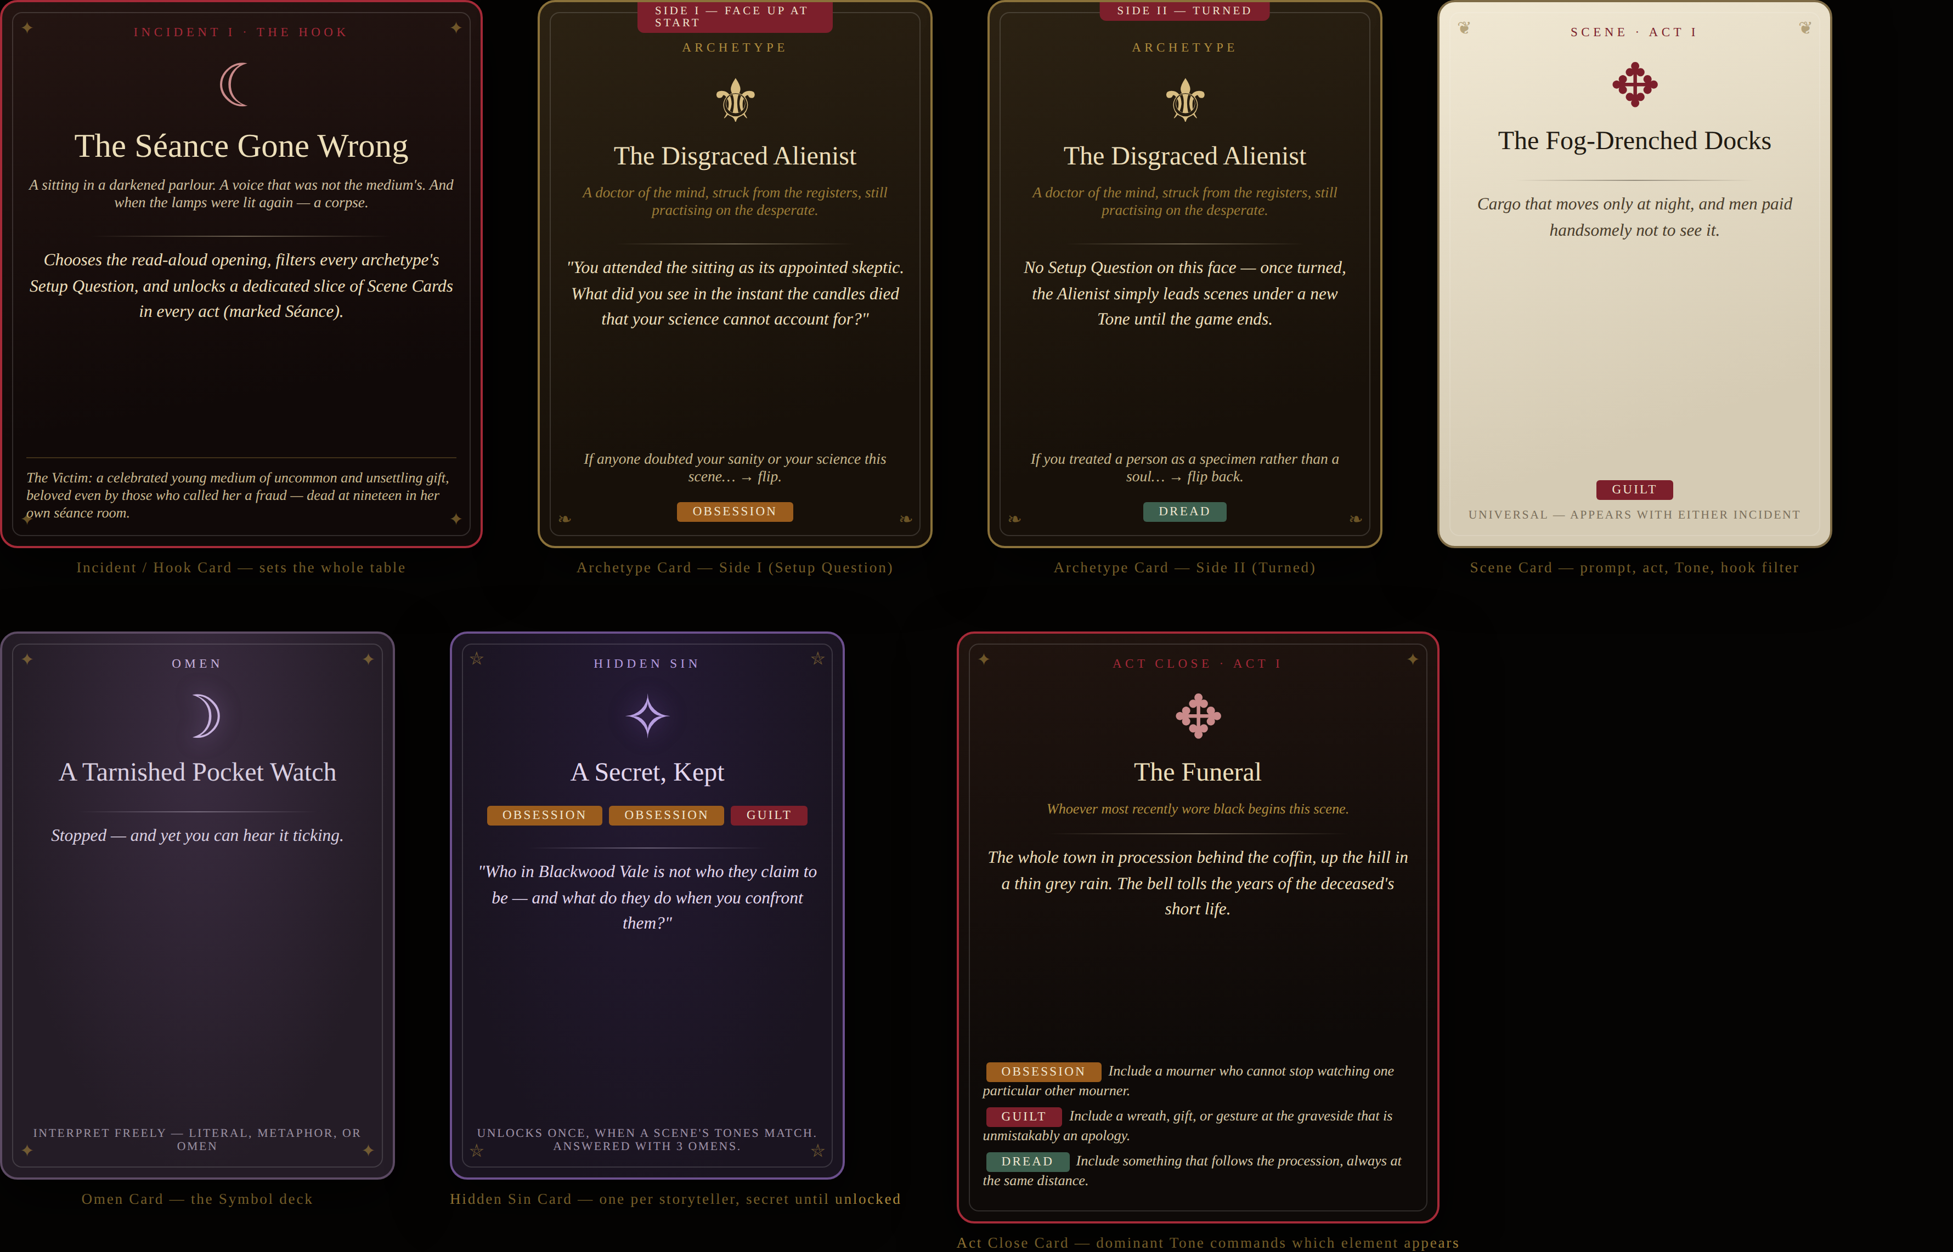
All six card types at a glance, with real content pulled from the shipped game.

Incident / Hook Card

Incident / Hook Card — rendered exactly as the browser build displays it.
Selected once, before setup. Carries the read-aloud epigraph, the one-line premise of the Victim, and (not printed on the card face, but true of its effect) which Archetype questions and Scene Cards it unlocks.

Archetype Card — Side I & Side II
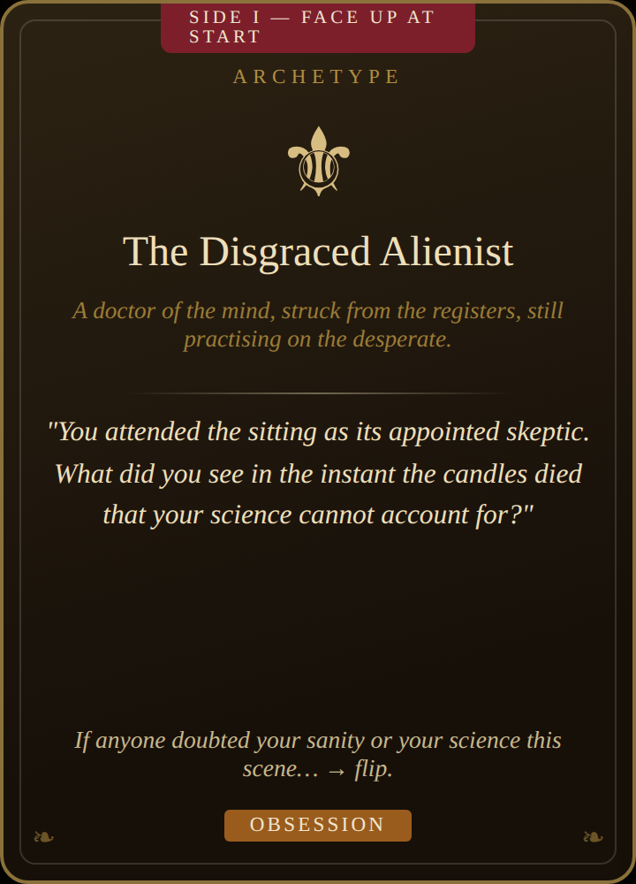 | 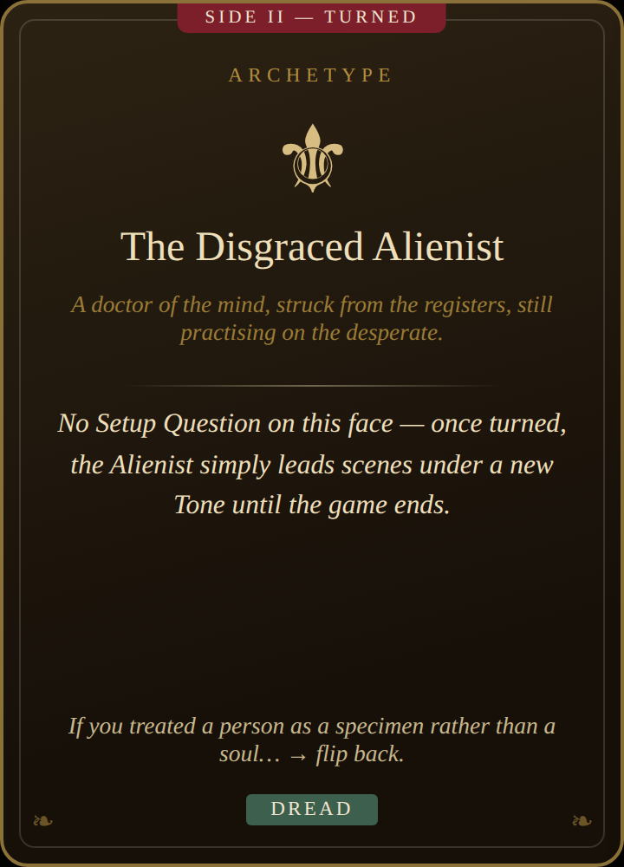
Archetype Card — Side I & Side II — rendered exactly as the browser build displays it.
Two-sided. Side I starts face-up and carries the Setup Question asked once, at the very beginning of play. Both sides carry a flip condition and a Tone; the card turns whenever its face-up condition is met at the end of a scene it appeared in, permanently changing which Tone it contributes going forward.

Scene Card
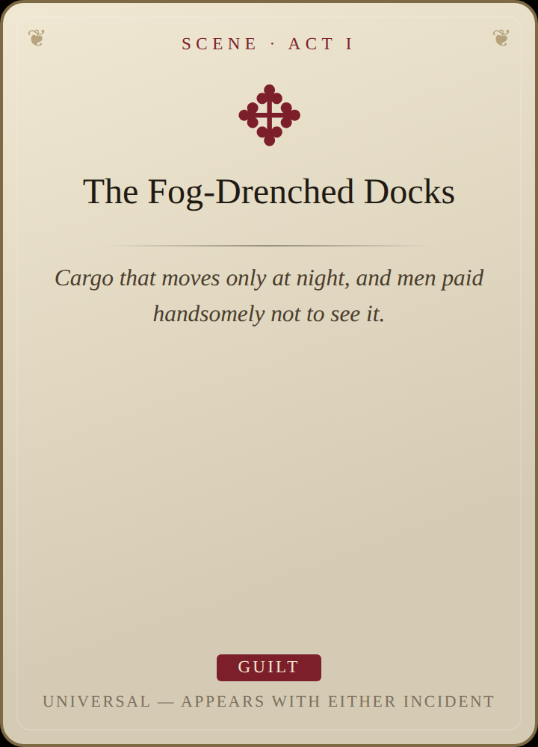
Scene Card — rendered exactly as the browser build displays it.
The primary engine of play. Title and prompt are a starting point, not a script — interpret freely. Carries one Tone. Some Scene Cards are tagged to a specific Incident and only enter the deck when that Incident is in play; most are universal.

Omen Card
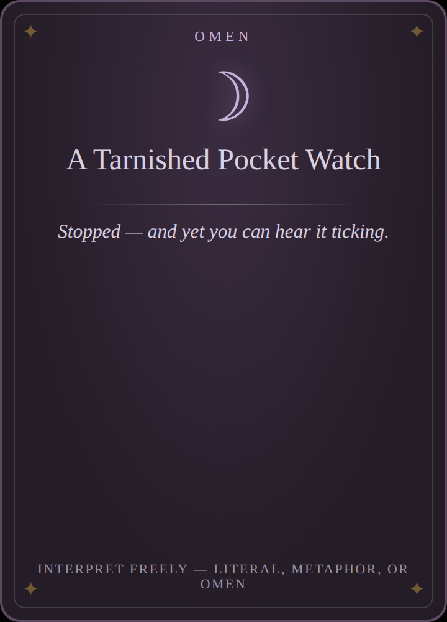
Omen Card — rendered exactly as the browser build displays it.
The Symbol deck. No Tone of its own — its power is purely interpretive. Six sit face-up at all times; playing one into a scene, or later trading a spent one back onto the deck for a fresh Scene Card, are the only two things a player does with it.

Hidden Sin Card
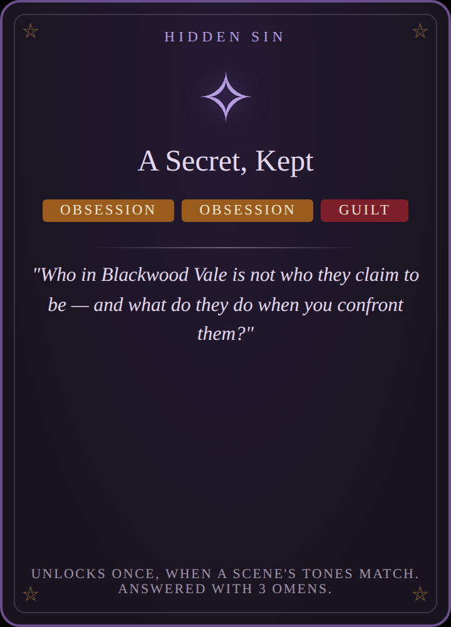
Hidden Sin Card — rendered exactly as the browser build displays it.
Dealt secretly, one per player (two in solo). Never shown to the table until its three-Tone combination appears in a resolved scene’s tally — at which point it triggers an Omen-only bonus scene and is discarded, spent, for the rest of the game.

Act Close Card
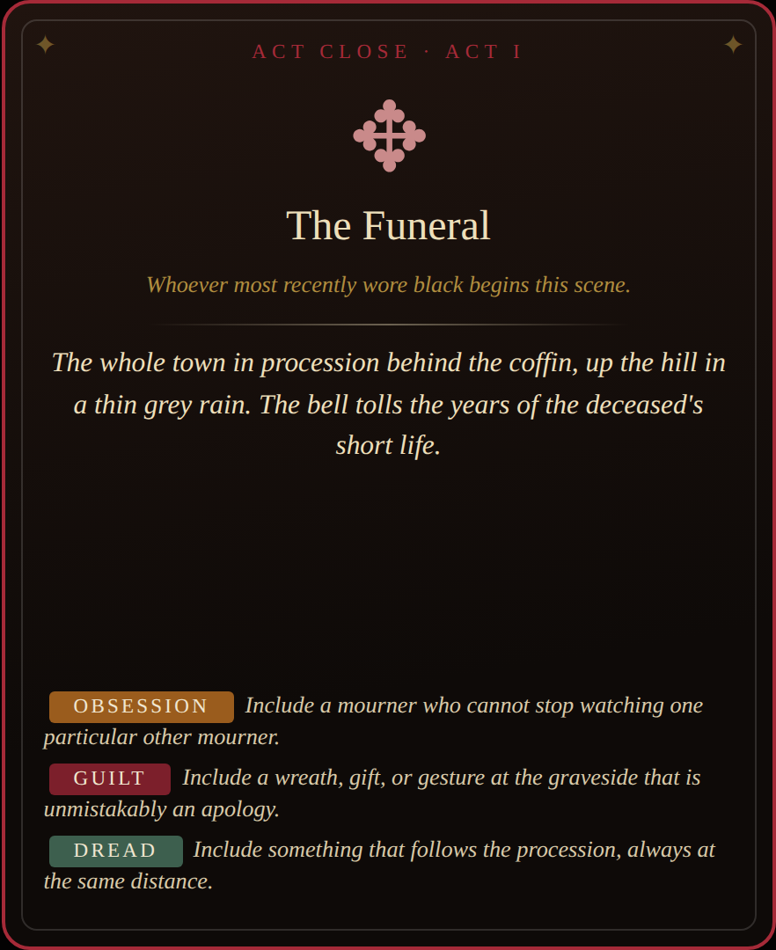
Act Close Card — rendered exactly as the browser build displays it.
One per act, drawn or chosen before play begins and readable by anyone throughout. Its top condition decides who opens the scene; its three Tone-tagged “include…” lines are mutually exclusive — only the act’s dominant Tone’s line is used.

5 · Content Library — Full Appendix
The complete, shipped card text: 8 Archetypes, 66 Scene Cards (22 per act), 24 Omens, 10 Hidden Sins, and 6 Act Close cards (one pair per act, drawn from the digital build’s ACT_CLOSES table). This is the authoritative source — it is generated directly from the live game data, not retyped, so it cannot drift out of sync with what ships in the browser.

5.1 · Archetypes
Archetype | Flavor | Setup Q — Séance | Setup Q — Manor | Side I (flip cond. / Tone) | Side II (flip cond. / Tone)
The Disgraced Alienist | A doctor of the mind, struck from the registers, still practising on the desperate. | You attended the sitting as its appointed skeptic. What did you see in the instant the candles died that your science cannot account for? | The family retained you, quietly, to treat the deceased. What malady were you actually treating — and what did you write in your notes instead? | If anyone doubted your sanity or your science this scene…  OBSESSION | If you treated a person as a specimen rather than a soul…  DREAD
The Opium-Addled Poet | Once the toast of the London reviews; now the Vale’s resident ruin, seeing too much. | The dead spoke through the medium in a voice you recognised. Whose voice was it — and what did it call you? | You summered at the manor once, as the family’s pet genius. What did you witness there that you turned into verse nobody understood? | If you told a beautiful lie…  GUILT | If you saw something no one else present could see…  DREAD
The Veiled Widow | Married into the Vale; buried her husband within the year; never lifted the veil since. | The sitting was held at your request. Who were you trying to reach — and who answered instead? | What promise did the deceased make to you at your husband’s graveside, and why did it frighten you? | If you wore your grief as armour…  GUILT | If you let someone glimpse what is beneath the veil…  OBSESSION
The Defrocked Priest | Stripped of his collar for a scandal no two people describe the same way. Still keeps the keys to the chapel. | You came that night to stop the sitting. What holy thing did you bring with you — and why did it fail? | You served the family chapel before your disgrace. What confession did the deceased make to you that you may never repeat? | If you invoked God without believing it…  GUILT | If you performed a rite you are forbidden to perform…  DREAD
The Resurrection Man | Digs for the anatomists by dark; knows the churchyard better than the sexton; owed money by respectable men. | You were paid to procure something for the medium before the sitting. What did you dig up — and what was wrong with it? | The family paid you once to open a grave in their private plot. Whose name was on the stone — and why was the coffin light? | If you profited from the dead…  OBSESSION | If the dead seemed to know your name…  DREAD
The Inspector from the Yard | Sent up from London on the night train; methodical, unwelcome, and not as untouched by the Vale as he pretends. | You were already watching that house the night of the death — on another matter entirely. What was it? | This is not the first death at the manor you have looked into. What did you put in your last report that your superiors struck out? | If you bent the law to serve the truth…  OBSESSION | If you concealed evidence…  GUILT
The Medium’s Apprentice | Keeps the séance room; knows where the wires are hidden; knows which effects need no wires at all. | You prepared the room before the sitting. Which of your preparations was a trick — and which one, God help you, was not? | The deceased wrote to your mistress begging for a reading of the house itself. What did the letters say was moving through the walls? | If you spoke with a voice not your own…  DREAD | If you told someone what they needed to hear…  GUILT
The Heir in Exile | Left the Vale years ago under a cloud; returned the very week of the death, trailing debts and rumours. | You returned to the Vale the day of the death, after years abroad. What drove you away — and what letter called you home? | The estate should have passed to you. What did you do — or what were you accused of — that saw you struck from the will? | If your name opened a door, or closed one…  OBSESSION | If you coveted something that belonged to the dead…  GUILT

5.2.1 · Act I Scene Cards (22)
Title | Prompt | Tone | Incident
Where They Were Found | The place still holds the shape of it. Who keeps returning here, and what do they leave behind? | DREAD | Universal
The Wake | Black crape, weak tea, and every mourner watching every other mourner. | GUILT | Universal
The Inquest | The coroner’s court convenes above the public house. Testimony is given. Some of it is even true. | OBSESSION | Universal
The Fog-Drenched Docks | Cargo that moves only at night, and men paid handsomely not to see it. | GUILT | Universal
The Last Photograph | A portrait taken mere days before the death. Something in the background does not belong. | DREAD | Universal
The Pawnbroker’s Ledger | An item pawned, redeemed, and pawned again. The dates tell a story of their own. | OBSESSION | Universal
The Empty Pew | Sunday service, and the whole town notices exactly who is missing. | GUILT | Universal
A Letter, Unsent | Found sealed and addressed. Deciding who reads it decides everything. | OBSESSION | Universal
The Physician’s Bag | What the doctor carried to the death-bed — and what he carried away from it. | GUILT | Universal
Beneath the Gas-Lamp | Two figures meet at the corner where the fog gathers thickest. One of them was followed. | OBSESSION | Universal
The Children’s Rhyme | The street children have already made a skipping song of the death. The words change every day. | DREAD | Universal
What the Servants Saw | Below stairs, the truth is common knowledge. Above stairs, it is unthinkable. | GUILT | Universal
The Midnight Visitor | A knock long after decent hours. A caller who cannot wait for morning — or be seen by it. | OBSESSION | Universal
The Broken Timepiece | Stopped at the hour of death, though it was wound faithfully that very morning. | DREAD | Universal
In the Public House | Gin loosens tongues. Someone finally says aloud what everyone has been thinking. | GUILT | Universal
The Mourning Shop | The proprietress sells grief-wear to the bereaved, and hears absolutely everything. | OBSESSION | Universal
The Broken Circle | The séance room, untouched since that night. Six chairs. Count the sitters again. | DREAD | Séance only
The Spirit Cabinet | The medium’s apparatus, examined by daylight. Which parts are trickery — and which are worn from use? | OBSESSION | Séance only
The Other Sitters | Those who held hands in the dark that night, gathered again. Unwillingly. | GUILT | Séance only
The Sealed East Wing | The room was locked from within. The dust has opinions about that. | DREAD | Manor only
The Portrait Gallery | Generations of the same face. One portrait has been turned to the wall. | OBSESSION | Manor only
The Reading of the Will | The solicitor clears his throat. The family holds its breath. The house listens. | GUILT | Manor only

5.2.2 · Act II Scene Cards (22)
Title | Prompt | Tone | Incident
The Anatomist’s Theatre | A lecture upon the body, attended by someone who knew it living. | DREAD | Universal
The Laudanum Bottle | Empty now. The chemist remembers precisely who bought it, and how often. | GUILT | Universal
The Asylum Visit | Someone the town chose to forget still has a great deal to say. | DREAD | Universal
A Damn Fine Cup of Tea | An unexpected kindness in a public tearoom. A confidence given — or extracted. | OBSESSION | Universal
The Threatening Letter | Words cut from newsprint. The paste is still tacky. | DREAD | Universal
Follow the Money | A debt called in, a bribe refused, a sum that cannot be explained by honest work. | OBSESSION | Universal
The Locked Diary | The clasp yields at last. The hand is familiar. The contents are not. | OBSESSION | Universal
In Fear of Their Wrath | Someone runs through the fog, certain beyond argument that they are followed. | DREAD | Universal
The Secret Assignation | Two people who must never be seen together, together. | GUILT | Universal
The Churchyard at Dusk | Fresh flowers on an old grave. Old flowers on a fresh one. | GUILT | Universal
The Confession Box | A voice through the lattice says rather more than it means to. | GUILT | Universal
The Printer’s Devil | The penny press has the story — or a version of it. The morning edition looms. | OBSESSION | Universal
What Was Taken | Something is missing from among the dead’s effects. Someone knows exactly what. | OBSESSION | Universal
The Quiet Funeral | Another death — smaller, hushed, hurried into the ground before questions form. | DREAD | Universal
An Alibi Unravels | A comfortable account of that night comes apart at a single loose thread. | GUILT | Universal
The Mirror at Midnight | A reflection does something a reflection should not. | DREAD | Universal
Automatic Writing | A hand moves across the paper of its own accord. The script belongs to the dead. | DREAD | Séance only
The Rival Medium | Another practitioner offers to finish what the sitting began — for a price. | OBSESSION | Séance only
What Answered | Whatever came through that night has not gone back. | DREAD | Séance only
The Priest Hole | A hiding place built for old persecutions — and used far more recently. | DREAD | Manor only
The Entail | The lawyer explains what the family may not sell, may not leave, and may never escape. | GUILT | Manor only
The Groundskeeper’s Silence | Forty years of faithful service, and one question he will not answer. | OBSESSION | Manor only

5.2.3 · Act III Scene Cards (22)
Title | Prompt | Tone | Incident
The Accusation | A name is spoken aloud at last, in front of witnesses. | OBSESSION | Universal
The Storm Breaks | The weather turns biblical. The roads drown. Everyone is now exactly where they will remain. | DREAD | Universal
The Exhumation | By lantern-light, with official sanction or without it, the earth is opened. | OBSESSION | Universal
Flight | Someone packs in desperate haste. The last train leaves at midnight. | GUILT | Universal
The Full Confession | An unburdening, at long last — but to entirely the wrong person. | GUILT | Universal
The Evidence Burns | A fire in the grate, fed page by careful page. | GUILT | Universal
The Reckoning at the Bridge | Two people meet where the town ends and the black water begins. | OBSESSION | Universal
The Truth in the Attic | What the house has kept is finally carried down into the light. | DREAD | Universal
The Mob | Grief curdles into fury. Torches are economical; rope is cheap. | OBSESSION | Universal
The Death-Bed | Another life gutters. Last words become currency. | GUILT | Universal
The Unmasking | A face, a name, an entire life revealed as a construction. | OBSESSION | Universal
The Bells at Wrong Hours | The church bells ring unbidden. The whole town counts the strokes. | DREAD | Universal
What the River Returns | The water gives back something it was trusted to keep. | DREAD | Universal
The Sacrifice | Someone takes another’s guilt upon themselves — publicly, and irrevocably. | GUILT | Universal
The Empty Grave | Opened officially, witnessed properly — and found vacant. | DREAD | Universal
The Inheritance | What passes to the living, and what it costs them to accept it. | OBSESSION | Universal
The Last Sitting | The circle re-forms around one empty chair, to ask the dead directly. | DREAD | Séance only
The Banishment | What came through must be sent back. It does not intend to go alone. | OBSESSION | Séance only
The Medium’s True Voice | For once, no performance at all. What she actually knew. | GUILT | Séance only
The Curse, Spoken | The words of the family curse, read aloud in full, for the first time in living memory. | DREAD | Manor only
The House Chooses | Doors lock. Doors open. The manor makes its preference known. | OBSESSION | Manor only
Blood Will Out | The lineage’s secret is written plainly on a living face. | GUILT | Manor only

5.3 · Omens (24)
Glyph | Title | Line
☽ | A Tarnished Pocket Watch | Stopped — and yet you can hear it ticking.
❧ | The Dead Songbird | In its gilded cage, still warm.
❈ | A Key Without a Lock | Old iron, warm to the touch.
❦ | The Black Dog | Seen at crossings, and at certain doors.
✧ | A Mourning Brooch | Woven from human hair. Not the deceased’s.
⁂ | The Extinguished Candle | Its smoke rises against the draught.
☾ | A Child’s Caul | Kept, sold, or stolen — sailors pay dearly for them.
▦ | The Mirror, Draped | And the drape has slipped.
☿ | A Vial of Black Bile | Shimmering. Medicinal. Wrong.
§ | The Hangman’s Rope | Cut into lucky lengths and sold at the gate.
◌ | A Wedding Ring, Swallowed | Found where it had no business being.
✻ | The Moth Swarm | Drawn to a flame that gives no heat.
◈ | A Daguerreotype of the Dead | Posed as if living. Eyes painted open.
♆ | The Cracked Church Bell | It rings flat, but only on holy days.
✋ | A Left-Handed Glove | Its partner was burned. Deliberately.
∞ | The Rat King | Knotted, squirming — an omen of houses.
⚘ | A Sprig of Rue | Worn against regret. Wilting fast.
❄ | The Frozen Rose | Blooming out of season, rimed with frost.
✉ | A Letter Edged in Black | The ink still wet after all these weeks.
☍ | The Second Shadow | Cast by no second light.
☻ | A Doll with Real Teeth | Somebody’s teeth.
⋯ | The Salt Line, Broken | Scattered by a deliberate foot.
⚓ | A Ship in a Bottle | Its little sails rigged in mourning-black.
☂ | The Weeping Wall | The damp has made a face of it. The face is familiar.

5.4 · Hidden Sins (10)
Every combination of three Tones is represented exactly once, so the ten Sins together cover the full possibility space of a three-Tone scene tally.
Tone Combination | Question (read aloud when unlocked)
OBSESSION OBSESSION OBSESSION | What have you pursued so long that it has begun pursuing you? Show us the moment you first realised.
OBSESSION OBSESSION GUILT | Who in Blackwood Vale is not who they claim to be — and what do they do when you confront them?
OBSESSION OBSESSION DREAD | What did you find that you should have destroyed — and where do you keep it now?
OBSESSION GUILT GUILT | What did the deceased ask of you in their final week — and how, precisely, did you fail them?
OBSESSION GUILT DREAD | What bargain did you strike to keep your place in this town — and who holds the note?
OBSESSION DREAD DREAD | What have you seen in the fog that you have told no one? Show it to us happening again.
GUILT GUILT GUILT | Whose forgiveness did you buy rather than earn? Show us the transaction.
GUILT GUILT DREAD | What did you bury — literally bury — and what has lately begun to surface?
GUILT DREAD DREAD | What sin do you rehearse confessing, but never confess? Show us one of the rehearsals.
DREAD DREAD DREAD | Something is coming for you. Show us how close it has gotten.

5.5.1 · Act I Close — both options
Title | Starter Condition | Prompt | If Obsession dominant | If Guilt dominant | If Dread dominant
The Funeral | Whoever most recently wore black begins this scene. | The whole town in procession behind the coffin, up the hill in a thin grey rain. The bell tolls the years of the deceased’s short life. | OBSESSION  Include a mourner who cannot stop watching one particular other mourner. | GUILT  Include a wreath, gift, or gesture at the graveside that is unmistakably an apology. | DREAD  Include something that follows the procession, always at the same distance.
The Vigil | Whoever last lit a flame — in real life — begins this scene. | By unspoken agreement, a candle burns in every window of the Vale tonight. The town keeps watch over itself. | OBSESSION  Include one window whose light will not stay lit, and someone who keeps re-lighting it. | GUILT  Include one house that keeps its windows dark — and the town noticing. | DREAD  Include a light answering from somewhere no house stands.

5.5.2 · Act II Close — both options
Title | Starter Condition | Prompt | If Obsession dominant | If Guilt dominant | If Dread dominant
The Public Meeting | Whoever spoke loudest this act begins this scene. | The town gathers in the assembly rooms to demand answers of someone. The room is far too small for the anger in it. | OBSESSION  Include an accusation with real evidence behind it. | GUILT  Include a public apology that nobody asked for, from someone unexpected. | DREAD  Include the meeting being interrupted by something none of them can explain.
The Night of Fog | Whoever most recently kept a secret in a scene begins this one. | The worst fog in living memory. The Vale becomes a rumour of itself; every gas-lamp an island; every footstep everyone’s. | OBSESSION  Include someone using the fog to do what daylight forbids. | GUILT  Include a voice confessing into the whiteness, unaware of its listeners. | DREAD  Include one place the fog refuses to touch.

5.5.3 · Act III Close — both options
Title | Starter Condition | Prompt | If Obsession dominant | If Guilt dominant | If Dread dominant
The Reckoning | Whoever began the game’s very first scene begins its last. | All of it converges — the guilty, the grieving, and the thing beneath it all — in one place, at one appointed hour. | OBSESSION  Include the truth of the death, spoken plainly at last — whether or not anyone believes it. | GUILT  Include a punishment that falls upon the wrong person, and is accepted willingly. | DREAD  Include what remains in Blackwood Vale after this night — and who has seen it.
The Departure | Whoever holds the fewest cards begins this scene. | Someone is leaving Blackwood Vale forever — by train, by coach, or by hearse. The town assembles to see them off. Or to be certain they go. | OBSESSION  Include a final question shouted from the platform — and its answer, or its silence. | GUILT  Include luggage that contains something belonging to the dead. | DREAD  Include the Vale, watched from the departing window, changing as it recedes.

6 · Digital Implementation Notes

Build Summary
- Single self-contained file: blackwood-vale.html. All markup, CSS, and JavaScript inline — no build step, no external dependencies except one Google Fonts import (IM Fell English / IM Fell English SC). Runs fully offline once loaded.
- No backend, no persistence layer. Game state lives in one in-memory object, G, for the duration of the browser tab.
- Content and engine are cleanly separated inside the file: a DATA block (Section 5’s source of truth) followed by an ENGINE block of rendering and state-transition functions.

The Game State Object (G)
A single object carries everything needed to resume rendering any screen:
- hook — the chosen Incident object
- players[] — name, hand (Scene Cards), omens (held), secrets (Hidden Sins), scenesLeft
- act — current act number (1–3; 4 signals game over / Chronicle)
- archetypes[] — all six, each with name, flipped state, and both sides’ text
- victim — name plus the array of established facts (one per Archetype answer)
- sceneDeck, discardTones[], omenDeck, omenRow[] — the physical decks/rows
- actClose — the drawn Act Close card per act
- journal[] — append-only log of every resolved scene, secret, and act close; this is the sole source for the Chronicle
- current — the in-progress scene or Act Close being played right now

Screen Flow
Title → Choose Incident → Player Setup → Read-Aloud Intro → Archetype Setup (×6) → Name the Victim → Act Hub ⇄ Scene (pick → play → resolve → optional Hidden Sin) — looping until every player’s scene quota for the act is spent → Act Close → next Act, or after Act III → the Chronicle.

Hotseat vs. Solo
The only branching logic between modes lives in startAct(): hand size, scenes-per-player, and (at setup) how many Hidden Sins are dealt. Everything else — scene structure, Tone counting, Act Close — is identical code path for one player or six.

The Chronicle / Export
Every journal entry carries a type (scene, close, secret, or note) and a struck boolean. renderChronicle() renders the live, toggleable record; buildMarkdown() walks the same journal, skipping struck entries, to produce the exportable case-file text — copied to the clipboard or downloaded as blackwood-vale-chronicle.md.

Extending the Content
- New Incident: add an entry to the HOOKS array, then add a seance/manor-style key for that hook to every Archetype’s setup object, and tag any exclusive Scene Cards with hook: ‘your-id’.
- New Scene Card / Omen / Hidden Sin / Act Close: append an object to the relevant array (SCENES[act], OMENS, SECRETS, or ACT_CLOSES[act]) following the existing shape — no engine code changes required.
- Re-theming: every colour is a CSS custom property on :root; swapping the palette or fonts does not touch layout logic.

Known Limits
- No save/resume — closing the tab loses an in-progress game (the finished Chronicle can still be exported any time after Act I begins via “The Record” in the top bar).
- No illustrated card art — typography and colour only, by design for the web build; see Roadmap.
- No online multiplayer — hotseat assumes players share one screen.

7 · Roadmap / Open Threads

Additional Incidents (sketched, not yet built)

The Ripper in the Fog
Ritualistic, serial murders stalking the gaslit streets rather than a single death — occult pattern-killing, a panicked penny press, and a city hunting for a monster it may already employ. Would need its own Archetype question set and a heavier skew toward Dread-tagged Scene Cards.

The Débutante in the Thames
The closest analogue to Tall Pines’ own Laura-Palmer premise: a promising young heiress found dead in the fog, Society pretending nothing is wrong. Natural fit for Guilt-heavy material — concealment, reputation, and inheritance.

A Godot 4 Port
The original brief that led to this browser build sketched a Godot 4 / HTML5-export architecture: a GameState autoload singleton mirroring the same shape as the browser build’s G object, a card-and-symbol board UI, and a generate_final_chronicle() routine functionally identical to buildMarkdown(). Because the mechanics were designed once and implemented twice in spirit, porting is mostly a UI/engine translation exercise, not a redesign — the DATA block in Section 5 can be transcribed directly into Godot resource files.

Other Open Threads
- Save/resume game state, so a session can be closed and picked back up.
- An illustrated pass on the six card types — the templates in Section 4 are built to accept real artwork in place of the glyph placeholders without a layout rework.
- Expanded content per Incident (more than 22 Scene Cards per act) for higher replayability within a single Incident.
- A lightweight print-and-play export of Section 5’s tables, for tables that want physical cards.

Closing Note
Everything in this manual — rules text, card content, and card imagery — is generated from or verified against the actual shipped blackwood-vale.html build, not written independently of it. Section 5 in particular is safe to treat as ground truth for the current state of the content library.

