FACULTY OF INFORMATION TECHNOLOGY
Mobile App Development 700
Practical Assignment: Written Report
Smart Pantry Manager
A Java Android application that suggests recipes based strictly on the ingredients already in your pantry, to cut food waste
Student name | Irfaan Subrathee
Student number | 402311943
Module | Mobile App Development 700
Date | 23 October 2026
GitHub repository | https://github.com/iri26subi/SmartPantryManager

Table of Contents
1. Introduction 3
1.1 The problem 3
1.2 The solution 3
1.3 Target users 3
1.4 Technologies 3
2. System Design 4
2.1 Screens and screen flow 4
2.2 Data model 4
2.3 Code structure 5
3. Screenshots of the Running Application 6
3.1 Pantry list (Read) and empty state 6
3.2 Add ingredient (Create) and input validation 7
3.3 Edit ingredient (Update) 8
3.4 Delete ingredient (Delete) 9
3.5 Suggested recipes 10
3.6 Recipe detail 11
3.7 Proof of the strict-matching rule 11
3.8 Settings and persistence 13
4. Key Code Snippets 13
4.1 The strict-matching rule 13
4.2 Ingredient name normalisation 14
4.3 Unit conversion 15
4.4 Seeding the database once 15
4.5 Displaying database data in the RecyclerView 16
5. Challenges and Solutions 16
5.1 Build failed: Gradle version too old for the Android Gradle Plugin 16
5.2 The first GitHub Actions build failed with exit code 126 16
5.3 Making the matching strict but still realistic 17
6. Conclusion and Reflection 17
6.1 Conclusion 17
6.2 Personal reflection 17
6.3 Future improvements 18
7. References 18

1. Introduction

1.1 The problem
A large share of household food waste happens because ingredients are forgotten until they expire, or because the recipes people find need extra items they do not have, so the food already at home is never used. Most recipe apps start from the recipe and produce a shopping list. That encourages buying more food rather than using what is already in the cupboard and fridge.

1.2 The solution
Smart Pantry Manager turns this around. The user records the ingredients they actually have at home (their pantry): name, quantity, unit and an optional expiry date. The app then suggests only those recipes that can be cooked right now with exactly what is in the pantry. A recipe is suggested only if every ingredient it needs is present in at least the required quantity. This strict-matching rule is the core business logic of the application.
Supporting features help reduce waste further: items that are about to expire are highlighted, a separate “Almost there” list shows recipes that are missing exactly one ingredient, and each recipe’s detail screen shows which ingredients are covered and which are missing or short.

1.3 Target users
The app is aimed at students, young professionals and families who want to save money and waste less food, and anyone who regularly asks “what can I cook with what I have?”. It works fully offline and keeps all data on the user’s own device.

1.4 Technologies
Area | Choice
Language / IDE | Java 17, Android Studio (Android Gradle Plugin 9.4.1, Gradle 9.6.1)
Minimum / target Android | API 26 (Android 8.0) / API 36
User interface | XML layouts (LinearLayout, ConstraintLayout, FrameLayout), Material Design 3 components
Lists | RecyclerView with three custom adapters
Navigation | Five Activities, explicit Intents with extras, bottom navigation bar
Persistence | SQLite via SQLiteOpenHelper (three tables); SharedPreferences for settings
Testing | 81 automated JUnit 4 tests, including Robolectric database and screen tests
Version control / CI | Git and GitHub; GitHub Actions builds the app and runs every test on each push

In line with the brief, the app does not use maps, location services or the internet, and the manifest requests no permissions.

2. System Design

2.1 Screens and screen flow
The application has five Activities. Pantry List, Suggested Recipes and Settings are top-level screens reached from the bottom navigation bar. Add/Edit Ingredient and Recipe Detail are opened from those screens with explicit Intents that carry the selected item’s database id as an extra.
Screen (Activity) | Purpose
Pantry List (MainActivity) | Launcher screen. Lists pantry items from SQLite in a RecyclerView; add, edit and delete; empty state; expiry banner and badges.
Add / Edit Ingredient (AddEditIngredientActivity) | One form used for both Create and Update. Validates input before writing to SQLite, then returns RESULT_OK to the pantry list.
Suggested Recipes (SuggestedRecipesActivity) | Runs the strict matcher. “Ready to cook” tab for full matches; separate “Almost there” tab for recipes missing one ingredient; zero-match message.
Recipe Detail (RecipeDetailActivity) | Name, description, time and servings, each ingredient with a pantry check, and the numbered method.
Settings (SettingsActivity) | Expiry alerts, alert window, ignoring expired items when matching, load sample pantry, clear pantry.

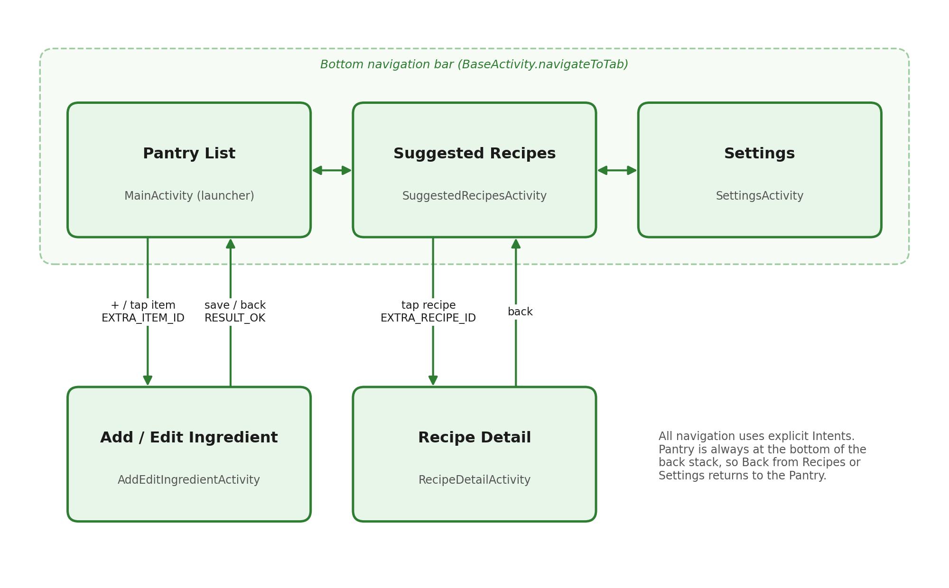
Figure 1: Screen-flow diagram showing how the five screens connect and what each Intent carries.

2.2 Data model
SQLite was chosen as the database option (Section 3.2 of the brief). The data belongs to a single user on a single device, so a local relational database is the simplest correct fit: it works offline, needs no server, account or network configuration, and it is the persistence approach covered in the module. SQLiteOpenHelper was used instead of Room so that the SQL stays visible and easy to explain, with no extra libraries.
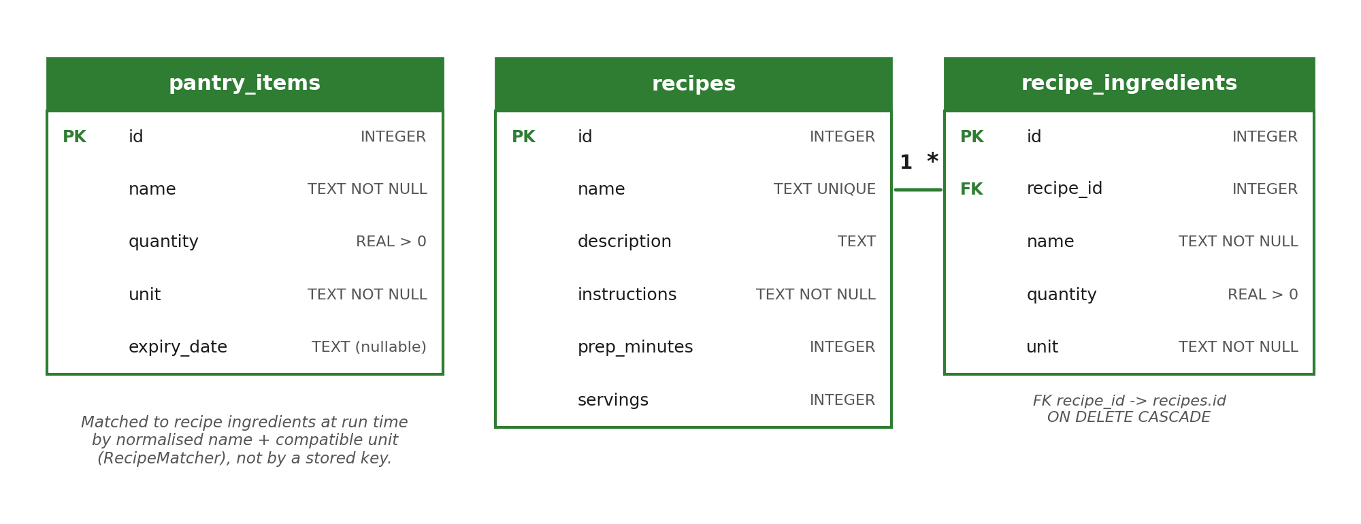
Figure 2: Entity-relationship diagram of the three SQLite tables.
- pantry_items stores the user’s ingredients. Quantity has a CHECK (quantity > 0) constraint and the expiry date is an optional ISO date string (yyyy-MM-dd), which sorts and parses reliably.
- recipes and recipe_ingredients have a one-to-many relationship. recipe_id is a foreign key with ON DELETE CASCADE, and foreign keys are switched on in onConfigure().
- Pantry items are deliberately not linked to recipe ingredients by a stored key. Users type ingredient names freely (“Tomatoes”, “tomato”), so the link is made at run time by the matching algorithm, which compares normalised names and compatible units.
- 24 starter recipes are seeded inside onCreate(), which Android runs only when the database file is first created. The seeding method also checks the row count and recipe names are UNIQUE, so recipes are never duplicated on later launches.
- User preferences (expiry alerts, alert window, ignore-expired) are simple key/value settings and are stored in SharedPreferences rather than a table.

2.3 Code structure
Package | Classes | Responsibility
model | PantryItem, Recipe, RecipeIngredient | Plain Java data classes
data | DatabaseHelper, PantryRepository, RecipeRepository, RecipeSeedData, DemoPantryData, AppSettings | Schema, CRUD, seeding, preferences
matching | RecipeMatcher, IngredientNormalizer, UnitConverter, MatchResult, IngredientCheck | Strict-matching algorithm (no Android code, so it is unit-testable)
ui | BaseActivity and the five Activities | Screens, Intents, lifecycle
ui.adapter | PantryAdapter, RecipeAdapter, IngredientCheckAdapter | Custom RecyclerView adapters
util | IngredientValidator, ExpiryUtils, QuantityFormatter | Validation and formatting helpers

3. Screenshots of the Running Application
All screenshots below were captured from the application running on an Android emulator (Google sdk_gphone x86_64 image, API level 37, 1080 × 2400 screen). Each figure shows one screen or one core function.

3.1 Pantry list (Read) and empty state
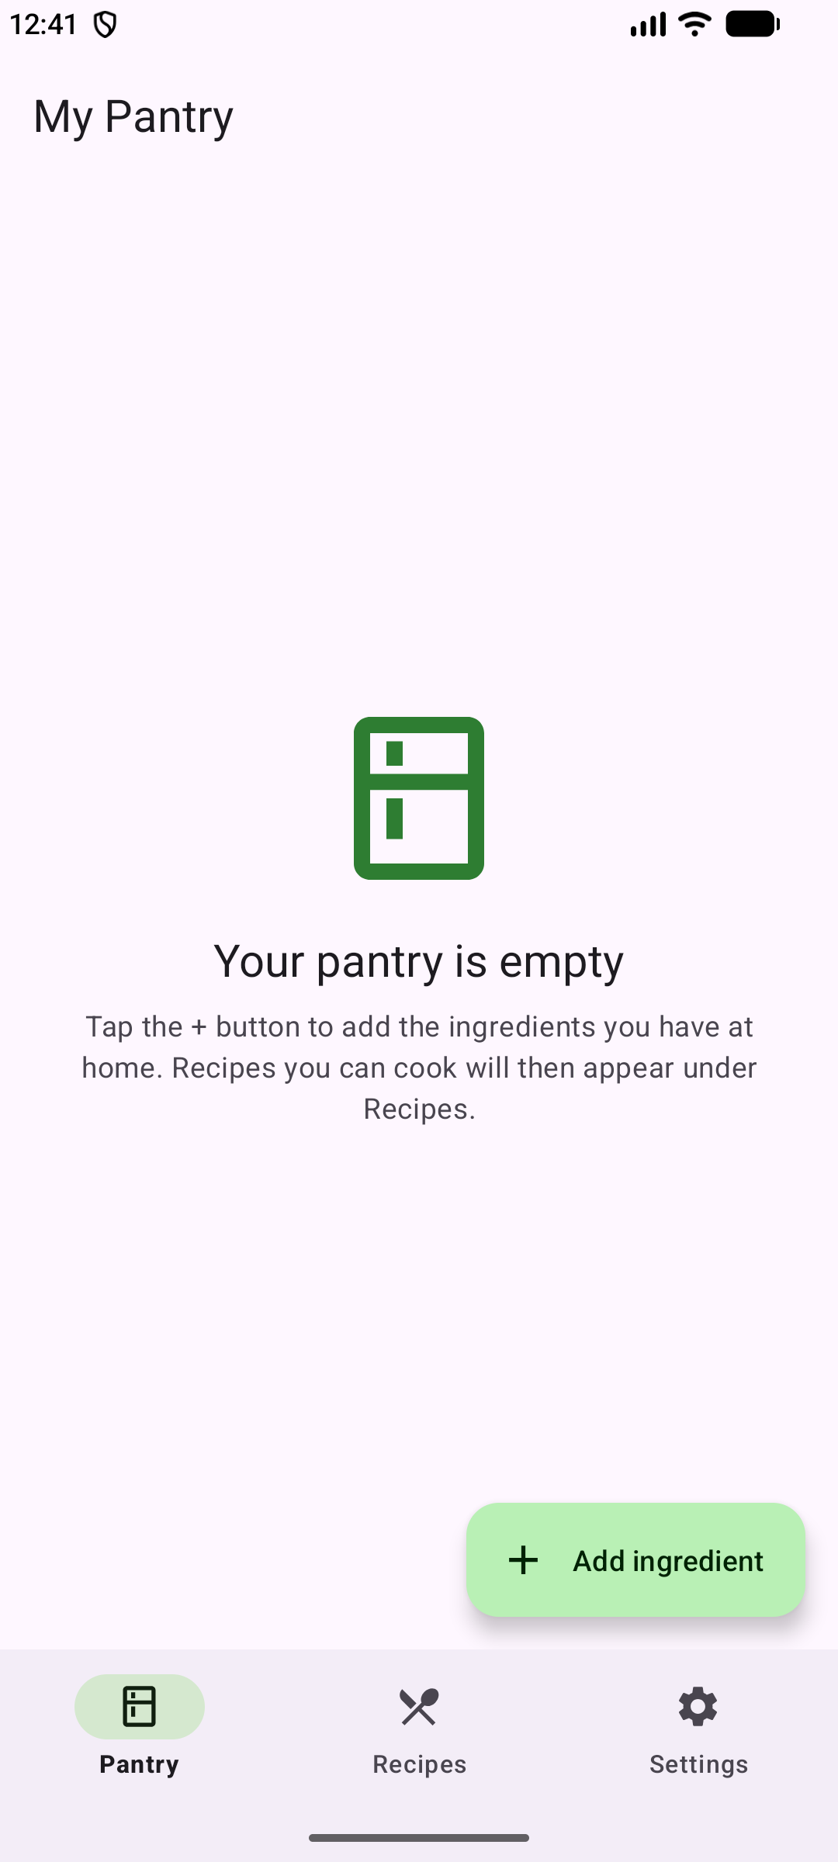  Figure 3: Pantry on first use: the empty-state message instead of a blank screen. | 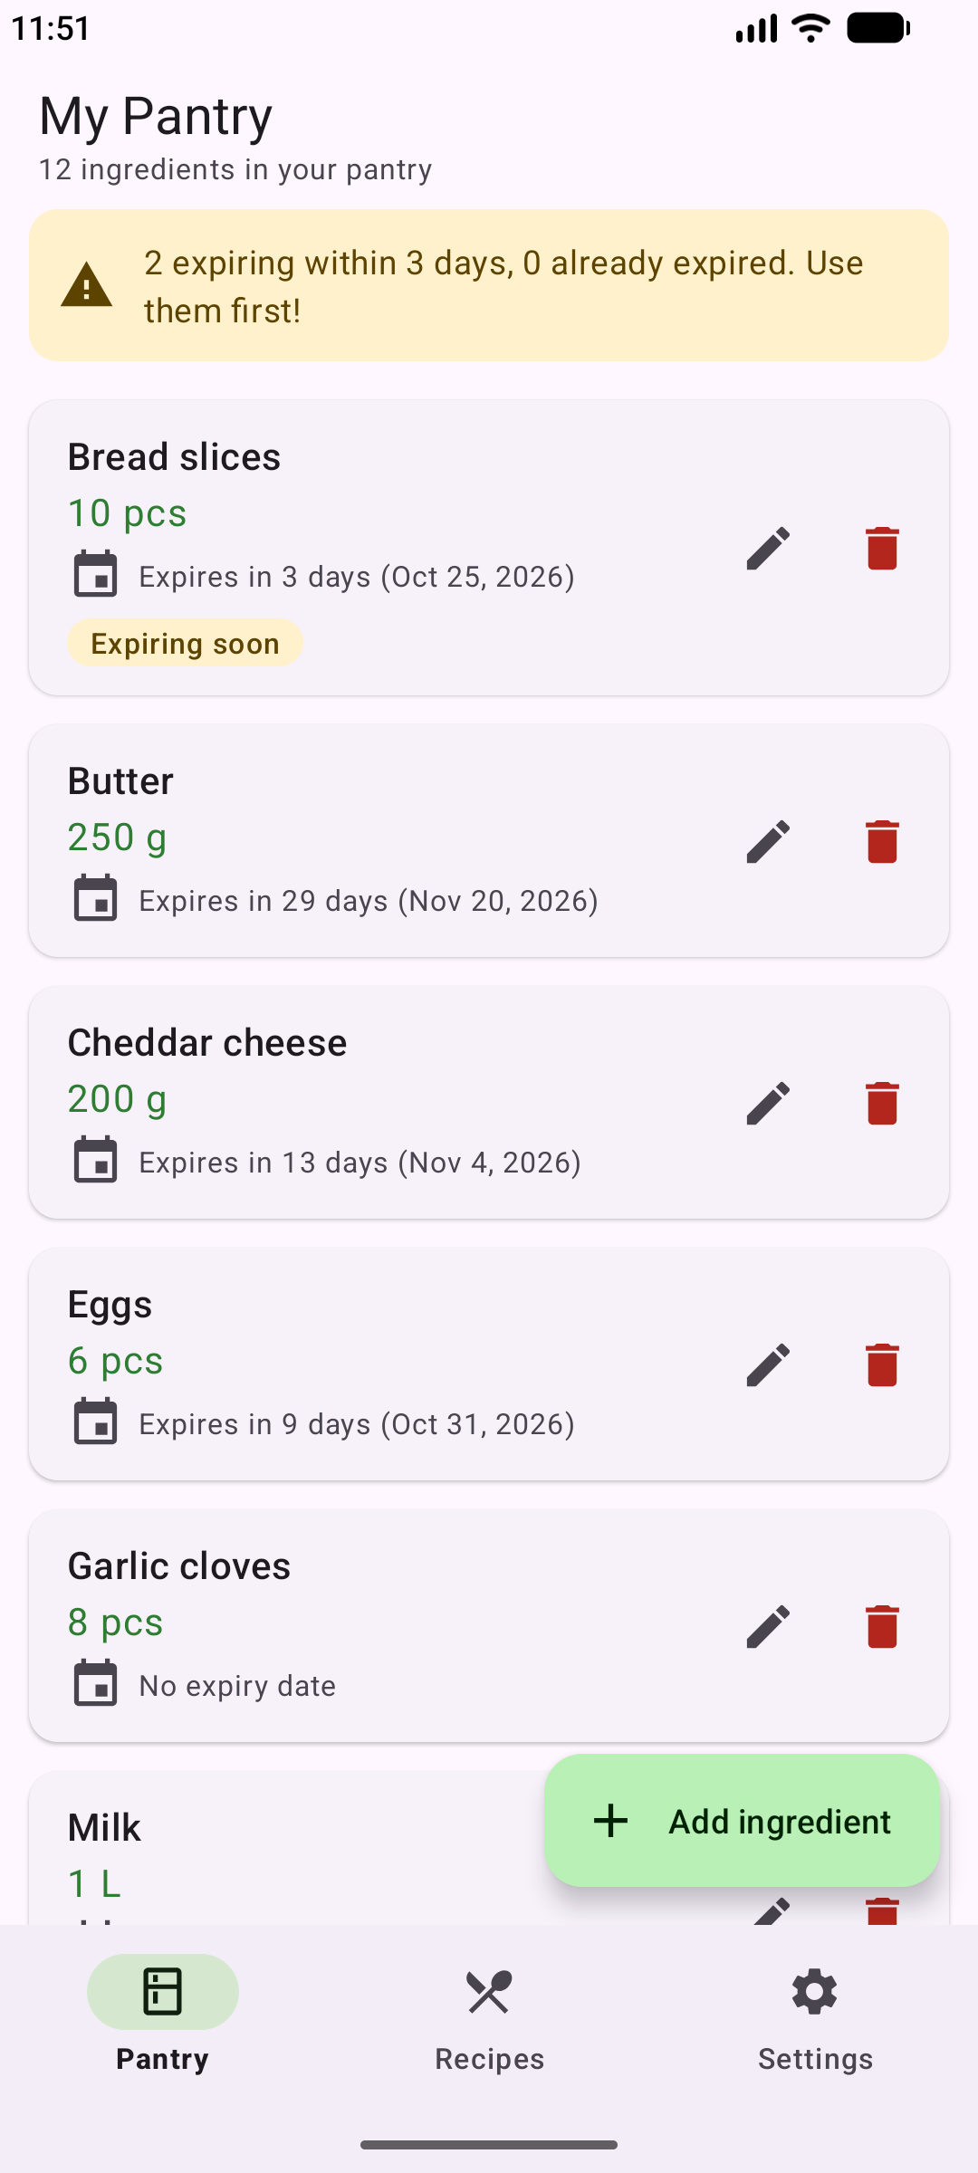  Figure 4: Pantry list (RecyclerView + PantryAdapter) with quantities, expiry dates, an “Expiring soon” badge and the warning banner. | 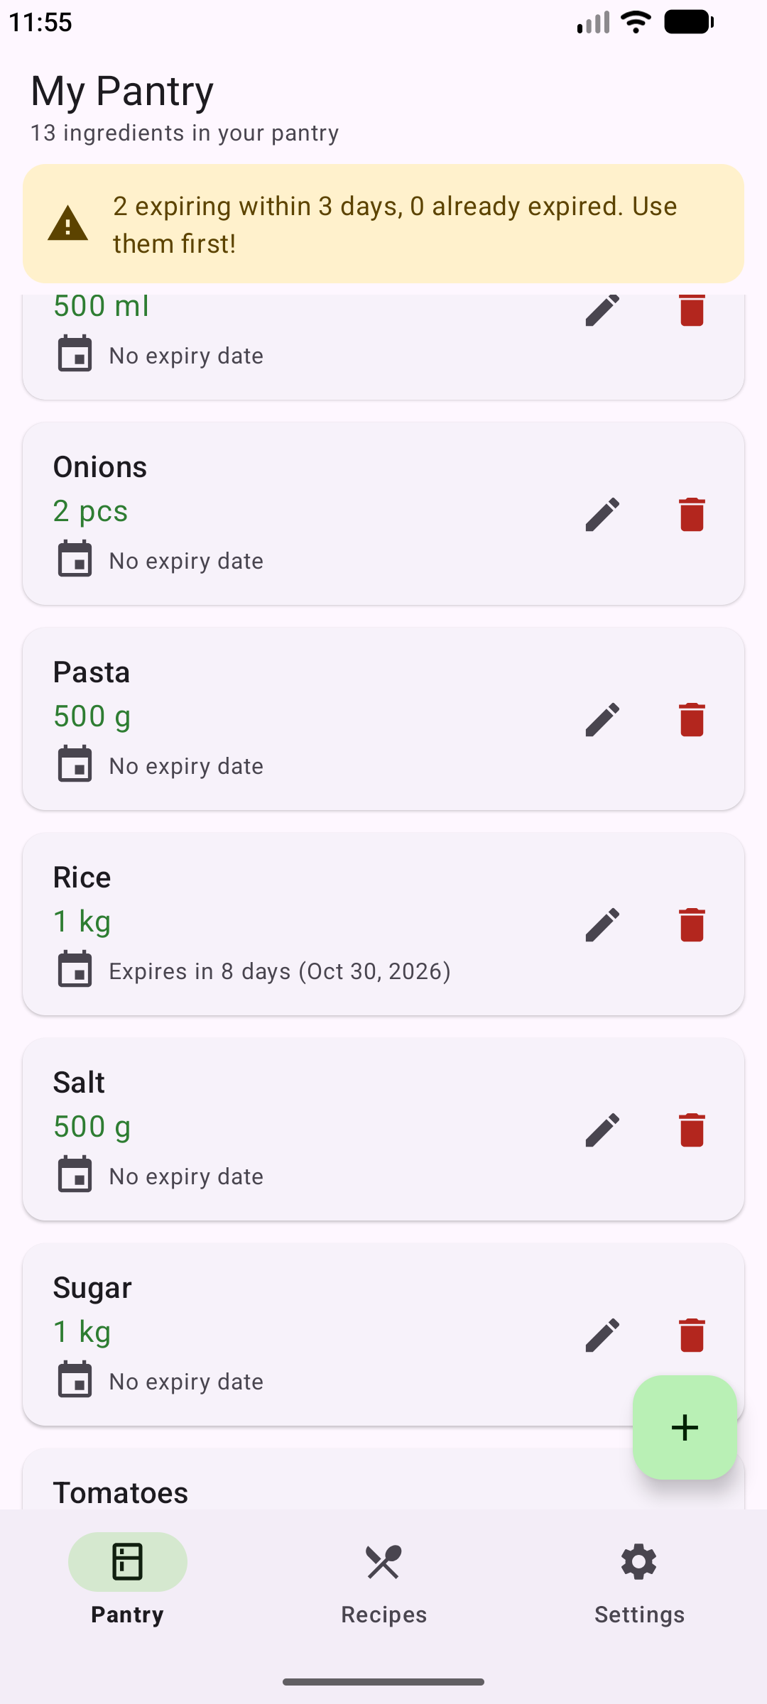  Figure 5: The list scrolled further down, sorted alphabetically, showing the newly added Rice.

3.2 Add ingredient (Create) and input validation
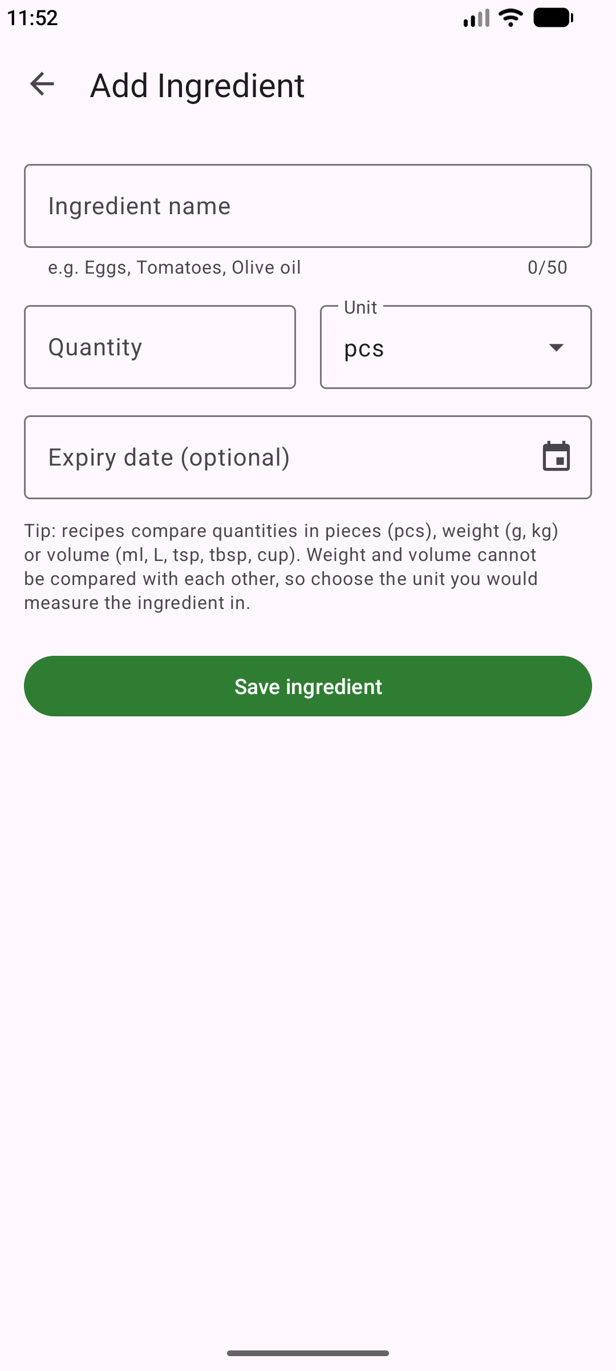  Figure 6: Empty Add Ingredient form with name, quantity, unit and optional expiry date. | 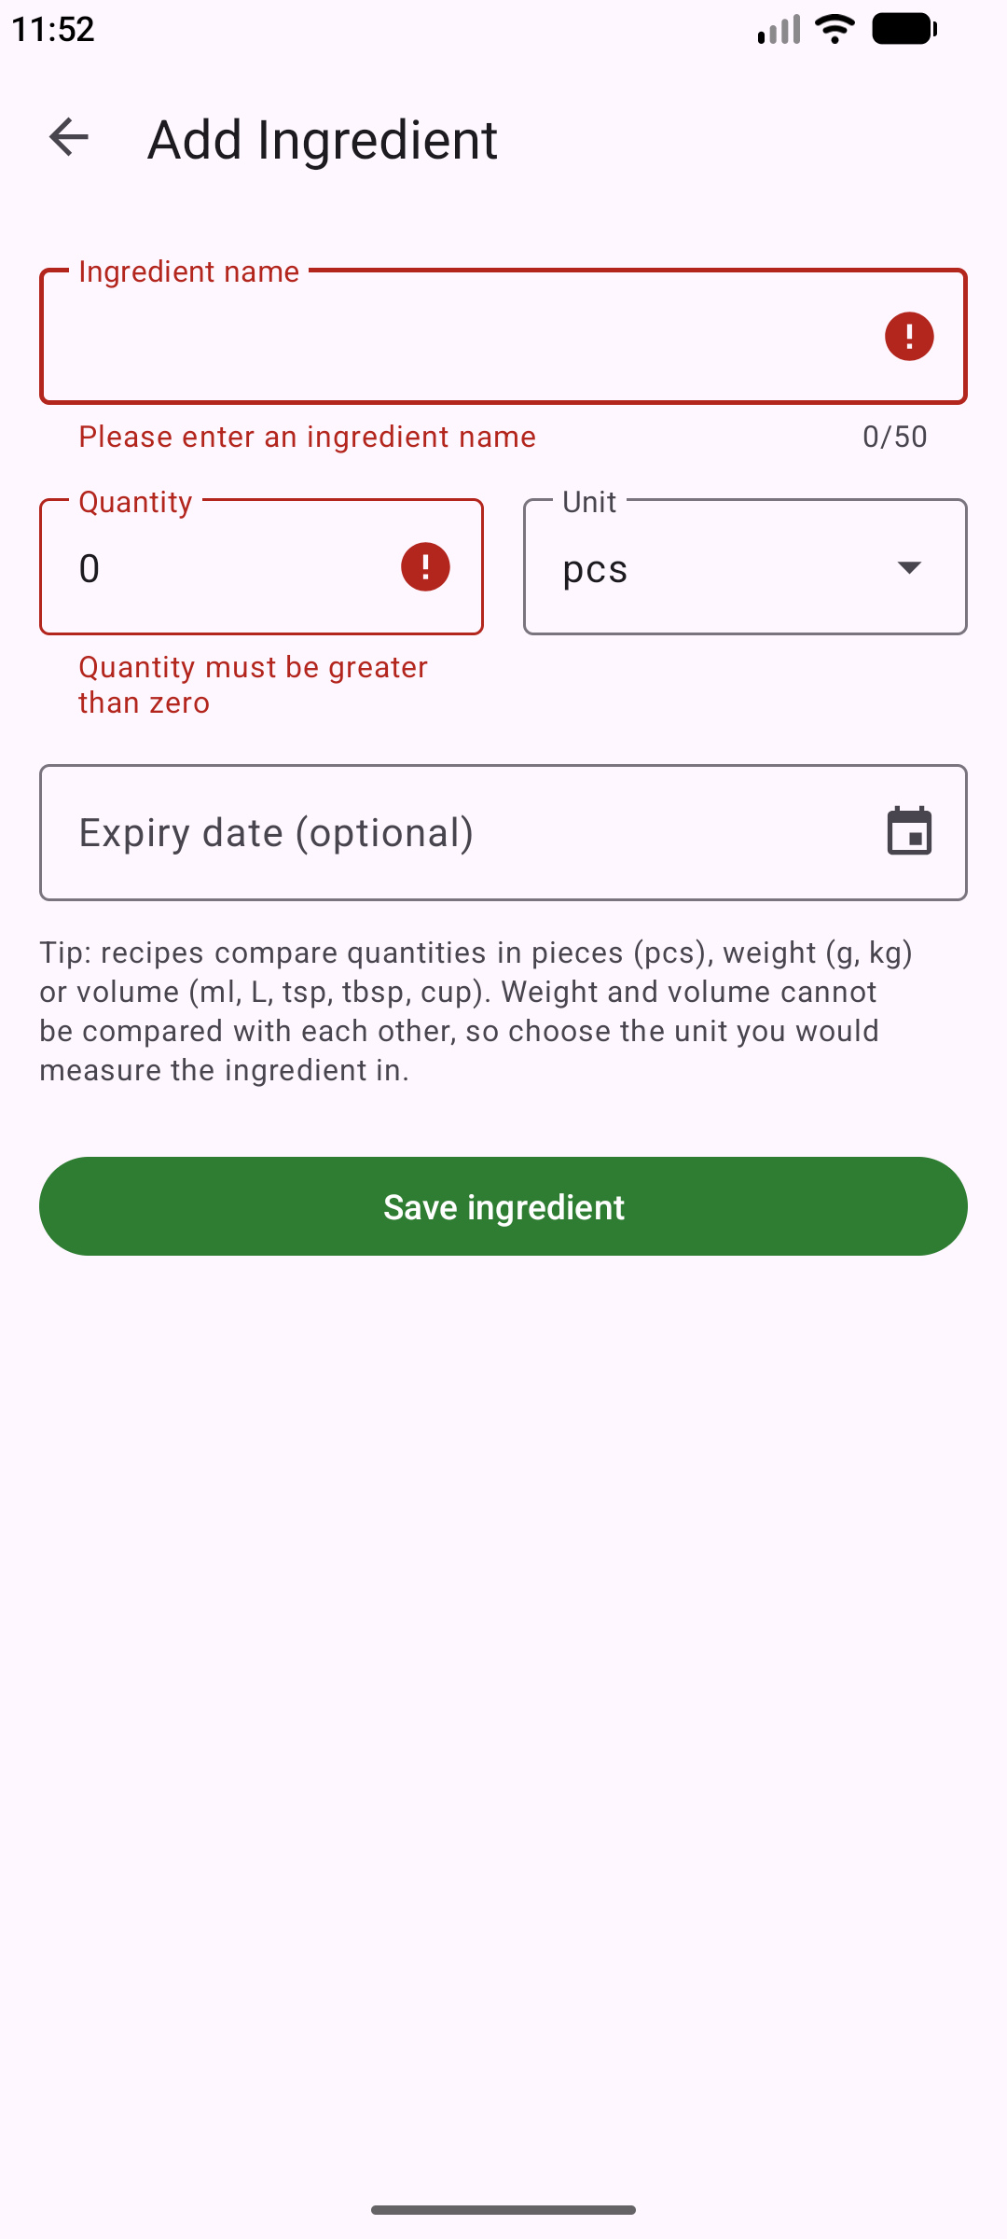  Figure 7: Validation: a blank name and a quantity of 0 are rejected with field-level error messages. | 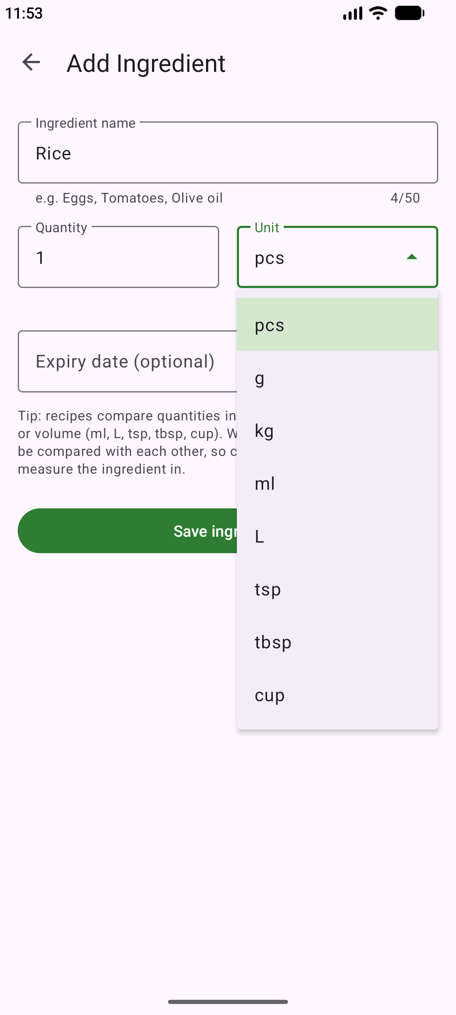  Figure 8: Unit dropdown limited to the supported units (pcs, g, kg, ml, L, tsp, tbsp, cup).

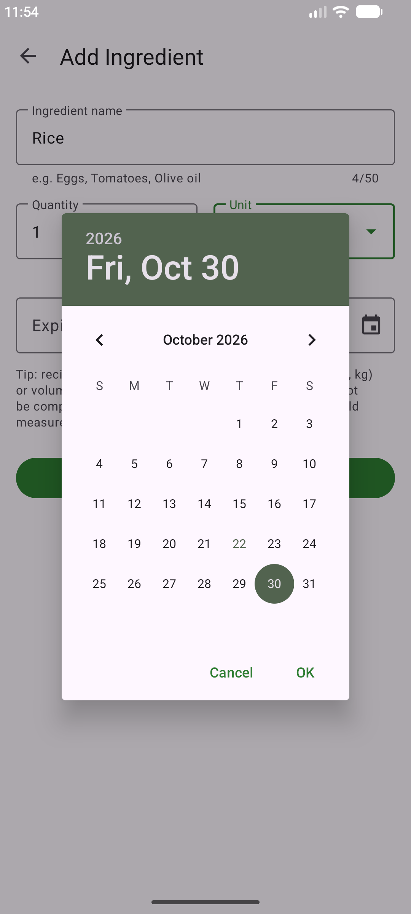  Figure 9: DatePickerDialog used to choose the optional expiry date. | 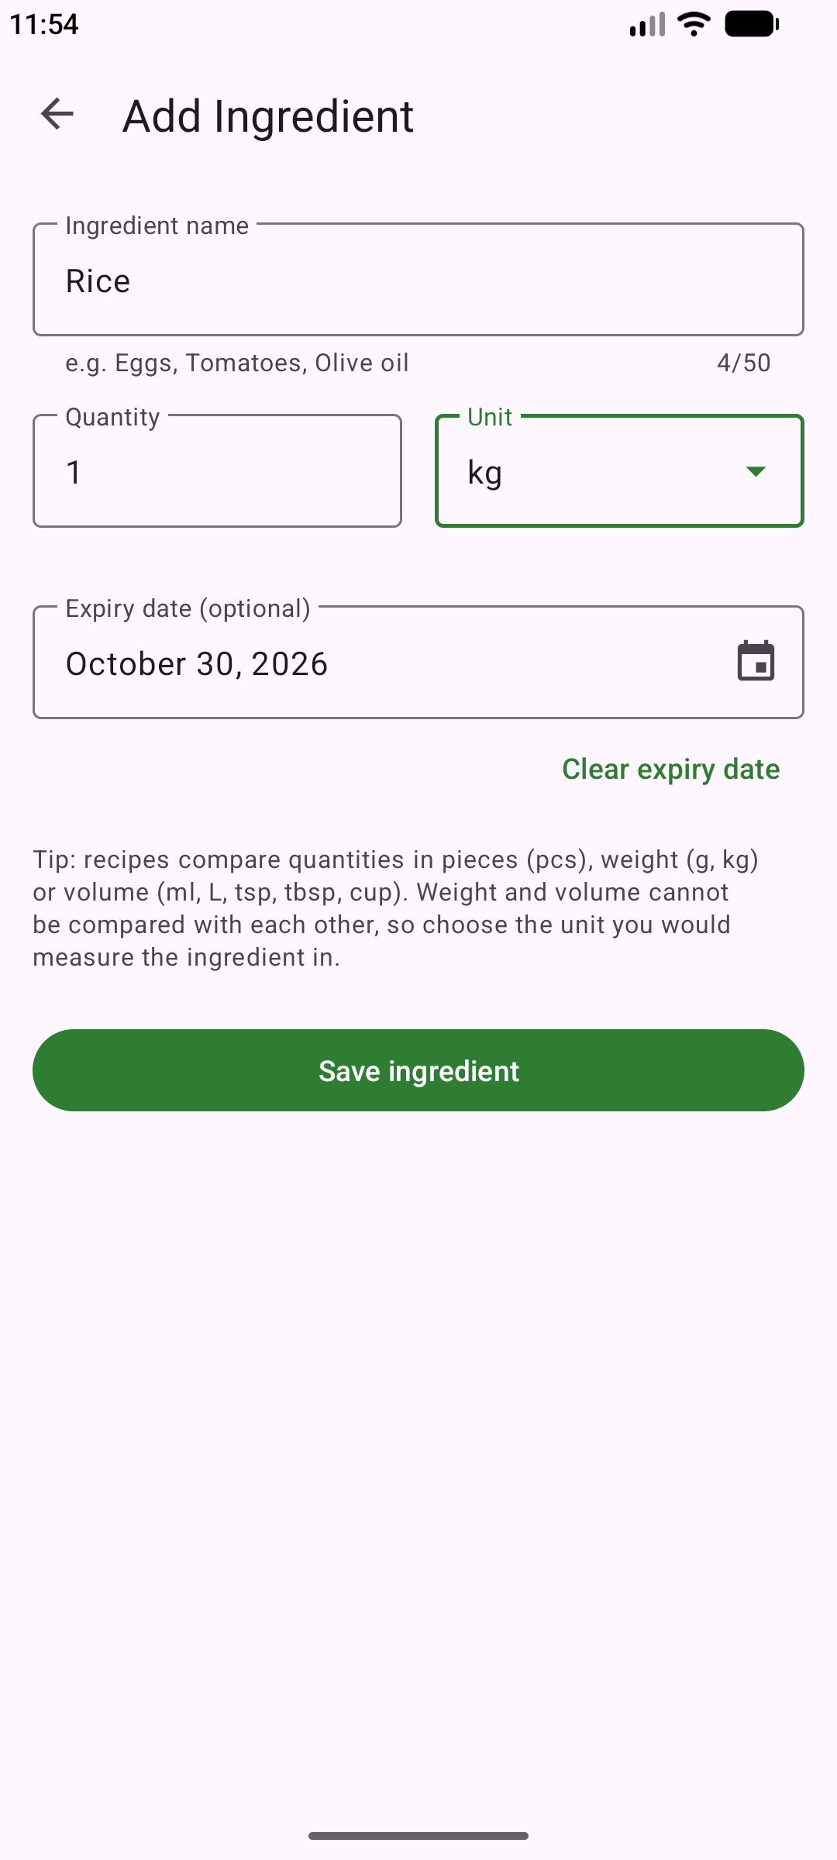  Figure 10: Completed valid form: Rice, 1 kg, expiring 30 October 2026. | 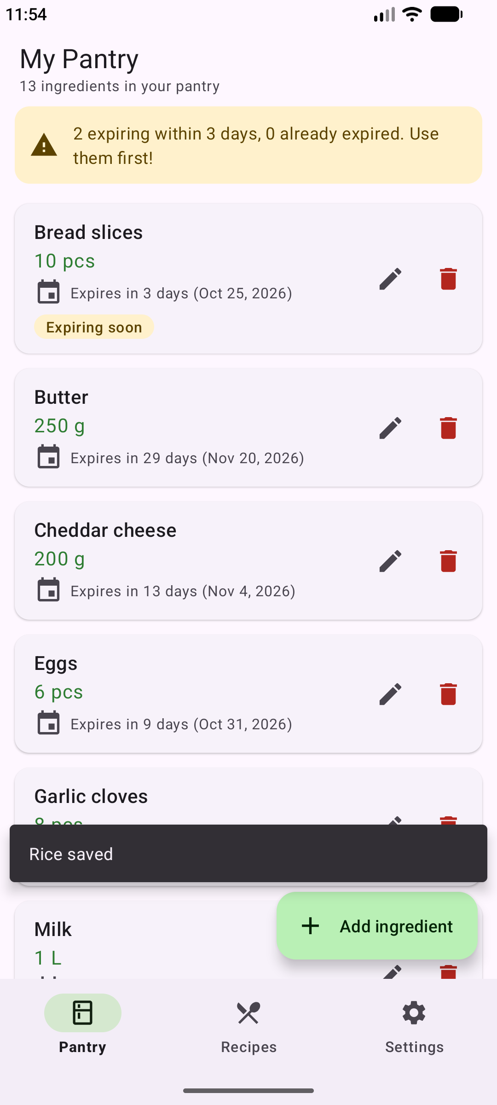  Figure 11: After saving, the app returns to the pantry, which refreshes (13 items) and shows “Rice saved”.

3.3 Edit ingredient (Update)
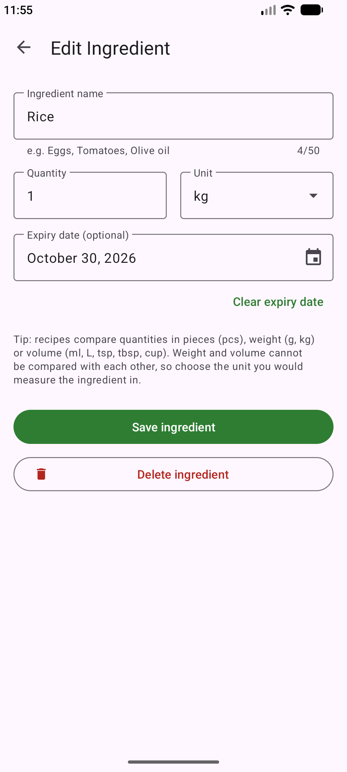  Figure 12: Edit mode: the same form loads the saved item by id from SQLite and shows a Delete button. | 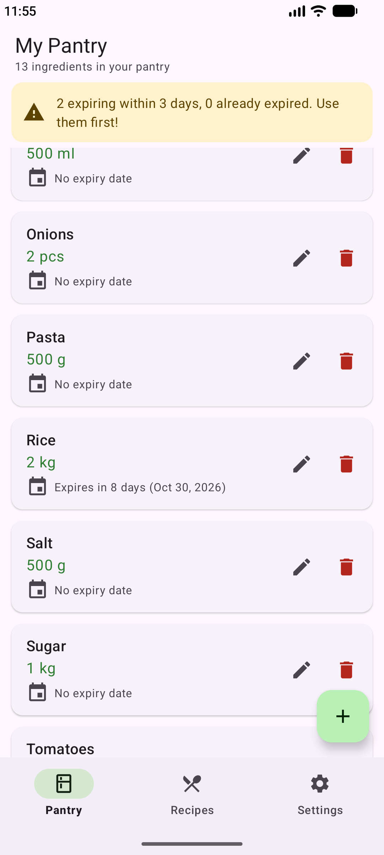  Figure 13: After changing the quantity to 2 and saving, the list shows Rice as 2 kg.

3.4 Delete ingredient (Delete)
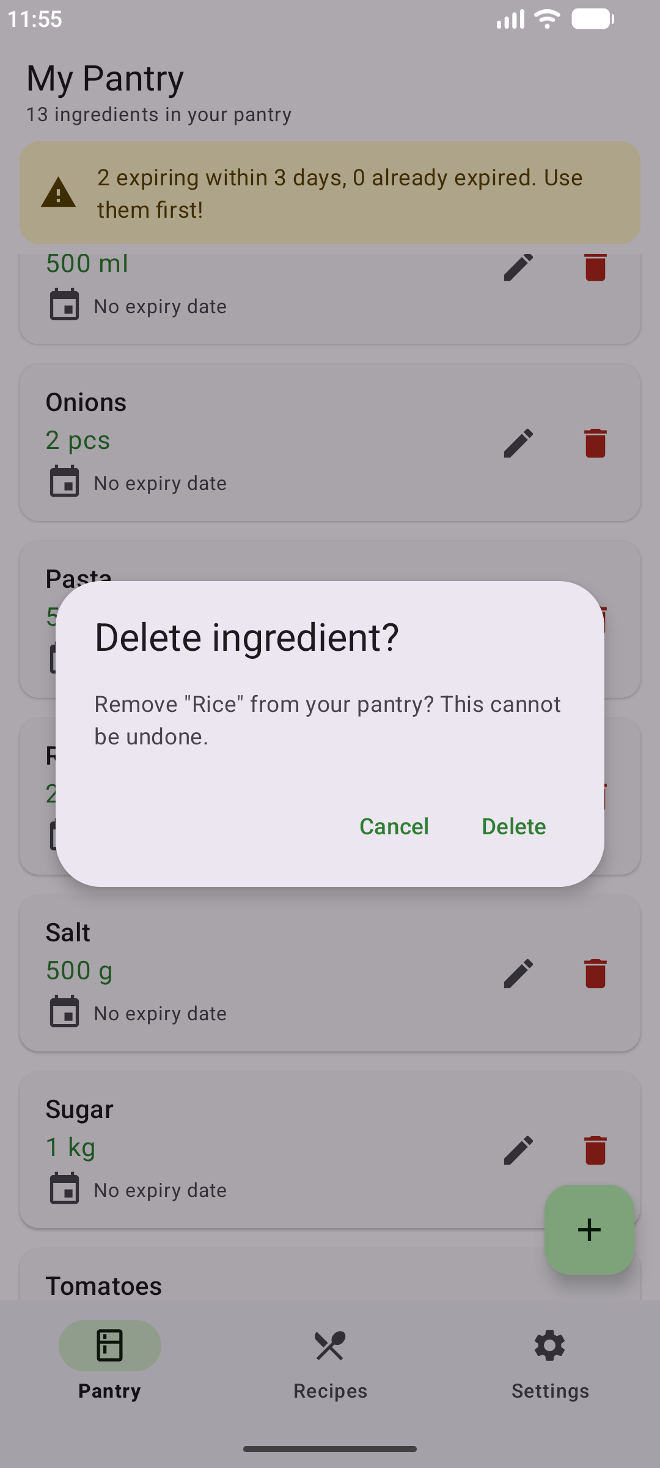  Figure 14: Tapping the bin icon asks for confirmation before deleting. | 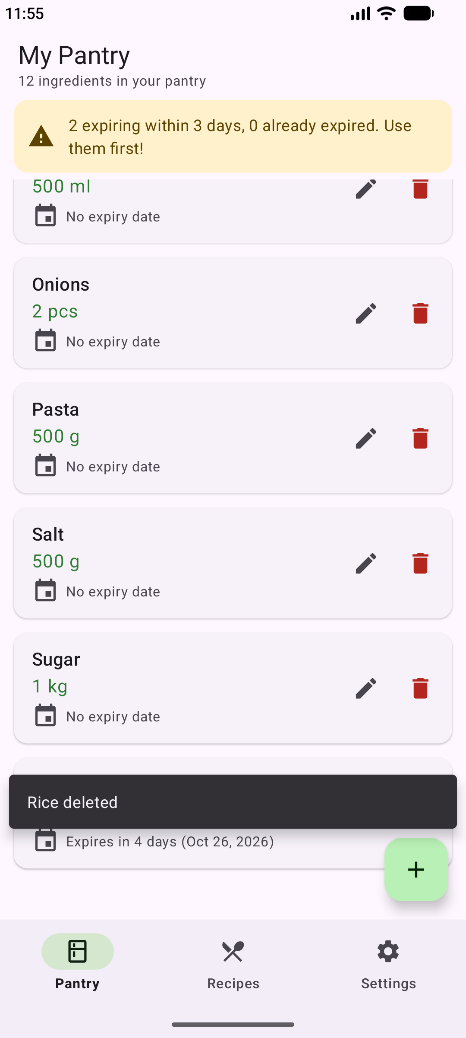  Figure 15: Rice has been removed from the database and the list (back to 12 items).

3.5 Suggested recipes
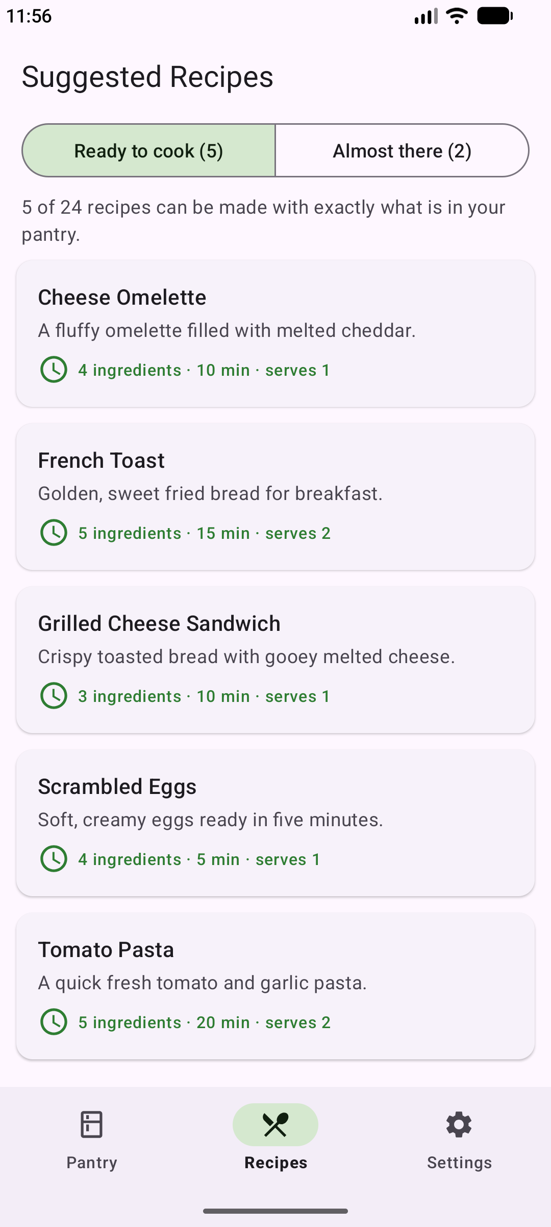  Figure 16: Ready to cook: 5 of the 24 recipes can be made with exactly what is in the pantry. | 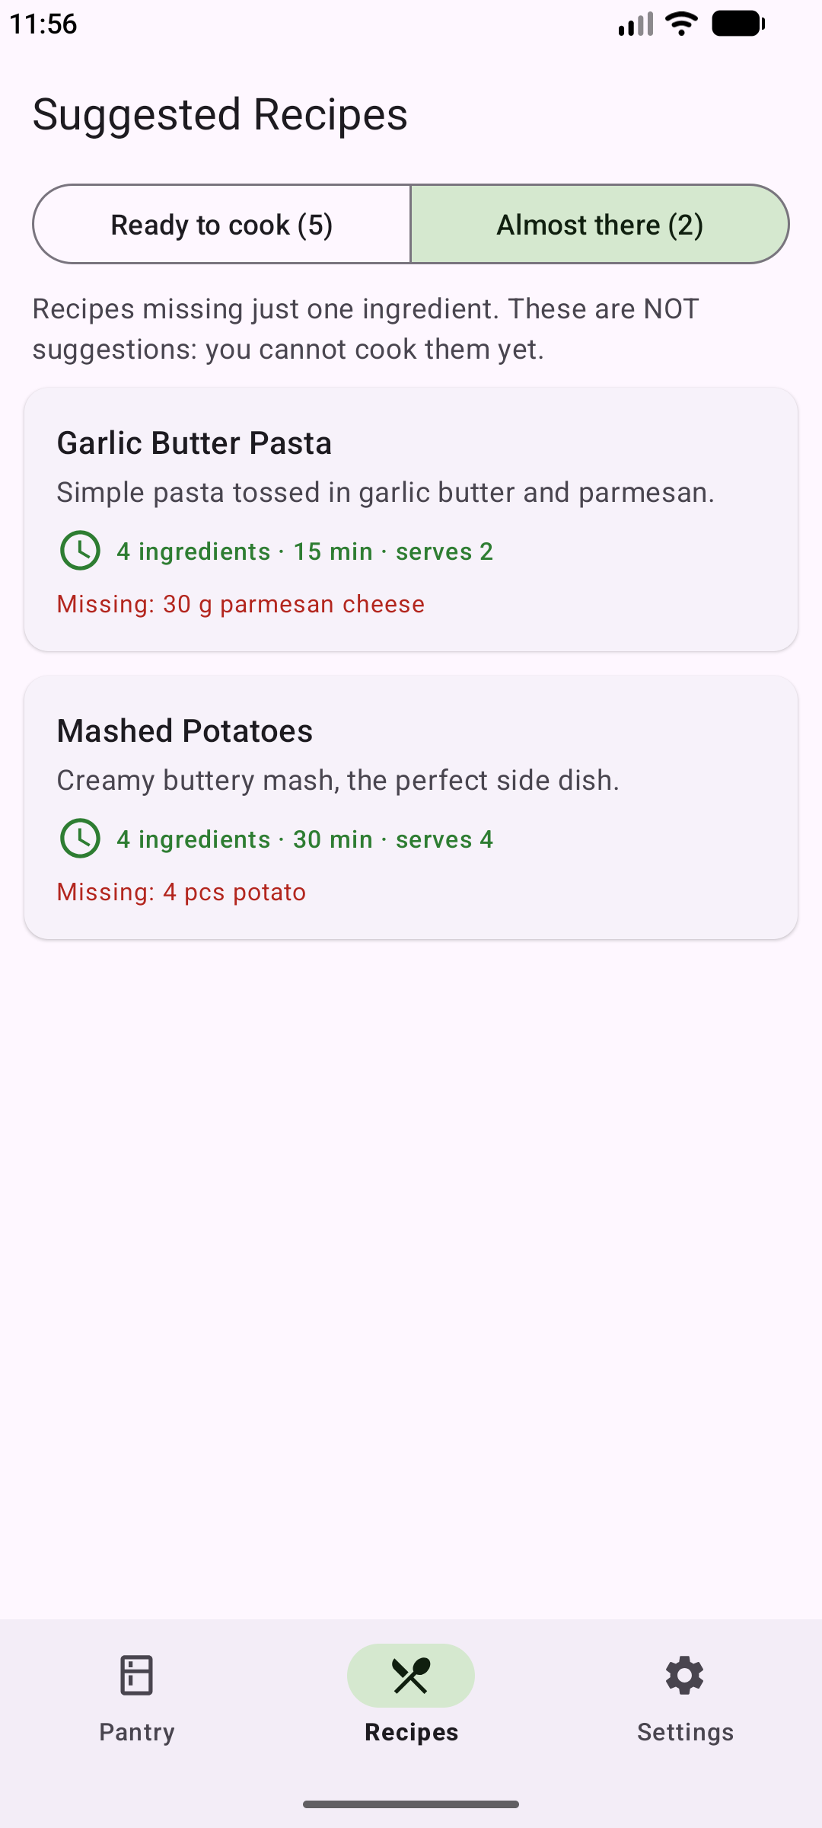  Figure 17: The separate “Almost there” tab: recipes missing exactly one ingredient, with what is missing. | 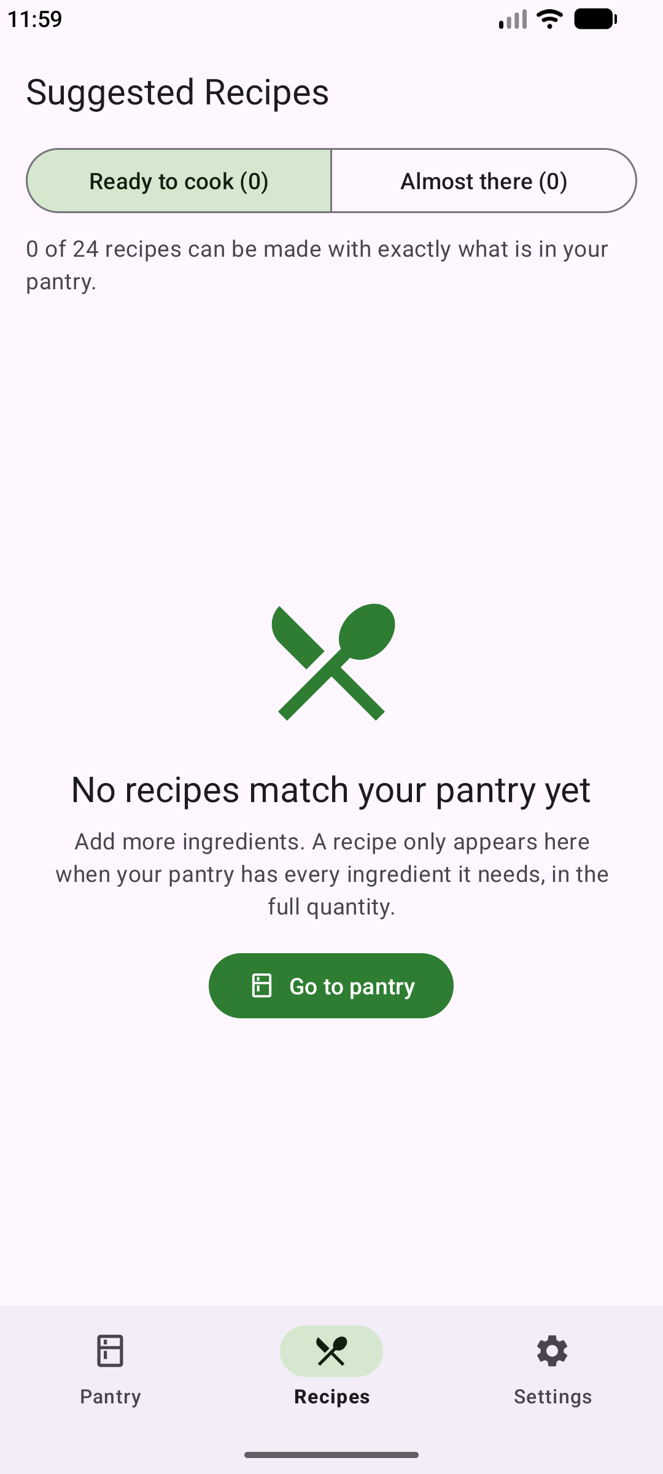  Figure 18: With an empty pantry the screen shows “No recipes match your pantry yet” instead of a blank list.

3.6 Recipe detail
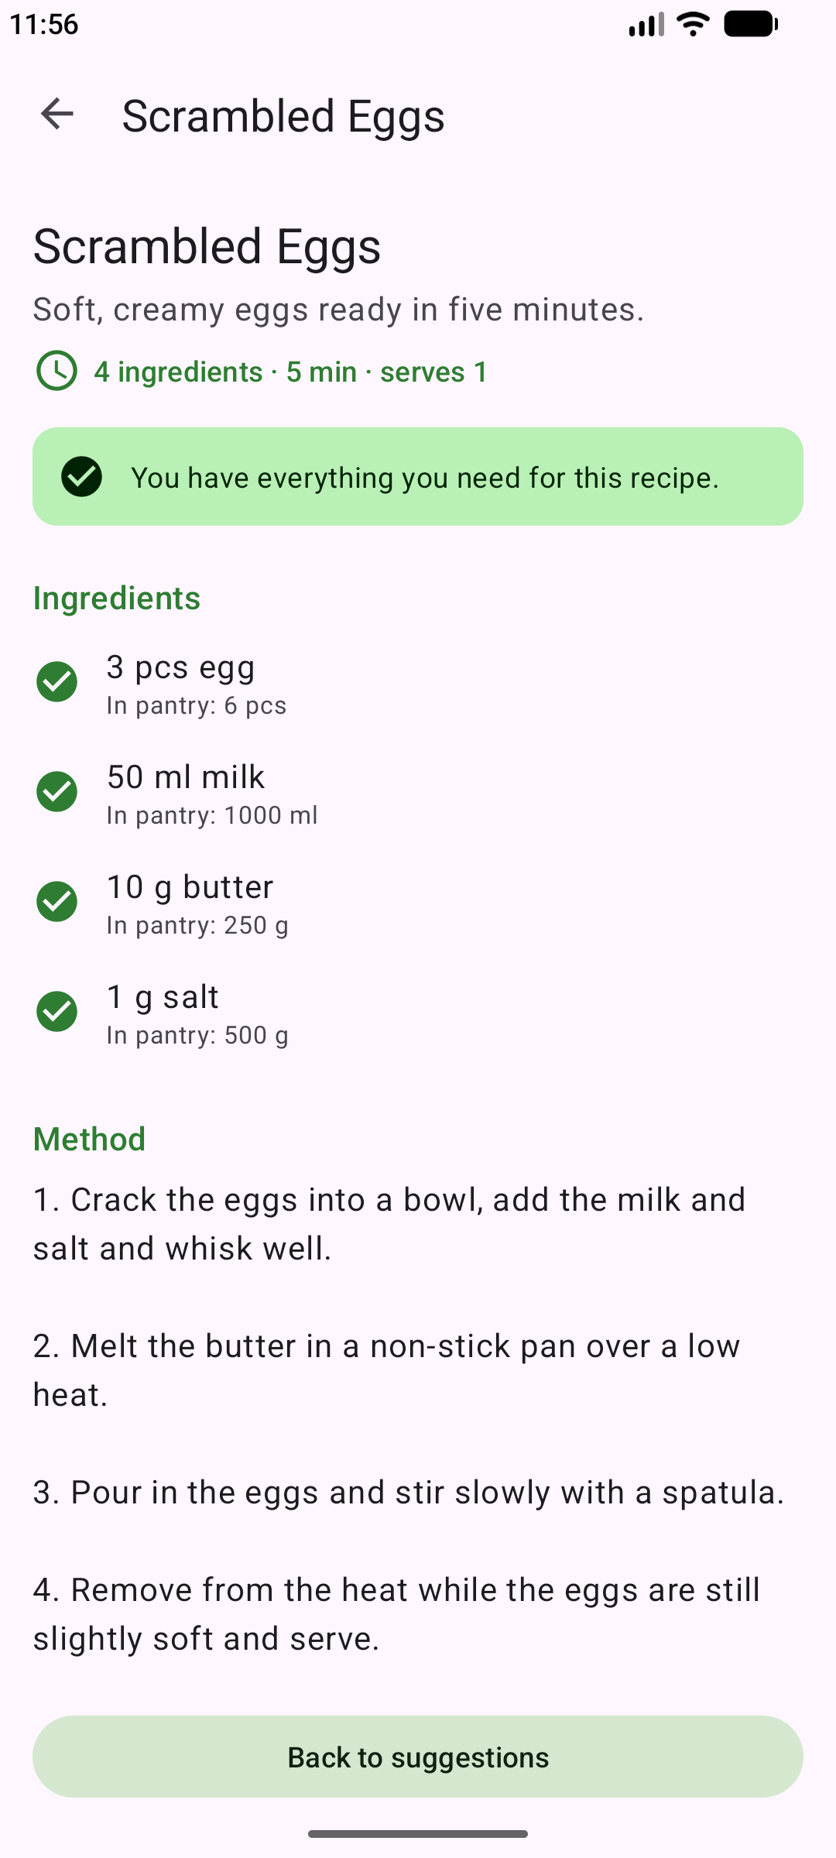  Figure 19: Scrambled Eggs: every ingredient is ticked with the amount in the pantry (milk 1 L shown as 1000 ml). | 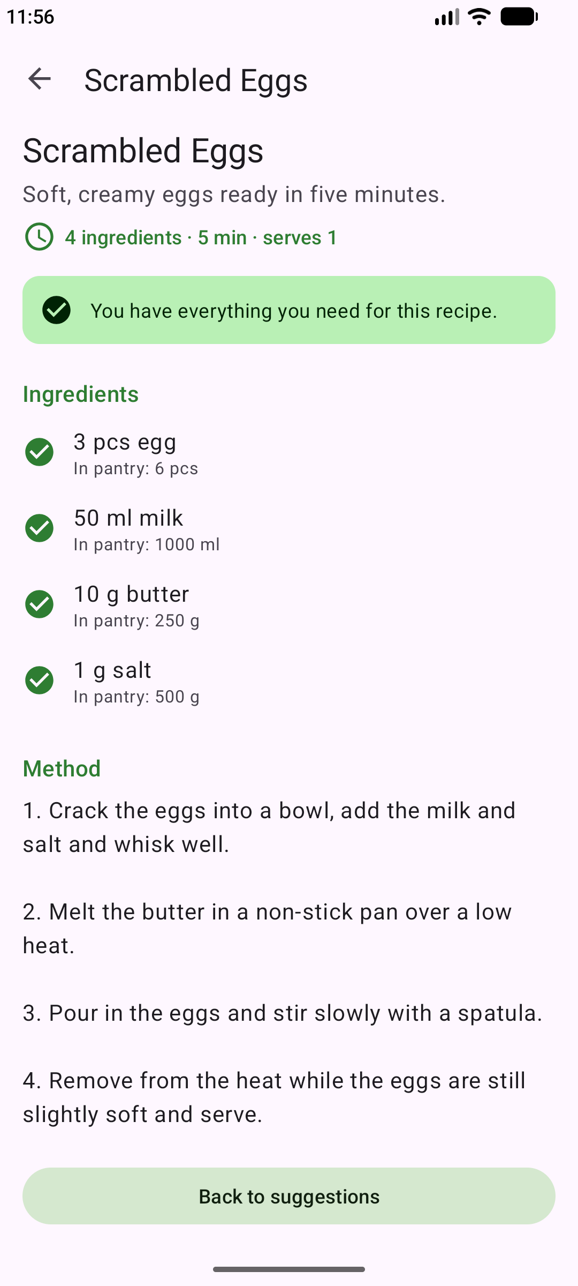  Figure 20: The numbered preparation method and the “Back to suggestions” button. | 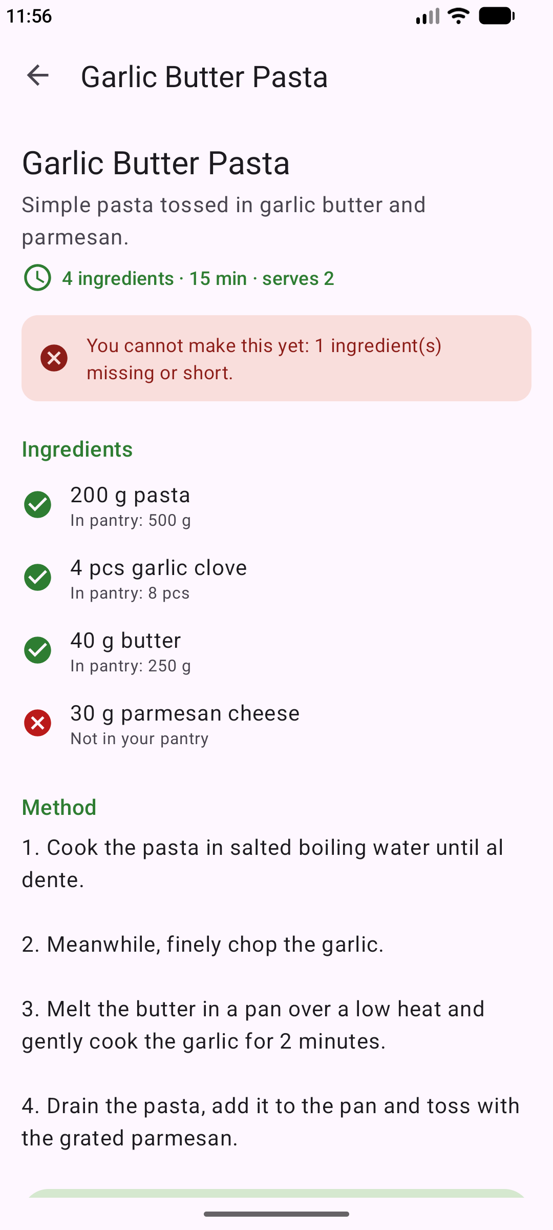  Figure 21: Garlic Butter Pasta cannot be made: parmesan cheese is not in the pantry.

3.7 Proof of the strict-matching rule
Scrambled Eggs and Cheese Omelette each need 3 eggs. Changing the pantry’s eggs from 6 to 2 removes both recipes from the suggestions; restoring 6 eggs brings them back.
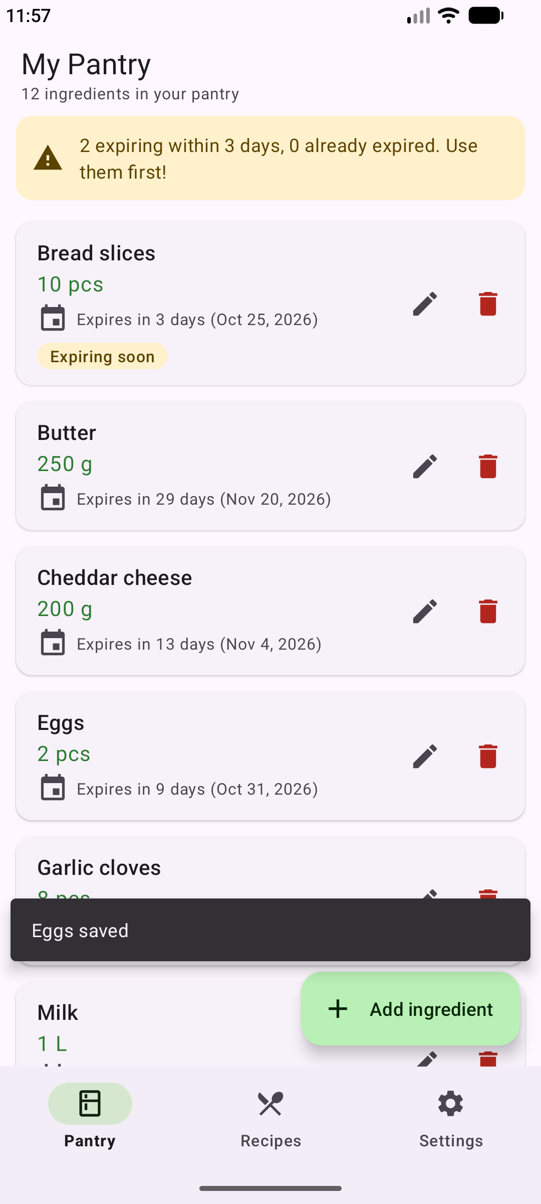  Figure 22: Eggs edited from 6 pcs to 2 pcs. | 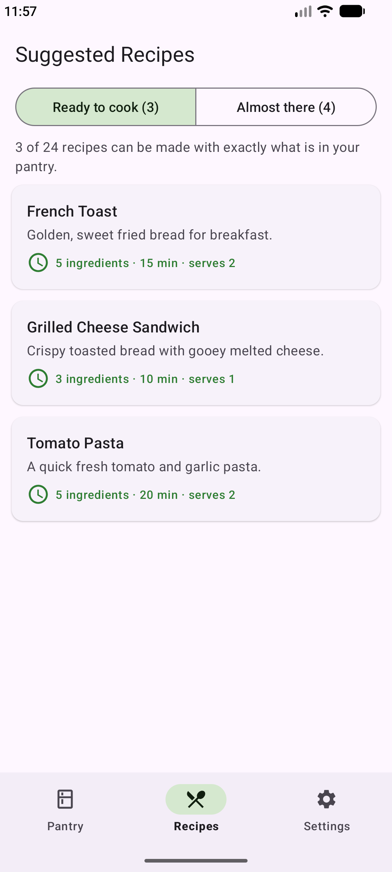  Figure 23: Ready to cook drops from 5 to 3: Scrambled Eggs and Cheese Omelette disappear. | 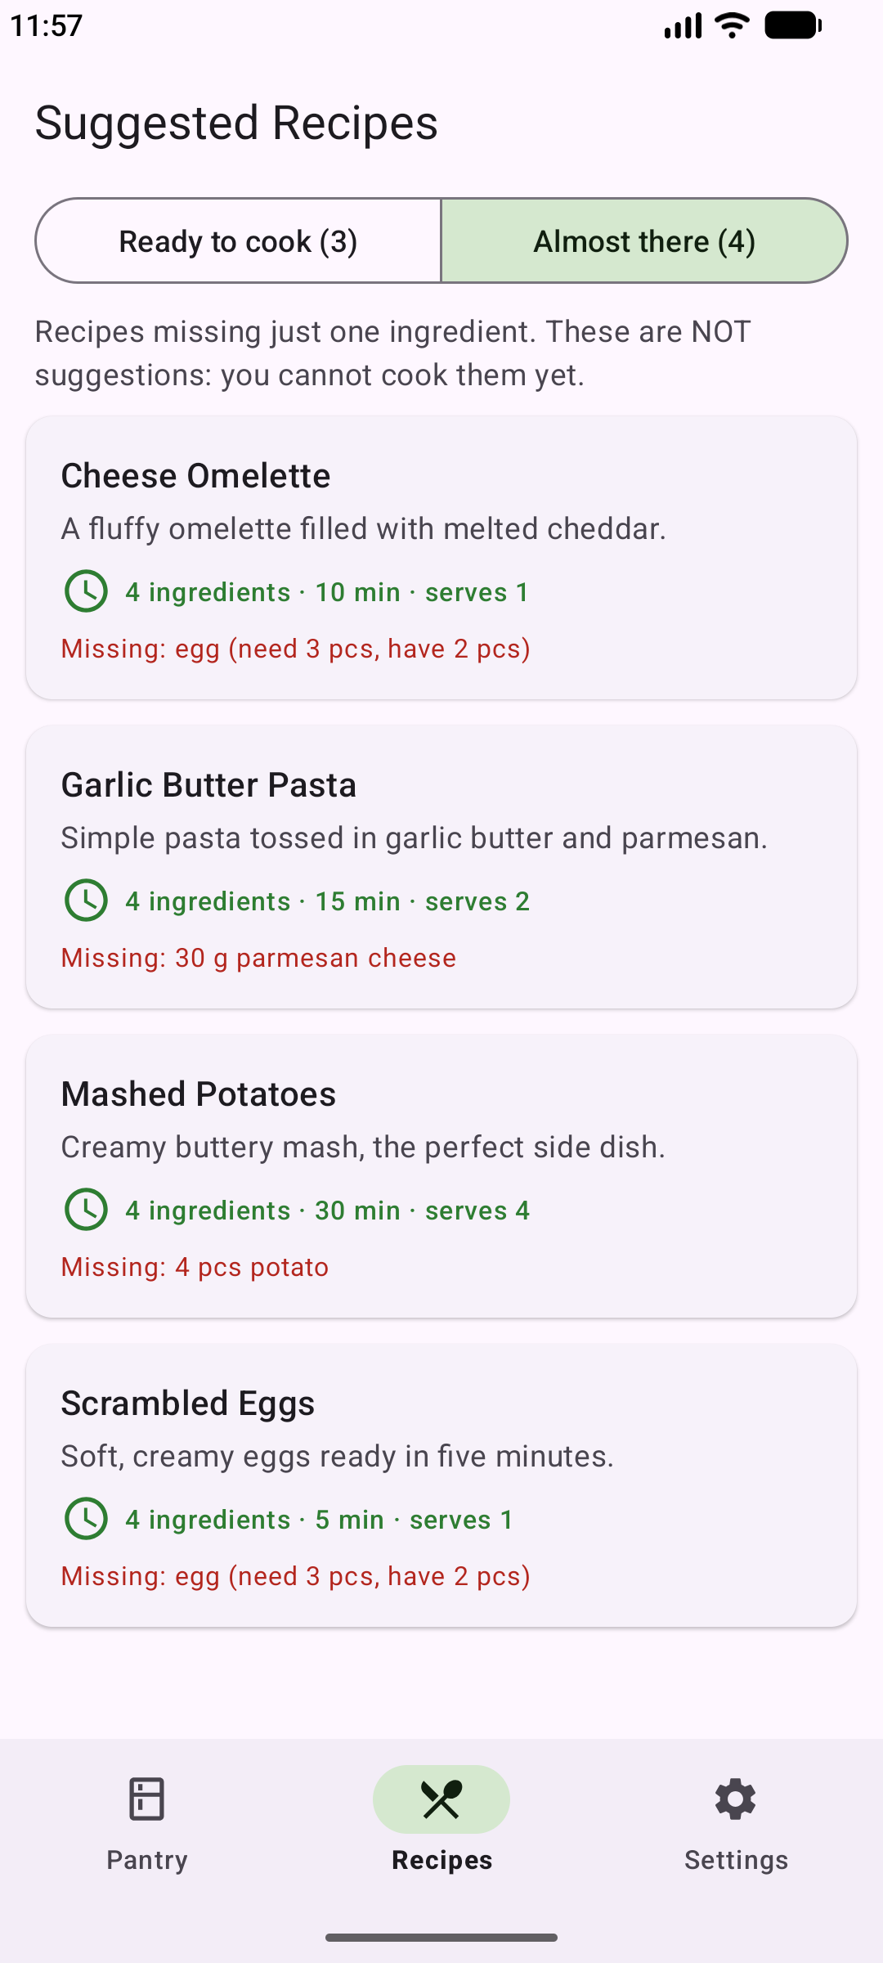  Figure 24: They now appear under Almost there: “Missing: egg (need 3 pcs, have 2 pcs)”.

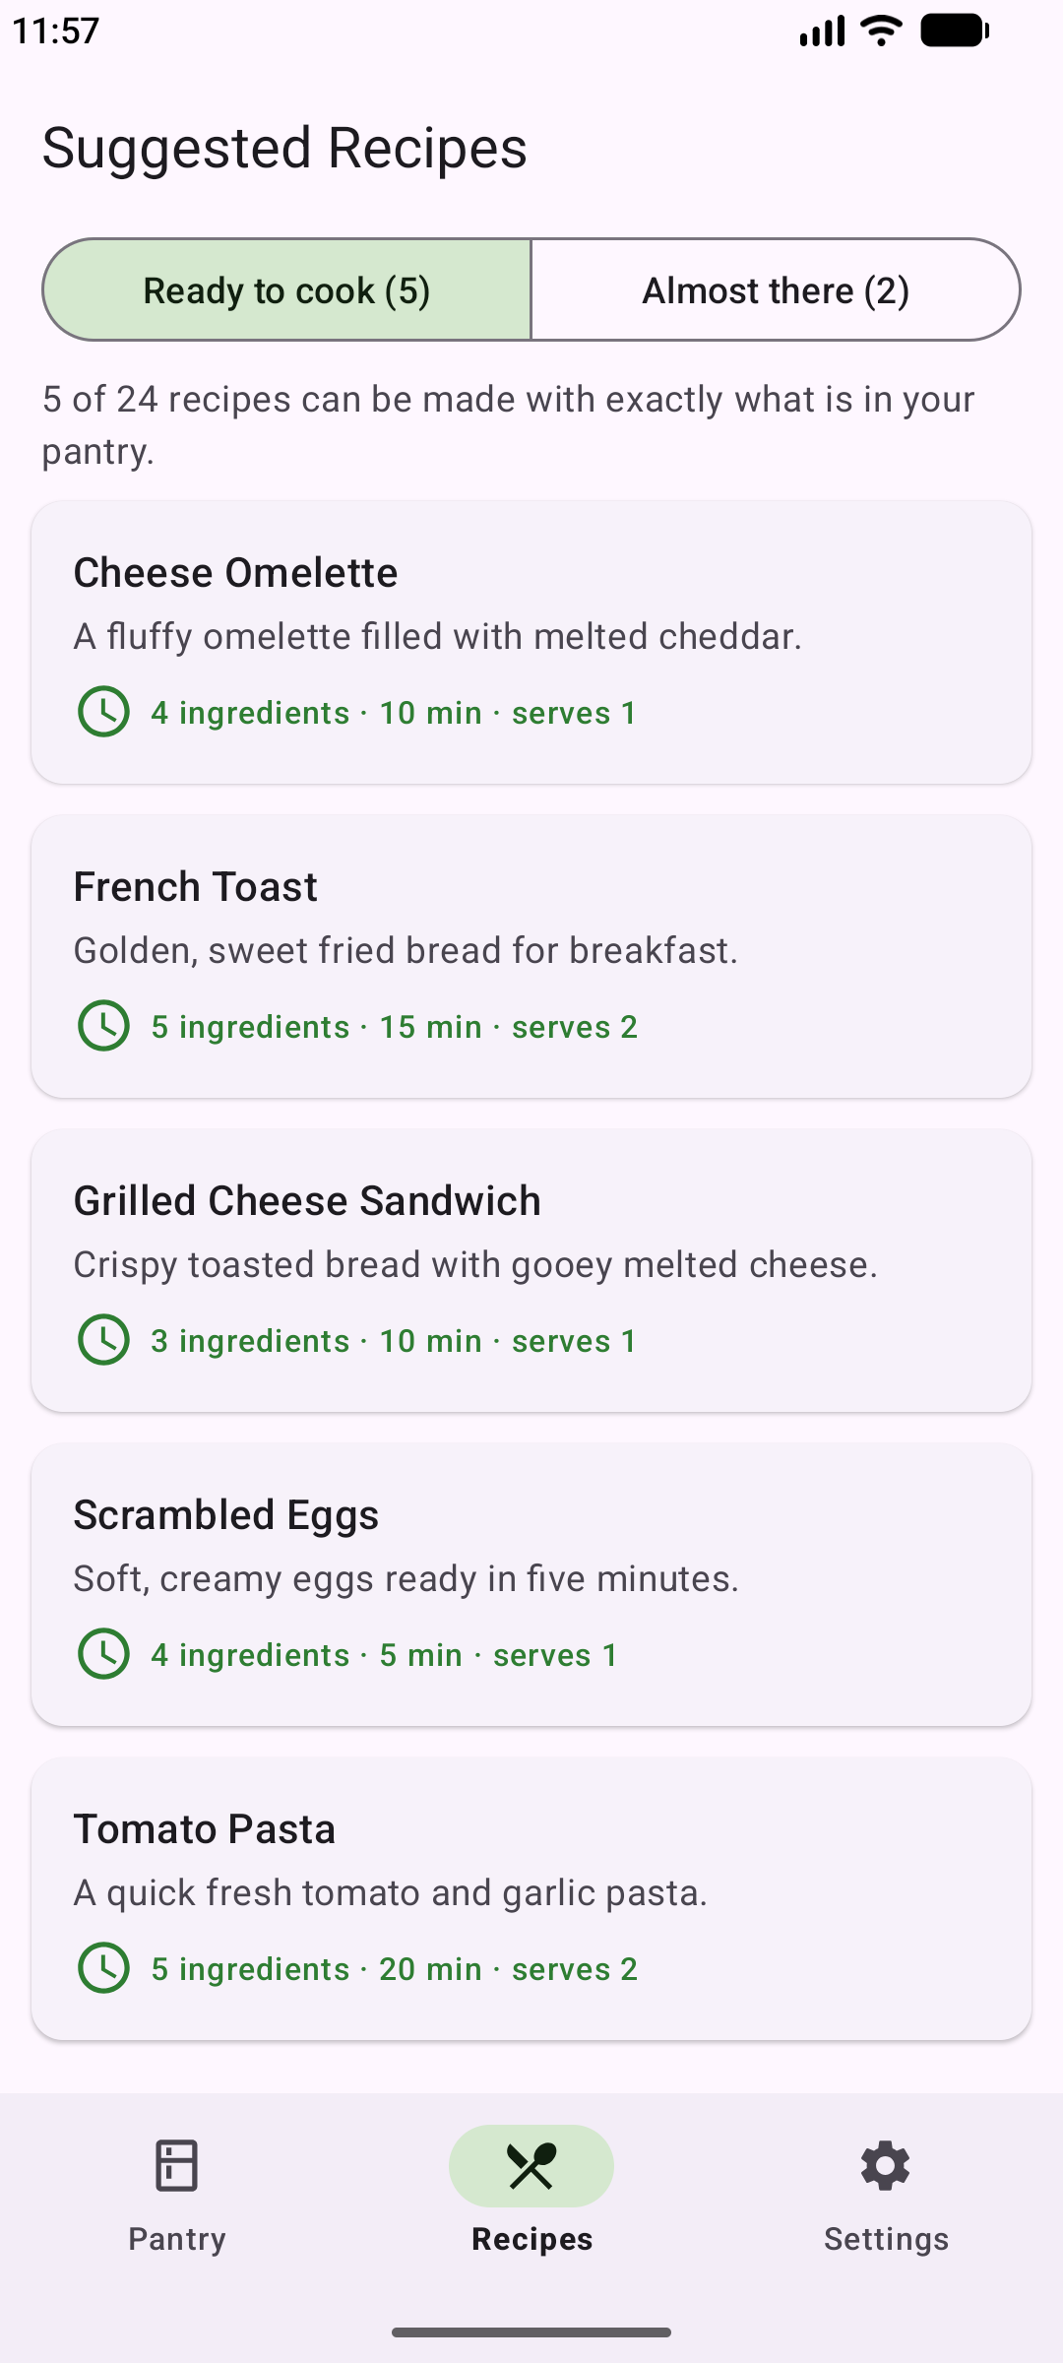
Figure 25: After restoring 6 eggs, both recipes are suggested again (5 recipes).

3.8 Settings and persistence
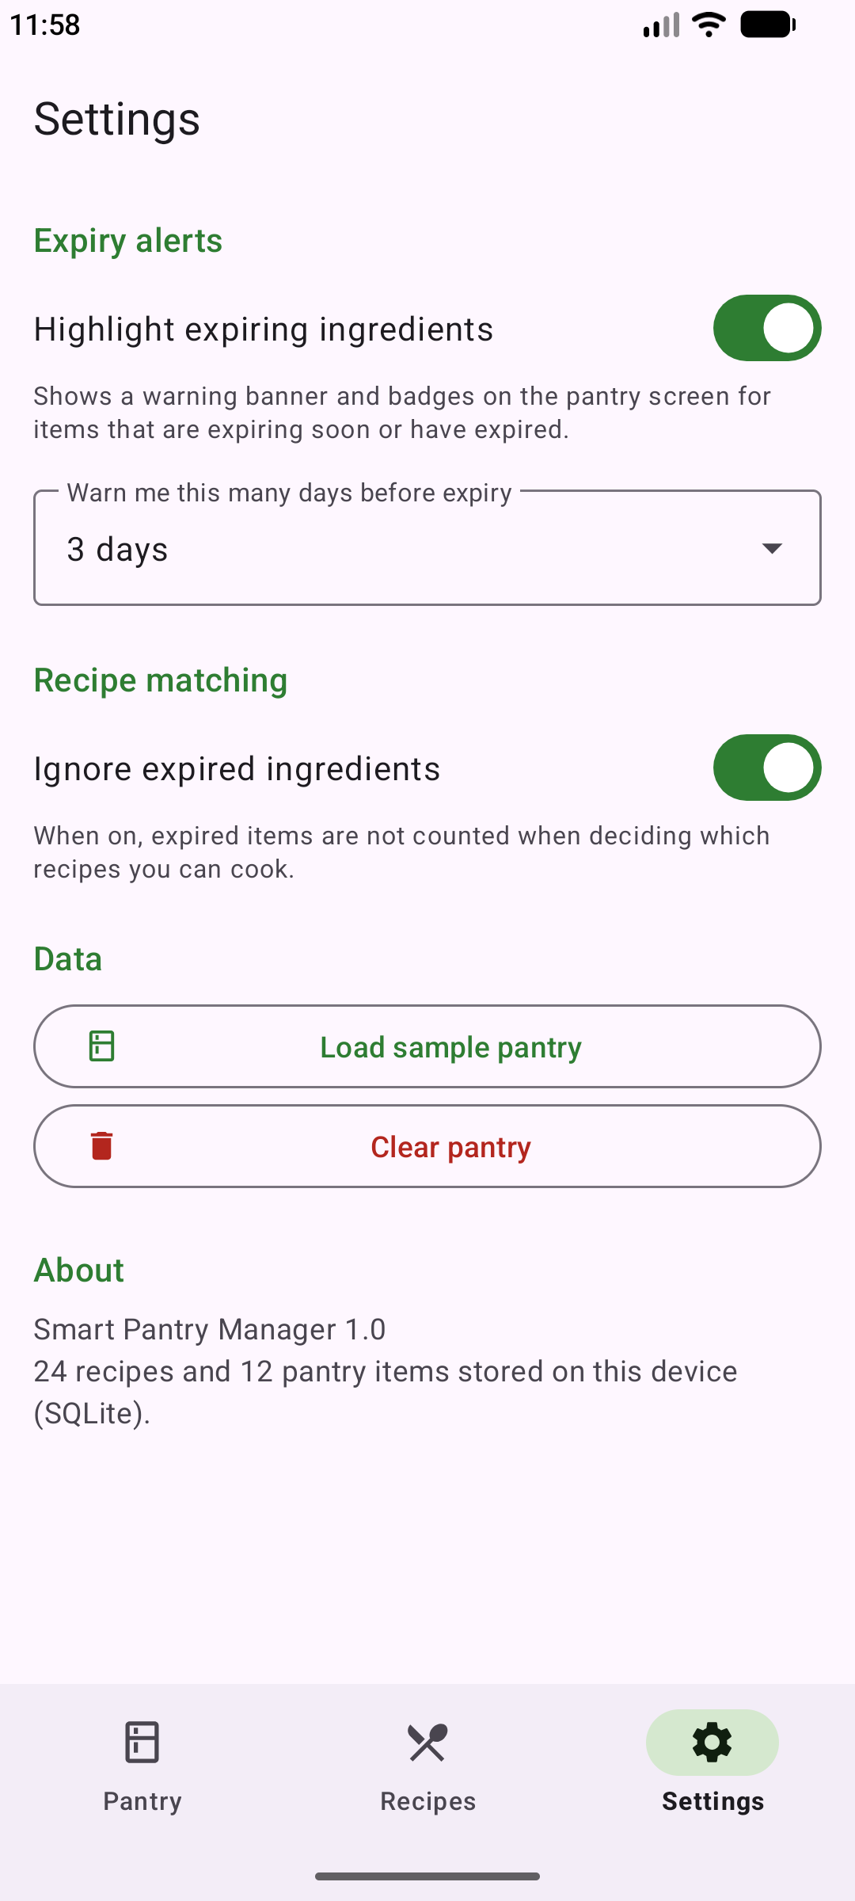  Figure 26: Settings: expiry alerts, warning window, ignore expired ingredients, data tools and About. | 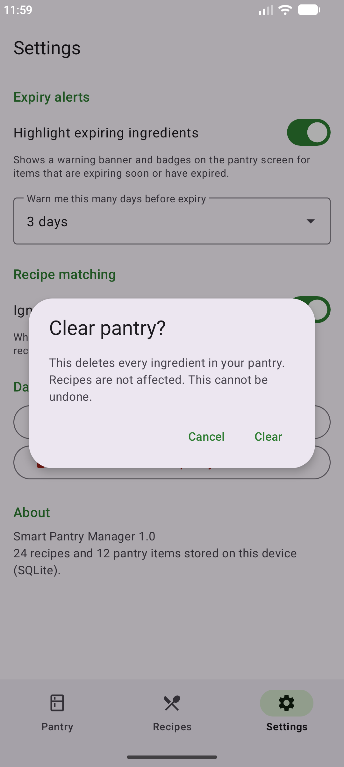  Figure 27: Clear pantry asks for confirmation; recipes are not affected. | 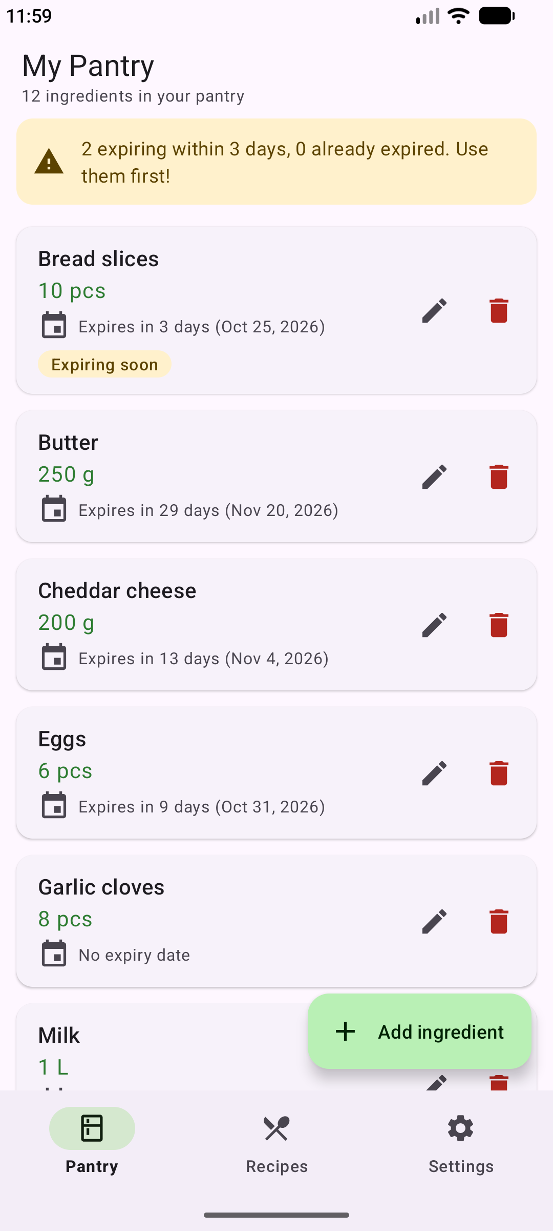  Figure 28: The app after being force-stopped and reopened: all 12 pantry items are still there (SQLite persistence).

4. Key Code Snippets

4.1 The strict-matching rule
private IngredientCheck checkIngredient(RecipeIngredient ingredient,
Map<String, Map<UnitConverter.Dimension, Double>> index,
Map<String, Double> requiredTotals) {
String key = IngredientNormalizer.normalize(ingredient.getName());
Map<UnitConverter.Dimension, Double> available = index.get(key);
UnitConverter.Dimension dimension = UnitConverter.getDimension(ingredient.getUnit());

if (available == null || available.isEmpty()) {
return new IngredientCheck(ingredient, IngredientCheck.Status.MISSING, 0);
}
if (dimension == null || ingredient.getQuantity() <= 0 || !available.containsKey(dimension)) {
// The pantry has this ingredient but its quantity cannot be compared
// reliably with the recipe, so the recipe must not be suggested.
return new IngredientCheck(ingredient, IngredientCheck.Status.INCOMPATIBLE_UNIT, 0);
}

double availableBase = available.get(dimension);
double requiredBase = requiredTotals.get(key + "|" + dimension);
double availableInRecipeUnit = UnitConverter.fromBase(availableBase, ingredient.getUnit());

if (availableBase + EPSILON >= requiredBase) {
return new IngredientCheck(ingredient, IngredientCheck.Status.AVAILABLE, availableInRecipeUnit);
}
return new IngredientCheck(ingredient, IngredientCheck.Status.INSUFFICIENT, availableInRecipeUnit);
}
Source: RecipeMatcher.java, line 115
public boolean isMatch() {
if (checks.isEmpty()) {
return false;
}
for (IngredientCheck check : checks) {
if (!check.isSatisfied()) {
return false;
}
}
return true;
}
Source: MatchResult.java, line 35
checkIngredient() classifies one recipe ingredient. It first finds the pantry total for the same normalised name. If there is none the ingredient is MISSING. If the pantry only holds it in a unit of a different kind (for example grams against teaspoons), it is INCOMPATIBLE_UNIT, because guessing a conversion could suggest a recipe the user cannot actually make. Otherwise both quantities are compared in base units: enough is AVAILABLE, too little is INSUFFICIENT. isMatch() then applies the strict rule: a recipe is suggested only if every check is AVAILABLE, so a recipe needing 5 ingredients with only 4 in the pantry is always excluded. A small EPSILON absorbs floating-point rounding so that exactly enough (3 eggs for a 3-egg recipe) counts as enough.

4.2 Ingredient name normalisation
static String singularize(String word) {
if (word.length() <= 3 || INVARIANT.contains(word)) {
return word;
}
String irregular = IRREGULAR.get(word);
if (irregular != null) {
return irregular;
}
if (word.endsWith("ies") && word.length() > 4) {
return word.substring(0, word.length() - 3) + "y"; // berries -> berry
}
if (word.endsWith("oes")) {
return word.substring(0, word.length() - 2); // avocadoes -> avocado
}
if (word.endsWith("ches") || word.endsWith("shes") || word.endsWith("sses")
|| word.endsWith("xes") || word.endsWith("zzes")) {
return word.substring(0, word.length() - 2); // peaches -> peach
}
if (word.endsWith("s") && !word.endsWith("ss")
&& !word.endsWith("us") && !word.endsWith("is")) {
return word.substring(0, word.length() - 1); // eggs -> egg
}
return word;
}
Source: IngredientNormalizer.java, line 109
A naive exact-string comparison fails on “tomato” vs “tomatoes”. Before comparing, every name is lower-cased, cleaned of punctuation, and its last word is singularised with these rules (plus a small table of irregular plurals such as leaves → leaf and words that are already singular such as hummus). Names must then be exactly equal. No substring matching is used, so “butter” never matches “peanut butter” and “egg” never matches “egg white”. Only the last word is singularised because that is where English puts the plural (“cherry tomatoes” → “cherry tomato”).

4.3 Unit conversion
static {
register(PIECES, Dimension.COUNT, 1, "pc", "piece", "pieces", "each", "whole", "item", "items", "unit", "units");
register(GRAMS, Dimension.MASS, 1, "gram", "grams", "gr", "gm");
register(KILOGRAMS, Dimension.MASS, 1000, "kilogram", "kilograms", "kilo", "kilos", "kgs");
register(MILLILITRES, Dimension.VOLUME, 1, "millilitre", "millilitres", "milliliter", "milliliters", "mls");
register(LITRES, Dimension.VOLUME, 1000, "l", "litre", "litres", "liter", "liters", "lt", "ltr");
register(TEASPOON, Dimension.VOLUME, 5, "teaspoon", "teaspoons", "tsps");
register(TABLESPOON, Dimension.VOLUME, 15, "tablespoon", "tablespoons", "tbsps", "tbs");
// Metric cup (250 ml), as used in South African recipes.
register(CUP, Dimension.VOLUME, 250, "cups", "c");
}
Source: UnitConverter.java, line 45
Every unit belongs to a dimension (count, mass or volume) and has a factor to that dimension’s base unit, so 1 cup becomes 250 ml and 0.2 kg becomes 200 g before comparing. A metric cup of 250 ml is used, as in South African recipes. There is deliberately no conversion between mass and volume, because that depends on each ingredient’s density.

4.4 Seeding the database once
void seedRecipes(SQLiteDatabase db) {
if (DatabaseUtils.queryNumEntries(db, TABLE_RECIPES) > 0) {
return;
}
db.beginTransaction();
try {
for (Recipe recipe : RecipeSeedData.getRecipes()) {
ContentValues recipeValues = new ContentValues();
recipeValues.put(COL_RECIPE_NAME, recipe.getName());
recipeValues.put(COL_RECIPE_DESCRIPTION, recipe.getDescription());
recipeValues.put(COL_RECIPE_INSTRUCTIONS, recipe.getInstructions());
recipeValues.put(COL_RECIPE_PREP_MINUTES, recipe.getPrepMinutes());
recipeValues.put(COL_RECIPE_SERVINGS, recipe.getServings());
long recipeId = db.insertWithOnConflict(TABLE_RECIPES, null, recipeValues,
SQLiteDatabase.CONFLICT_IGNORE);
if (recipeId == -1) {
continue; // a recipe with this name already exists
}
for (RecipeIngredient ingredient : recipe.getIngredients()) {
ContentValues ingredientValues = new ContentValues();
ingredientValues.put(COL_RI_RECIPE_ID, recipeId);
ingredientValues.put(COL_RI_NAME, ingredient.getName());
ingredientValues.put(COL_RI_QUANTITY, ingredient.getQuantity());
ingredientValues.put(COL_RI_UNIT, ingredient.getUnit());
db.insertOrThrow(TABLE_RECIPE_INGREDIENTS, null, ingredientValues);
}
}
db.setTransactionSuccessful();
} finally {
db.endTransaction();
}
}
Source: DatabaseHelper.java, line 154
seedRecipes() is called from onCreate(), which SQLiteOpenHelper runs only when the database file does not exist yet. The row-count guard and CONFLICT_IGNORE on the UNIQUE recipe name make it safe even if it is called again. The whole seed runs in one transaction: it is much faster than more than 130 separate inserts, and if anything fails nothing is half-written.

4.5 Displaying database data in the RecyclerView
private void loadPantry() {
List<PantryItem> items = pantryRepository.getAll();
LocalDate today = LocalDate.now();
boolean alertsEnabled = settings.isExpiryAlertsEnabled();
int windowDays = settings.getExpiryWindowDays();

adapter.setItems(items, alertsEnabled, windowDays, today);

boolean isEmpty = items.isEmpty();
emptyState.setVisibility(isEmpty ? View.VISIBLE : View.GONE);
recyclerView.setVisibility(isEmpty ? View.GONE : View.VISIBLE);
if (isEmpty) {
// Nothing to scroll, so show the full "Add ingredient" label again.
fabAdd.extend();
}
toolbar.setSubtitle(isEmpty ? null
: getResources().getQuantityString(R.plurals.pantry_summary, items.size(), items.size()));

updateExpiryBanner(items, today, alertsEnabled, windowDays);
}
Source: MainActivity.java, line 102
loadPantry() is called from onResume(), so the list is reloaded from SQLite every time the screen becomes visible, including after returning from the Add/Edit screen. The adapter receives the new list and its onBindViewHolder() fills each card. The empty-state view and the expiry banner are switched on or off from the same data, so the screen is never blank or out of date.

5. Challenges and Solutions

5.1 Build failed: Gradle version too old for the Android Gradle Plugin
Problem. The first build stopped with “Minimum supported Gradle version is 9.6.0. Current version is 9.5.1.” The Gradle wrapper had been generated with Gradle 9.5.1, but Android Gradle Plugin 9.4.1 requires Gradle 9.6 or newer.
Solution. The distributionUrl in gradle/wrapper/gradle-wrapper.properties was changed to Gradle 9.6.1. The next build succeeded. The lesson was that the Android Gradle Plugin and the Gradle wrapper versions must be upgraded together. The same build also showed Gradle 10 deprecation warnings for the old Groovy property value syntax, so app/build.gradle was rewritten using property = value assignments.

5.2 The first GitHub Actions build failed with exit code 126
Problem. A GitHub Actions workflow was added so that every push builds the app and runs all the unit tests. The project built and passed every test on the Windows development machine, but the first run on GitHub’s Linux server stopped at the build step with “Process completed with exit code 126”.
Solution. Exit code 126 means a file was found but could not be executed. The project had been committed from Windows, which does not record the Unix “executable” permission, so the gradlew wrapper script was stored as a normal file. Running git update-index --chmod=+x gradlew and committing fixed it, together with a .gitattributes rule that keeps the script’s Unix line endings. The same commit moved the workflow to the current versions of the GitHub actions, because the old ones were reported as deprecated. The lesson was that “it works on my machine” is not enough, and an automated build on a clean machine catches problems like this early.

5.3 Making the matching strict but still realistic
Problem. Two situations could make the matcher give the wrong answer. First, recipes measure salt in grams, but a user might enter salt in teaspoons; converting between the two needs density data the app does not have. Second, a user may have two pantry rows for the same ingredient (two egg boxes with different expiry dates), and comparing only one row would wrongly exclude recipes. Combining rows has a side effect worth knowing for testing: if two Eggs rows exist, editing one of them down to 2 will not remove Scrambled Eggs, because the rows together still add up to enough.
Solution. Quantities are only compared within the same dimension. Mass-vs-volume cases are reported as “a unit that cannot be compared” and the recipe is excluded, which keeps the strict rule safe. Duplicate rows with compatible units are summed in base units, and when a user adds an ingredient that already exists the app tells them the two rows will be combined. Unit tests cover each case (for example incompatibleUnitsExcludeTheRecipe and duplicatePantryRowsAreAddedTogether).

6. Conclusion and Reflection

6.1 Conclusion
Smart Pantry Manager meets the requirements of the brief. It is a Java Android application with five screens connected by explicit Intents and a bottom navigation bar. It provides full Create, Read, Update and Delete operations on pantry items stored in SQLite, data that persists after the app is closed, validated data entry, and 24 seeded recipes. Most importantly, it applies the strict-matching rule: a recipe is suggested only when every ingredient is in the pantry in sufficient quantity, while plural names, unit conversions and duplicate pantry rows are handled correctly. 81 automated tests pass locally and in GitHub Actions, and the behaviour was confirmed on an emulator, as the screenshots in Section 3 show.

6.2 Personal reflection
This project turned the module’s Android fundamentals into something concrete. The clearest lesson was about the Activity lifecycle: because the pantry list and the recipe suggestions are reloaded in onResume(), every screen shows current data when the user comes back from adding or editing an ingredient, without any extra refresh code. Passing only database ids between screens in Intent extras, and loading the record again on the next screen, kept the screens independent and avoided showing stale data. Writing the RecyclerView adapters showed why the ViewHolder pattern exists: each row layout is inflated once and then only re-bound as the user scrolls.
The hardest part was the strict-matching rule. Comparing names directly fails on “tomato” versus “tomatoes”, but loose substring matching would wrongly treat “peanut butter” as “butter”. Normalising names and then demanding an exact match, and refusing to compare grams with millilitres, made the rule both robust and safe. Testing taught a related lesson. The automated tests proved the logic, yet running the app on an emulator still revealed a bug that no test had covered (the add button stayed collapsed on an empty screen), and the first GitHub Actions run exposed a problem that never appeared on Windows. Both were fixed and are now covered by a test and an automated build. Given more time, I would add the improvements listed below, starting with a “Mark as cooked” button.

6.3 Future improvements
- A “Mark as cooked” button that subtracts a recipe’s ingredients from the pantry.
- Letting users add, edit and favourite their own recipes.
- Expiry reminders as system notifications using WorkManager.
- Density-based gram ↔ millilitre conversion for common ingredients such as sugar, flour and milk.
- Moving database work to a background thread (ExecutorService) as the data grows.
- Barcode scanning to add pantry items faster.

7. References
Android Developers (n.d.) Save data using SQLite. Available at: https://developer.android.com/training/data-storage/sqlite (Accessed: 23 October 2026).
Android Developers (n.d.) Create dynamic lists with RecyclerView. Available at: https://developer.android.com/develop/ui/views/layout/recyclerview (Accessed: 23 October 2026).
Android Developers (n.d.) Intents and intent filters. Available at: https://developer.android.com/guide/components/intents-filters (Accessed: 23 October 2026).
Android Developers (n.d.) The activity lifecycle. Available at: https://developer.android.com/guide/components/activities/activity-lifecycle (Accessed: 23 October 2026).
Android Developers (n.d.) Get a result from an activity. Available at: https://developer.android.com/training/basics/intents/result (Accessed: 23 October 2026).
Android Developers (n.d.) Save simple data with SharedPreferences. Available at: https://developer.android.com/training/data-storage/shared-preferences (Accessed: 23 October 2026).
Android Developers (n.d.) Display content edge-to-edge in views. Available at: https://developer.android.com/develop/ui/views/layout/edge-to-edge (Accessed: 23 October 2026).
Google (n.d.) Material Components for Android. Available at: https://github.com/material-components/material-components-android (Accessed: 23 October 2026).
Robolectric (n.d.) Robolectric: test-drive your Android code. Available at: https://robolectric.org (Accessed: 23 October 2026).
Richfield Graduate Institute of Technology (2026) Mobile App Development 700 module notes, chapters 1–6.
Anthropic (2026) Claude [AI assistant]. Used to help generate and test the application code and to draft this report.

