Crop Water Requirement Satisfaction Index (WRSI)

Model Description
(updated by Gabriel Senay, July 2004)
senay@usgs.gov

The spatially explicit water requirement satisfaction index (WRSI*) is an indicator of crop performance based on the availability of water to the crop during a growing season. FAO studies have shown that WRSI can be related to crop production using a linear yield-reduction function specific to a crop (FAO, 1977; FAO, 1979; FAO, 1986). More recently, Verdin and Klaver (2002) demonstrated a regional implementation of the FAO WRSI in a grid-cell based modeling environment for Southern Africa. Senay and Verdin (2003) revised and extended the spatial implementation of the model in an operational mode to the rest of Africa, Central America and Afghanistan.

WRSI is the ratio of seasonal actual crop evapotranspiration (AETc) to the seasonal crop water requirement, which is the same as the potential crop evapotranspiration (PETc). PETc denotes crop specific potential evapotranspiration after an adjustment is made to the reference crop potential evapotranspiration (PET) by the use of appropriate crop coefficients (Kc). Kc values define the water use pattern of a crop. Published values (FAO, 1998) are available for critical points in a crop phenology and intervening values are linearly interpolated. For example, maize Kc values are given as 0.3, 0.3, 1.20, 1.20, and 0.35 for the times corresponding to 0%, 16%, 44%, 76%, and 100% of LGP, respectively.

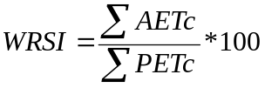 (1) (1)
The water requirement of the crop (PETc) at a given time in the growing season is calculated by multiplying standard reference crop PET by the crop coefficient (Kc).

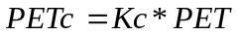 (2) (2)
AETc represents the actual amount of water withdrawn from the soil water reservoir (“bucket”) where shortfall relative to potential crop evapotranspiration (PETc) is calculated by a function that takes into consideration the amount of available soil water in the “bucket”.

Soil water content (SW) is estimated through a simple mass balance equation where the total volume is defined by the water holding capacity (WHC) of the soil in the effective root zone of the crop. SW is the amount of soil water present at a given time step. Its value varies from a minimum of 0 to a maximum equal to WHC (mm). Each time step’s new SW is obtained after determining the actual extraction by the crop (AETc). To determine AETc, dekadal rainfall (PPT) is first added to the existing SW to produce a plant-available-water (PAW) value:

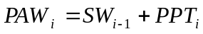 (3)

Depending on the plant available water (PAW) in the “bucket”, the value of AETc is determined by the following set of functions (Senay and Verdin, 2003). (A schematic diagram of model components is shown in Figure 1.)

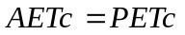 When PAW >= SWC (4)

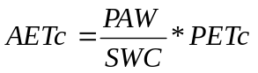 When PAW < SWC (5)

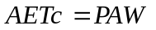 When AETc > PAW (6)

SWC (mm) is the critical soil water level in the “bucket” below which AETc will be less than PETc. SWC varies by crop and growth stage according to the following equation:

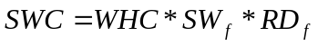 (7)

SW_{f} is the fraction of WHC that defines the available soil water level below which AETc becomes less than PETc during the mature stage of the crop (root depth fraction, or RD_{f} = 1.0). For corn the SW_{f} is 0.45; the literature reports that this value can be estimated as one minus the allowable depletion fraction (FAO, 1998).

The root depth fraction, RD_{f}, varies between 0.1 and 1.0 during the growing season. The effective root depth increases linearly from emergence until the mid-growing season when it attains effective depth (RD_{f} = 1.0) for the remainder of the season. For maize, the effective root depth grows from a value of 0.1 m at emergence to a maximum of 0.9 m beginning on mid-season (after 44% of the growing season). The effective root depth is defined as the 70% of the maximum crop root depth (Driessen and Konijn, 1992). The use of the root depth fraction is meant to simulate a young crop withstanding dry soil profiles (smaller SWC) thanks to light rain showers that replenish the upper root zone where the young crop’s roots are concentrated.

(8)

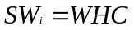 When SW > WHC (upper limit) (9)

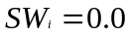 When SW < 0.0 (lower limit) (10)

Where SW is the final soil water content at the end of simulation period, PPT is precipitation, and i is the time step index.
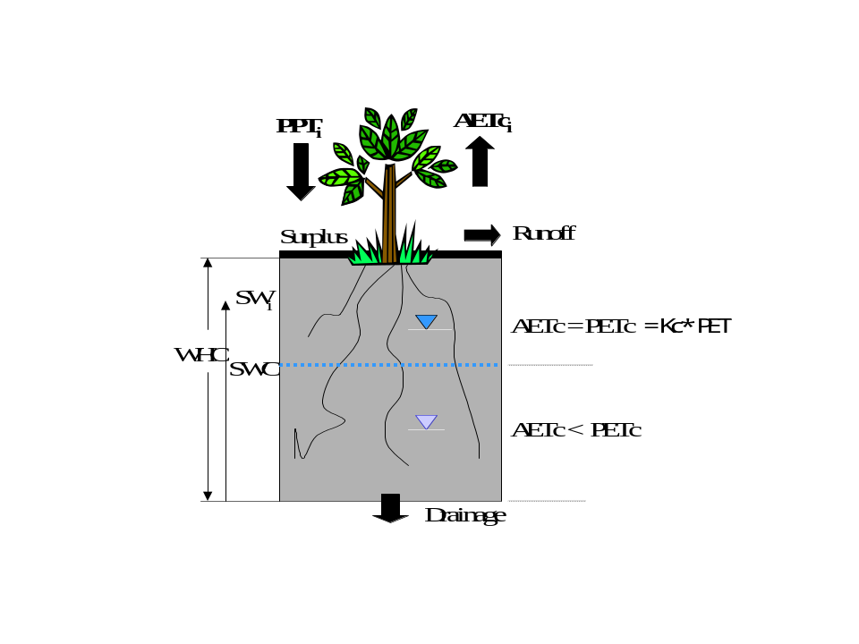
Figure 1: Components of a Crop Water Balance Model

The most important inputs to the model are precipitation and potential evapotranspiration (PET). FEWS NET at the USGS calculates daily PET values for Africa at 1.0-degree resolution from 6-hourly numerical meteorological model output using the Penman-Monteith equation (Shuttleworth, 1992; Verdin and Klaver, 2002). Blended satellite-gauge rainfall estimate (RFE) images for the African continent are obtained from NOAA at 0.1-degree (~10 km) spatial resolution. Rainfall images are produced using an interpolation method that combines data from Meteosat cold cloud duration (CCD), the Special Sensor Microwave/Imager (SSM/I) of the Defense Meteorological Satellite Program, the Advanced Microwave Sounding Unit (AMSU) on board the NOAA-15 polar orbiter, and reporting rain gauge data from Global Telecommunication System (GTS) (Xie and Arkin, 1997). For historical WRSI simulation, the Collaborative Historical African Rainfall Model (CHARM) by Funk et al. (2003) is used. CHARM-based WRSI is available from 1961 through 1996 for the east and west Africa and from 1962 through 1996 for southern Africa. For a more detail explanation of the CHARM data set a separate documentation is available (see CharmDescript.Doc). The CHARM WRSI uses the long-term average PET extracted from FAO’s (1961-1990) average monthly data (M. Bernardi, personal communication). Furthermore, the WRSI model uses relevant soil information from the FAO (1988) digital soils map.

WRSI calculation requires a start-of-season time (SOS) and end-of-season time (EOS) for each modeling grid-cell. Maps of these two variables are needed to define the spatial variation of the timing of the growing season and, consequently, the crop coefficient function, which defines the crop water use relative to a standard reference crop. The model determines the SOS using two methods: 1) using onset-of-rains, based on simple precipitation accounting. (The time step of analysis is the dekad (WMO, 1992) whereby a month is divided into three parts, the first two which are ten days long while the last one completes the month.) The onset-of-rains (SOS) is determined using a threshold amount and distribution of rainfall received in three consecutive dekads. SOS is established when there is at least 25 mm of rainfall in an initial dekad followed by a total of at least 20 mm of rainfall in the following two consecutive dekads. 2) on the second method SOS is determined when the ratio between rainfall and PET in a given dekad is greater than 0.5 (Hare and Oglallo, 1993; Mersha, 2001)). The two methods generally provide similar results for most areas. However, the first method tends to be too strict in semi-arid areas, preventing the establishment of an SOS in some years. While the first method is used for monitoring activities using observed rainfall, the CHARM-WRSI is generated using the second method.

The length of growing period (LGP) for each pixel is determined by the persistence, on average, above a threshold value of a climatological ratio between rainfall and potential evapotranspiration. Thus, EOS was obtained by adding LGP to the SOS dekad for each grid cell. The WRSI model is capable of simulating different crop types whose seasonal water use pattern has been published in the form of a crop coefficient. Such crops include maize (corn), sorghum, millet, wheat, rice etc.

At the end of the crop growth cycle, or up to a certain dekad in the cycle, the respective sums of crop actual evapotranspiration (AETc) and crop potential evapotranspiration (PETc) are used to calculate WRSI (equation 1). A case of “no deficit” will result in a WRSI value of 100, which corresponds to the absence of yield reduction related to water deficit. A seasonal WRSI value less than 50 is regarded as a crop failure condition (Smith, 1992).

Yield reduction estimates based on WRSI contribute to food security preparedness and planning. As a monitoring tool, the crop performance indicator can be assessed at the end of every 10-day period during the growing season. As an early warning tool, end-of-season crop performance can be estimated using long-term average meteorological data.

Due to the difference in the growing season, WRSI maps are generated and distributed on a region-by-region basis (e.g., the Sahel, Southern Africa, Greater Horn of Africa regions). At the end of every dekad, two image products associated with the WRSI are produced and disseminated for the FEWS NET activity. The following paragraphs provide a brief description of these products.

Brief Description of the Two Image Products:

1. Current WRSI
This map portrays WRSI values for a particular crop from the start of the growing season until this time period. It is based on the actual estimates of meteorological data to-date. For example, if the cumulative crop water requirement up to this period was 200 mm and only 180 mm was supplied in the form of rainfall, the crop experienced a deficit of 20 mm during the period and thus the WRSI value will be ((180 / 200) * 100 = 90 %). This approach is slightly different from the traditional FAO update where the cumulative supply-to-date is compared to the seasonal crop water requirement, instead of the requirement up to the current period. Note that, unlike the FAO update, the current WRSI can increase in value in the later part of the growing season if the demand (crop water requirement) and supply (rainfall) relationship becomes favorable.

2. Extended WRSI
This is a forecast estimate of WRSI at the end of the growing season. Long-term average climatological data are used to calculate WRSI for the period between the current dekad and the end-of-season. The calculation principles are the same as the “Current WRSI”. This is also a deficit-based estimate of WRSI. The “current” and “extended” WRSI are the same when the end-of-season dekad becomes the current dekad.

The long-term average PET and rainfall is extracted from FAO’s (1961-1990) long-term average monthly data (M. Bernardi, personal communication). Note that at the end of the growing season, only current-year PET and PPT are used as input.

In addition, a third product (image) called “Soil Water Index” is produced as part of the suite of WRSI products. This image is a by-product of the water requirements satisfaction index (WRSI) model. The values in this image represent the amount of water stored in the crop root depth as a percentage of the water holding capacity (WHC) of the soil at the end of a particular dekad “i”:

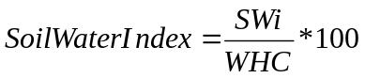 11

Where, SW is soil water content and “i” is the time step index.

Application:
This index is an indicator of the soil moisture status at the end of a particular dekad. Therefore, it may be used as a tool to assess the crop water status in the next dekad based on the available moisture in the soil. The index is presented in four broad qualitative categories. For example, an index with 100% (“sufficient”) implies that there is enough soil water in the crop root zone to support the crop through the next dekad without experiencing water stress. A soil water index of “satisfactory” (60 – 99%) at the end of the dekad implies conditions ranging from some degree of stress (on the lower end) to areas with enough moisture to avoid crop stress in the next dekad. In the “stress” range (10 – 60%), the crop is likely to experience water stress (from severe to moderate) if there is no rainfall in the next dekad. In the “wilting” group (0 – 10%), the soil is already at very low moisture level such that continued drought may cause wilting of the crop. The agronomic definition of wilting is when the soil water is at 0% of WHC; thus, the plant will avoid wilting if there is rainfall before moisture is completely depleted. Spatial association (proximity) of the classes can be used to identify areas that are in the low or high side of a given class. For example, within the “satisfactory” class those areas likely to experience stress will be found adjacent to the “stress” areas.

This index can potentially be used for planning activities that rely on existing soil moisture conditions in combination with forecast rainfall. Such activities may include supplemental irrigation (e.g., if current soil water index is very low and rainfall forecast for the next dekad is negligible) or the identification/application of control measures for high-risk areas for malaria.

Note:
Soil water index (% WHC) is calculated only for areas where a crop is considered to be growing, i.e., where there is a start-of-season in the WRSI calculation. A value of 100% represents that the soil is at least at field capacity (condition of soil moisture 2 to 3 days after a rain event that brings the soil water content to saturation). A value of 0.0% represents a soil moisture status at permanent wilting point.

Soil water index is calculated for the current dekad only, with memory for soil water content carried from previous dekads via the soil water content parameter SW_{i-1}. If the current dekad is after end-of-season, soil water extraction by the crop is minimal (low crop water requirement); this may result in a high soil water index value, even with a moderate amount of rainfall in that dekad.

Unlike the WRSI, the soil water index does not provide information about the crop condition; however, crop water status for the next dekad may be inferred.

REFERENCE
Driessen, P.M., and Konijn, N.T. (editors). 1992. Land-use Systems Analysis. Wageningen Agricultural University, Wageningen, The Netherlands.

FAO, 1977. Crop water requirements. FAO Irrigation and Drainage Paper No. 24, by Doorenbos J and W.O. Pruitt. FAO, Rome, Italy.

FAO, 1979. Agrometeorological crop monitoring and forecasting. FAO Plant Production and Protection paper No. 17, by M. Frère and G.F. Popov. FAO, Rome, Italy.

FAO, 1986. Early Agrometeorological crop yield forecasting. FAO Plant Production and Protection paper No. 73, by M. Frère and G.F. Popov. FAO, Rome, Italy.

FAO, 1988. FAO/UNESCO Soil Map of the World: Revised Legend. FAO, Rome. World Resources Report Number 60.

FAO, 1998. Crop Evapotranspiration: Guidelines for Computing Crop Water Requirements. FAO, Rome. Irrigation and Drainage Paper 56.

Funk, C., J. Michaelsen, J. Verdin, G. Artan, G. Husak, G. Senay, H. Gadain, and T. Magadzire, 2003. The Collaborative Historical African Rainfall Model: Description and Evaluation. Int. J. Climatology, 23, 47-66.
Shuttleworth, J. 1992. Evaporation. In Handbook of Hydrology. Edited by M. Maidment, McGraw-Hill: New York. pp. 4.1-4.53.

Hare, F.K and L.A.J. Ogallo, 1993. Climate variations, droughts and desertification. World Meteorological Organization, WMO, Report No. 653. Geneva, Switzerland.

Mersha, E., 2001. Application of agroclimatic analogue technique to characterize the crop growing season in Ethiopia. Ethiopian Journal of Natural Resources, 3(1):1-18.

Senay G.B. and J. Verdin, 2003. Characterization of Yield Reduction in Ethiopia Using a GIS-Based Crop Water Balance Model. Canadian Journal of Remote Sensing, 29(6):687-692.

Smith, M., 1992. Expert consultation on revision of FAO methodologies for crop water requirements. FAO, Rome, Publication 73.

Verdin, J., and Klaver, R. 2002. Grid cell based crop water accounting for the famine early warning system. Hydrological Processes, Vol.16, pp. 1617-1630.

World Meteorological Organization. 1992. International Meteorological Vocabulary, 2nd edn. WMO: Geneva, Switzerland. WMO Publication 182.

Xie, P., and Arkin, P.A. 1997. A 17-year monthly analysis based on gauge observations, satellite estimates, and numerical model outputs. Bulletin of the American Meteorological Society, Vol. 78, No. 11, pp. 2539-58.

* Originally developed by FAO, the WRSI has been adapted and extended by USGS in a geospatial application to support FEWS NET monitoring requirements.

