Database Systems
Final Project Report
School Management System

Amila Senadheera
UGC0725003
[MAA120130 Database Systems]
LNBTI
July 2025

1. Introduction
The School Management System is a Java desktop application designed to digitalise the administrative operations of a single school. It replaces manual, paper-based workflows with a centralised, role-based platform covering student registration, academic structure management, attendance recording, examination and grade management, school timetabling, fee collection, and report card generation.
Three user roles interact with the system: Principal, Teacher, and Office Staff. Each role is presented with a dashboard and navigation tailored to their responsibilities. The application is built using Java 17, JavaFX 21, and Apache Maven, and connects to a MySQL 8 relational database over a local area network.
The database consists of 22 tables organised into six functional groups: Authentication, People, Academic Structure, Attendance and Timetable, Examinations and Grading, and Fees. Four database views are defined to support common reporting queries. The schema enforces referential integrity through foreign key constraints with appropriate cascade rules, and uses utf8mb4 collation to support Sinhala Unicode text in student and subject names.

2. Entity Relationship Diagram
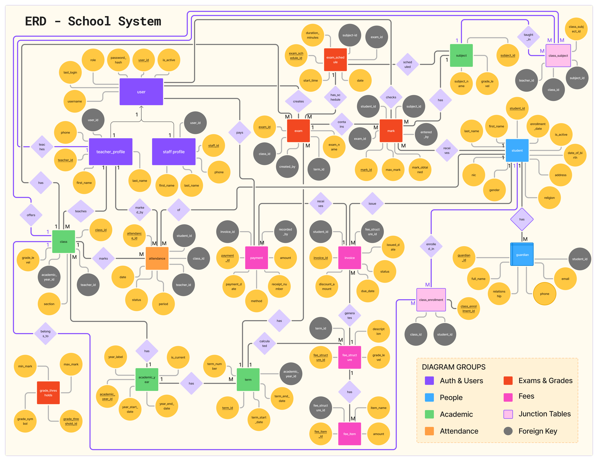
01
Figure 1 — Entity Relationship Diagram of the School Management System database. The diagram covers 22 tables across six groups: Auth & Users, People, Academic Structure, Attendance & Timetable, Exams & Grades, and Fees.

3. Relational Mapping
The following relational schema is derived directly from the ER diagram. Primary keys are underlined; foreign keys are marked with †.

3.1 Authentication & Users
users(user_id, username, password_hash, role, is_active, last_login, created_at)
teacher_profiles(teacher_id, user_id†, first_name, last_name, phone)
staff_profiles(staff_id, user_id†, first_name, last_name, phone)

3.2 People
students(student_id, first_name, last_name, first_name_si, date_of_birth, nic, gender, religion, address, enrollment_date, is_active, created_at)
guardians(guardian_id, student_id†, full_name, relationship, phone, email)

3.3 Academic Structure
academic_years(academic_year_id, year_label, start_date, end_date, is_current)
terms(term_id, academic_year_id†, term_number, start_date, end_date)
subjects(subject_id, name, name_si, grade_level)
classes(class_id, academic_year_id†, grade_level, section, homeroom_teacher_id†)
class_subjects(class_subject_id, class_id†, subject_id†, teacher_id†)
class_enrollments(class_enrollment_id, student_id†, class_id†)

3.4 Attendance & Timetable
attendance(attendance_id, student_id†, class_id†, date, period, status, marked_by†)
timetable(id, class_id†, day, period, subject_id†, teacher_id†)
period_config(period, label, start_time, end_time, is_interval)

3.5 Exams & Grading
grade_thresholds(grade_threshold_id, grade_symbol, min_mark, max_mark)
exams(exam_id, name, class_id†, term_id†, created_by†, created_at)
exam_schedules(exam_schedule_id, exam_id†, subject_id†, date, start_time, duration_minutes)
marks(mark_id, student_id†, exam_id†, subject_id†, mark_obtained, max_mark, entered_by†, entered_at)

3.6 Fees
fee_structures(fee_structure_id, term_id†, grade_level, description)
fee_items(fee_item_id, fee_structure_id†, item_name, amount)
invoices(invoice_id, student_id†, fee_structure_id†, issued_date, due_date, discount_amount, discount_reason, status, created_at)
payments(payment_id, invoice_id†, amount, payment_date, method, receipt_number, recorded_by†, recorded_at)

4. SQL Queries
The following queries demonstrate a range of SQL features including multi-table JOINs, subqueries, aggregate functions, GROUP BY, HAVING, ORDER BY, and CASE expressions. All queries are written for MySQL 8.

Query 1 — Students with Their Enrolled Class (Multi-table JOIN)
This query retrieves each active student's full name along with the class they are currently enrolled in, using a four-table JOIN across students, class_enrollments, classes, and academic_years. Only students enrolled in the current academic year are returned.

SELECT
s.id AS student_id,
CONCAT(s.first_name, ' ', s.last_name) AS student_name,
CONCAT('Grade ', c.grade_level, ' - ',
c.section) AS class_name,
ay.year_label AS academic_year
FROM students s
JOIN class_enrollments ce ON ce.student_id = s.id
JOIN classes c ON c.id = ce.class_id
JOIN academic_years ay ON ay.id = c.academic_year_id
WHERE s.is_active = TRUE
AND ay.is_current = TRUE
ORDER BY c.grade_level, c.section,
s.last_name, s.first_name;

SQL features used: INNER JOIN (×3), CONCAT(), WHERE with multiple conditions, ORDER BY.
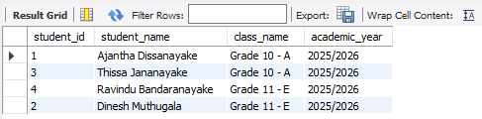

Query 2 — Attendance Summary per Student (Aggregate Functions)
This query produces an attendance report per student, counting the number of periods marked as Present, Absent, Late, and Medical Leave, and computing the overall attendance percentage. It uses conditional SUM() — a common aggregate pattern in MySQL — and ROUND() to format the percentage.

SELECT
CONCAT(s.first_name, ' ', s.last_name) AS student_name,
COUNT(*) AS total_periods,
SUM(a.status = 'P') AS present,
SUM(a.status = 'A') AS absent,
SUM(a.status = 'L') AS late,
SUM(a.status = 'ML') AS medical_leave,
ROUND(
SUM(a.status = 'P') / COUNT(*) * 100,
1) AS attendance_pct
FROM attendance a
JOIN students s ON s.id = a.student_id
GROUP BY a.student_id, s.first_name, s.last_name
HAVING attendance_pct < 80
ORDER BY attendance_pct ASC;

SQL features used: JOIN, COUNT(*), SUM() with boolean expression, ROUND(), GROUP BY, HAVING clause to filter students below 80% attendance, ORDER BY.
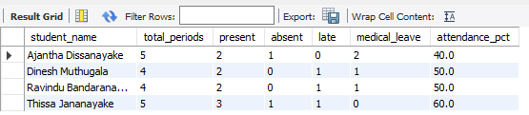

Query 3 — Outstanding Fee Balances Using Subqueries
This query identifies students with unpaid or partially paid invoices. Instead of joining fee_items and payments directly to invoices (which would cause a cartesian product), both totals are pre-aggregated in independent subqueries before being joined to the invoices table.

SELECT
CONCAT(s.first_name, ' ', s.last_name) AS student_name,
i.due_date,
i.status,
COALESCE(fi_sum.total_fee, 0) AS total_fee,
COALESCE(p_sum.total_paid, 0) AS total_paid,
COALESCE(fi_sum.total_fee, 0)
- COALESCE(p_sum.total_paid, 0) AS outstanding
FROM invoices i
JOIN students s ON s.id = i.student_id
LEFT JOIN (
SELECT fee_structure_id,
SUM(amount) AS total_fee
FROM fee_items
GROUP BY fee_structure_id
) fi_sum ON fi_sum.fee_structure_id
= i.fee_structure_id
LEFT JOIN (
SELECT invoice_id,
SUM(amount) AS total_paid
FROM payments
GROUP BY invoice_id
) p_sum ON p_sum.invoice_id = i.id
WHERE i.status IN ('unpaid', 'partial')
ORDER BY outstanding DESC;

SQL features used: Correlated subqueries in FROM clause, LEFT JOIN, COALESCE(), arithmetic expressions, WHERE with IN(), ORDER BY DESC.
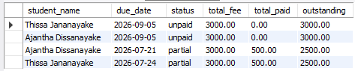

Query 4 — Student Marks with Auto-Calculated Grade (CASE Expression)
This query retrieves all marks for a specific exam and automatically assigns a grade symbol by comparing each student's percentage against the grade_thresholds table using a BETWEEN condition. The CASE expression computes a grade category label alongside the symbol.

SELECT
CONCAT(s.first_name, ' ', s.last_name) AS student_name,
sub.name AS subject,
m.mark_obtained,
m.max_mark,
ROUND(m.mark_obtained / m.max_mark
* 100, 2) AS percentage,
g.grade_symbol,
CASE g.grade_symbol
WHEN 'A+' THEN 'Distinction'
WHEN 'A' THEN 'Merit'
WHEN 'B' THEN 'Credit'
WHEN 'C' THEN 'Pass'
WHEN 'D' THEN 'Weak Pass'
ELSE 'Fail'
END AS grade_category
FROM marks m
JOIN students s ON s.id = m.student_id
JOIN subjects sub ON sub.id = m.subject_id
JOIN exams e ON e.id = m.exam_id
LEFT JOIN grade_thresholds g
ON (m.mark_obtained / m.max_mark * 100)
BETWEEN g.min_mark AND g.max_mark
WHERE e.id = 1
ORDER BY s.last_name, sub.name;

SQL features used: Multiple JOINs, arithmetic expression for percentage, BETWEEN in JOIN condition, CASE expression, ORDER BY multiple columns.
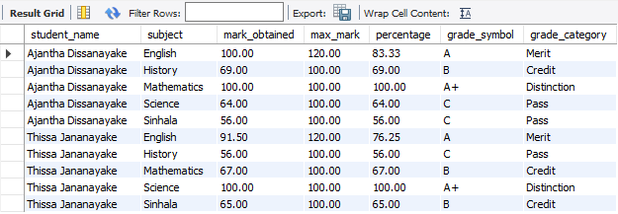

Query 5 — Teacher Workload Summary (GROUP BY + Aggregate)
This query summarises each teacher's current workload by counting the number of distinct classes they teach in, the number of subject assignments, and whether they serve as a homeroom teacher. It joins teacher_profiles, class_subjects, and classes, filtering to the current academic year.

SELECT
CONCAT(tp.first_name, ' ', tp.last_name) AS teacher_name,
COUNT(DISTINCT cs.class_id) AS classes_count,
COUNT(cs.id) AS subject_assignments,
SUM(c.homeroom_teacher_id = tp.id) AS is_homeroom
FROM teacher_profiles tp
LEFT JOIN class_subjects cs ON cs.teacher_id = tp.id
LEFT JOIN classes c ON c.id = cs.class_id
LEFT JOIN academic_years ay ON ay.id = c.academic_year_id
WHERE ay.is_current = TRUE
OR ay.id IS NULL
GROUP BY tp.id, tp.first_name, tp.last_name
ORDER BY subject_assignments DESC;

SQL features used: LEFT JOIN, COUNT(DISTINCT …), COUNT(), SUM() with boolean, GROUP BY, ORDER BY.
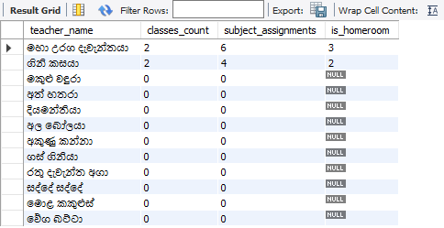

Query 6 — Term-wise Fee Collection Report (JOIN + GROUP BY + HAVING)
This query produces a financial summary per academic term, showing the total fees billed, total amount collected, total outstanding, and the collection rate as a percentage. The HAVING clause filters to terms where collection is below 100%.

SELECT
ay.year_label,
CONCAT('Term ', t.term_number) AS term,
COUNT(DISTINCT i.id) AS total_invoices,
SUM(COALESCE(fi_sum.fee, 0)) AS total_billed,
SUM(COALESCE(p_sum.paid, 0)) AS total_collected,
SUM(COALESCE(fi_sum.fee, 0))
- SUM(COALESCE(p_sum.paid, 0)) AS total_outstanding,
ROUND(
SUM(COALESCE(p_sum.paid, 0)) /
NULLIF(SUM(COALESCE(fi_sum.fee, 0)),0)
* 100, 1) AS collection_pct
FROM terms t
JOIN academic_years ay ON ay.id = t.academic_year_id
JOIN fee_structures fs ON fs.term_id = t.id
JOIN invoices i ON i.fee_structure_id = fs.id
LEFT JOIN (
SELECT fee_structure_id,
SUM(amount) AS fee
FROM fee_items GROUP BY fee_structure_id
) fi_sum ON fi_sum.fee_structure_id = fs.id
LEFT JOIN (
SELECT invoice_id, SUM(amount) AS paid
FROM payments GROUP BY invoice_id
) p_sum ON p_sum.invoice_id = i.id
GROUP BY t.id, ay.year_label, t.term_number
HAVING collection_pct < 100
OR collection_pct IS NULL
ORDER BY ay.year_label, t.term_number;

SQL features used: Multiple JOINs including subqueries, COUNT(DISTINCT …), SUM(), COALESCE(), NULLIF() to prevent division by zero, ROUND(), GROUP BY, HAVING with alias reference, ORDER BY.
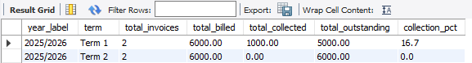

End of Report!

