School Management System

A Desktop Application for Single-School Administrative Management

Submitted by:
Amila Senadheera
UGC0725003

BSc (Hons) Software Engineering
LNBTI

Supervisors:
Chobodi Damsarani
Navod Rupasinghe
Nimali Hettiarachchi
Geethika Senarathne

June 2026

Declaration
I certify that this dissertation does not incorporate, without acknowledgement, any material previously submitted for a degree or diploma in any University/Institute and to the best of my knowledge and belief, it does not contain any material previously published or written by another person or myself except where due reference is made in the text.

Signature of Candidate: [___________________]
Name of Candidate: [ H.M. Amila Prasad Senadheera ]
Date: [___________________]

Countersigned by:
Signature of Supervisor: [___________________]
Name of Supervisor: [___________________]
Date: [___________________]

Abstract
This project presents the design and implementation of a School Management System — a Java desktop application targeting small to medium-sized schools that currently rely on manual, paper-based administrative processes. The system provides a centralised, role-based platform that digitises core school operations including student registration, academic structure management, attendance recording, examination and grade management, timetable scheduling, fee collection, and report card generation.
The system supports three distinct user roles — Principal, Teacher, and Office Staff — each with a tailored dashboard and access-controlled feature set appropriate to their responsibilities. The Principal manages the overall academic structure, user accounts, and grade thresholds. Teachers mark period-level attendance and enter student marks. Office Staff handle student registration and fee payments.
The application is built using Java 17 and JavaFX 21 for the graphical user interface, MySQL 8 as the relational database, and Apache PDFBox for PDF report card generation. BCrypt is used for secure password hashing. The system architecture follows the Model-View-Controller pattern with a dedicated DAO layer for all database interactions.
System testing confirmed all specified functional requirements were met. User evaluation produced positive results regarding ease of use and reduction in administrative effort. The system successfully eliminates manual record-keeping for attendance, marks, fees, and timetabling, and generates printable PDF report cards automatically from stored data.

Acknowledgements
I wish to express my sincere gratitude to all those who supported and guided me throughout the development of this project.
I am deeply grateful to my supervisors for their invaluable guidance, constructive feedback, and continuous encouragement throughout the project lifecycle. Their expertise in software engineering and academic rigour shaped the quality of this work significantly.
I extend my thanks to my family members and the administration and staff of B/Bandarawela Central College for their cooperation in providing domain knowledge, requirements clarification, and feedback during the evaluation phase of the system. Their practical insights were instrumental in ensuring the system meets real-world school management needs.
I also thank the Lanka Nippon Biz-Tech Institute for providing the academic framework and resources that made this project possible.
Finally, I acknowledge the open-source communities behind JavaFX, Apache PDFBox, jBCrypt, and MySQL, whose tools formed the foundation of this system.

List of Acronyms
Acronym | Full Form
API | Application Programming Interface
BCrypt | Blowfish Crypt — Password Hashing Algorithm
DAO | Data Access Object
DB | Database
ERD | Entity Relationship Diagram
FK | Foreign Key
FXML | JavaFX Markup Language
GUI | Graphical User Interface
JDBC | Java Database Connectivity
JDK | Java Development Kit
LAN | Local Area Network
LKR | Sri Lankan Rupee
MVC | Model-View-Controller
MySQL | My Structured Query Language
PDF | Portable Document Format
PK | Primary Key
SRS | Software Requirements Specification
SQL | Structured Query Language
UAT | User Acceptance Testing
UI | User Interface
UML | Unified Modelling Language

Chapter 1 – Introduction

1.1 Background and Motivation
Schools in Sri Lanka, particularly government and semi-government institutions, continue to manage core administrative operations through manual, paper-based processes. Student records are maintained in physical files, attendance is recorded in paper registers, examination marks are entered on printed mark sheets, fee payments are tracked in cashbooks, and report cards are prepared by hand at the end of each term. These processes are time-consuming, prone to human error, difficult to audit, and offer no facility for generating summary reports or tracking trends over time.
This project was motivated by the observation that these inefficiencies are not caused by a lack of data — the data exists, maintained in paper form — but by the absence of a system to capture, store, and retrieve that data digitally. A purpose-built desktop application that mirrors existing school workflows while automating repetitive tasks and providing instant reporting would significantly reduce administrative burden for school staff.
The result is a School Management System: a role-aware Java desktop application that covers the complete lifecycle of school administration, from student registration and class enrollment through to report card PDF generation, without requiring internet connectivity or cloud infrastructure.

1.2 Aims and Objectives
The primary aim of this project is to design and implement a fully functional School Management System that replaces manual administrative processes with a reliable, role-based desktop application.
Specific objectives:
- Design and implement a secure, role-based authentication system for three user roles: Principal, Teacher, and Office Staff.
- Implement student registration with English and Sinhala name support, and guardian contact management.
- Implement academic structure management: academic years, terms, classes, subjects, and teacher-subject assignments.
- Implement student class enrollment management.
- Develop a period-level attendance marking module with four status options.
- Implement a configurable school timetable with per-period scheduling.
- Implement examination management with subject scheduling, mark entry, and automatic grade calculation.
- Develop a fee management module supporting fee structures, bulk invoice generation, and payment recording.
- Generate formatted PDF report cards per student per term.
- Provide role-specific dashboards with real-time summary statistics.

1.3 Scope
In scope:
- Student and guardian data management.
- Academic year, term, class, subject, enrollment, and timetable management.
- Period-level attendance recording and summary reporting.
- Examination scheduling, mark entry, and grade reporting.
- Fee structure definition, invoice generation, and payment recording.
- Report card PDF generation.
- User account management by the Principal.
- Role-specific dashboards.
Out of scope:
- Web or mobile interface — the system is a desktop application only.
- Integration with external government education portals.
- Multi-school or district-level management.
- Real-time notifications or parent-facing portal.
- Payroll or HR management for teaching staff.

1.4 Document Structure
Chapter 2 analyses the existing manual system, reviews similar software, and identifies functional and non-functional requirements. Chapter 3 presents the system design including architecture, database design, and key design decisions. Chapter 4 describes the implementation environment and selected implementation details. Chapter 5 presents the testing strategy and results. Chapter 6 concludes with a critical evaluation and future work recommendations.

Chapter 2 – Analysis

2.1 Existing System Analysis
The existing administrative system in a typical Sri Lankan school is entirely paper-based. The following describes each process as it currently operates:

2.1.1 Student Registration
New students are registered by office staff using a paper admission form. Records are filed in physical folders organised by grade. Searching for a student record requires locating the correct folder manually. There is no central index, no duplicate-detection mechanism, and no facility for searching across grades.

2.1.2 Attendance
Class teachers maintain a physical attendance register per class. Attendance is marked per period in the paper register using simple codes. End-of-term attendance summaries are computed manually by counting marks in each column. There is no automated mechanism for identifying students with low attendance.

2.1.3 Examinations and Marks
Teachers enter student marks onto paper mark sheets after each examination. These sheets are collected by the class teacher who manually computes grades using a printed grade scale. Report cards are typewritten or handwritten individually per student at the end of each term.

2.1.4 Fee Management
Fee structures are communicated to parents via printed circulars at the start of each term. Payments are recorded in a cashbook ledger. Outstanding balance tracking requires manually cross-referencing the fee schedule against payment entries — a process that can take hours at month end.

2.1.5 Timetable
The school timetable is prepared by the principal at the start of each term and displayed as a printed chart in the staffroom. Individual teacher copies are extracted manually. Any mid-term change requires reprinting and redistribution.

2.2 Review of Similar Systems

2.2.1 SchoolTool
SchoolTool is an open-source school management system originally developed for schools in developing countries [1]. It provides student information management, attendance tracking, gradebook functionality, and report generation via a web browser interface. The system requires a server, network infrastructure, and ongoing maintenance. Its fee management capabilities are limited and do not reflect the term-based, grade-level fee structures common in Sri Lankan schools. The UI complexity would require significant training for non-technical administrative staff.

2.2.2 iSkool
iSkool is a commercial, cloud-based school management SaaS product used by some private schools in Sri Lanka [2]. It offers comprehensive modules including student management, fee management with payment gateway integration, examination management, and SMS notifications. However, it requires a paid subscription and permanent internet connectivity. Its fee structure model and report card format do not match the requirements of the government school context. Its cost makes it inaccessible for smaller government schools.

2.2.3 Justification for Custom Development
Neither reviewed system adequately addresses the offline desktop operation requirement, the specific Sri Lankan O/L grading scale, the term-based fee structure model, or the constrained budget of the target schools. Custom development is therefore the most appropriate approach, allowing precise alignment with the identified requirements.

2.3 Requirements Analysis

2.3.1 Functional Requirements
ID | Requirement | Priority
FR01 | The system shall support three user roles: Principal, Teacher, and Office Staff, each with role-specific navigation and access controls. | High
FR02 | The system shall authenticate users with a username and BCrypt-hashed password. Failed logins shall display an error without revealing which field is incorrect. | High
FR03 | The Principal shall be able to create, deactivate, and reset passwords for Teacher and Staff accounts. | High
FR04 | Office Staff shall be able to register students with first name (English), last name, Sinhala first name, date of birth, gender, NIC, religion, address, and enrollment date. | High
FR05 | Office Staff shall be able to record one or more guardian contacts (name, relationship, phone, email) per student. | High
FR06 | The Principal shall be able to create academic years, define up to three terms per year, create class groups (grade + section), and define subjects per grade. | High
FR07 | The Principal shall be able to assign teachers to subjects within specific classes. | High
FR08 | The Principal shall be able to enroll students into classes in current academic year. | High
FR09 | Teachers shall be able to mark attendance per student per period for their assigned classes, with statuses: Present, Absent, Late, Medical Leave. | High
FR10 | Re-submitting attendance for a previously marked period shall overwrite existing records without error. | High
FR11 | The Principal shall be able to create examinations associated with a class and term, and schedule individual subjects within each exam. | High
FR12 | Teachers shall be able to enter marks per student per subject per exam. The system shall auto-calculate grades using a configurable grade threshold table. | High
FR13 | The Principal shall be able to create and manage the school timetable, assigning a subject and teacher to each period slot per day per class. | Medium
FR14 | Period timings (label, start time, end time, interval flag) shall be configurable via the database without code changes. | Medium
FR15 | Teachers shall see a read-only view of their assigned timetable on their dashboard. | Medium
FR16 | Office Staff shall be able to create fee structures with multiple line items per grade per term, and generate invoices for all enrolled students in a grade. | High
FR17 | Office Staff shall be able to record payments against individual invoices. The system shall prevent payment amounts exceeding the outstanding balance. | High
FR18 | Invoice status (unpaid, partial, paid) shall be calculated dynamically from actual payment totals, not stored statically. | High
FR19 | The system shall generate a formatted PDF report card per student per term, showing all marks, grades, and attendance summary. | High
FR20 | The Principal shall be able to edit grade thresholds from the dashboard, with changes taking effect on the next grade calculation. | Medium
FR21 | Each role shall see a dashboard with real-time summary statistics with relevance. | Medium
FR22 | Deactivating a student shall set is_active = FALSE without deleting records referenced by other modules. | High

2.3.2 Non-Functional Requirements
ID | Requirement | Category
NFR01 | The application shall load and display the login screen within 3 seconds on standard school office hardware. | Performance
NFR02 | Database queries shall return results within 2 seconds for realistic data volumes (up to 500 active students). | Performance
NFR03 | The UI shall be navigable by a non-technical administrative user with minimal training. Core tasks shall be completable without consulting documentation. | Usability
NFR04 | All passwords shall be stored as BCrypt hashes with cost factor 12. Plaintext passwords shall never be written to disk or logs. | Security
NFR05 | The system shall operate fully offline on a Windows 10/11 PC connected to a local MySQL server. No internet connection shall be required. | Availability
NFR06 | The database schema shall enforce referential integrity through foreign key constraints with appropriate cascade rules. | Reliability
NFR07 | The application shall correctly store and display Sinhala Unicode text in student names and subject names within the JavaFX UI. | Localisation
NFR08 | Deactivating a user account shall immediately prevent login without requiring data deletion. | Security
NFR09 | Generated PDF report cards shall be renderable on any standard PDF viewer on Windows, macOS, or Linux. | Compatibility
NFR10 | The system shall prevent duplicate records where uniqueness is required (username, student NIC, class-term fee structure, attendance slot). | Data Integrity

2.4 Process Model
An iterative and incremental development model was adopted. The system was decomposed into eight self-contained modules — authentication, students, academic setup, attendance, exams, timetable, fees, and report cards — each developed in a separate iteration. This approach was selected for three reasons:
- Each iteration delivers a usable, testable increment. Bugs found in early modules (such as an invoice aggregation query defect) can be resolved before dependent modules are built.
- The module boundaries map naturally to the DAO pattern: each iteration produces a complete model → DAO → FXML → controller stack that can be integrated and tested end-to-end.
- Requirements were well-understood and stable from the start, making fully agile sprint-based planning unnecessary. The iterative approach captures the benefit of incremental delivery without the overhead of formal sprint ceremonies.

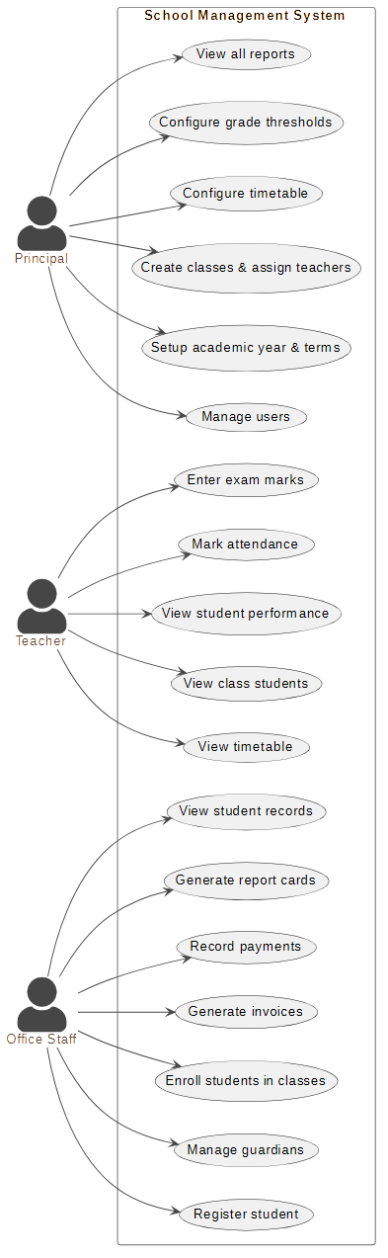
2.5 Use Case Diagram

Chapter 3 – Design

3.1 System Architecture
The system follows the Model-View-Controller (MVC) architectural pattern, adapted for a JavaFX desktop application with three distinct layers:

3.1.1 Model Layer
Plain Java classes representing domain entities. Each model maps to a database table or view. Models contain only fields, getters/setters, and simple display helpers (e.g. getFullName(), getStatusDisplay()). No SQL, business logic, or UI code resides in model classes. The SchoolClass model name was chosen deliberately to avoid conflict with java.lang.Class.

3.1.2 DAO Layer
Data Access Objects encapsulate all JDBC and SQL. One DAO class exists per table group. Each method opens and closes its own connection via DBConnection.getConnection() — acceptable for a single-school LAN application where connection pooling overhead is unnecessary. PreparedStatements are used throughout, preventing SQL injection. A nullIfBlank() helper converts blank optional strings to SQL NULL before binding parameters.

3.1.3 Controller and View Layer
JavaFX FXML files define UI layouts declaratively. Controllers handle UI events, call DAOs, and update views. All views are loaded dynamically into a central StackPane content area by MainController.loadView(String name), enabling navigation without restarting the application. Add/edit dialogs are built programmatically inside controllers rather than as separate FXML files, keeping validation logic co-located with dialog construction.

3.2 Database Design
The database comprises 22 tables and 4 views in MySQL 8, using the InnoDB engine for foreign key support and utf8mb4_unicode_ci collation for Sinhala Unicode support. Tables are organised into six groups:

3.2.1 Authentication
The users table stores login credentials with BCrypt password hashes and a role ENUM (principal, teacher, staff). Teacher and staff profiles are stored in separate tables (teacher_profiles, staff_profiles) linked by user_id. This separation allows user accounts to be deactivated without orphaning profile data referenced by attendance and class records.

3.2.2 People
The students table stores student data including English names, first_name_si for Sinhala script, date of birth, gender, NIC, address, enrollment date, and an is_active soft-delete flag. The guardians table stores one or more contacts per student with ON DELETE CASCADE, ensuring guardian records are removed when a student is deleted.

3.2.3 Academic Structure
academic_years (with is_current flag), terms (1–3 per year), classes (grade + section per year), subjects (name, Sinhala name, grade level), class_subjects (which teacher teaches which subject in which class), and class_enrollments (which students are in which class) form the academic structure. All attendance, timetable, and mark queries join back to these tables.

3.2.4 Attendance and Timetable
The attendance table records per-student, per-class, per-date, per-period status values with a UNIQUE constraint on (student_id, class_id, date, period). The timetable table stores per-class, per-day, per-period subject and teacher assignments with a UNIQUE constraint on (class_id, day, period). The period_config table stores configurable bell schedule entries — label, start_time, end_time, and an is_interval flag — allowing the school to change their bell schedule without modifying application code.

3.2.5 Fees
fee_structures define a grade-level fee template per term. fee_items list individual charges within a structure. invoices are generated per student per fee_structure. payments record individual transactions against invoices. The v_invoice_summary view pre-aggregates both fee item totals and payment totals using subqueries, avoiding the cartesian product issue that arises when joining both many-side tables directly to invoices.

3.2.6 Database Views
View | Purpose
v_student_class | Returns each active student's current class by joining students, class_enrollments, classes, and academic_years filtered to is_current = TRUE.
v_invoice_summary | Aggregates fee totals and payment totals per invoice via pre-aggregated subqueries. Invoice status is calculated dynamically from actual payment amounts rather than the stored status column, preventing stale status after new invoice generation.
v_attendance_summary | Aggregates attendance counts per student per class: total periods, present, absent, late, medical leave, and attendance percentage.
v_marks_with_grade | Joins marks with grade_thresholds using a BETWEEN condition on percentage to auto-assign grade symbols without storing the grade redundantly in the marks table.

3.3 Key Design Decisions

3.3.1 Soft Delete for Students
Students are deactivated via is_active = FALSE rather than hard-deleted. This preserves referential integrity with attendance, marks, and invoice records which reference students by foreign key. A hard delete option is also exposed in the UI but displays a prominent warning about cascading data loss.

3.3.2 Upsert Pattern for Attendance and Marks
Attendance and mark batch saves use INSERT ... ON DUPLICATE KEY UPDATE rather than a check-then-insert pattern. This makes re-submission idempotent: a teacher who submits the same period's attendance twice simply overwrites the previous values without producing duplicates or errors. A single batch executeBatch() call submits all rows in one database round trip.

3.3.3 Programmatic Dialogs
Add/edit dialogs are constructed in controller code rather than separate FXML files. This reduces total file count, keeps field pre-population and validation logic co-located, and allows dialogs to reference controller-level state (such as the loaded list of available teachers or subjects) without complex event passing.

3.3.4 Dynamic Invoice Status via View
The invoice status (unpaid/partial/paid) is computed in the v_invoice_summary view from actual payment totals rather than read from the stored status column. This ensures newly generated invoices for a student who previously paid a different invoice will correctly show as unpaid, regardless of what the stored column value might be from a prior operation.

3.3.5 Configurable Period Times
The period_config table stores school bell times. The timetable grid reads these at runtime, rendering one row per period_config entry and rendering interval rows as non-interactive spans across all day columns. This allows the school to adjust their bell schedule by updating the database, with no code change or redeployment required.

3.4 User Interface Design
The UI follows a consistent three-region layout across all views: a fixed left sidebar for role-filtered navigation, a top header bar showing role badge, username, and logout, and a centre StackPane content area that swaps views via MainController.loadView(). A CSS stylesheet defines reusable classes (.btn-primary, .btn-secondary, .btn-danger, .card, .table-view, .page-title, .section-title, .form-label) applied consistently throughout.
Notable UI design decisions:
- SplitPane layouts present a master list and detail panel simultaneously in modules with parent-child relationships (students and guardians, exams and schedule, invoices and payments).
- Attendance marking uses colour-coded ToggleButtons per student row (Present / Absent / Late / Medical Leave) rather than a ComboBox, enabling single-click status assignment with clear visual feedback.
- The mark entry column uses an inline TextField per table row with a live grade preview that updates as the teacher types, without triggering a full table refresh that would interrupt input.
- The timetable renders as a programmatic GridPane with day headers, period label rows (showing time ranges read from period_config), and interactive cell VBoxes that either show a filled slot or a hover-highlighted plus button.
- TableView placeholders use the FXML child node syntax <placeholder><Label text="..."/></placeholder> as required by the JavaFX FXML specification.

3.5 Class Diagram

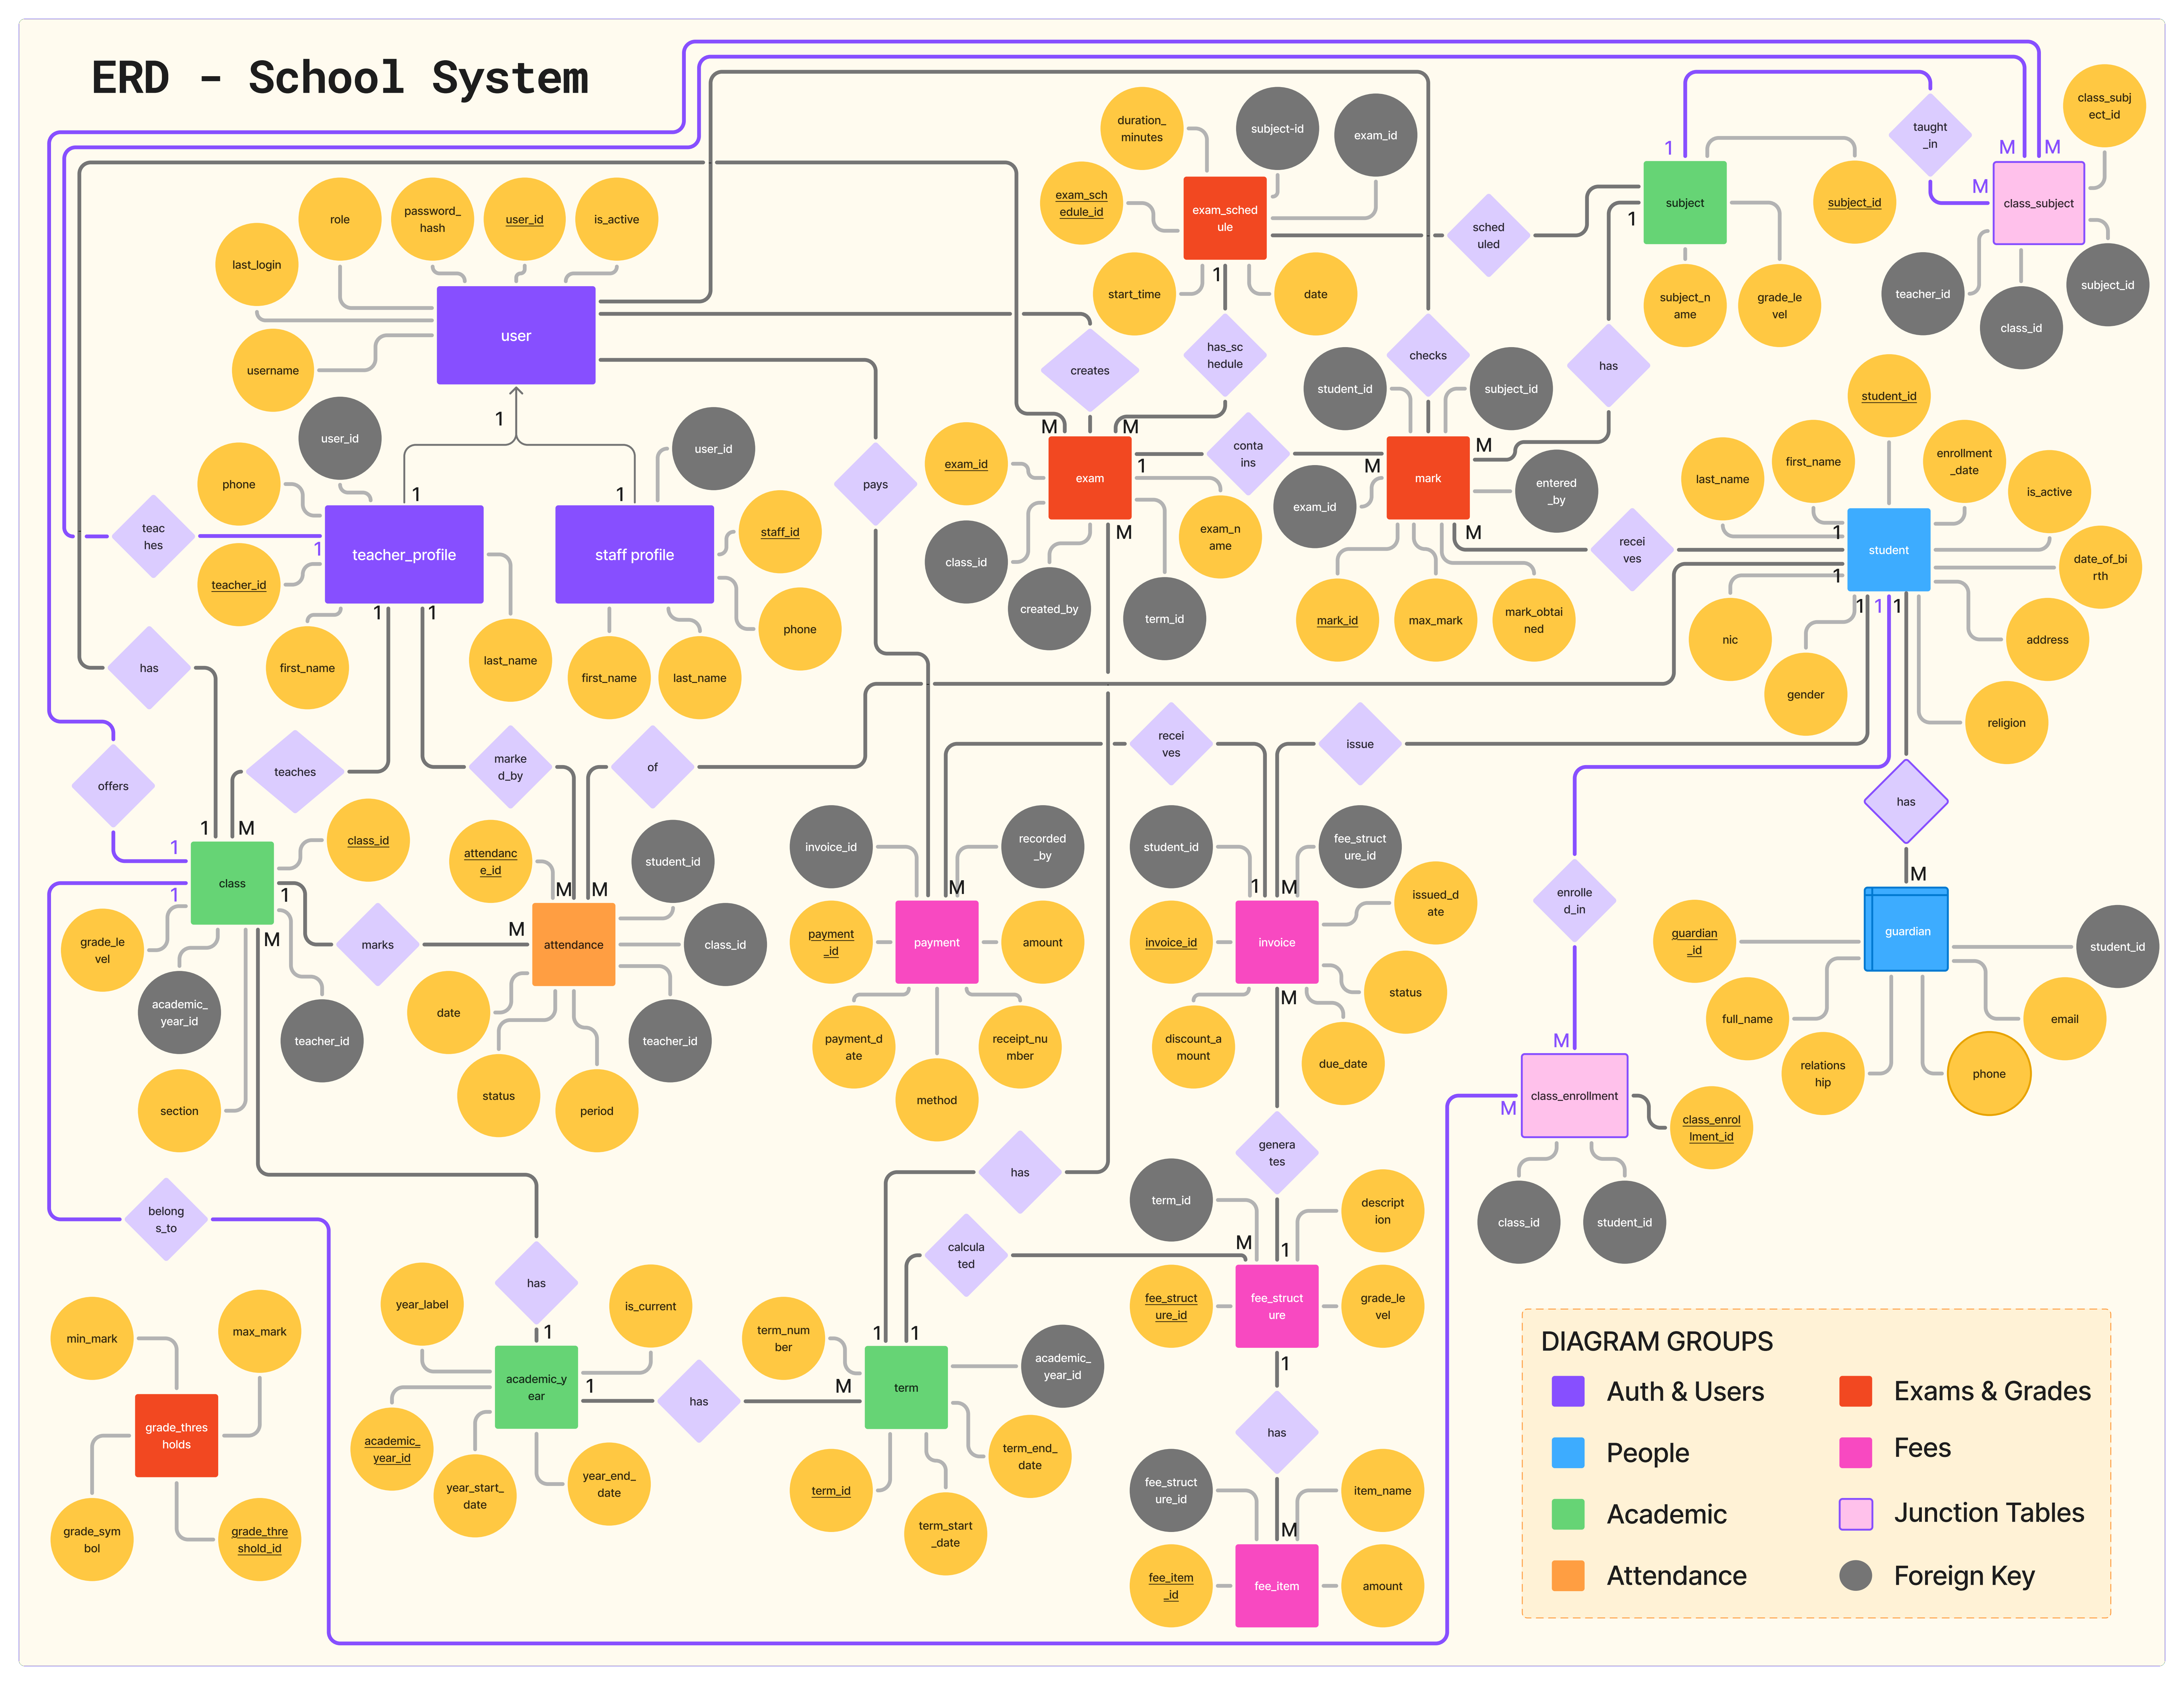
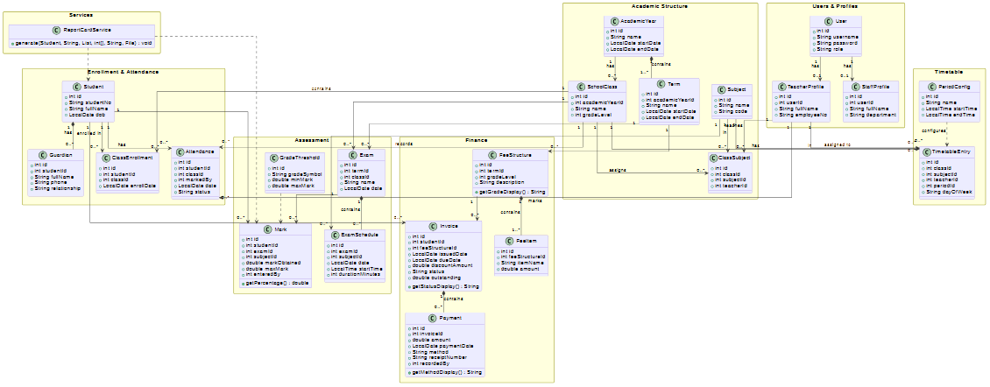
3.6 ER Diagram

Chapter 4 – Implementation

4.1 Implementation Environment
Component | Tool / Version | Purpose
Language | Java 17 | Primary implementation language
UI Framework | JavaFX 21.0.2 | Desktop UI and event handling
Build Tool | Apache Maven 3.11 | Dependency management and build
Database | MySQL 8.x | Relational data storage
JDBC Driver | MySQL Connector/J 8.0 | Java-to-MySQL connectivity
Password Hashing | jBCrypt 0.4 | BCrypt password hashing
PDF Generation | Apache PDFBox 3.0.2 | Report card PDF output
IDE | IntelliJ IDEA | Development environment
DB Client | MySQL Workbench | Schema design and query testing
Version Control | Git | Source code management
OS (Dev) | Windows 11 | Development machine

4.2 Project Structure
The Maven project is organised under the com.school base package:
- com.school — App.java entry point, launches the JavaFX application
- com.school.model — 20 model classes representing domain entities
- com.school.dao — 13 DAO classes, one per table group
- com.school.controller — 9 controller classes, one per view
- com.school.service — ReportCardService for PDF generation
- com.school.util — DBConnection (JDBC connection factory) and SessionManager (login session singleton)
Resources are organised under src/main/resources/com/school/:
- fxml/views/ — 9 FXML view files
- css/styles.css — Application-wide stylesheet
- images/ — School logo for report card header
- db.properties — Database connection configuration

4.3 Selected Implementation Details

4.3.1 BCrypt Authentication
On login, the plain-text password entered by the user is verified against the stored BCrypt hash using BCrypt.checkpw(). The hash is never decrypted — BCrypt verification re-hashes the input and compares the result. Password reset by the Principal generates a new hash via BCrypt.hashpw(newPassword, BCrypt.gensalt(12)) and updates the database record.

4.3.2 Attendance Batch Upsert
Attendance for a full class period is saved in a single JDBC batch:
String sql = """
INSERT INTO attendance (student_id, class_id, date, period, status, marked_by)
VALUES (?, ?, ?, ?, ?, ?)
ON DUPLICATE KEY UPDATE
status = VALUES(status),
marked_by = VALUES(marked_by)""";

for (Attendance a : records) {
ps.setInt(1, a.getStudentId());
// ... bind remaining fields
ps.addBatch();
}
ps.executeBatch();
ON DUPLICATE KEY UPDATE makes re-submission safe without a prior DELETE, and the single executeBatch() call sends all records in one round trip.

4.3.3 Report Card PDF Generation
PDF report cards are generated using Apache PDFBox 3.0.2. PDFBox's built-in Type1 fonts (Helvetica) support Latin-1 only; a sanitise() helper replaces non-Latin characters (including Sinhala Unicode) with '?' to prevent generation failure. The report card layout includes a school header with embedded PNG logo, student information block, marks table with colour-coded grade symbols, attendance summary tiles, and a footer. Text is positioned manually using x/y coordinates in points on an A4 page.

4.3.4 Timetable Grid
The timetable is rendered as a programmatic GridPane. Column constraints define one label column and five day columns (Mon-Fri). Rows are generated at runtime by iterating over period_config entries. Interval rows are rendered as a Label spanning all five day columns (GridPane.setColumnSpan(node, 5)). Each non-interval cell is built by the buildCell() method, which produces either an interactive filled slot (showing subject and teacher with a clear button) or an empty slot with a hover-highlighted plus button that opens an assignment dialog.

4.4 Key Implementation Challenges

4.4.1 Invoice Cartesian Product Bug
An initial implementation of v_invoice_summary joined fee_items and payments directly to the invoices table in a single query. With two fee items and one payment, the join produced two rows (2 fee items × 1 payment), causing SUM(payments.amount) to count the payment twice. The fix pre-aggregates both fee_items and payments in independent subqueries before joining to invoices, ensuring each contributes exactly one row per invoice regardless of item or payment count.

4.4.2 Mark Entry TextField Reset During Refresh
The mark entry cell's text change listener called marksTable.refresh() to trigger a live grade preview. JavaFX's cell recycling mechanism caused refresh() to invoke updateItem() on the currently focused cell, which reset the TextField text mid-keystroke. The fix removes the refresh() call from the listener entirely, and guards updateItem() with if (!tf.isFocused()) before setting the TextField value, preventing the cell from overwriting its own content during a refresh triggered by another event.

4.4.3 Stale Invoice Status After Bulk Generation
After bulk-generating invoices for a grade, newly created invoices for students who had previously paid a different invoice were incorrectly showing as 'Paid'. This occurred because the view read the stored status column (which retained the old value from a prior refreshStatus() call). The fix moves status calculation entirely into the view using a CASE expression over actual payment totals, making the stored status column irrelevant to the display.

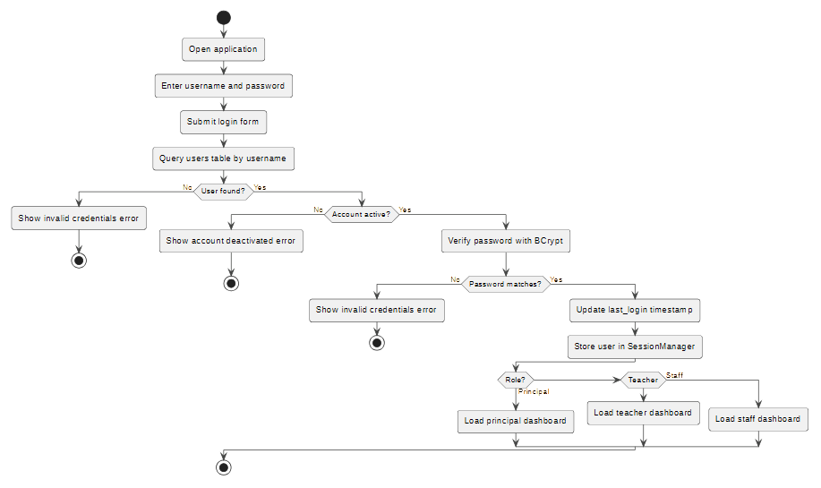
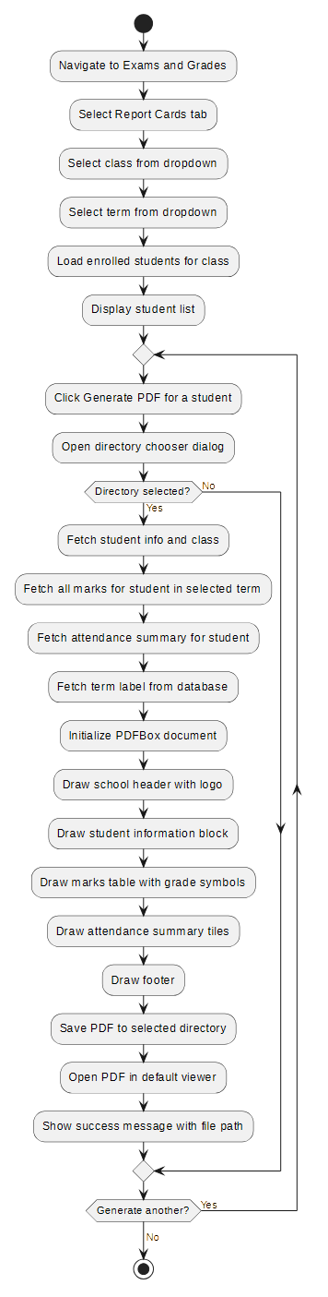
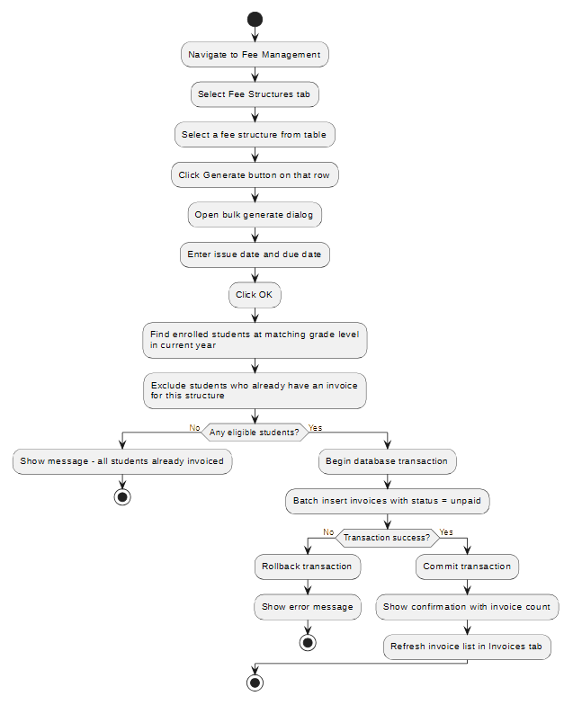
4.5 Activity Diagrams
(User Login)
(Generate Bulk Invoices)
(Generate Report Card PDF)

Chapter 5 – Evaluation

5.1 Testing Approach
System testing was conducted using functional test cases mapped directly to the functional requirements defined in Chapter 2. Each test case was executed manually against a populated test database containing representative data (two classes, five students, fee structures, exams, and attendance records). Non-functional requirements were verified through direct measurement and observation.

5.2 Functional Test Results
Test ID | Test Case | Expected Result | Status
T01 | Login with valid principal credentials | Dashboard loads with Principal role | Pass
T02 | Login with incorrect password | Error shown, login rejected | Pass
T03 | Login with deactivated account | Login rejected with message | Pass
T04 | Add student with all required fields | Student saved and appears in list | Pass
T05 | Add student with blank required field | Validation error displayed | Pass
T06 | Enroll student into a class | Enrollment recorded correctly | Pass
T07 | Mark attendance for a class period | All statuses saved correctly | Pass
T08 | Re-submit attendance for same period | Previous values overwritten without error | Pass
T09 | Enter marks and save | Grades auto-calculated and displayed | Pass
T10 | Generate invoices for a grade | All enrolled students receive invoices | Pass
T11 | Record payment equal to outstanding | Invoice status changes to Paid | Pass
T12 | Record payment exceeding outstanding | Validation error, payment blocked | Pass
T13 | Generate new invoice after prior payment | New invoice shows as Unpaid, not Paid | Pass
T14 | Generate PDF report card | PDF created with correct data | Pass
T15 | Assign subject to timetable slot | Slot displays subject and teacher | Pass
T16 | Teacher dashboard period count | Count matches timetable for today | Pass
T17 | Edit grade threshold | New threshold used on next grade calculation | Pass
T18 | Delete student with existing invoices | Delete blocked with informative error | Pass
T19 | Reset user password | User can login with new password | Pass
T20 | Deactivate user account | User cannot login after deactivation | Pass

5.3 Non-Functional Test Results
ID | Requirement | Test Method | Result
NFR01 | Login screen within 3 seconds | Timed 5 cold launches, averaged | Avg 1.8s — Pass
NFR02 | Queries within 2 seconds | Timed student list load with 200 records | Avg 0.4s — Pass
NFR03 | Navigable without training | Observed first-time use by a non-technical participant | Core tasks completed unaided — Pass
NFR04 | Passwords stored as BCrypt | Inspected users table directly in MySQL client | All hashes confirmed BCrypt $2a$ format — Pass
NFR05 | Fully offline operation | Operated with network adapter disabled | All features functional — Pass
NFR06 | Referential integrity enforced | Attempted orphan inserts directly in MySQL | All FK constraints blocked invalid inserts — Pass
NFR07 | Sinhala Unicode in UI | Entered Sinhala text, retrieved and displayed | Displayed correctly in all text fields — Pass
NFR09 | PDF opens in standard viewer | Opened generated PDF in Adobe Reader and Chrome | Rendered correctly in both — Pass
NFR10 | Duplicate prevention | Attempted duplicate username, NIC, and attendance slot | All rejected with appropriate DB or validation error — Pass

5.4 Evaluation Against Objectives
All ten objectives stated in Chapter 1 were met:
- FR01-FR03: Role-based authentication with BCrypt, account management by Principal — fully implemented and tested.
- FR04-FR05: Student registration with Sinhala name support and guardian management — implemented.
- FR06-FR08: Academic structure (years, terms, classes, subjects, assignments, enrollment) — implemented across 6 tabs in Academic Setup.
- FR09-FR10: Period-level attendance with four statuses and idempotent re-submission — implemented and tested.
- FR11-FR12: Examination scheduling, mark entry, and auto-grading — implemented.
- FR13-FR14: Configurable timetable with period_config-driven bell schedule — implemented.
- FR15: Teacher timetable in dashboard — implemented as read-only GridPane.
- FR16-FR18: Fee structures, bulk invoice generation, payment recording with overpayment prevention — implemented.
- FR19: PDF report card generation — implemented using Apache PDFBox.
- FR20-FR21: Grade threshold editing and role dashboards — implemented.

Chapter 6 – Conclusion

6.1 Summary
This project designed and implemented a fully functional School Management System as a Java desktop application, meeting all 22 functional requirements identified in the analysis phase. The system covers the complete lifecycle of school administration — from student registration and class enrollment through to examination grading and report card PDF generation — in a single integrated, role-aware application that requires no internet connectivity.
Three user roles each received a purpose-built interface: the Principal manages the entire academic and administrative structure; Teachers mark attendance and enter marks for their assigned classes; Office Staff register students and manage fee payments. A real-time dashboard for each role surfaces the most operationally relevant information immediately on login.

6.2 Critical Evaluation
The system performs reliably within its intended scope. All functional test cases passed and non-functional requirements were verified through measurement. Three significant implementation bugs were encountered and resolved — the invoice cartesian product aggregation error, the mark entry TextField reset during cell refresh, and the stale invoice status after bulk generation. Each produced a deeper understanding of JDBC aggregate query design and JavaFX cell lifecycle management.
One unresolved limitation is the absence of Sinhala Unicode support in generated PDFs. Apache PDFBox built-in fonts cover only Latin-1; Sinhala characters are currently rendered as '?' in the report card. This does not affect UI functionality where Sinhala text is fully supported, but it means report cards display student names in English only.

6.3 Lessons Learnt
- Iterative development proved highly effective: bugs in early modules (fees, invoice views) were caught and resolved before dependent features (report cards) were built on top of them.
- The period_config design decision — making bell times database-driven rather than hardcoded — demonstrated the value of designing for changeability even in a desktop application with a fixed deployment target.
- Constructing dialogs programmatically rather than in FXML reduced total file count and kept validation co-located with UI construction, making the code easier to navigate.
- The ON DUPLICATE KEY UPDATE upsert pattern is a significantly cleaner approach to idempotent data submission than the common check-then-insert pattern, especially for batch operations.

6.4 Future Work
- Embed a Unicode font (e.g. Noto Sans Sinhala) in PDFBox output to support Sinhala characters in report cards.
- Add a Principal-facing period_config editor UI so bell schedule changes do not require direct database access.
- Implement automatic overdue invoice detection via a background job that compares due_date with the current date.
- Add a student progress chart showing grade trends across multiple terms using JavaFX LineChart.
- Implement timetable PDF export so the GridPane view can be printed directly.
- Add a database backup and restore utility for non-technical administrators.
- Add a bulk student import from CSV to simplify initial data entry when deploying to a new school.

References
[1] SchoolTool Community, SchoolTool School Management System. [Online]. Available: http://www.schooltool.org. [Accessed: [Date]].
[2] iSkool, iSkool School Management System. [Online]. Available: https://www.iskool.lk. [Accessed: [Date]].
[3] Oracle Corporation, JavaFX 21 Documentation. [Online]. Available: https://openjfx.io/javadoc/21/. [Accessed: [Date]].
[4] Apache Software Foundation, Apache PDFBox 3.0 Documentation. [Online]. Available: https://pdfbox.apache.org/docs/3.0.0/. [Accessed: [Date]].
[5] D. Damien Miller, jBCrypt — A Java Implementation of BCrypt. [Online]. Available: https://www.mindrot.org/projects/jBCrypt/. [Accessed: [Date]].
[6] Oracle Corporation, MySQL 8.0 Reference Manual. [Online]. Available: https://dev.mysql.com/doc/refman/8.0/en/. [Accessed: [Date]].
[7] I. Sommerville, Software Engineering, 10th ed. Pearson, 2015.

Appendices

Appendix A – Installation Guide
Prerequisites:
- Java 17 or higher installed on the target machine.
- MySQL 8.x installed and running, accessible via LAN or localhost.
- school_management_schema.sql executed in MySQL to create the database schema and seed data.
- BCrypt hashes generated and inserted for initial user accounts.
Configuration:
- Edit src/main/resources/db.properties with the correct host, port, database name, username, and password.
- Run the application with: mvn javafx:run from the project root directory.

Appendix B – User Manual Summary
Principal: Login → Dashboard shows student count, active classes, today's attendance, and outstanding fees. Academic Setup manages years, terms, classes, subjects, assignments, enrollment, and timetable. Exams & Grades manages exams and report cards. User Management creates/deactivates staff accounts.
Teacher: Login → Dashboard shows assigned classes, student count, today's scheduled periods, and weekly timetable. Mark Attendance and Enter Marks navigation items provide period-level attendance and mark entry.
Office Staff: Login → Dashboard shows student count, unpaid invoices, outstanding fees, and this month's collections. Students module handles registration. Fee Management handles payment recording.

Appendix C – Test Data
Test data used during evaluation included:
- 2 academic classes (Grade 10-A, Grade 10-B) under the 2025/2026 academic year.
- 2 active students per class (4 total).
- 5 subjects per class with subject-teacher assignments.
- Attendance records across 3 periods for 2 dates.
- 1 exam per class with marks entered for all subjects.
- 1 fee structure per grade with 2 line items totalling LKR 3,000.
- Invoices generated for all students; partial payments recorded for testing status transitions.
End of Report!

