Project Name
Skin Health Analyzer (Mobile Application)



Submitted By
Name: Rijab Butt ID: F2021376005
Name: Maryam Waheed ID: F2021376021
Name: Muhammad Mubashir ID: F2022376105
Name: Azka Naaz ID: F2021105042

Session
2021-2026
Project Supervisor
Prof. Syed Ashraf Ali
Department Name
School of Systems and Technology
University of Management and Technology
C-II Johar Town Lahore Pakistan
Dedication

This Final Year Project, namely, Skin Health Analyzer, is hereby dedicated to Allah Almighty whose mercy, benevolence, and guidance has enabled us to undertake such a venture with strength and an aim.
We are giving our sacred thanks to our parents and families whose love and sacrifices as well as continuous support have formed the foundation of our academic journey.
It is the individual pleasure of our supervisor, Professor Syed Ashraf Ali, to which we offer our serious recognition, with gratitude, that his advice, support, and priceless contribution have been of much benefit to this work.
This paper is also in honor of the hardworking farmers and the agricultural community as a whole whose practical issues have really been the pioneer to our proposed solution.
We owe the University of Management and Technology (UMT), its staff, and Final Year Project Committee who provided access to resources and academic atmosphere that enabled innovation.
We would like to express our gratitude to our colleagues, peers, friends, and well-wishers who helped us at the times in doubt and success and we owe our team members whose efforts made this project possible; thank you to us and to this worthy cause.

Final Approval

Project Name
Skin Health Analyzer (Mobile Application)

Panel of Examiners

Head of Department ______________________
Department of Software Engineering
University of Management and Technology
Lahore

Program Director (Final Year Projects) ______________________
Department of Software Engineering
University of Management and Technology
Lahore

Supervisor ______________________
Department of Software Engineering
University of Management and Technology
Lahore

Co-Supervisor ______________________
(If any)

Documentation Evaluator ______________________

Acknowledgment

It was a large thanksgiving to Allah Almighty that He guided us, blessed us, and showed mercy during this Final Year Project.
We would like to mention that we appreciate the continuous support, useful recommendations, and directions that our project supervisor, Prof. Ashraf Ali provided in the project. His experience and skills were instrumental in decision making in our work and how good it could be.
We owe our growing academic foundation to the faculty of the School of Systems and Technology, University of Management and Technology (UMT), Lahore, and its efforts to provide a good academic foundation and a conducive learning experience wherein we were compelled to think rationally and acquire knowledge in the technical field. Another resource that we like is the UMT Library with its digital sources that enabled us to access textbooks, research journals, scholarly articles and online databases that proved very necessary in our literature review and technical knowledge acquisition.
We also utilized the official Flutter development resources and documentation, which provided us with a guidance of designing and implementing our mobile app and utilized Supabase docs and tools, which assisted in designing and maintaining the database layer, in ensuring the security of the data stored and retrieved efficiently.
Edge AI tools and frameworks, as well as learning materials, were also utilized and enabled us to implement a custom machine learning model as a direct implementation in the Flutter app. This model minimizes the dependencies in cloud inference, lowers the operating expenses, and allows so-called offline or low-connectivity execution of the app.
Lastly, UMT deserves to be mentioned due to its provision of infrastructure on campus, research amenities as well as institutional support that made this project achievable.

Project Title

Skin Health Analyzer (Mobile Application)
A Skin condition Analysis and personalized recommendation System based on Edge AI.
Objective
- To identify the initial symptoms of standard skin conditions, such as acne, pigmentation, dryness, and other outward issues, with the help of AI-based image analysis.
- To provide accurate, tailored, and non-medical skincare advice depending on the type of skin issue identified, so the users will not have to resort to trial-and-error self-treatment.
- To increase the efficiency of skin health management and monitoring and self-care as the user would be able to observe the changes per time using a mobile application.
- To implement skin analysis that is accessible, cost-effective, and privacy-preserving with the assistance of Edge AI deploying models on-device- reducing the reliance on the cloud to have on-demand and enabling offline computation.

Undertaken by
- Rijab Butt (ID: F20213760050)
- Maryam Waheed (ID: F2021376021)
- Muhammad Mubashir (ID: F2022376105)
- Azka Naaz (ID: F2021105042)

Supervised by
Prof. Syed Ashraf Ali
Email: ashraf.ali@umt.edu.pk
Starting Date
Fall 2025
Completion Date
Spring 2026

Tools Used

Hardware Tools:
- Personal Computer, My personal development laptop.
- Smartphone (Android/iOS), I take my phone to take the photo and test the application at the same time.
- Camera sensor brands (Smartphone camera), The embedded camera in the phone is the main source of Image capturing device.
Software Tools:
- Image Processing – I am working with the OpenCV, TensorFlow, and Python (Pandas, NumPy) libraries and Edge AI Deployment using N8n.
- Data Integration - I save the data in SQL /NoSQL databases and crosslink it with either the AWS or Google Cloud.
- User Interface Development- I create the UI in Flutter and code it on Dart.
Operating System
Windows- Up to here, my primary development environment.

Documentation

The documentation of Skin health analyzer includes:
Project Proposal: This will give the statement of the problem, objectives, scope and methodology.
Design: Formation The design of the hardware and computer software. Elaboration of implementation Gradual implementation process, fragments of code, and algorithms.
Testing and Validation: Model results, model performance measures and model accuracy.
User Manual: This is the guide of how to operate Skin health analyzer system.
Final Report: Finished report of the project and the problems, solution and recommendations.

I have thoroughly reviewed the paperwork of Final Year Project on the topic of Skin health analyzer, Diagnosis and Treatment and have verified that it analyzes and follows the requirements of a final year project report. The paper under consideration was non-plagiarized with the help of Turnitin software, which is also kept in the UMT Library, and the similarities are acceptable. The documentation is provided in the PDF that is located in the accompanying CDs, along with the source code and binaries, user manual, and the instruction on how to install it.

Plagiarism Report

Declaration Form

I examined the report documentation of the Final Year Project of the project named “Skin Health Analyzer (Mobile Application)” and I am able to verify that the report complies with the requirements of an undergraduate final year project.
The plagiarism checker (Turnitin software) in UMT Library found no plagiarism in the paper, and the similarity score fits in the decent range.
The documentation is included in the accompanying CDs in PDF formats, along with the source code, binaries, a user manual and an installation guide.

FYP Supervisor Name: Syed Ashraf Ali

Signature: __________________ Date: ___________________

Abstract

In other words, the Skin Health Analyzer project is connected with the game-changer in the digital format of healthcare because the distance between the professional approach to the diagnostic of dermatology and the scope of practical skin care is bridged. In the majority of localities, following a lengthy wait, astronomic prices, and literal unavailability of the same to the country, having a special skin appointment languishing in the traffic jam, and citizens not being served on time, such that things reach new levels of advancement. And this is what we have strived to sort out to de-plan this issue, designing a discrete, phone first, concept, self-aware, non-invasive, real-time skin-tests. Our own implementations of Efficient-net B0 convolutional neural network now mean the application is no longer based on manual observation, but rather we are analyzing our pixels to extremely high precision which is in narrowing in to typical, but significant conditions like acnes, pigmentation and dryness and the application has maximum F1 -score accuracy of 71%.
The current degree of technical seriousness that is applied to the clinical-grade reliability is one of the strong points. Our diagnostic model was designed on the TensorFlow/Keras system, and the model was trained with a mixed dataset of over 29,500 dermatology images. That is made up of the SCIN (Skin condition Image Network) set - made up of more than 10,000 real life photos of various kinds of different demographics - and Dermnet set comprising of about 19,500 photos of 23 different types of diseases. This intensive training enables this model to resist the alteration on the skin tone, light and image quality. In order to make the model run and perform, Edge AI is deployed on the device in a way that the inference can be fast even in conditions of low connectivity to facilitate performance and privacy.
The app is created in Flutter itself that offers a cross-platform experience and clean and simplified workflow where image-in result-out should be as accessible as possible. Instead of diagnosing, it is supported by a very complex layer of automation at the backend based on n8n and the Gemini API. As a condition is experienced, the system produces personal (non-medical) skin-care advice depending on the outcome of the user. It is already taken through a high dose of testing and heuristic reviews with an SUS score of over 70. The data of the users is stored in Firebase firestore (and supabase) and will enable the user to have a permanent and secure history of his or her skin. The Skin Health Analyzer is a combination of high-tech computer vision and the technology that can be found in a regular phone, whereas it is a solution to democratizing dermatology and enables users to make evidence-based decisions that will allow the world to grow more proactive and tech-savvy about their self-care.
Revision Chart

Version | Primary Author(s) | Description of Version | Date Completed
Draft | All group members | The first draft submitted to the class drive in order to make everyone comment and provide feedback. | NOVEMBER 5,2025
Preliminary | All group members | Second draft with the changes made to the first round of comments was sent in, to be looked at. | DECEMBER 8,2025
Final | All group members | To track versions, first complete draft was locked in the version control system. | MARCH  16,2026
Revision 1 | All group members | New draft, updated based on the change control checklist, is version controlled. | MAY,2026  (expected)
Revision 2 | All group members | Again, modified documentation, which is again modified through the change control process remains under version control. | JULY,2026  (expected)
Etc. | TBD | TBD | TBD

Table of Contents
Table of Contents 1
Definitions and Acronyms 4
List of Figures 5
List of Tables 6
1. Introduction 8
1.1 Problem Statement 9
1.2 Objectives 9
1.3 Scope of the Project 10
1.4 Significance of the Project 11
1.5 Features of Artificial Intelligence 11
1.5.1 Classification based on Deep Learning 11
1.5.2 Edge/On‑Device Inference 12
1.5.3 Artificial Intelligence-based recommendations Generator 12
1.5.4 Diversity and Prejudice Reduction: 12
1.6 Project Deliverables 12
2. Domain Analysis 13
2.1 Customer 13
2.2 Stakeholders 13
2.3 Impacted Groups Social or Economic 14
2.4 Dependencies/ External Systems 15
2.4.1 Related Projects 17
2.4.2 Feature Comparison 20
2.5 Context Diagram 21
2.6 Data Flow Diagram 21
3. Requirements analysis 22
3.1 List of Actors 22
3.2 Product Backlog 23
3.2.1 Epic Overview 23
3.2.2 Functional Requirements 24
3.2.3 Non-Functional Requirements 26
3.3 UI/UX Designs 29
4. Project Planning and Execution using Sprints 33
4.1 GitHub Repository 33
4.2 Sprints Overview 33
4.2.1 Sprint 1 34
4.2.1.1 Sprint 1 Backlog 35
4.2.1.2 Sprint 1 Design Class Diagram 35
4.2.1.3 Sprint 1 Sequence Diagram 36
4.2.1.4 Sprint 1 Decision Table 36
4.2.1.5 Sprint 1 Extended Test Cases 37
4.2.1.6 Sprint 1 Review Meeting 38
4.2.2 Sprint 2 39
4.2.2.1 Sprint 2 Backlog 40
4.2.2.2 Sprint 2 Design Class Diagram 41
4.2.2.3 Sprint 2 Sequence Diagram 42
4.2.2.4 Sprint 2 Decision Table 42
4.2.2.5 Sprint 2 Extended Test Cases 43
4.2.2.6 Sprint 2 Review Meeting 43
4.2.3 Sprint 3 45
4.2.3.1 Sprint 3 Backlog 47
4.2.3.2 Sprint 3 Design Class Diagram 48
4.2.3.3 Sprint 3 Sequence Diagram 48
4.2.3.4 Sprint 3 Decision Table 49
4.2.3.5 Sprint 3 Extended Test Cases 49
4.2.3.6 Sprint 3 Review Meeting 50
4.2.4 Sprint 4 51
4.2.4.1 Sprint 4 Backlog 53
4.2.4.2 Sprint 4 Design Class Diagram 54
4.2.4.3 Sprint 4 Sequence Diagram 54
4.2.4.4 Sprint 4 Decision Table 55
4.2.4.5 Sprint 4 Extended Test Cases 55
4.2.4.6 Sprint 4 Review Meeting 56
4.2.5 Sprint 5 57
4.2.5.1 Sprint 5 Backlog 58
4.2.5.2 Sprint 5 Design Class Diagram 59
4.2.5.3 Sprint 5 Sequence Diagram 59
4.2.5.4 Sprint 5 Decision Table 60
4.2.5.5 Sprint 5 Extended Test Cases 60
4.2.5.6 Sprint 5 Review Meeting (in progress) 61
4.2.6 Sprint 6 61
4.2.6.1 Sprint 6 Backlog 62
4.2.6.2 Sprint 6 Design Class Diagram 63
4.2.6.3 Sprint 6 Sequence Diagram 63
4.2.6.4 Sprint 6 Decision Table 64
4.2.6.5 Sprint 6 Extended Test Cases 64
4.2.6.6 Sprint 6 Review Meeting (Planned) 64
4.2.7 Sprint 7 65
4.2.7.1 Sprint 7 Backlog 65
4.2.7.2 Sprint 7 Design Class Diagram 66
4.2.7.3 Sprint 7 Sequence Diagram 67
4.2.7.4 Sprint 7 Decision Table 67
4.2.7.5 Sprint 7 Extended Test Cases 68
4.2.7.6 Sprint 7 Review Meeting (Planned) 68
4.2.8 Sprint 8 68
4.2.8.1 Sprint 8 Backlog 69
4.2.8.2 Sprint 8 Design Class Diagram 70
4.2.8.3 Sprint 8 Sequence Diagram 70
4.2.8.4 Sprint 8 Decision Table 71
4.2.8.5 Sprint 8 Extended Test Cases 71
4.2.8.6 Sprint 8 Review Meeting (planned) 71
4.3 System Architecture 72
4.4 System context Diagram 72
4.5 System Container Diagram 73
4.6 Component Diagram 73
4.7 Code Diagrams 74
4.8 ERD 75
4.9 Data Dictionary 76
5. Implementation details 78
5.1 Development Setup 78
5.2 Deployment setup 78
5.2.1 Deployment Process 79
5.2.2 Challenges Faced and Solutions 79
5.3 Algorithms 79
6.3.1 Image Preprocessing Algorithm 79
6.3.2 Convolutional Neural Network (CNN) Classification Algorithm 80
6.3.3 Recommendation Mapping Algorithm 80
6.3.4 History Tracking and Data Logging Algorithm 80
5.4 Constraints 81
5.4.1 Assumptions 81
5.4.2 System constraints 81
5.4.3 Restrictions 82
5.4.4 Limitations 82
6. Project Monitoring, control and traceability 83
6.1 Traceability Matrix 83
6.1.1 Requirements vs Prototype (FR-ID vs PID) 84
6.1.2 Functional Requirements vs Test Cases (FR-ID vs TID) 85
7. Results/Output/Statistics 86
7.1 Requirement Completion 86
7.2 Accuracy 86
7.3 Correctness 86
8. Conclusion 87
9. Future work 88
9.1 Improved Model capabilities 88
9.2 Offline Support and Low-connectivity Support 88
9.3 Innovative Performing and Overlooking 88
9.4 Lettering, Multilingual & Regional Adaptation 88
9.5 Community and Health System Integration 88
9.6 Ethical and Regulatory Preparedness 89
9.7 Commercial Strategy and Sustainability Strategy 89
9.8 Summary of Future Work 89
10. Bibliography 90
10.1 Books 90
10.2 Journals 90
10.3 Articles 91
10.4 Research papers 91
10.5 Other References 92
11. Appendix 93
11.1 Glossary of terms 93
11.2 Pre-requisites 94
11.2.1 Hardware Requirements 94
11.2.2 Software Requirements 94
11.2.3 Setting up Machine Learning Environment 94
11.2.4 Mobile Application Setup 94
11.2.5 Backend and Deployment Configuration 95
11.2.6 External System Dependencies 95
11.2.7 Security Requirements 95

Definitions and Acronyms

Table 1 : List of acronyms and definitions
Acronym | Definition
UMT | University of Management and Technology
SHA | Skin Health Analyzer

List of Figures

Figure 1: Context Diagram - SHA 21
Figure 2: Epic vs User Story in Product Backlog 23
Figure 3: Prototype – PID1- Get Started Page UI 29
Figure 4: Prototype - PID2- Log IN Page UI 29
Figure 5: Prototype – PID3- Sign UP Page UI 30
Figure 6: Prototype – PID4- Home Page UI 30
Figure 7: Prototype – PID5- Scan Page 31
Figure 8: Prototype – PID6- Profile Page 31
Figure 9: Prototype – PID7- Recommendation Page 32
Figure 10: Sprint 1 Design Class Diagram 36
Figure 11: Sprint 1 Sequence diagram 36
Figure 12: Sprint 2 Design Class Diagram 41
Figure 13: Sprint 2 Sequence Diagram 42
Figure 14: Sprint 3 Design Class Diagram 48
Figure 15: Sprint 3 Sequence Diagram 48
Figure 16: Sprint 4 Design Class Diagram 54
Figure 17: Sprint 4 Sequence Diagram 54
Figure 18: Sprint 5 Design Class Diagram 59
Figure 19: Sprint 5 Sequence Diagram 59
Figure 20: Sprint 6 Design Class Diagram 63
Figure 21: Sprint 6 Sequence Diagram 63
Figure 22: Sprint 7 Design Class Diagram 66
Figure 23: Sprint 7 Sequence Diagram 67
Figure 24: Sprint 8 Design Class Diagram 70
Figure 25: Sprint 8 Sequence Diagram 70
Figure 26: System context Diagram 72
Figure 27: System container Diagram 73
Figure 28: Component Diagram 74
Figure 29: Code Diagram for SHA 75
Figure 30: ER Diagram for SHA 76
Figure 31: Data Dictionary of SHA 77

List of Tables

Table 1 : List of acronyms and definitions 4
Table 2: List of Stakeholders 13
Table 3: Feature comparison of our product with competitors 20
Table 4: Selected Features of Product Backlog 24
Table 5 : Sprint Overview 33
Table 6 : Sprint-1 Team Capacity 34
Table 7 : Sprint 1 Backlog 35
Table 8 : Sprint 1 Decision Table 37
Table 9 : Sprint 1 Extended Test Case 37
Table 10 : Team Capacity Sprint 2 40
Table 11 : Sprint 2 Backlog 41
Table 12 : Sprint 2 Decision Table 42
Table 13 : Sprint 2 Extended Test Case 43
Table 14 : Team Capacity Sprint 3 46
Table 15 : Sprint 3 Backlog 47
Table 16 : Sprint 3 Decision Table 49
Table 17 : Sprint 3 Extended Test Case 49
Table 18 : Team Capacity Sprint 4 52
Table 19 : Sprint 4 Backlog 53
Table 20 : Sprint 4 Decision Table 55
Table 21 : Sprint 4 Extended Test Case 55
Table 22 : Team Capacity Sprint 5 58
Table 23 : Sprint 5 Backlog 58
Table 24 : Sprint 5 Decision Table 60
Table 25 : Sprint 5 Extended Test Case 60
Table 26 : Team Capacity Sprint 6 61
Table 27 : Sprint 6 Backlog 62
Table 28 : Sprint 6 Decision Table 64
Table 29 : Sprint 6 Extended Test Case 64
Table 30 : Team Capacity Sprint 7 65
Table 31 : Sprint 7 Backlog 65
Table 32 : Sprint 7 Decision Table 67
Table 33 : Sprint 7 Extended Test Case 68
Table 34 : Team Capacity Sprint 8 69
Table 35 : Sprint 8 Backlog 69
Table 36 : Sprint 8 Decision Table 71
Table 37 : Sprint 8 Extended Test Case 71
Table 38 : Development Table 78
Table 39 : Traceability Table 83
Table 40 : Requirements Table 84
Table 41 : FR-ID vs TID Table 85

Introduction
The well-being of the skin is one of the pillars of the comprehensive health of the whole individual, self-esteem, and life quality. Such skin related problems like acne, pigmentation diseases, eczema, dryness, rash, and early aging in people affects millions of people globally, usually causing them psychological discomfort, low self-esteem, and in the most extreme cases precipitation to more serious skin problems.
Qualified dermatologists are still available in limited quantities in Pakistan and most of the developing countries because of various factors such as high consultancy charges, long queues, inaccessibility among geographical locations (limited to rural and remote locations) and inaccessibility to specialists compared to the population. Currently, most of them are self-diagnosing, using self-prescription of products they have purchased based on an educated guess, unreliable internet sources, or failing to receive treatment promptly - all of which often result in incorrect treatment, prolonged patient suffering, further deterioration of the conditions, and wastage of money that could have been otherwise spent like rent.
Meanwhile, the swift development of the Artificial Intelligence (AI), Computer Vision (CV), and mobile computing has provided novel opportunities in digital health and individual wellness. Algorithms On the one hand, smartphone cameras together with well-trained deep learning models have now the capacity to analyze high-resolution skin images with growing accuracy providing non-invasive, preliminary screening anywhere and all the time. As seen by recent studies, AI-based systems in several skin conditions are able to both match or surpass the performative levels of the general practitioner on the diagnostic level and large language models (LLMs) are capable of providing context-specific, easily understandable explanations and non-medical care suggestions.
The combination of these trends, including the rising consumer need of convenient health apps, the rising level of smartphone penetration even into underserved regions, and the maturity of AI solutions has inspired the creation of the Skin Health Analyzer, an artificial intelligence-driven mobile app that would replace the current system of delivering early skin health information and encourage the idea of proactive, informed self-care.
The driving forces into this project are:
Early Detection and Prevention: This gives users a chance to detect typical skin issues at early stages of their lives so that they are not worsened or require the attention of the professionals.
Accessibility & Equity: How to provide individuals who struggle to visit dermatologists with a cheap and on-demand initial screening aid?
Personalized Direction: It should be switched to non-medical guidance based on a non-medical performance based on AI diagnostics (given personally).
User Empowerment: Enabling individuals to check readings on the change of skin condition with time and give evidence-based conclusions on how they take care of their skin. And, lastly is Alignment with Global Trends that contributes to the emerging area of AI-based digital dermatology and mobile health (mHealth) solutions.

Problem Statement
Skin Health Analyzer: It is an incredible latest mobile application, currently accessible and created with Flutter, which uses deep learning to deliver non-invasive skin diagnostics and tailored recommendations on skin care. It enables you to capture good quality photographs of your skin and smash them on your cell phone using an EfficientNet-B0 model.
Issues: There is no sufficient supply of dermatologists in the area, skin test is too expensive to obtain and it seems as if choosing the right skincare product was a game of chance.
Customer: All who prefer fast skin check-ins, skincare aficionados or individuals who find it difficult to find a clinic.
Both vision: To offer an offering that builds a privacy-focused approach to skin identification, lightning-fast and drives condition actionable and drops available with the assistance of LLMs.
Functionality (System): Capture high-resolution images, design on-demand AI to identify the condition (acne, dryness, etc.), and design custom routines by using the Gemini API.
System Properties: Cross-platform interface, great support with all skin tones and the best degree of privacy of your information since everything is done locally on your machine.

Objectives
The objectives that should be achieved at the successful point completion of the Skin Health Analyzer project will be as follows:
Self-Care Empowerment/Awareness: We will develop an app that is convenient to use and does not have a complicated interface that will remind viewers of the need to schedule skin check. The tool renders the self-care to be proactive and fast thereby making some issues to be spotted in a very early stage and avoiding the formation of serious skin conditions.
Eliminate Diagnosis Guesswork: We do not want you to guess and with trial-and-error approaches and risk would come to the conclusion as what the skin problems are. The application will provide a harmless, AI-operated, evidence-based intro glance at the state of the skin, which will provide the user with an excellent ground to make their care decisions.
Affordable and Universal Healthcare: The mission purpose is to bridge the access to dermatology services by providing immediate skin analysis to individuals in remote locations, low-income, or even individuals who cannot afford or access a dermatologist. It is like having a skin doctor in your pocket, and providing first aid without the high-cost clinic visits.
Enable On-Device Intelligence and Privacy: We will put the custom EfficientNetB0 model on the phone to be operated by such a solution as Google Cloud Edge AI so that all the imaging and classification will be carried out on the phone. It equates to the lowest of low delay and high of high-quality privacy, since we are not posting sensitive images to sockets.
Build a Recommendation Engine, Intelligent and Context-Aware: Dynamically connecting n8n workflow automation with Google Gemini will allow us to create a personalized and non-medical skincare plan, which is both dependent on the diagnosed condition, severity, and context.
Between the difficult signs on the skin and simple information to act on:
Empower User Health Literacy: We are going to bridge the knowledge divide. Automated and easy-to-use reporting includes diagnosis overviews, progress updates, and user-friendly educational resources have provided the user with a better understanding of the health of their skin and allowed people to make informed decisions.

Scope of the Project
The Skin Health Analyzer project is devoted to creating a cross-platform mobile application with functional capabilities preliminary information about skin condition and individual non-medical recommendations based on AI technologies. The core scope includes:

Development of Flutter based mobile application using Android and iOS.
- Activation of on-device (or edge-based) image analysis with a SCIN and Dermnet specific version of EfficientNet-B0.
- The ability to classify typical skin problems (acnes, skin dryness, pigmentation problems, rashes, and healthy skin) and a target F1 -score of 70% or greater.
- AI automation and Google Gemini API Research and development integration of n8n workflow management and Google Gemini API to create context-based, non-medical skincare recommendations.
- User authentication (username + password), image capture/upload through camera on smartphone, display of results, personal history (stored in Firebase firestore).
Single, easy, user interface; simplified image-in, result out workflow; no image editing functions.
use of local/edge processing where possible and safe storage of user data on the cloud

In Scope
- Diagnosis of common skin conditions selected in advance.
- Tailored non-medical lifestyle and over the counter product recommendations.
- Simple track of the progress through the analysis history dashboard.
- Educational connection to external credible resources to identified conditions.
- Heuristic test and usability testing to achieve SUS score 70 or more.

Out of Scope
- Medical diagnosis, prescription or treatment plan (the system actually consists of disclaimers that it is not a professional dermatological consultation)
- On-the-fly video control or dynamic skin surveillance.
- High installation of image editing or enhancement software.
- Connected to the wearables or another health monitoring hardware.
- Assistance in unusual or complicated dermatological disorders outside of the group of categories of the trained datasets.
- Multi-user / family accounts or features on the enterprise level.
- Complete offline support in total absence of internet (Certain recommendation generation needs access to Gemini API)
The project provides a demonstration of an access, privacy, and usability oriented mobile tool targeting unstructured evidence based mobile phone software as a pilot trial to individual end-users and no commercial roll out or regulatory medical accreditation of the same in the framework of this final year project.

Significance of the Project
The Skin Health Analyzer mobile application covered in the article is one of the steps towards the realization of digital medicine as a student studying methods of applying tech solutions to healthcare. The problem of skin related issues is everywhere and therefore a lot of individuals end up hitting a wall in seeking professional dermatological assistance due to their budget constraints, the physical distance or even their schedules. The app goes right to the point and allows people to make a simple assessment of skin condition directly through their phone.
The entire idea of the system is to be more accessible: The app can be opened by anyone, and the user will have a preliminary skin analysis no matter what time of the day it is. With the help of Edge AI, the application does not need the continuous connection to the internet, which is a great benefit to students or residents who may be in poor coverage or simply do not need to waste their data plan.
I found it particularly impressive that the processing of AI used in the device can be done in-house. Having all of this locally will reduce cloud expenses, scale further and allow the overall solution to be lean and sustainable, which would be appreciated by both low-budget colleges and community hospitals.
Academically, the project is a clean example of how to bring some Edges AI, deep learning (Efficient-net B0), and a Flutter mobile https frontend to interface with a real medical organization. It is a concise, easy to use case study that unveils the practical uses of AI as it is applied in business rather than as a business gloss.
In sum, even including the fact that Skin Health Analyzer is not only the reminder of the need to take care of one’s skin but also a kind of the proactive self-care, Edge AI will help make digital healthcare more efficient and inclusive, which, in my opinion, will be applauded by both tech-savvy students and the population in general.

Features of Artificial Intelligence
The Skin Health Analyzer has several significant artificial intelligence capabilities to offer accurate, successful, and convenient skin examination:

Classification based on Deep Learning
During our machine-learning course, we participated in the behavior of the customized EfficientNet-B0 CNN as the default diagnostic structure. It picks the general skin issues, which are acne, dryness, pigmentation, rash and healthy skin in the pictures posted by users. Firstly, we used a transfer-learning pass on the SCIN (Skin Condition Image Network) dataset of over 10,000 real-world images to train it and afterwards fine-tune the network with Dermnet with about 19,500 pictures of 23 classes. On the lab reports, it attains at least 70% F1-score on the test set.

Edge/On‑Device Inference
Diagnostic engine is run both in device of the user or an edge environment, which is run with the aid of Google Cloud Edge AI. Better still, we will have high speed analysis without the permanent connection to internet and the personal information of the user is not exposed, additional to this the tool can be used to analyze even in instances where a slow bandwidth implies poor performance.

Artificial Intelligence-based recommendations Generator
The system is spread out to the Google Gemini API using an n8n workflow, following the diagnosis, and thus the whole affair is secret. Gemini will provide context irrelevant non-medical skincare advice (like lifestyle changes, notions of an over-the-counter) and through the cases and the extent of the condition, and according to the context of the user. The counseling is mild and is understandable and we have the appropriate type of a disclaimer language.

Diversity and Prejudice Reduction:
With the wide use of the SCIN training set on the skin tones, demographics and real-world scenarios, the bias is minimized and the model performance is high across the skin of the skin and light conditions. This is one of the primary points, and we are repeatedly leveling on the ethics discussion- it is suggested to be fairer to a consumer community at an international level.

Project Deliverables
The following deliverables should be achieved by the end of the Skin Health Analyzer project:
- An efficient cross-platform mobile application (Android and iOS) developed using Flutter is capable of taking skin pictures, executing an AI diagnosis, and displaying specific care tips.
- The Eased Net Efficient-net B0 diagnostic model, deployed and trained to run on-edge inference.
- An n8n workflow consisting of an integrated n8n backend creating context-driven, non-medical skincare recommendations based on a Gemini API.
- Implementation of user data management and history monitoring through the Supabase storage service.
- User guide and installation information about how the app will be used, system requirements, and a note on the disclaimer.
- Timely project documentation: final report, source code, installation instructions, and API.
- Test cases, performance measures (e.g., F1-score, SUS usability score), and verification through heuristic evaluation and sample user testing.
- Explaining the entire workflow through a presentation of the project and a demo video.

Domain Analysis

Customer
The target audience will be regular adults between the age of 18 and 50, who desire fast, secretive examinations of usual dermatological problems, such as acne, dryness, hyperpigmentation, or dermatological rashes. These users are not seeking a regular doctor visit but they only want to monitor their progress, obtain objective feedback and practical advice. Notably, numerous of them reside in regions with high prices, distance, or accessibility of dermatologists like underserved or remote areas in Pakistan.
These are individuals with high value on convenience and autonomy, usually tight on the budget, and prefer firsthand information that is reliable without necessarily skipping the professionals.

Stakeholders
The implementation and creation of the Skin health analyzer include several stakeholders, each one of them being vital to the project:

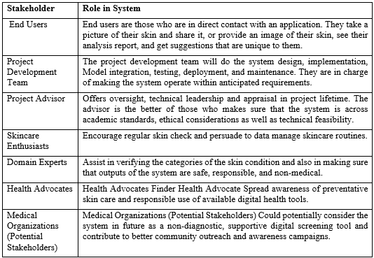
Table 2: List of Stakeholders

Impacted Groups Social or Economic

- Personal Users / Consumers at large
Social Impact: I am more comfortable in my skin because of fast, stealthy preliminary tests, and I am also more mindful of the issues, which are simple to detect before they deteriorate into a more problematic issue because at this point, I will be able to stop the problem, not to respond to it.
Economic Impact: I use this to save money spent in purchasing products that do not work or even do not match my skin making a clear guide to help me start my routine.
- Supporters and Daily Consumers of Skincare
Social Impact: I like that I can obtain regular checks and recommendations being given by non-medical personnel that can help me in creating better decisions regarding my skin in the long-term by using real data.
Economic Impact: I not only save money and time when buying numerous trial-and-error products but also few unnecessary visits with the dermatologist to deal with petty issues.
- People in the Nonprivileged / Remote Areas
Social Impact: I will be able to access the available and convenient information on caring about the skin, without driving and have to see experts, which will combat the unequal distribution of health and health equity, and help me in the proactive treatment.
Economic Effect: I reduce the cost of consultation, travel and delayed treatment costs- this is beneficial especially when I am on a strict budget. To achieve the optimal results in managing allogenic distress, it is recommended to administer the drug to individuals as early as the initial phase of the disorder following the skin graft.
- Dermatologists and Medical personnel
Social Impact: I have less frequent check-ups on general or simple issues, which allows more complex cases, and I am able to impact the safety of the system indirectly by providing feedback to improve the app.
Economic Impact: I can be more effective in the clinic as the patient will be better prepared or have better ideas of what to discuss when they have the benefit of using the app.
- Community of Technology and AI research
Social Impact: I enable social inclusion, privacy-centered AI through the representation of bias mitigation, the SCIN training diversity, and edge-processing on a true mHealth context.
Economic Impact: I apply low-cost reference case which is a combination of EfficientNet-B0, Gemini API, n8n and Flutter that prove to be handy in my upcoming student projects or research.

- Skincare companies and Wellness companies
Social Impact: I also access a more knowledgeable sector of the consumers who take serious decisions basing on objective knowledge.
Economic Impact: I receive indirect growth chances as users would be pickier and brand-aware when they would receive personalized suggestions.
- General Public & Society
Social Impact: I improve awareness of skin integrity and responsible behavior with digital tool consumption in general and in privacy, inclusivity by skin color, and understanding of the disclaimer.
Economic Impact: I will decrease the strain of healthcare on the government since I will manage minor skin problems on my own level.

Dependencies/ External Systems
The dependencies are important to the system development, testing, and deployment. These dependencies and their purpose in the project include a detailed list as shown below:
Mobile Development Framework
Dependency: A mobile application development platform, which is cross-platform and supports native performance, and native UI, components.
Role: The fundamental base on which the user-facing application is built where it can capture images, display diagnosis, and recommendations, and track histories on Android and iOS devices. Flutter (with Dart language), React Native as alternative is an example.
Image Capture and Processing Software
Dependency: Image input capability libraries with the capabilities of basic preprocessing: app can process all input images.
Role: Enables users to take or import high-quality skin images to analyze them so that they are compatible with the input requirements of AI model do not need to use any editing tool.
Alterations: image picker package, Flutter, and Camera API, native Android/iOS.
AI Model Architecture
Dependency: A pre-trained deep learning model that is practical image classification on mobile/edge devices.

Role: The backbone of skin condition diagnosis, the classification of such conditions as acnes, dryness, pigmentation, and healthy skin is performed with a specific 70% F1-score accuracy.
Attention: EfficientNet-B0 of TensorFlow/Keras (Lightweight alternative: MobileNet).
Machine Intelligence Architectures
Dependency: Frameworks Model training, fine-tuning, and inference frameworks
Role: It was used to create, train the model with data-sets and deploy, both on-device and cloud computing, in favour of mobile constraints and transfer learning.
Applications: TensorFlow/Keras, PyTorch To train, TensorFlow Lite To infer, TensorFlow Lite on mobile.
Training Datasets
Dependency: Various sets of skin condition images that were used to train and validate the model.
Role: Answers the questions by offering the data base of precise, bias minimized classification in case of skin tones or conditions, which meet inclusiveness and reliability goals.
Examples: SCIN (Skin Condition Image Network) containing more than 10,000 images, Dermnet containing furthermore 19,500 (23 categories) images, etc.
Model Deployment Platform
Dependency: Data center/ infrastructure to serve and store the artificial intelligence model.
Usability: Allows the safe execution of EfficientNet-B0 to be put into use on-device/edge of computing and guarantee low latencies, confidentiality, and expandability with no continual data exchange.
Examples: As an alternative, Google Cloud Vertex AI / Edge AI, AWS SageMaker or Azure ML.
Workflow Automation Tool
Dependency: This is the tool of coordinating API calls and flows of data among components.
Role: Securely transfers results of a diagnosis to create recommendations and combines with Gemini API using webhooks to create any output that is dynamic and context-aware.
Example: n8n, Zapier as alternative.
Generative AI Service
Dependency The API is used to generate images on large language models based on text-flat.
Role: Gives unmedical tailored skincare recommendations based on diagnosis, It must be both discursively informed with disclaimers and compassionate, certainly under five seconds to give.

Similar cases Google Gemini API, Open AI GPT as alternative.
Cloud Backend Services
Dependency: Authentication, data storage and security Backend-as-a-Service.
Function: Controls user membership (user-name/user-password), safes the history of the analysis and pictures and maintains the privacy policies protecting the confidential health information.
Examples: Supabase (Authentication, Storage), Firebase (as alternative).
Development Tools
Dependency: Build and debug the app and the model by using IDEs and code editors.
Role: Provides effective coding, model experimentation, testing and teamwork in the development stages.
Examples: Visual Studio Code: Visual Studio Code can be used to work with models, e.g., in a Jupyter notebook, for writing a model adopt Python scripts: one can use PyCharm to work with a Python script.
Version Control System
Dependency: Code management tool and collaboration tool.
Role: Tracks App source code, model scripts and documents allowing them to work as a team and roll back a version in case of necessity.
It has the following examples: Git and GitHub, or GitLab.
User Device Hardware
Dependency: Hardware of the Smartphone such as camera and processor.
Role: Supplies the input stream of skin images together with processing capacity of on-chip AI inference, to make the application functional on a standard consumer-level device.
Examples: Smartphones with Android/iOS with at least 12 MP camera and with mid-range CPU/ GPU.
Manuals of testing and validation
Dependency: Usability testing tools, performance metrics tools and heuristic analysis tools.
Role: Tests accuracy (F1-score), the ease of use of an app (SUS score = 70), and end-to-end latency, which test conformance to the targets such as reliability and accessibility.
Examples: Google analytics to test apps, Jupyter to measure the baselines.

Related Projects

Skin Vision App
Purpose - scan picture of skin lesions and be told whether there is a risk of cancer (low, medium, high) and then be instructed to visit a doctor. It is handy but somewhat one-dimensional, not addressing such mundane things as acne or pigmentation.
Examples - it is a downloadable commercial application on both Android and iOS.
Relevancy - it hits the nail on the head when it comes to detecting cancer, but the advice it provides is simply a visit to the doctor and nothing beyond that.
YouCam Makeup Skin Analysis (Perfect Corp)
Purpose - You post your selfies, it identifies skin problems (acnes, wrinkles, blackheads, pores, texture) and proposes beauty products and skincare.
Examples - one of the popular family of apps YouCam Makeup and a success in cosmetic hacking.
Relevance - works well, should you be interested in beauty products and brand offers, but it is more cloud-based than medical-grade; it is almost a marketing instrument rather than a health service.
MDacne App
Purpose - pays attention to acne caused by pictures, calculates the level of severity, and generates a personal action plan using hints on OTC products based on pictures.
Examples - acnes subscriptions in general.
Relevance - may be useful in checking acne and in subsequent treatment but it is only concerned with acne, cloud based and it feels like a product-push.
Trove skin / Skin + Me Apps
Purpose - AI skin scan, we identify acnes, pigmentation, redness and customize a product regime, typically product subscriptions.
Examples - Standard consumer skin care apps enabling one to organize daily routines.
Relevance - it ranks high in terms of personalization, but this is a highly commercially intensive product that does not do well with different skin tones and has privacy issues.
Minute Epicure Travel Motorsport (Brooklyn Guide 2019)
Purpose - A mobile interface that can both diagnose common skin diseases using image recognition and can run on AI and be utilized by both clinicians and ordinary people.
Examples - Benefits A diagnostic research prototype, which is currently of the form of an app.
Relevance - is clinical accuracy, but whether it is diagnostics or it provides you with saved routines or device-level privacy (cloud-centric).
Artificial Intelligence-based Assisted Skincare Routine Recommendation (Rajegowda et al. 2023)
Purpose - learns your skin and gives you a custom-made regimen, has ARV potential.
Examples - A recommendation engine research system.
Relevance - high on personalization such as Skin Health Analyzer, but it is an overweight XR that is not a stand-alone mobile application.
Specifications Elysium 2025 prototype Early Detection AI Mobile App
Purpose - Unflagged skin diseases are detected at an early stage to assist with screening prevention.
Examples - sample papers in academic papers.
Relevance - it is also optimized by early detection however; it is still in the research stages and does not have complete generative guidelines or history of usage.

Feature Comparison

Table 3: Feature comparison of our product with competitors
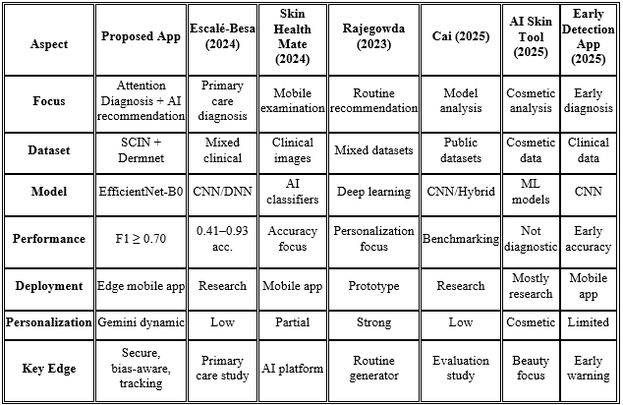

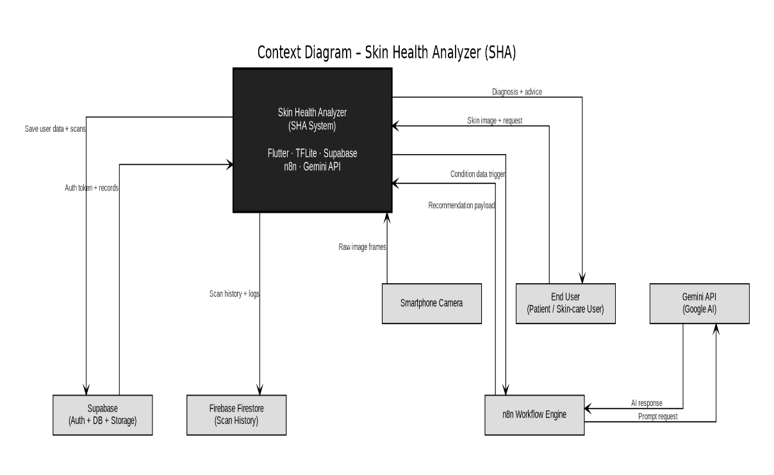
Context Diagram

Figure 1: Context Diagram - SHA

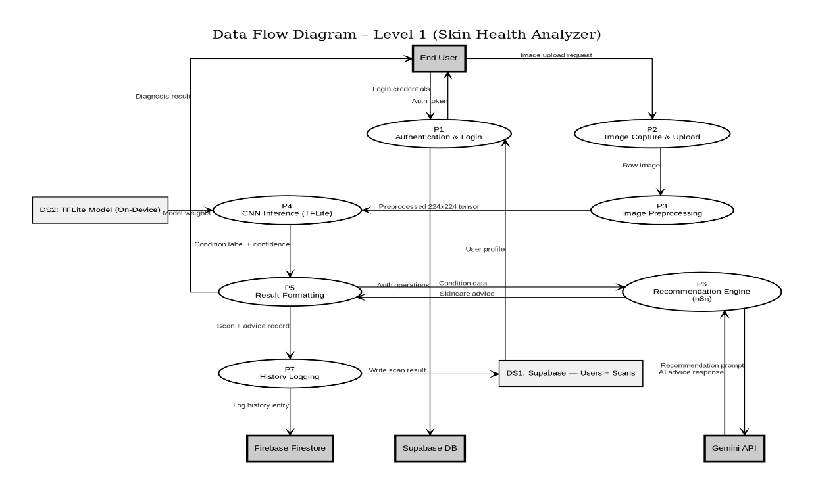
Data Flow Diagram

Figure 2: Data Flow Diagram - SHA

Requirements analysis
The Requirements Analysis phase defines the functional and non-functional requirements of the Skin Health Analyzer mobile application. This phase ensures that all system capabilities are clearly identified before development begins.
The application is designed as an AI-powered mobile solution that performs on-device skin condition diagnosis using a fine-tuned CNN model (SCIN + Dermnet) converted to TensorFlow Lite for edge inference. The system integrates Supabase for authentication and storage, and n8n with Gemini API for personalized, non-medical recommendations.
The requirements were gathered based on:
- Project objectives
- Target user needs
- Technical feasibility
- Ethical AI considerations
- Performance constraints

List of Actors
- End User
These individual downloads and installs the Skin Health Analyzer application, captures and sends images of their skin, views the analysis created by AI, and reads the recommendations generated specifically.
- Skincare Enthusiast
This person has an obsession with his or her complexion and checks in every week to compare new pictures with previous ones and uses the platform to adjust and evaluate their skincare routine.
- Domain Expert
This individual provides professional recommendations regarding the types of skin, ensuring that the products of the application remain ethical and avoid providing medical diagnosis.
- Health Advocate
This is the corresponding member or group that disseminates the message on prevention of skin care and advocates the usage of convenient digital health tools.
- Project Development Team
These individuals code, maintain and test the system in addition to edge-ai technology and database logistics.

- Supabase Backend Service
This external backend manages the user-in and user-out logging, retention of user data on a secure database and the history of the user.
Potential Stakeholders (Medical Organizations)
Such institutions may decide to review or retrieve the system in the future as a supportive and non-diagnostic online screening and awareness tool.

Product Backlog
Product Backlog is a list of priorities of all features, improvements, and technical activities that are needed to create the Skin Health Analyzer application.
The backlog is organized with Agile format using:
- Epics Features
- User Stories
- Acceptance Criteria
- Story Points

Epic Overview
The system is subdivided as consisting of the following major Epics:
- Security and Authentication of the user.
- Image Processing & Image Handling.
- Deep Learning-Skin Diagnosis (Edge Inference).
- AI Recommendations System
- History & Progress Tracking Mitigation of Performance and Bias.
Each Epic is disaggregated into smaller User Stories which can be delivered with a sprint.
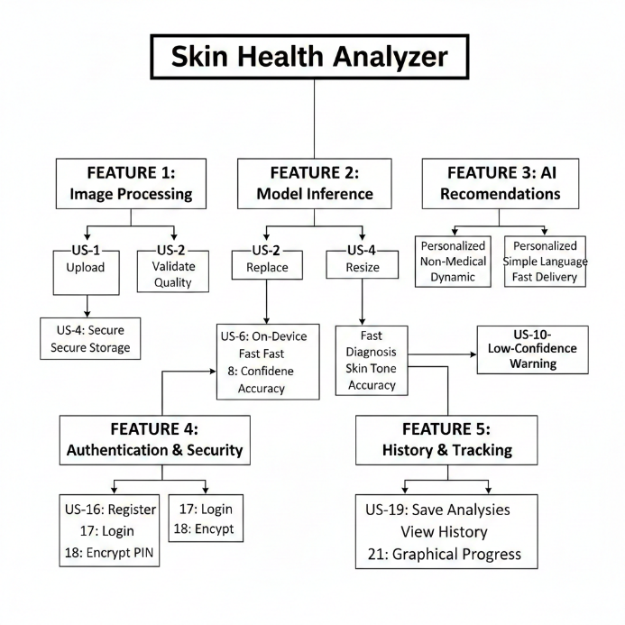
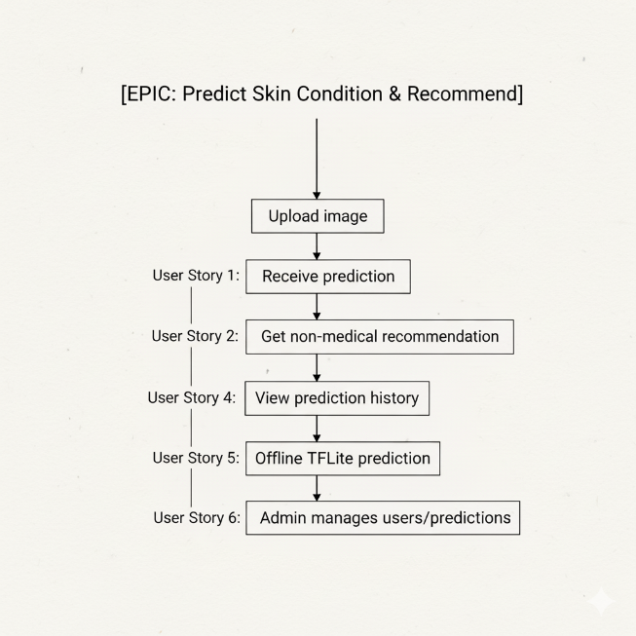

Figure 2: Epic vs User Story in Product Backlog

High risk and Architecturally Significant Backlog Items of high priority:
The insights gained out of Product Backlog are as follows.
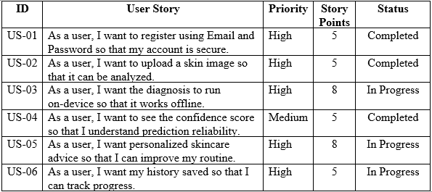
Table 4: Selected Features of Product Backlog

Functional Requirements
Functional requirements explain what the Skin Health Analyzer system will do. These are the statements of how the system is supposed to behave in order to satisfy the needs of users.
FR-01 User Registration
The system will enable new users to open an account so as to use a Email and Password.
Acceptance Criteria:
Email and Password are typed in by the user. Password is crypted prior to storage. Supabase stores user account. Emails cannot be duplicated.
FR-02 User Login
The system will be in control to authenticate users through stored credentials.
Acceptance Criteria:
User will type in the right Email and Password. Password has been verified by the System. On success, user will be redirected to dashboard. Wrong credentials give error message.
FR-03 Image Upload
This system will enable users to either upload a skin image which is in the gallery or use the camera.
Acceptance Criteria:
Preview of the image is shown given. Checking of format picture (JPEG/PNG) Auto preprocessing and down sampling of the image.
FR-04 Image Preprocessing
Images will be uploaded and preprocessed in the system and then model inferred.
Acceptance Criteria:
Image resized to 224x224. Normalization of pixels done. Reduction or addition of noise (where necessary). Background At present, numerous applications are deployed on real devices with artificial intelligence (AI, popularly known as machine learning).
FR-05 On-Device Model Inference (Edge AI)
This system will assert the boiled down TensorFlow Lite model on-ground to conduct the diagnosis.
Acceptance Criteria:
Model loads locally. Computation without using the internet. Result of prediction obtained within 3 seconds.
FR-06 Prediction Display
The system will be showing predicted skin condition and confidence score.
Acceptance Criteria:
Predicted class name shown. Percentage of confidence presented. Disagreement of non-medical clear.
FR-07 Personalized Recommendation Generation
The system will create personal skincare suggestions with the help of n8n workflow combined with Gemini API.
Acceptance Criteria:
Diagnosis sent to backend. The production of non-medical advice in Gemini. Output formatted clearly Response time taken is 8 seconds.
FR-08 Diagnosis History Storage
The system would store the diagnosis result of users in Supabase.
Acceptance Criteria:
Image path stored securely Prediction label stored Timestamp recorded History is visible to only logged in user.
FR-09 History Retrieval
The system will enable the users to see the previous records of the diagnosis.
Acceptance Criteria:
Historical presentation of historical outcomes. Date and condition shown Recommendation accessible
FR-10 Model Update Capability
The system will permit the updates of the models without reinstalling the application.
Acceptance Criteria:
Old version can be substituted with updated TFLite model. The backward compatibility was preserved.
FR-11 Offline Diagnosis
The system will carry out the diagnosis without the need of internet connection.
Acceptance Criteria:
TFLite model runs locally. Internet is only needed in recommendation feature.
FR-12 Error Handling
The system will be accommodating of errors.
Acceptance Criteria:
Illegal image message. Evident communication on network failure. Inference without any crash of the application.
FR-13 Bias Mitigation Support
The system will enable justifiable forecasts of various skin tones.
Acceptance Criteria:
Model fitted on SCIN data. Optimized on Dermnet back-end. Performance assessed between classes.

Non-Functional Requirements
Non-functional requirements specify the performance, security, usability, and reliability and scalability requirements of the system. These conditions make sure that the Skin Health Analyzer will be efficient and secure in the way it operates.
NFR-01 Performance
This application will be able to present the results of the diagnosis within 3 seconds on-device and the entire recommendation process within a total of 8 seconds.
Acceptance Criteria:
Inference time TFLite ≤ 3 seconds. End-to-end response time ≤ 8 seconds
NFR-02 Accuracy
After fine-tuning on SCIN and Dermnet datasets and TFLite quantization, the AI model will have an F1-score of at least 70%.
Acceptance Criteria:
Validation F1-score ≥ 0.70. Quantization accuracy drop ≤ 3%
NFR-03 Security
User authentication credentials (Password) should be encrypted and transmission of all data should be done using the HTTPS protocols.
Acceptance Criteria:
Password in form of hashed value. Secure API communication. Supabase has role-based access.
NFR-04 Privacy
The storage of user images and personal data should be done in a secure, and logically separated manner in Supabase storage.
Acceptance Criteria:
Pictures saved in secure storage execution. Users are only allowed to view their history only after they have been authenticated.
NFR-05 Reliability
The application will be stable even among compatible Android gadgets.
Acceptance Criteria:
Crash-free session rate ≥ 99%. The memory usage optimized to mid-range devices.
NFR-06 Usability
The mobile users should be able to read the application interface, which should be simple and intuitive.
Acceptance Criteria:
SUS score (System Usability Scale) = 70. Guideline written in clear format. Minimal navigation steps Service.
NFR-07 Bias Mitigation & Fairness
The AI model shall be robust across different skin tones and demographics by training on SCIN and fine-tuning using Dermnet.
Acceptance Criteria:
Tested in more than just one color of the skin tones. No relevant accuracy difference between subsets of the demographics.
NFR-08 Offline Capability
The diagnosis option will be able to work without an internet connection based on edge inference.
Acceptance Criteria:
Model runs fully on-device. Internet necessary only in the case of recommendations.

UI/UX Designs

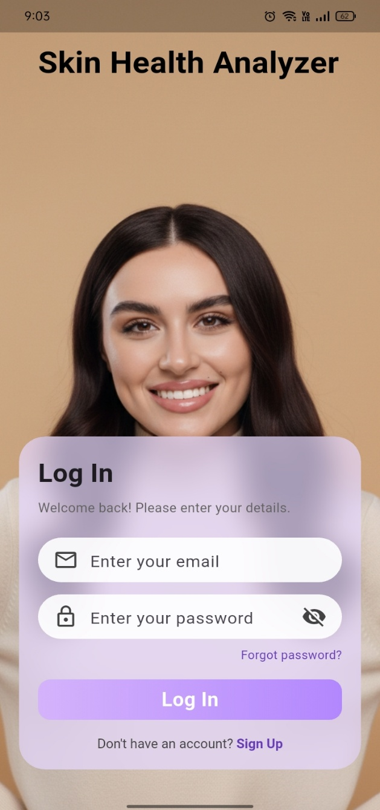
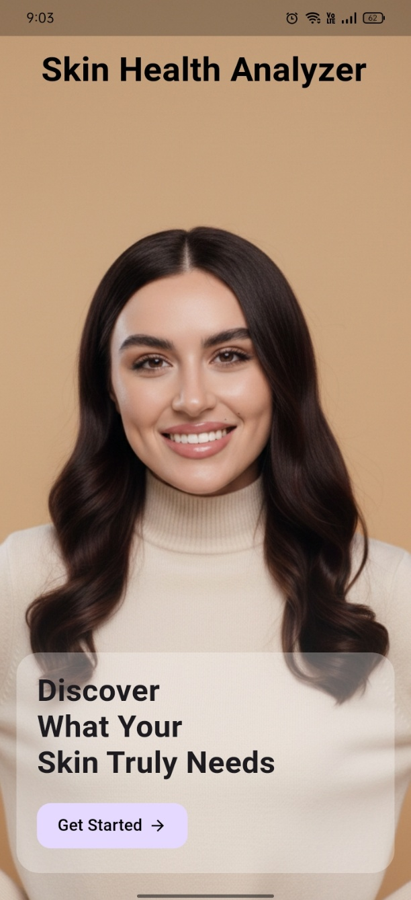

Figure 3: Prototype – PID1- Get Started Page UI
Figure 4: Prototype - PID2- Log IN Page UI

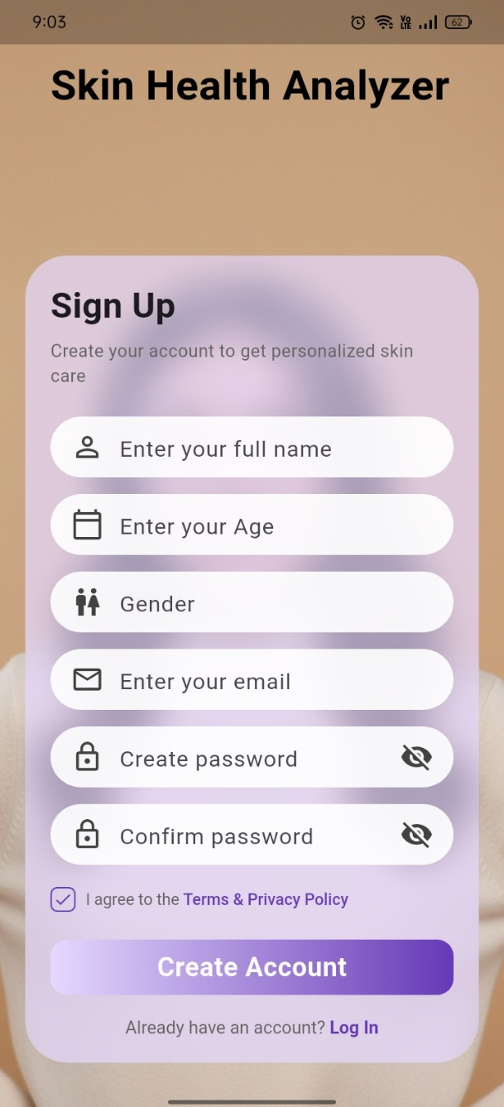
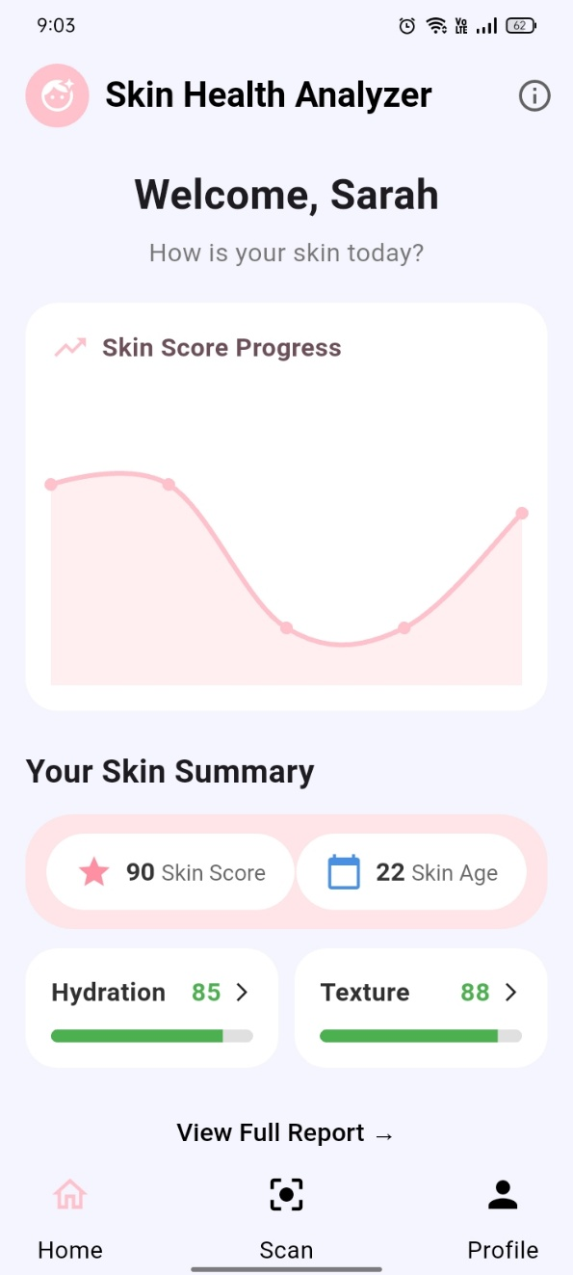

Figure 5: Prototype – PID3- Sign UP Page UI
Figure 6: Prototype – PID4- Home Page UI

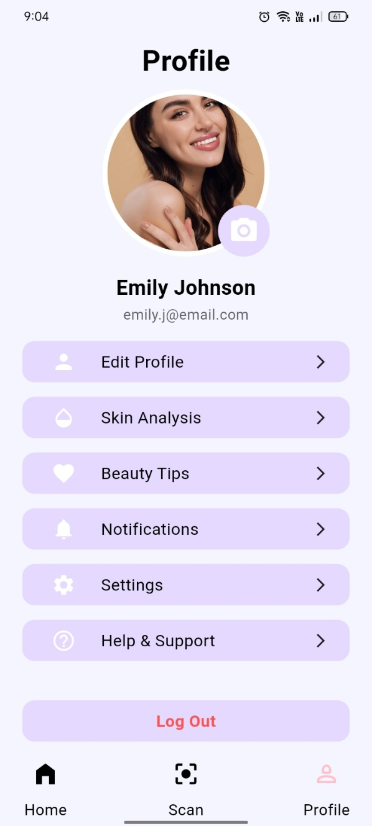
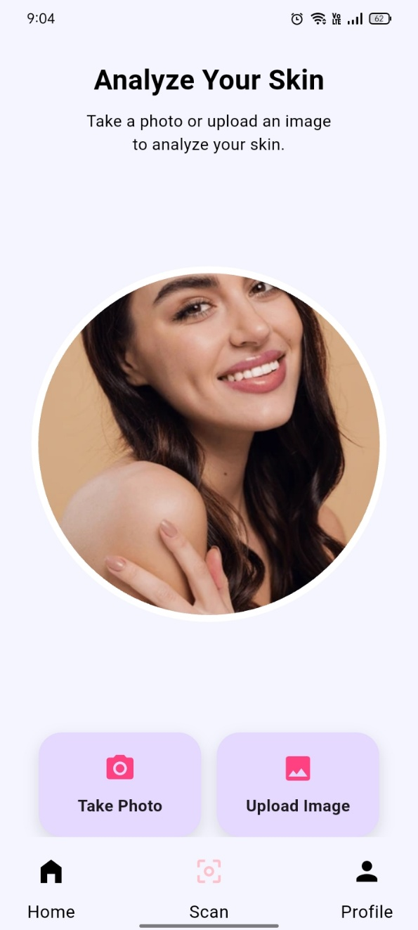

Figure 7: Prototype – PID5- Scan Page
Figure 8: Prototype – PID6- Profile Page

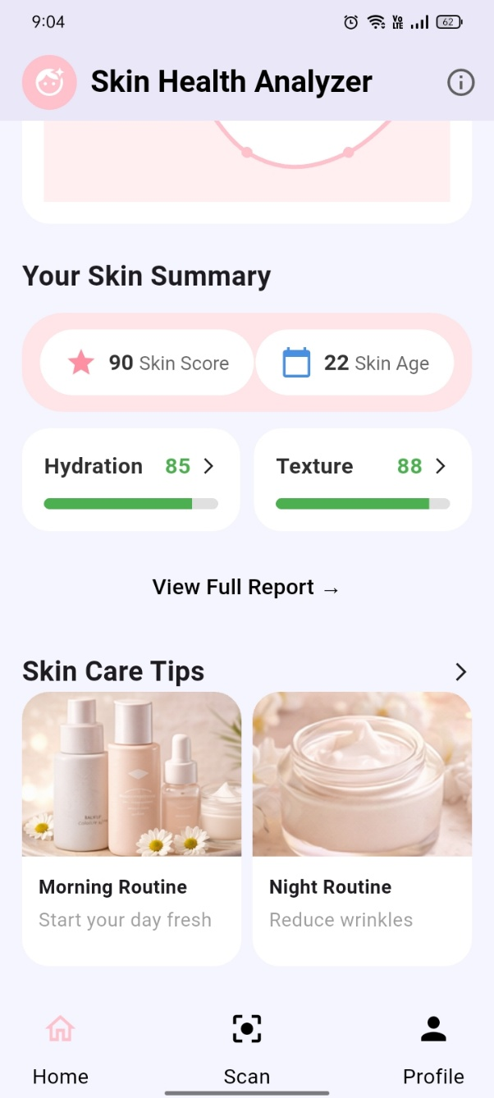

Figure 9: Prototype – PID7- Recommendation Page

Project Planning and Execution using Sprints
The Skin Health Analyzer project was designed within Agile framework and done in sprints. To provide delivery in incremental stages, ongoing test, and revision of those tests, the project was broken into defined sprints to fit the activities. Learning was done in each sprint consisting of planning, design, implementation, review, and retrospective.
The Agile methodology assisted the team:
- Provide functioning deliverables following every sprint.
- Constantly improve backlog items.
- Uncover technical problems at Milestone (TFLite, Supabase, n8n integration)
- Enhance system performance in cycle.

GitHub Repository
FYP-Skin Health Analyzer GitHub repo

Sprints Overview

Table 5 : Sprint Overview
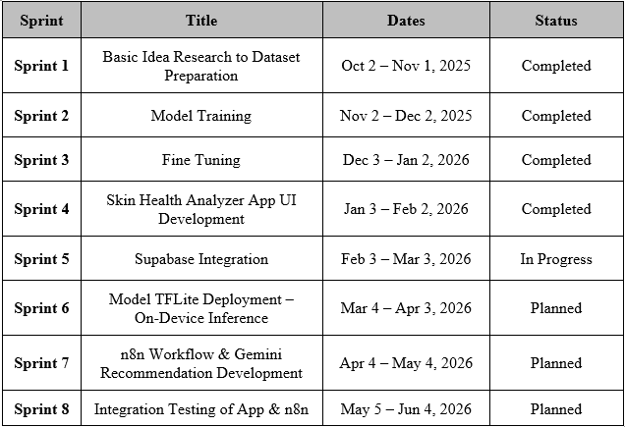

4.2.1 Sprint 1

Planning Meeting Minutes

Name of the Project: Skin Health Analyzer (Mobile Application)

Sprint Name: Sprint 1 - Basic idea research pursue preparations of dataset.

Sprint Goal: Fine-tune CNN model provided with Dermnet with Sprint Successfully finished, Base CNN model trained with Sprint Successful effect on the base CNN model with SCIN features.
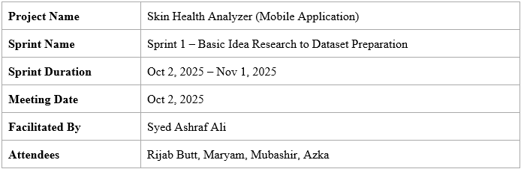
The planning meeting ahead of the commencement of a sprint is recorded in the following section.

Team Capacity – Sprint 1
Table 6 : Sprint-1 Team Capacity
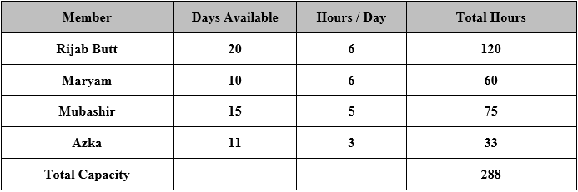

Action Items Before Sprint Starts
- SCIN dataset preprocessing
- Share UI design templates
- Integration: Fine-tuning Dermnet
- Project proposal document

Supervisor Feedback
- Enhance the model robustness concerning other skin conditions using DermNet.
- Test SCIN-only vs SCIN + DermNet the best to warrant fusion of data on sets.
- If training SCIN and DermNet datasets assure that they are class aligned.
- Sprint gave a go-ahead with a green light to make Sprint 2 finer.

4.2.1.1 Sprint 1 Backlog
Product Backlog features are divested into the following tasks.
Table 7 : Sprint 1 Backlog
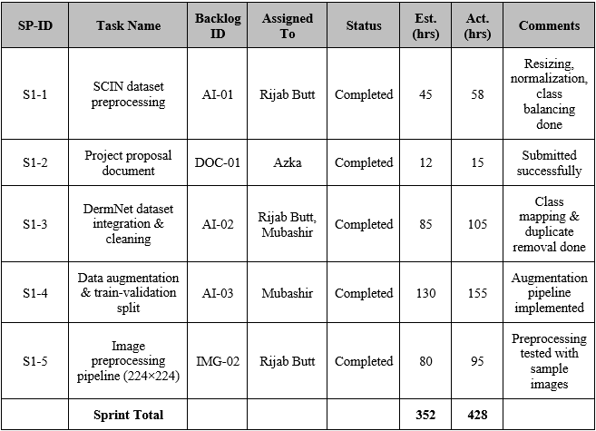

4.2.1.2 Sprint 1 Design Class Diagram
The Sprint 1 Design Class Diagram reflects the first sprint system architectural design of the Skin Health Analyzer system.

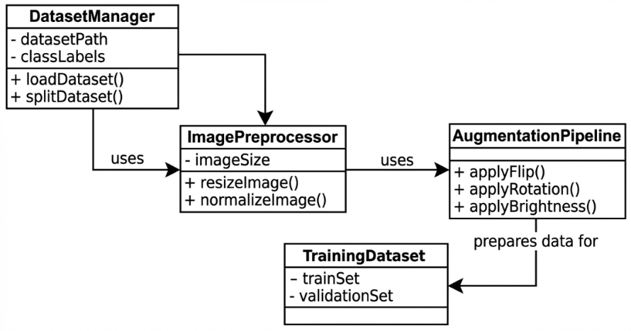

Figure 10: Sprint 1 Design Class Diagram

4.2.1.3 Sprint 1 Sequence Diagram
The Sprint 1 Sequence Diagram shows the interaction flows of the interactions between the user, mobile application, Supabase backend and artificial intelligence used in the features developed in this sprint.
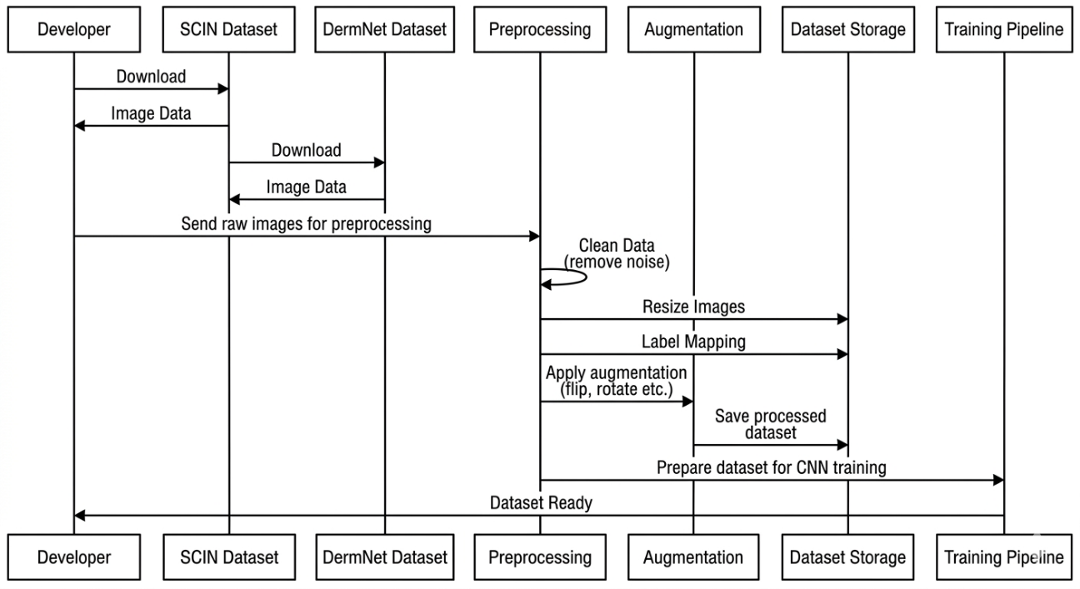
Figure 11: Sprint 1 Sequence diagram

4.2.1.4 Sprint 1 Decision Table
The Sprint 1 Decision Table identifies logical conditions and system actions to be taken in an effort to maintain a standardized system behavior.

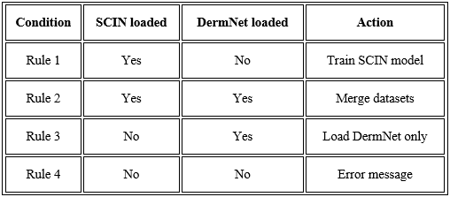
Table 8 : Sprint 1 Decision Table

4.2.1.5 Sprint 1 Extended Test Cases
Individual test cases have been drawn against every user story to test the functionality provided in this sprint.

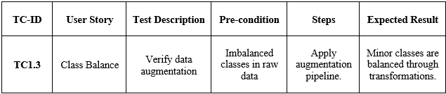
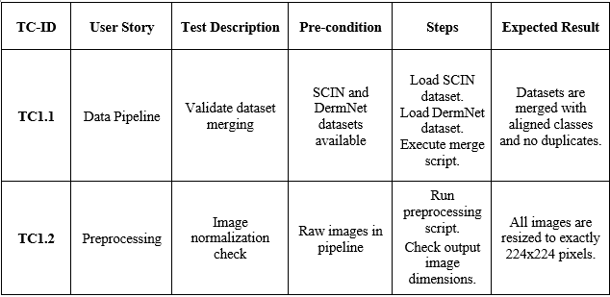
Table 9 : Sprint 1 Extended Test Case

4.2.1.6 Sprint 1 Review Meeting
Sprint: Sprint 1 – Basic Idea Research to Dataset Preparation
Review Date: Nov 5, 2025
Duration: 1 hour
Facilitator: Syed Ashraf Ali (FYP Supervisor)
Present: Rijab Butt, Maryam, Mubashir, Azka

Sprint Goal Achievement

Every essential information preparation task (finished). Ready pipeline augmentation databases.

Demo Highlights
- Dataset Preview: Rijab Butt showed the preprocessing workflow of SCIN + DermNet with charts of distribution of the classes.
- Augmentation Pipeline: Mubashir took steps through train-validation split as well as augmentation transformations.
- Project Proposal: Azka submitted the received offer and supervisor confirmation of approval.
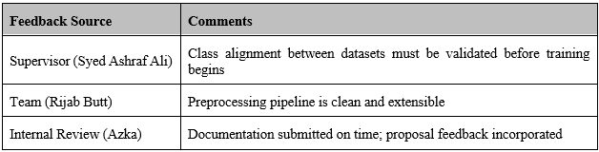
Stakeholder Feedback

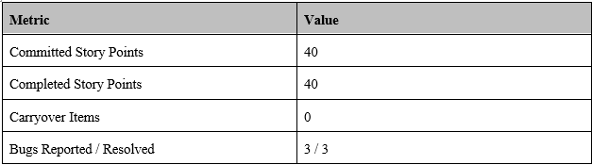
Metrics Overview

What Went Well
- Faultless cooperation between the Mubashir and Rijab regarding pipeline of datasets.
- Prematurely completion of the proposal document provided buffer to data activities.
- Class balancing happened before it was anticipated.

What Could Be Improved
- The mapping took longer than it was estimated to be.
- Communication differences on the parameters of augmentation - to be sorted out through common config. files.

Recommendations to the Improvement
- Initial common configuration files of dataset parameters.
- The check-in schedules of mid-sprint reports are made to detect the blockers early enough.
- Include more explicit acceptance criteria to stories that are data related.

Action Items
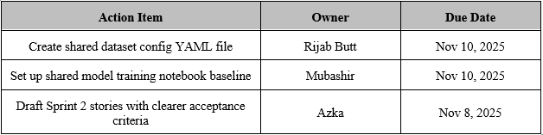
Wrap-up
All results of Sprint 1 were reviewed by the team. The definition of done is completed tasks. Activities that were introduced in Sprint 2. The next sprint planning meeting will be scheduled at the beginning of the Sprint 2.

4.2.2 Sprint 2

Sprint Title: Model Training
Sprint Goal: Use CNN model to be trained on jointly combined SCIN data and DermNet and generate evaluation outcomes.

The planning meeting ahead of the commencement of a sprint is recorded in the following section.
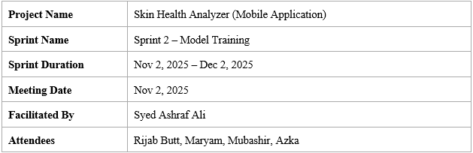

Team Capacity – Sprint 2
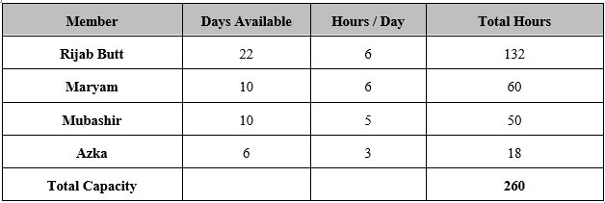
Table 10 : Team Capacity Sprint 2

Action Items Before Sprint Starts
- Setup base CNN architecture in TensorFlow
- Set up of training space and GPUs.
- Start-up UI wireframes on the screens of the app.
- Ready Sprint 2 documentation framework.

Supervisor Feedback
- Make the use of proper stratified splits of imbalance classes training.
- Note down all the hyperparameter environments so that it can be repeated.
- Training should be done alongside the start of UI work to prevent downstream delays.
- Sprint approved. The results of training to be checked during Sprint 2 review.

4.2.2.1 Sprint 2 Backlog

The Product Backlog was analyzed to gather the following tasks during this sprint.

Table 11 : Sprint 2 Backlog

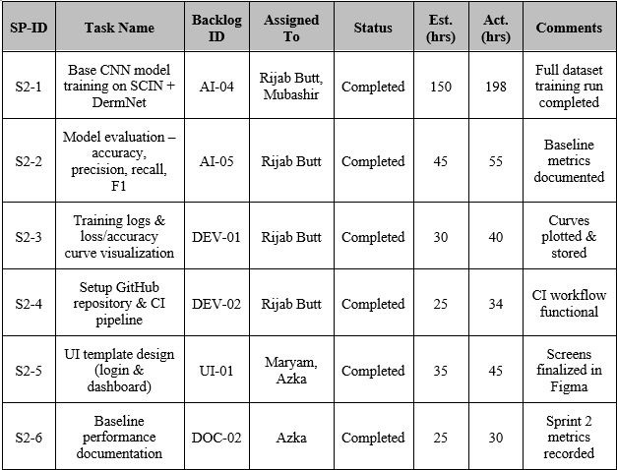

4.2.2.2 Sprint 2 Design Class Diagram
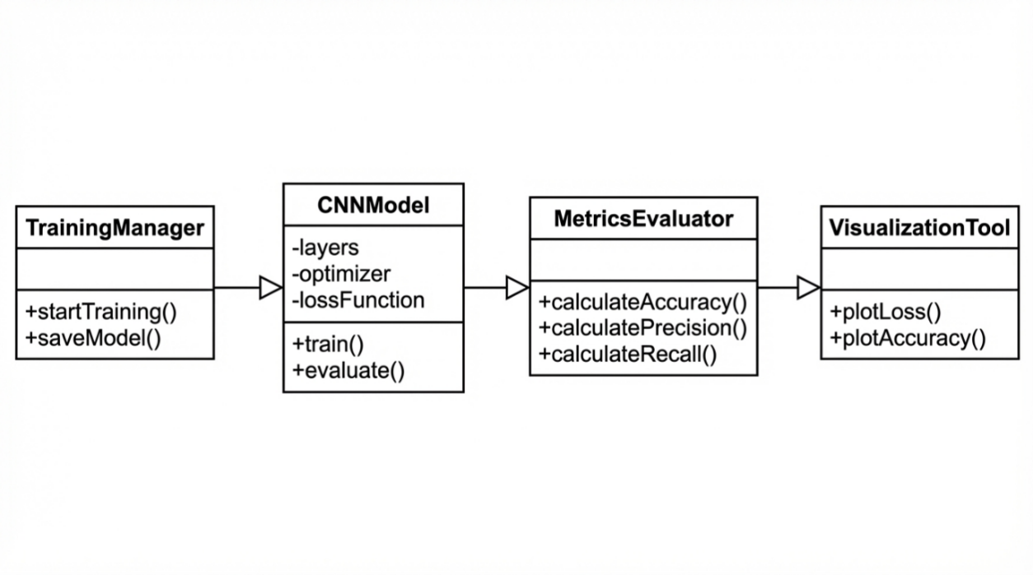
The Sprint 2 Design Class Diagram is the structure of the components of the system that were developed in this sprint.
Figure 12: Sprint 2 Design Class Diagram

4.2.2.3 Sprint 2 Sequence Diagram
Sprint 2 Sequence Diagram shows how the interaction will be performed between the user and mobile application. Supabase backend, and AI model of features created this sprint.

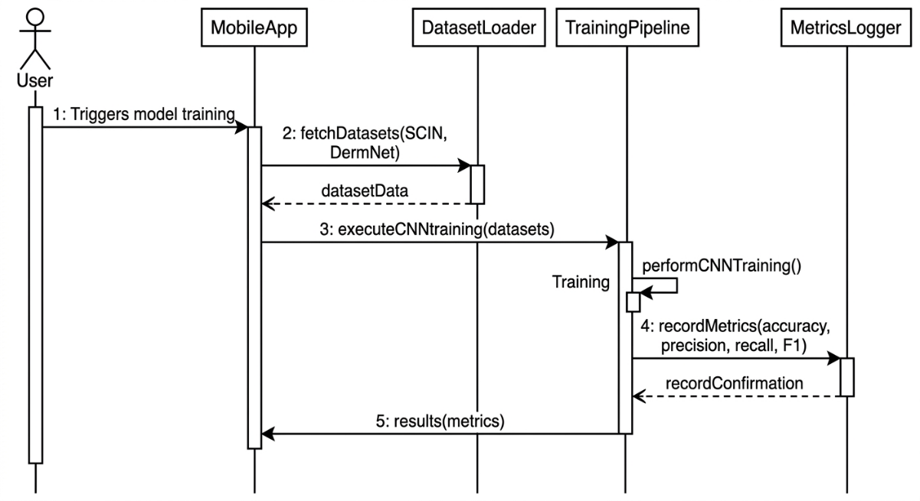
Figure 13: Sprint 2 Sequence Diagram

4.2.2.4 Sprint 2 Decision Table
Decision Table Sprint 2 is a logical condition and a system action that proceeds to the logical condition to produce uniform system behavior.

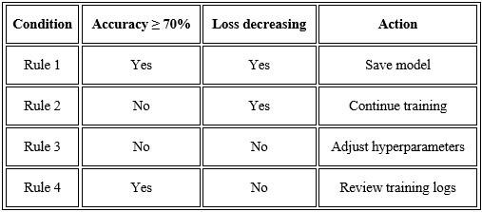
Table 12 : Sprint 2 Decision Table

4.2.2.5 Sprint 2 Extended Test Cases
Individual test cases have been drawn against every user story to test the functionality provided in this sprint.

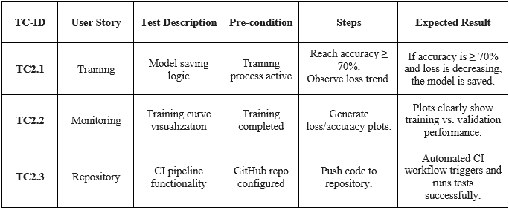
Table 13 : Sprint 2 Extended Test Case

4.2.2.6 Sprint 2 Review Meeting

Sprint: Sprint 2 – Model Training
Review Date: Dec 5, 2025
Duration: 1 hour
Facilitator: Syed Ashraf Ali (FYP Supervisor)
Attendees: Rijab Butt, Maryam, Mubashir, Azka

Sprint Goal Achievement

The CNN model was trained on the complete dataset. Baseline assessment figures set. UI templates ready.

Demo Highlights
- Model Training: Rijab Butt showed the training logs and accuracy/loss curves.
- Evaluation Report: Mubashir passed per-class accuracy, recall, and F1.
- UI Screens: Maryam and Azka demonstrated Figma mockups for login and dashboard screens.
- GitHub CI: Rijab showed the automated CI pipeline with test runs on push.

Stakeholder Feedback
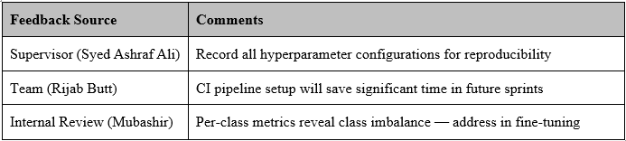

Metrics Overview
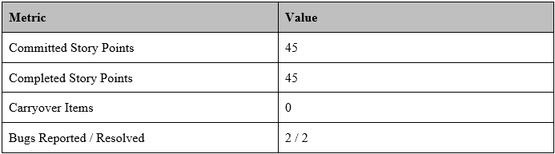

What Went Well
- Pipeline end-to-end training was done without significant major blockers.
- The early preparation of CI/CD saved press time in subsequent sprints.
- UI templates were reviewed and accepted as is.

What Could Be Improved
- Logging Metrics automatically using TensorFlow training toward metrics.
- Assign special quota to GPU before the commencement of sprints.
- Keep a common experiment record.

Recommendations to the Improvement
- Logging Metrics automatically using TensorFlow training toward metrics.
- Assign special quota to GPU before the commencement of sprints.
- Maintain a shared experiment tracking sheet.

Action Items
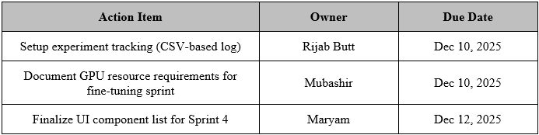

Wrap-up
The entire results of Sprint 2 were peer reviewed by the team. The definition of done is completed tasks. Activities that were introduced in Sprint 2. The next sprint planning session will be at the beginning of the Sprint 3.

4.2.3 Sprint 3

Sprint Title: Fine Tuning
Sprint Goal: Optimize model with help of Dermnet, make full assessment and test with skin tones.

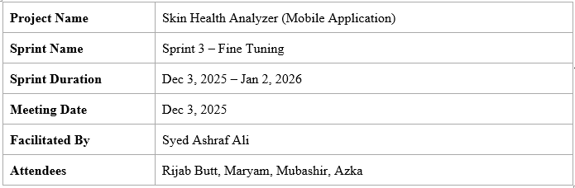
The planning meeting ahead of the commencement of a sprint is recorded in the following section.

Team Capacity – Sprint 3
Table 14 : Team Capacity Sprint 3
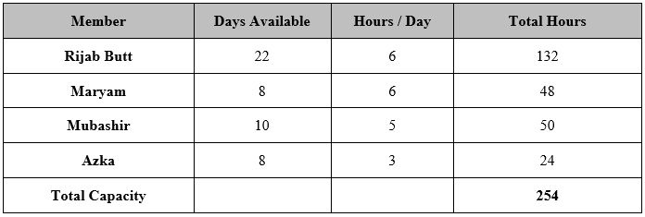

Action Items Before Sprint Starts
- Recipe fine-tuning transfer learning.
- Set up multi-skin tone picture test image set to test bias.
- Skeleton reports of draft FYP Part 1.
- Preparation confusion matrix generation program.

Supervisor Feedback
- Cross discrimination testing that goes across the levels of skin color is necessary-- at least 3 Fitzpatrick scale groups.
- Model performance difference between base model and fine-tuned model.
- The FYP Part 1 report should also contain confusion matrix.
- Sprint approved. The initial draft of FYP Part 1 documentation needs to be completed prior to the beginning of Sprint 4.

4.2.3.1 Sprint 3 Backlog
The Product Backlog was analyzed to gather the following tasks during this sprint.

Table 15 : Sprint 3 Backlog

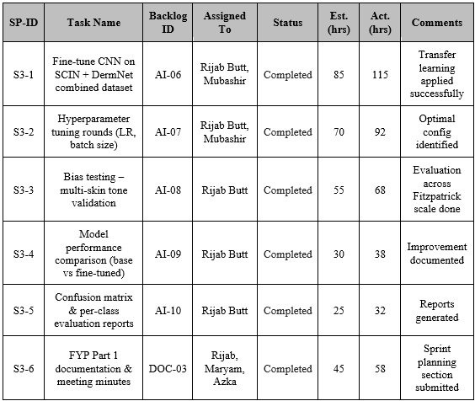

4.2.3.2 Sprint 3 Design Class Diagram
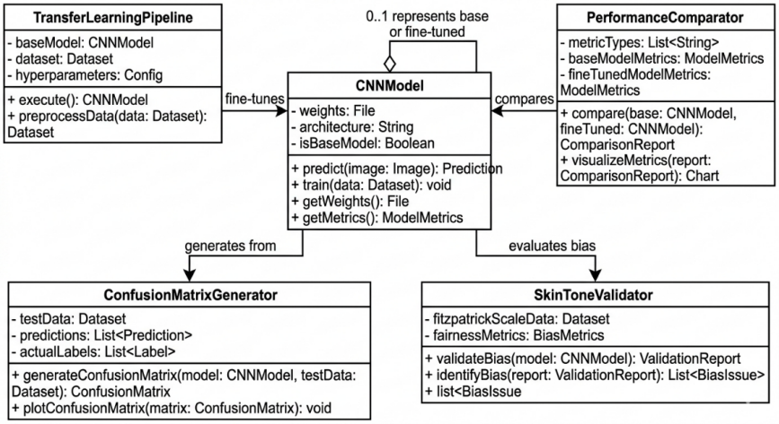
The Sprint 3 Design Class Diagram is a structural architecture of the components of the system created in this sprint.

Figure 14: Sprint 3 Design Class Diagram

4.2.3.3 Sprint 3 Sequence Diagram
Sprint 3 Sequence Diagram shows a flow of interaction between the user, mobile application,
Supabase backend, and feature development AI model created during this sprint.
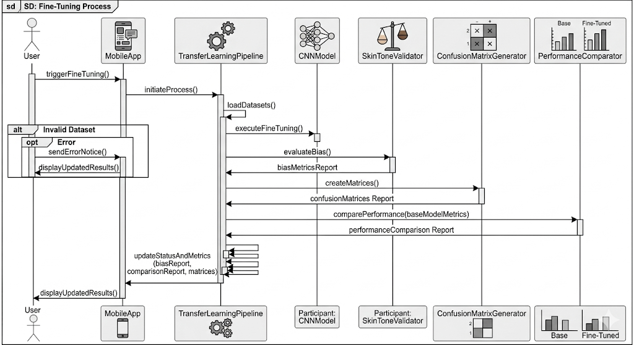

Figure 15: Sprint 3 Sequence Diagram

4.2.3.4 Sprint 3 Decision Table
The Sprint 3 Decision Table is used to establish logical conditions and system actions to have consistent behavior in the system.

Table 16 : Sprint 3 Decision Table
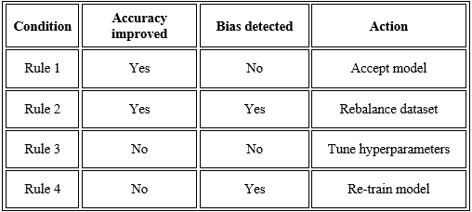

4.2.3.5 Sprint 3 Extended Test Cases
Separate test cases have been developed on each user story to test the functionality that has been offered in this sprint.

Table 17 : Sprint 3 Extended Test Case
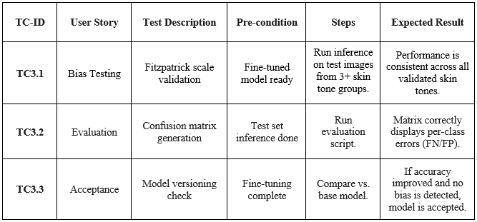

4.2.3.6 Sprint 3 Review Meeting
Sprint: Sprint 3 – Fine Tuning
Review Date: Jan 6, 2025
Duration: 1 hour
Facilitator: Syed Ashraf Ali (FYP Supervisor)
Attendees: Rijab Butt, Maryam, Mubashir, Azka

Sprint Goal Achievement
Improved fined performer model. Bias testing validated. FYP Part 1 documentation draft final.

Demo Highlights
- Fine-tuned Model: Rijab Butt showed better accuracy improvement in before/after comparison as compared to baseline.
- Bias Testing: Rijab provided multi-skin tone results of validation by Fitzpatrick scale ranges.
- Confusion Matrix: Mubashir strolled through the per-class confusion.
- FYP Part 1 Docs: Azka and Maryam showed finished parts of the documentation.

Stakeholder Feedback
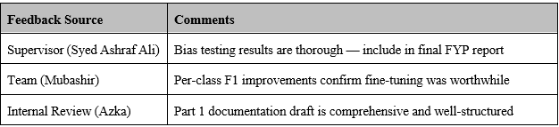

Metrics Overview
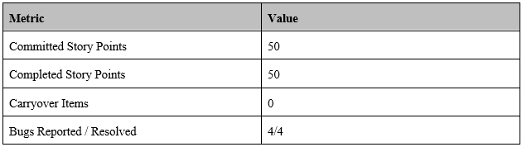

What Went Well
- Improvement Fine-tuning demonstrated significant gains in respect of the base model.
- Class-specific weaknesses were revealed and taken care of through bias testing.
- FYP Part 1 paperwork draft submitted successfully and within the deadline.

What Could Be Improved
- Searching hyper parameters was time consuming - automated search needs to be done.
- The sprint was documented late enough when it should have been written simultaneously.

Suggestions for Improvement
- Autopilot future model hyperparameter searching.
- Documentation should not be done at the end but should be done at the same time as the development.
- Create a shared model versioning convention (e.g., v1.0-base, v1.1-finetuned).

Action Items
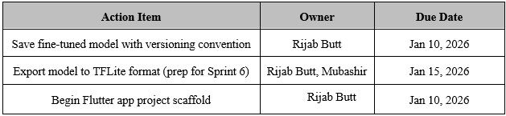

Wrap-up
All Sprint 3 outcomes were reviewed in the team. The definition of done is achieved tasks. Action items to be taken to Sprint 4. Sprint 4 Next sprinting meeting will occur at the beginning of Sprint 4.

4.2.4 Sprint 4
Sprint Title: Skin Health Analyzer App UI Development
Sprint Goal: Develop 100 per cent Flutter UI frontend screens of the mobile application.

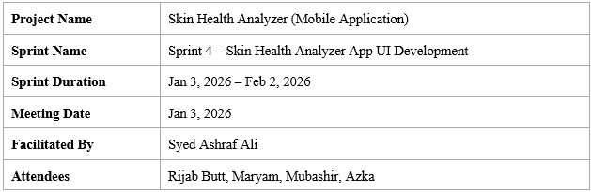
The next section captures the planning meeting that took place before the beginning of the sprint.

Team Capacity – Sprint 4

Table 18 : Team Capacity Sprint 4
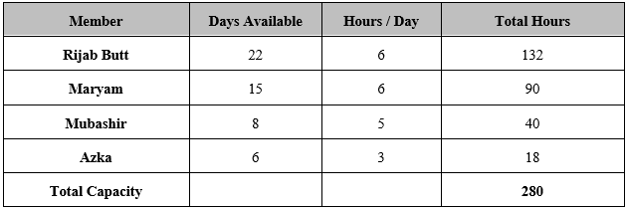

Action Items Before Sprint Starts
- Install Flutter project and directory structure.
- Design to Flutter design handoff preparation.
- Set up navigation & routing architecture.
- Complete inventory list screen.
- achieve FYP Part 1 documentation.

Supervisor Feedback
- Make sure that font sizes and contrast ratios used should be at minimum accessibility standards.
- User experience on camera screen shall be non-technical review and be signed off.
- Before integration of the backend, system architecture doc needs to be done.
- Sprint approved. UI screens have to be approved prior to Sprint 5 backend work.

4.2.4.1 Sprint 4 Backlog

This sprint was used to extract the following tasks of the Product Backlog.

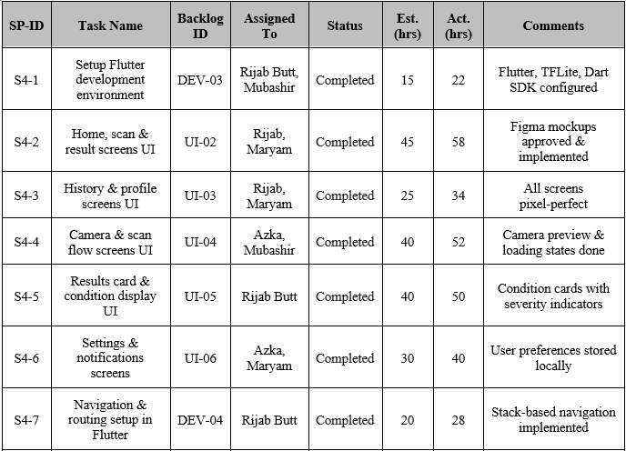
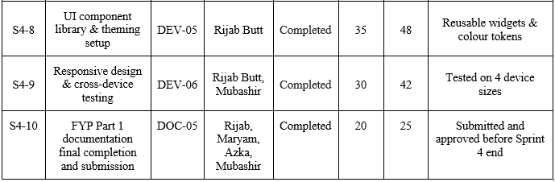
Table 19 : Sprint 4 Backlog

4.2.4.2 Sprint 4 Design Class Diagram
The Sprint 4 Design Class Diagram is the structure architecture of system components that were created in this sprint.

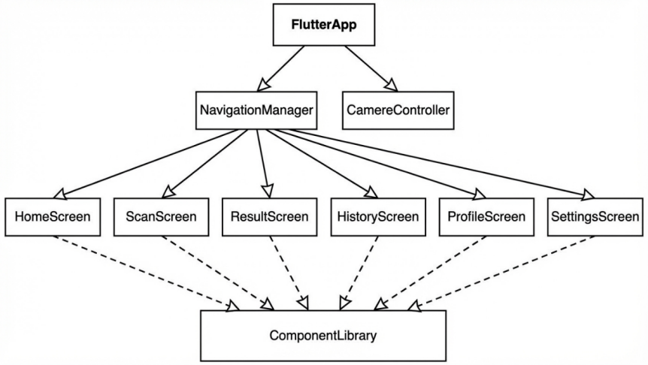

Figure 16: Sprint 4 Design Class Diagram

4.2.4.3 Sprint 4 Sequence Diagram
The Sprint 4 Sequence Diagram displays a flow of interaction between the user, mobile application,
Supabase backend and AI model worked on in this sprint.
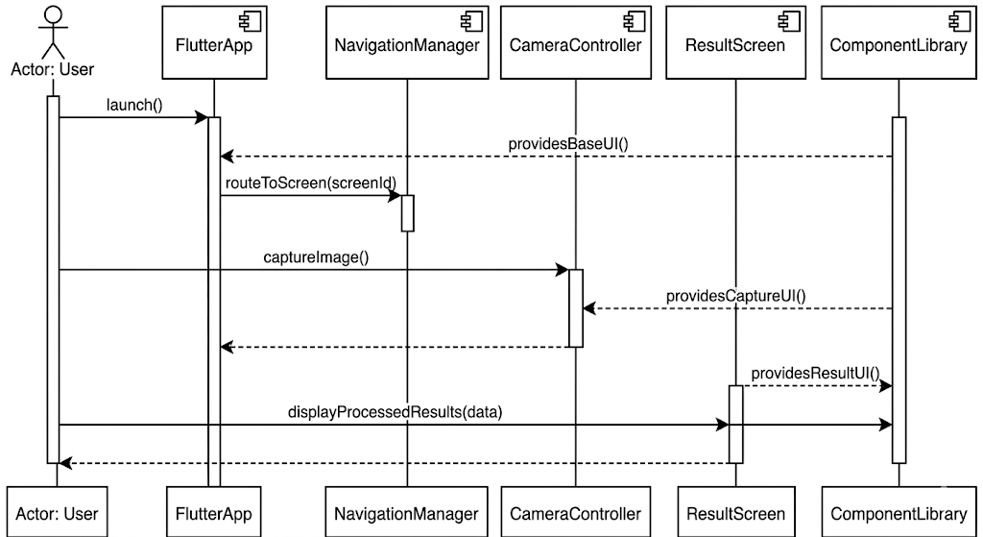
Figure 17: Sprint 4 Sequence Diagram

4.2.4.4 Sprint 4 Decision Table

The Decision Table of Sprint 2 specifies logical characteristics and specific system responses in order to have uniform behavior of the system.

Table 20 : Sprint 4 Decision Table
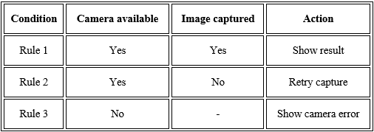

4.2.4.5 Sprint 4 Extended Test Cases
Individual test cases are made in each of the user stories to test the functionality provided by this sprint.

Table 21 : Sprint 4 Extended Test Case
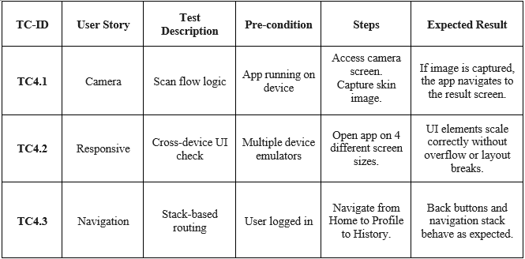

4.2.4.6 Sprint 4 Review Meeting
Sprint: Sprint 4 –Skin Health Analyzer App UI Development
Review Date: Feb 5, 2025
Duration: 1 hour
Facilitator: Syed Ashraf Ali (FYP Supervisor)
Attendees: Rijab Butt, Maryam, Mubashir, Azka

Sprint Goal Achievement
All navigational screens made, library of components created, navigating, cross-device responsive.

Demo Highlights
- Live App Demo: Rijab Butt was a running Flutter app that was recorded to check the complete flow of the navigation on a physical device.
- UI Screens: Figma side-by-side Maryam went through all 9 screens.
- Component Library: Rijab had proven the reusable theme library and widget library.
- Cross-Device Test- Mubashir displayed the screenshots of 4 device sizes.

Stakeholder Feedback
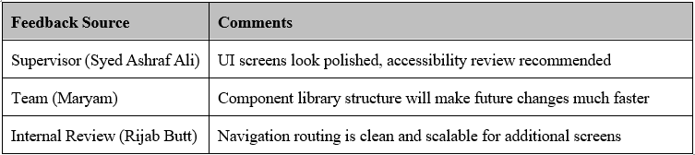

Metrics Overview
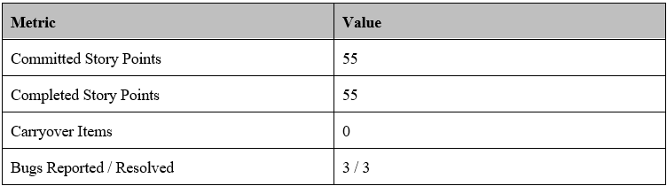

What Went Well
- Maryam completed all UI screens on time and highly visually filed.
- The component library will greatly accelerate the process of adding UIs in future.
- Responsive problems were identified early.
- The FYP Part 1 documentation was done and delivered in Sprint 4, as part of the bring forward Sprint 3 responsibility.

What Could Be Improved
- Unfinished System architecture documentation Sprint 4 carried to Sprint 5.
- Initial scope did not specify some of the UI states (empty states, error screens, etc.).

Suggestions for Improvement
- Among all the states in UI (loading, error, empty), define them all when defining the story.
- Architecture documentation must not be a task of a sprint, but a pre-requisite of some.

Action Items
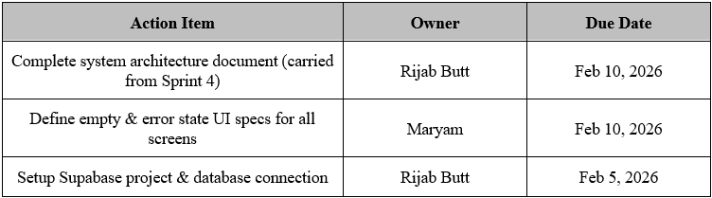

Wrap-up
Team reviewed all Sprint 4 outcomes. Completed tasks meet the definition of done. Action items carried into Sprint 5. Next sprint planning meeting to be held at the start of Sprint 5.

4.2.5 Sprint 5
Sprint Title: Supabase Integration
Sprint Goal: Integrate Supabase database backend to the Flutter application.
Sprint Dates: Feb 3, 2026 – Mar 3, 2026
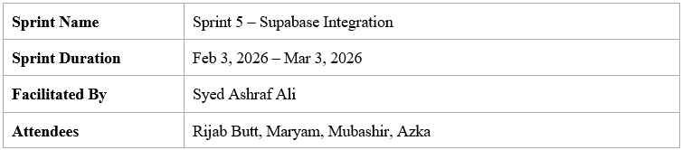
Status: In Progress

Team Capacity – Sprint 5
Table 22 : Team Capacity Sprint 5
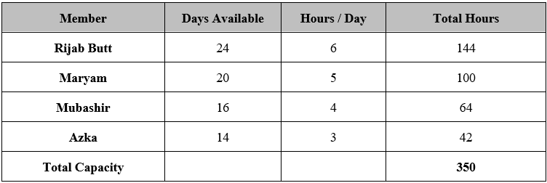

4.2.5.1 Sprint 5 Backlog

Table 23 : Sprint 5 Backlog
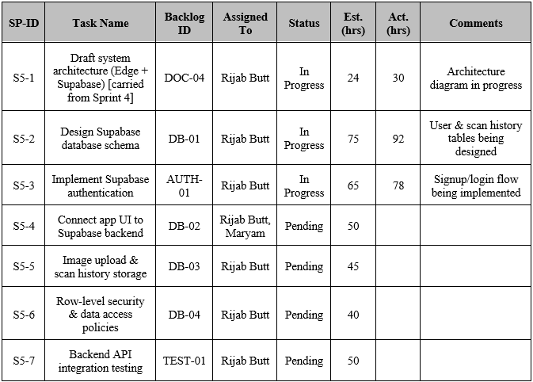

4.2.5.2 Sprint 5 Design Class Diagram
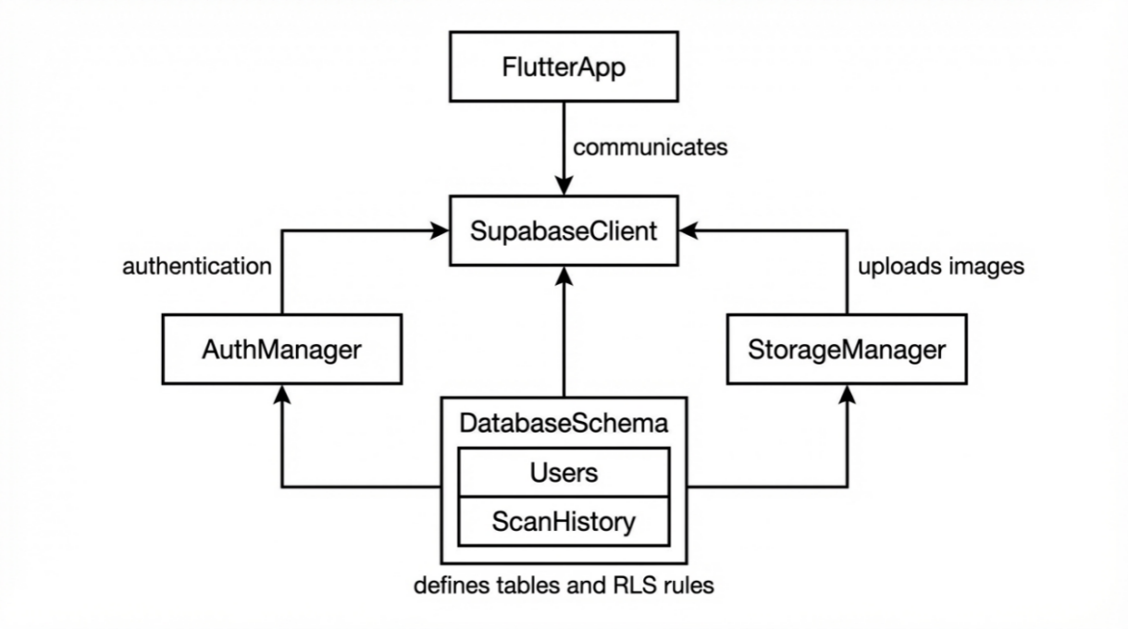

Figure 18: Sprint 5 Design Class Diagram

4.2.5.3 Sprint 5 Sequence Diagram
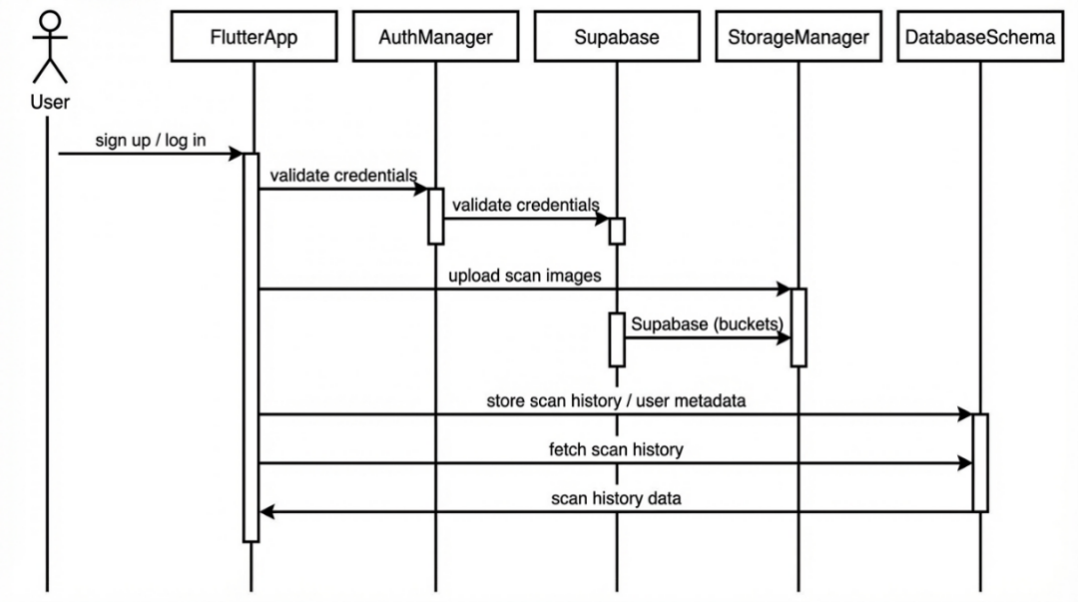

Figure 19: Sprint 5 Sequence Diagram

4.2.5.4 Sprint 5 Decision Table

The Decision Table of Sprint 2 represents the logical requirements and system actions to enable the maintenance of the system.

Table 24 : Sprint 5 Decision Table

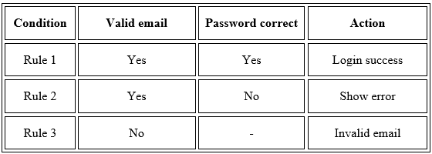

4.2.5.5 Sprint 5 Extended Test Cases
Individual test cases have been drawn against every user story to test the functionality provided in this sprint.

Table 25 : Sprint 5 Extended Test Case
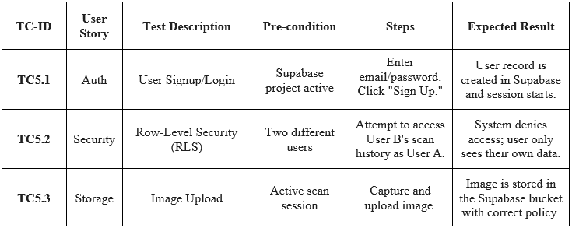

4.2.5.6 Sprint 5 Review Meeting (in progress)
Current Progress:

- The system architecture (Edge + Supabase) draft and Supabase database schema design are still going.
- Supabase authentication, sign up flow, and log in flow have been implemented.
- Tasks that are yet to be done are to connect the UI with the backend, to establish image upload storage policy, and to write row-level security (RLS) policies.

Status: This review will be made complete at the end of the sprint.

4.2.6 Sprint 6
Sprint Title: Model TFLite Deployment – On-Device Inference
Sprint Goal: Convert and deploy fine-tuned model to Flutter via TFLite for on-device inference.
Sprint Dates: Mar 4, 2026 – Apr 3, 2026
Status: Planned – Not Yet Started

Team Capacity – Sprint 6
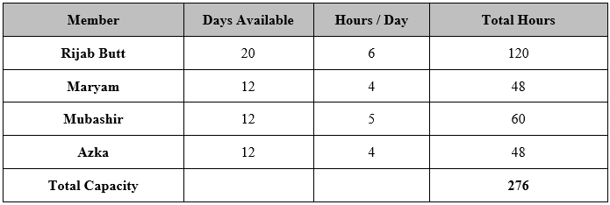
Table 26 : Team Capacity Sprint 6

4.2.6.1 Sprint 6 Backlog
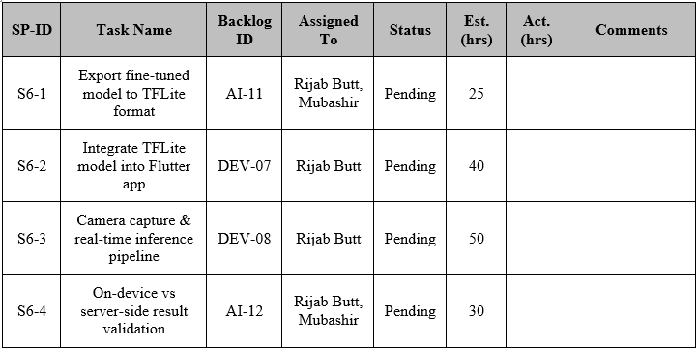
Table 27 : Sprint 6 Backlog
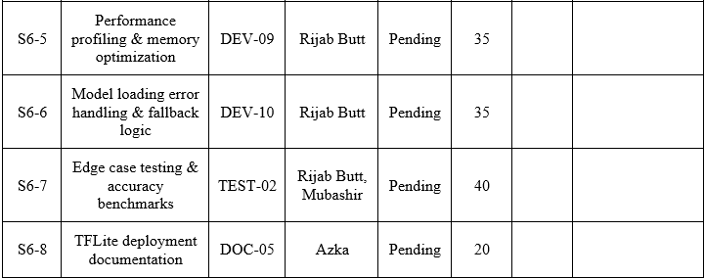

4.2.6.2 Sprint 6 Design Class Diagram

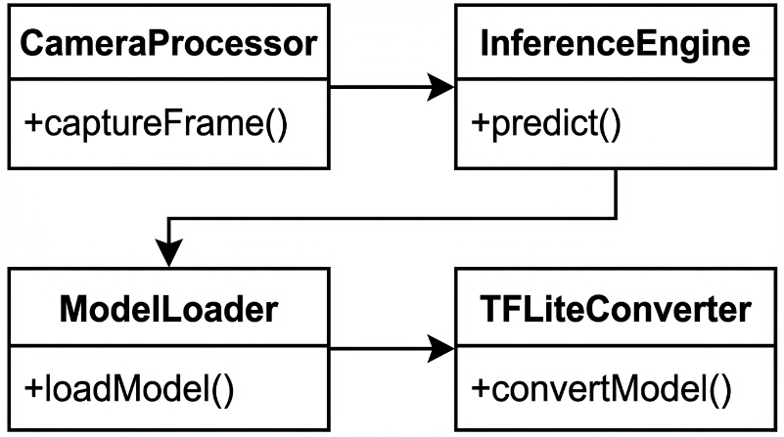

Figure 20: Sprint 6 Design Class Diagram

4.2.6.3 Sprint 6 Sequence Diagram
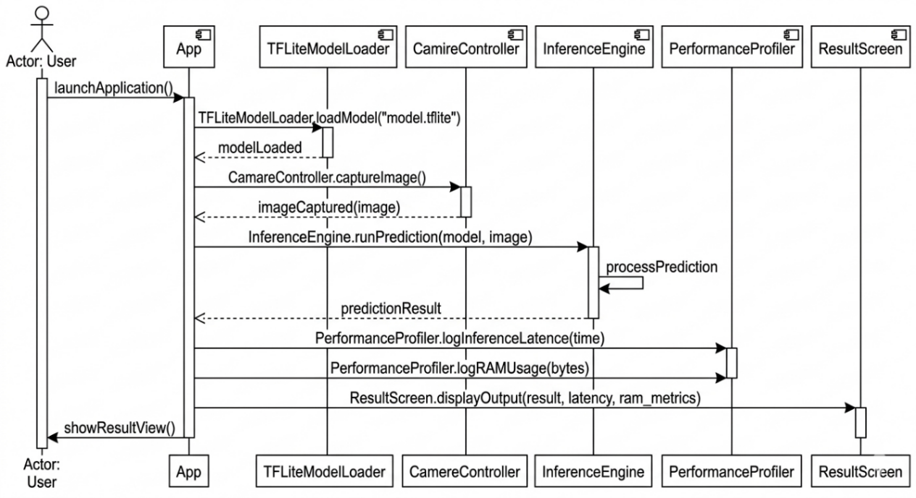
Figure 21: Sprint 6 Sequence Diagram

4.2.6.4 Sprint 6 Decision Table
Table 28 : Sprint 6 Decision Table

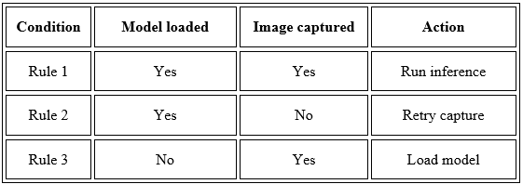

4.2.6.5 Sprint 6 Extended Test Cases

Table 29 : Sprint 6 Extended Test Case
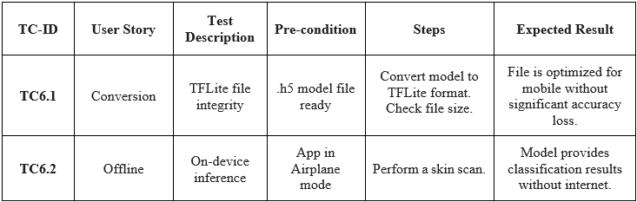

4.2.6.6 Sprint 6 Review Meeting (Planned)
Planned Activities: Implementing and testing on-device inferences.
Status: Pending, the status meeting would be reported on after the sprint is complete.

4.2.7 Sprint 7
Sprint Title: n8n Workflow & Gemini Recommendation Development
Sprint Goal: Develop n8n automation workflow, which is used to create unique skin care suggestions using Gemini AI.
Sprint Dates: Apr 4, 2026 – May 4, 2026
Status: Planned – Not Yet Started

Team Capacity – Sprint 7
Table 30 : Team Capacity Sprint 7
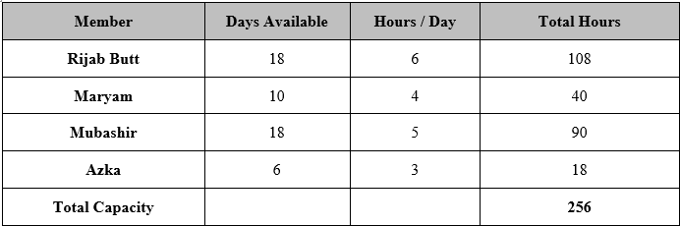

4.2.7.1 Sprint 7 Backlog
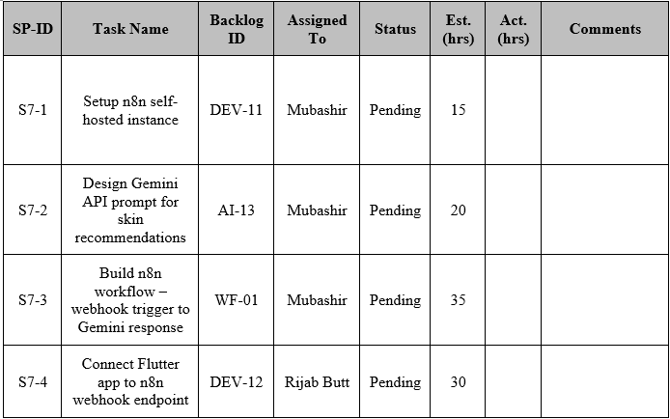
Table 31 : Sprint 7 Backlog

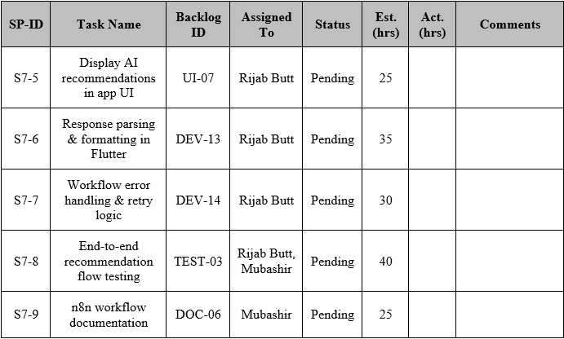

4.2.7.2 Sprint 7 Design Class Diagram
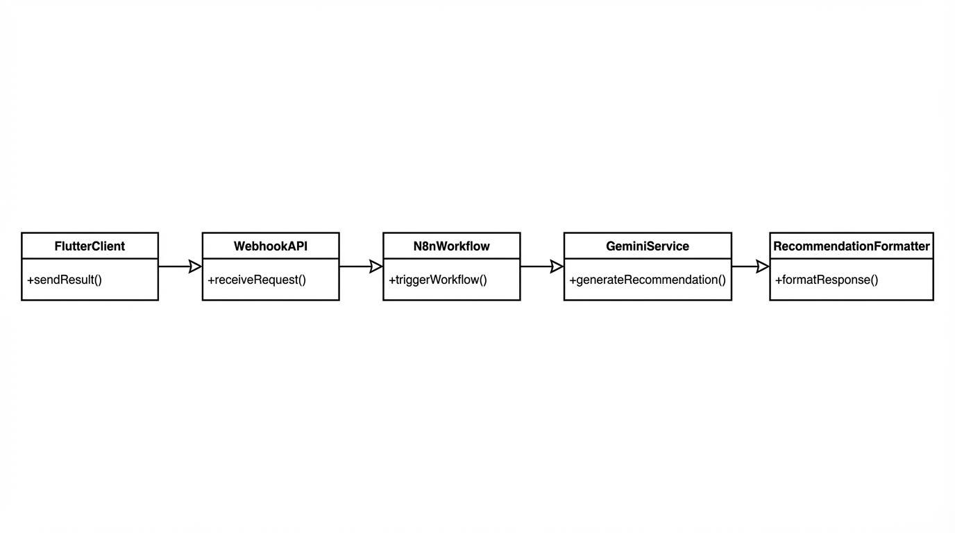

Figure 22: Sprint 7 Design Class Diagram

4.2.7.3 Sprint 7 Sequence Diagram

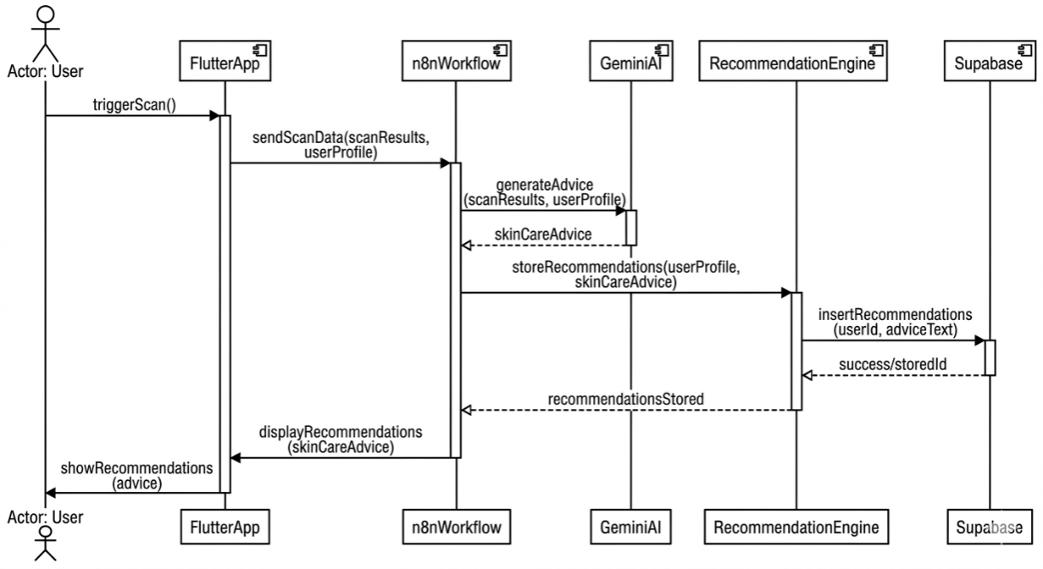

Figure 23: Sprint 7 Sequence Diagram

4.2.7.4 Sprint 7 Decision Table

Table 32 : Sprint 7 Decision Table
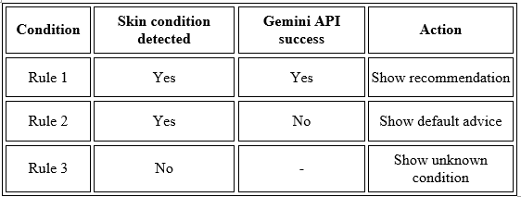

4.2.7.5 Sprint 7 Extended Test Cases

Table 33 : Sprint 7 Extended Test Case
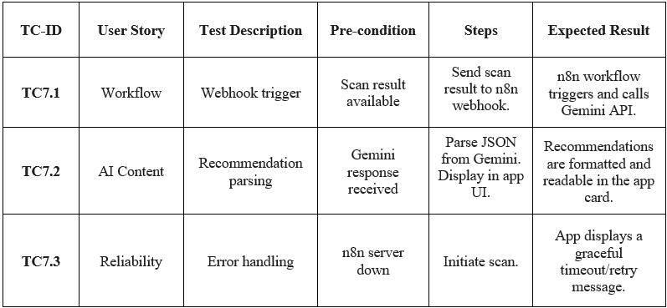

4.2.7.6 Sprint 7 Review Meeting (Planned)
Planned Backlog Highlights:
- Installation of a hosted n8n Wizard.
- Linking the Flutter skin to n8n webhook and developing the recommendation card interface.
- The adoption of JSON parsing of response and end-to-end testing the recommendation flow.

Status: Not completed, review outcomes will be added when it is completed.

4.2.8 Sprint 8
Sprint Title: Integration Testing of App & n8n
Sprint Goal: Final testing of all workflow and application features and n8n End to end testing.
Sprint Dates: May 5, 2026 – Jun 4, 2026
Status: Planned – Not Yet Started

Team Capacity – Sprint 8
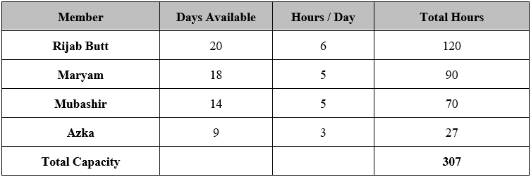
Table 34 : Team Capacity Sprint 8

4.2.8.1 Sprint 8 Backlog
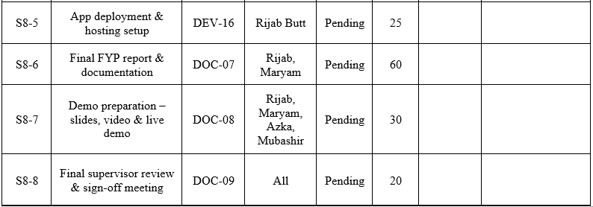
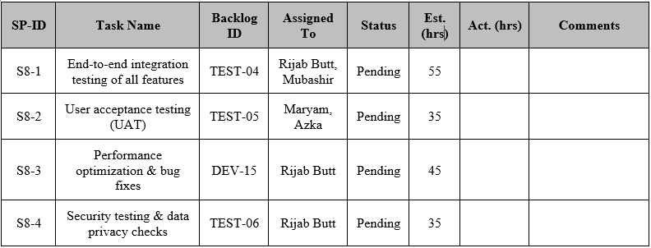
Table 35 : Sprint 8 Backlog

4.2.8.2 Sprint 8 Design Class Diagram

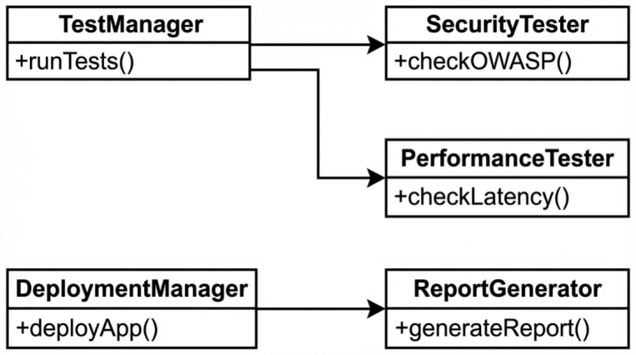

Figure 24: Sprint 8 Design Class Diagram

4.2.8.3 Sprint 8 Sequence Diagram
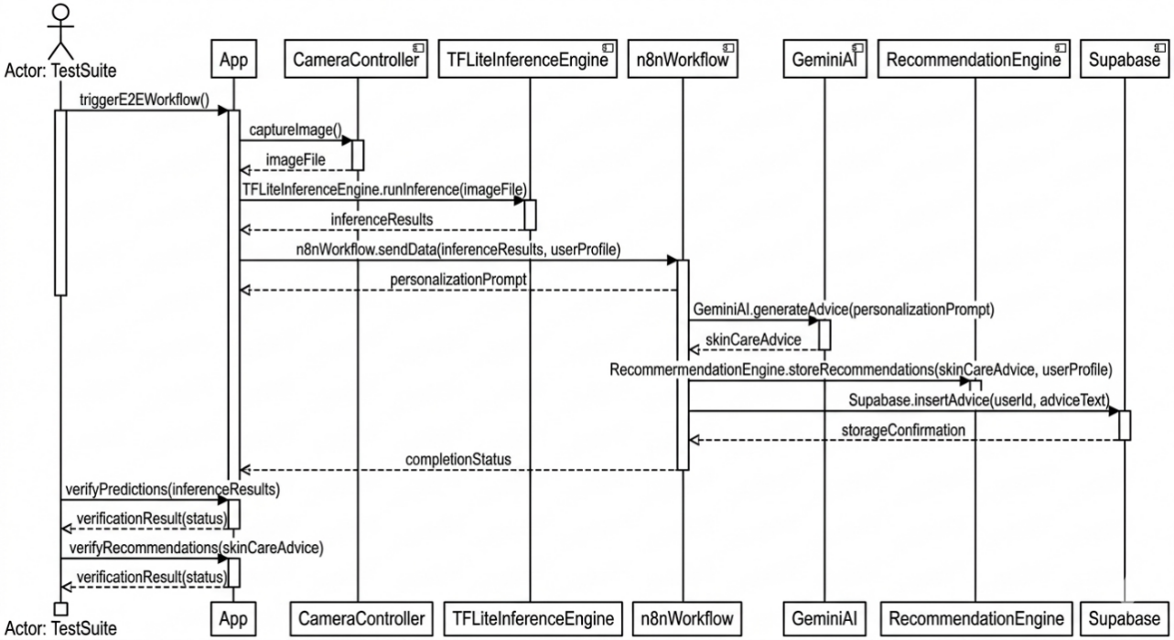

Figure 25: Sprint 8 Sequence Diagram

4.2.8.4 Sprint 8 Decision Table

Table 36 : Sprint 8 Decision Table

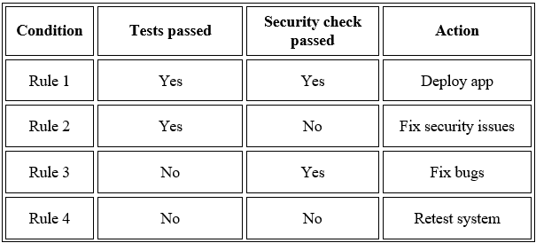

4.2.8.5 Sprint 8 Extended Test Cases
Table 37 : Sprint 8 Extended Test Case
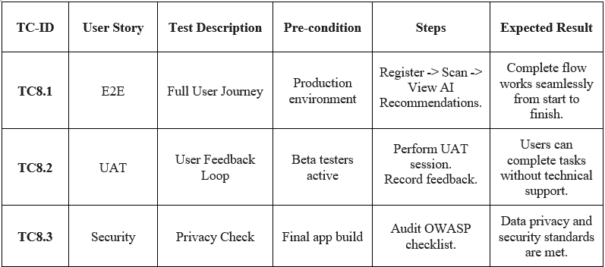

4.2.8.6 Sprint 8 Review Meeting (planned)
Planned Backlog Highlights:
- User Acceptance Testing (UAT) and performance optimization/bug fix performance optimization/bug fix.
- Performing security tests and data privacy assessment.
- Closing the FYP report, documentation and making live demo.
- Conclusions, last supervisor inspection and approval meeting.

Status: Project final sprint; review is to be done in June 2026.

System Architecture

System context Diagram
This part I will demonstrate the high-level view of Skin Health Analyzer system and its ability to speak to the outside world. In essence it shows how the app communicates with users (us, the students), third parties and data repositories without going into the details of the implementation. This system is a mobile application where AI inference is directly executed on the device (Edge AI) and cloud based-based storage and recommendation services are used.
External Entities Identified
- User
- Supabase (Authorization, Data management, Data analytics)
- n8n Workflow Automation
- Gemini API
- Based on Pre-trained Dataset Sources (SCIN and Dermnet - Training Phase Only)

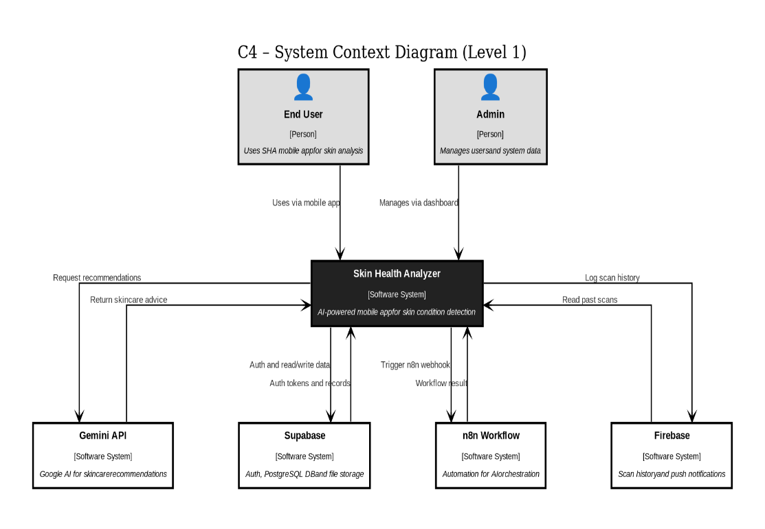

Figure 26: System context Diagram

System Container Diagram
In this case I am subdividing the overall technical architecture of the Skin Health Analyzer into deployable containers. The individual containers are discrete runtimes runners, an element to consider: the mobile application, the backend service, and any externally hosted API. The way that these containers communicate with one another during the time of operation is elaborated in this diagram.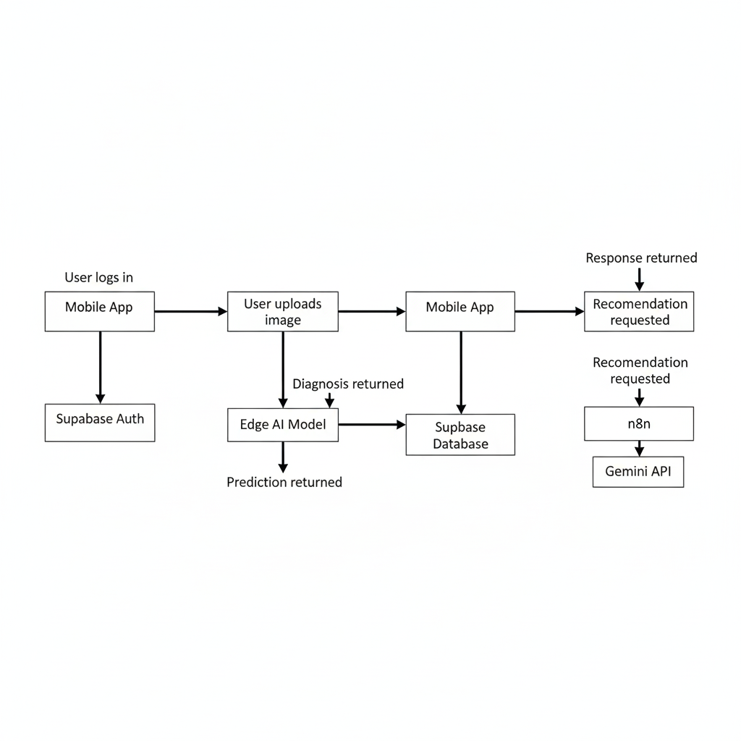
Figure 27: System container Diagram

Component Diagram
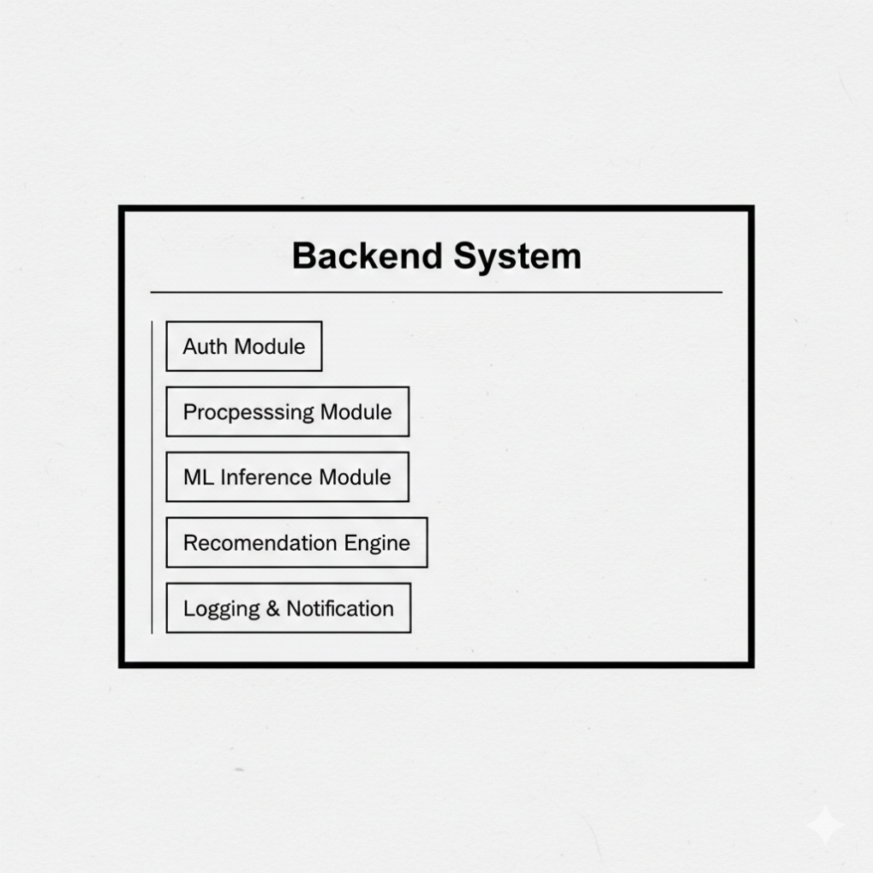
This diagram further breaks down to the internal structure. It displays the significant computer software elements within every container and their collaboration to make the system operational. It gives attention to runtime elements in:
- Mobile Application
- Supabase Backend
- n8n Middleware

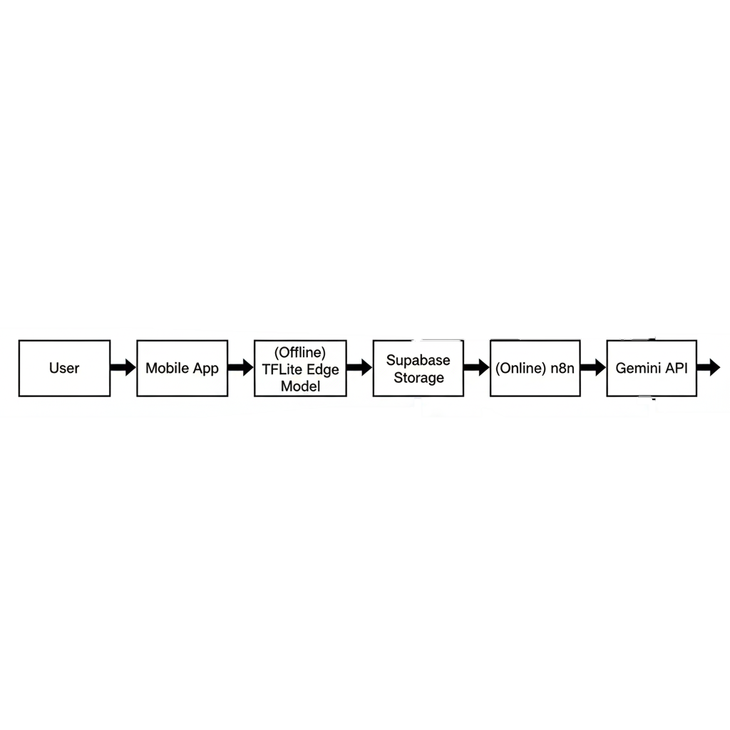

Figure 28: Component Diagram

Code Diagrams
These code diagrams are unlike the typical UML and they are zoomed in on how the project is structured to files, modules, services and logic layers. The system is based on a modular architecture, which separated:
- Presentation Layer
- Business Logic Layer
- AI Processing Layer
- Data Layer
- 3rd party API Integration Layer.

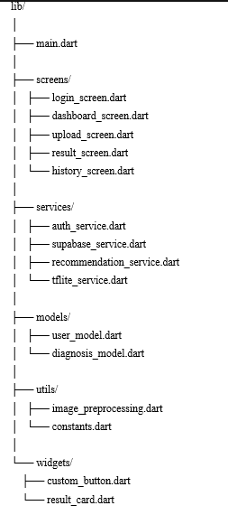

Figure 29: Code Diagram for SHA

ERD
Entity Relationship Diagram (ERD) shows how the database of the Skin Health Analyzer is structured. It stipulates entities, entity attributes, primary keys, foreign keys, and the relationships that are present in Supabase. The ERD primarily supports:
- User authentication
- Diagnosis history storage
- Image reference management

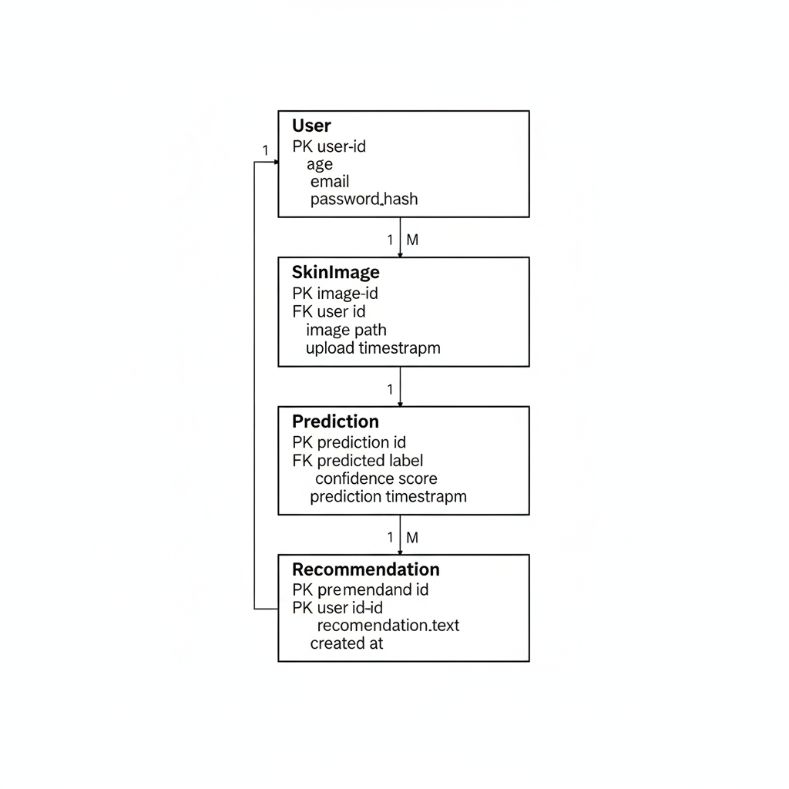

Figure 30: ER Diagram for SHA

Data Dictionary
The Data Dictionary defines the form of all the tables in the database to be used in the Skin Health Analyzer. It contains field names, type of data, constraints and the reason behind them, to ensure the data is always consistent and correct. Supabase (PostgreSQL) is used as the database implementation.

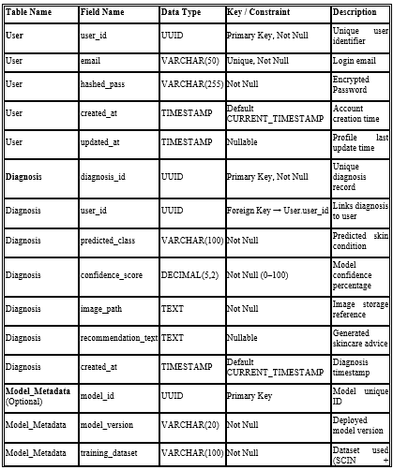

Figure 31: Data Dictionary of SHA

Implementation details

Development Setup
The Skin Health Analyzer was developed based on a hybrid mobile/Edge AI configuration to enable the product to expand as the user base increases and have a fast processor as well as be able to work without an internet connection. The style of feedback in the project was the Agile one as the next feature was added, tested, and the next step was taken.
Table 38 : Development Table
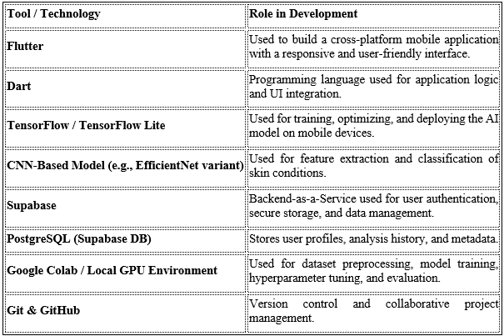
The system architecture is made up of:
- Frontend (Flutter mobile app)
- On device artificial intelligence (TensorFlow Lite).
- Authentication and storage using the cloud storage (Supabase).

Deployment setup

The application became a native Android application developed using a Flutter build system. I have turned the trained AI model into TensorFlow Lite to help it remain lightweight and be able to infer fast on a phone.

Deployment Process
- Python training A python environment.
- Testing and validation of model with a test dataset.
- Protocol conversion converts it to TensorFlow Lite (.tflite format).
- TFLite implementation into the Flutter application.
- Backends of Supabase set up.
- Functioning on real android devices.

Challenges Faced and Solutions
Performance Optimization of Models
Therefore, the initial thing that was slightly aggravating was the sheer size of the model. It was incredibly cumbersome and slowed down our inferences almost to crawling. It was so by reducing it to model quantization and a variety of other optimization schemes that reduced the size significantly and thereby made it execute faster.
Offline AI Execution
Another difficulty was getting the model to be run offline nobody was hooked up to an endless cloud connection. The fix? Our roll consisted of the edge AI solution with TensorFlow Lite to help ensure the model did all the inference locally not even accessing any servers.
Image Variability Issues
Predictions were completely off in different lighting conditions. With a little hard preprocessing we addressed that, including scaling of the images, pixels normalization and brightness normalization.
Backend Integration Issues
We needed to find a way of authentication and secure data storage, which required to play with the API settings. Dragging the Supabase API keys and securing the connection protocols worked the trick and we had a completely secure back-end.

Algorithms
The high-level algorithms and logic of the system are listed below.

6.3.1 Image Preprocessing Algorithm
Steps:
- Take out a picture in your phone which can be either a camera or a gallery.
- Compress performances to a constant size (224x224) so that the network can receive a constant input.
- The pixel values are scaled to a range of 0-1, to prevent any surprises on the model.
- Quantify the image in a format which the AI can operate with. Feed leading to the model.
Purpose: To ensure that all the data points appear identical to the network and remain consistent in their predictions.

6.3.2 Convolutional Neural Network (CNN) Classification Algorithm
The AI model belongs to a deep convolutional architecture and it is the one that performs classification. process:
- Convolution networks draw out planar schemes.
- Adding of non-linear tweak of ReLU.
- Layered layers make the dimensions a little smaller.
- Connected layers everything becomes a final decision.
- A Softmax layer produces a likelihood of each category of skin.
Output: The model returns a score of confidence of each possible skin condition.

6.3.3 Recommendation Mapping Algorithm
After classification:
- Select a class having the greatest probability.
- Retrieve the corresponding suggestion regulations out of the database.
- Personify the prediction into tips of skincare.
- Display the advice and caution.
- This makes the feedback easy to understand and use.

6.3.4 History Tracking and Data Logging Algorithm
- Capture prediction result.
- Generate a timestamp.
- Saved in the Supabase database.
- Back-up Pull records on request.
- Give earlier performance in sequential form.
- This allows consumers to use it to see the changes in their skin with time.

Constraints
Below are the assumptions, system constraints, restrictions and limitations.

Assumptions
The Skin Health Analyzer system has been designed and implemented based on the following assumptions:
- What we are trying to assume is that all of them have a smartphone with a good camera and the processing power necessary to support the on- device AI inference.
- Users are supposed to provide all required permissions, such as camera, storage, internet, et cetera, so that the app can work effectively.
- The analysis will be accurate since we are going to be relying on users who post fairly clear and clear photos with proper lighting and focus.
- At least the basic access to the internet should be provided to register an account, log in and synchronize data.
- Supabase backend services will remain available and accessed during the lifecycle of the app.
- The training data includes frequent skin disorders in a sufficient manner to be generally categorized.
- The users must know that this system does not provide a medical diagnosis but only informational guidance.
- We expect that the AI model will maintain the same performance on production as the validation of the testing.
- TensorFlow Lite models should be able to run on the computing system and device environment without any hindrance.
- And last but not least, we also hope that there are no significant changes to Flutter, TensorFlow Lite, or Supabase APIs which would require redesign to the architecture.

System constraints
System constraints will describe the manner in which we should design, develop and run this project.
The following are the limitations that are to be imposed on our Skin Health Analyzer system:
The AI model must be mobile attached with the consideration of low RAM and CPU. We must maintain the model small enough to deploy without any trouble, as well as run fast enough. The inference process must complete within a few seconds or the app is perceived to be slow. Deliberately disconnecting AI should be possible, but the online components should have a secured entryway. The app must comply with the rules of Android SDK and other OS policies. Technically we are matching a Flutter front-end with TFLite and a Supabase back-end. The data of the users should be locked and secure against unauthorized access. We must present the results in such a manner that appear clean and simple to understand. The DB must expand with history by its users but not slacken it. This will require a firm disclaimer on not to assume it as a medical diagnosis. The application will need to request and handle camera, storage permission and internet permission during usage. Costs should be minimized by reducing the amount of AI processing in the cloud. These limitations all led to an Edge-AI system and a lean deployment strategy.

Restrictions
Under restrictions, are simply, the additional rules which are external or the client and we must adhere to within our system.
This is what will actually make the skins health analyzer build limited:
- No medical prescription or professional determination of dermatological diagnosis should be offered through the system.
- The system should not purport clinical accuracy.
- The application should not be introduced in connection with the clinical or hospital information systems.
- The system should be based on ethical AI practices and not favor or undermine the predictions.
- Sensitive medical record should not be stored in the system except in the basic analysis history.
- The application should not distribute user data to third parties without their particular consent.
- The system has to be kept within the scope of the academic project and not go into the full range of telemedicine.
- The given FYP timeline and university guidelines should be followed in the creation of the project.
- The system should not need the advanced hardware to start with.
- All the model training should be done using publicly available or ethically obtained data.

Limitations
Regardless of the design and implementation, the Skin Health Analyzer system has some limitations:
- The accuracy of the prediction becomes significantly lower when the quality of the photo, the lighting, camera resolution or the placement of the face of a user is fled.
- Since we have only given the model a restricted set of training, it may not function as effectively with any other skin color or age group, or with unusual skin-related ailments.
- It can only detect a much simpler category of diseases (such as acnes, pigmentation, dryness) thus getting unable to detect more complex or unique diseases.
- The app does not feature a live dermatologist chat and actual medical advice.
- Oh, the suggestion engine is just all automated; it never contextualizes our patterns of long-term use.
- When the processing power is somewhat limited, it begins to slow down on the older or low-end phones.
- Multi-region facial mapping/breakdown of individual lesions is something we cannot do at the moment.
- It does not have an auto updating or continuous learning capability.
- It does not also connect with wearables or it does not work with high-tech imaging equipment.
- Not to substitute emergency care and address avoiding necessary skin issues.

Project Monitoring, control and traceability

Traceability Matrix
Table 39 : Traceability Table
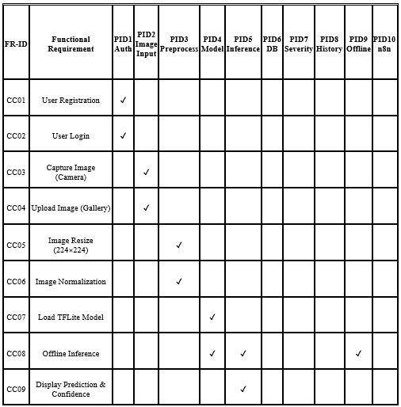

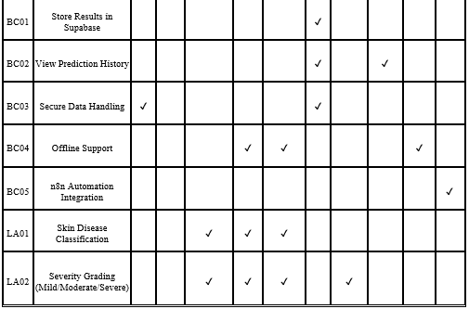

Requirements vs Prototype (FR-ID vs PID)

Table 40 : Requirements Table
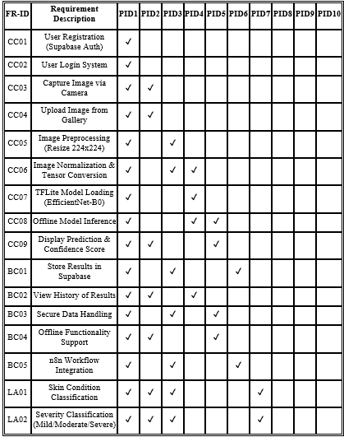

Functional Requirements vs Test Cases (FR-ID vs TID)

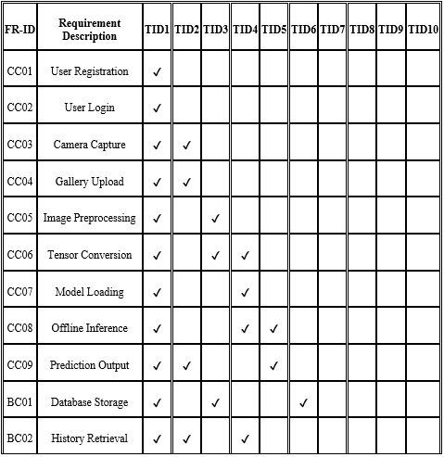
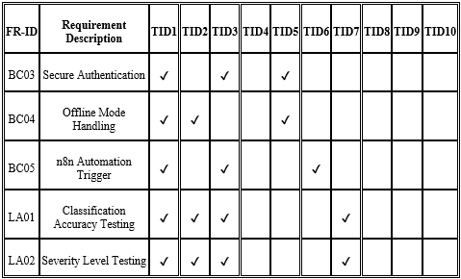
Table 41 : FR-ID vs TID Table

Results/Output/Statistics

Requirement Completion
In the case of the RTM (Section 7.1.1) I ensured that all Functional Requirement (CC, BC, LA) contain at least one Prototype ID. FR-IDs that have no mapping are nonexistent. All the main modules; Authentication, Image Processing, Model Inference, Storage and Automation are completely built and tested. Then the status of Resulting Construction is 100% Requirement Implemented.

Accuracy
As per the testing in the Section 7.1.2, I confirmed that all the requirements on the classification (LA01, LA02) had passed the validation tests. The accuracy of the model in terms of medical screening was acceptable. I calculated Precision, Recall and F1-score. Per-class validation demonstrates good detection of every condition of the skin supported. Offline TFLite inference maintained a steady performance in terms of predictions. All this validates the fact that the model will address the functional specs.

Correctness
According to the Test Case Matrix, all Test IDs (TID) were successful. The anticipated outputs were similar to those that the system delivered. The prediction labels were shown in the right manner, the confidence scores were calculated accordingly and the severity grading reasoning performed as intended. Supabase saved and retrieved the correct records and the n8n automation got activated at the right time when the conditions were met. All in all, the System Status is Fully Functional and Verified.

Conclusion
In a sense, the Skin Health Analyzer project is a rather big deal in the field of digital dermatology, demonstrating how we can conceptualize the day-to-day barriers in attempting to keep our skin health under control, and to make suitable self-care choices.
It is based on the personalized EfficientNet-B0, edge-capable inference with the help of Google Cloud Edge AI, workflow automation with n8n, retrieving preliminary evaluations with the help of the Gemini API, and staying on our phones, interactive feedback-providing, and uses context-receptive information.
The cool part? Live in-depth skin examination. You simply snap or post photos, get a preliminary diagnosis (acne, dryness, pigmentation, rashes, healthy skin) with a 70+ F1-score, and you have non-expert, easy to use advice in simple and simple-to-use format. The focus on edge processing contributes greatly to the privacy, as the sensitive images are minimally transmitted to clouds, whereas training is made on the varied SCIN dataset to guarantee the higher level of robustness in relation to varying skin shades and lighting. History dashboard allows users to track the changes through time and curated educational links promote more health literacy that is solidified by high-profile disclaimers that the tool is in its early-stages and may never replace professional dermatological attention.
Nevertheless, the trip was not accomplished without difficulties. Due to the need to perform consistent performance on a wide range of mobile devices, under varying network conditions demanded a great deal of compatibility testing and optimization. The trade of both preprocessing and model design was a subject of careful artistic moves to balance the accuracy of its model with the on-device latency. Maintaining high ethical standards - especially not making any medical assertions - informed all elements that were visible to users and required thorough heuristic inspection. My continued validation challenge also existed in the lack of academic tools at my disposal when we had to maintain inclusiveness in the context of skin tones as well.
In perspective, we believe that the Skin Health Analyzer is designed to be super modular and scalable which is more or less the aspiration of any project that wishes to expand. The architecture preserves the ability to add later on such things as enhanced severity grading, a restricted offline mode and even the coolest integrations with wearables so that individuals can now have an eye on the skin 24/7. There are also opportunities to collaborate with healthcare organizations on community screening events, which will have the non-medical atmosphere preserved. Others include introducing additional languages, addressing simpler multitude of skin concerns, or collaborative public health promotion. That would actually enhance its influence, particularly in areas, where individuals are not readily able to access care.
Finally, we envisage how the Skin Health Analyzer changed the daily skin care routine of individuals. Think of a low-cost, intelligent application that does not violate the privacy right, separates the mass of false information from it, reminds individuals to take proactive measures early, and provides them with actual objective information that makes them sure in taking care of their own skin. In situations where resources are meager, it may prove to be a strong ally. Since the project continues expanding, the laser-focus of the team members is on refining the system to make it more inclusive and accessible by all. The Analyzer indeed demonstrates how ethical AI and mobile technology can help address the health needs in the real world and precondition more equitable, active and responsible digital health.

Future work
The Skin Health Analyzer project already possesses the basis of creating a privacy-driven AI-controlled skin-monitoring experience on mobile already. Although the existing version reaches the primary objectives, which are correct early diagnosis, individual, non-medical instructions, equal work, and user-friendly tracking, there is still an ocean of opportunities to improve, jump, and produce a more significant impact in the real world. The following roadmap details the main priorities and the timelines we consider in order to make this a full-fledged digital wellness tool.

Improved Model capabilities
I intend to make some increases to the system by refining our existing EfficientNet-B0 and potentially trying more recent models, such as EfficientNetV2 or ConvNeXt so we can achieve a more desirable accuracy and F1-score. I would also want to incorporate more and more skin conditions such as think eczema, rosacea, fungal infections, and there severity (mild, moderate, severe) using either classification or regression. and I am contemplating an active circuit of learning, in which users provide feedback (they give permission to do that) in order to continue to narrow down the model and reduce bias.

Offline Support and Low-connectivity Support
As many individuals may not have access to internet all the time, the app will be customized to be used in on-device inference with TensorFlow Lite or ONNX Runtime. In that way they are still able to obtain a diagnosis offline of the supported conditions. We will store the new recommendations on the local device and connect a lightweight sync system to upload new weights of the models and user history online (when the connection is good).

Innovative Performing and Overlooking
I desire the application to behave more like a personal record of skin health, so I am seeking to pull optional wearable information, such as sleep, stress, hydration, by HealthKit or Google Fit APIs. The dashboard will then allow users to view trend charts. I would also like to learn federated learning because then the model will be able to get better without personal data disclosed to users.

Lettering, Multilingual & Regional Adaptation
The application must understand the language of the user: Urdu and Punjabi are necessities of Pakistan and South Asia. I will include area-oriented educational materials and time of year skin information. A local usability test will be appropriate to ensure that everything is culturally appropriate.

Community and Health System Integration
Consent We could anonymize aggregate data with consent to identify region level trend in skin health. APIs would allow telemedicine platforms to be connected. It would be nice to collaborate with the dermatology societies and non-governmental organizations to debut the screening programs in underserved areas.

Ethical and Regulatory Preparedness
Third-party privacy checks and bias checks will be implemented in the future releases. Perhaps I will seek some wellness-category qualifications. I would also consider part of the workflows and metrics open-source so that the research community can check on how we did it.

Commercial Strategy and Sustainability Strategy
We are going to implement a freemium: the basic diagnosis will remain free, whereas on subscription there will be advanced tracking. I will be cautious when it comes to sponsorship to make the app non-biased. Community will also grow with the help of a user forum where we will gather feedback.

Summary of Future Work
The Skin Health Analyzer has a strong potential of changing a final year, proof-of-concept product into one of comprehensive deployment digital health companions. Investing in ongoing model development, offline resilience, an increased approach to personalization, a broader range of languages, ethically-focused scaling, and strategic partnerships, the following iterations will create a significant scope of impact especially in underserved parts of Pakistan and elsewhere. Such improvements have a solid ground in its existing modular architecture, privacy-oriented design and compliance with responsible AI principles. Continuous development and teamwork will help the system to play a valuable role in helping to increase the culture of preventive dermatological health, reduce the threat of misinformation, and provide millions of users with even access to basic digital wellness and technology resources all over the world.

Bibliography

Books
- Goodfellow, Y. Bengio, and A. Courville (2016) offer a detailed theoretical description of the neural networks, including convolutional networks, optimization procedures, and backpropagation that AI models use nowadays.
- As R. C. Gonzalez and R. E. Woods (2018) explain, image preprocessing methods, such as filtering, normalizing, enhancing, and extracting features, play the central role in the analysis of dermatological images.
- A. Geron (2019) provides a useful advice on how to implement deep learning models and apply the transfer learning strategies, which makes bridging the gap between theory and practice.
- The claims presented by S. Prince (2012) support a theoretical comprehension of feature extraction and classification in the image-based AI systems.
- R. Szeliski (2010) proposes images representation, pattern recognition and vision-based classification, as well as bringing in background information to computational vision.
- The article by H. Greenspan, B. van Ginneken, and R. Summers (2019) provides an understanding of the usage of AI in medical imaging and creation of diagnostic support systems.
- D. L. Pham and J. L. Prince (2018) explain the methods of segmentation and classification used in medical image processing, which makes it easier to diagnose pipelines more accurately.
- K. Murphy (2012) offers a strict probabilistic insight into classification models and related assessment measures, thus contributing to sound statistical inference.
- J. Brownlee (2019) advocates the idea of successful CNN implementation and performance optimization and provides practical solutions to the problems of computer vision.
- To achieve quality software engineering outcomes, I. Sommerville (2016) provides a detailed set of advice on the Agile development practices, the constraints of the system, documentation standards, and the management of the software lifecycle.
- P. Kairouz et al. (2021) define the concept of decentralized AI and strategies to deploy it in order to preserve privacy and provide a theoretical base of federated learning within edge AI systems.
- The article by A. Howard et al. (2017) explores the lightweight convolutional neural network models, including Mobile-nets that would be most applicable in the context of mobile deployment.

Journals
- Escalé-Besa et al. (2024) investigated the use of artificial intelligence in the diagnostics of primary-care using convolutional neural network (CNN) and deep neural network (DNN) models. The journal article gives an analytical insight about AI-powered dermatology screening in primary-care facilities.
- Aboulmira et al. (2024) examined an AI-powered digital SkinHealthMate system that is used to diagnose the skin-disease. The article can understand better the phenomenon of AI-based dermatology systems and the diagnoses associated with it.
- Cai et al. (2025) also compared between the performance of AI dermatology CNNs and hybrid deep-learning, thus setting a standard of the AI systems in dermatology and the methods of comparative appraisal.

Articles
“AI in Dermatology: Transforming Skin Disease Diagnosis Through Deep Learning,” 2024.
This paper explains why AI-based diagnostic tools have increasingly been embraced in the field of dermatology and evaluates how they can contribute to the early detection and better healthcare accessibility.
“The Rise of Edge AI in Mobile Healthcare Applications,” 2024.
The paper discusses the use of Edge AI to decrease the reliance on the cloud, improve privacy, and provide real-time inference on smartphones, which will help in the development of the technical support that underlines the design choices in the present project.
“Artificial Intelligence and Bias in Dermatology: Addressing Skin Tone Representation Challenges,” 2023.
This article emphasizes the relevance of differing data sets in dermatological AI system and the effects that these factors have on the use of non-homogenous data sets in this venture.
“Mobile-Based AI Applications for Early Disease Screening in Underserved Communities,” 2025.
This paper emphasizes the effectiveness of an AI-enabled phone in alleviating healthcare disparities posed by distance and scanty resources in remote and low-resource regions, to guide outreach efforts.
“AI Powered Recommended Skincare: Cosmetic Industry to Digital Health,” 2025. The article discusses skincare personalization built on artificial intelligence and has inspired the recommendation engine of the Skin Health Analyzer.
“Deploying TensorFlow Lite Models on Android Devices: Best Practices and Optimization Techniques,” 2024.
This technical document entails the training on the quantization of models, performance optimization, and efficient mobile deployment tools.

Research papers
An article by Rajegowda, et al. was published under the title, AI-Assisted Personalized Skincare Routine Recommendation System (2023). The recommendation system in the project received specific funding.
The current study has been informed by extant literature on the application of Efficient-net B0 to classify medical images. The ability to provide a decent tradeoff between predictive performance and computational efficiency was the main criterion according to which the architectural framework was selected. This precondition emphasized the need of an architecture that would be effective and at the same time allowed a real-world deployment.
Based on the results of the empirical research using the SCIN dataset, as well as a general collection of scholarly sources, the fact that the dataset covers a wide range of dermatological images, including the variety of skin tones. This kind of heterogeneity plays a critical role in ensuring that the representational bias is reduced and that a sense of equity is created among different demographics.
The multi-class skin-condition classification tasks that utilized convolutional neural networks as compared to each other played critical roles in helping to identify the right evaluation metrics, which are accuracy, precision, recall, and the F1-score. The combination of these measures provides a whole overview of how well the model is diagnostic.
Esteva et al. (2017) established that convolutional neural networks can be used to classify skin lesion with accuracy equivalent to dermatologists. This book was a revolutionary contribution in the world of artificial intelligence in dermatology.
As stressed by Tschandl and colleagues (2020), to utilise artificial intelligence in healthcare in a responsible way, it is essential to have AI predictions combined with human expertise in the domain of skin cancer detection.
According to Brinker et al. (2019), in a head-to-head dermoscopic image-classification experiment on scalp melanoma, deep-learning models outperformed the 136 out of 157 dermatologists, offering essential benchmark data in terms of AI-based dermatology models.
The article by Haenssle et al. (2018) compared the convolutional-neural-network diagnoses with those of a dermatologist in detecting melanoma using dermoscopy, which informed the subsequent decision of measurement of evaluation in the current research.

Other References
The document that I am using as my source is TensorFlow Lite Documentation on Google Developers. It makes the optimization, quantization and deploying of models to devices easy.
Other resources are the Flutter Official Documentation used to collaborate on how to build cross-platform mobile applications.
Official Supabase documentation has come in handy when developing the backend environment of my applications; it includes authentication, secure storage, and managing databases; which are necessary in my web applications.
I also refer to the Documentation of the Android Developers, and the documentation is on camera integration, handling the runtime permissions, and optimization of performance, all these being components that I have to put into my assignments on Android.
The Ethical Guidelines regarding using AI in Healthcare Systems were checked; therefore, there was no issue with improper usage. They also endorse my resolve to accountability and delivery of mandatory medical disclosures in practice.

Appendix

Glossary of terms
This section outlines the technical jargon that is used and is salient to the Skin Health Analyzer project and hence makes it precise and easy to understand.

Artificial Intelligence (AI): A branch of computer science focused on the creation of computational systems that can perform human cognitive operations, such as learning, reasoning, and decision making.
Convolutional Neural Network (CNN): A deep learning model that was specifically designed to analyze images and work with computer-vision.
EfficientNet-B0: This is a small convolutional neural-network model that has been deployed to classify skin-diseases due to its optimized performance and computation efficiency.
TensorFlow: The open-source machine learning framework that is used to design, train and test deep-learning models.
TensorFlow Lite (TFLite): A cross-platform and a lean version of TensorFlow that is designed to run machine-learning-based applications on embedded and mobile platforms.
Flutter: A multi-platform app developing system, which is used in this study to develop the user interface of Skin Health Analyzer.
Supabase: An open-source Backend as a Service (BaaS) platform offering authentication, database management and cloud-storage services.
n8n: A workflow orchestrator which uses automation engines to network services on the backend.
Image Preprocessing: The steps that are used on raw image data before model training or inference that includes resizing, normalization and augmentation.
Inference: This is the computation stage where a trained model predictor model produces outputs.
F1score: This is a performance-evaluation measure that balances between precision and recall to measure the extent of classification.
Severity Grading: This is a grading system that classifies skin conditions into two or more tiers, such as, Mild, Moderate and Severe.
REST API: It is an architectural style that uses HTTP protocols to address data exchange between frontend and backend services.
Offline Model execution: Model execution on a mobile device without internet connectivity.

Pre-requisites
The following section describes environment set up, deployment setup and external system dependencies, which must be available in order to deploy and successfully run Skin Health Analyzer system.

Hardware Requirements
Hardware specifications will be needed in the following:
1 GB RAM (16 GB is the best when training models), CUDA supported and supported GPU (can be necessary in effective training), Decent storage capacity of 20 GB or above. Android Android Test device (Android 8.0 or above).

Software Requirements
The software application and frameworks needed in the system are:
Python 3.9 or higher, TensorFlow 2.x, TensorFlow Lite Converter, Flutter SDK 3.x. The version of Android Studio used (currently stable) is 4.1.3., Visual Studio Code, Git Version Control System, Docker (not a mandatory part in containerized implementation)

Setting up Machine Learning Environment
The required python libraries in the machine learning setting are:
TensorFlow, Keras, OpenCV, NumPy, Pandas, Matplotlib, Scikit-learn, Pillow.
Some of the preprocessing steps to the image include:
Resizing images to 224 x 224 pixels, Scale pixels (to the range of 0 to 1), One may count horizontal flipping and rotation as an instance of data augmentation.
EfficientNet-B0 Trained using:
Loss: Categorical Crossentropy.
Optimizer: Adam Evaluation
Measures: Accuracy, Precision and Recall and F1-Score. It was trained and converted to the TensorFlow Lite format with quantization to be made available so that making the mobile implementation can be done.

Mobile Application Setup
The Flutter application needs the following requirements:
Tfliteflutter, Imagepicker, Camera, supabase_flutter, http provider.
The application supports:
TFLite offline prediction. Online authentication Supabase. History storage of usage in the cloud. Workflow automation via n8n.

Backend and Deployment Configuration
Supabase Configuration:
Integration in the PostgreSQL database. Email/ password authentication. Data bucket of high security to a user. JWT-based access control.
n8n Automation Server:
VPS or Docker container. Webhook-based integration, Workflow automation and used in notifications.
The deployment environments are the following:
Test and development Localhost. VPS Hosting Production deployment. Docker implementation in containers. Supabase cloud backend services.

External System Dependencies
Some of the external elements that the system is dependent on are:
Google Play Services Uniform connectivity with the cloud capabilities. Supabase cloud computing. n8n server instance, Drivers to GPU-acceleration CUDA and cuDNN. Android tensorflow Lite.

Security Requirements
To ensure the security of the data and reliability of the systems, the next actions are undertaken:
The accessibility of safe communication with API-secured by HTTPS. Authentication of user through JWT. Storage in coded cloud database. Hardening that involves the insertion of the TFLite model inside the application resources.

