Activity 1: Plan Mode
Build the first piece of INTAKE with plan mode and PACT
Name | Date | Start time | End time
Facilitator answer key | 2026-11-04 | 2026-11-04 | 2026-11-04

Goal
Use plan mode and the PACT loop (Plan, Approve, Code, Test) to build the first piece of INTAKE, the first program of Firm-Producer Sync. You will not type any COBOL yourself. Your job is to give Claude the right context, check its plan, and prove the result.
How this sheet works. Each step gives you a prompt to type (fill in the [brackets] with your own details), then a grey box. Run the prompt, take a screenshot of the result, and paste it into the grey box. Your facilitator will read the finished sheet. Time: about 60 minutes.

The scenario
Firm-Producer Sync is a small, fictional daily batch for broker-dealer firms and their producers. INTAKE is the first program: it reads the daily file, checks every record, and writes the good records and the rejected records to separate files. In this activity INTAKE only handles firms and has one rule:
- A firm record with a blank firm ID is rejected. Every other firm is valid.

The input file
File data/DAILY-A1.DAT has 8 records, one per line. It uses the layout below (you will reuse the same layout in Activity 2). All names are fictional.
Columns | Field | Meaning
1 | REC-TYPE | F = firm, P = producer
2-9 | ID | Firm ID or producer ID, 8 characters
10-17 | PARENT-ID | On a producer: the ID of its firm. Blank on a firm
18-37 | NAME | Name, 20 characters
38-46 | TIN | Taxpayer ID, 9 characters. Blank on a firm
47 | STATUS | A = active, I = inactive
48-60 | FILLER | Spaces. Each record is exactly 60 characters

The facilitator's package contains DAILY-A1.DAT. Copy it into your project's data folder before you start.

Step 1 Set up your project
- Create a project folder named firm-producer-sync with four folders inside: src, data, out and bin. Copy DAILY-A1.DAT into data.
- Open the folder in VS Code, open the terminal, and run: git init
- Start Claude Code with the command: claude. Then type /status.
Screenshot: the /status output (model, account, connected).
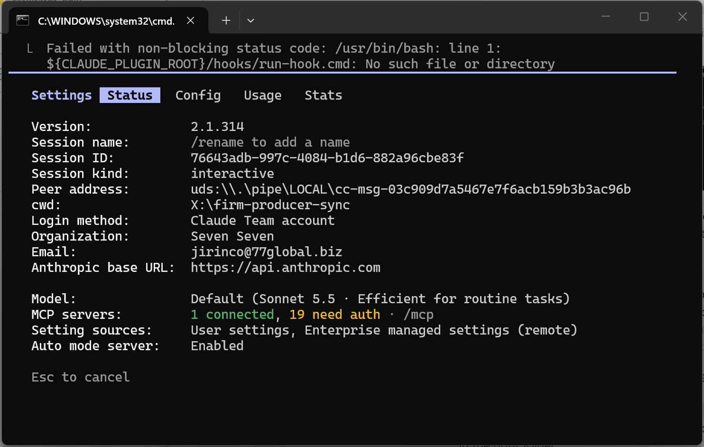

Step 2 P: Plan (plan mode, no code)
Switch to plan mode: type /plan, or press Shift+Tab until the status line shows plan mode. Then send the prompt below. A good plan prompt carries the five things the deck calls RTCIF: a role, the task, the context, the input, and the constraints.
PROMPT TO TYPE
Go to plan mode. You are a senior COBOL developer.
Task: plan INTAKE, a batch program that reads data/DAILY-A1.DAT and
splits it into out/VALID.DAT and out/REJECT.DAT.
Context: GnuCOBOL 3.2, fixed format (columns 8-72), LINE SEQUENTIAL
files. Record layout (60 bytes): [paste the layout table from this sheet].
Rule: a firm record with a blank firm ID is rejected.
Reject records are the original 60 bytes, a space, then an 8-character
reason: BLANK-ID.
Constraints: [add two of your own, for example: test FILE STATUS after
every OPEN, return code 12 if the input is missing].
No code yet. Give me a numbered plan.

Screenshot: Claude's plan.
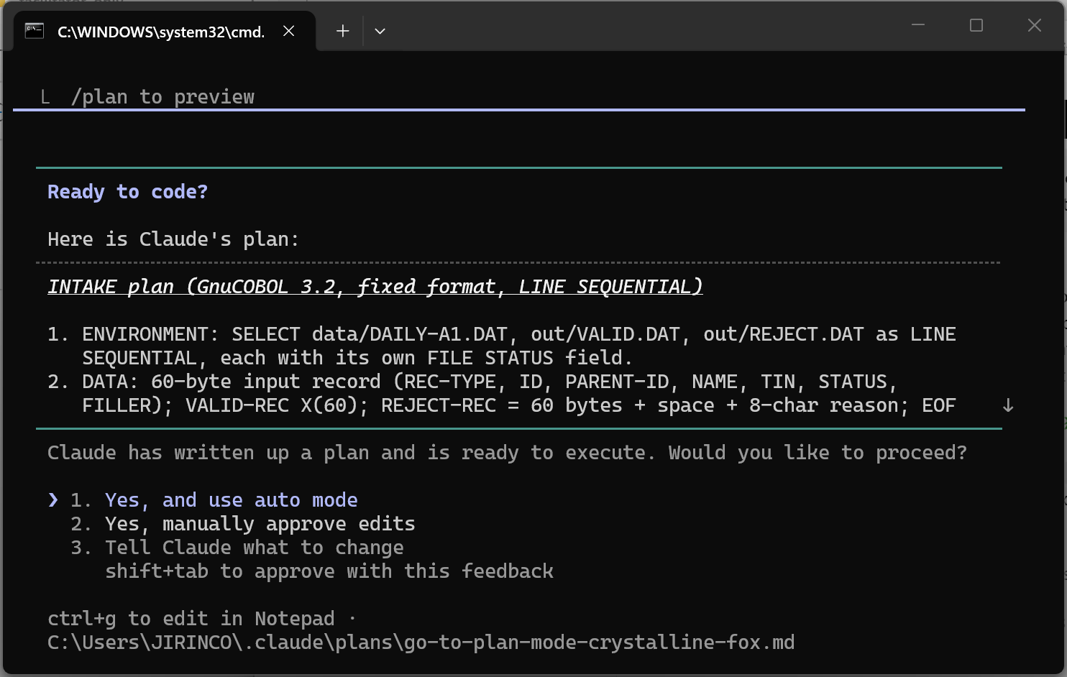
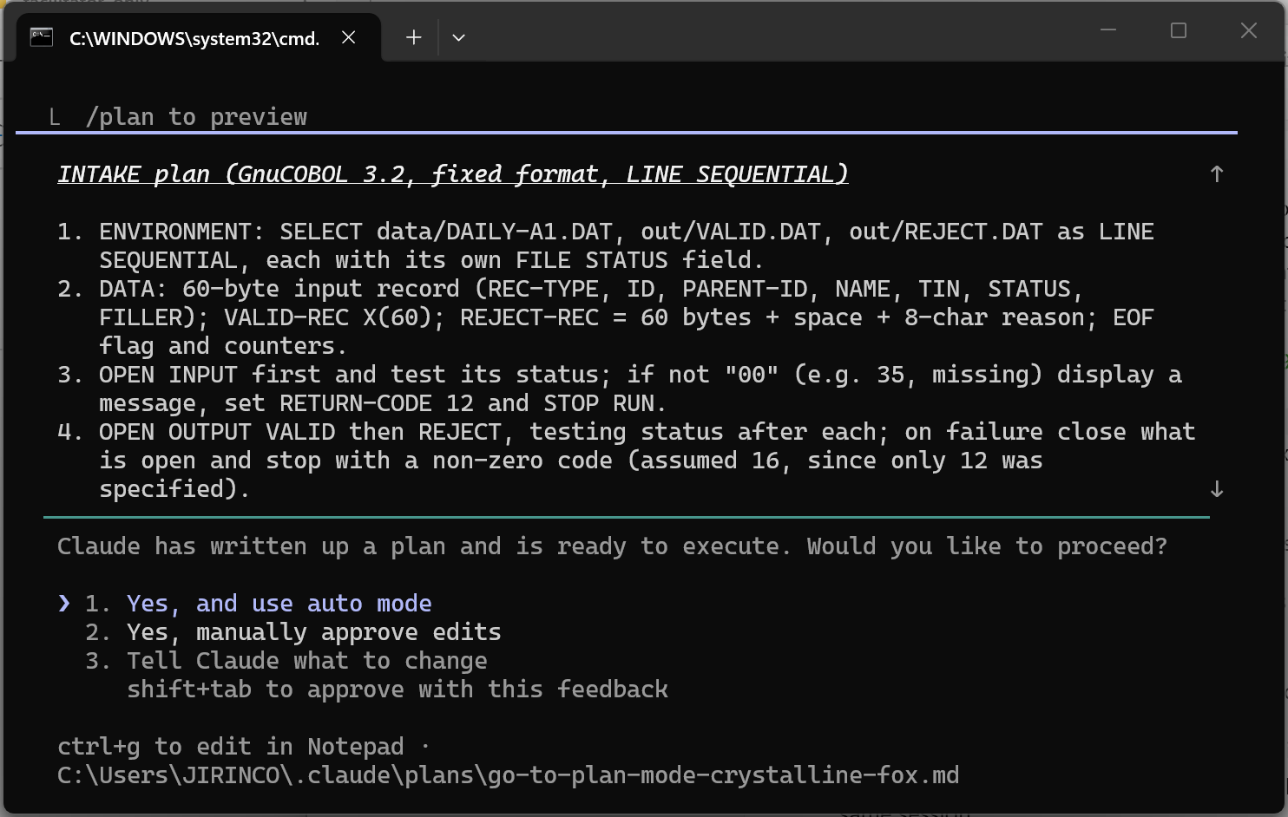
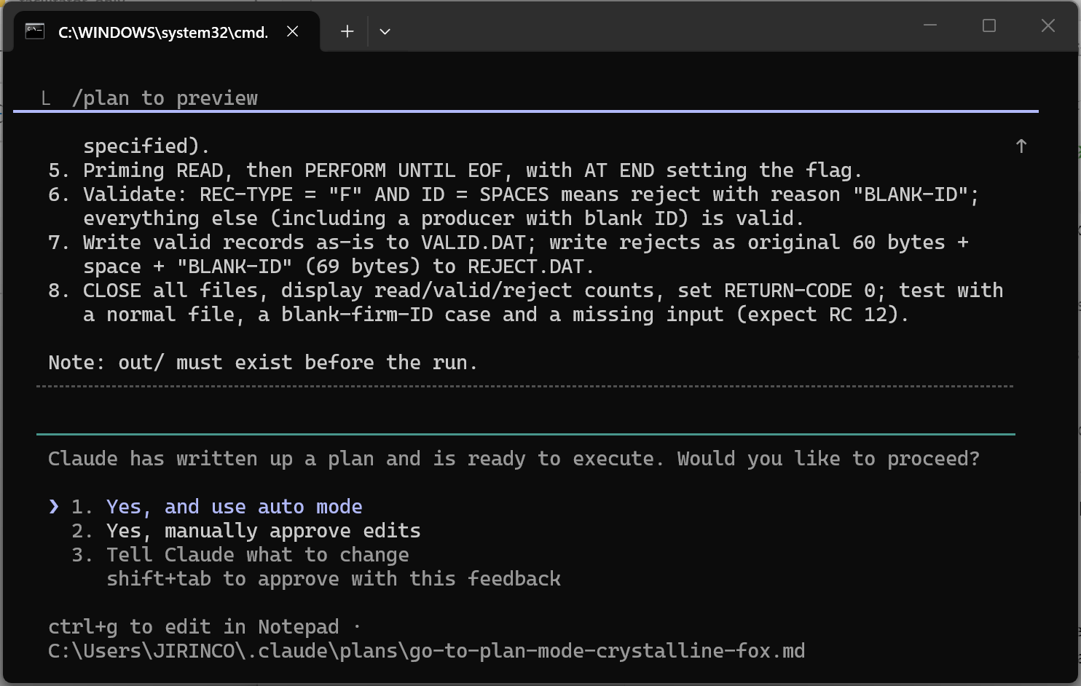

Step 3 A: Approve (read it, then correct it)
Do not accept the plan blindly. Read it against this checklist:
- Does it handle a firm ID of all spaces?
- Does it keep the record length at 60 bytes and write the reason in the right place?
- Does it use the file names and folders you gave it?
- Does it test FILE STATUS and set a return code?
- Did Claude write any code yet? It should not have.
Find at least one thing to correct or add, and send it as a prompt. If the plan is genuinely perfect, ask Claude what it assumed and check that. Then approve it in words, for example: Plan approved.
Screenshot: your correction prompt and Claude's updated plan.
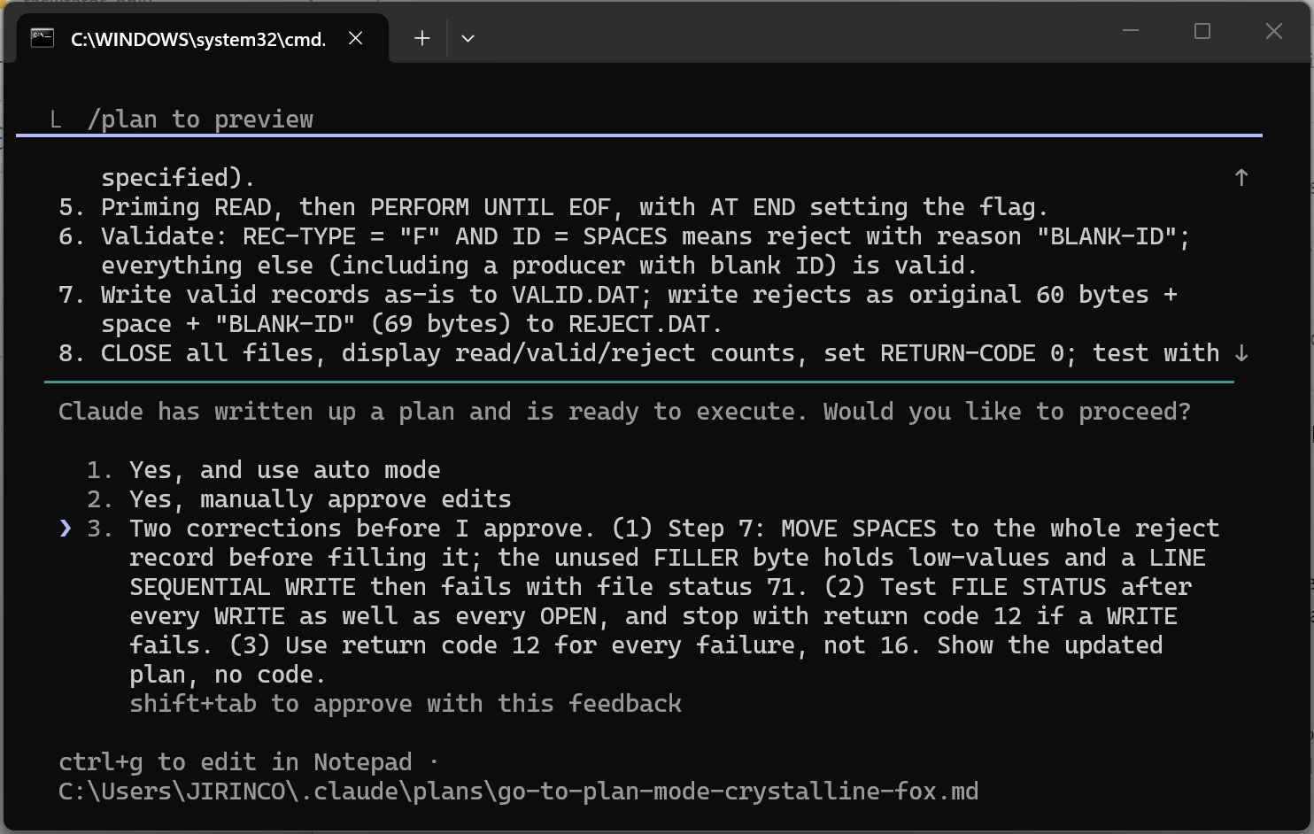
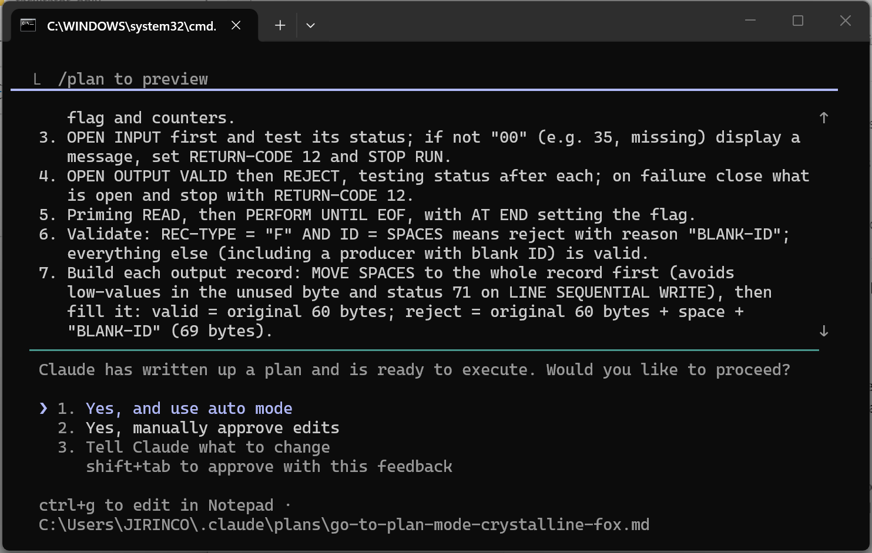
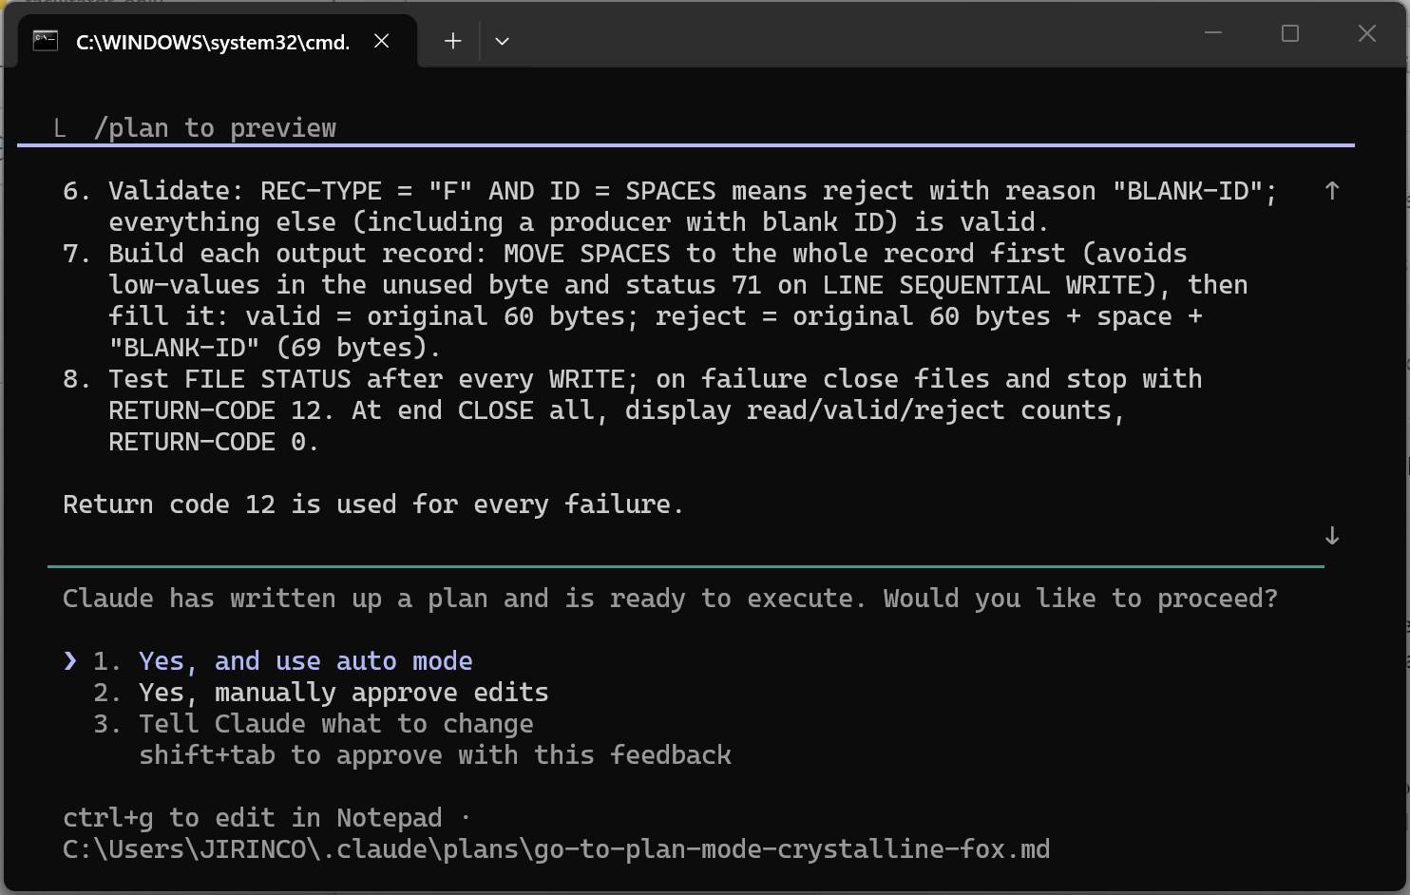
In one or two sentences, what did you change and why?
I made two corrections to the plan. (1) Any failure ends the run with RETURN-CODE 12; Claude's plan had assumed 16, which the sheet never asked for. (2) The reject record is built with MOVE SPACES to the whole record first, and FILE STATUS is tested after every WRITE, not only after OPEN.
Why it matters: the unused FILLER byte holds low-values, so a LINE SEQUENTIAL WRITE of a reject can fail with status 71 and leave REJECT.DAT empty while the counts still look right. Testing the status after each WRITE makes sure such a failure is seen.

Step 4 C: Code (one file only)
PROMPT TO TYPE
Plan approved. Write src/INTAKE.cbl only. Match the plan. Do not
create any other files yet.

Screenshot: Claude's changes. Type /diff, or open src/INTAKE.cbl in VS Code.
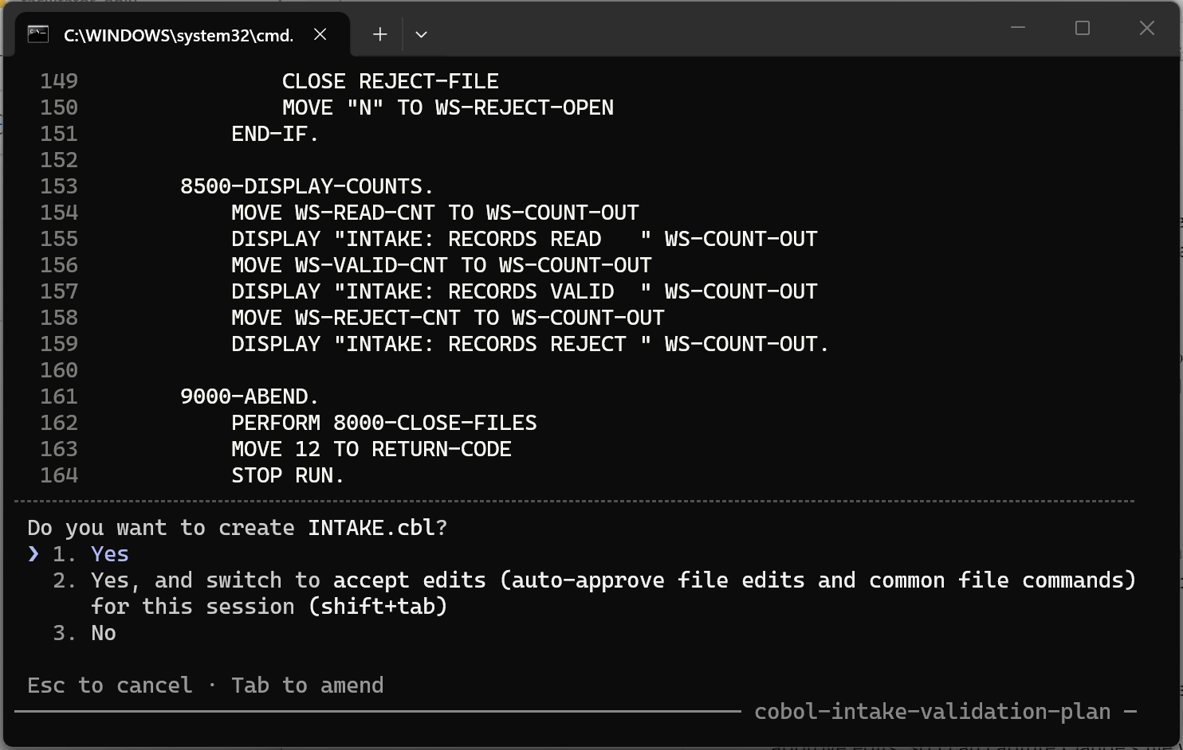
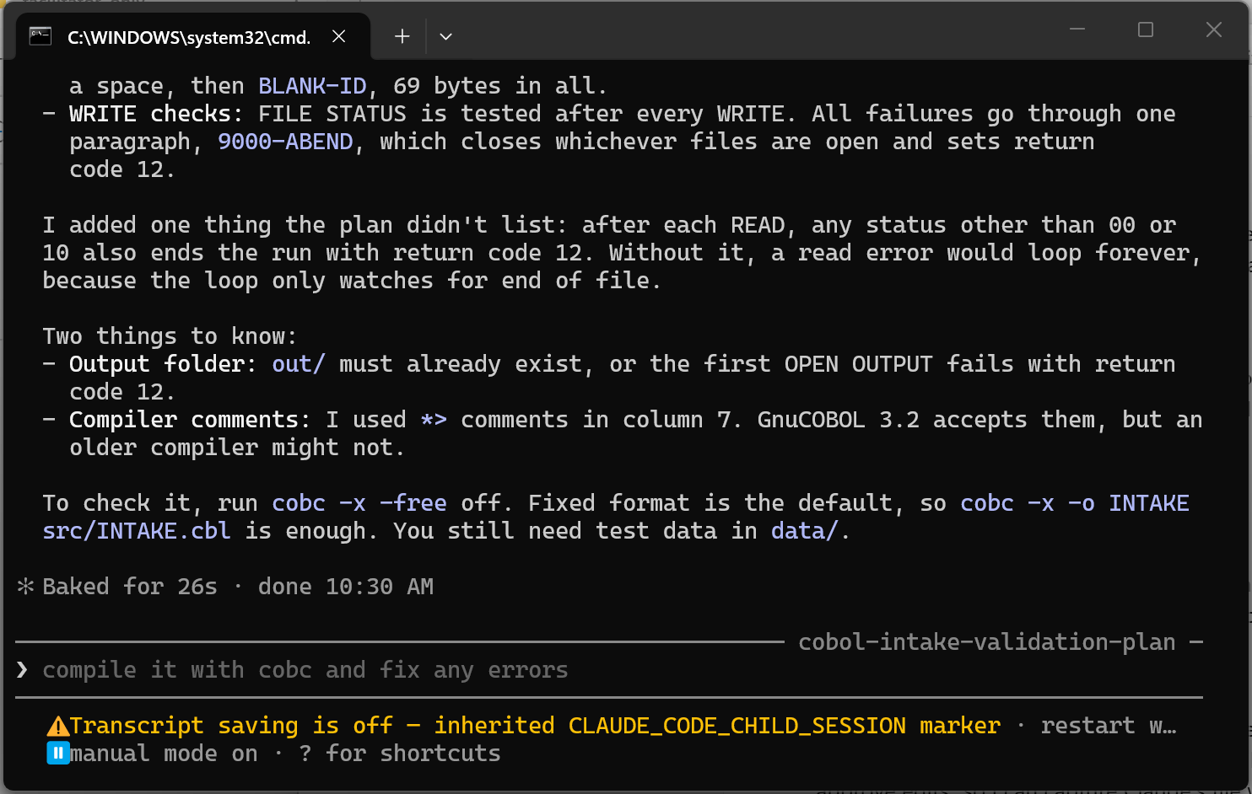
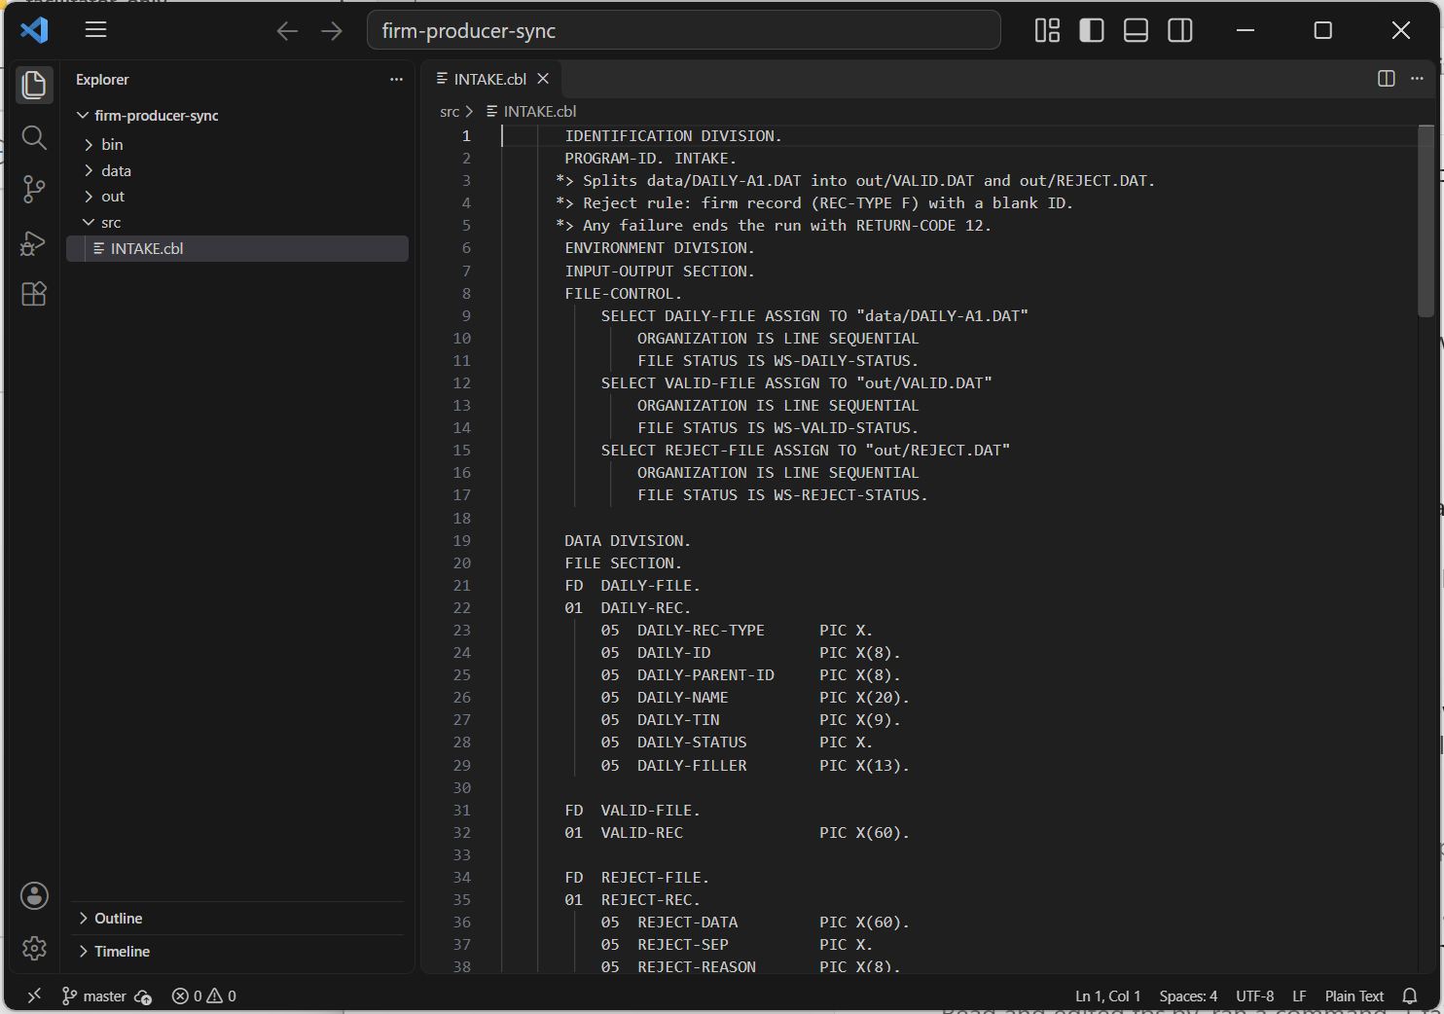
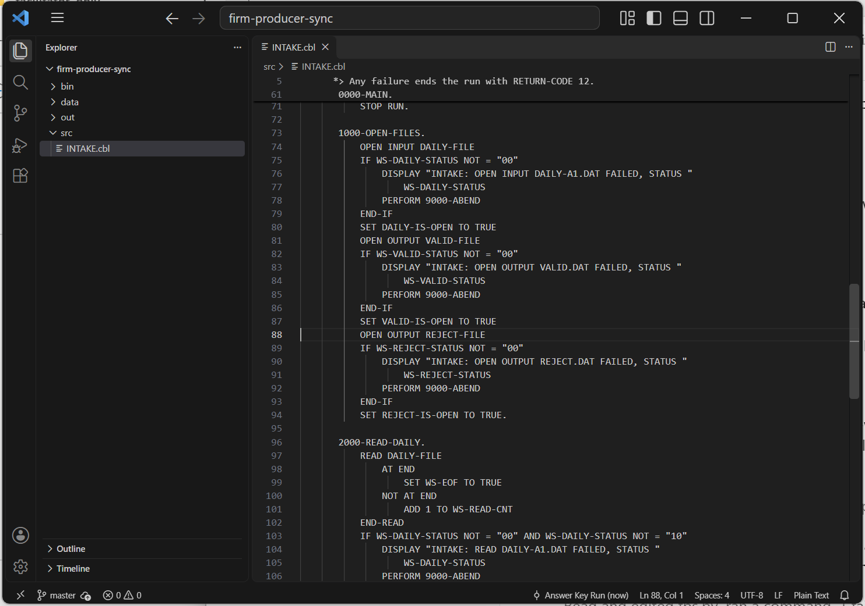
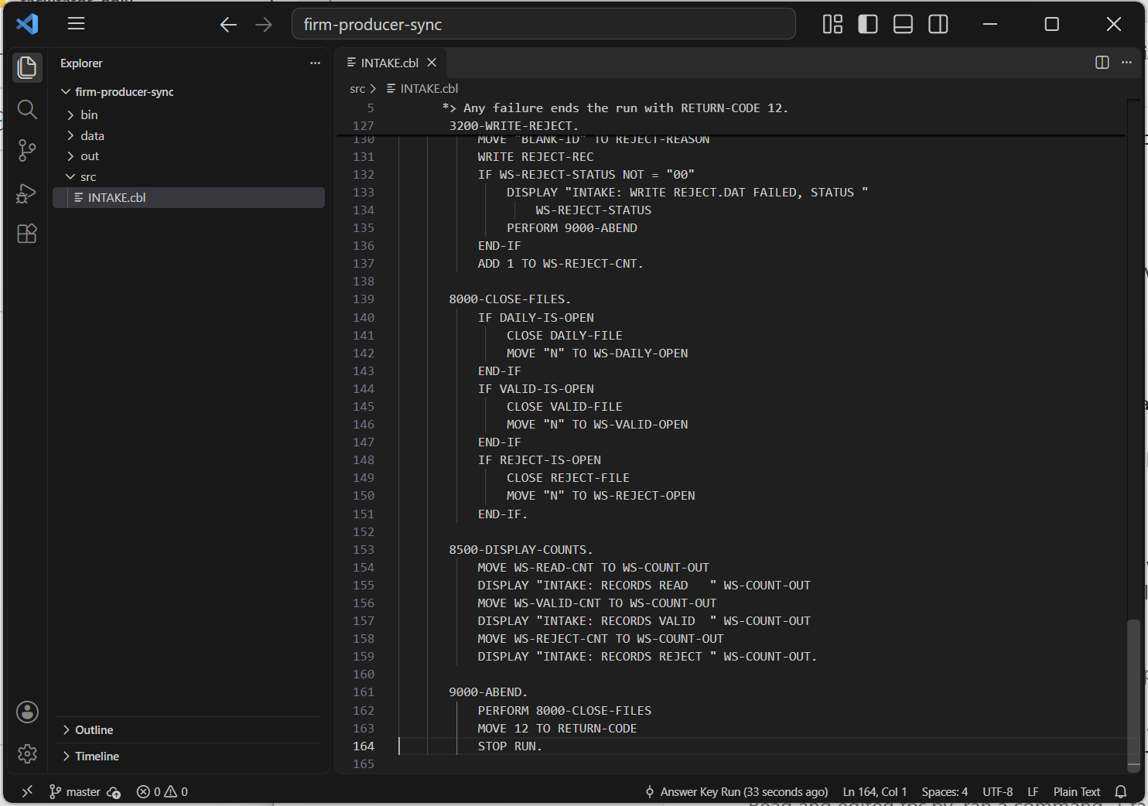

Step 5 T: Test (compile, run, check)
PROMPT TO TYPE
Compile with: cobc -x -o bin/INTAKE src/INTAKE.cbl
Then run it from the project root and show me: the return code, the
number of records in out/VALID.DAT and out/REJECT.DAT, and the full
contents of out/REJECT.DAT. If anything fails, fix it and re-run.

Expected result. 8 records read, 6 valid, 2 rejected. Both rejected records are the firms with a blank ID, and each ends with BLANK-ID. If your numbers differ, paste the error or the difference back to Claude and let it fix the program.
Screenshot: the run result and the contents of REJECT.DAT.
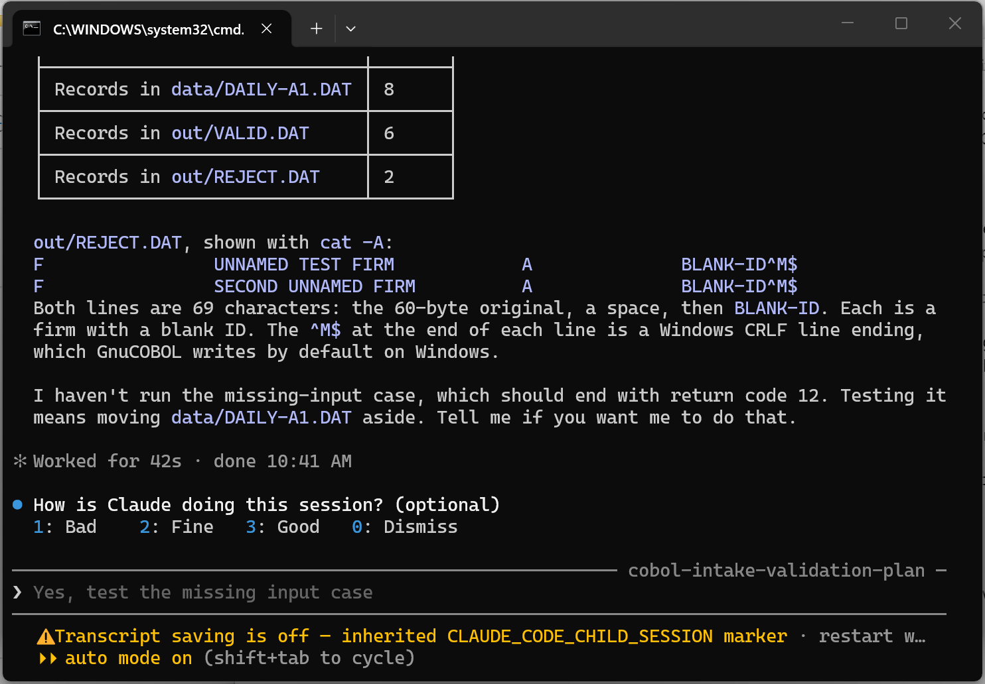
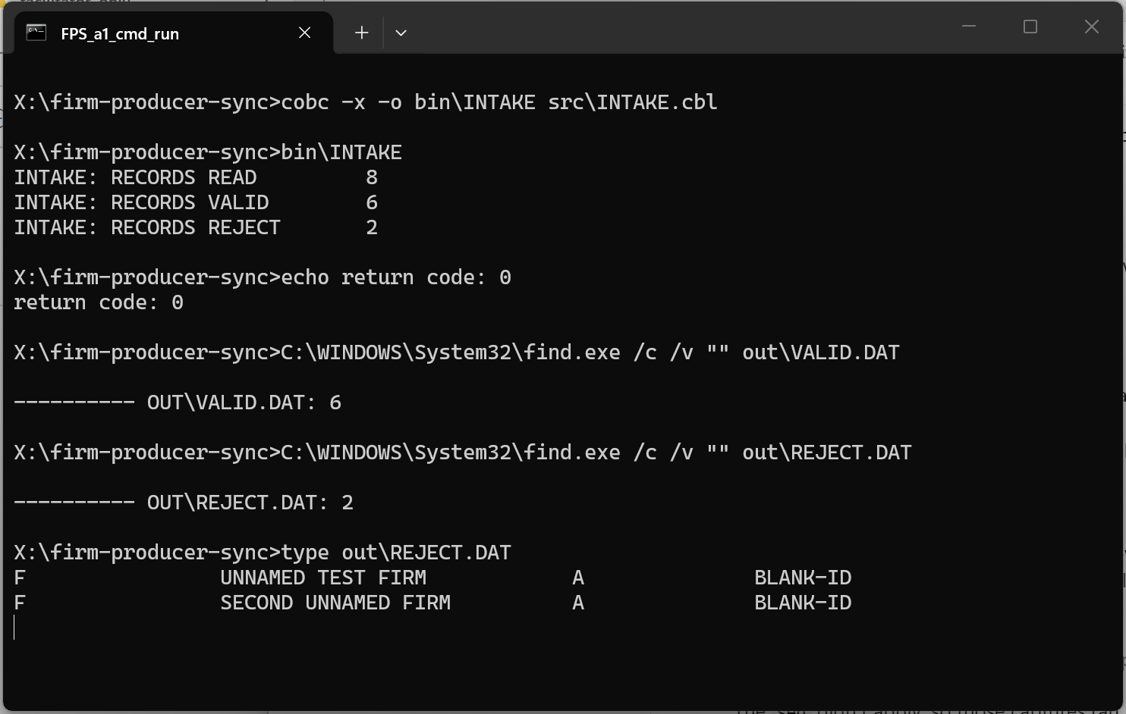

Step 6 Commit your work
Ask Claude to commit, or run these yourself in the terminal:
git add .
git commit -m "Activity 1: INTAKE reads firms, rejects blank firm IDs"
git log --oneline

Screenshot: the git log.
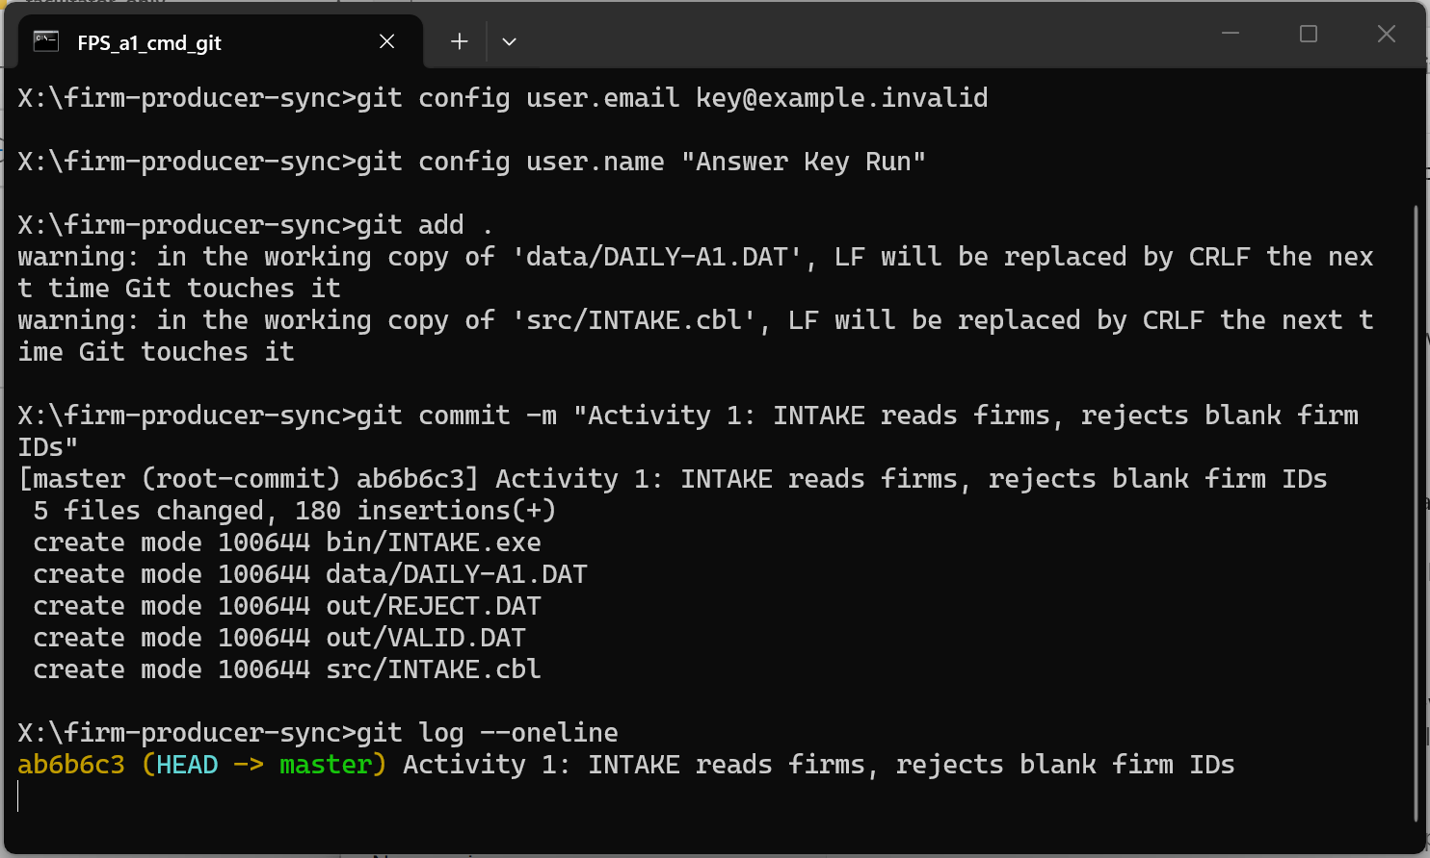

Reflection
1. What did Claude assume in its first plan that you had not told it? How did you find out?
Claude's first plan assumed return code 16 on failure (the sheet says 12), did not say how the 69-byte reject record is built (original 60 bytes, one space, BLANK-ID in columns 62-69), and did not test FILE STATUS after WRITE. I found all three by reading the plan against the Step 3 checklist.

2. What would have happened if you had skipped the Approve step?
Skipping Approve means a wrong or missing assumption goes straight into the code. Here it would have been the wrong return code and the status 71 problem: an empty or damaged REJECT.DAT with plausible counts, found only after the program was built and run. Approve is the cheapest place to catch it.

Keep this project. In Activity 2 you will grow this same INTAKE program.

