Activity 2: Prompt Chaining
Grow INTAKE with a chain of small, checked prompts
Name | Date | Start time | End time
Facilitator answer key | 2026-11-04 | 2026-11-04 | 2026-11-04

Goal
Grow your Activity 1 INTAKE program using prompt chaining: a sequence of small prompts where the output of each step is the input of the next, with a human checkpoint before any code is written. You will add producer records and three new features.
How this sheet works. Same as Activity 1: type the prompt (fill in the [brackets]), then paste a screenshot of the result into the grey box. Steps 1 and 2 must not produce any code. Time: about 60 minutes.

What you are adding
INTAKE now has to read a daily file that contains both firms and producers. Starting from your working Activity 1 program, add:
# | Feature | Rule
1 | Producer records | A record with REC-TYPE P is a producer. It uses the same 60-byte layout as a firm.
2 | TIN rule | A producer's TIN must be exactly 9 digits. Otherwise reject it with reason BAD-TIN.
3 | Firm-reference rule | A producer's PARENT-ID must be the ID of a valid firm earlier in the same file. Otherwise reject it with reason NO-FIRM. A firm that was itself rejected is not valid. Check the TIN rule first.
4 | Control counts | Write out/INTAKE.RPT with five lines: RECORDS READ, RECORDS VALID, RECORDS REJECTED, FIRMS VALID, PRODUCERS VALID.

The new input is data/DAILY-A2.DAT: 11 records using the same layout as Activity 1 (reminder below). Copy it into your data folder. All names, IDs and TINs are fictional.
Columns | Field | Meaning
1 | REC-TYPE | F = firm, P = producer
2-9 | ID | Firm ID or producer ID, 8 characters
10-17 | PARENT-ID | On a producer: the ID of its firm. Blank on a firm
18-37 | NAME | Name, 20 characters
38-46 | TIN | Taxpayer ID, 9 characters. Blank on a firm
47 | STATUS | A = active, I = inactive
48-60 | FILLER | Spaces. Each record is exactly 60 characters

Step 1 Understand (no code)
Open a fresh Claude Code session (/clear) in your firm-producer-sync folder. Ask Claude to explain the program you built last time.
PROMPT TO TYPE
Read src/INTAKE.cbl. Summarise in bullet points: the files it uses,
the record layout, how it decides a firm is valid, and what it writes
to each output file. No code changes in this step.

Screenshot: Claude's summary.
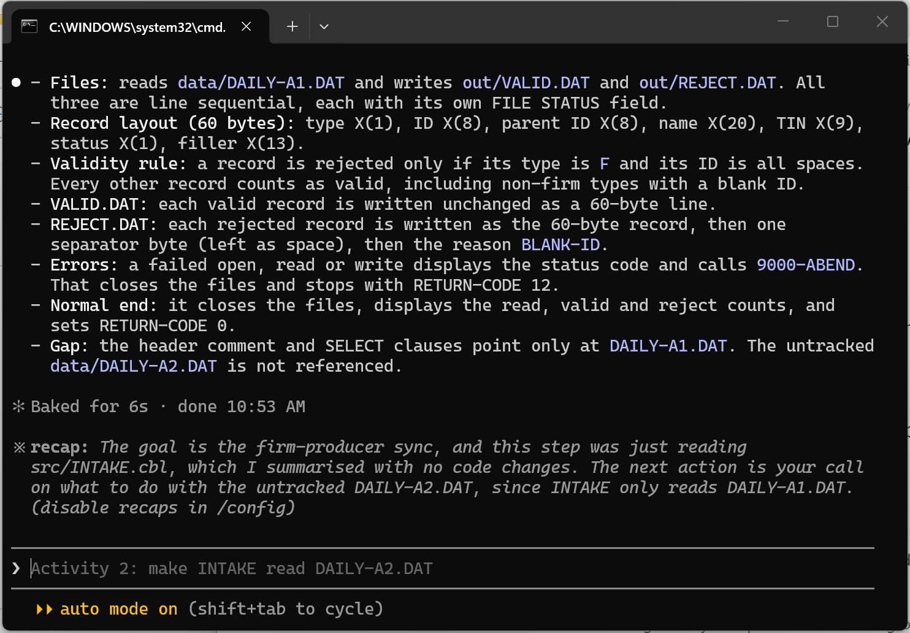

Step 2 Map the changes (no code)
Pass the summary into the next prompt. This is the chain: the output of Step 1 is the input of Step 2.
PROMPT TO TYPE
Using your summary of INTAKE, I want to add: producer records (type P),
a TIN rule (9 digits, else BAD-TIN), a firm-reference rule (parent must
be a valid earlier firm, else NO-FIRM) and control counts in
out/INTAKE.RPT. List each paragraph or file that must change or be
added, one line each. [Add any question you want answered.] No code.

Screenshot: the list of changes.
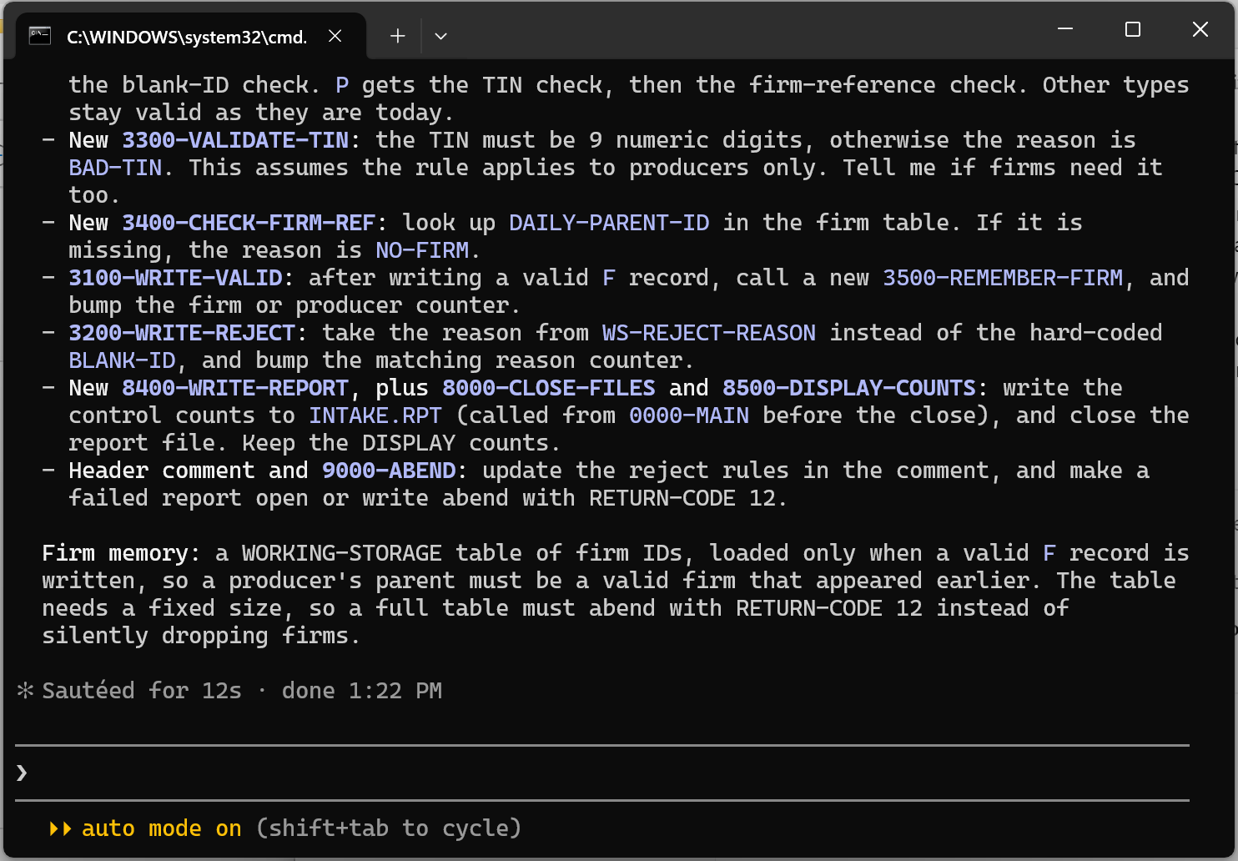

Step 3 Write the plan, then STOP and approve
PROMPT TO TYPE
For each change in your list, write a step-by-step plan. Order them
smallest first. Do not write any code. Stop and wait for my approval.

Read the plan. Check it against the rules in the table above, especially: what counts as a valid firm, and which rule is checked first. Correct anything that is wrong or missing, then approve it in words.
Screenshot: the plan, and your correction or approval.
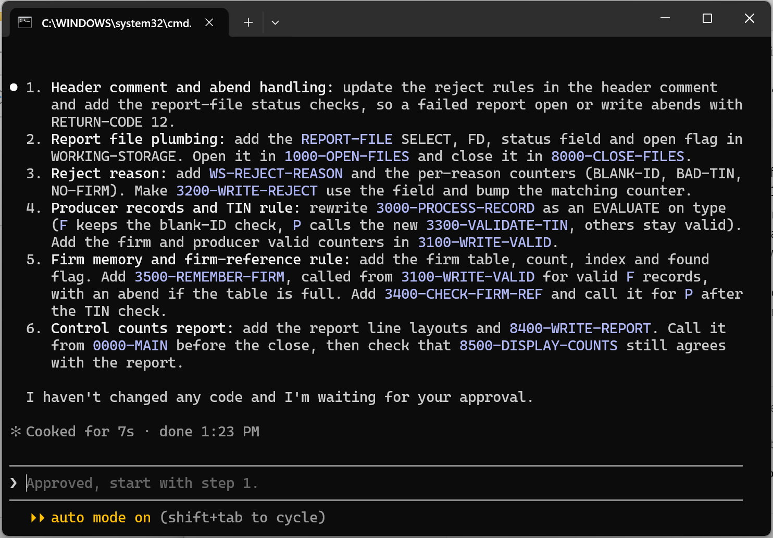
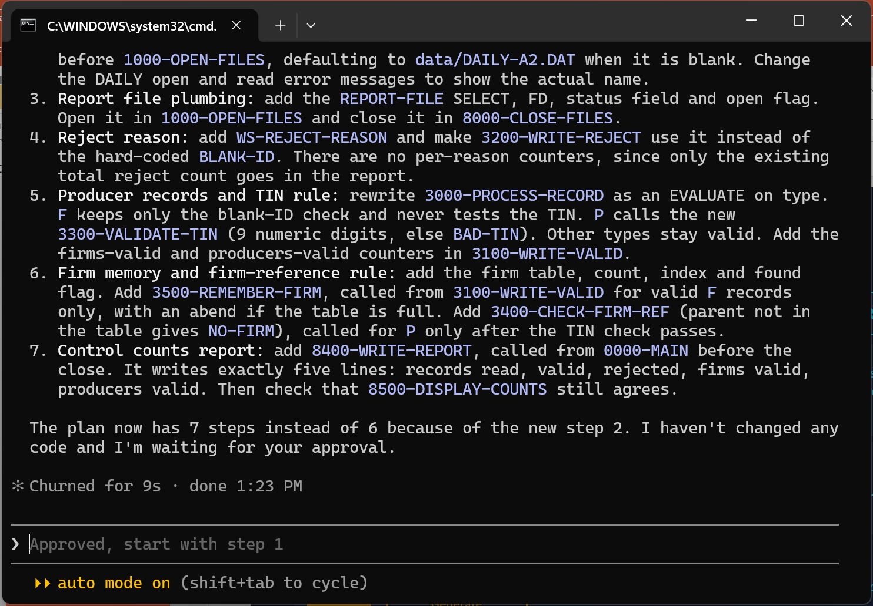
What did you correct, and why?
I corrected four things. (1) The TIN rule applies to producers only: a firm's TIN is blank, so it is never tested on F records. (2) INTAKE.RPT has exactly five lines (read, valid, rejected, firms valid, producers valid); Claude's first plan added per-reason counters, which must stay out of the report. (3) Only valid firms go into the firm table, and for a producer the TIN is checked first, then the firm reference. (4) The input file name comes from the command line, default data/DAILY-A2.DAT, so the program can also be run on DAILY-A1.DAT; this became a new step 2 and the plan went from 6 to 7 steps.

Step 4 Implement one change at a time
Send one prompt per change. Compile and run after each one, and paste the evidence. Use this pattern, with the change swapped in:
PROMPT TO TYPE
The plan is approved. Implement change [number and name] only. Do not
touch anything else. Compile with cobc -x -o bin/INTAKE src/INTAKE.cbl,
run it on data/DAILY-A2.DAT, and show me [what to look at].

4a. Producers and the TIN rule. Look at: out/REJECT.DAT. You should see two BAD-TIN records.
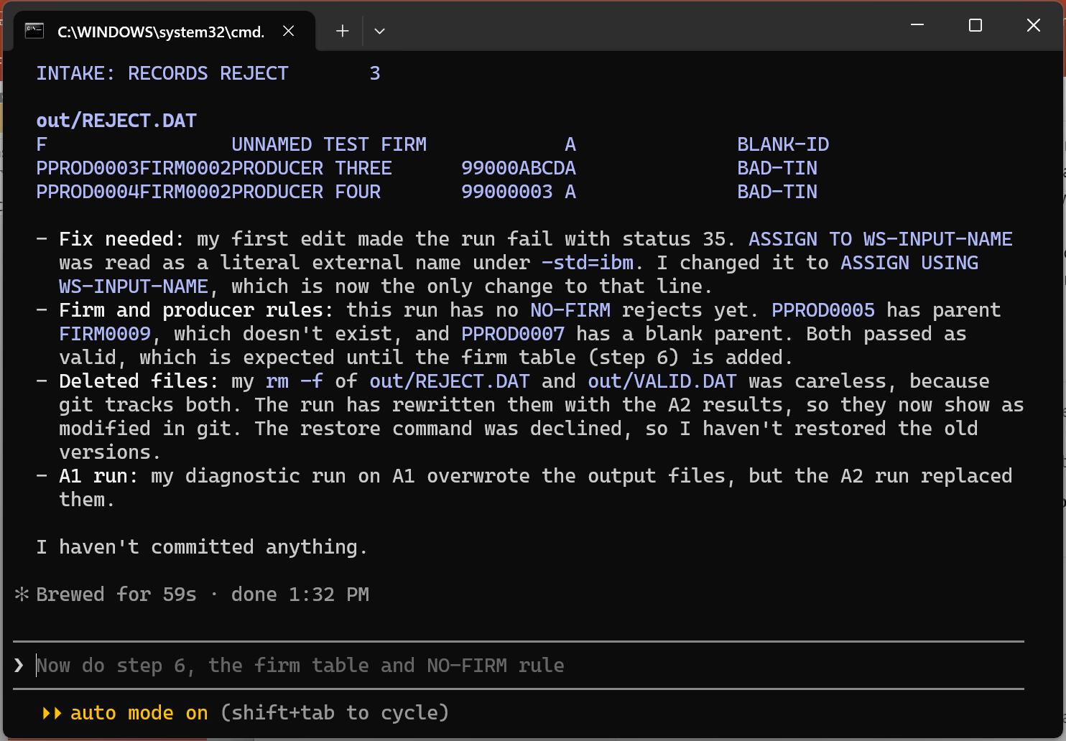

4b. The firm-reference rule. Look at: out/REJECT.DAT. You should now also see NO-FIRM records.
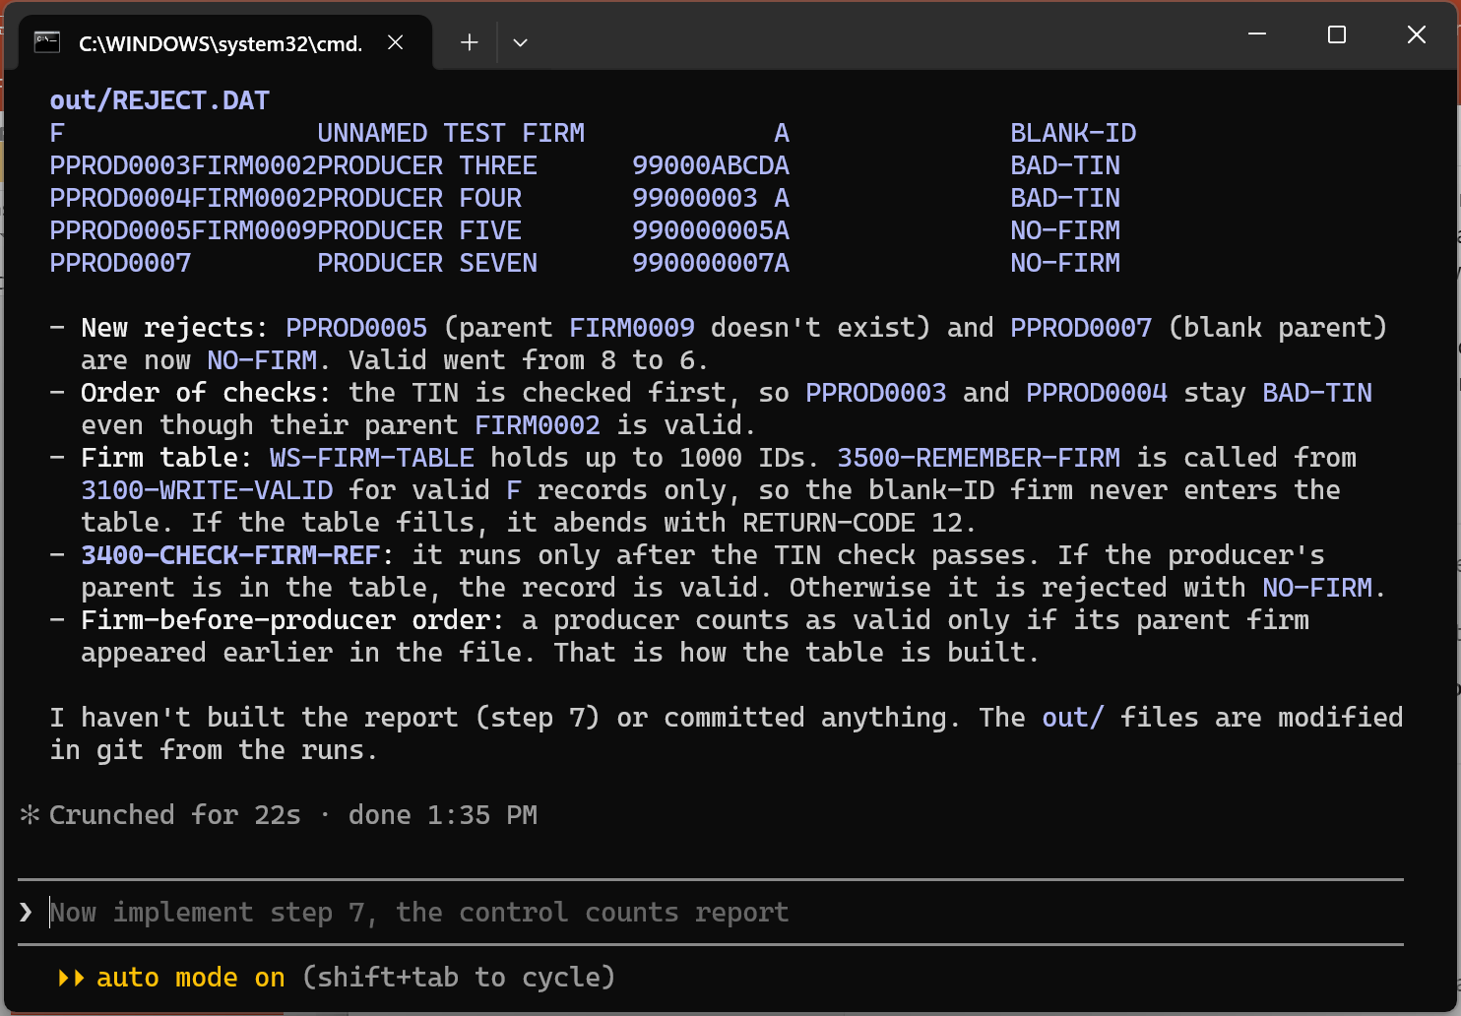

4c. Control counts. Look at: out/INTAKE.RPT.
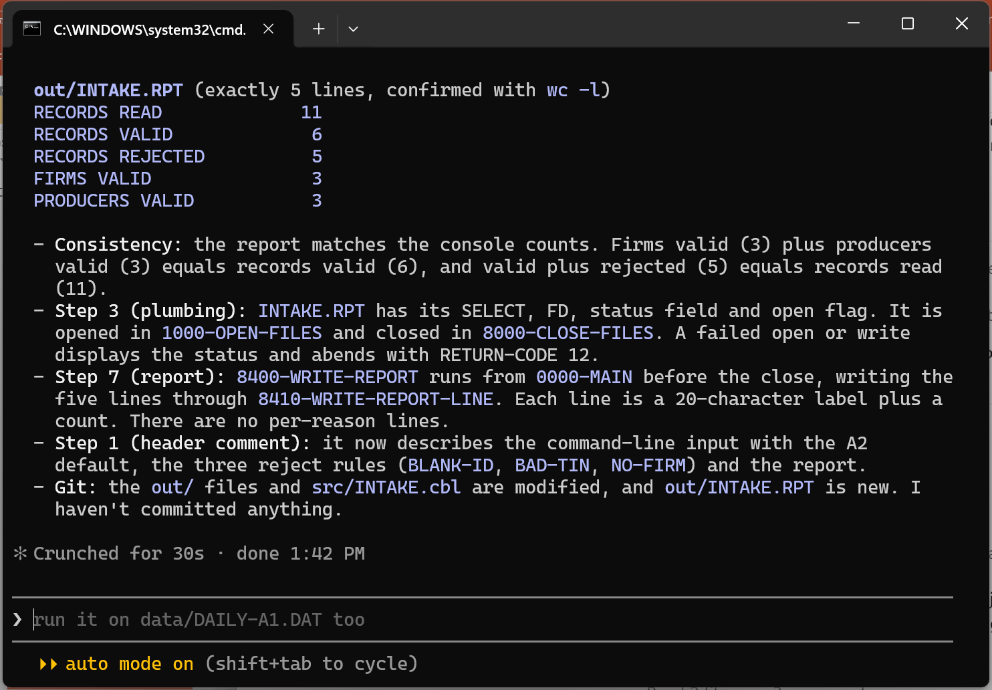

Step 5 Final check
Run the finished program on data/DAILY-A2.DAT and compare with the expected results:
Check | Expected
INTAKE.RPT | RECORDS READ 11, RECORDS VALID 6, RECORDS REJECTED 5, FIRMS VALID 3, PRODUCERS VALID 3
Records in VALID.DAT | 6
Records in REJECT.DAT | 5: one BLANK-ID, two BAD-TIN, two NO-FIRM
Read = valid + rejected | 11 = 6 + 5

If anything differs, give Claude the difference and let it find the cause. Then also run the program on data/DAILY-A1.DAT. It should still give the Activity 1 result: 8 read, 6 valid, 2 rejected.
Screenshot: the final INTAKE.RPT and the count of records in each output file.
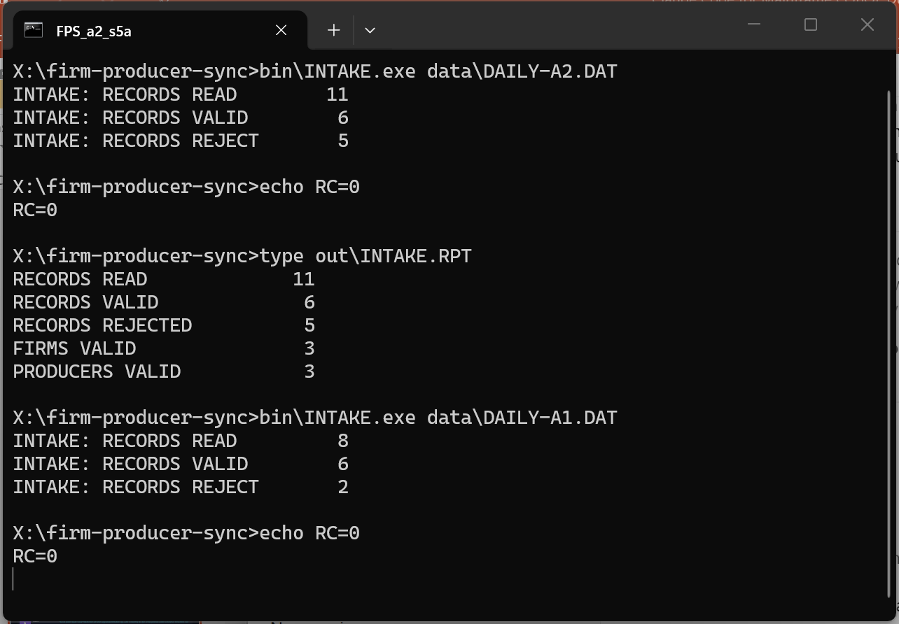
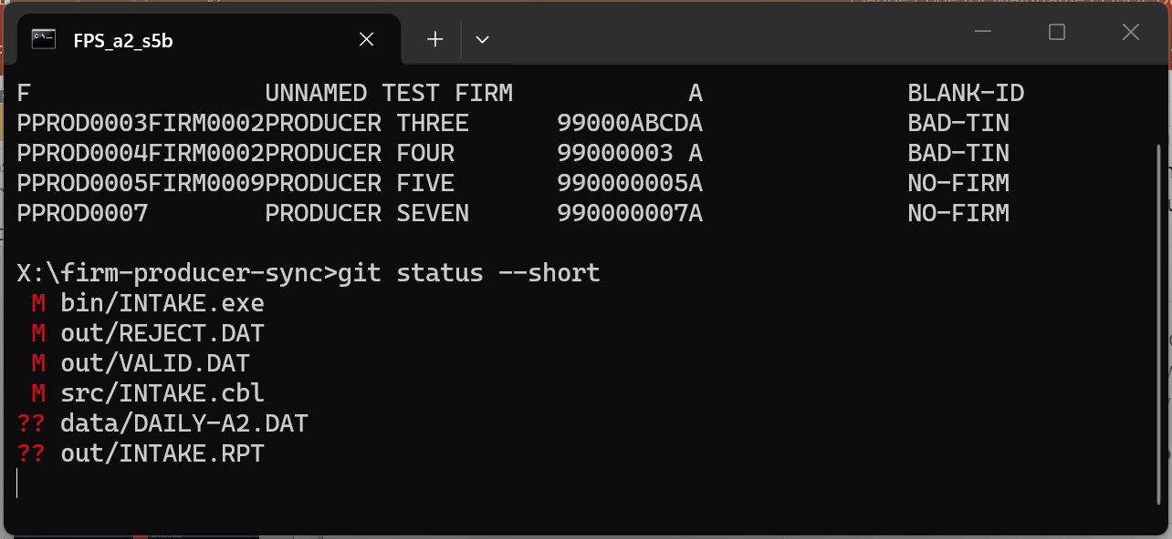

Step 6 Commit your work
git add .
git commit -m "Activity 2: producers, TIN rule, firm reference, control counts"
git log --oneline

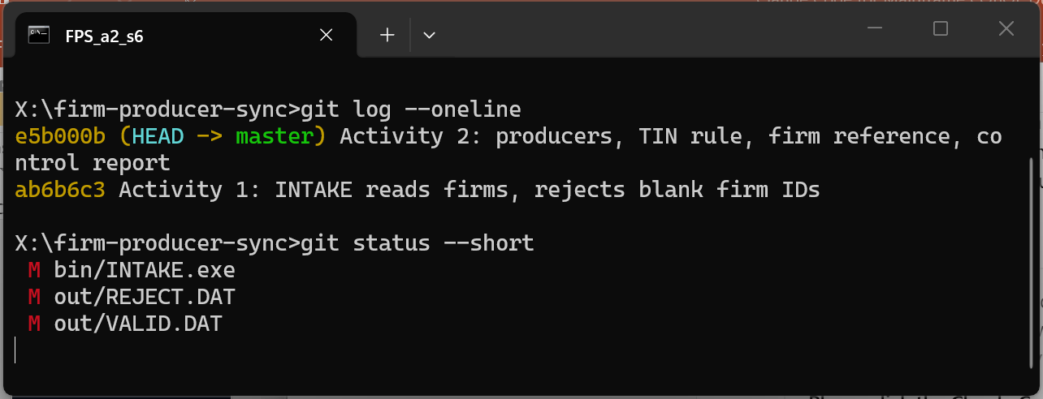

Reflection
1. Where did the human checkpoint in Step 3 catch something Claude had wrong or missed?
The Step 3 checkpoint caught that the first plan had no input file name rule (the program would keep reading DAILY-A1.DAT), padded the report with per-reason counters, and left the rule order open. Without the correction the final counts would not have matched 11 read / 6 valid / 5 rejected / 3 firms / 3 producers.

2. Why is one small prompt per change better than asking for all four features at once?
Each change can be tested on its own: after 4a there were 3 rejects (1 BLANK-ID, 2 BAD-TIN), after 4b 5 rejects (2 NO-FIRM added), after 4c the five-line report. When a count is wrong, I know which change caused it. The diff stays small, a wrong assumption is caught before it spreads, and the context stays short. Name each change in words (for example "the firm memory and firm-reference rule, step 6") so Claude does not guess which change is meant. Real catches during 4a: ASSIGN TO with a data name was read as a literal under -std=ibm (status 35) and had to become ASSIGN USING; Claude also deleted the tracked out/ files with rm -f, which is why every change is committed and checked in git.

Next: your facilitator reveals the capstone. You will write a spec for all of Firm-Producer Sync and use what you practised here to build it.

