FACILITATOR ANSWER KEY — DO NOT DISTRIBUTE TO TRAINEES

Activity 1 · Answer Key — Plan Mode & PACT
Name | Wave No. | Date

Scenario:
Firm-Producer Sync is a small, fictional daily batch for broker-dealer firms and their producers. You are building INTAKE, its first program: it reads data/DAILY-A1.DAT, checks every record, and writes the good records to out/VALID.DAT and the rejected records to out/REJECT.DAT.
In this activity INTAKE only handles firms and has one rule: a firm record with a blank firm ID is rejected. You will not type any COBOL yourself. Your job is to give Claude the right context, check its plan, and prove the result.

How this sheet works. Each step gives you a prompt to copy into Claude Code. Fill in the highlighted [brackets] with your own details, run it, then paste a screenshot of the result into the box below it. Your facilitator will read the finished sheet. Time: about 60 minutes.

FACILITATOR NOTE
Tested 5 Nov 2026. The reference INTAKE (facilitator-only\firm-producer-sync-key) was compiled and run on DAILY-A1.DAT: 8 read, 6 valid, 2 rejected, return code 0. REJECT.DAT and INTAKE.RPT are byte-identical to the files in evidence\ (ignoring Windows line endings). Missing input gives FILE STATUS 35 and return code 12; an empty file gives 0 / 0 / 0 and return code 0.
Screenshots in this key. Black Windows cmd and VS Code images are from the facilitator's own Claude Code run on the training PC. Images titled "Test evidence · reproduced by Claude" are real runs of the same reference code, repeated on GnuCOBOL 3.1.2 to check the expected results; they are not trainee screens.
Normal, not a bug: GnuCOBOL drops trailing spaces when it writes LINE SEQUENTIAL files, so VALID.DAT lines look 47 characters long in an editor and BAD-TIN rejects look 68. The program still works with 60-byte records.

REFERENCE — The Input File
data/DAILY-A1.DAT has 8 records, one per line. You will reuse the same layout in Activity 2. All names are fictional.
Columns | Field | Meaning
1 | REC-TYPE | F = firm, P = producer
2-9 | ID | Firm ID or producer ID, 8 characters
10-17 | PARENT-ID | On a producer: the ID of its firm. Blank on a firm
18-37 | NAME | Name, 20 characters
38-46 | TIN | Taxpayer ID, 9 characters. Blank on a firm
47 | STATUS | A = active, I = inactive
48-60 | FILLER | Spaces. Each record is exactly 60 characters

0. Set Up Your Project
Create the project, copy the test data, and start Claude Code.
- Create a project folder named firm-producer-sync. Open it in VS Code, then open the terminal (Ctrl+`).
- In the terminal, create the four folders and copy both test data files. Replace <package> with the folder your facilitator gave you (it contains day0).

Run in the terminal:
New-Item -ItemType Directory -Force src, data, out, bin
Copy-Item "<package>\day0\data\*.DAT" data\
(Get-Content data\DAILY-A1.DAT).Count
git init
claude

Check: the Count command must print 8. If it prints an error or another number, stop and ask your facilitator. Do not ask Claude to create test data: the expected result in Step 4 only works with this exact file.

When Claude Code starts, type /status.
Screenshot — /status Output
Paste your /status screenshot below (model, account, connected)
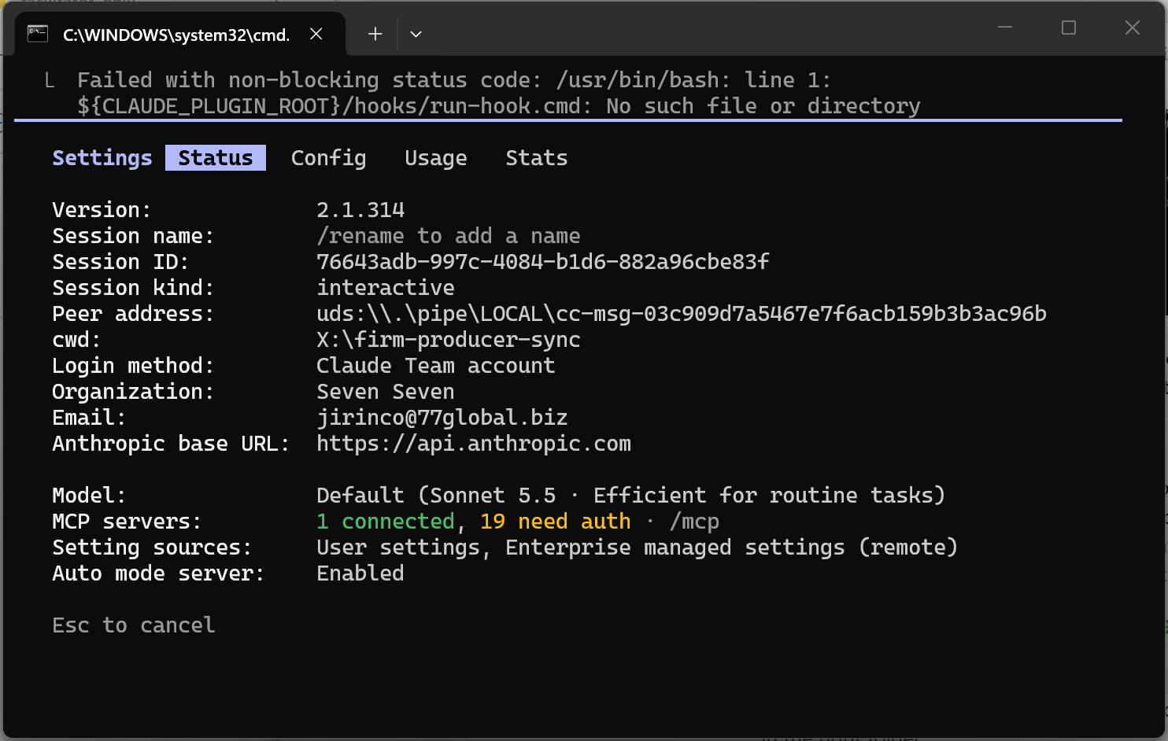

PART A — Structure Your Prompt Before You Plan
Claude cannot see this sheet. It only knows what you put in the prompt. Fill in each section below first, then carry your answers into the /plan prompt in Part B.
This is the RTCIF structure from the deck: Role, Task, Context, Input and Constraints. Section A5 is the one most people skip, so don't skip it.

A1. Task Definition
Write a clear action verb, define scope (what's in and what's out), explain why INTAKE is needed, and confirm this is a single coherent task. Out of scope today: producers, TIN checks, reports.
Your Task Definition:
FACILITATOR ANSWER
Plan INTAKE, a GnuCOBOL batch program that reads data/DAILY-A1.DAT and splits it into out/VALID.DAT and out/REJECT.DAT, so later stages only ever see clean firm records.
In scope: firm records (REC-TYPE F) and the blank-ID rule. Out of scope: producers, the TIN rule, the control report. One program, one task.

A2. Technical Context
List your stack and version, the file names and folders, the file organisation, and the record layout Claude must follow.
Your Technical Context:
FACILITATOR ANSWER
GnuCOBOL 3.2, fixed format (columns 8-72), compiled with cobc -x -o bin/INTAKE src/INTAKE.cbl and run from the project root.
Files: input data/DAILY-A1.DAT, outputs out/VALID.DAT and out/REJECT.DAT, all ORGANIZATION LINE SEQUENTIAL, each with its own FILE STATUS field.
Record layout: the 60-byte table above (REC-TYPE, ID, PARENT-ID, NAME, TIN, STATUS, FILLER).

A3. Expected Output
Describe every file the program produces, the exact record format, and how a run reports success or failure.
Your Expected Output:
FACILITATOR ANSWER
out/VALID.DAT: each valid record, unchanged. out/REJECT.DAT: the original 60 bytes, one space, then the 8-character reason BLANK-ID in columns 62-69 (69 bytes).
Console: records read, valid and rejected. Return code 0 on success, 12 on any file error. For DAILY-A1.DAT: 8 read, 6 valid, 2 rejected.

A4. Constraints
List must-haves and must-NOT-haves. Add at least two of your own. Be explicit about what Claude should never do.
Your Constraints:
FACILITATOR ANSWER
Must: test FILE STATUS after every OPEN, READ and WRITE; any failure ends the run with return code 12 (not 16); MOVE SPACES to the whole reject record before filling it.
Must not: write code before the plan is approved; create any file other than src/INTAKE.cbl; create or change test data.

A5. Edge Cases & Errors
Define what happens with invalid input, empty or missing files, and boundary conditions. Think about: a firm ID of all spaces, an empty input file, a missing input file, a record shorter than 60 characters.
Your Edge Cases & Errors:
FACILITATOR ANSWER
Firm ID all spaces: reject with BLANK-ID. Missing input file: message with the FILE STATUS (35), return code 12, no further processing.
Empty input file: 0 read, 0 valid, 0 rejected, empty output files, return code 0. Short record: LINE SEQUENTIAL pads it with spaces, so it is checked like any other record.
Any REC-TYPE other than F: not in scope today; ask Claude to say what the plan does with it rather than guess.

PART B — The PACT Loop: Plan, Approve, Code, Test
Now use your Part A answers. Follow the four PACT steps below in order. No code is written until you approve the plan in Step 2.

1. Plan
What would you type in plan mode? (role + task + context + input + constraints)
First switch to plan mode. Type this command, or press Shift+Tab until the status line shows plan mode:
/plan

Use this /plan prompt:
You are a senior COBOL developer.
Task: plan INTAKE, a batch program that reads data/DAILY-A1.DAT and
splits it into out/VALID.DAT and out/REJECT.DAT.
Context: GnuCOBOL 3.2, fixed format (columns 8-72), LINE SEQUENTIAL
files. Record layout (60 bytes):
Column 1 REC-TYPE F = firm, P = producer
Columns 2-9 ID firm or producer ID, 8 characters
Columns 10-17 PARENT-ID producer: ID of its firm; blank on a firm
Columns 18-37 NAME 20 characters
Columns 38-46 TIN 9 characters; blank on a firm
Column 47 STATUS A = active, I = inactive
Columns 48-60 FILLER spaces; every record is 60 characters
Rule: a firm record with a blank firm ID is rejected.
Reject records are the original 60 bytes, a space, then an 8-character
reason: BLANK-ID.
Constraints: [paste your two or more constraints from A4]
Edge cases: [paste your edge cases from A5]
No code yet. Give me a numbered plan: at most 8 steps, one line each.

Notice: the record layout is already in the prompt because Claude cannot see this sheet. Asking for "at most 8 steps, one line each" is a format constraint: it keeps the plan short enough to actually review.

FACILITATOR NOTE
What a good plan shows: 6-8 numbered steps covering SELECT/FD for three files, open with status checks, a priming READ loop, the blank-ID test on F records, the 69-byte reject record, close and counts. Typical misses to point out: return code 16 instead of 12, no check after WRITE, no MOVE SPACES before building the reject record.

Screenshot — Plan Output
Paste your /plan mode screenshot below
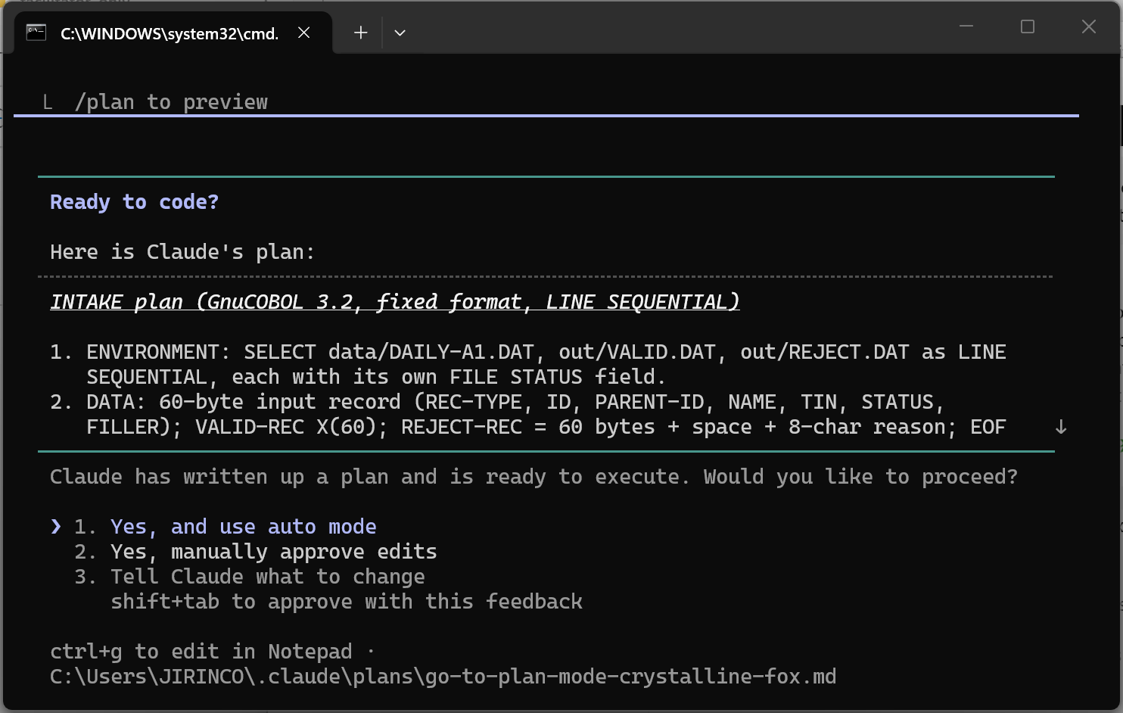
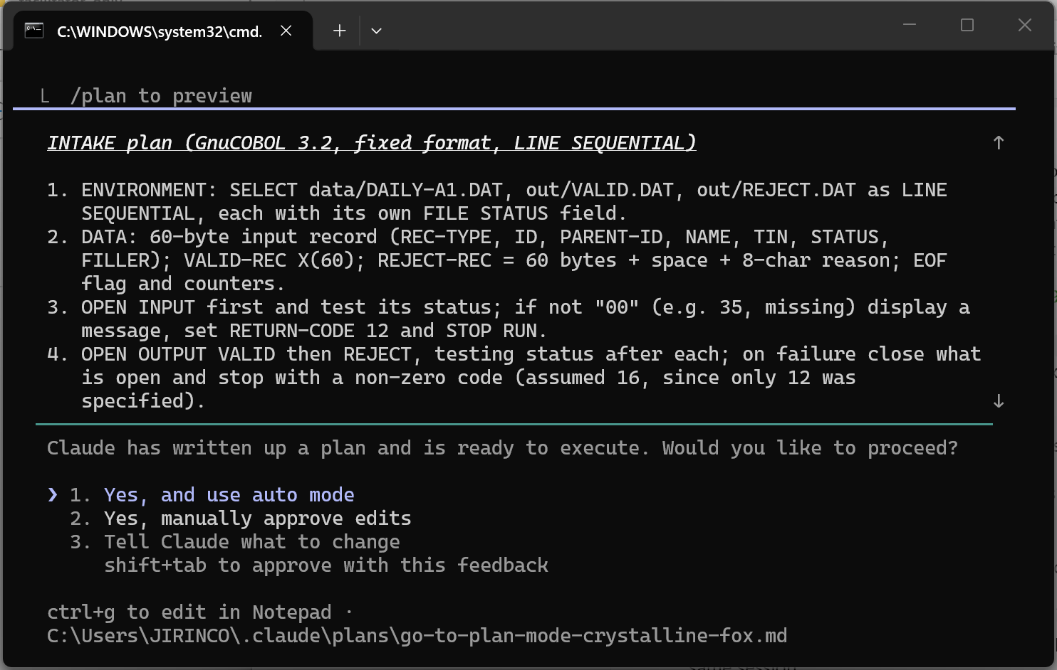
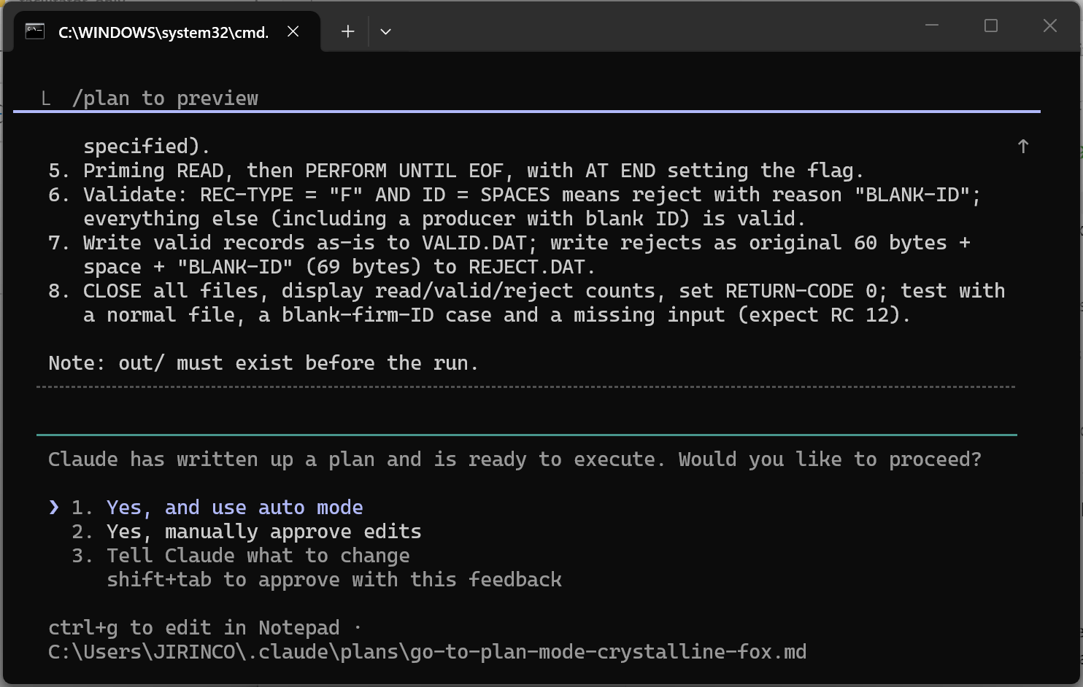

2. Approve
What would you check in the plan? (steps, assumptions, anything missing or wrong?) Do not accept the plan blindly. Read it against this checklist:
- Does it handle a firm ID of all spaces?
- Does it keep the record length at 60 bytes and write the reason in the right place?
- Does it clear the reject record (MOVE SPACES) before filling it, so no LOW-VALUES are written?
- Does it use the file names and folders you gave it?
- Does it test FILE STATUS and set a return code?
- Does it cover every edge case you listed in A5?
- Did Claude write any code yet? It should not have.

Find at least one thing to correct or add, and send it as a prompt. If the plan is genuinely perfect, ask Claude what it assumed and check that.
Your correction prompt:
Before I approve: [the thing you found missing or wrong, and how to fix it].
Show only the changed steps, one line each. Still no code.

When the plan is right, approve it in words, for example: Plan approved.
FACILITATOR NOTE
Correction prompt used in the facilitator run: Two corrections before I approve. (1) Step 6: MOVE SPACES to the whole reject record before filling it; the unused FILLER byte holds low-values and a LINE SEQUENTIAL WRITE then fails with file status 71. (2) Test FILE STATUS after every WRITE as well as every OPEN, and stop with return code 12 if a WRITE fails. Show only the changed steps, one line each, and no code.

What did you check or change before approving, and why?
FACILITATOR ANSWER
I made two corrections. (1) Any failure ends the run with RETURN-CODE 12; Claude's plan had assumed 16, which the sheet never asked for. (2) The reject record is built with MOVE SPACES to the whole record first, and FILE STATUS is tested after every WRITE, not only after OPEN.
Why it matters: the unused FILLER byte holds low-values, so a LINE SEQUENTIAL WRITE of a reject can fail with status 71 and leave REJECT.DAT empty while the counts still look right. Testing the status after each WRITE makes sure such a failure is seen.

Screenshot — Approve Output
Paste your correction prompt and Claude's updated plan below
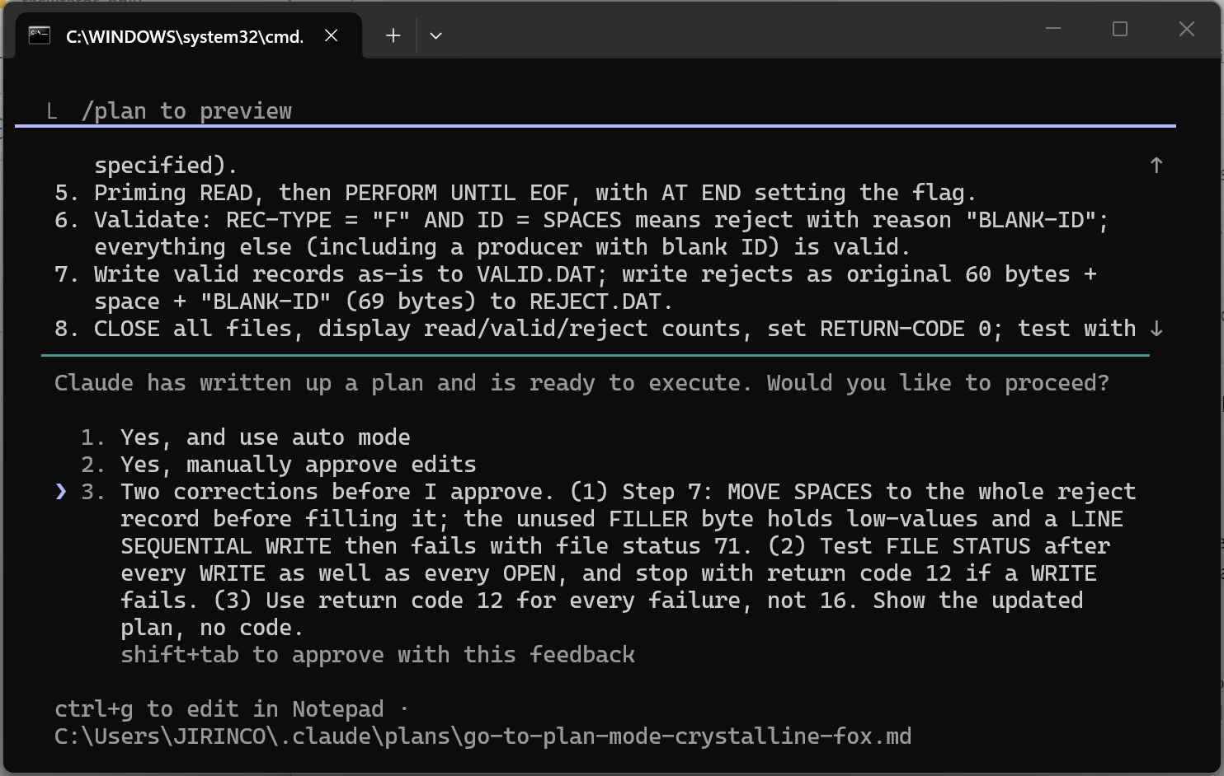
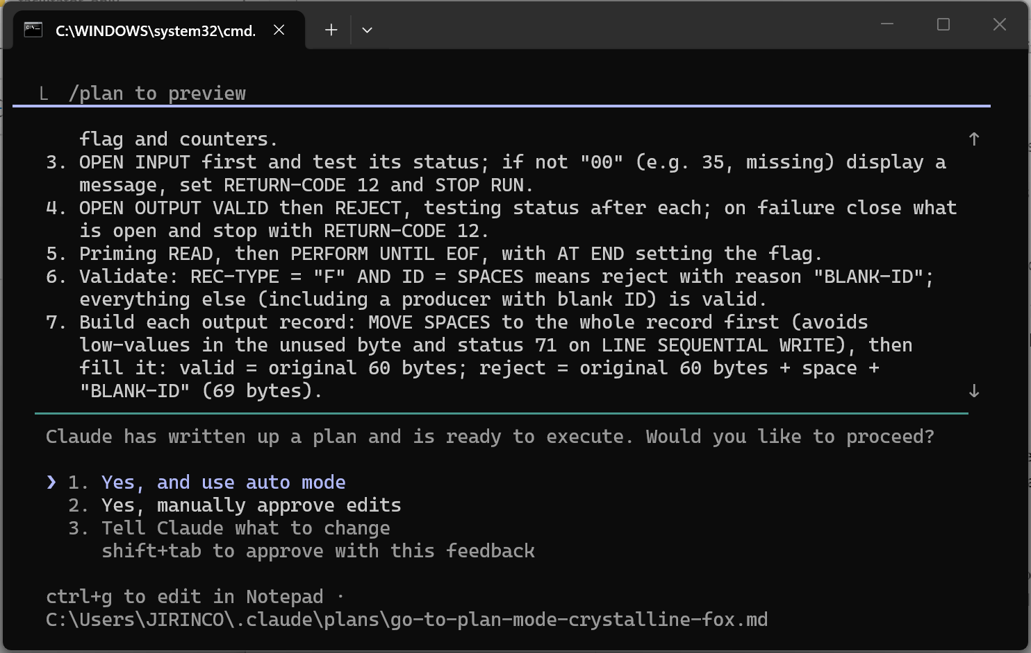
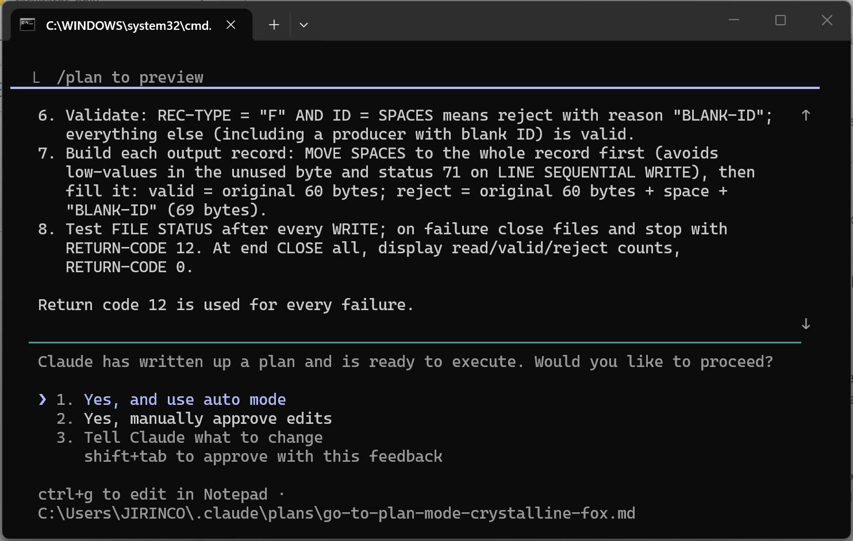

3. Code
Ask for one file only, matching the approved plan.
Your Step 3 prompt:
Plan approved. Write src/INTAKE.cbl only. Match the plan. Do not
create any other files yet.

Review what Claude wrote: type /diff, or open src/INTAKE.cbl in VS Code.
Screenshot — Code Output
Paste your new INTAKE.cbl (or the /diff) screenshot below
Claude asks before creating src/INTAKE.cbl: approve with 1 (Yes).
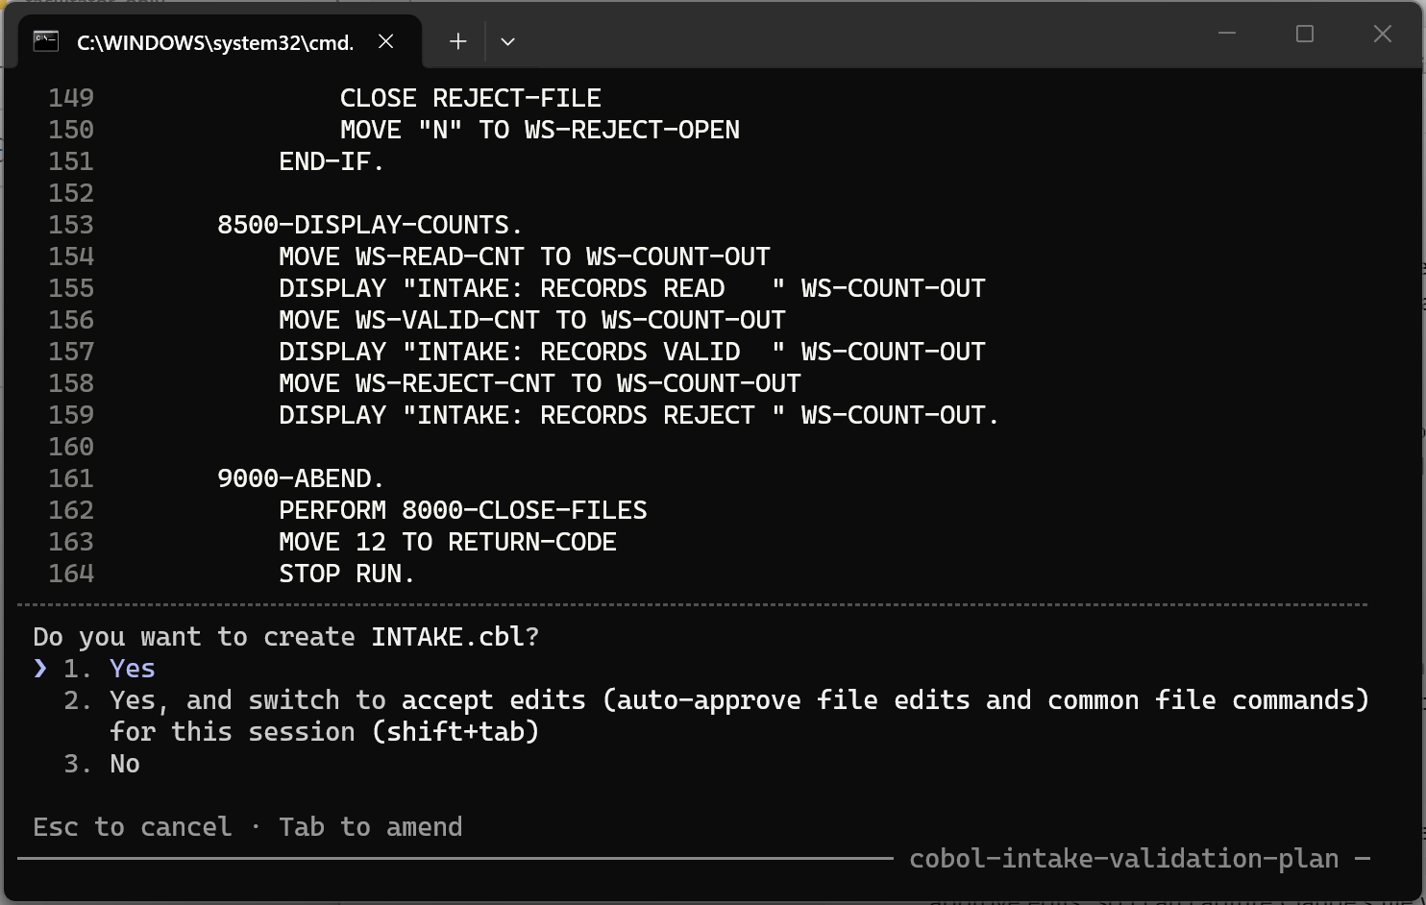
Claude's summary of what it wrote, including the extra READ status check.
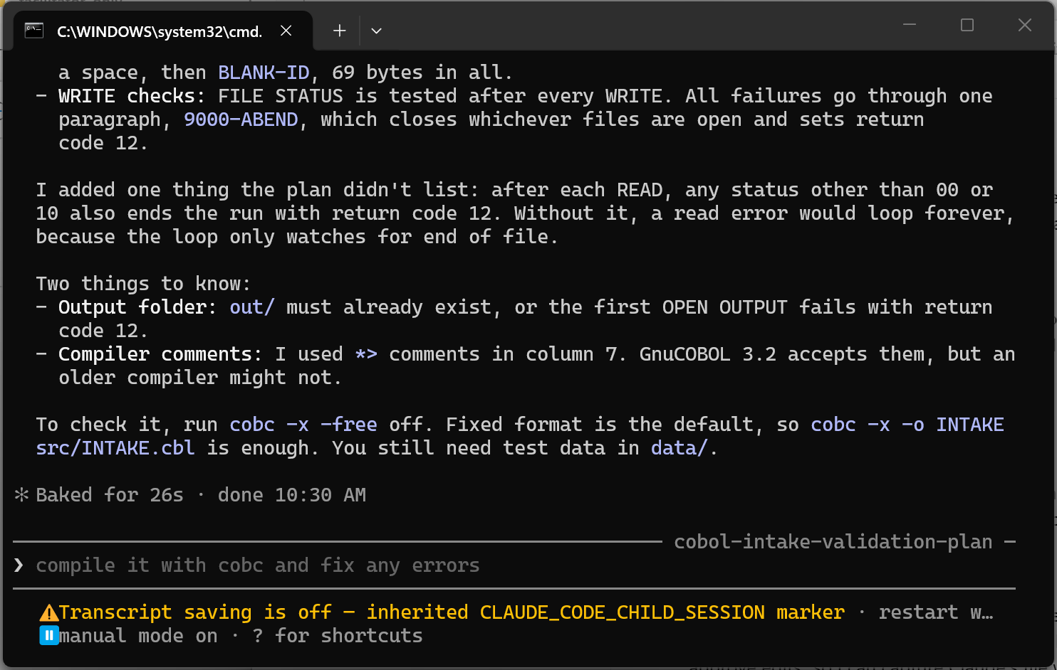
The finished program in VS Code.
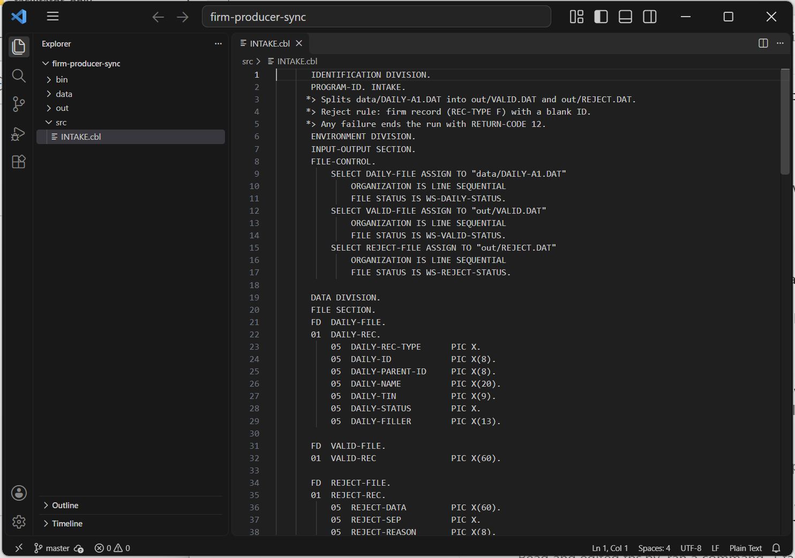
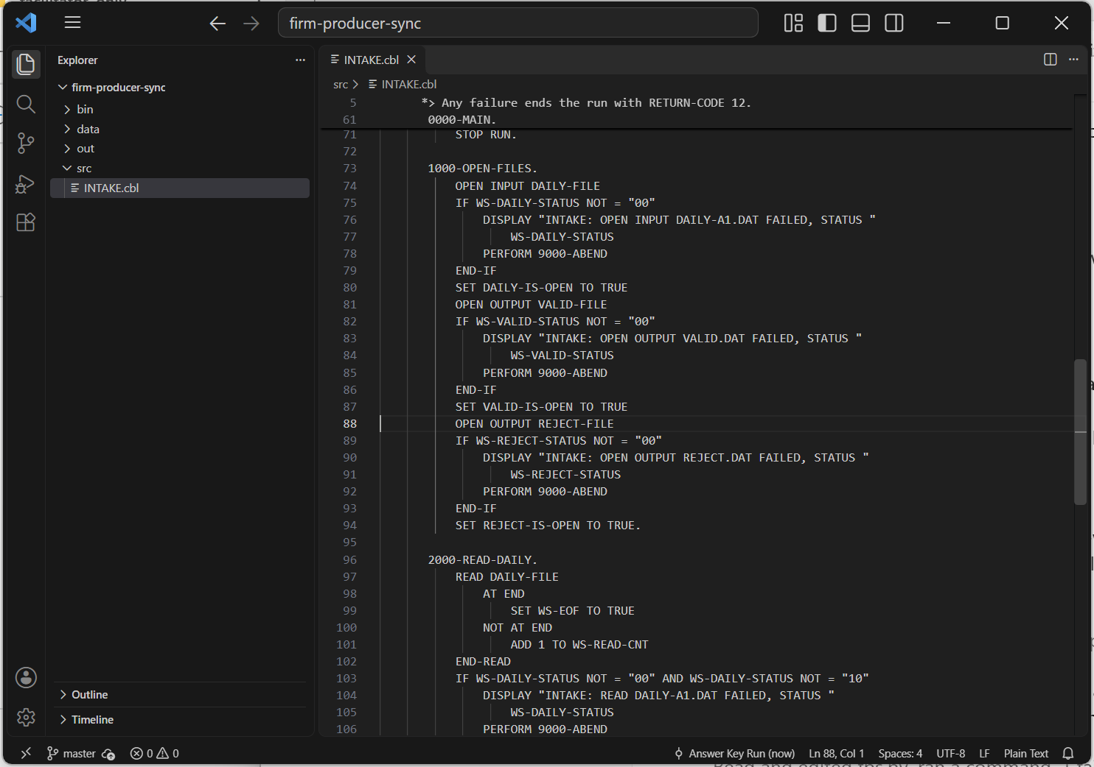
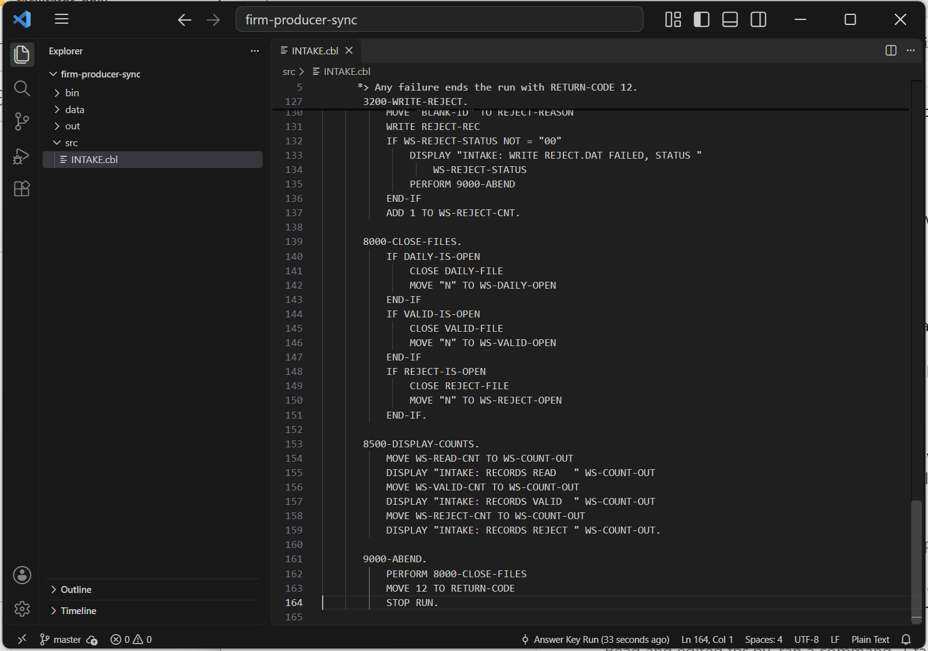

4. Test
Compile, run and prove the result against the expected numbers.
Your Step 4 prompt:
Compile with: cobc -x -o bin/INTAKE src/INTAKE.cbl
Then run it from the project root and show me: the return code, the
number of records in out/VALID.DAT and out/REJECT.DAT, and the full
contents of out/REJECT.DAT. If anything fails, fix it and re-run.

Expected result:
Check | Expected
Records read | 8
Records in VALID.DAT | 6
Records in REJECT.DAT | 2: both are the firms with a blank ID, and each ends with BLANK-ID
Read = valid + rejected | 8 = 6 + 2

If your numbers differ, paste the error or the difference back to Claude and let it find the cause and fix the program.

Screenshot — Test Output
Paste your run result and the contents of REJECT.DAT below
Claude's report of the run: 8 / 6 / 2, both rejects end with BLANK-ID.
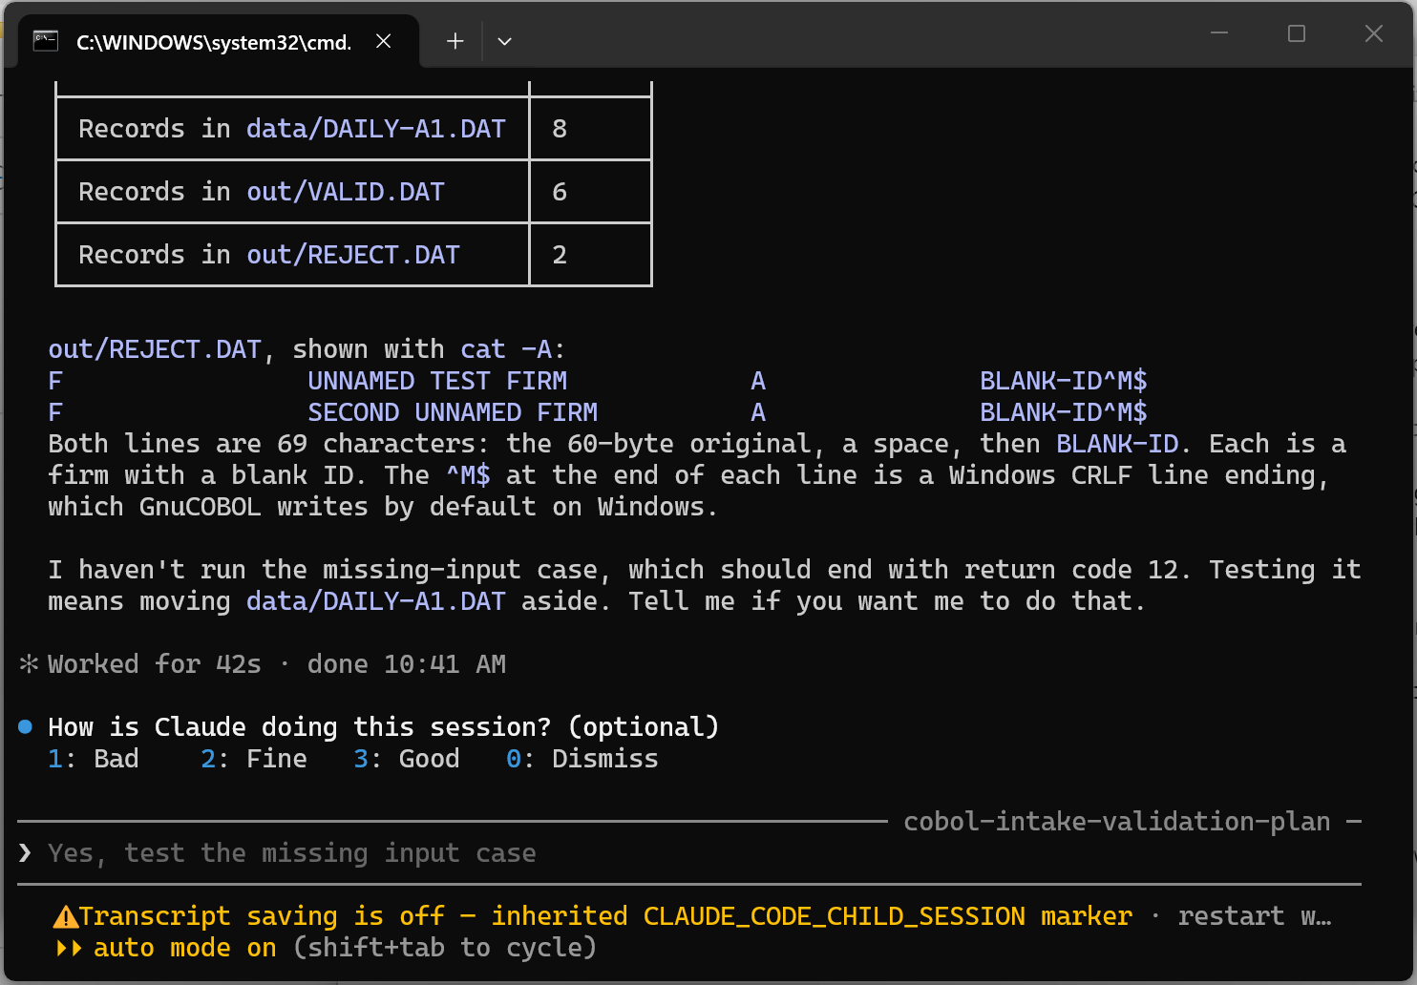
The same run checked by hand in cmd.
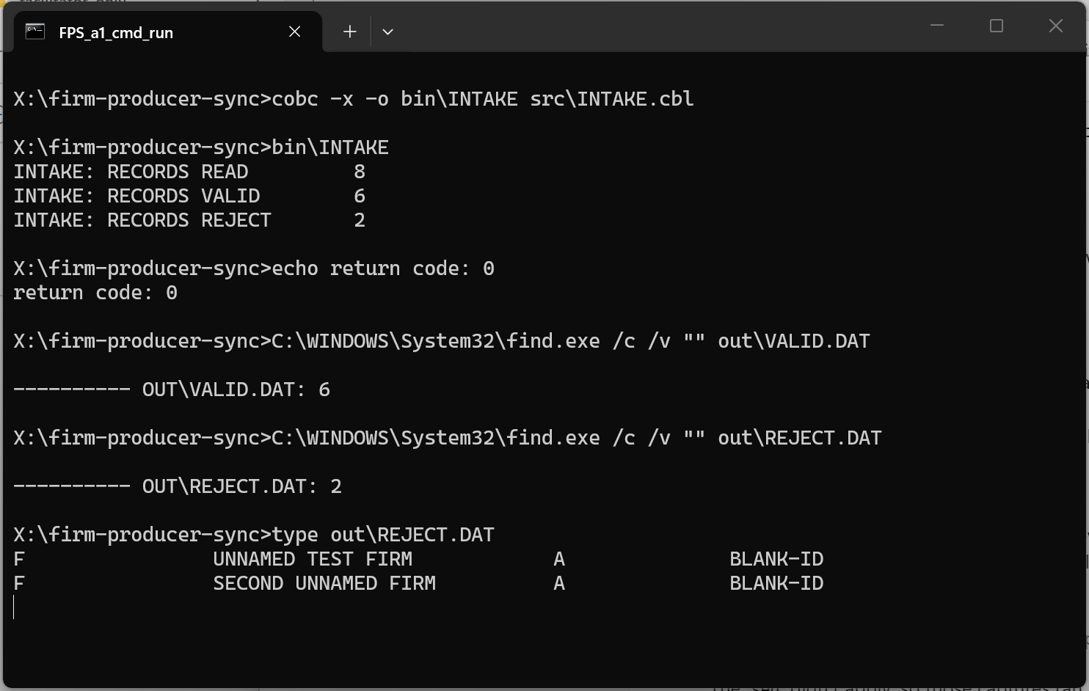
Reproduced check of the reference program: same counts and REJECT.DAT.
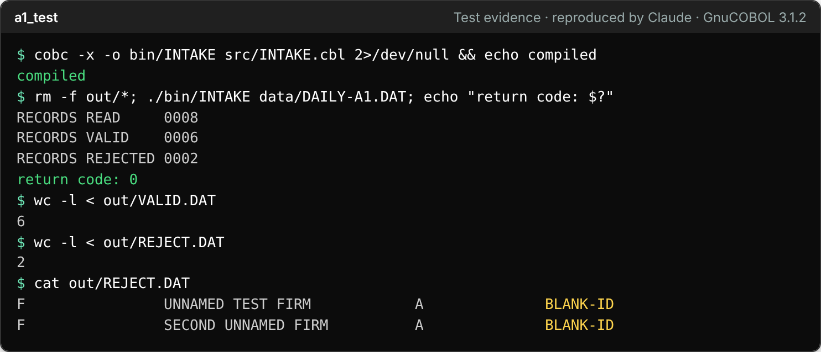
Edge cases from A5: missing input gives return code 12, an empty file gives 0 / 0 / 0.
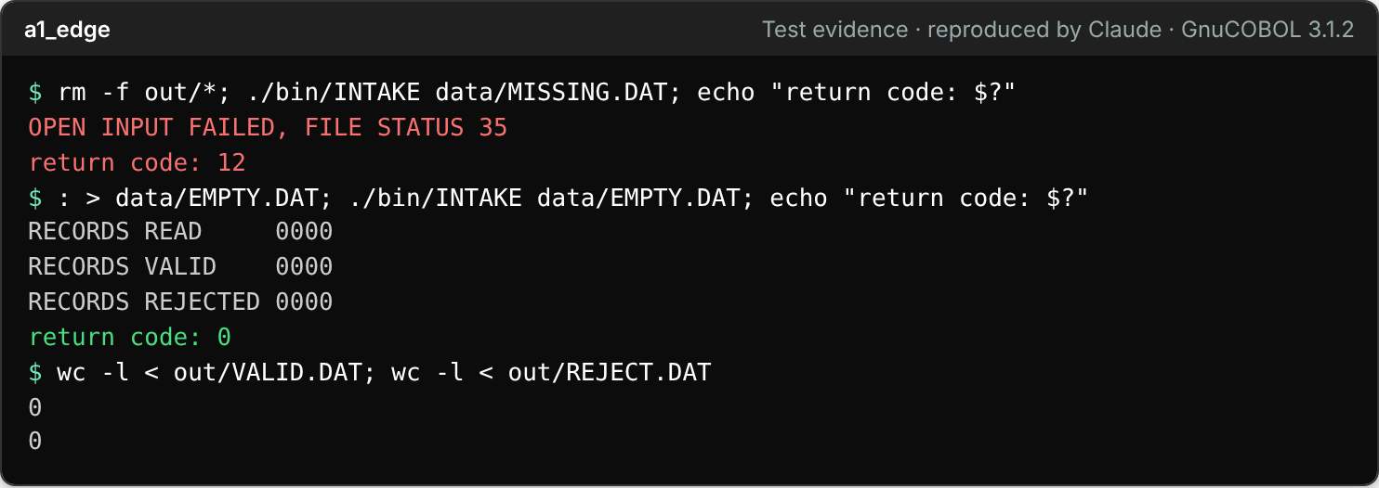

5. Feature Output & Commit
Show the finished, working feature and save it. Ask Claude to commit, or run these yourself in the terminal:
git add .
git commit -m "Activity 1: INTAKE reads firms, rejects blank firm IDs"
git log --oneline

Screenshot — Final Output
Paste your git log --oneline screenshot below
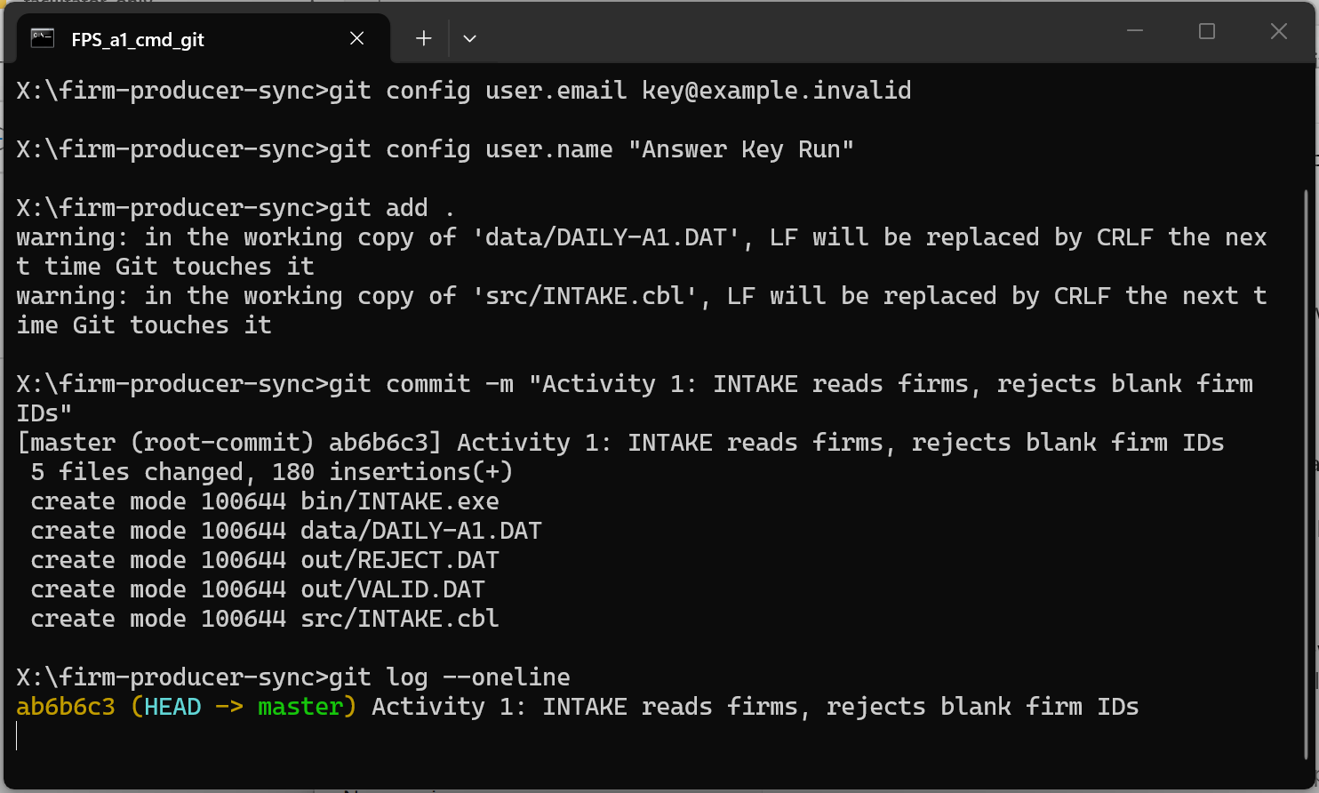

Reflection
1. What did Claude assume in its first plan that you had not told it? How did you find out?
FACILITATOR ANSWER
Claude's first plan assumed return code 16 on failure (the sheet says 12), did not say how the 69-byte reject record is built (original 60 bytes, one space, BLANK-ID in columns 62-69), and did not test FILE STATUS after WRITE. I found all three by reading the plan against the Step 2 checklist.

2. Which Part A section (A1–A5) changed Claude's plan the most? What would have happened if you had skipped the Approve step?
FACILITATOR ANSWER
A4 and A5 changed the plan most: stating return code 12 and the missing and empty file cases made Claude add FILE STATUS checks and a clear failure path.
Skipping Approve means a wrong or missing assumption goes straight into the code. Here it would have been the wrong return code and the status 71 problem: an empty or damaged REJECT.DAT with plausible counts, found only after the program was built and run. Approve is the cheapest place to catch it.

Keep this project. In Activity 2 you will grow this same INTAKE program.

