FACILITATOR ANSWER KEY — DO NOT DISTRIBUTE TO TRAINEES

Activity 2 · Answer Key — Prompting Techniques & Prompt Chaining
Name | Wave No. | Date

Scenario:
Continuing from Activity 1, your INTAKE program already reads firms and rejects any firm with a blank ID. In this activity sheet you will first practise four prompting techniques on the INTAKE domain, then apply Prompt Chaining to grow INTAKE: producer records, a TIN rule, a firm-reference rule and control counts.
All names, IDs and TINs are fictional. You still do not type any COBOL yourself.

FACILITATOR NOTE
Tested 5 Nov 2026. Each reference stage in facilitator-only\firm-producer-sync-key\src\stages was compiled and run on DAILY-A2.DAT: 4a gives 11 / 8 / 3, 4b gives 11 / 6 / 5, 4c gives the five-line report. The final program matches evidence\ byte for byte (ignoring Windows line endings) on both DAILY-A1.DAT and DAILY-A2.DAT.
Fixed today. The key INTAKE.cbl, stages 4b and 4c, and day0-reference\INTAKE.cbl had no firm-table limit check (the bug in Part A 2.1, question 4). All four now stop with return code 12 when the table is full; class results are unchanged. The .exe files in bin\ were built before the fix: recompile them on the training PC.
Screenshots in this key. Every screenshot is from a real Claude Code 2.1.318 run of this enhanced sheet on 5 Nov 2026, using the exact prompts printed here. Part A is six fresh sessions; Part B is one fresh session chained with claude -p --continue. It ran in Claude's cloud workspace (Linux terminal, GnuCOBOL 3.1.2), so it looks different from a trainee's Windows cmd window. Claude's wording varies between runs, so check the key points and the counts, not the exact words.

PART A — Try the Prompting Techniques
Run each prompt below in Claude Code, inside your firm-producer-sync folder. Screenshot the output and paste it in the box. Notice how different techniques produce different quality responses. Part A does not change any files. Time: about 20 minutes.

1.1 Zero-Shot Prompting
No examples: rely only on the model's pre-trained knowledge.

Try both prompts below. Copy, paste into Claude Code, and screenshot the output.
Prompt A — Classification
Classify the following change request as one of:
'feature', 'bug', 'refactor', or 'chore'.

Request: "INTAKE accepts a producer whose TIN is 99000003
followed by a space."

Prompt B — Code Explanation
Explain what this COBOL paragraph does in one sentence,
for a junior developer:

2100-CHECK-FIRM.
IF IN-ID = SPACES
MOVE 'BLANK-ID' TO WS-REASON
PERFORM 3200-WRITE-REJECT
ELSE
PERFORM 3100-WRITE-VALID
END-IF.

Screenshot — Zero-Shot Output
Paste your zero-shot output screenshot below
Prompt A: Claude answers bug.
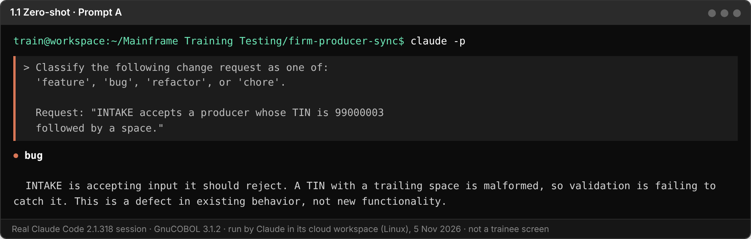
Prompt B: one sentence covering both branches.
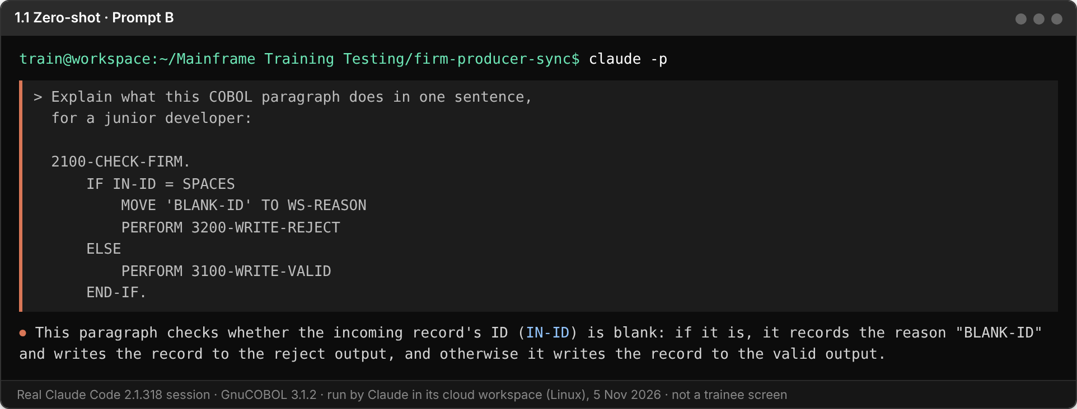

FACILITATOR ANSWER
Prompt A: bug. The TIN rule already exists and should reject "99000003 " (8 digits and a space is not 9 digits), so the program is not doing what it is meant to do.
Prompt B: "If a firm record's ID is all spaces it is written to the reject file with reason BLANK-ID; otherwise it is written to the valid file." Any one clear sentence with both branches is correct.
Point to make: zero-shot works for simple, well-known tasks, but the answer format is whatever the model chooses.

1.2 Few-Shot Prompting
Show examples first, then Claude follows the pattern.

Notice how Claude matches the exact format and length of your examples. Compare to the Zero-Shot output above. These are the same reject reasons you will build in Part B.
Prompt — Record Classifier (Few-Shot)
Classify each INTAKE record as VALID or REJECT <reason>,
and briefly explain why.

Input: REC-TYPE=F ID=FIRM0101 PARENT-ID=(blank) TIN=(blank)
Output: VALID (firm with a non-blank ID)

Input: REC-TYPE=F ID=(blank) PARENT-ID=(blank) TIN=(blank)
Output: REJECT BLANK-ID (firm ID is all spaces)

Input: REC-TYPE=P ID=PROD0101 PARENT-ID=FIRM0101 TIN=98000001X
Output: REJECT BAD-TIN (TIN contains a letter)

Input: REC-TYPE=P ID=PROD0102 PARENT-ID=FIRM0199 TIN=980000012
Output: REJECT NO-FIRM (no valid firm FIRM0199 earlier in the file)

Now classify this:
Input: REC-TYPE=P ID=PROD0103 PARENT-ID=FIRM0101 TIN="98000013 "
Output: ???

Screenshot — Few-Shot Output
Paste your few-shot output screenshot below
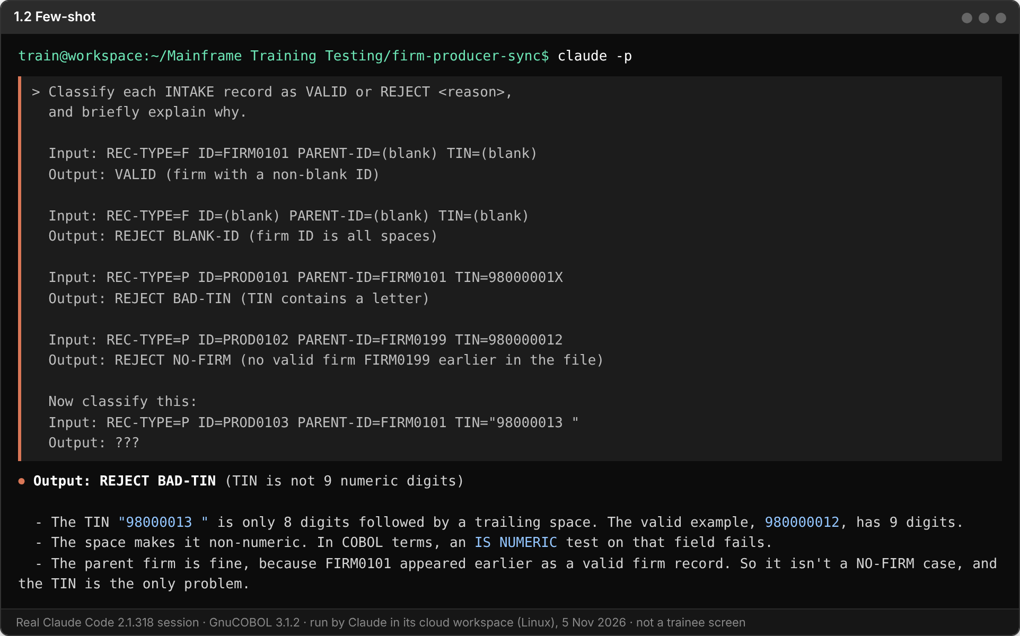

FACILITATOR ANSWER
Expected: Output: REJECT BAD-TIN (TIN is 8 digits and a space, not 9 digits).
In this run Claude answered "Output: REJECT BAD-TIN (TIN is not 9 numeric digits)" in the same shape as the examples, then added three short bullets, because the prompt also says briefly explain why. It also ruled out NO-FIRM on its own, since FIRM0101 appeared earlier.
Point to make: the examples set the format. This is the same case as PROD0004 in DAILY-A2.DAT, so trainees have now predicted one of the Part B rejects.

2.1 Chain of Thought (CoT)
Make the model reason step by step before answering.

Notice how Claude shows its reasoning before giving the answer. Compare the depth with asking the same question without "think step by step".
Prompt A — Zero-Shot CoT (trigger phrase)
Before writing any code, think step by step about how INTAKE could
wrongly accept a producer under the firm-reference rule, for example
when its parent firm appears later in the file, or when the parent
firm was itself rejected.

Then suggest a fix.

Prompt B — Few-Shot CoT (show the reasoning pattern)
Q: Is IF IN-ID = SPACES safe if the ID holds LOW-VALUES?
Thinking: LOW-VALUES are X'00', not spaces -> comparison is false ->
record treated as valid -> a bad firm passes.
A: No. Also test for LOW-VALUES, or clear the record before use.

Q: Is ADD 1 TO WS-READ safe if WS-READ is PIC 9(2) and 150 records arrive?
Thinking: PIC 9(2) holds at most 99 -> ADD drops the high-order digit
silently -> count wraps -> INTAKE.RPT is wrong.
A: No. Size the field for the volume, or use ON SIZE ERROR.

Q: Is READ DAILY-FILE safe if the OPEN failed?
Thinking: failed OPEN sets FILE STATUS other than 00 -> READ on a file
that is not open -> runtime error -> the job abends.
A: No. Test FILE STATUS after OPEN and stop with return code 12.

Q: Is SEARCH WS-FIRM-TABLE safe if 120 valid firms are loaded into
a table defined OCCURS 100 TIMES?
Thinking: ???
A: ???

Screenshot — Chain of Thought Output
Paste your chain of thought output screenshot below
Prompt A. Claude first noticed that INTAKE has no firm-reference rule yet, then reasoned through the failure modes, including the blank-ID match that would accept PROD0007.
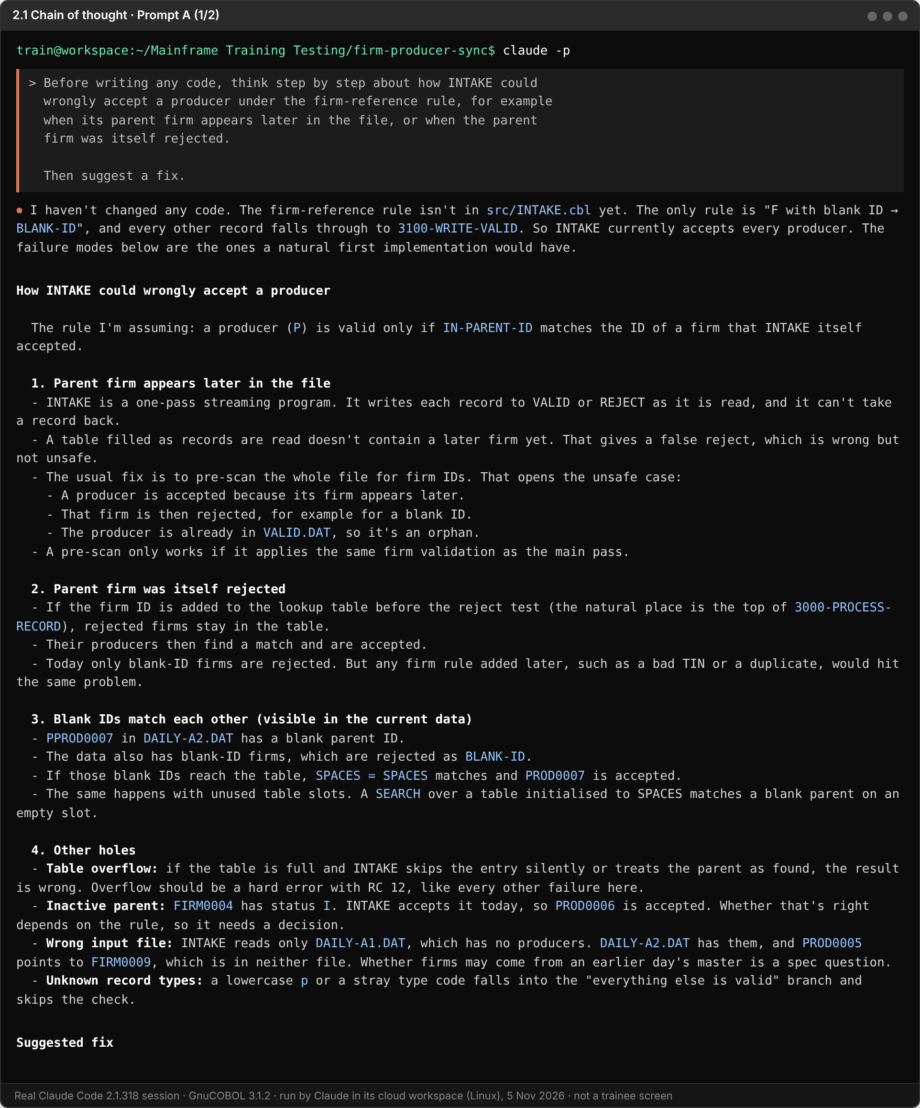
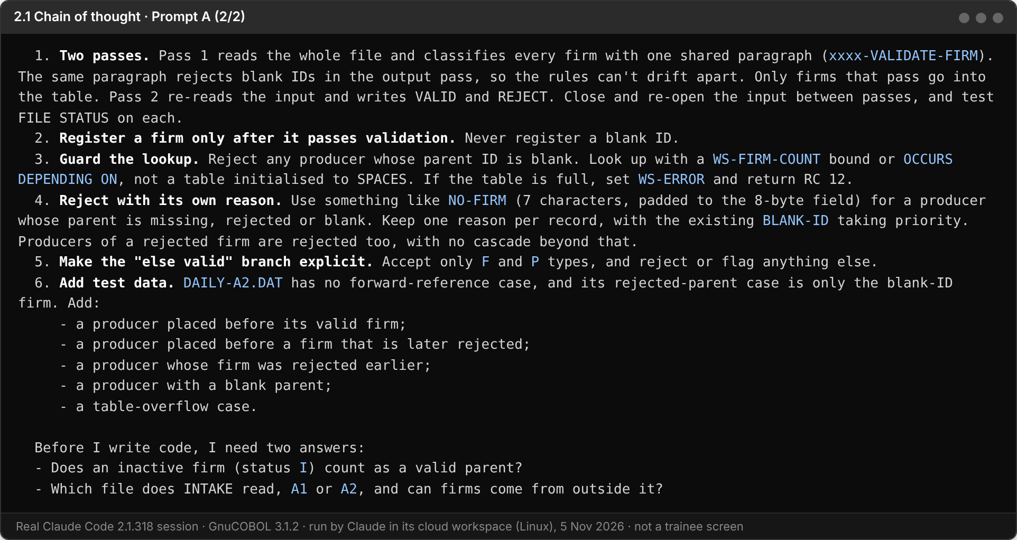
Prompt B: Claude completes question 4 in the same Q / Thinking / A pattern.
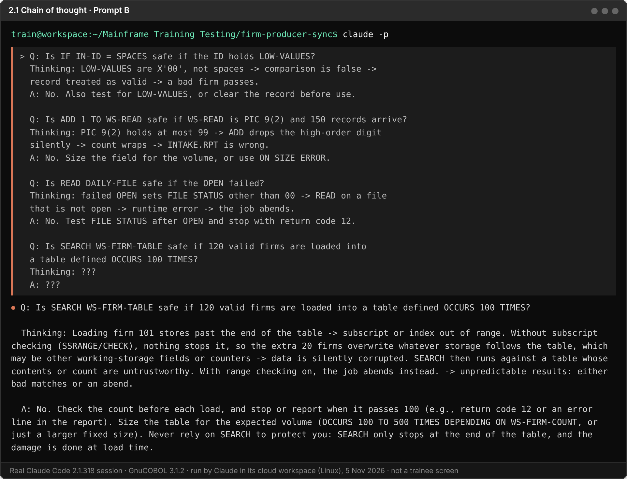
Facilitator evidence for question 4: the reference programs before and after today's fix.
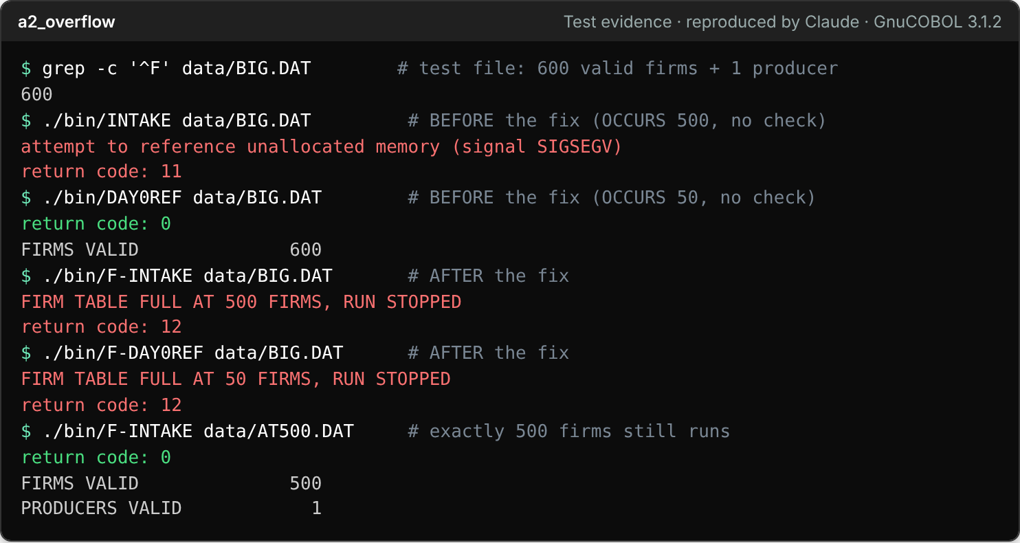

FACILITATOR ANSWER
Prompt A, key points: INTAKE reads the file once, top to bottom, so a firm that appears later is not yet known and the producer is correctly rejected NO-FIRM. A producer is wrongly accepted if a firm is stored in the table before it passes its own check: a blank-ID firm would store an all-spaces ID, and PROD0007 (blank PARENT-ID) would then match it. Fix: store only valid firms, never match a blank PARENT-ID, and check the TIN first.
Prompt B, question 4: Thinking: the table has 100 entries -> firm 101 uses subscript 101 -> GnuCOBOL does not check subscripts by default -> the MOVE writes past the table into other storage, or the program crashes -> wrong counts or an abend with no clear message. A: No. Before adding a firm, test the count against the table size and stop with return code 12, and size the table for the real volume. Compiling with cobc -debug in testing catches the bad subscript.

FACILITATOR NOTE
Real example to show the room: our own reference programs had exactly this bug. With 600 firms, the key solution (OCCURS 500) crashed with SIGSEGV and the day0-reference (OCCURS 50) silently reported 600 valid firms. Both now stop with "FIRM TABLE FULL" and return code 12 (see the screenshot above).

2.2 Tree of Thought (ToT)
Explore several paths in parallel, then the model picks the best.

Notice how Claude evaluates ALL three paths before recommending. The constraint at the end ("under 500 firms, firms come before their producers") drives the final recommendation. Try changing the constraint and see how the answer changes.
Prompt — Valid-Firm Lookup Design Decision
INTAKE must remember which firms are valid so the firm-reference rule
can check each producer's PARENT-ID. GnuCOBOL 3.2, LINE SEQUENTIAL input.

Explore 3 approaches:
A) A WORKING-STORAGE table (OCCURS) searched with SEARCH (linear)
B) A table with ASCENDING KEY searched with SEARCH ALL (binary)
C) Write valid firms to a temporary INDEXED file and READ by key

For each approach: pros, cons, and implementation complexity.

Then recommend the best option for a daily file of under 500 firms,
read once top to bottom, where firms always appear before their
producers and firm IDs are not guaranteed to be in sorted order.

Screenshot — Tree of Thought Output
Paste your tree of thought output screenshot below
Claude explores all three approaches before it recommends one.
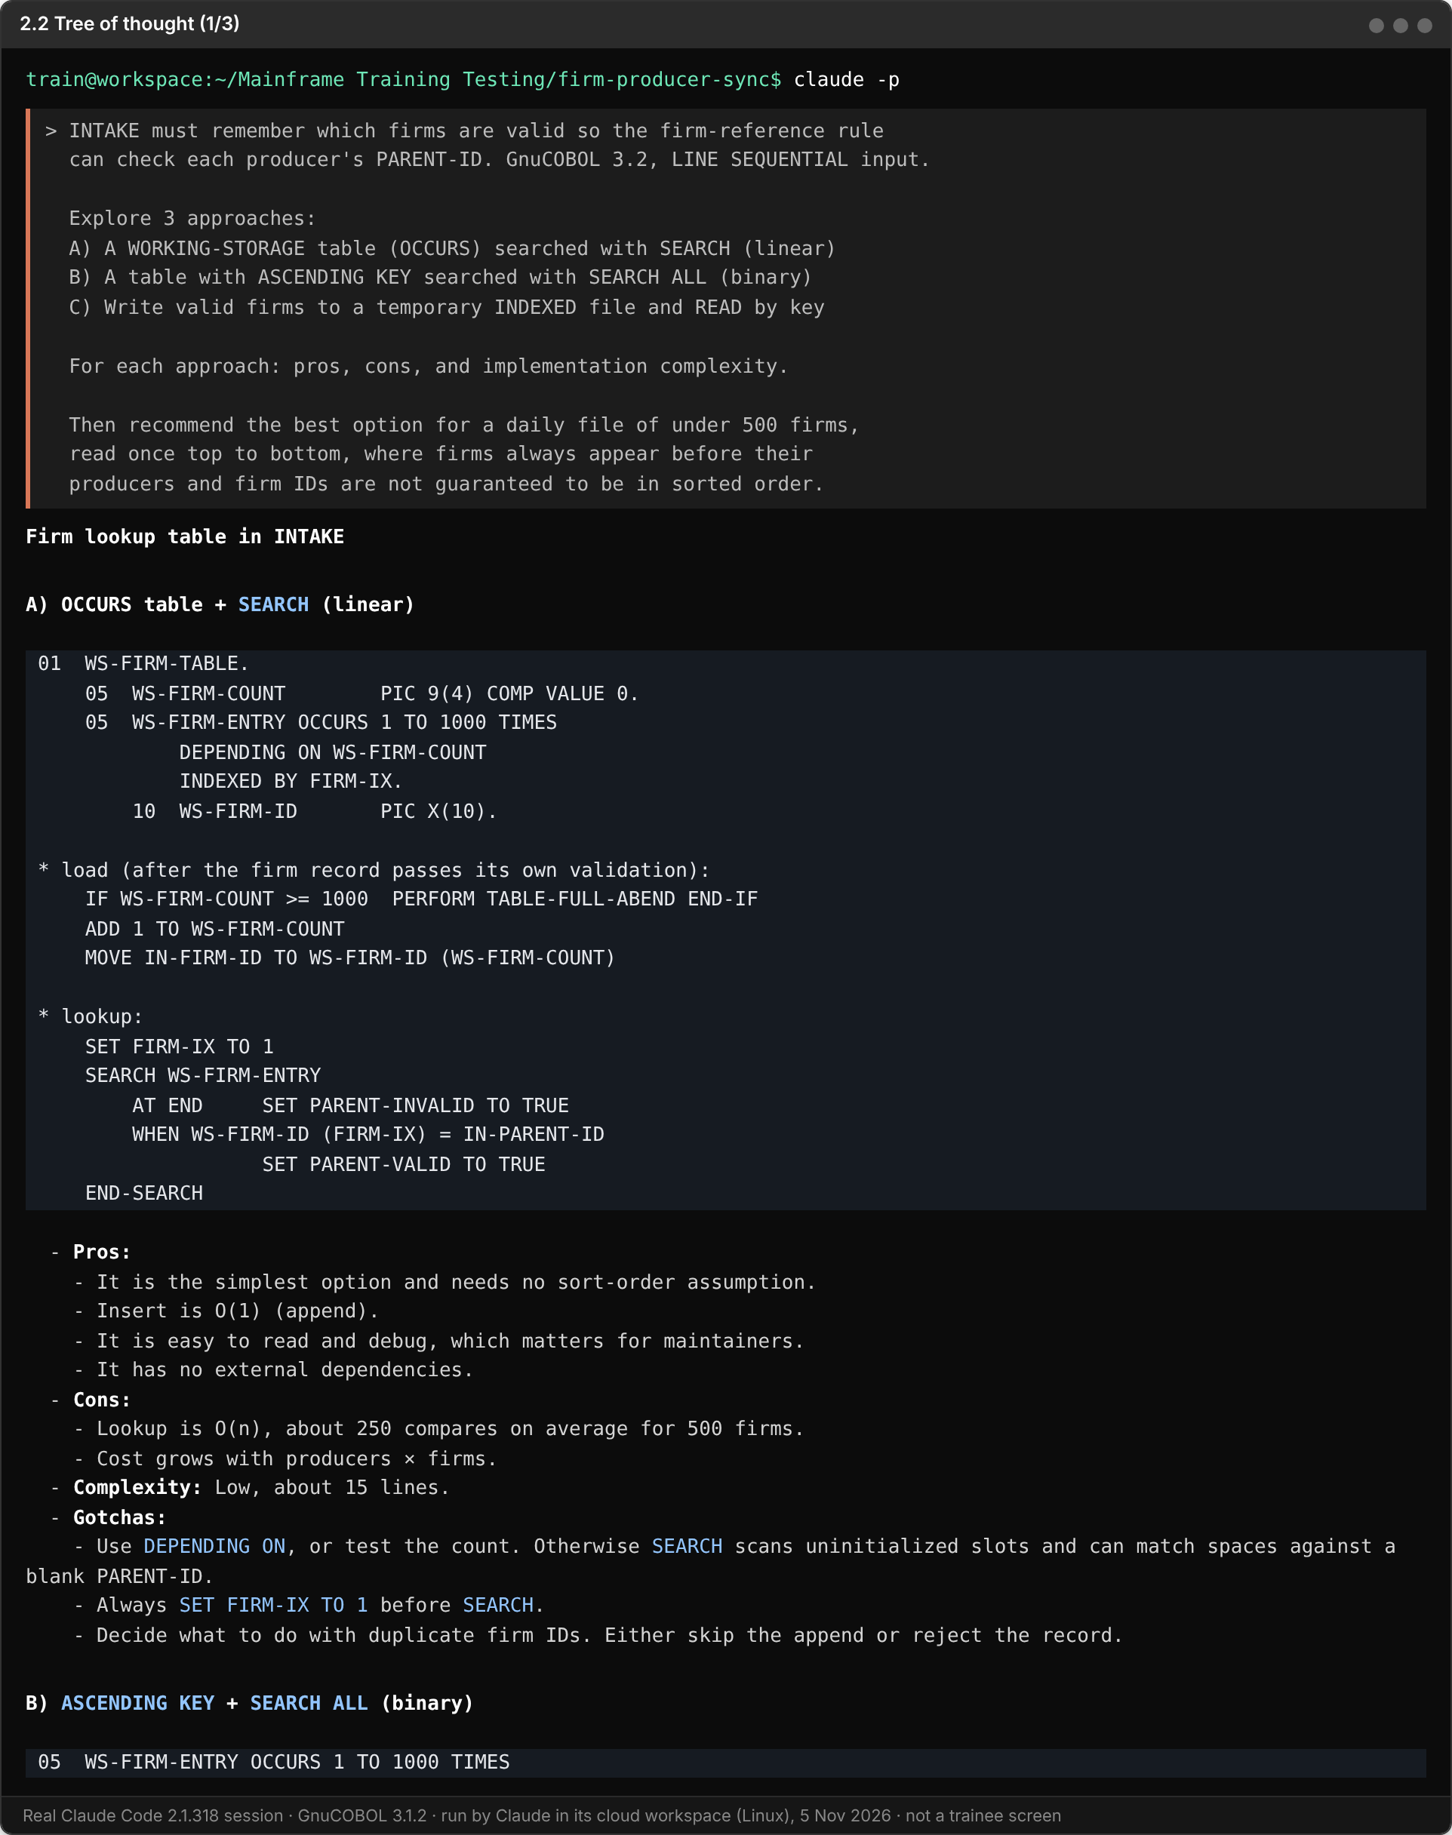
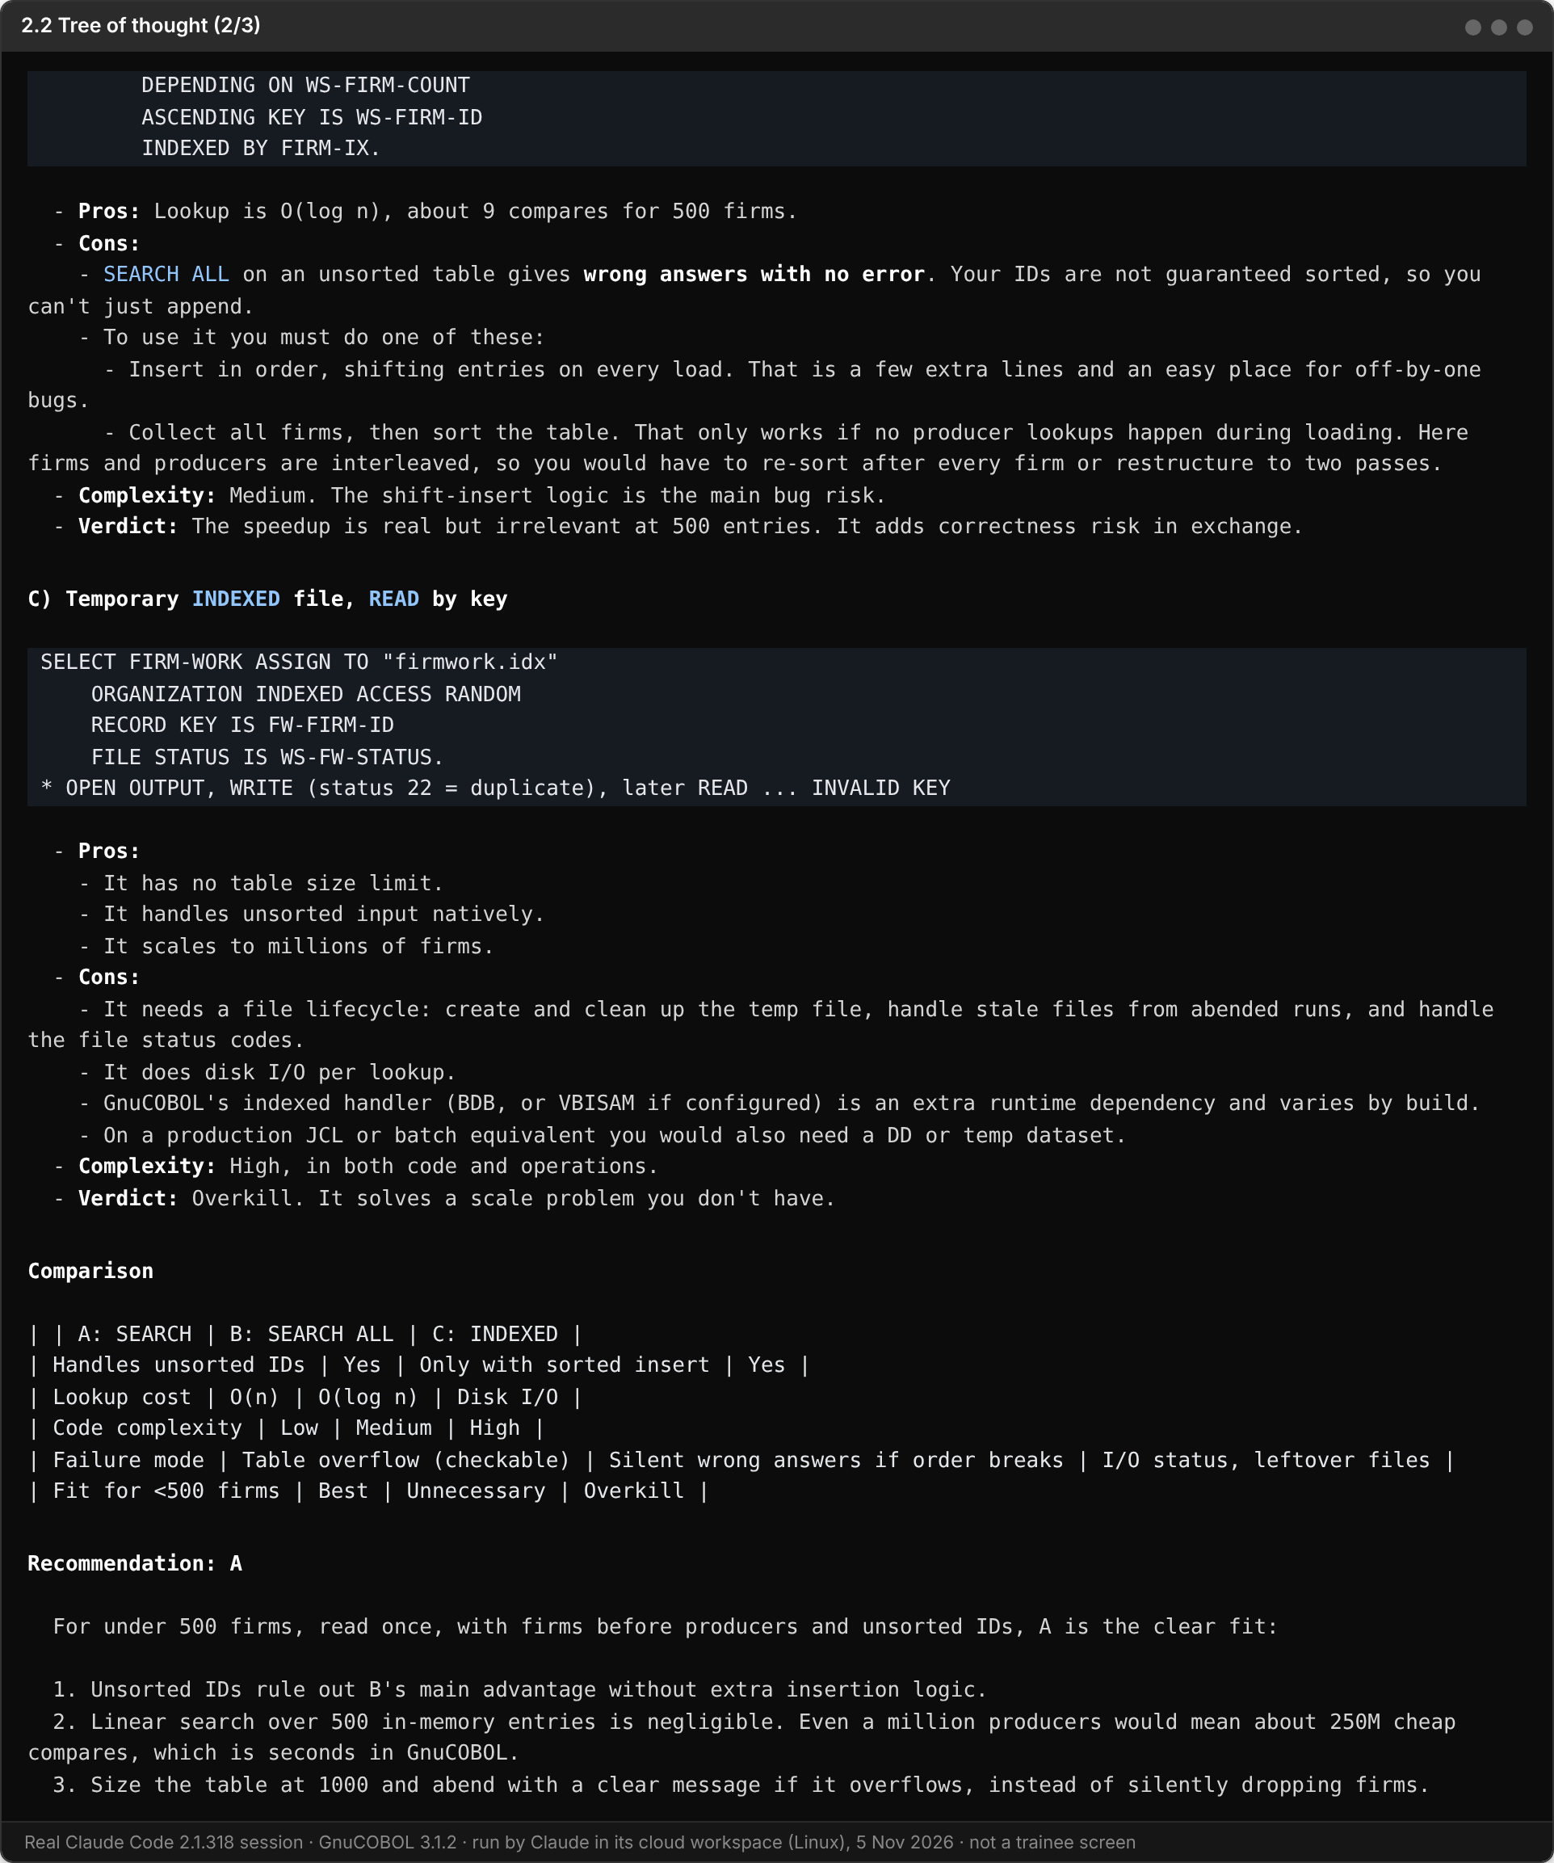
The comparison table and the recommendation: A, driven by the under-500-firms constraint.
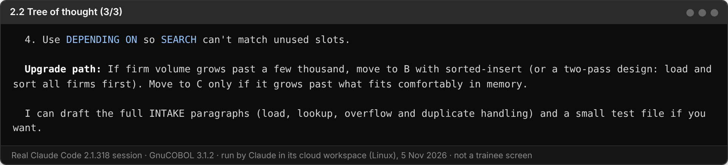

FACILITATOR ANSWER
A) Linear table: simplest, no sort needed, fine for a few hundred firms. Needs a size limit check. B) SEARCH ALL: fast, but only correct if the table is in key order; firm IDs are not guaranteed sorted, so it needs a sort or insertion step, and on unsorted data it gives wrong answers silently. C) Indexed file: no size limit, but adds file handling, status checks and clean-up for a tiny data set.
Recommendation: A, a WORKING-STORAGE table searched in order, sized above the real volume, with a table-full check. This is what the reference solution does.
Point to make: change the constraint to "2 million firms" and the recommendation moves to C. The constraint drives the choice.

Reflection before Part B: Which technique produced the most useful output for you? Which one surprised you the most? Write 1–2 sentences below before moving on.

FACILITATOR ANSWER
Open answer. Good answers name a technique and a reason, for example: "Few-shot was most useful because the output matched our reject format exactly; tree of thought surprised me because one constraint changed the whole recommendation."

PART B — Final Activity: Prompt Chaining
Now apply everything you've learned. Use Prompt Chaining to grow your Activity 1 INTAKE program: a sequence of small prompts where the output of each step is the input of the next, with a human checkpoint before any code is written. Follow the steps below in order. Steps 1 to 3 must not produce any code. Time: about 40 minutes.

What you are adding
# | Feature | Rule
1 | Producer records | A record with REC-TYPE P is a producer. It uses the same 60-byte layout as a firm.
2 | TIN rule | A producer's TIN must be exactly 9 digits. Otherwise reject it with reason BAD-TIN. Never check a firm's TIN (it is blank).
3 | Firm-reference rule | A producer's PARENT-ID must be the ID of a valid firm earlier in the same file. Otherwise reject it with reason NO-FIRM. A firm that was itself rejected is not valid. Check the TIN rule first.
4 | Control counts | Write out/INTAKE.RPT with exactly five lines: RECORDS READ, RECORDS VALID, RECORDS REJECTED, FIRMS VALID, PRODUCERS VALID.

The new input file
data/DAILY-A2.DAT has 11 records using the same layout as Activity 1. You copied it into your data folder in Activity 1. Check it before you start:
(Get-Content data\DAILY-A2.DAT).Count

Check: it must print 11. If the file is missing, copy it from <package>\day0\data\ as in Activity 1, or ask your facilitator. Do not ask Claude to create test data: the expected counts only work with this exact file.

Columns | Field | Meaning
1 | REC-TYPE | F = firm, P = producer
2-9 | ID | Firm ID or producer ID, 8 characters
10-17 | PARENT-ID | On a producer: the ID of its firm. Blank on a firm
18-37 | NAME | Name, 20 characters
38-46 | TIN | Taxpayer ID, 9 characters. Blank on a firm
47 | STATUS | A = active, I = inactive
48-60 | FILLER | Spaces. Each record is exactly 60 characters

1. Understand — Read & Summarize
Open a fresh Claude Code session (/clear) in your firm-producer-sync folder. Ask Claude to explain the program you built last time. Keep it high-level — no code changes.
Your Step 1 prompt:
Read src/INTAKE.cbl. Summarize in bullet points:
- the files it uses
- the record layout
- how it decides a firm is valid
- what it writes to each output file

No code changes in this step.

Screenshot — Step 1 Output
Paste your step 1 output screenshot below
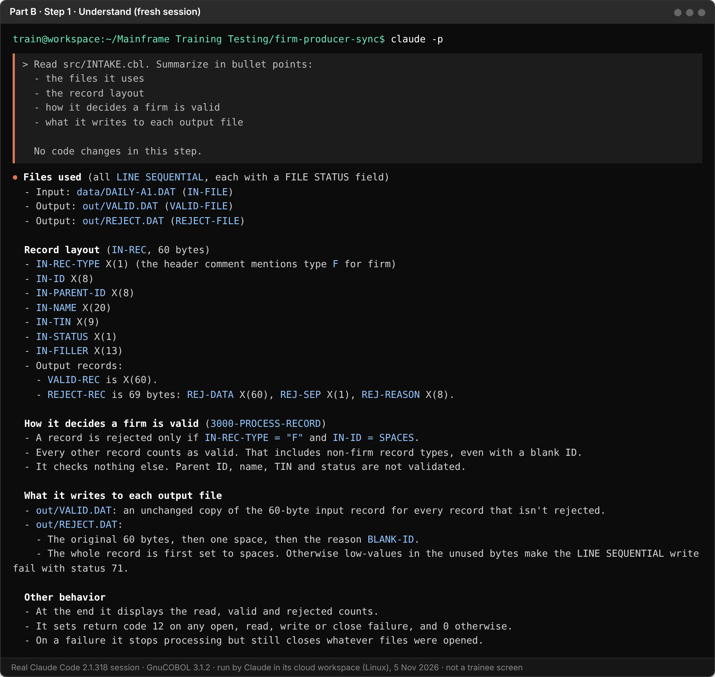

FACILITATOR NOTE
Check: the summary must say INTAKE only reads data/DAILY-A1.DAT and only knows firms. That is the gap Step 2 has to close.

2. Map the Changes — Identify What Must Change
Pass the Step 1 summary as context. This is the chain: the output of Step 1 is the input of Step 2. Ask Claude which paragraphs and files must change or be added, one line each. No code yet.
Your Step 2 prompt:
Using your summary of INTAKE, I want to add:
- producer records (type P)
- a TIN rule (producers only: 9 digits, else BAD-TIN)
- a firm-reference rule (parent must be a valid earlier firm,
else NO-FIRM; TIN rule checked first)
- control counts in out/INTAKE.RPT (exactly five lines)

List each paragraph or file that must be:
- Added (new paragraphs, tables, files)
- Modified (existing paragraphs that need changes)
One line each. [Add any question you want answered.]
Do not write any code yet.

Screenshot — Step 2 Output
Paste your step 2 output screenshot below
In this run the [question] was: Does an inactive firm (STATUS I) still count as a valid parent?
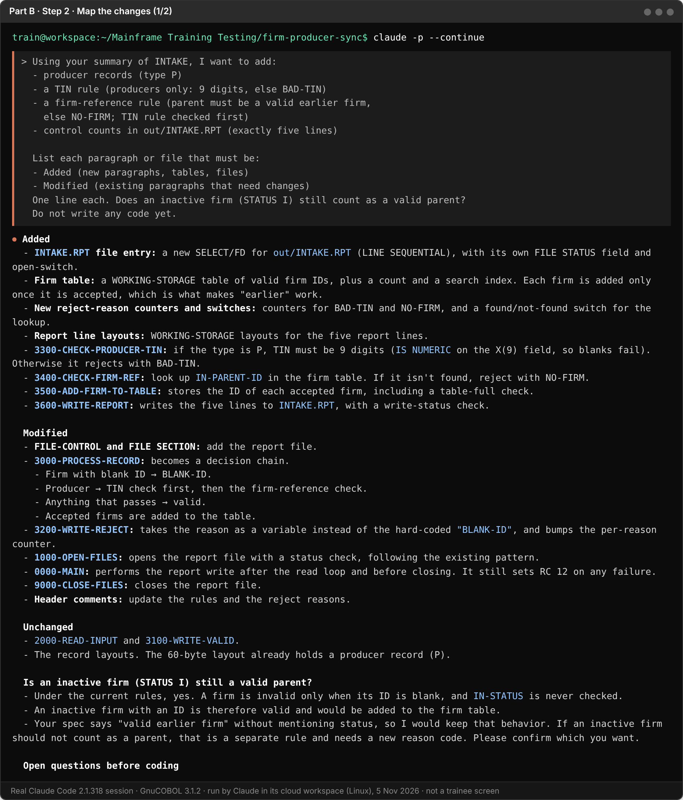
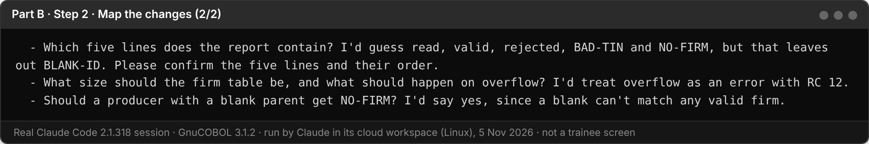

3. Write the Plan — Then STOP and Approve
Pass the change list as context. Ask for a step-by-step implementation plan in plan mode. Read the plan carefully before approving.
First type this command to enter plan mode:
/plan

Your Step 3 prompt:
Based on the change list above, write a step-by-step implementation plan.
For each change include:
1. What needs to be done
2. In what order (smallest change first)
3. Any dependency on another change

Also take the input file name from the command line, default
data/DAILY-A2.DAT, so I can still run it on DAILY-A1.DAT.

Do not write any code yet.
I will review and approve the plan before we proceed.

Check the plan against the rules table before approving:
- Is the TIN rule applied to producers only?
- Does only a valid firm go into the firm table (a rejected firm does not count)?
- For a producer, is the TIN rule checked before the firm reference?
- Does INTAKE.RPT have exactly the five lines, with no extras?
- Is the table big enough for the data (remember your CoT answer in 2.1)?

Correct anything that is wrong or missing, then approve it in words, for example: Plan approved.
FACILITATOR NOTE
Correction prompt used in this run: Corrections before I approve. (1) INTAKE.RPT has exactly these five lines, in this order: RECORDS READ, RECORDS VALID, RECORDS REJECTED, FIRMS VALID, PRODUCERS VALID. Each line is the label, then the count. No per-reason lines. (2) Confirmed: an inactive firm still counts as a valid parent; a producer with a blank parent gets NO-FIRM; a full firm table stops the run with return code 12. (3) Group the work into three changes I can test one at a time: 4a producers, the TIN rule and the command-line file name; 4b the firm table and the firm-reference rule; 4c the control counts. Show the corrected plan as at most 6 one-line steps. No code.

What did you correct, and why?
FACILITATOR ANSWER
The real catch: Claude's plan guessed the five report lines as READ, VALID, REJECTED, BAD-TIN and NO-FIRM, and listed that under its assumptions. The rule says FIRMS VALID and PRODUCERS VALID, not reject counts. I gave the five lines in order.
I also answered its three questions from the rules table: an inactive firm still counts as a valid parent, a blank parent gets NO-FIRM, and a full firm table stops the run with return code 12. Then I grouped the work into 4a, 4b and 4c, so each change is tested on its own.

Screenshot — Plan Output
Paste your plan and your correction or approval screenshot below
The first plan. Note the guessed report lines under its assumptions.
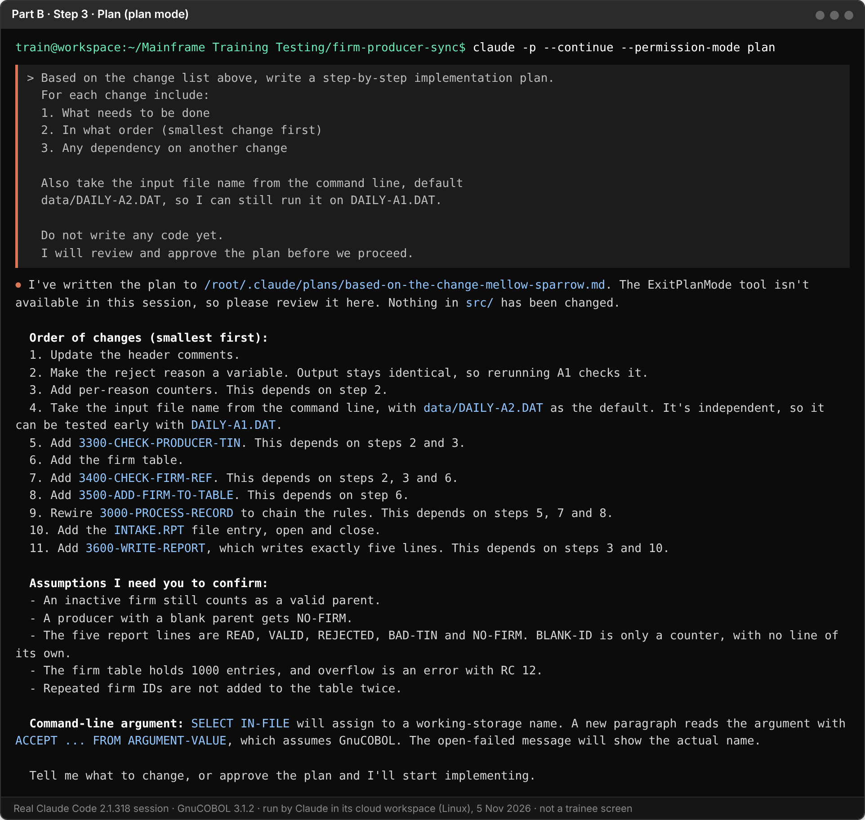
After the correction: 6 steps, grouped as 4a / 4b / 4c, with the right five report lines.
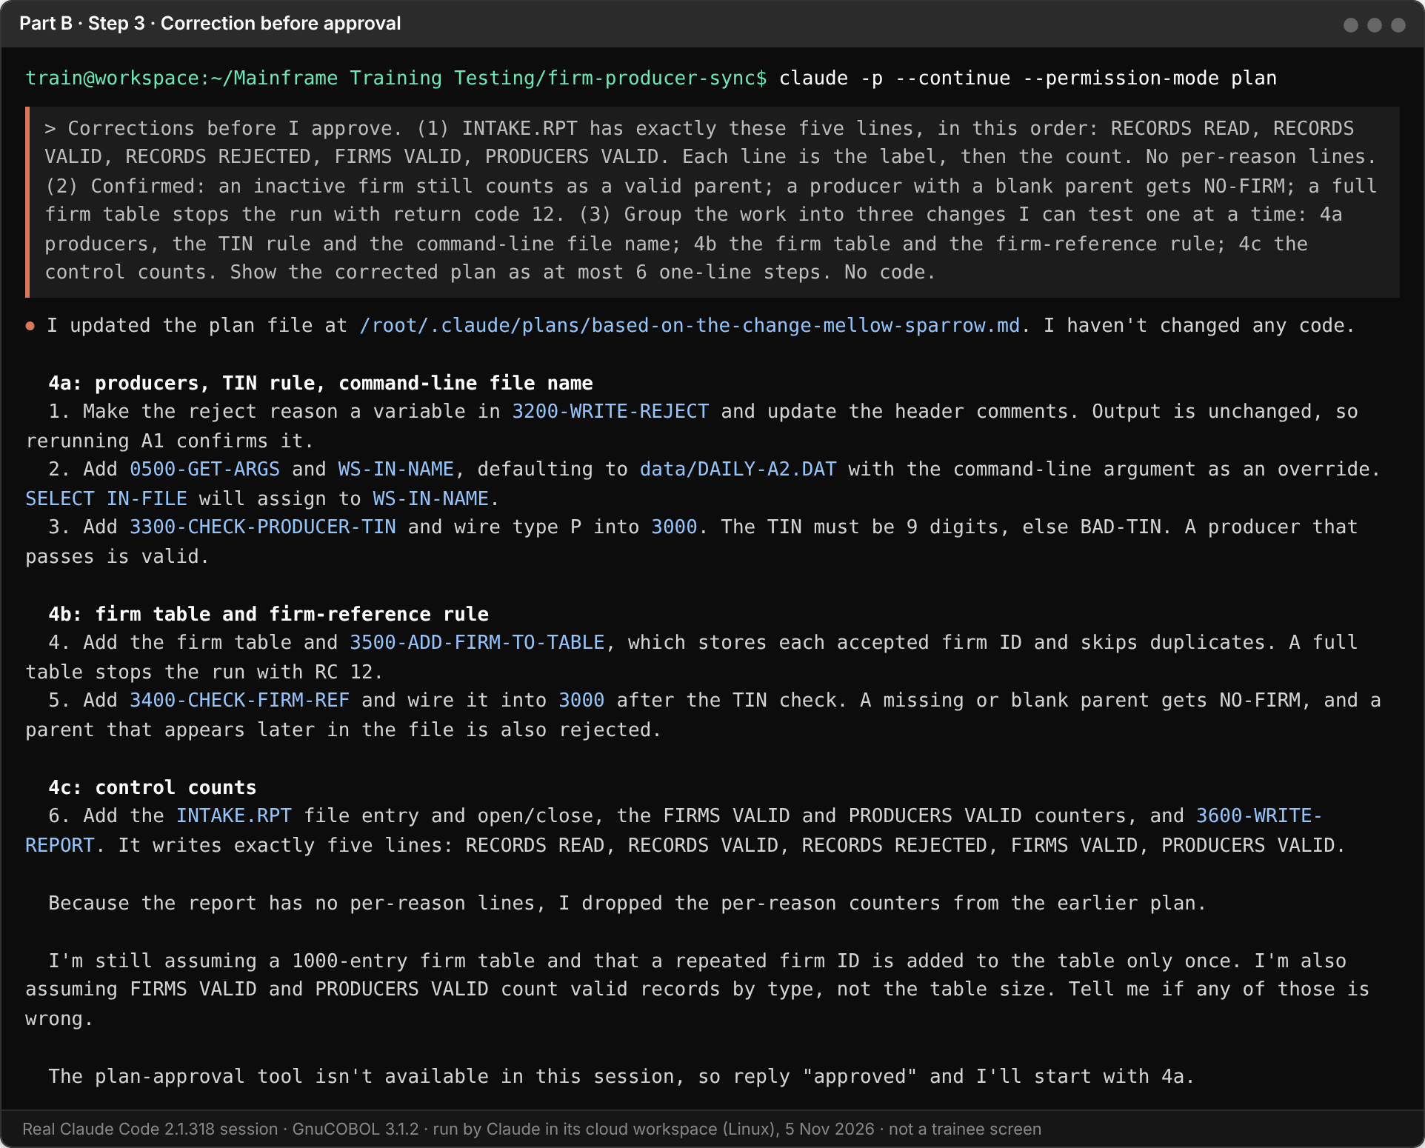

4. Implement — One Change at a Time
Plan approved. Send one prompt per change. Compile and run after each one, and paste the evidence before moving to the next.
4a — Producers and the TIN rule
The plan is approved. Implement ONLY producer records (type P) with the
TIN rule, plus taking the input file name from the command line.
Do not touch anything else. Compile with cobc -x -o bin/INTAKE
src/INTAKE.cbl, run it on data/DAILY-A2.DAT, and show me out/REJECT.DAT.

Look at out/REJECT.DAT. You should see two BAD-TIN records.
Screenshot — 4a Output
Paste your 4a run result and REJECT.DAT screenshot below
3 rejects (1 BLANK-ID, 2 BAD-TIN), 11 / 8 / 3. PROD0005 and PROD0007 are still valid at this stage, and Claude says why. Its extra test runs overwrote out/, and it reran the A2 default to put the A2 results back.
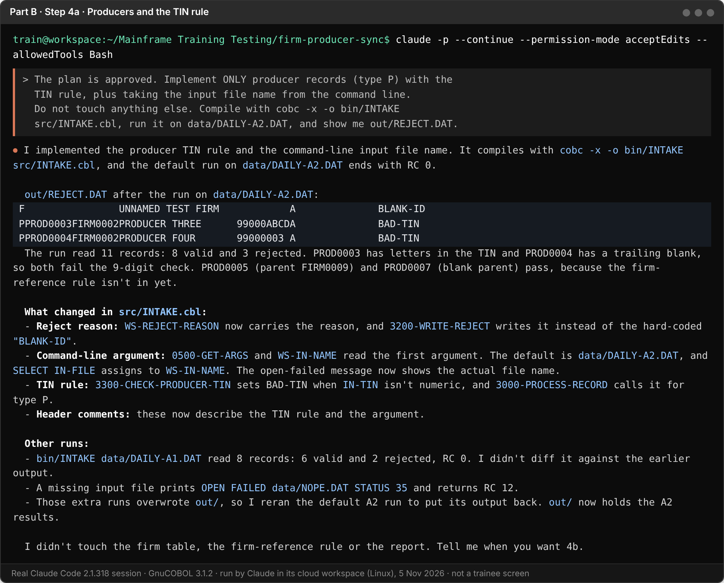

4b — The firm-reference rule
The plan is approved. Implement ONLY the firm-reference rule and the
table of valid firms it needs. Do not touch anything else. Compile,
run it on data/DAILY-A2.DAT, and show me out/REJECT.DAT.

Look at out/REJECT.DAT. You should now also see two NO-FIRM records.
Screenshot — 4b Output
Paste your 4b run result and REJECT.DAT screenshot below
PROD0005 (parent FIRM0009 not in the file) and PROD0007 (blank parent) are now NO-FIRM, 11 / 6 / 5. PROD0006 stays valid.
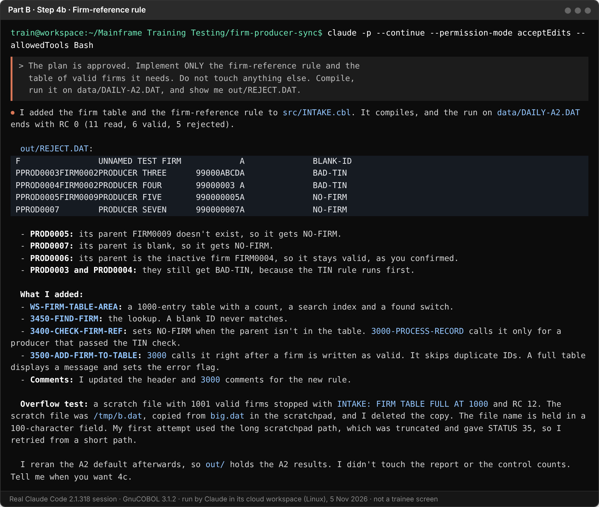

FACILITATOR NOTE
Trap to watch for: PROD0006 belongs to FIRM0004, which is inactive (STATUS I) but valid. It must stay valid. A plan that treats inactive firms as invalid gives 4 producers rejected and the wrong counts.

FACILITATOR NOTE
Discuss with the room: in 4b Claude tested a full table without being asked. It made a 1001-firm scratch file outside the project, then deleted it, and its first try failed with status 35 because the long path was cut off by the 100-character file-name field. The class data was checked afterwards and is unchanged. The sheet says not to ask Claude for test data; this is a good moment to talk about when its own scratch tests are fine, and why it must say what it did.

4c — Control counts
The plan is approved. Implement ONLY the control counts in
out/INTAKE.RPT (exactly the five lines). Do not touch anything else.
Compile, run it on data/DAILY-A2.DAT, and show me out/INTAKE.RPT.

Screenshot — 4c Output
Paste your 4c INTAKE.RPT screenshot below
Exactly five lines, 11 / 6 / 5 / 3 / 3. Claude also checked that 3 + 3 = 6 valid.
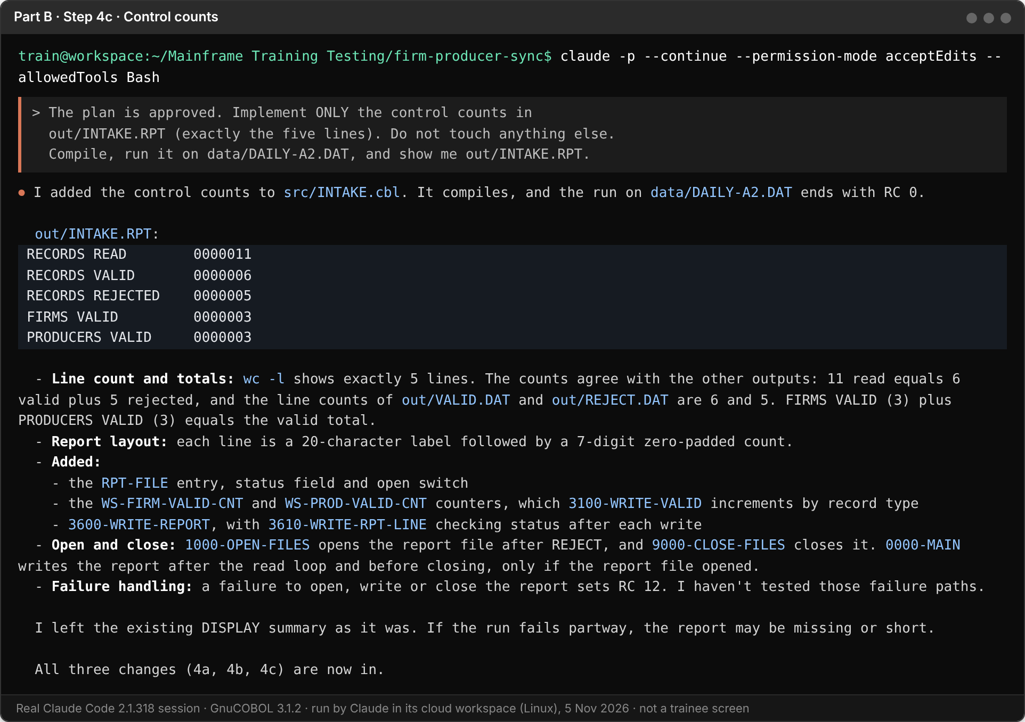

FACILITATOR NOTE
Format can differ: Claude chose a 20-character label and a 7-digit zero-padded count (RECORDS READ 0000011). The reference prints RECORDS READ 11. Both are correct: the sheet fixes the five lines and their counts, not the layout.

5. App / Feature Output — Final Check
Run the finished program on data/DAILY-A2.DAT and compare with the expected results.
Check | Expected
INTAKE.RPT | RECORDS READ 11, RECORDS VALID 6, RECORDS REJECTED 5, FIRMS VALID 3, PRODUCERS VALID 3
Records in VALID.DAT | 6
Records in REJECT.DAT | 5: one BLANK-ID, two BAD-TIN, two NO-FIRM
Read = valid + rejected | 11 = 6 + 5
Regression: run on DAILY-A1.DAT | Still the Activity 1 result: 8 read, 6 valid, 2 rejected

If anything differs, give Claude the difference and let it find the cause. Do not edit the expected numbers to match your output.

Screenshot — Final App / Output
Paste your final INTAKE.RPT and the record count of each output file below
Final check on DAILY-A2.DAT (reasons 1 / 2 / 2), the DAILY-A1.DAT regression (8 / 6 / 2) and the default with no argument.
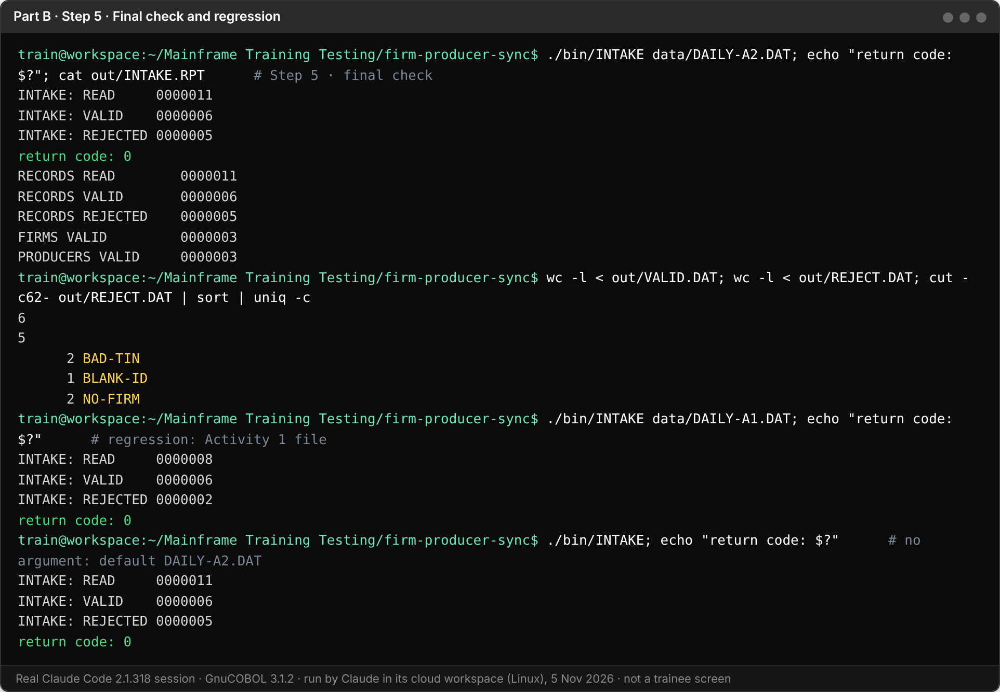

6. Commit Your Work
git add .
git commit -m "Activity 2: producers, TIN rule, firm reference, control counts"
git log --oneline

Screenshot — Commit Output
Paste your git log --oneline screenshot below
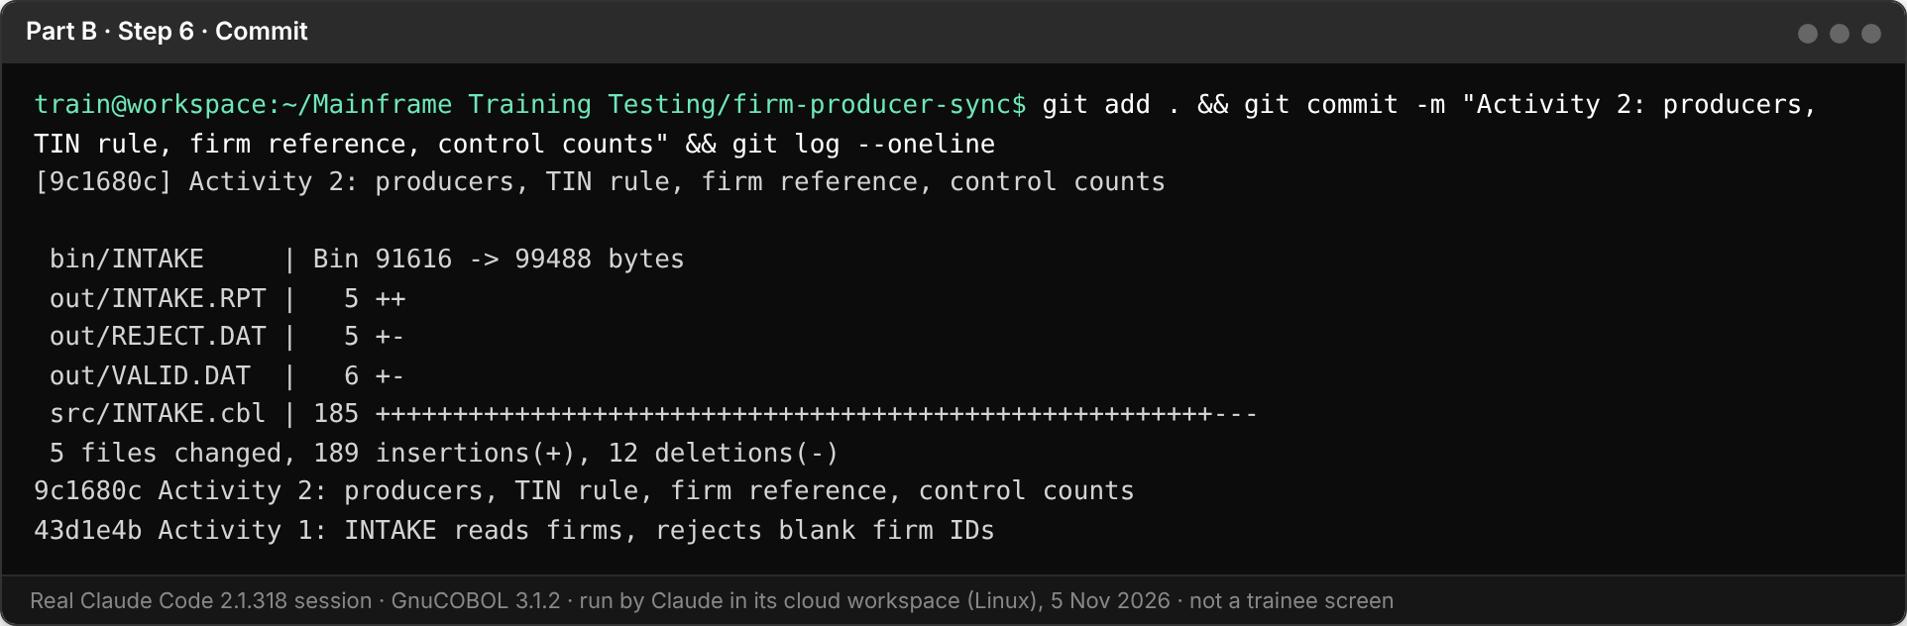

Reflection
1. Where did the human checkpoint in Step 3 catch something Claude had wrong or missed?
FACILITATOR ANSWER
It caught the report lines. Claude planned READ, VALID, REJECTED, BAD-TIN and NO-FIRM instead of FIRMS VALID and PRODUCERS VALID. Without the correction, 4c would have produced a tidy five-line report that fails the Step 5 check. The checkpoint was also where its three open questions (inactive firms, blank parent, table size) got answered from the rules instead of guessed.

2. Why is one small prompt per change better than asking for all four features at once?
FACILITATOR ANSWER
Each change can be tested on its own: after 4a there were 3 rejects (1 BLANK-ID, 2 BAD-TIN), after 4b 5 rejects (2 NO-FIRM added), after 4c the five-line report. When a count is wrong, I know which change caused it, and the diff stays small.
Real examples from this run: in 4a Claude noticed that its own extra runs had overwritten out/ and reran the A2 default; in 4b its scratch overflow test first failed with status 35 because of a 100-character file-name field. Both were easy to see because each step did one thing.

3. Which Part A technique did you end up using in Part B without being told to? Where?
FACILITATOR ANSWER
Typical answers: few-shot when listing the exact reason codes in the Step 2 prompt; chain of thought when checking rule order and the table limit in Step 3; tree of thought when choosing the firm table for 4b. Any answer that links a technique to a specific step is good.

Next: your facilitator reveals the capstone. You will write a spec for all of Firm-Producer Sync and use what you practised here to build it.

