Activity 1 Answer Key
Plan Mode: build the first piece of INTAKE with PACT
About the screenshots. They come from a real run of this activity on 6 November 2026: the sheet's prompts sent to Claude Code 2.1.318, and the compile, run and git steps run in a terminal. That run was on Linux with GnuCOBOL 3.1.2, so paths use / and the window looks different from a trainee's Windows screen. Claude's wording varies between runs; the counts and files must not.
Facilitator only. Do not share with trainees. This key matches the current day0\ACTIVITY-1.docx. Every expected result below was produced by compiling and running the reference program in the appendix on data\DAILY-A1.DAT.

1. The answer at a glance
Check | Expected
Records read | 8
Records in out/VALID.DAT | 6 (FIRM0001, 0002, 0004, 0005, 0007, 0008)
Records in out/REJECT.DAT | 2, both BLANK-ID (UNNAMED TEST FIRM, SECOND UNNAMED FIRM)
Return code, normal run | 0
Return code, input file missing | 12, with message OPEN INPUT FAILED, FILE STATUS 35
VALID.DAT record length | 60 (trailing spaces may be trimmed on disk, which is normal for LINE SEQUENTIAL)
REJECT.DAT record | Original 60 bytes, one space, then BLANK-ID in columns 62-69

The one trap in the data: FIRM0004 has STATUS = I (inactive). It is still valid. Activity 1 has only one rule, the blank firm ID. If a trainee's plan rejects inactive firms, they let Claude invent a rule. That is the best catch of the whole activity.

2. Step by step

Step 1 Set up your project
- The data folder holds DAILY-A1.DAT (8 lines) and DAILY-A2.DAT (11 lines). The folders src, out and bin exist.
- git init ran without error.
- Screenshot shows: /status with the model name, the trainee's account, and a connected status.
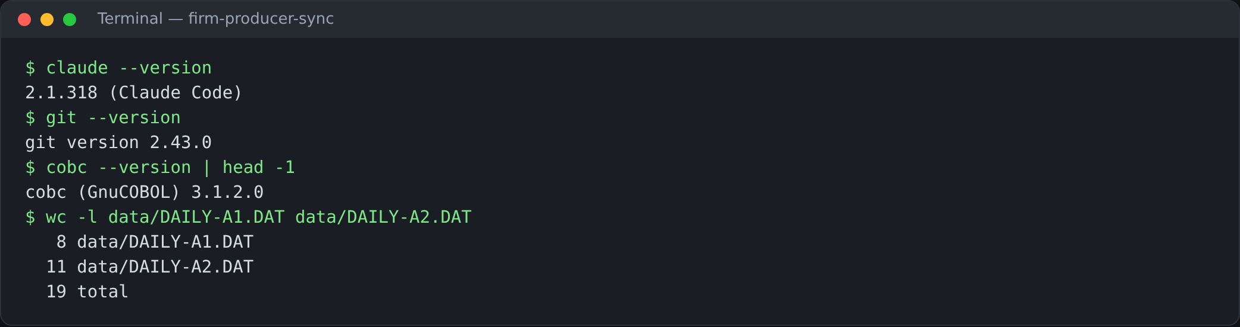
Screenshot from a real run: tool versions and the two data files (8 and 11 lines)
Watch for: a trainee who asked Claude to make up test data. Their counts will not match Step 5. Send them back to copy the real files.

Step 2 P: Plan
The prompt is given in full on the sheet, including the constraints, so every trainee sends the same prompt. A good plan from Claude looks roughly like this (wording will vary):
MODEL PLAN (what good looks like)
1. Define three files: input data/DAILY-A1.DAT, outputs out/VALID.DAT and
out/REJECT.DAT, all LINE SEQUENTIAL, each with its own FILE STATUS.
2. Describe the 60-byte record with fields REC-TYPE, ID, PARENT-ID, NAME,
TIN, STATUS, FILLER. Reject record = 60 bytes + 1 space + 8-byte reason.
3. Open the input. If FILE STATUS is not 00, display it, set RC 12, stop.
4. Open both outputs and test FILE STATUS after each OPEN.
5. Read each record until end of file.
6. If ID is spaces, write a reject record with reason BLANK-ID;
otherwise write the record to VALID.DAT.
7. Test FILE STATUS after every WRITE; RC 12 and stop if one fails.
8. Close all files, display read / valid / rejected counts, end with RC 0.

A plan passes if: it has numbered steps, no code, the exact file names, the BLANK-ID rule only, FILE STATUS after OPEN and WRITE, and return code 12.
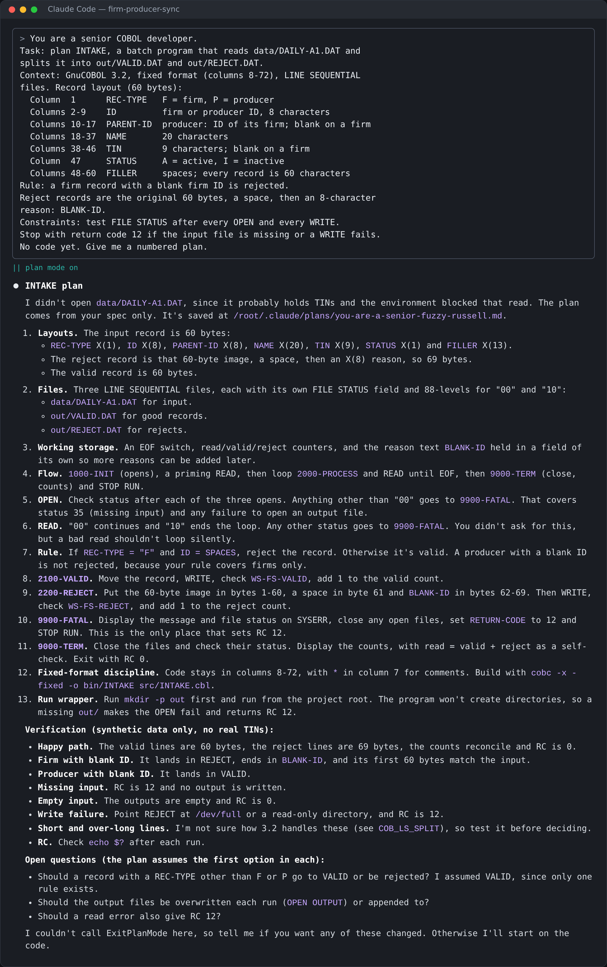
Screenshot from a real run: the sheet's Step 2 prompt in plan mode, and Claude's plan
In this run the plan was sound: firms only, BLANK-ID in bytes 62-69, FILE STATUS everywhere, RC 12. It did not clear the reject record first and asked three open questions, which the correction below dealt with.

Step 3 A: Approve
Trainees must send at least one correction. The strongest corrections, in order of value:
What to catch | Why it matters
Clear the whole reject record (MOVE SPACES) before filling it. | The unused FILLER byte between the data and the reason starts as low-values. On the training VM (GnuCOBOL 3.2) a LINE SEQUENTIAL WRITE of that record then failed with file status 71. This is the most common real failure.
Do not reject inactive firms. | STATUS is not a rule in Activity 1. If the plan mentions STATUS at all, ask why.
A firm ID of all spaces counts as blank. | In COBOL R-ID = SPACES covers both an empty and an all-spaces ID, so one test is enough. The plan should say so.
Keep the record at 60 bytes; reason starts in column 62. | Some plans write the reason straight after column 60 with no space, or trim the record.
Do not create extra files. | Claude may offer a run script, a copybook or test data. Activity 1 asks for src/INTAKE.cbl only.

MODEL CORRECTION PROMPT
Two corrections before I approve.
(1) Step 6: MOVE SPACES to the whole reject record before filling it.
The unused FILLER byte holds low-values and a LINE SEQUENTIAL WRITE
then fails with file status 71.
(2) STATUS is not a rule. An inactive firm with an ID is valid.
Show only the changed steps, one line each. No code.

(then, after reading the updated plan) Plan approved.

Model answer, "What did you change and why?": I told Claude to clear the reject record before filling it, because an uninitialised FILLER byte can make the WRITE fail with status 71. I also confirmed that inactive firms stay valid, because STATUS is not a rule in this activity.
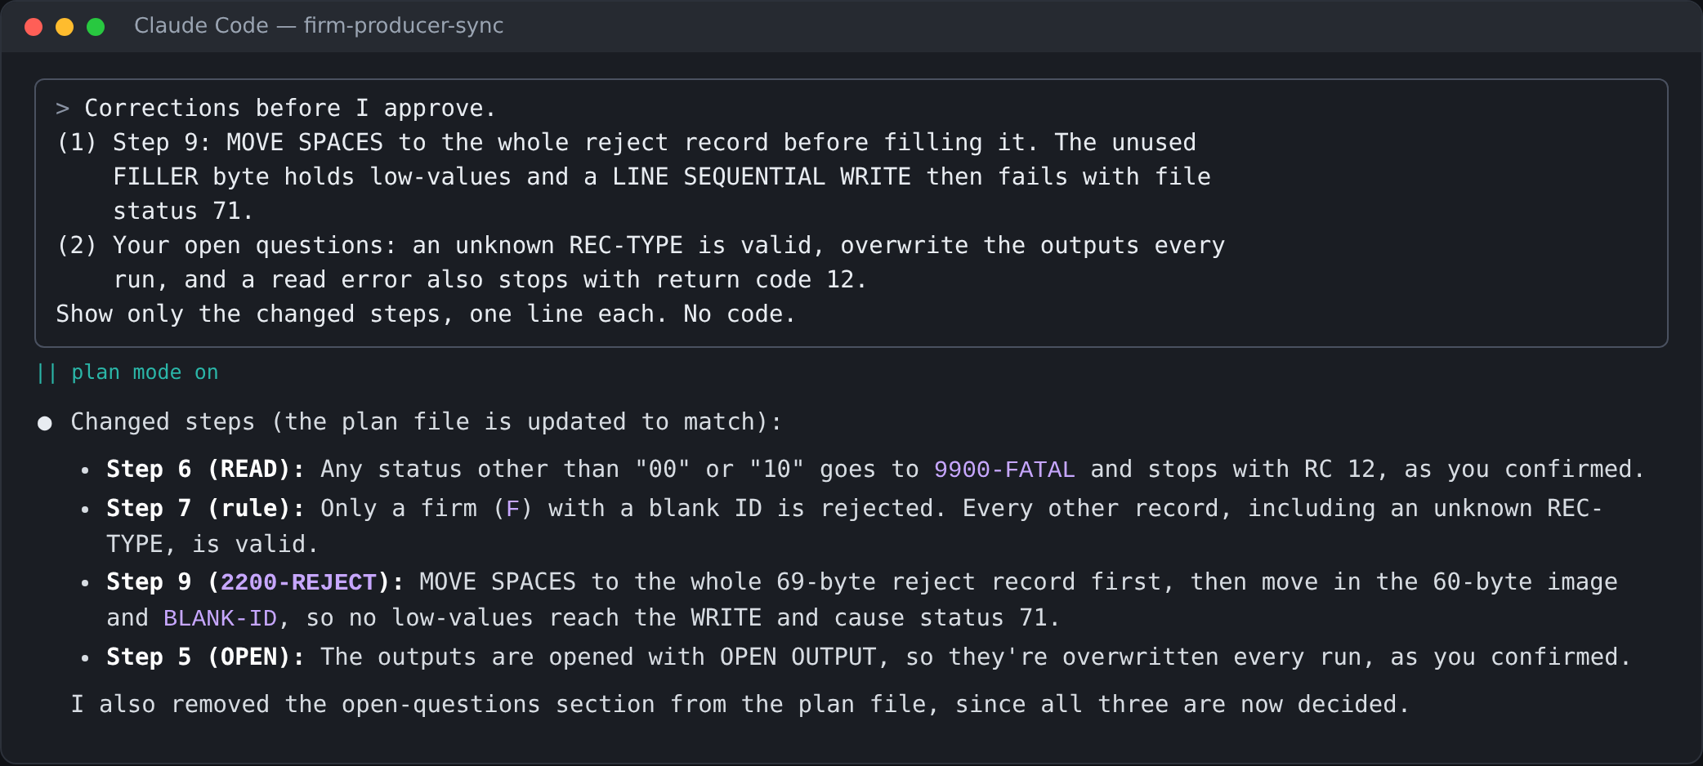
Screenshot from a real run: the correction sent in this run, and Claude's changed steps

Step 4 C: Code
Check the trainee's src/INTAKE.cbl (or /diff) against this list:
- Only src/INTAKE.cbl was created. No other files.
- Fixed format: code in columns 8-72, no tabs, no GO TO.
- SELECT ... FILE STATUS IS on all three files.
- FILE STATUS tested after every OPEN and every WRITE, with MOVE 12 TO RETURN-CODE.
- The blank test is IF R-ID = SPACES (or equivalent).
- MOVE SPACES to the reject record before the data and reason are moved in.
- Numbered paragraphs, such as 0000-MAIN, 1000-OPEN, 2000-READ, 3000-PROCESS.
The reference program in the appendix meets every item.
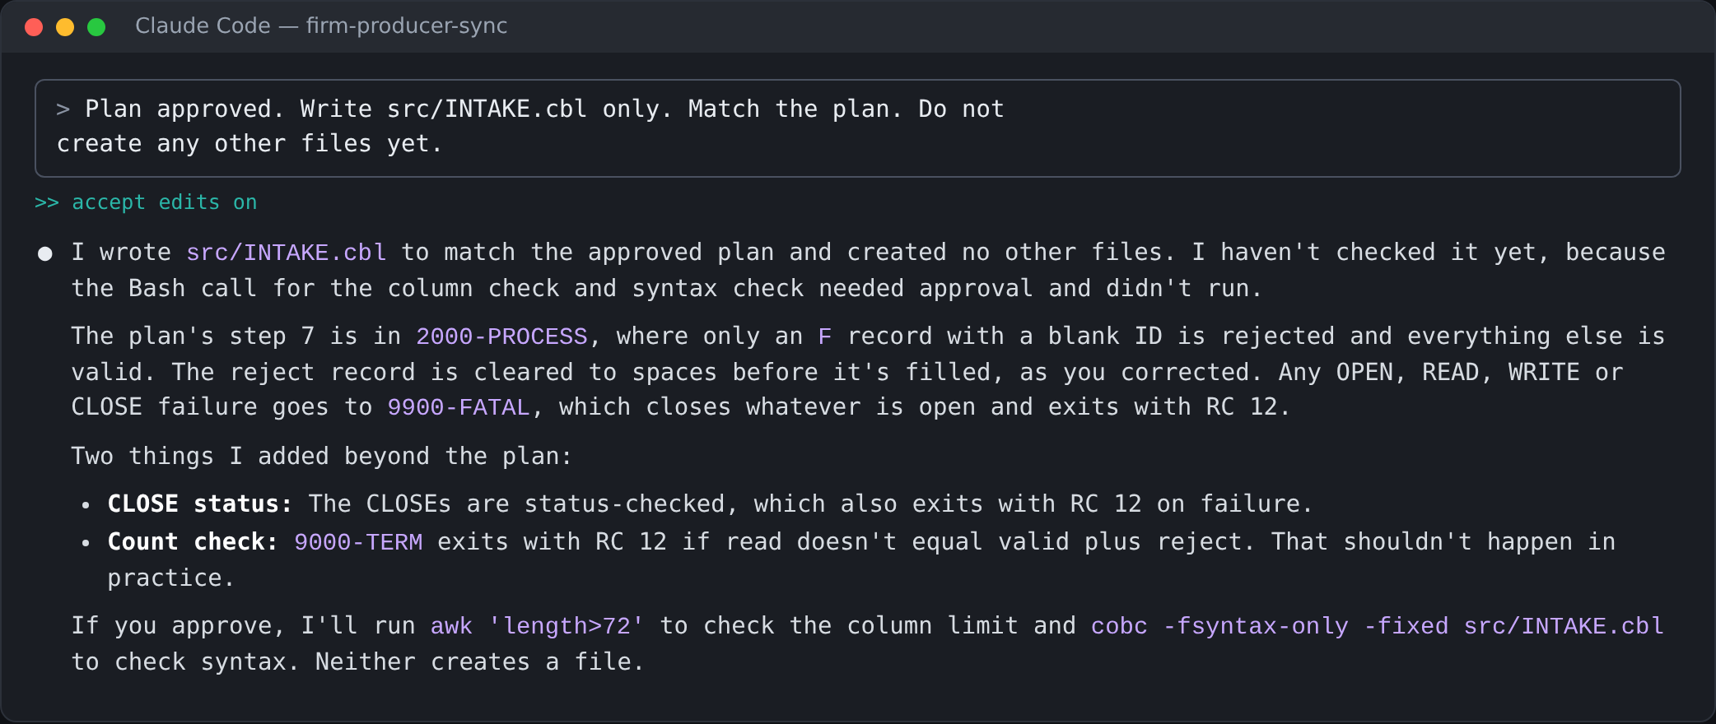
Screenshot from a real run: the Step 4 prompt and Claude's reply
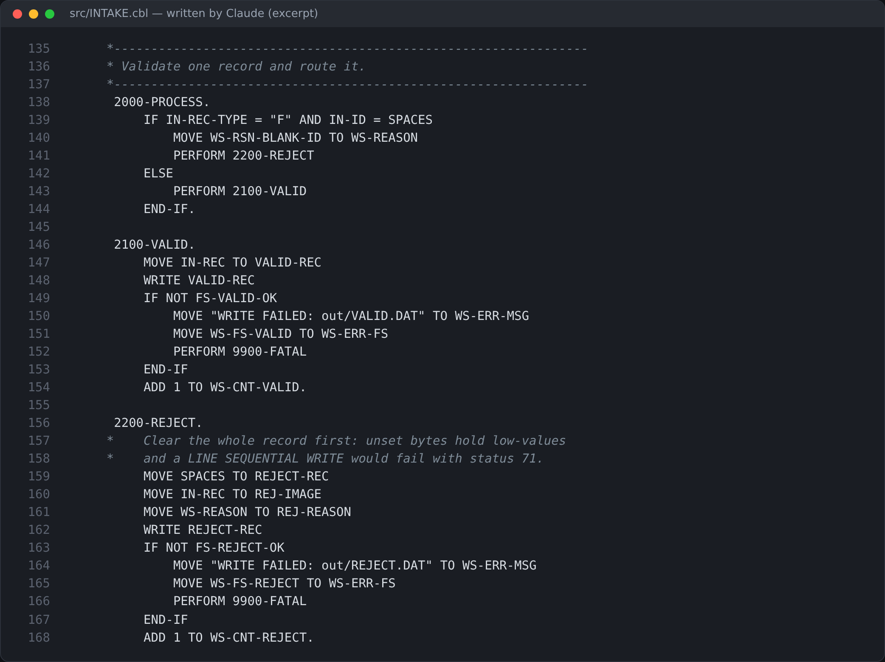
Screenshot from a real run: the routing rule and reject paragraph Claude wrote, with the MOVE SPACES fix

Step 5 T: Test
Expected terminal output:
RUN RESULT
RECORDS READ 0008
RECORDS VALID 0006
RECORDS REJECTED 0002
RC=0

out/REJECT.DAT (exact)
F UNNAMED TEST FIRM A BLANK-ID
F SECOND UNNAMED FIRM A BLANK-ID

out/VALID.DAT (exact)
FFIRM0001 NORTHWIND FIRM 01 A
FFIRM0002 NORTHWIND FIRM 02 A
FFIRM0004 NORTHWIND FIRM 04 I
FFIRM0005 NORTHWIND FIRM 05 A
FFIRM0007 NORTHWIND FIRM 07 A
FFIRM0008 NORTHWIND FIRM 08 A

The counts may display as 8 instead of 0008: either is fine. What matters is 8 / 6 / 2 and the two BLANK-ID lines.
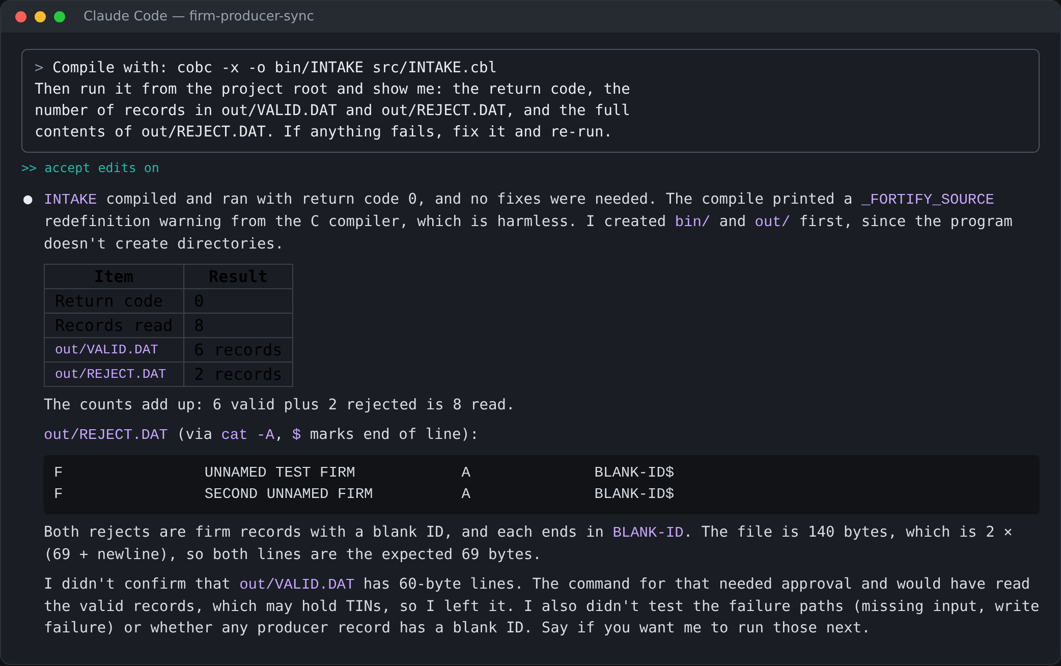
Screenshot from a real run: the Step 5 prompt; Claude compiled, ran and reported 8 / 6 / 2
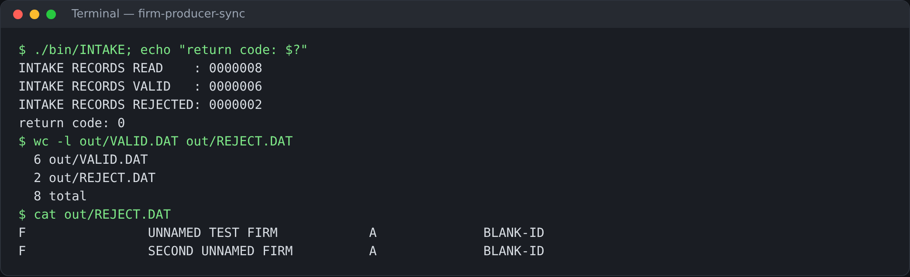
Screenshot from a real run: the same program run again in the terminal
Optional extra check for fast finishers: rename data\DAILY-A1.DAT for a moment and run again. The program must stop with return code 12 and a FILE STATUS 35 message. Rename the file back afterwards.

Step 6 Commit
git log --oneline shows at least one commit, for example Activity 1: INTAKE reads firms, rejects blank firm IDs. The out/ files may or may not be committed; either is acceptable today.
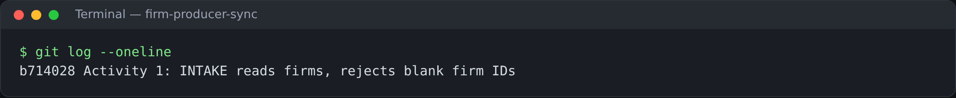
Screenshot from a real run: git log after the Activity 1 commit

3. Common problems and fixes
Symptom | Cause | What to tell the trainee
Run stops with WRITE REJECT FAILED, status 71 | Reject record not cleared; low-values in the FILLER byte | Paste the error to Claude and ask it to MOVE SPACES to the whole reject record first.
VALID 5, REJECT 3 | FIRM0004 (inactive) rejected | Ask: which rule rejects FIRM0004? There is none.
OPEN fails, status 35 | Run from the wrong folder, or data file not copied | Run from the project root; check data\DAILY-A1.DAT exists.
OPEN VALID FAILED, status 30 | The out folder does not exist | Create the out folder, then run again.
Counts differ from 8 / 6 / 2 | Claude created its own test data | Copy the real DAILY-A1.DAT from the package.
cobc not recognised, or return status 1 | Compiler not on PATH | See the runbook, section 5.

Appendix: reference program
Also saved as facilitator-only\day0-reference\INTAKE-A1.cbl. Compile with cobc -x -o bin/INTAKE src/INTAKE.cbl and run from the project root.
src/INTAKE.cbl (Activity 1 reference)
* INTAKE - ACTIVITY 1 ANSWER KEY. FIRMS ONLY.
* RULE: A FIRM WITH A BLANK FIRM ID IS REJECTED (BLANK-ID).
* GNUCOBOL 3.2, FIXED FORMAT. RUN FROM THE PROJECT ROOT.
IDENTIFICATION DIVISION.
PROGRAM-ID. INTAKE.
ENVIRONMENT DIVISION.
INPUT-OUTPUT SECTION.
FILE-CONTROL.
SELECT DAILY-IN ASSIGN TO "data/DAILY-A1.DAT"
ORGANIZATION IS LINE SEQUENTIAL
FILE STATUS IS FS-IN.
SELECT VALID-OUT ASSIGN TO "out/VALID.DAT"
ORGANIZATION IS LINE SEQUENTIAL
FILE STATUS IS FS-VALID.
SELECT REJECT-OUT ASSIGN TO "out/REJECT.DAT"
ORGANIZATION IS LINE SEQUENTIAL
FILE STATUS IS FS-REJECT.
DATA DIVISION.
FILE SECTION.
FD DAILY-IN.
01 IN-REC PIC X(60).
FD VALID-OUT.
01 VALID-REC PIC X(60).
FD REJECT-OUT.
01 REJECT-REC.
05 REJ-DATA PIC X(60).
05 FILLER PIC X.
05 REJ-REASON PIC X(8).
WORKING-STORAGE SECTION.
01 FS-IN PIC XX.
01 FS-VALID PIC XX.
01 FS-REJECT PIC XX.
01 WS-EOF PIC X VALUE "N".
01 WS-REC.
05 R-TYPE PIC X.
05 R-ID PIC X(8).
05 R-PARENT PIC X(8).
05 R-NAME PIC X(20).
05 R-TIN PIC X(9).
05 R-STATUS PIC X.
05 FILLER PIC X(13).
01 WS-REASON PIC X(8).
01 WS-CNT-READ PIC 9(4) VALUE 0.
01 WS-CNT-VALID PIC 9(4) VALUE 0.
01 WS-CNT-REJECT PIC 9(4) VALUE 0.
PROCEDURE DIVISION.
0000-MAIN.
PERFORM 1000-OPEN
PERFORM 2000-READ
PERFORM UNTIL WS-EOF = "Y"
PERFORM 3000-PROCESS
PERFORM 2000-READ
END-PERFORM
CLOSE DAILY-IN VALID-OUT REJECT-OUT
DISPLAY "RECORDS READ " WS-CNT-READ
DISPLAY "RECORDS VALID " WS-CNT-VALID
DISPLAY "RECORDS REJECTED " WS-CNT-REJECT
STOP RUN.
1000-OPEN.
OPEN INPUT DAILY-IN
IF FS-IN NOT = "00"
DISPLAY "OPEN INPUT FAILED, FILE STATUS " FS-IN
MOVE 12 TO RETURN-CODE
STOP RUN
END-IF
OPEN OUTPUT VALID-OUT
IF FS-VALID NOT = "00"
DISPLAY "OPEN VALID FAILED, FILE STATUS " FS-VALID
MOVE 12 TO RETURN-CODE
STOP RUN
END-IF
OPEN OUTPUT REJECT-OUT
IF FS-REJECT NOT = "00"
DISPLAY "OPEN REJECT FAILED, FILE STATUS " FS-REJECT
MOVE 12 TO RETURN-CODE
STOP RUN
END-IF.
2000-READ.
READ DAILY-IN INTO WS-REC
AT END MOVE "Y" TO WS-EOF
NOT AT END ADD 1 TO WS-CNT-READ
END-READ.
3000-PROCESS.
MOVE SPACES TO WS-REASON
* R-ID = SPACES IS TRUE FOR AN EMPTY ID AND FOR ALL SPACES.
IF R-ID = SPACES
MOVE "BLANK-ID" TO WS-REASON
END-IF
IF WS-REASON = SPACES
WRITE VALID-REC FROM WS-REC
IF FS-VALID NOT = "00"
DISPLAY "WRITE VALID FAILED, FILE STATUS " FS-VALID
MOVE 12 TO RETURN-CODE
STOP RUN
END-IF
ADD 1 TO WS-CNT-VALID
ELSE
PERFORM 3900-WRITE-REJECT
END-IF.
3900-WRITE-REJECT.
* CLEAR THE WHOLE RECORD FIRST: THE UNUSED FILLER BYTE HOLDS
* LOW-VALUES AND MAKES A LINE SEQUENTIAL WRITE FAIL (STATUS 71).
MOVE SPACES TO REJECT-REC
MOVE WS-REC TO REJ-DATA
MOVE WS-REASON TO REJ-REASON
WRITE REJECT-REC
IF FS-REJECT NOT = "00"
DISPLAY "WRITE REJECT FAILED, FILE STATUS " FS-REJECT
MOVE 12 TO RETURN-CODE
STOP RUN
END-IF
ADD 1 TO WS-CNT-REJECT.

