Activity 2 Answer Key
Prompt Chaining: grow INTAKE with a chain of small, checked prompts
About the screenshots. They come from a real run of this activity on 6 November 2026: the sheet's prompts sent to Claude Code 2.1.318, and the compile, run and git steps run in a terminal. That run was on Linux with GnuCOBOL 3.1.2, so paths use / and the window looks different from a trainee's Windows screen. Claude's wording varies between runs; the counts and files must not.
Facilitator only. Do not share with trainees. This key matches the current day0\ACTIVITY-2.docx. Every expected result below was produced by compiling and running the reference program (appendix) and its stage versions on data\DAILY-A2.DAT and data\DAILY-A1.DAT. The final output matches the saved evidence in firm-producer-sync-key\evidence.

1. The answer at a glance
Check | Expected
out/INTAKE.RPT | RECORDS READ 11, RECORDS VALID 6, RECORDS REJECTED 5, FIRMS VALID 3, PRODUCERS VALID 3
Records in out/VALID.DAT | 6: FIRM0001, FIRM0002, FIRM0004, PROD0001, PROD0002, PROD0006
Records in out/REJECT.DAT | 5: one BLANK-ID, two BAD-TIN, two NO-FIRM
Read = valid + rejected | 11 = 6 + 5
Re-run on DAILY-A1.DAT | READ 8, VALID 6, REJECTED 2, FIRMS VALID 6, PRODUCERS VALID 0
Return code | 0 on both files

2. Record by record
Use this table when a trainee's counts are wrong: find the record their program got wrong, and ask them which rule decides it.
# | Record | Result | Why
1 | F FIRM0001 | Valid | Firm with an ID.
2 | F FIRM0002 | Valid | Firm with an ID.
3 | F (blank ID) | Reject BLANK-ID | Same rule as Activity 1.
4 | F FIRM0004 (inactive) | Valid | Trap. STATUS is not a rule. FIRM0004 must stay valid, and so must its producer PROD0006.
5 | P PROD0001, firm FIRM0001 | Valid | TIN 990000001 is 9 digits; FIRM0001 is a valid earlier firm.
6 | P PROD0002, firm FIRM0001 | Valid | Same as above.
7 | P PROD0003, TIN 99000ABCD | Reject BAD-TIN | Letters in the TIN. Its firm FIRM0002 is valid, so this proves the TIN rule is checked first.
8 | P PROD0004, TIN 99000003 (space) | Reject BAD-TIN | Trap. Only 8 digits plus a trailing space. A program that trims or ignores spaces wrongly accepts it.
9 | P PROD0005, firm FIRM0009 | Reject NO-FIRM | FIRM0009 is not in the file.
10 | P PROD0006, firm FIRM0004 | Valid | FIRM0004 is inactive but valid (record 4).
11 | P PROD0007, blank firm | Reject NO-FIRM | Trap. The blank-ID firm (record 3) was rejected. If rejected firms go into the firm table, a blank parent matches the blank ID and PROD0007 is wrongly accepted.

3. Step by step

Before you start
(Get-Content data\DAILY-A2.DAT).Count prints 11. If not, the trainee needs to copy the file from the package again.
Important set-up point: the Activity 1 program reads data/DAILY-A1.DAT by a fixed name. Activity 2 needs it to read DAILY-A2.DAT, and Step 5 runs it on both files. The cleanest fix is to take the input file name from the command line with a default of data/DAILY-A2.DAT. Good trainees raise this in Step 2 or 3; if nobody does, it appears in the model correction below.

Step 1 Understand (no code)
A good summary has these points. Check that Claude changed no files.
- Input data/DAILY-A1.DAT; outputs out/VALID.DAT and out/REJECT.DAT; all LINE SEQUENTIAL with FILE STATUS.
- 60-byte record: REC-TYPE, ID, PARENT-ID, NAME, TIN, STATUS, FILLER.
- A firm is valid if its ID is not spaces; otherwise it is rejected with BLANK-ID.
- Valid records are copied as-is; reject records are the 60 bytes, a space, and the 8-byte reason.
- FILE STATUS tested after OPEN and WRITE; return code 12 on failure.
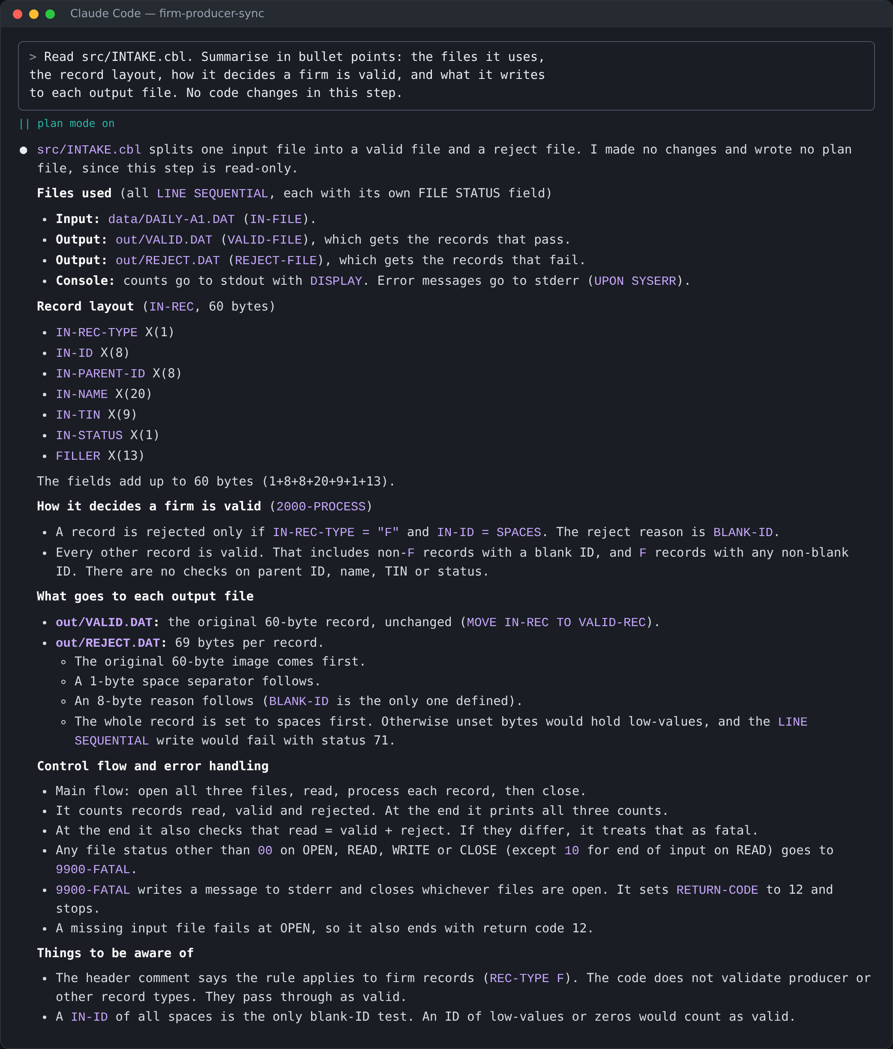
Screenshot from a real run: the Step 1 prompt in a fresh session, and Claude's summary

Step 2 Map the changes (no code)
MODEL CHANGE LIST
1. Input file name: take it from the command line, default data/DAILY-A2.DAT.
2. New file RPT-OUT for out/INTAKE.RPT, with FILE STATUS and an OPEN check.
3. 3000-PROCESS: branch on REC-TYPE - F to the firm check, P to the producer check.
4. 3100-CHECK-FIRM: unchanged rule; also store each VALID firm ID in a table.
5. New 3200-CHECK-PRODUCER: TIN rule first (BAD-TIN), then firm reference (NO-FIRM).
6. New 3210-FIND-FIRM: search the table of valid firm IDs.
7. New counters: read, valid, rejected, firms valid, producers valid.
8. New 4000-REPORT: write the five lines of INTAKE.RPT.
How it remembers firms: a WORKING-STORAGE table (OCCURS) of valid firm IDs.

A good question to add in the [bracket]: "How will the program remember the firms it has already seen?" The answer should be a table in WORKING-STORAGE that holds only valid firms.
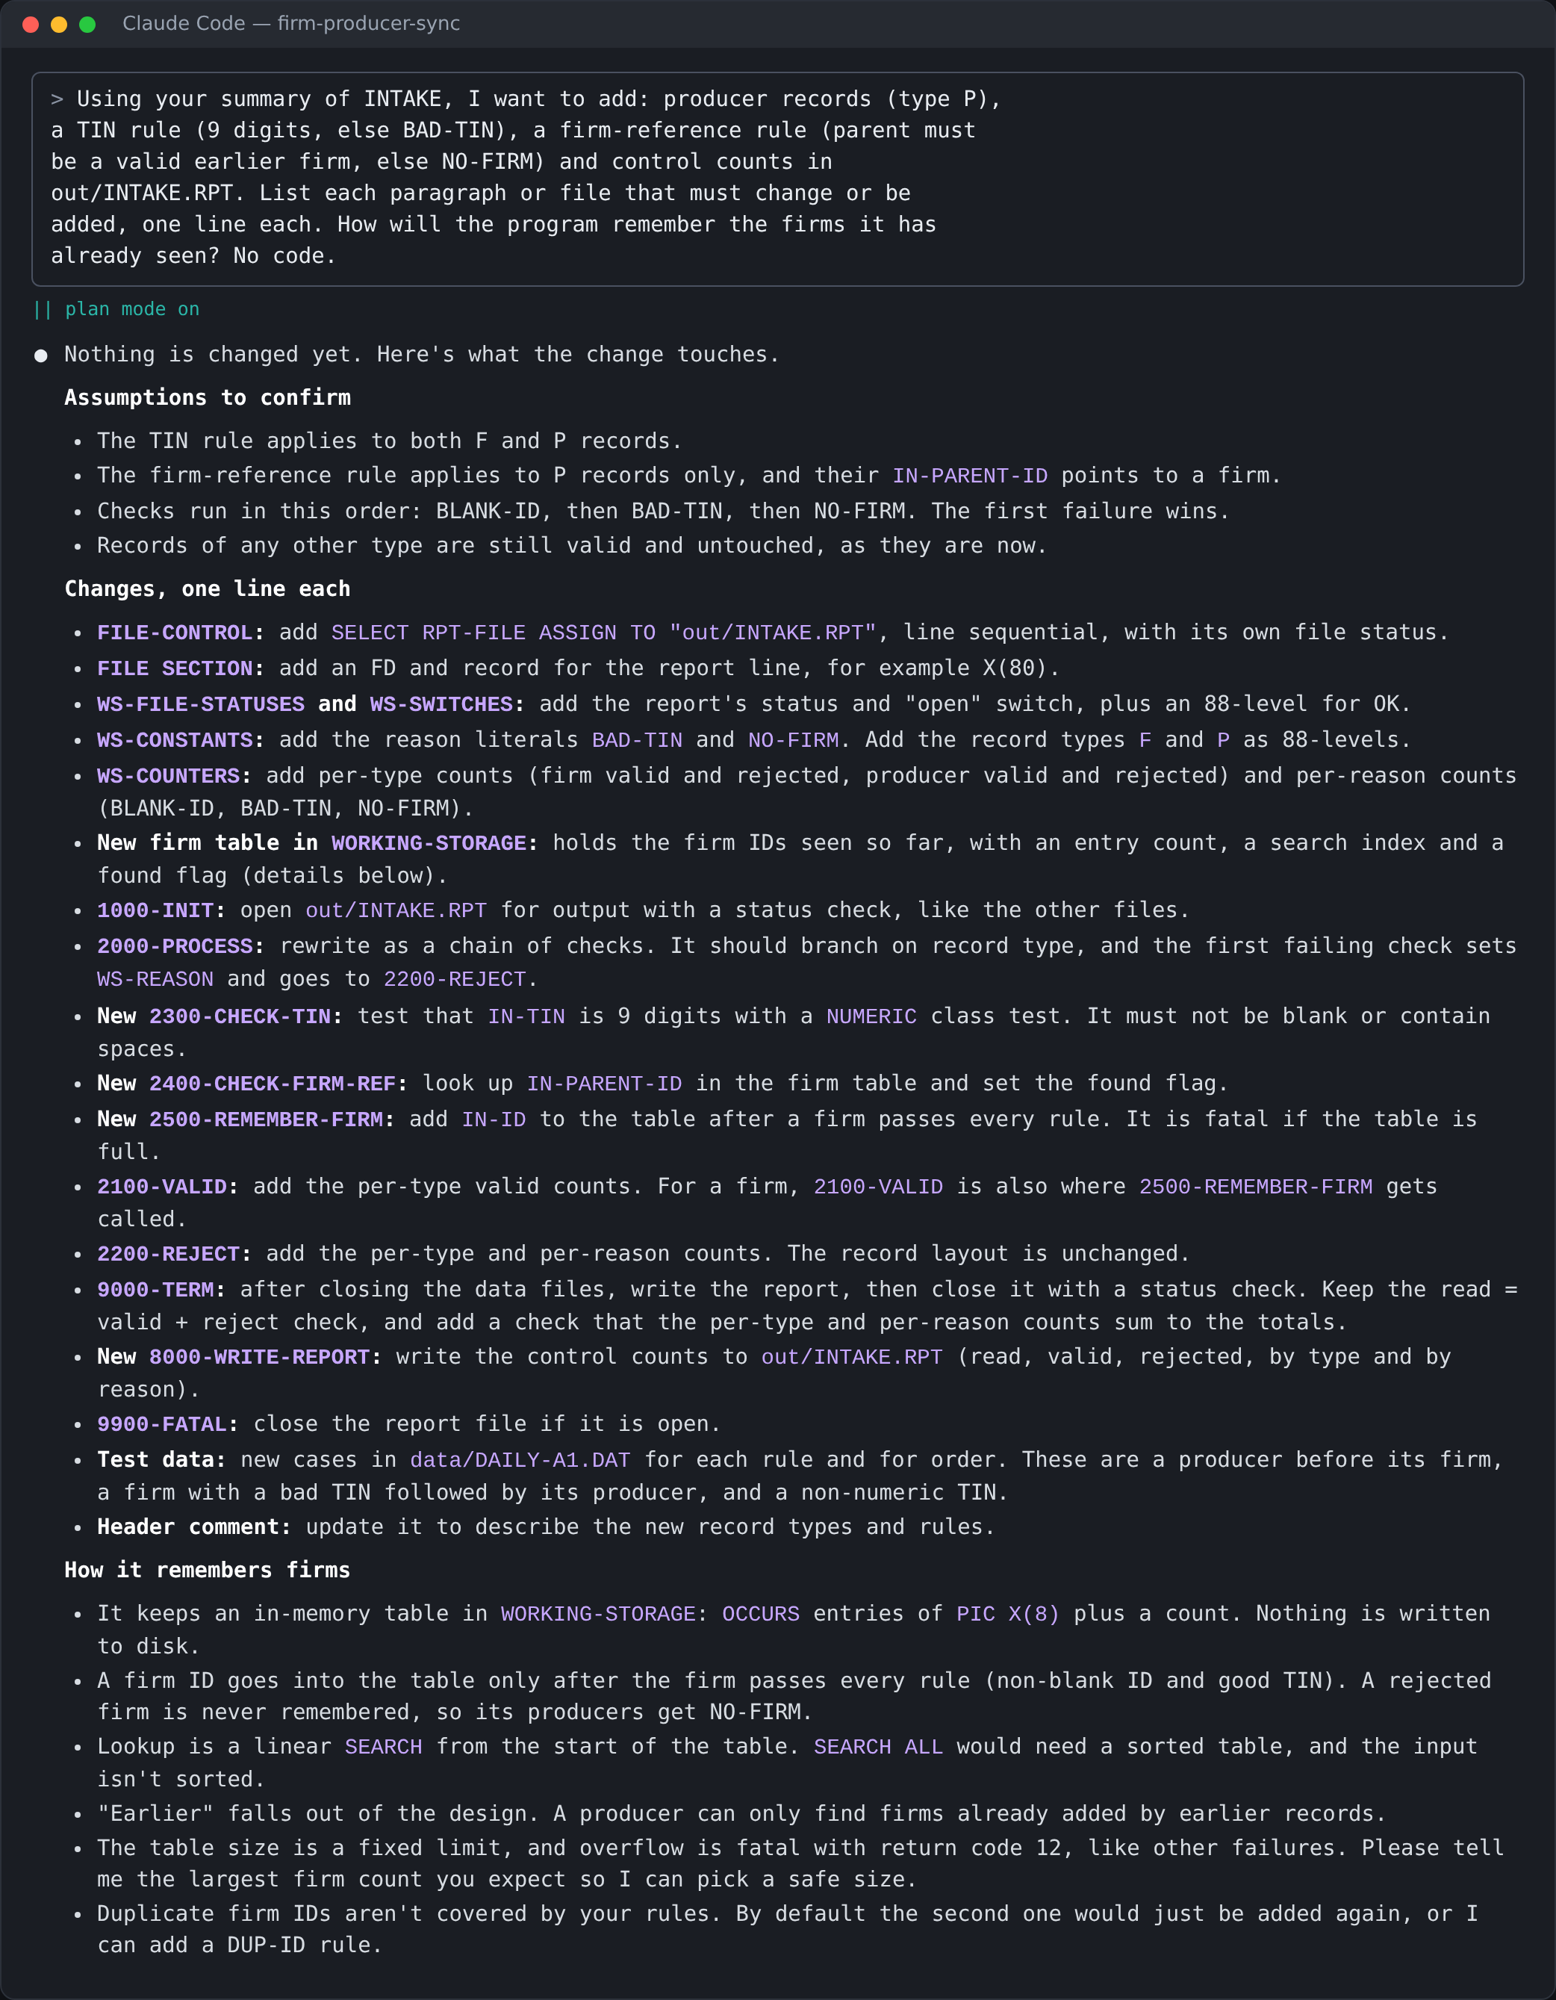
Screenshot from a real run: the Step 2 prompt and Claude's change list
What happened in the real run: Claude assumed the TIN rule applies to firms too (every firm would become BAD-TIN), planned per-type and per-reason report lines, and planned to add records to the test data. These are exactly the mistakes Step 3 exists to catch. Use this screenshot in the debrief.

Step 3 Plan, then STOP and approve
Check Claude's plan against the rules. These are the corrections most often needed, most important first:
What to catch | Why it matters
Only valid firms go into the firm table. | Otherwise the rejected blank-ID firm is in the table and PROD0007 (blank parent) is wrongly accepted. Record 11 above.
For a producer, check the TIN first, then the firm. | The sheet says so. PROD0003 has a valid firm but a bad TIN: it must be BAD-TIN, not valid.
The TIN rule is for producers only. | A firm's TIN is blank. If the plan checks every record's TIN, every firm becomes BAD-TIN.
INTAKE.RPT has exactly five lines. | Claude often adds per-reason or per-type lines. Step 5 compares exactly five.
Take the input file name from the command line. | Needed to run on both DAILY-A2.DAT and DAILY-A1.DAT in Step 5.
STATUS is still not a rule. | FIRM0004 and PROD0006 must stay valid.

MODEL CORRECTION PROMPT
Corrections before I approve.
(1) The TIN rule applies to producers only: a firm's TIN is blank,
so never check a firm's TIN.
(2) INTAKE.RPT has exactly five lines: RECORDS READ, RECORDS VALID,
RECORDS REJECTED, FIRMS VALID, PRODUCERS VALID. No extra lines.
(3) Only valid firms go into the table, and for a producer the TIN
rule is checked first, then the firm reference.
(4) Take the input file name from the command line, default
data/DAILY-A2.DAT, so I can also run it on DAILY-A1.DAT.
Show the corrected plan as at most 6 one-line steps. No code.

(then, after reading the corrected plan) Plan approved.

Model answer, "What did you correct, and why?": Claude planned to store every firm in the table, including rejected ones, so a producer with a blank parent would have matched the rejected blank-ID firm. I told it to store only valid firms and to check the TIN before the firm reference, as the rules say.
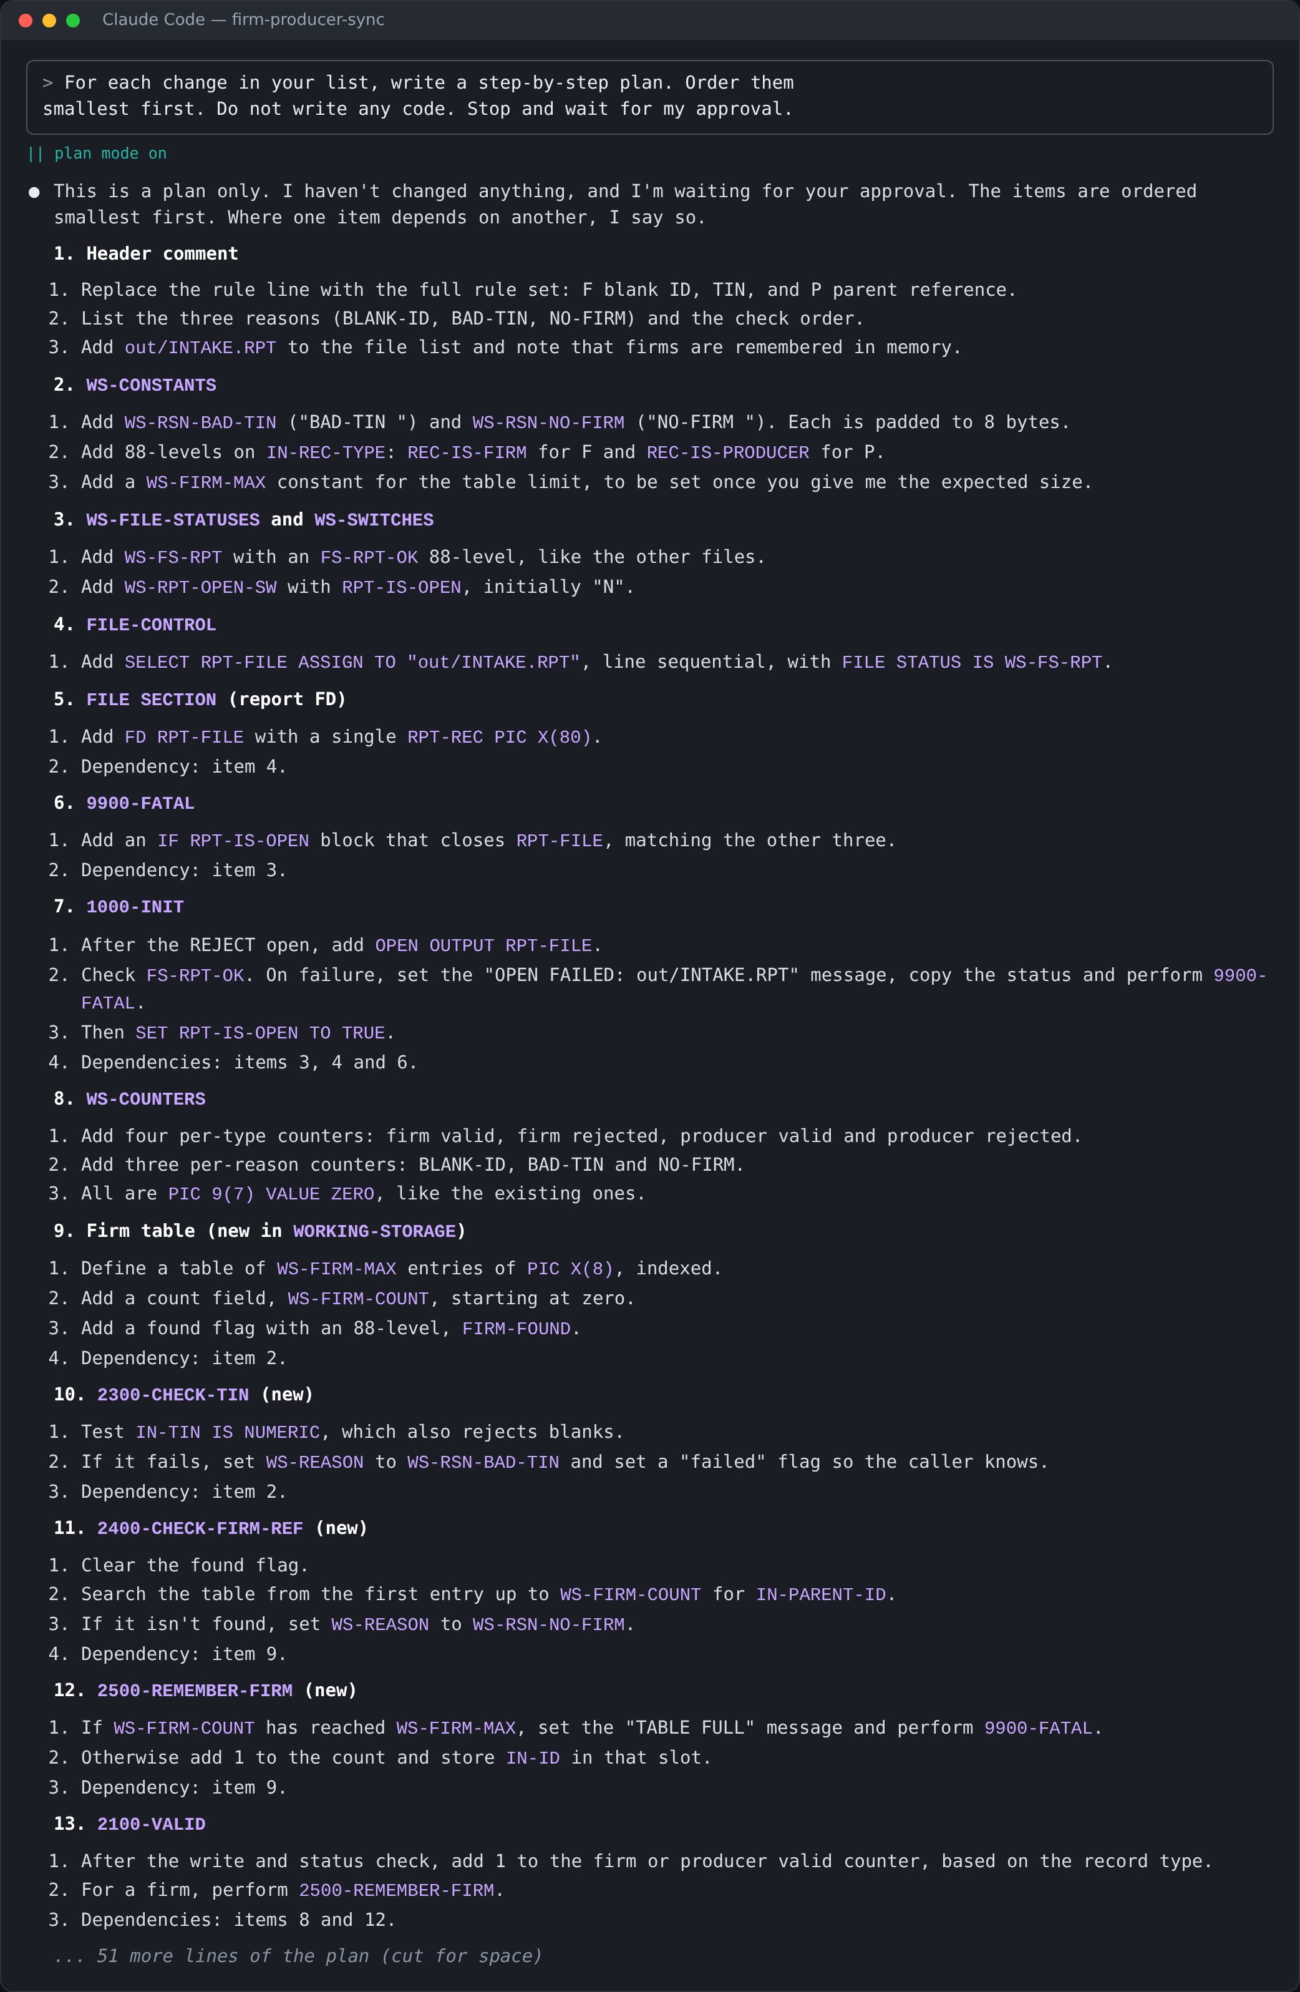
Screenshot from a real run: the Step 3 prompt and the start of Claude's plan (18 items; cut for space)
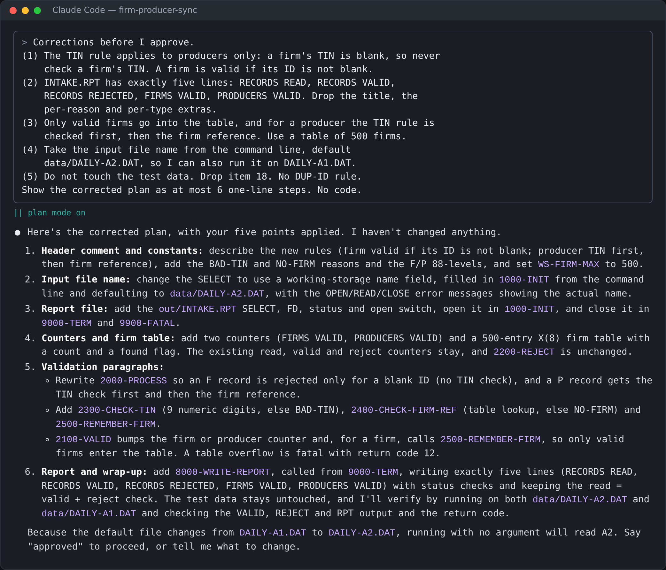
Screenshot from a real run: the correction sent in this run, and the corrected 6-step plan

Step 4 Implement one change at a time
Each change compiles and runs on its own. These are the exact results after each step, from the stage programs:
After | Run result | out/REJECT.DAT
4a Producers and TIN rule | READ 11, VALID 8, REJECTED 3 | BLANK-ID (unnamed firm)  BAD-TIN (PROD0003)  BAD-TIN (PROD0004)
4b Firm-reference rule | READ 11, VALID 6, REJECTED 5 | As 4a, plus  NO-FIRM (PROD0005)  NO-FIRM (PROD0007)
4c Control counts | Same as 4b | Same as 4b; INTAKE.RPT now has five lines

Note on 4a: after 4a, PROD0005 and PROD0007 are still valid, because the firm-reference rule does not exist yet. That is correct for this stage. A trainee who sees them in VALID.DAT at 4a has not made a mistake.
MODEL PROMPTS (the sheet's pattern, filled in)
4a: The plan is approved. Implement change 1 only: producer records (type P)
with the TIN rule, and the input file name from the command line
(default data/DAILY-A2.DAT). Do not touch anything else. Compile with
cobc -x -o bin/INTAKE src/INTAKE.cbl, run it on data/DAILY-A2.DAT, and
show me out/REJECT.DAT.

4b: ... Implement change 2 only: the firm-reference rule and the table of
valid firms it needs. ... show me out/REJECT.DAT.

4c: ... Implement change 3 only: the control counts in out/INTAKE.RPT,
exactly five lines. ... show me out/INTAKE.RPT.
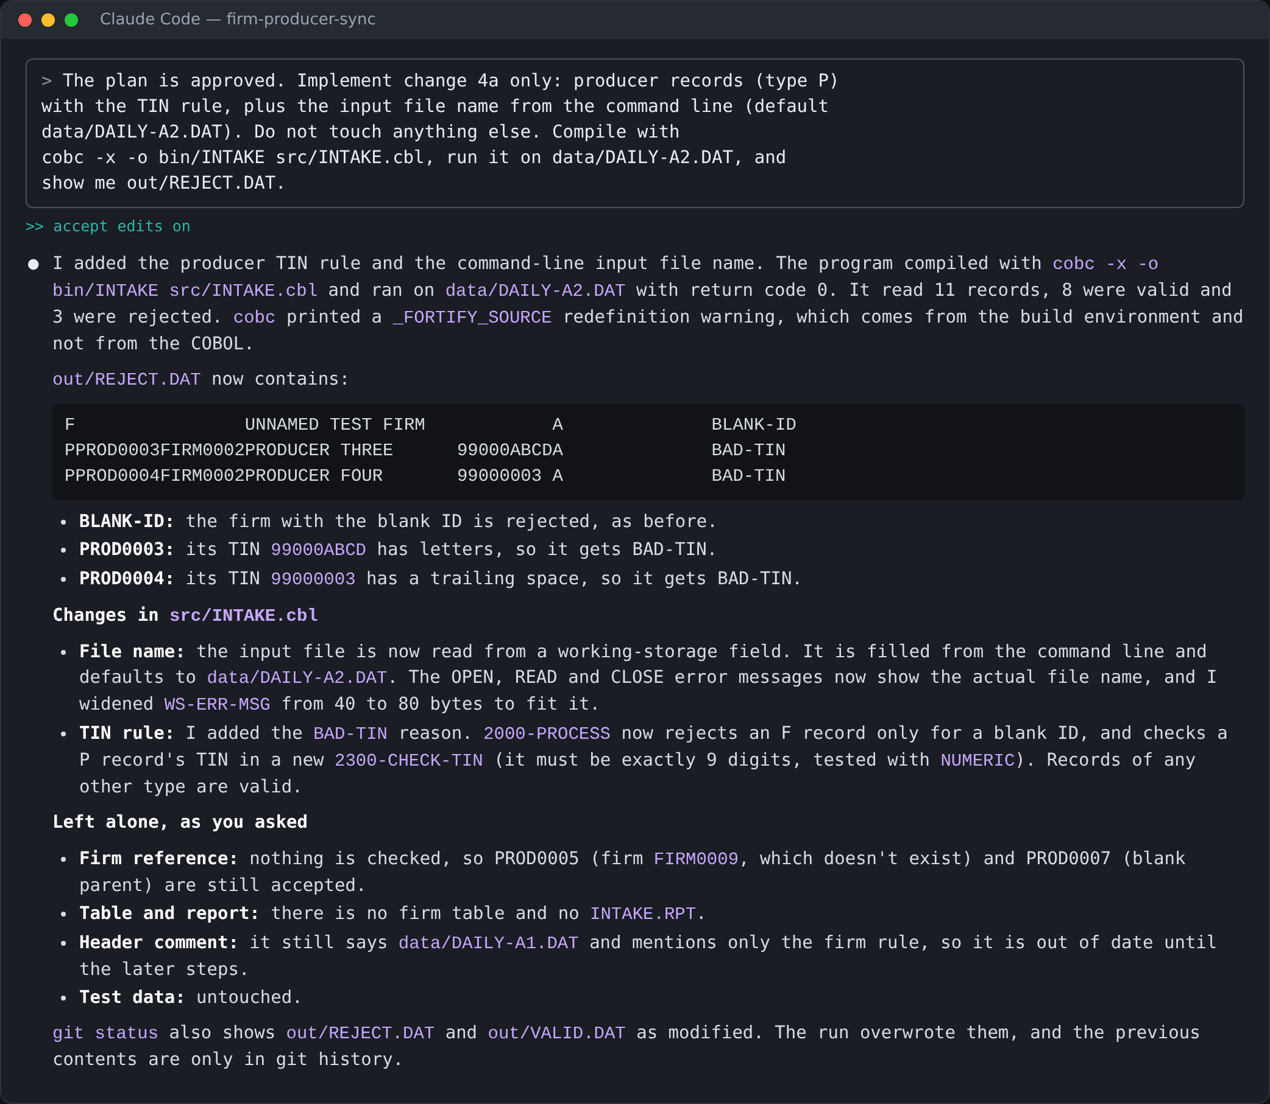
Screenshot from a real run: 4a: producers and the TIN rule. VALID 8, REJECT 3
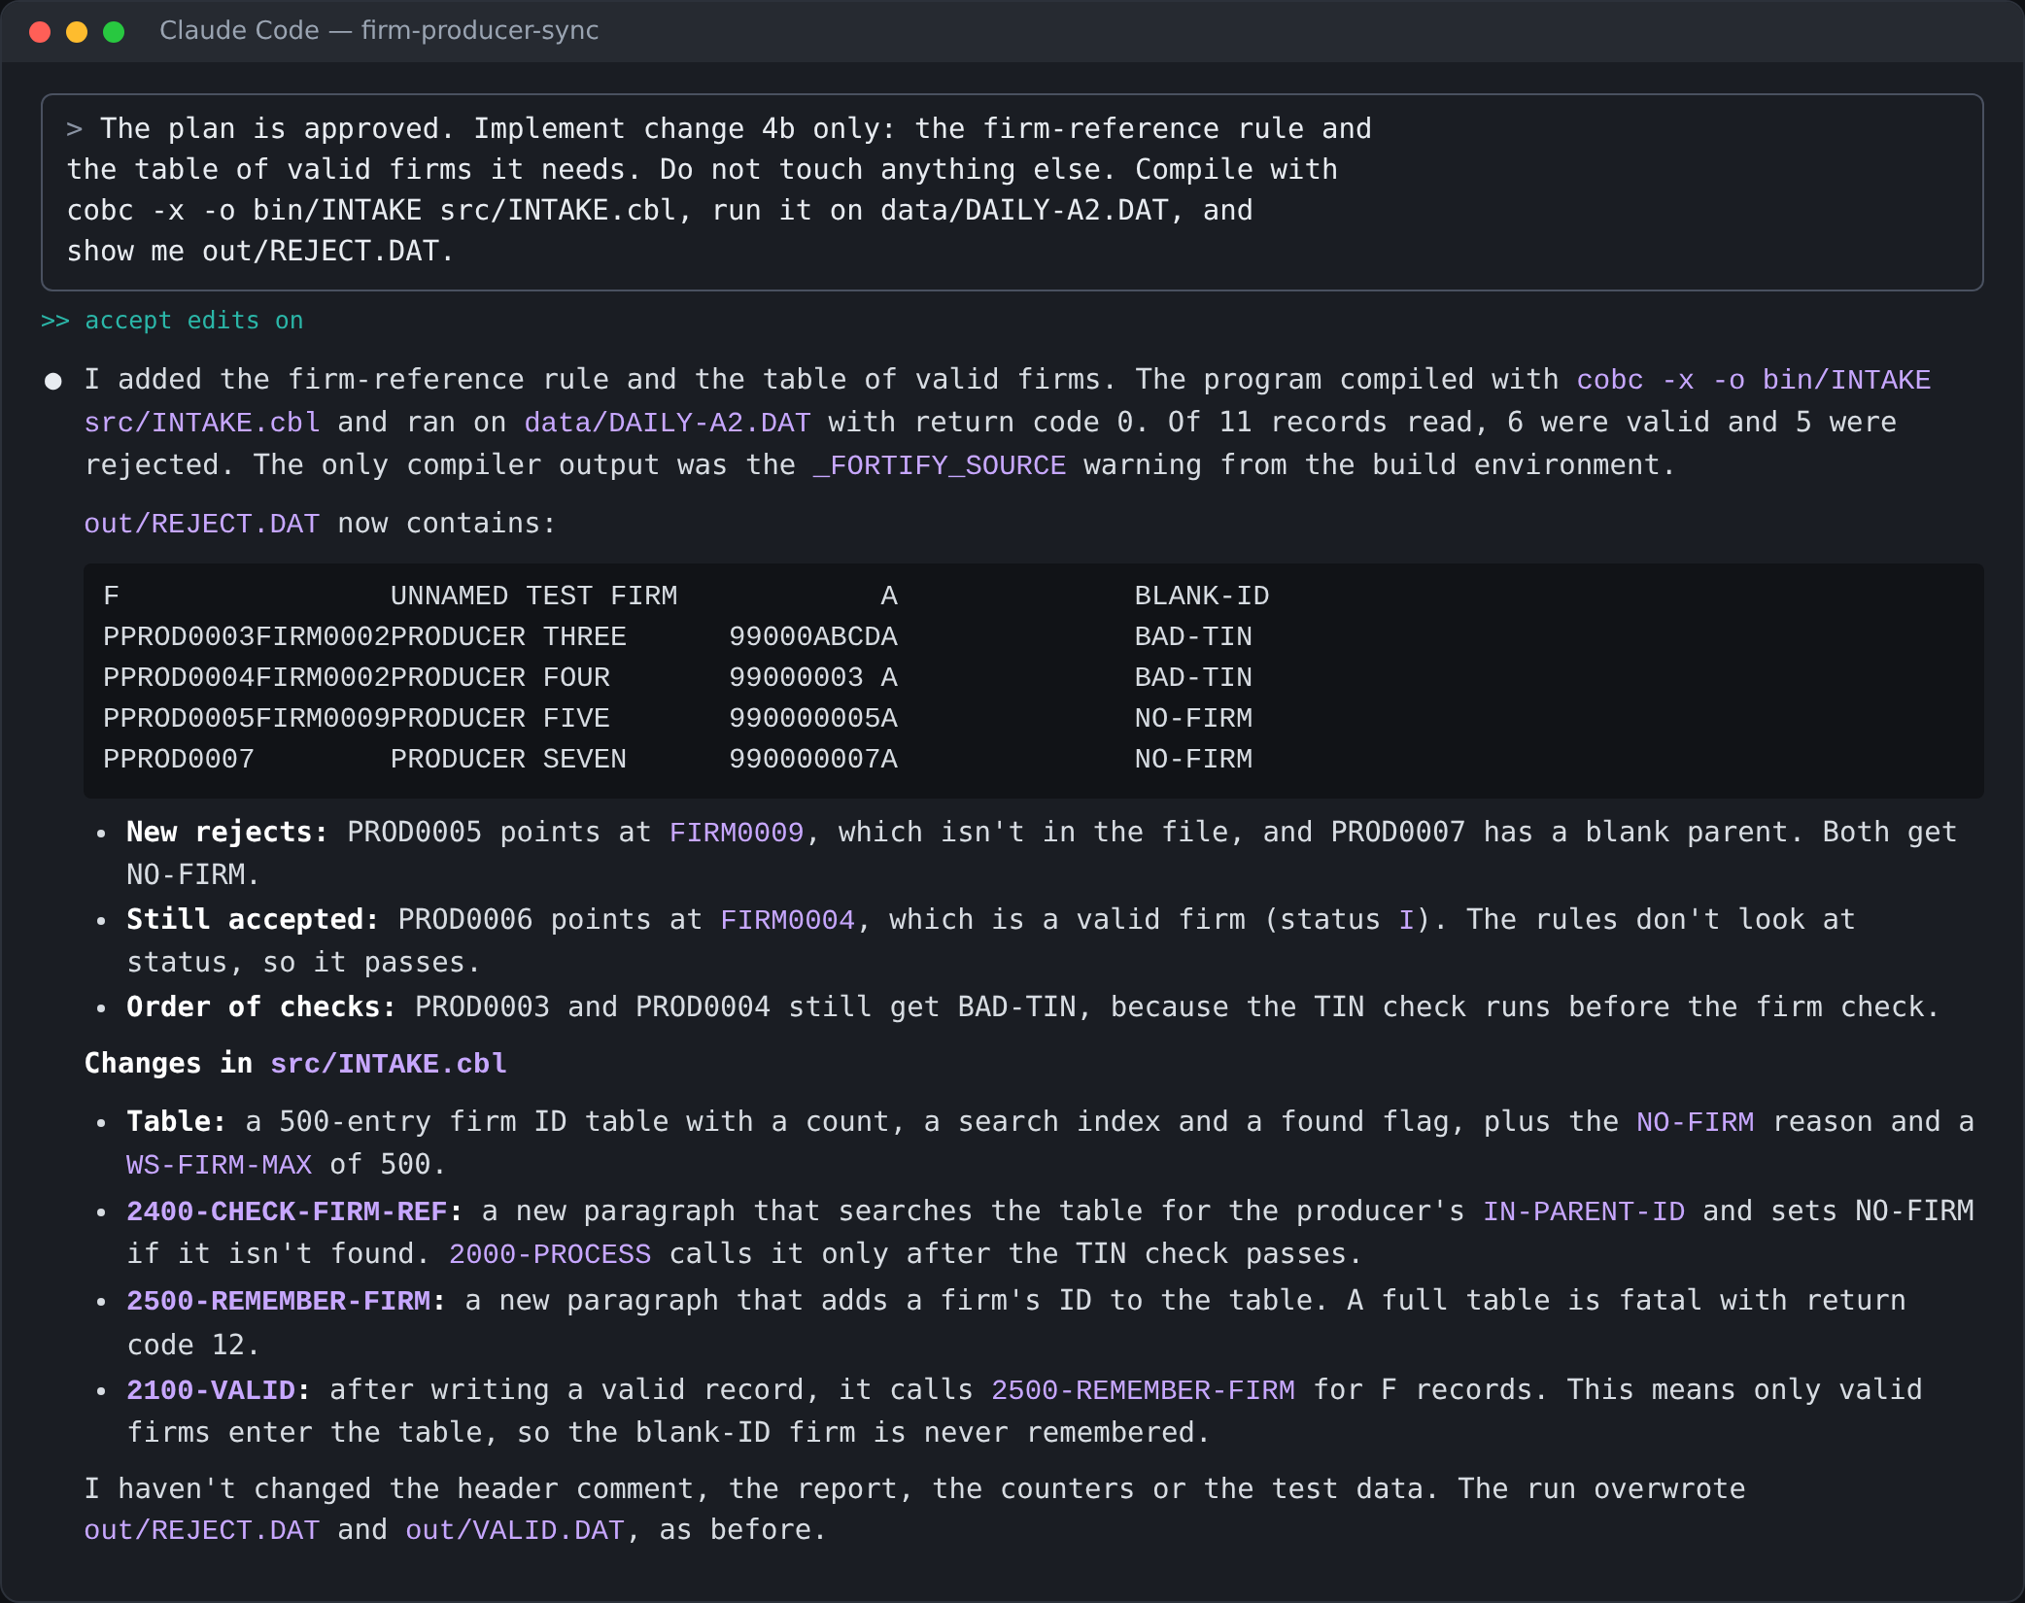
Screenshot from a real run: 4b: the firm-reference rule. VALID 6, REJECT 5
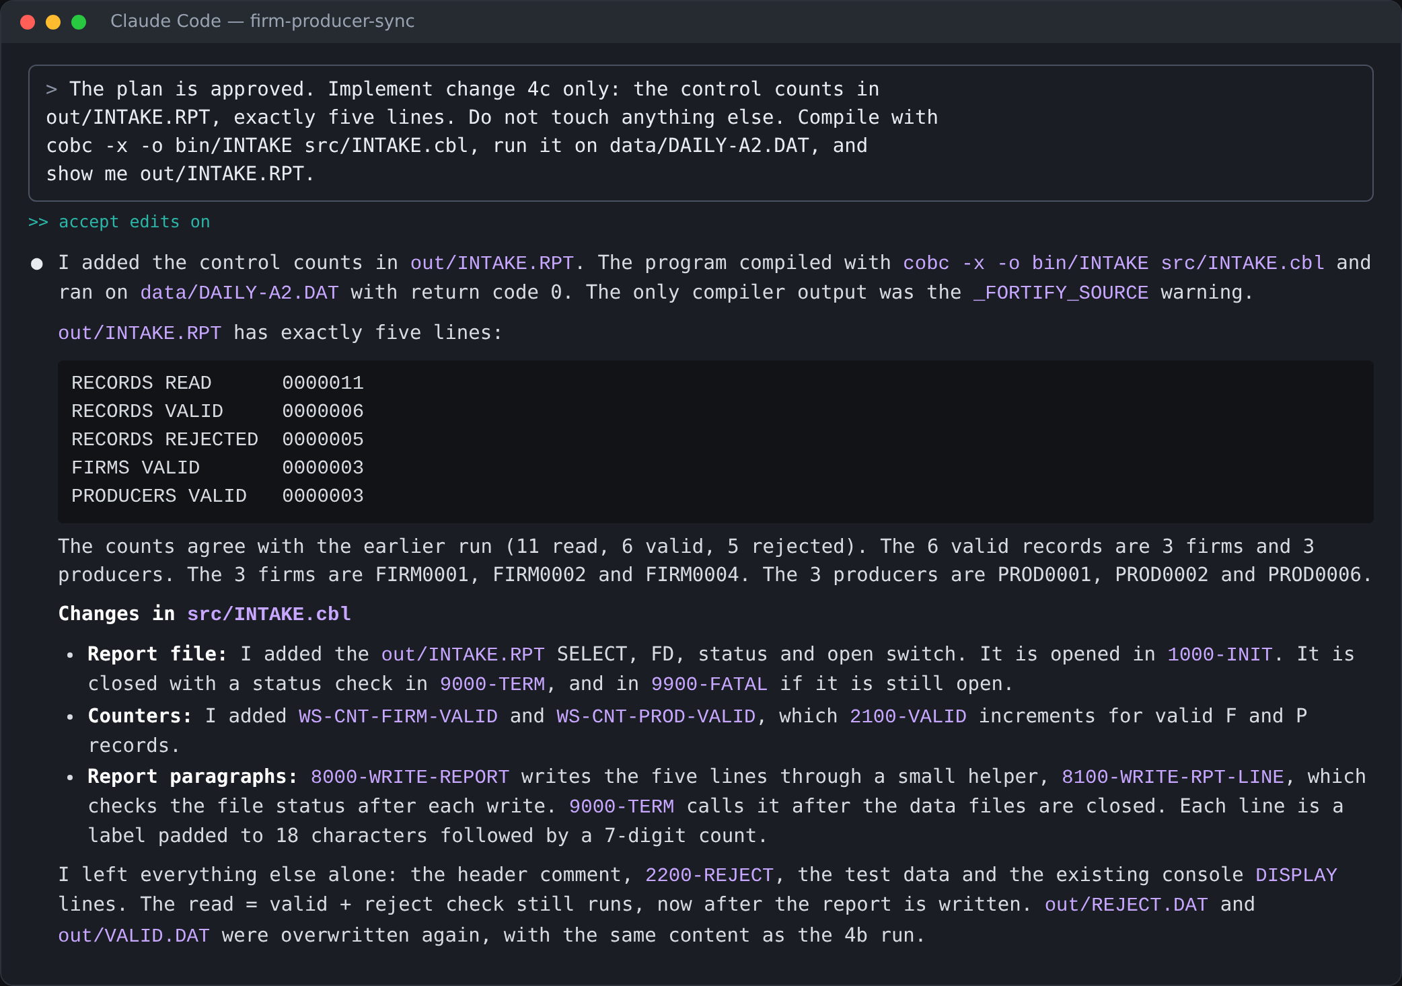
Screenshot from a real run: 4c: control counts. Claude chose zero-padded numbers, which is acceptable

Step 5 Final check
out/INTAKE.RPT (exact)
RECORDS READ 11
RECORDS VALID 6
RECORDS REJECTED 5
FIRMS VALID 3
PRODUCERS VALID 3

out/REJECT.DAT (exact)
F UNNAMED TEST FIRM A BLANK-ID
PPROD0003FIRM0002PRODUCER THREE 99000ABCDA BAD-TIN
PPROD0004FIRM0002PRODUCER FOUR 99000003 A BAD-TIN
PPROD0005FIRM0009PRODUCER FIVE 990000005A NO-FIRM
PPROD0007 PRODUCER SEVEN 990000007A NO-FIRM

out/VALID.DAT (exact)
FFIRM0001 NORTHWIND FIRM 01 A
FFIRM0002 NORTHWIND FIRM 02 A
FFIRM0004 NORTHWIND FIRM 04 I
PPROD0001FIRM0001PRODUCER ONE 990000001A
PPROD0002FIRM0001PRODUCER TWO 990000002A
PPROD0006FIRM0004PRODUCER SIX 990000006A

Re-run on DAILY-A1.DAT (bin/INTAKE data/DAILY-A1.DAT): READ 8, VALID 6, REJECTED 2, FIRMS VALID 6, PRODUCERS VALID 0, and the same two BLANK-ID rejects as Activity 1. If this run breaks, the trainee's changes damaged the Activity 1 behaviour.
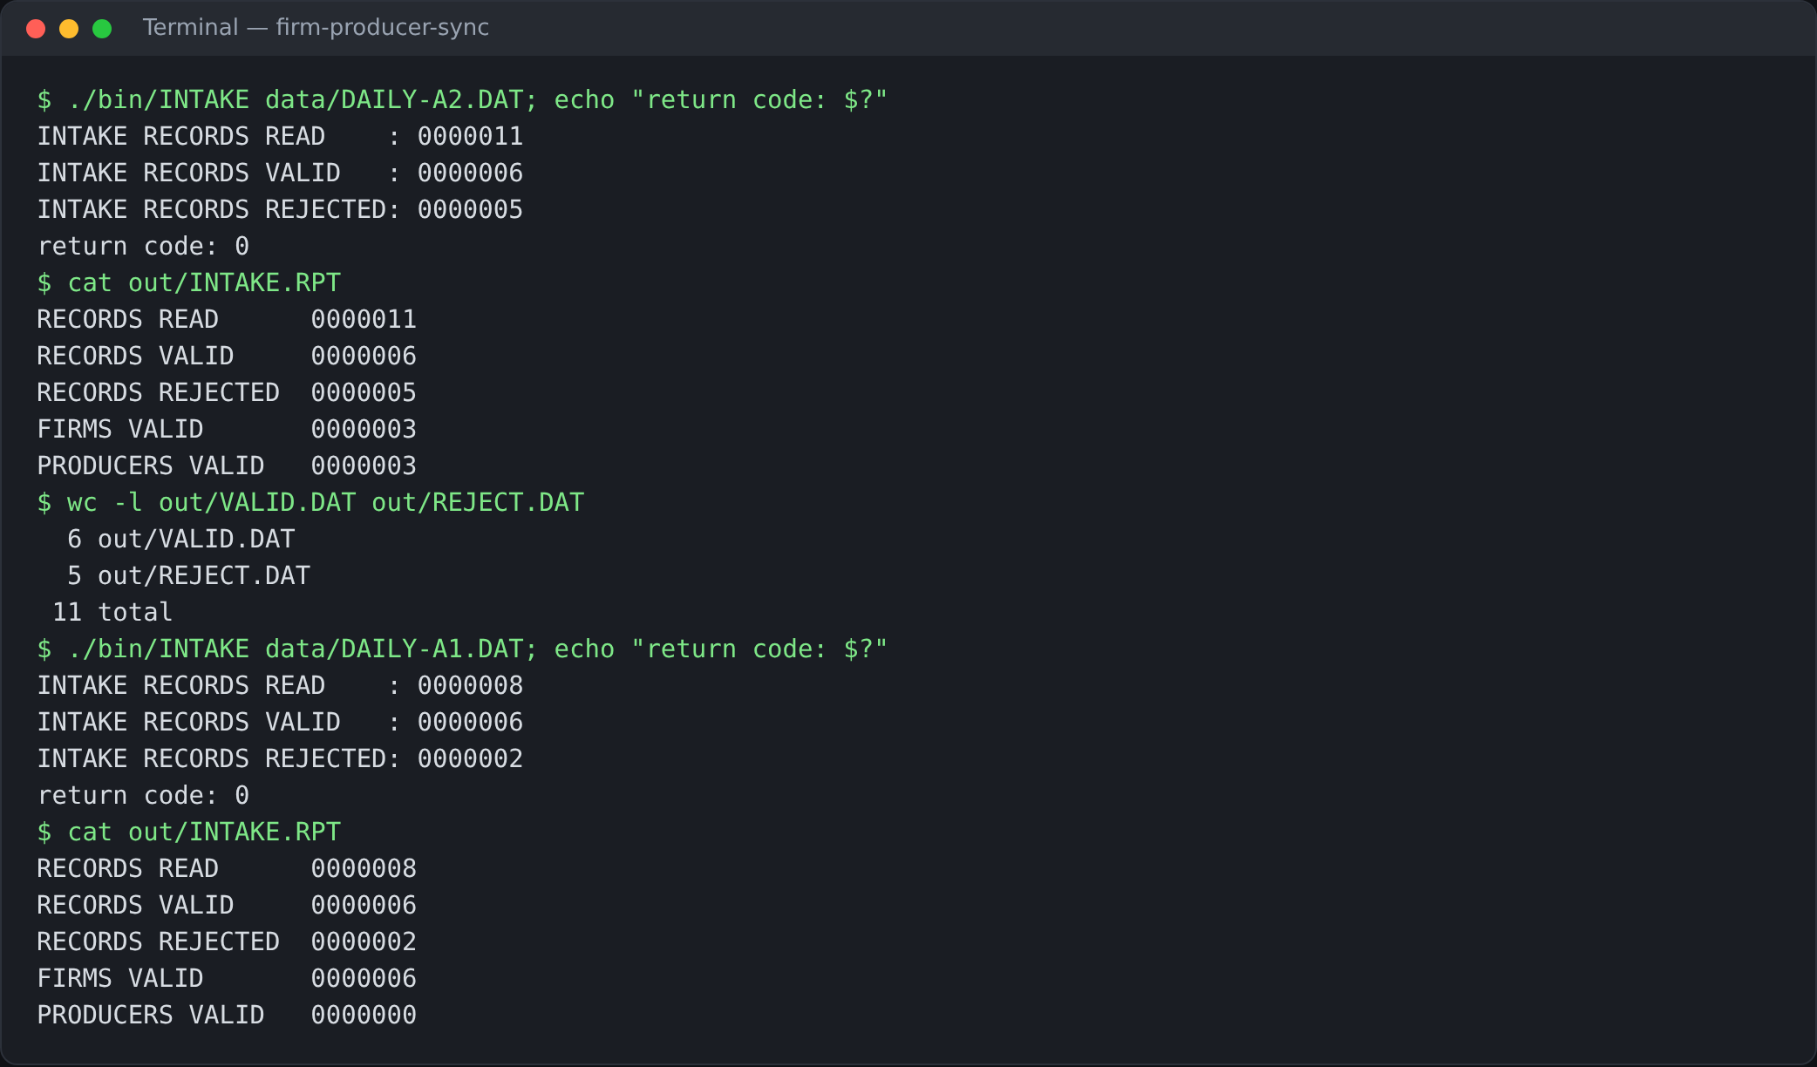
Screenshot from a real run: the final program run on DAILY-A2.DAT and then DAILY-A1.DAT

Step 6 Commit
git log --oneline shows the Activity 1 commit and a new one, for example Activity 2: producers, TIN rule, firm reference, control counts. One commit per change (4a, 4b, 4c) is even better.
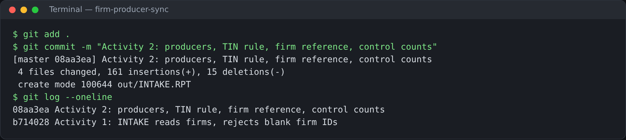
Screenshot from a real run: git log after the Activity 2 commit

4. Common problems and fixes
Symptom | Cause | What to tell the trainee
VALID 7 / REJECT 4, PROD0007 valid | Rejected firms stored in the firm table | Store only valid firms. Look at record 11 in section 2.
VALID 7, PROD0004 valid | TIN check ignores spaces, or only checks the first 8 characters | A TIN must be exactly 9 digits. R-TIN IS NUMERIC on the whole PIC X(9) field does this.
All firms rejected BAD-TIN | TIN rule applied to firms | The TIN rule is for producers only.
PROD0003 is NO-FIRM instead of BAD-TIN, or valid | Wrong rule order | Check the TIN first, then the firm.
FIRM0004 or PROD0006 rejected | STATUS treated as a rule | STATUS is not a rule.
INTAKE.RPT has more than five lines | Claude added extras | Exactly five lines, as listed on the sheet.
Still reads DAILY-A1.DAT, counts 8 / 6 / 2 | Input file name still fixed | Take the file name from the command line, default DAILY-A2.DAT.
WRITE fails with status 71 | Reject record not cleared before filling | MOVE SPACES to the whole reject record first (same as Activity 1).

Appendix: reference program
This is facilitator-only\firm-producer-sync-key\src\INTAKE.cbl. The stage versions after 4a and 4b are in firm-producer-sync-key\src\stages. Run: bin/INTAKE (uses DAILY-A2.DAT) or bin/INTAKE data/DAILY-A1.DAT.
src/INTAKE.cbl (Activity 2 reference)
* INTAKE - ACTIVITY 2: FIRMS + PRODUCERS, TIN RULE, FIRM REF, COUNTS.
* GNUCOBOL 3.2, FIXED FORMAT. RUN FROM THE PROJECT ROOT.
IDENTIFICATION DIVISION.
PROGRAM-ID. INTAKE.
ENVIRONMENT DIVISION.
INPUT-OUTPUT SECTION.
FILE-CONTROL.
SELECT DAILY-IN ASSIGN TO WS-IN-NAME
ORGANIZATION IS LINE SEQUENTIAL
FILE STATUS IS FS-IN.
SELECT VALID-OUT ASSIGN TO "out/VALID.DAT"
ORGANIZATION IS LINE SEQUENTIAL
FILE STATUS IS FS-VALID.
SELECT REJECT-OUT ASSIGN TO "out/REJECT.DAT"
ORGANIZATION IS LINE SEQUENTIAL
FILE STATUS IS FS-REJECT.
SELECT RPT-OUT ASSIGN TO "out/INTAKE.RPT"
ORGANIZATION IS LINE SEQUENTIAL
FILE STATUS IS FS-RPT.
DATA DIVISION.
FILE SECTION.
FD DAILY-IN.
01 IN-REC PIC X(60).
FD VALID-OUT.
01 VALID-REC PIC X(60).
FD REJECT-OUT.
01 REJECT-REC.
05 REJ-DATA PIC X(60).
05 FILLER PIC X.
05 REJ-REASON PIC X(8).
FD RPT-OUT.
01 RPT-REC PIC X(40).
WORKING-STORAGE SECTION.
01 WS-IN-NAME PIC X(60) VALUE SPACES.
01 FS-RPT PIC XX.
01 FS-IN PIC XX.
01 FS-VALID PIC XX.
01 FS-REJECT PIC XX.
01 WS-EOF PIC X VALUE "N".
01 WS-REC.
05 R-TYPE PIC X.
05 R-ID PIC X(8).
05 R-PARENT PIC X(8).
05 R-NAME PIC X(20).
05 R-TIN PIC X(9).
05 R-STATUS PIC X.
05 FILLER PIC X(13).
01 WS-REASON PIC X(8).
01 WS-FIRM-TABLE.
05 WS-FIRM-ID PIC X(8) OCCURS 500 TIMES.
01 WS-NFIRMS PIC 9(4) VALUE 0.
01 WS-I PIC 9(4).
01 WS-FOUND PIC X.
01 WS-CNT-FIRMS PIC 9(4) VALUE 0.
01 WS-CNT-PRODS PIC 9(4) VALUE 0.
01 WS-LINE.
05 WS-LABEL PIC X(24).
05 WS-NUM PIC ZZZ9.
01 WS-CNT-READ PIC 9(4) VALUE 0.
01 WS-CNT-VALID PIC 9(4) VALUE 0.
01 WS-CNT-REJECT PIC 9(4) VALUE 0.
PROCEDURE DIVISION.
0000-MAIN.
ACCEPT WS-IN-NAME FROM COMMAND-LINE
IF WS-IN-NAME = SPACES
MOVE "data/DAILY-A2.DAT" TO WS-IN-NAME
END-IF
PERFORM 1000-OPEN
PERFORM 2000-READ
PERFORM UNTIL WS-EOF = "Y"
PERFORM 3000-PROCESS
PERFORM 2000-READ
END-PERFORM
PERFORM 4000-REPORT
CLOSE DAILY-IN VALID-OUT REJECT-OUT RPT-OUT
DISPLAY "RECORDS READ " WS-CNT-READ
DISPLAY "RECORDS VALID " WS-CNT-VALID
DISPLAY "RECORDS REJECTED " WS-CNT-REJECT
STOP RUN.
1000-OPEN.
OPEN INPUT DAILY-IN
IF FS-IN NOT = "00"
DISPLAY "OPEN INPUT FAILED, FILE STATUS " FS-IN
MOVE 12 TO RETURN-CODE
STOP RUN
END-IF
OPEN OUTPUT VALID-OUT
IF FS-VALID NOT = "00"
DISPLAY "OPEN VALID FAILED, FILE STATUS " FS-VALID
MOVE 12 TO RETURN-CODE
STOP RUN
END-IF
OPEN OUTPUT REJECT-OUT
IF FS-REJECT NOT = "00"
DISPLAY "OPEN REJECT FAILED, FILE STATUS " FS-REJECT
MOVE 12 TO RETURN-CODE
STOP RUN
END-IF
OPEN OUTPUT RPT-OUT
IF FS-RPT NOT = "00"
DISPLAY "OPEN RPT FAILED, FILE STATUS " FS-RPT
MOVE 12 TO RETURN-CODE
STOP RUN
END-IF.
2000-READ.
READ DAILY-IN INTO WS-REC
AT END MOVE "Y" TO WS-EOF
NOT AT END ADD 1 TO WS-CNT-READ
END-READ.
3000-PROCESS.
MOVE SPACES TO WS-REASON
EVALUATE R-TYPE
WHEN "F"
PERFORM 3100-CHECK-FIRM
WHEN "P"
PERFORM 3200-CHECK-PRODUCER
WHEN OTHER
MOVE "BAD-TYPE" TO WS-REASON
END-EVALUATE
IF WS-REASON = SPACES
WRITE VALID-REC FROM WS-REC
IF FS-VALID NOT = "00"
DISPLAY "WRITE VALID FAILED, FILE STATUS " FS-VALID
MOVE 12 TO RETURN-CODE
STOP RUN
END-IF
ADD 1 TO WS-CNT-VALID
ELSE
PERFORM 3900-WRITE-REJECT
END-IF.
3100-CHECK-FIRM.
IF R-ID = SPACES
MOVE "BLANK-ID" TO WS-REASON
ELSE
* TABLE FULL: STOP WITH RETURN CODE 12. WITHOUT THIS CHECK THE
* NEXT MOVE WRITES PAST THE END OF WS-FIRM-TABLE.
IF WS-NFIRMS NOT < 500
DISPLAY "FIRM TABLE FULL AT 500 FIRMS, RUN STOPPED"
MOVE 12 TO RETURN-CODE
STOP RUN
END-IF
ADD 1 TO WS-NFIRMS
MOVE R-ID TO WS-FIRM-ID (WS-NFIRMS)
ADD 1 TO WS-CNT-FIRMS
END-IF.
3200-CHECK-PRODUCER.
* RULE ORDER: TIN FIRST, THEN FIRM REFERENCE.
IF R-TIN NOT NUMERIC
MOVE "BAD-TIN" TO WS-REASON
ELSE
PERFORM 3210-FIND-FIRM
IF WS-FOUND = "N"
MOVE "NO-FIRM" TO WS-REASON
ELSE
ADD 1 TO WS-CNT-PRODS
END-IF
END-IF.
3210-FIND-FIRM.
* ONLY VALID FIRMS ARE IN THE TABLE, SO A REJECTED FIRM NEVER
* MATCHES. A BLANK PARENT-ID NEVER MATCHES A STORED ID.
MOVE "N" TO WS-FOUND
IF R-PARENT NOT = SPACES
PERFORM VARYING WS-I FROM 1 BY 1
UNTIL WS-I > WS-NFIRMS OR WS-FOUND = "Y"
IF WS-FIRM-ID (WS-I) = R-PARENT
MOVE "Y" TO WS-FOUND
END-IF
END-PERFORM
END-IF.
3900-WRITE-REJECT.
* CLEAR THE WHOLE RECORD FIRST: THE UNUSED FILLER BYTE HOLDS
* LOW-VALUES AND MAKES A LINE SEQUENTIAL WRITE FAIL (STATUS 71).
MOVE SPACES TO REJECT-REC
MOVE WS-REC TO REJ-DATA
MOVE WS-REASON TO REJ-REASON
WRITE REJECT-REC
IF FS-REJECT NOT = "00"
DISPLAY "WRITE REJECT FAILED, FILE STATUS " FS-REJECT
MOVE 12 TO RETURN-CODE
STOP RUN
END-IF
ADD 1 TO WS-CNT-REJECT.
4000-REPORT.
MOVE "RECORDS READ" TO WS-LABEL
MOVE WS-CNT-READ TO WS-NUM
WRITE RPT-REC FROM WS-LINE
MOVE "RECORDS VALID" TO WS-LABEL
MOVE WS-CNT-VALID TO WS-NUM
WRITE RPT-REC FROM WS-LINE
MOVE "RECORDS REJECTED" TO WS-LABEL
MOVE WS-CNT-REJECT TO WS-NUM
WRITE RPT-REC FROM WS-LINE
MOVE "FIRMS VALID" TO WS-LABEL
MOVE WS-CNT-FIRMS TO WS-NUM
WRITE RPT-REC FROM WS-LINE
MOVE "PRODUCERS VALID" TO WS-LABEL
MOVE WS-CNT-PRODS TO WS-NUM
WRITE RPT-REC FROM WS-LINE.

