No-PO invoice finder

Version 1.0

UiPath Cartographer
UiPath
16 September 2026

Document Control
Version | Date | Author | Description
1.0 | 16 September 2026 | UiPath Cartographer | Initial release

1. Business Context

1.1 Problem Statement
The Accounts Payable team performs approximately one manual review per day in Coupa to find invoices from the past week that have no properly linked purchase order. The team filters records, copies invoice fields, groups them by requester, and sends a Slack message to the AP responsible; the task may otherwise be missed until a supplier chases payment. The manual process creates avoidable handling effort and a visibility risk against the no-PO-no-pay policy.

1.2 Objectives
- Replace the manual review with a fully automated weekday run at 10:00 Romania time.
- Apply the approved status, date-window, PO-linkage and credit-note rules consistently on every run.
- Send one Slack message to the SME stating how many invoices have no linked purchase order, and link to them in Coupa.
- Send nothing on a day when no invoice qualifies.
- Keep the automation within the notification boundary: no PO creation, invoice approval or Coupa record change.

1.3 Expected Value
The automation provides earlier and more consistent visibility of missing-PO exceptions, reduces manual filtering and message preparation, and lowers the risk of omissions caused by inconsistent timing. It also makes a clean result distinguishable from a technical failure, improving operational confidence; measured acceptance signals are defined in Section 8.

2. Scope

2.1 Scope Boundaries
In Scope | Out of Scope
Weekday execution at 10:00 Romania time | Purchase-order creation
Coupa invoice retrieval | Invoice approval or payment release
Past-week filtering | Coupa record modification
Status draft or new filtering | Supplier communication
Missing or invalid PO-link detection | Requester follow-up tracking
Credit-note exclusion | Full invoice lifecycle automation
Summary count of invoices without a linked PO | Audit-retention design
One Slack message to the SME | Listing individual invoices in the message
No message on a clean day | Retry, fallback and error-recovery behaviour

2.2 Systems and Applications
System | Role in Process | Access Type
Coupa | Source of invoice records and PO-linkage data | read
Slack | Destination for the summary notification | write
Weekday schedule | Starts the run at 10:00 on weekdays | both

3. Current State

3.1 Overview
An AP team member manually reviews the Coupa invoice list, filters for status draft or new in the past week, excludes credit notes, and identifies invoices without a properly linked PO. The member copies invoice fields into a message, groups the entries by requester, and sends the message to the AP responsible on Slack. The task is approximately daily but can be delayed until a supplier follows up.

3.2 Pain Points
Where | What breaks | Impact
Coupa review | Filtering is manual and timing is inconsistent | Missing-PO invoices may remain unseen until supplier follow-up
Message preparation | Fields are copied and grouped manually | AP effort and transcription/omission risk
Notification control | Clean days and technical failures are not clearly distinguished | A quiet failure can look like a clean result
Follow-up | Requester action is not tracked in this task | No confirmed closure evidence

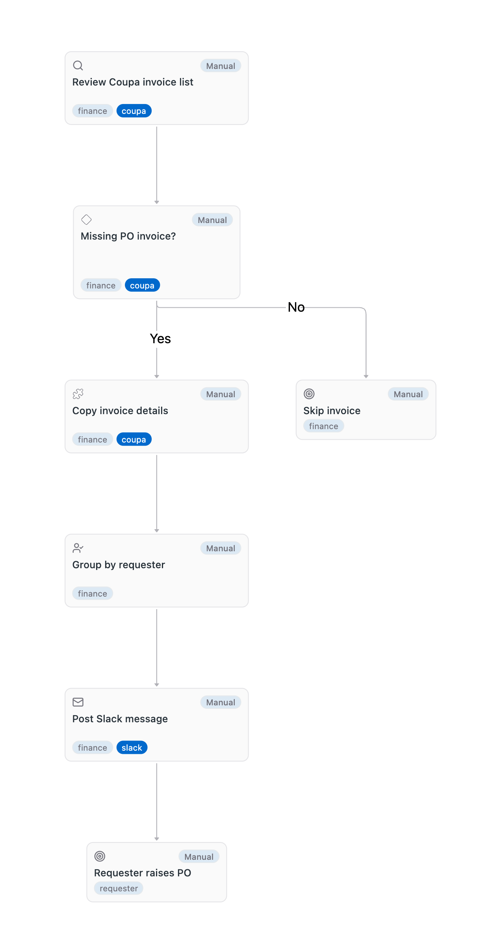

4. Future State

4.1 Vision
The future process is a fully automated weekday control. The run starts at 10:00 Romania time, reads invoices from Coupa, applies the rules below, groups what qualifies by requester, and sends one Slack message to the AP responsible. It is a short linear process — read, filter, format, send — and nothing else. No AI agent or human review is retained in the normal path, and the automation does not alter invoices or create POs.
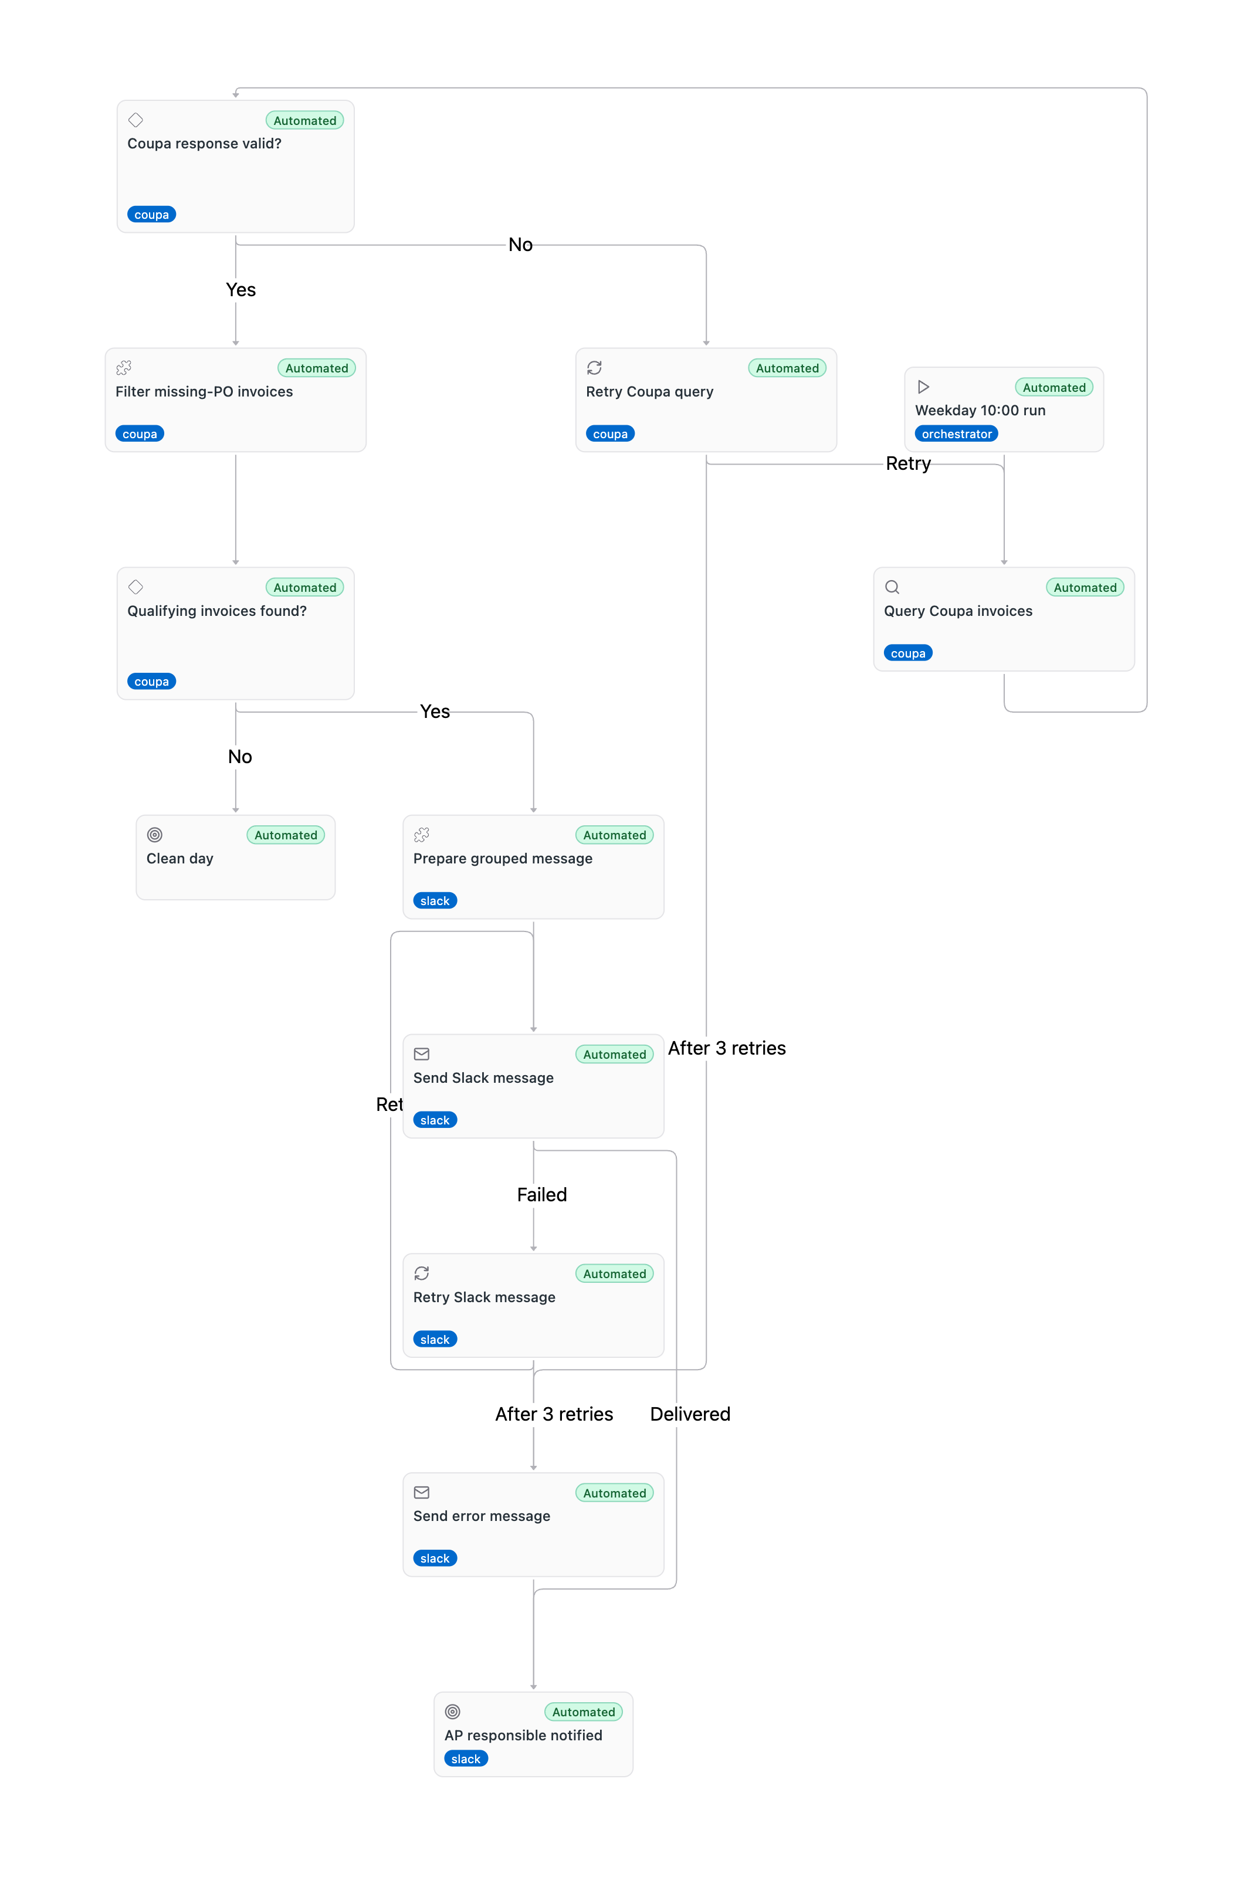

4.2 Target Flow
# | Automation unit / step | Mode | Owner or system | Input | Output | Exception path
1 | Start weekday run | Fully automated | Weekday schedule | Schedule and Romania timezone | Run context | None
2 | Query and filter Coupa invoices | Fully automated | Coupa | Date window and invoice fields | Qualifying records | None
3 | Compose the summary message | Fully automated | Automation | Qualifying records | One summary message | Empty result produces no message
4 | Deliver Slack notification | Fully automated | Slack | Prepared message | Delivered notification | None

4.3 Notification content
Example, with the count from a live sample: "194 invoices from the last seven days have no purchase order linked. An invoice without a linked PO cannot be matched or paid under our no-PO-no-pay policy, and payment to the supplier stalls until it is fixed. Please make sure a purchase order exists for these invoices and is correctly linked to each one. Open the list in Coupa: https://uipath-test.coupahost.com/invoices?q%5Binvoice_date_gteq%5D=<window start>&q%5Binvoice_date_lteq%5D=<window end>&q%5Bstatus_eq%5D=draft"
Message template. The notification is sent as a Slack Block Kit message, not as plain text, so it renders with a title, icon-led lines, an action button and a footer. The whole payload below goes in the body parameter of the Slack HTTP Request activity.
Title: :receipt: {{invoice_count}} invoices need a purchase order
Body, three lines, each led by an icon:
:warning: {{invoice_count}} invoices from the last seven days have no purchase order linked.
:no_entry: An invoice without a linked PO cannot be matched or paid under our no-PO-no-pay policy, and payment to the supplier stalls until it is fixed.
:point_right: Please make sure a purchase order exists for these invoices and is correctly linked to each one.
Button: Open the list in Coupa, styled primary, linking to {{coupa_url}}.
Footer: :calendar: Invoices dated {{window_start}} to {{window_end}} · :robot_face: No-PO Invoice Chaser · checked {{run_date}}
Placeholders. {{invoice_count}} is the number of qualifying invoices; {{coupa_url}} is the filtered Coupa list URL; {{window_start}} and {{window_end}} are the invoice date window the run used; {{run_date}} is the date of the run. The message is a direct message to the SME, addressed by Slack member ID WLX9BD8FN, never by email.
The count appears twice on purpose - in the title so it is readable in the Slack sidebar without opening the message, and in the first body line. A clean day sends nothing at all.
The exact Block Kit JSON is recorded verbatim in the architectural considerations, section 4, so the build reproduces it rather than re-inventing the layout.
The Coupa link points at the invoice list filtered to the same window the run used. Coupa holds purchase-order linkage on the invoice LINES, not the header, so the list cannot be filtered to "no PO" by URL alone - the message carries that number instead, and the link takes the SME to the matching invoices.
Element | Content
Recipient | The SME, Irina Capatina (irina.capatina@uipath.com, Slack member ID WLX9BD8FN), by Slack direct message.
Headline | The total number of invoices from the past seven days that have no linked purchase order. Individual invoices are not listed.
Why it matters | One short sentence: an invoice with no linked purchase order cannot be matched or paid under the no-PO-no-pay policy, and it holds up the supplier.
Action requested | Ask the SME to make sure a purchase order exists for those invoices and is properly linked to each one.
Link to Coupa | A link that opens the Coupa invoice list filtered to the same seven-day window, so the SME can work the list without searching for it.
On a clean day | Nothing is sent when the count is zero.

4.4 What Changes

The future design deliberately stays simple, and should be built that way. The data is structured, the rules are deterministic, the volume is a handful of invoices a day, and both systems are stable and well understood. Nothing here is error-prone. No AI classification, human approval, retry logic, fallback path or recovery behaviour is required or wanted: the automation is the short linear sequence described above, and anything beyond read, filter, format, send is out of scope.

5. Business Rules
Rule ID | Description
BR-001 | Apply the no-PO-no-pay policy to invoices without a properly linked purchase order.
BR-002 | A PO number typed into the invoice description but not properly linked does not satisfy the PO requirement.
BR-003 | Exclude credit notes from the notification population.
BR-004 | Include only invoices with status draft or new and an invoice date within the past seven days.
BR-005 | Count the invoices that qualify. The message reports that count; individual invoices are not listed.
BR-006 | Send the count to the SME, Irina Capatina (irina.capatina@uipath.com, Slack member ID WLX9BD8FN), on Slack, with a note on why a linked purchase order matters, a request to make sure one exists and is linked, and a link to the filtered invoice list in Coupa.
BR-007 | Send nothing when a successful query returns no qualifying invoices.
BR-008 | No retry, fallback or recovery behaviour is required. The process is low volume and reads stable, structured data, so a run that cannot complete is simply reported as a failed run.
BR-009 | A run that cannot complete produces no notification. Nobody is told twice, and no second message path exists.
BR-010 | The automation does not create or modify purchase orders, approve invoices, change Coupa records, or track requester completion.

6. People

6.1 Roles and Personas
Stakeholder | Responsibility
No-PO invoice finder automation | Queries Coupa, applies the rules, prepares the message, and delivers the Slack notification.
SME - Irina Capatina (irina.capatina@uipath.com, Slack member ID WLX9BD8FN) | Receives the Slack message and makes sure a purchase order is raised and linked.
Requester | Person recorded on the invoice who is associated with raising or arranging the missing PO; direct notification is out of scope.
Coupa | System of record for invoice and PO-linkage data.
Slack | Destination system for the notification.

7. Exceptions

7.1 Known Exceptions
Exception | Trigger | AS-IS Handling | TO-BE Handling
Credit note | Invoice type is credit note | AP skips the record | Automation excludes it and records the exclusion reason
Description-only PO | PO text appears only in description | AP treats it as missing | Automation treats it as missing and includes it if other rules pass
No qualifying invoices | Successful query returns zero matches | Not defined | Send a slack message saying congrats that all invoices have a po assigned.

8. Acceptance Criteria

8.1 Acceptance Signals
- A weekday test run executes at 10:00 Romania time.
- Records with status draft or new and an invoice date within the past seven days are evaluated.
- Credit notes are excluded.
- A PO number present only in the description does not satisfy the PO-linkage rule.
- The message reports the total number of invoices with no linked purchase order.
- One Slack message is sent to the SME, Irina Capatina (irina.capatina@uipath.com, Slack member ID WLX9BD8FN), and it carries a working link to the filtered Coupa list.
- A successful empty result produces no Slack message.
- A run that cannot complete is reported as a failed run.
- The automation does not modify Coupa records or create purchase orders.

9. Next Steps
# | Action item
1 | Confirm the reminder wording and the Coupa link open the intended filtered list.
2 | Confirmed: the SME is Irina Capatina (irina.capatina@uipath.com, Slack member ID WLX9BD8FN).
3 | Agree the final reminder wording and a readable date and amount format.

Appendix A: Process Map and Diagrams
The current-state process map is embedded in Section 3.4 and the future-state automation map is embedded in Section 4.1. These canonical maps show the approved business shape for the manual baseline and the fully automated target process.

Integration Diagram
An integration sequence diagram is not included: the process is one linear sequence from Coupa to Slack.

