# Appendices

## A1. Interview with the customer

## A2. System diagram

## A3. Use Cases Diagrams

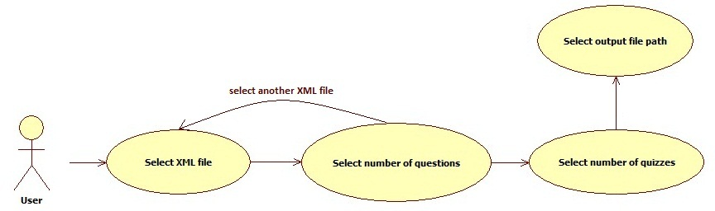

## A4. Class Diagrams

## A5. Sequence Diagrams

## A6. State Diagrams

## A7. Document Evolution

## A8. Report regarding team meetings

**Date**:

**Location**:

**Participants**:

**Summary**:

**Activity**:

Title

Description (4 lines)

**Results**:

Element

Description (2-3 lines)

## A9. Conclusions regarding the activity