Politehnica University of Bucharest

Software Engineering

Quiz-generator
Software Design Document

Team:
Teodora Mohai, gr. 1262E
Salvador Canas Moreno , gr. 1262E
Irina Talmaciu, gr. 1262E
David Suarez Caro, gr. 1262E

Coordinator:  As. Lucian Pestritu  As. Alexandra Todiruta | Date created:  Saturday, November 07, 2026

Delivery Report
(will be delivered along with the project)

Name Group Project implementation [%, reason] Signature

_______________ ______ ____________________________ _________
____________________________
____________________________

_______________ ______ ____________________________ _________
____________________________
____________________________

_______________ ______ ____________________________ _________
____________________________
____________________________

Delivery date:
__________________________________

Table of Contents

Delivery Report 2
Table of Contents 3
System Design 4
Document Change History 4
1. Introduction 4
1.1. Purpose 4
1.2. Target Public 4
1.3. Definitions, Acronyms and Abbreviations 4
1.4. Document Structure 4
2. References 5
3. Decomposition Description 6
3.1. Modules Description 6
3.2. Description of Concurrent Processes 6
3.3. Description of Data Modules 6
4. Dependency Description 8
4.1. Dependencies among modules 8
4.2. Dependencies among processes 8
4.3. Dependencies among data modules 8
5. Interface Description 9
5.1. Module Interfaces 9
5.2. Processes Interfaces 9
6. Detailed Design 10
6.1. Modules detailed design 10
6.2. Data Modules Detailed Design 10
Appendices 11
A1. Use cases diagrams 11
A2. Class diagrams 11
A3. Sequence diagrams 11
A4. Document evolution 11
A5. Conclusions on activity 11

System Design

According to the IEEE STD-1016-1998, IEEE Recommended Practice for Software Design Descriptions.

Document Change History
Depending on the chosen type of development, retention of all changes made to this document may be useful. For example, for a project using the Waterfall w/ milestones methodology, all the changes made between two project evaluation moments (milestones) will be retained. A chronological sorting of the list of changes is indicated.

Version | Date | The author/authors of the change | Details of changes
1.00 | 28.11.2012 | Teodora Mohai  Salvador Canas Moreno Irina Talmaciu  David Suarez Caro | Basic version

1. Introduction

1.1. Purpose
This Software Design Document provides the design details of Politechnica University Bucharest Quiz-generator application. It means this is the document which will guide all the developers in their work. All the technical details have to be written clearly in this document in order to be understood by all the developers.

The expected audience is University Politehnic of Bucharest, including all the teachers who work there, the student developers, the student assistants and people who will maintain the application.

1.2. Target Public
Name | Last name | Role
Teodora | Mohai | Student developer
Salvador | Moreno Canas | Student developer
Irina | Talmaciu | Student developer
David | Suarez Caro | Student developer
Lucian | Pestritu | Assistant
Alexandra | Todiruta | Assistant
Nicolae | Goga | Proffesor

1.3. Definitions, Acronyms and Abbreviations

Acronyms:

XML- Extensible Markup Language
SQL-Structured Query Language
UML-Unified Modeling Language
IEEE-Institute of Electrical and Electronic Engineers
SDD-Software Design Document
SRS-Software Requirement Specification
Tbn-To be named
Tbd-To be decided
Web Site-A place on the world wide web
Definitions:

Connection String = string used to connect to a database, containing server name or IP, database name, database user name and password.

Data Source = data retrieved from the database based on an SQL query, used in displaying structured information.

Query = primary mechanism for retrieving information from a database and consist of questions presented to the database in a predefined format. Many database management systems use the SQL standard query format.

Java = object-oriented programming language originally developed by James Gosling at Sun Microsystems and released in 1995 as a core component of Sun Microsystems' Java platform.

Class = a construct that is used to create instances of itself – referred to as class instances, class objects, instance objects or simply objects.

Method = subroutine (or procedure) associated with a class. Methods define the behavior to be exhibited by instances of the associated class at program run time.

Entity – Relationship model (ER model) = an abstract way to describe a database. Diagrams created to design these entities and relationships are called entity–relationship diagrams or ER diagrams.

Pattern = software solutions that solve a recurring problem within a given context. The use of patterns has many advantages. Patterns encapsulate a design expert's time and expertise to solve a software problem.

1.4. Document Structure

The remaining chapters and their contents are listed below.

Section 2 is a reference list which shows all the sources used to develop this document.
All the references are numbered and dated. The authors are also named with the corresponding reference.
This allows a clear explanation where you can obtain more details of some part of the design.

Section 3 is a Decomposition Description that specifies the different modules we described previously in the SRS document and all their characteristics detailed. This chapter also contains the description of the concurrent processes and the data modules with all their specifications.

Section 4 is a Dependency Description where you can find all the dependencies firstly named in the previous chapter and detailed in this chapter.

Section 5 is an Interface Description which presents the external characteristics of the user interface showing all the different actions the users can do.

Section 6 is Detailed Design which shows all the modules previously named and described. This part contains diagrams and examples of the code that developers can follow.

Section 7 is the Appendices where you will find all the diagrams which describe the behavior of the application.

2. References
[1] IEEE STD-1016-1998, IEEE Recommended Practice for Software Design Descriptions

[2] [IEEE] The applicable IEEE standards are published in “IEEE Standards Collection,”
2001 edition.

[3][XML] All the tutorials to understand the XML language are in http://www.w3schools.com/xml/.

[4][HTML]The standars HTML documents are described in http://www.w3.org/.

3. Decomposition Description
This article corresponds to chapter 6.2.1., Decomposition description, from [1].

3.1. Modules Description
Modules description according to 5.3.1 -5.3.10, from [1]. The modules can be identified on the use case diagram(s) from the Software Requirements Specification.

3.1.1. Description of Module 1

Name | Name of module 1
Type | Subprogram or Code module or Procedure or Process or Data module
Purpose | Purpose of the module
Way of operating | Description of the operating way
Subordination | [optional] Identification of the subordinate modules
Dependencies | [optional] Identification of the module’s dependencies
Resources | Necessary resources for this module (e.g. MySQL, PHP)

3.1.2. Description of Module 2
...

3.2. Description of Concurrent Processes
Description of concurrent processes according to 5.3.1 – 5.3.10, from [1]. The processes can be identified on the sequence diagram(s) from the Software Requirements Specification.

3.2.1. Description of Process 1

Name | Name of process 1
Type | Process
Purpose | Purpose of the process
Way of operating | Description of the operating way
Subordination | [optional] Identification of the subordinate processes
Dependencies | [optional] Identification of the process’ dependencies
Resources | Necessary resources for this process (e.g. global timer (NTP))

3.2.2. Description of Process 2
...

3.3. Description of Data Modules
Description of data modules according to 5.3.1 – 5.3.10, from [1]. The data modules can be identified on the use case diagram(s) from the Software Requirements Specification.

3.3.1. Description of Data Module 1

Name | Name of data module 1
Type | Data module
Purpose | Purpose of the data module
Way of operating | Description of the way of operating on data from this module
Subordination | [optional] Identification of subordinate modules
Dependencies | [optional] Identification of the data module’s dependencies
Resources | Necessary resources for this data module (e.g. relational data base, SQL compatible)

3.3.2. Description of Data Module 2
...

4. Dependency Description
This chapter corresponds to chapter 6.2.2, Dependency description, from [1].

4.1. Dependencies among modules
The dependencies identified in chapter 3.1 are detailed. Detailed diagrams are recommended.

4.2. Dependencies among processes
The dependencies identified in chapter 3.2 are detailed. Detailed diagrams are recommended.

4.3. Dependencies among data modules
The dependencies identified in chapter 3.3 are detailed. Detailed diagrams are recommended.

5. Interface Description
This chapter corresponds to chapter 6.2.3, Interface description, from [1].

5.1. Module Interfaces
The module interfaces described in chapter 3.1 are detailed. Detailed diagrams are recommended.

5.1.1. Module 1 Interface

Name | Name of module 1 (see 3.1.1)
Type | (see 3.1.1)
Purpose | (see 3.1.1)
Way of operating | (see 3.1.1)
Interface 1 | Description  E.g.: result Login(user_name, password)
Input | E.g.:  user_name: string – the user name, read from the keyboard  password: string – user access password, read from the keyboard
Output | E.g.:  result: string – OK or FAILED, depending on the search result of the (user_name, password) pair in the user data base (see chapter X.Y)
Description | Description of the module in which the interface works  E.g.:  The registration operation is made by introducing a user name and a password from the keyboard; the existence of this pair is verified in the user data base; the data base search result will be returned as a string.

5.1.2. Module 2 Interface
...

5.2. Processes Interfaces
The processes interfaces described in chapter 3.2 are detailed. Detailed diagrams are recommended.

5.2.1. Process 1 Interface

5.2.2. Process 2 Interface
...

6. Detailed Design
This chapter corresponds to chapter 6.2.3, Interface description, from [1].

6.1. Modules detailed design
The modules described in chapter 3.1 are detailed. Detailed diagrams are recommended.

6.1.1. Module 1

Name | Name of module 1 (see 3.1.1)
Type | (see 3.1.1)
Purpose | (see 3.1.1)
Way of operating | (see 3.1.1)
Classes | Identification of constitutive classes

6.1.1.1. Module 1, class 1

Name | Name class 1
Purpose | Description of the purpose of this class within the module
Members | Identification of the class’ members
Methods | Identification of the constitutive methods (functions)

Class diagram (see class diagrams from the Software Requirements Document).

6.1.1.1.1. Module 1, class 1, method 1

Name | Name of method 1
Purpose | Description of the purpose of this method within the class
Prototype | Description of the method’s prototype
Input | Description of the method’s input
Output | Description of the method’s output
Caller | Routines that call this method
Calls | Other routines called by this method
Algorithm | Description of the algorithm/procedure of operating

...

6.1.2. Module 2
...

6.2. Data Modules Detailed Design
The data modules described in chapter 3.3. are detailed. Detailed diagrams are recommended.

6.2.1. Data module 1

6.2.2. Data module 2
...

Appendices

A1. Use cases diagrams

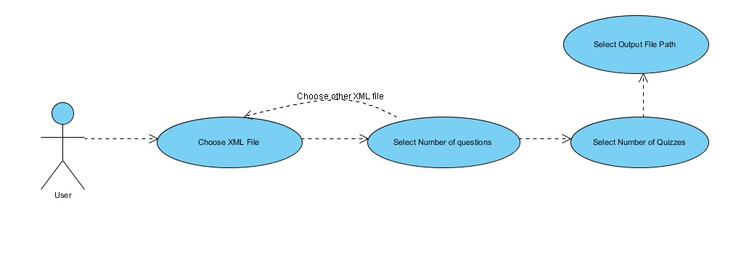
A use case diagram is a graphical representation of a user's interaction with the system and depicting the specifications of a use case. A use case diagram can portray the different types of users of a system and the various ways that they interact with the system.

A2. Class diagrams

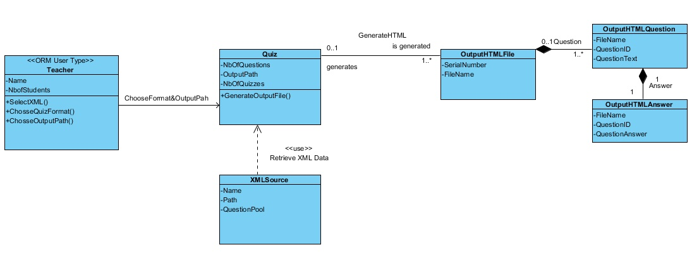
A class diagram in UML should describes the structure of a system by showing the system's classes, their attributes, operations (or methods), and the relationships among the classes.

A3. Sequence diagrams

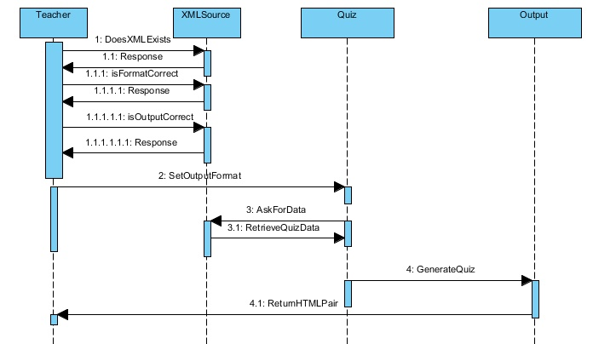
A sequence diagram in UML is a kind of interaction diagram that shows how processes operate with one another and in what order. It is a construct of a Message Sequence Chart. A sequence diagram shows object interactions arranged in time sequence.

A4. Document evolution
Throughout this document, the developpers of the application intend to organize a structured plan of all the software requirements needed in order to develop a functional application. Here are discussed important details regarding :
- all the sources used to develop this document.

- the different modules described previously in the SRS document and all their characteristics in detail.

- the description of the concurrent processes and the data modules with all their specifications.

- a Dependency Description where we can find all the dependencies.

- an Interface Description which presents the external characteristics of the user interface showing all the different actions the users can do.

- a Detailed Design which shows all the modules previously named and described. This part contains diagrams and examples of the code that developers can follow.

This Software Design Document is meant to add several important details to the SRS document offering the design details for the Quiz-generator application. This document is intended to guide its developers in their work.

The SDD document comprises more specific details on how the application should be developped and its main functionalities. All the technical details are written very clearly and syntactically correct, in order to be well understood by all its users.

The expected users are from the Politechnica University of Bucharest, including all the teachers who work there, the student developers, the student assistants and people who will maintain the application.

A5. Conclusions regarding the activity

The SDD document manages to offer a detailed description of the Quiz-generator application. We can observe that it has an easy to read structure, with additional diagrams and shemas, in order to make the requirements as clear as they can be, for an easy interpretation by its readers e.g. the programmers in the developping team.

This document provides a complete picture of the software, addressing the data, functional, and behavioral domains from an implementation perspective.

We can now conclude that the project and the developping team is ready for starting the next phase in the lifecycle of the application, which is the actual implementation of the theoretical capabilities and start writing the code.

