3. Decomposition Description

3.1. Modules Description

3.1.1. Description of Module 1

Name | Quizzes generate
Type | Code module
Purpose | To generate randomly quizzes.
Way of operating | The user opens the command line and he will be asked to introduce the location of the xml file which contains the questions for the quizzes. If the xml file is not a valid one, an error message will displayed and the user must introduce once more the location.  Next, the operator will have to choose the number of questions he wants from the xml file. If this number will not be a valid one, he gets an error message and will have to enter again a number.  Afterwards the user will have to choose between: introducing a new location for another xml file or go one step forward.  The operator will be asked to enter the number of quizzes and then to write the output directory path where the quizzes which will be generated will be saved.
Resources | Teacher, Quiz, XMLSource, OutputHTMLFile

3.2. Description of Concurrent Processes

3.2.1. Description of Process 1

Name | SelectXML
Type | Process
Purpose | To get the location of the xml file which contains the questions for the quizzes
Way of operating | Description of the operating way
Subordination | NumberQuestions
Dependencies | This process’ behavior depends on the input given by the teacher.
Resources | Necessary resources for this process (e.g. global timer (NTP))

3.2.2. Description of Process 2
Name | NumberQuestions
Type | Process
Purpose | To choose the number of questions from the xml file
Way of operating | Description of the operating way
Subordination | NumberQuizzes
Dependencies | SelectXML & and the input given by the teacher in this process.
Resources | Necessary resources for this process (e.g. global timer (NTP))

3.2.3. Description of Process 3
Name | NumberQuizzes
Type | Process
Purpose | To choose the number of quizzes
Way of operating | Description of the operating way
Subordination | ChooseOutputPath
Dependencies | NumberQuestions & and the input given by the teacher in this process.
Resources | Necessary resources for this process (e.g. global timer (NTP))

3.2.4. Description of Process 4
Name | ChooseOutputPath
Type | Process
Purpose | To choose the output directory path where the quizzes which will be generated will be saved
Way of operating | Description of the operating way
Subordination | This process do not have any subordination.
Dependencies | NumberQuizzes & and the input given by the teacher in this process.
Resources | Necessary resources for this process (e.g. global timer (NTP))

3.3. Description of Data Modules

3.3.1. Description of Data Module 1

Name | Quizzes generate
Type | Data module
Purpose | The purpose is to introduce the location of the question pool in order to extract questions to generate quizzes for students. The quizzes must be unique for each student – means: the order of the questions and that the multiple-choice questions must have randomize choices every time.
Way of operating | Introducing the data from the command line accordingly to what will be required to enter.
Resources | Java Virtual Machine, Teacher, Quiz, XMLSource, OutputHTMLFile

4. Dependency Description

4.1. Dependencies among modules
This project has only 1 module.

4.2. Dependencies among processes

Processes:
- SelectXML
- NumberQuestions
- NumberQuizzes
- ChooseOutputPath

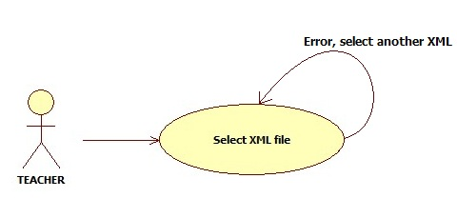
Fig. 1

In fig. 1, there is only 1 process, the first one. If any error occurs, we continue in it, otherwise, we advance to the next one.

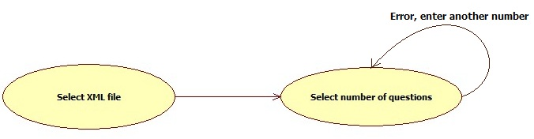

Fig. 2

In fig. 2, there are 2 processes. This figure represents the second step in this software. We come from the XML file selection and now we have to enter the number of questions we want.

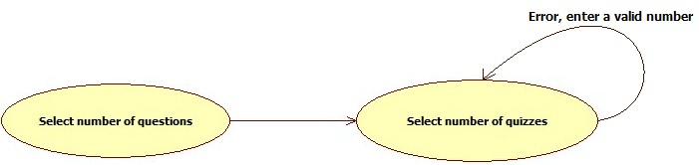

Fig. 3

In fig. 3, there are 2 processes. This figure represents the third step in this software. We come from the number of questions selection and now we have to enter the number of quizzes we want.

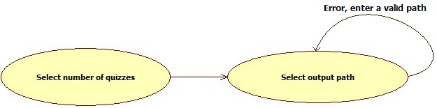

Fig. 4

In fig. 4, there are 2 processes. This figure represents the fourth step in this software. We come from the number of quizzes selection and now we have to enter the output directory path where the generated quizzes will be will be saved.

4.3. Dependencies among data modules
This project has only 1 data module.

