SQL script showing table description and constraints

- Map your E-R model to the relational model using SQL on Oracle 8. If you rerun the SQL script more than one time, you may need to drop the existing tables before you run the script. To drop a table, use the following SQL statement: DROP TABLE <table name> CASCADE CONSTRAINTS;
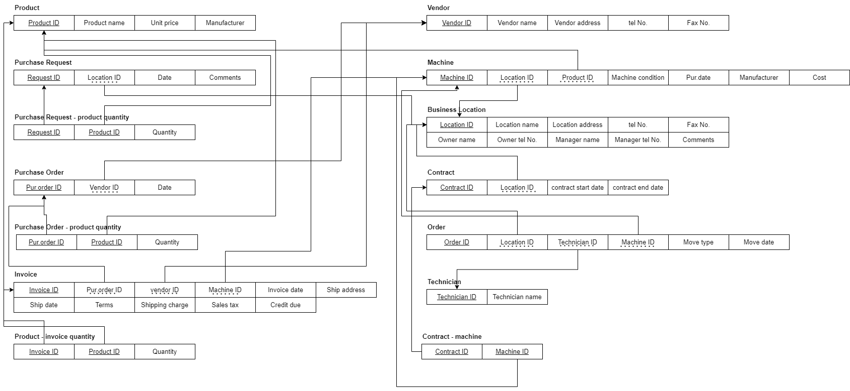
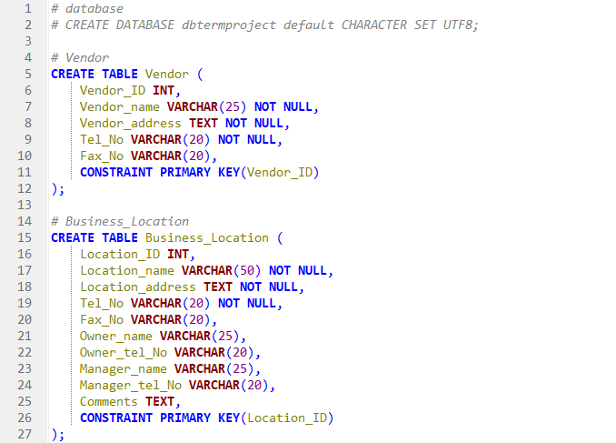
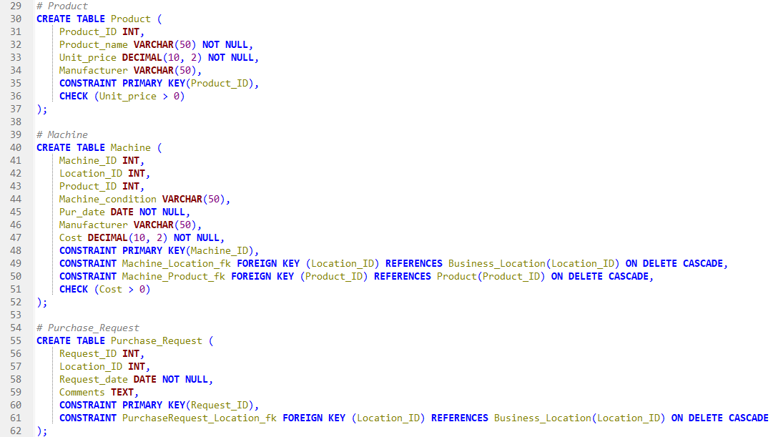
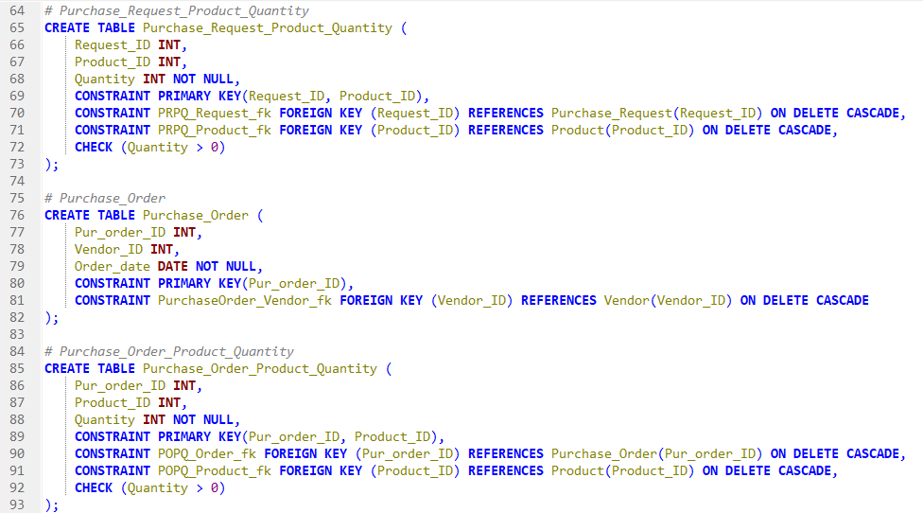
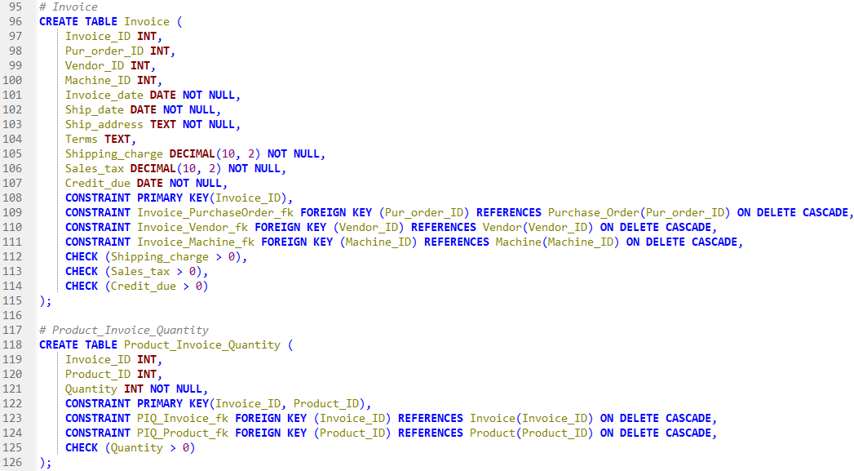
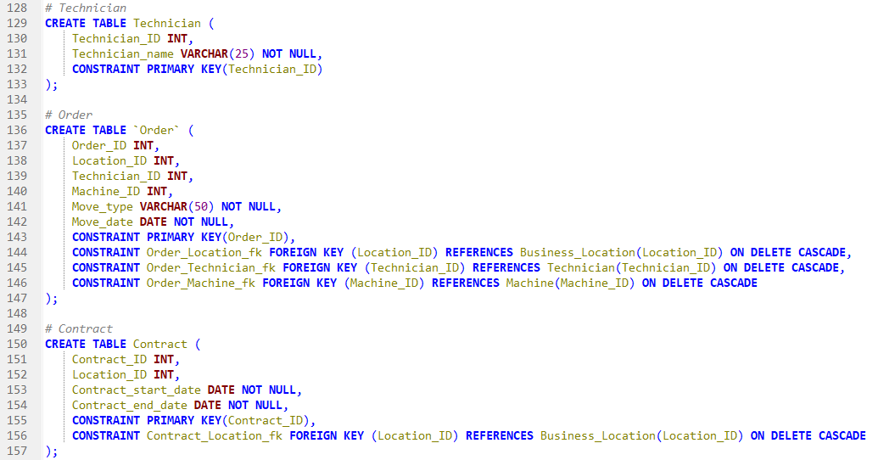
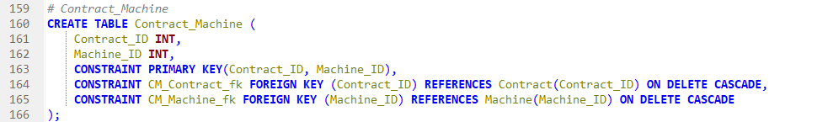

- Describe all the tables you’ve created and show the constraints using the following statements:

/* Show all the tables created from your database design. */

select table_name
from USER_TABLES;
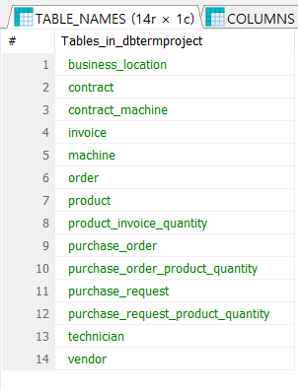

/* For each table, show the attributes using desc. */

desc <table name>
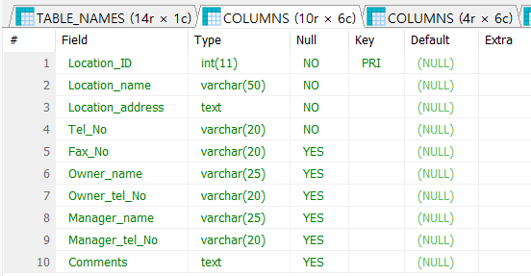

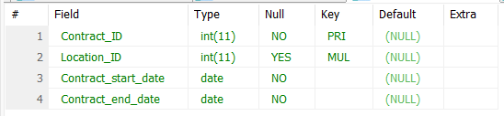

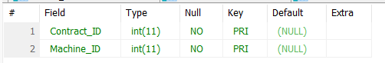

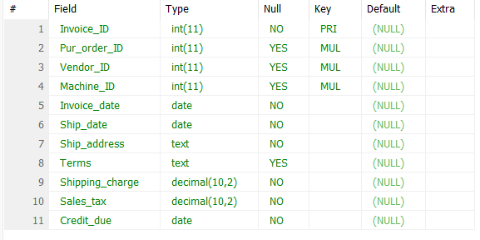

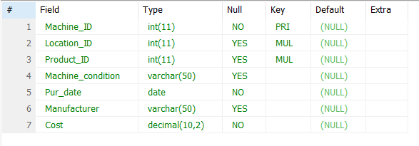

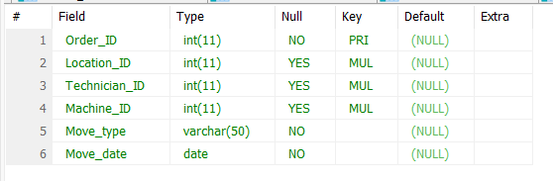

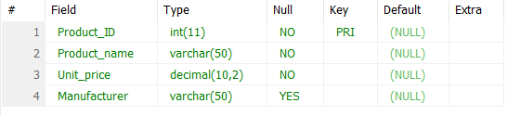

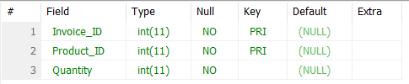

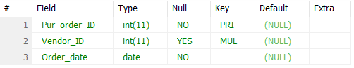

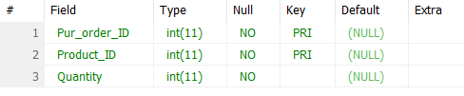

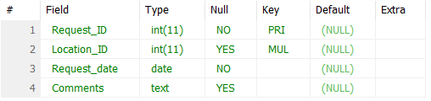

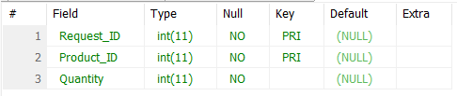

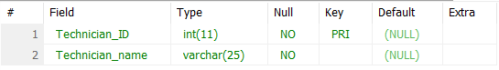

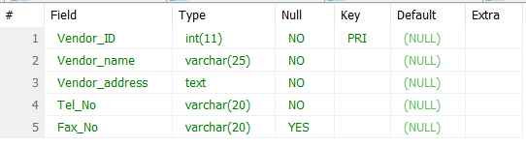

/* Now show the constraints using a data dictionary. */

select constraint_name, constraint_type, table_name
from user_constraints;
