**OUTPUTS**

**Student CS 260A Irina Golovko**

**HW#5 - onsplit**

(Outputs contain some extra outputs for debugging

script and better understanding logic)

**With zero arguments**

[igolovko@hills ~]$ onsplit

usage: onsplit needs files for combine.

[igolovko@hills ~]$ 30

**option ‘h’**

[igolovko@hills ~]$ onsplit -h

onsplit <option> <argument>

-f filename: combines partitions in one file with

given name "filename" (default - "noname");

Option 'l' only for text files (not for binary)

-l number: combines partitions in one file with given

number of lines (default number of lines = 1000)

-c number: combines partitions in one file with given

number of bytes (default number of bytes equals

the size of created file)

-d: delete all partitions after combine it together

-h: display help

Examples: onsplit -f filename filename*

onsplit -f -d f1 f2 f3

onsplit -l 100 -f filename -d f1 f2 f3

onsplit f1 f2 f3

onsplit -c 25000 f1 f2 f3

onsplit -h

**without any options for binary files**

[igolovko@hills ~]$ onsplit neaa neab neac nead neae

-rw-r--r-- 1 igolovko students 910088 May 5 12:44 noname

[igolovko@hills ~]$ rm noname

[igolovko@hills ~]$

**options ‘f’ ‘c’ with given number of bytes bigger then real size**

**of all partitions for binary files (partitions from vi)**

[igolovko@hills ~]$ onsplit -f MYVI -c 1200000 oaa oab oac oad oae

fsize = 910088

diffsize = 289912

289912+0 records in

289912+0 records out

289912 bytes (290 kB) copied, 0.254888 s, 1.1 MB/s

-rw-r--r-- 1 igolovko students 1200000 Apr 30 23:02 MYVI

[igolovko@hills ~]$ MYVI

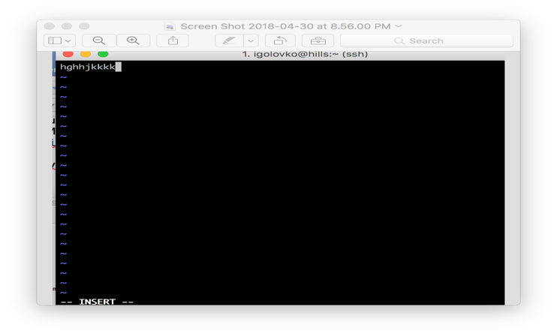

[igolovko@hills ~]$

**options ‘f’ ‘c’ with given number of bytes less then real size**

**of all partitions for binary files (partitions from vi)**

[igolovko@hills ~]$ onsplit -f MYVI1 -c 700000 oaa oab oac oad oae

fsize = 910088

We cannot create file MYVI1 with size less than

size of all partitions.

Created file will be badly damaged.

The size of file MYVI1 supposed to be no less then 910088

[igolovko@hills ~]$

**option ‘l’ for binary files**

[igolovko@hills ~]$ onsplit -f MYVI1 -l 10000 oaa oab oac oad oae

MYVI1 is a binary file.

We cannot use option l for binary files.

[igolovko@hills ~]$

**option ‘d’**

[igolovko@hills ~]$ onsplit -d oaa oab oac oad oae

-rw-r--r-- 1 igolovko students 910088 Apr 30 23:09 noname

[igolovko@hills ~]$ ls -la noname

-rw-r--r-- 1 igolovko students 910088 Apr 30 23:09 noname

[igolovko@hills ~]$ ls -la oa*

ls: cannot access oa*: No such file or directory

[igolovko@hills ~]$ rm noname

[igolovko@hills ~]$

**options ‘f’ and ‘l’ for text files**

[igolovko@hills ~]$ ls -la ac*

-rw------- 1 igolovko students 30 Apr 30 23:12 ac1.txt

-rw------- 1 igolovko students 29 Apr 30 23:12 ac2.txt

-rw------- 1 igolovko students 38 Apr 30 23:12 ac.txt

[igolovko@hills ~]$ wc -l ac*

4 ac1.txt

3 ac2.txt

4 ac.txt

11 total

[igolovko@hills ~]$ onsplit -f acm -l 25 ac*

type of file us-ascii

numlines = 25 flines = 11

diffl = 14

-rw-r--r-- 1 igolovko students 111 Apr 30 23:19 acm

[igolovko@hills ~]$ wc -l acm

25 acm

[igolovko@hills ~]$

**option ‘l’ for text files with default name of file ‘noname’**

[igolovko@hills ~]$ onsplit -l 5 ac.txt ac1.txt ac2.txt

type of file us-ascii

numlines = 5 flines = 11

diffl = -6

We cannot create file noname with number of lines

less than the whole number of lines in the all partitions.

The number of lines of the file noname supposed to be

no less then 11.

[igolovko@hills ~]$

**options ‘c’ ‘d’ ‘f’ for text files**

[igolovko@hills ~]$ onsplit -f fff -c 12000 -d ac.txt ac1.txt ac2.txt

fsize = 97

diffsize = 11903

11903+0 records in

11903+0 records out

11903 bytes (12 kB) copied, 0.0126052 s, 944 kB/s

-rw-r--r-- 1 igolovko students 12000 Apr 30 23:29 fff

[igolovko@hills ~]$ wc -l fff

11 fff

[igolovko@hills ~]$ ls -la ac*.txt

ls: cannot access ac*.txt: No such file or directory

**without any options for text file with default name ‘noname’**

**and default number of lines = 1000 and combine just only 1 file**

[igolovko@hills ~]$ wc -l 1.txt

17 1.txt

[igolovko@hills ~]$ onsplit 1.txt

type of file us-ascii

numlines = 1000 flines = 17

diffl = 983

-rw-r--r-- 1 igolovko students 1493 May 1 00:32 noname

[igolovko@hills ~]$ ls -la no*

-rw-r--r-- 1 igolovko students 1493 May 1 00:32 noname

[igolovko@hills ~]$ wc -l noname

1000 noname

[igolovko@hills ~]$ rm noname

[igolovko@hills ~]$

**without any options for text file with default name ‘noname’**

**and default number of lines = 1000**

[igolovko@hills ~]$ onsplit SanFrancisco2.html 1.txt

type of file us-ascii

numlines = 1000 flines = 2517

diffl = -1517

We cannot create file noname with 1000 number of lines

by default because it less than the whole number of lines

in the all partitions. The number of lines of the file

noname supposed to be no less then 2517.

[igolovko@hills ~]$

**with option f for text file**

**and default number of lines = 1000**

[igolovko@hills ~]$ onsplit -f ru 1.txt 2.txt

type of file us-ascii

numlines = 1000 flines = 38

diffl = 962

-rw-r--r-- 1 igolovko students 1999 May 5 13:28 ru

[igolovko@hills ~]$ wc -l ru

1000 ru

[igolovko@hills ~]$

**combine files which don’t exist, don’t have ‘read’ permission**

[igolovko@hills ~]$ ls -la nea*

-rw------- 1 igolovko students 200000 May 5 10:07 neaa

-rw------- 1 igolovko students 200000 May 5 10:07 neab

---x------ 1 igolovko students 200000 May 5 10:07 neac

-rw------- 1 igolovko students 200000 May 5 10:07 nead

-rw------- 1 igolovko students 110088 May 5 10:07 neae

[igolovko@hills ~]$

[igolovko@hills ~]$ onsplit -f ql -c 1200000 neaa neab neac nead neak

File neak doesn't exist.

[igolovko@hills ~]$ onsplit -f ql -c 1200000 neaa neab neac nead neae

Please give permission read for file neac

in order to combine this file.

[igolovko@hills ~]$

**combined file with given name already exist**

[igolovko@hills ~]$ ls -la qw

-rwxr--r-- 1 igolovko students 1200000 May 5 10:37 qw

[igolovko@hills ~]$ onsplit -f qw -c 1200000 neaa neab neac nead neae

File qw already exist.

[igolovko@hills ~]$

[igolovko@hills ~]$ ls -la noname

-rw------- 1 igolovko students 13 May 5 11:01 noname

[igolovko@hills ~]$ onsplit -c 1200000 neaa neab neac nead neae

By default the name of combine files is 'noname'.

File noname already exists.

Please use option 'f' to give specific filename.

[igolovko@hills ~]$