Overall comments:

Quite challenging task for me for different reasons

* Not many of the task items I’m currently required to use in my work,
* Most of the things I’ve used before, but it has been a while so needed time to dig my memory remembering how to do things, like setting up Db and EF
* Connecting to public API I’ve tried once, hence it would require me to spent longer time to set it up, but it’s definitely doable for me
* Due to the current heavy workload didn’t manage to implement Task2, but I created a frame for the solution and shared my ideas on how I would proceed in inline comments

GitHub: https://github.com/irinaBalib/A-Tasks

First task  
Must use:  
• Azure Function (Cloud/Local)  
• Azure Storage (Cloud /Local storage emulator)  
a. Table  
b. Blob  
• .Net Core 6

Didn’t have the VS 2022, needed to instal  
Already used my free trial period for Azure, so didn’t deploy anything, and used emulator for storage. Haven’t used the emulator before, spent some time to explore.

Achieve:  
• Every minute, fetch data from  
<https://api.publicapis.org/random?auth=null> [1] and store  
success/failure attempt log in the table and full payload in the blob.

Hope I understood this correctly – ‘attempt log’ refers to Http call and its result status?

Already have had experience with blob containers to store data, but not tables, needed to research it a little.

Implemented the data fetch, records saved in Azurite Db.

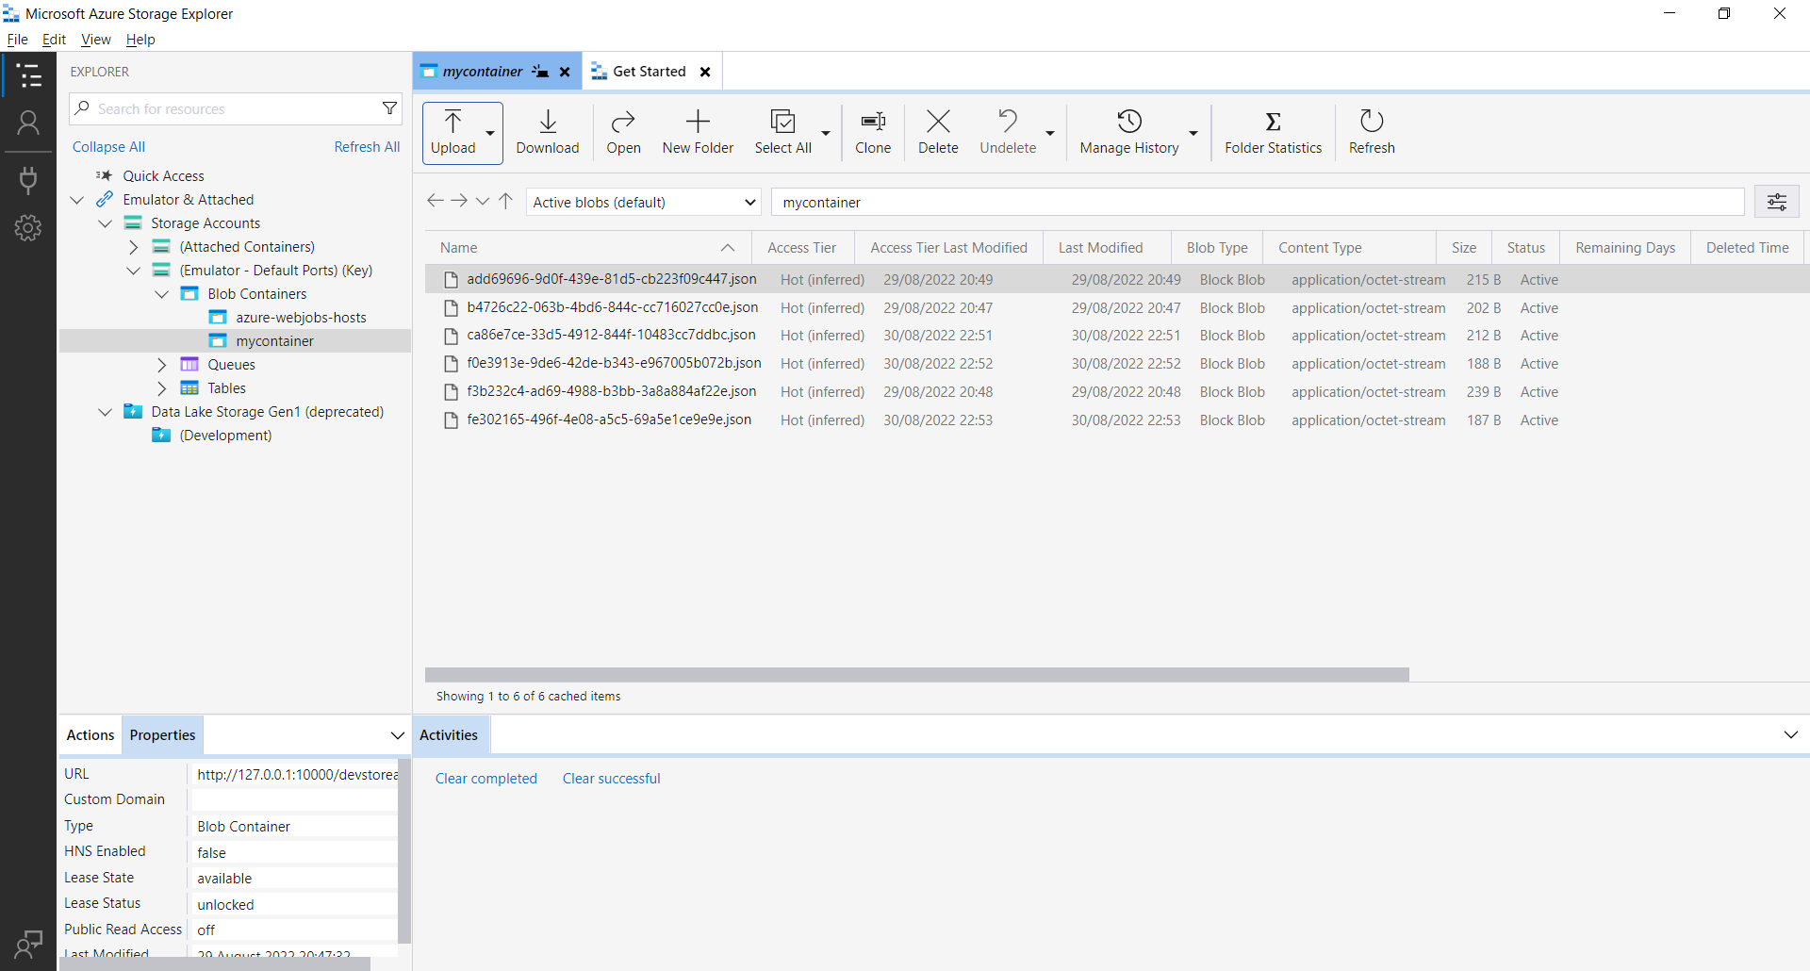

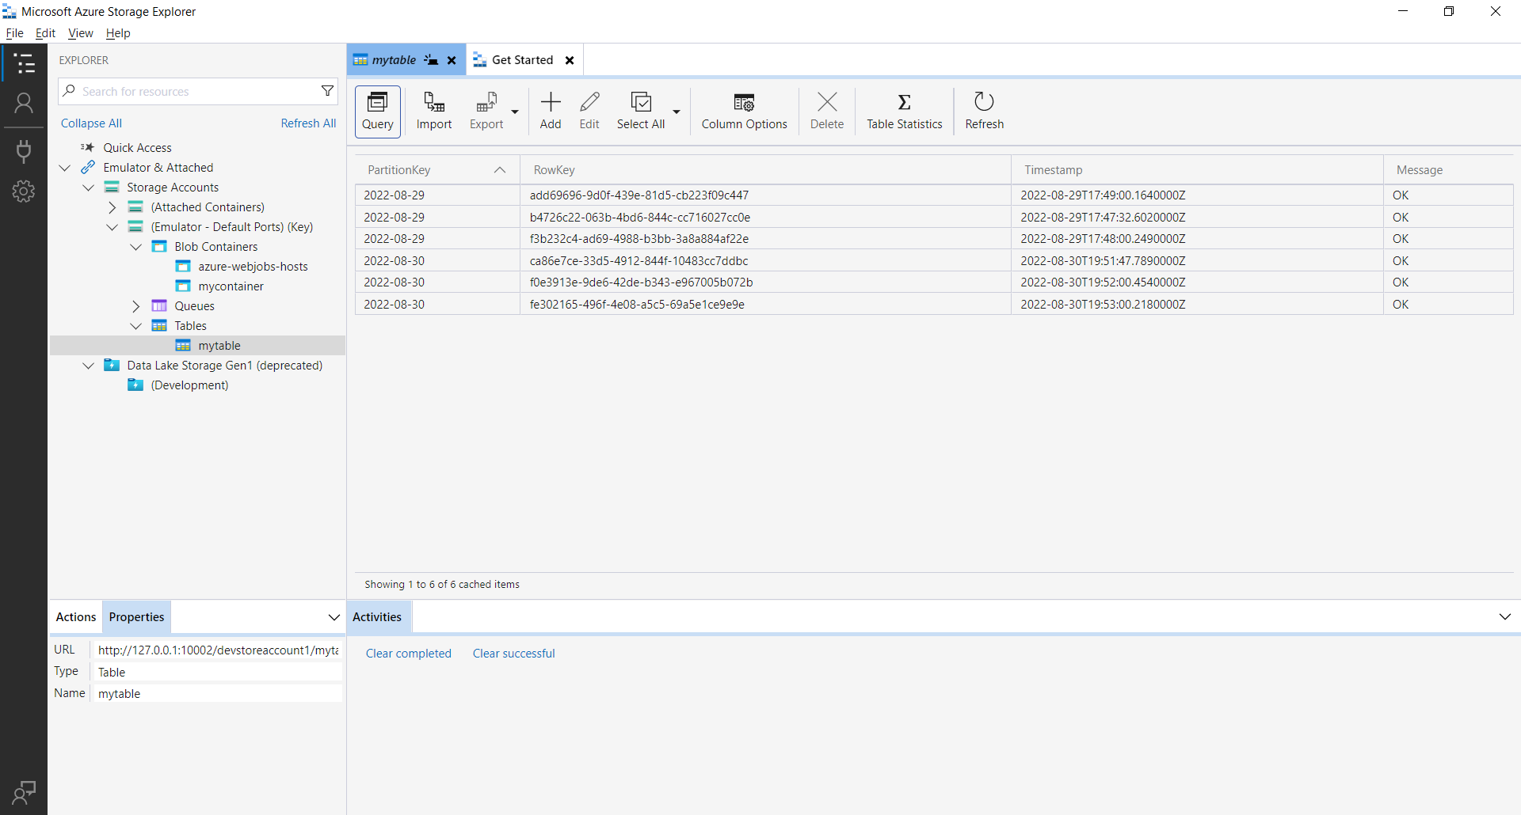

• Create a GET API call to list all logs for the  
specific time period (from/to)  
  
• Create a GET API call to fetch a payload from blob  
for the specific log entry

Named blob entries by log id. Other approach would try is adding tags.  
Created the calls, but they didn’t go through. The issue is with connecting to emulator using MS provided endpoints, I guess I’m configuring them wrong. Would investigate in that direction.  
• Publish code on GitHub (public)

Overall time spent – around 4h.

Second task   
Must use:  
• [ASP.NET](http://asp.net/) CORE MVC (6)  
• C#  
• JavaScript  
  
Achieve:  
  
Using any public weather API receive data (country, city,  
temperature, clouds, wind speed) from at least 10 cities in 5  
countries with periodical update 1/min, store this data in the database  
and show the 2 graphs:  
  
- min temperature (Country\\City\\Temperature\\Last update time)  
  
- highest wind speed (Country\\City\\Wind Speed\\Last update time)

- temperature & wind speed trend for last 2 hours on click for both  
previous graphs"

Overall time spent on Task2 - another 4h