Figures 1B, Fig2A,B,C and Fig4B,C

library(reshape2)  
library(ggplot2)  
library(tidyverse)

## -- Attaching packages ------------------------------ tidyverse 1.3.0 --

## v tibble 3.0.3 v dplyr 1.0.1  
## v tidyr 1.1.1 v stringr 1.4.0  
## v readr 1.3.1 v forcats 0.5.0  
## v purrr 0.3.4

## -- Conflicts --------------------------------- tidyverse_conflicts() --  
## x dplyr::filter() masks stats::filter()  
## x dplyr::lag() masks stats::lag()

library(gridExtra)

##   
## Attaching package: 'gridExtra'

## The following object is masked from 'package:dplyr':  
##   
## combine

library(tidyr)  
library(ggpubr)  
library("readxl")  
library(datasets)   
library(purrr)  
library(ggridges)

-Figure 1.B ‘we noticed that DEGs are more transcriptionally isolated then SEGs’

read_tsv("data_figures/DEG_SEG_dist_thrE.txt")->DEG_SEG_dist_thr

## Parsed with column specification:  
## cols(  
## gene = col_character(),  
## chr = col_character(),  
## start = col_double(),  
## end = col_double(),  
## ecto = col_double(),  
## endo = col_double(),  
## meso = col_double(),  
## min_dist = col_double(),  
## Len = col_double(),  
## percCG = col_double(),  
## percGC = col_double(),  
## percC = col_double(),  
## percCHG = col_double(),  
## set = col_character(),  
## thrE = col_double(),  
## thrGE = col_character(),  
## set_ds = col_character(),  
## log.dist = col_double()  
## )

DEG_SEG_dist_thr%>%  
 ggplot(aes(set_ds, log.dist, fill = set_ds)) +  
 geom_violin(draw_quantiles = 0.5) +  
 theme_bw(base_size = 16) +  
 scale_fill_manual(values = c("blue","yellow")) +  
 ylab("dist2nearest expr gene (log10 bp)\n") +  
 xlab(element_blank()) +  
 theme(axis.title.y = element_text(size = 14), plot.title = element_text(size = 14, hjust = 0.5)) +   
 ggtitle("dist for DEG SEG") -> v2ds.deg  
 v2ds.deg #all thr dumpted together

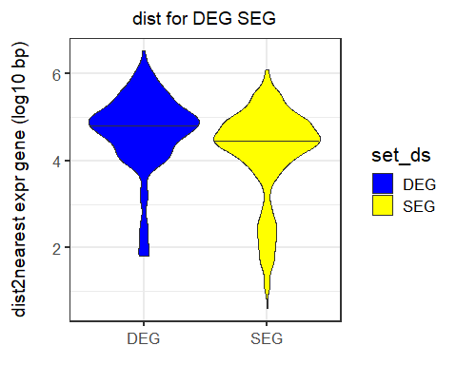

v2ds.deg+facet_grid(~thrGE)+ theme(legend.position = "none")+theme(axis.text.x=element_text(angle=90,hjust=1,vjust=0.5)) ->v02  
v02+ggtitle("distances in DEG SEG per GE threshold")

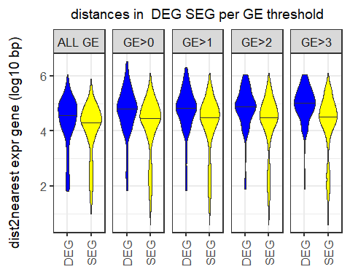

#------------------------no title  
v02+ggtitle("")

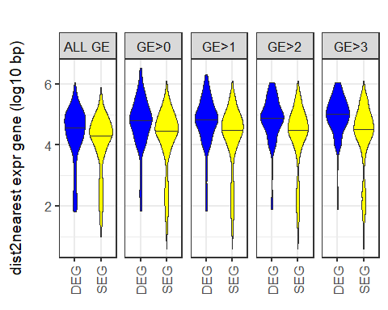 -Figure 2. A B C DEG vs SEG scatter EG and densities, pairwise here ‘show how we computed DEGs and SEGs’

#---------------------Fig2.A  
read_tsv("data_figures/pw_DEG_histo.txt")->diff

## Parsed with column specification:  
## cols(  
## GE_diff = col_double(),  
## freq = col_double()  
## )

#head(diff)  
  
pdiff<- ggplot(diff, aes (x=GE_diff, y=freq, fill=abs(GE_diff))) +  
 geom_bar(stat='identity',show.legend = FALSE)+  
 scale_colour_gradient2()+  
 theme_minimal(base_size = 14)+  
 theme(panel.grid.major = element_blank(), panel.grid.minor = element_blank())+  
 #ggtitle("A or C")+  
 xlab("Gene expression difference")+  
 ylab("counts")  
pdiff

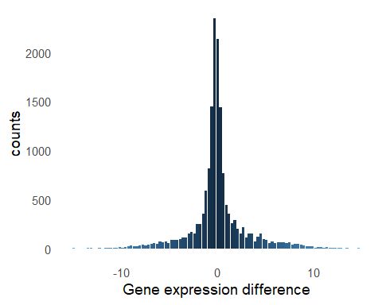 -Fig2 B `scatter plots for SEG, Dect Dmes

read_tsv("data_figures/scat_sim.txt")->scat_sim

## Parsed with column specification:  
## cols(  
## ge_ect = col_double(),  
## ge_end = col_double(),  
## ge_mes = col_double(),  
## gene_type = col_character()  
## )

#head(scat_sim)  
  
read_tsv("data_figures/scat_ect.txt")->scat_ect

## Parsed with column specification:  
## cols(  
## ge_ect = col_double(),  
## ge_end = col_double(),  
## ge_mes = col_double(),  
## gene_type = col_character()  
## )

#head(scat_ect)  
  
read_tsv("data_figures/scat_mes.txt")->scat_mes

## Parsed with column specification:  
## cols(  
## ge_ect = col_double(),  
## ge_end = col_double(),  
## ge_mes = col_double(),  
## gene_type = col_character()  
## )

#head(scat_mes)  
  
pp<- ggplot(scat_sim, aes (x=ge_ect,y=ge_mes)) +  
 geom_point(size=2,color="orange")+  
 geom_point(data = scat_ect,color="green",size=2)+  
 geom_point(data = scat_mes,color="magenta",size=2)+  
 ylim(-10, 12)+  
 theme_minimal(base_size = 14)+  
 theme(panel.grid.major = element_blank(), panel.grid.minor = element_blank())+  
 #ggtitle("C")+  
 xlab("Gene expression Ect")+  
 ylab("Gene expression Mes")  
pp

## Warning: Removed 45 rows containing missing values (geom_point).

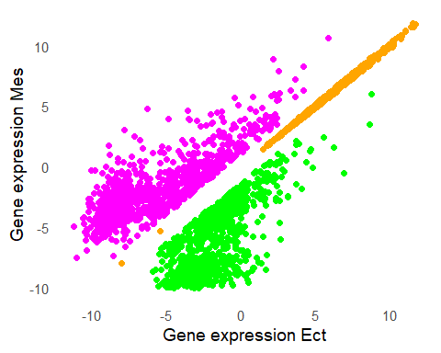 -Fig2. C

read_tsv("data_figures/GE_long_SEG.txt")->Sim

## Parsed with column specification:  
## cols(  
## GE = col_double(),  
## layer = col_character()  
## )

pd4<- ggplot(Sim, aes(x = GE, y = layer,fill=layer)) + geom_density_ridges(  
 aes(point_fill = layer, point_shape = layer),  
 alpha = .4) +  
 xlab("Gene expression")+  
 ylab(" ")+  
 scale_fill_manual(values = c("green", "blue","magenta"))  
#pd4  
  
#-------------------------------all genes  
  
read_tsv("data_figures/GE_long_ALL.txt")->ALL

## Parsed with column specification:  
## cols(  
## v = col_double(),  
## layers = col_character()  
## )

pd1<- ggplot(ALL, aes(x = v, y = layers,fill=layers)) + geom_density_ridges(  
 aes(point_fill = layers, point_shape = layers),  
 alpha = .4) +  
 xlab(" ")+  
 ylab(" ")+  
 scale_fill_manual(values = c("green", "blue","magenta"))  
 #, labels = c("female", "male","unknown"))   
#pd1  
  
#---------------------DifEct  
read_tsv("data_figures/GE_long_DifEct.txt")->DifEct

## Parsed with column specification:  
## cols(  
## GE = col_double(),  
## layer = col_character()  
## )

pd2<- ggplot(DifEct, aes(x = GE, y = layer,fill=layer)) + geom_density_ridges(  
 aes(point_fill = layer, point_shape = layer),  
 alpha = .4) +  
 xlab(" ")+  
 ylab(" ")+  
 scale_fill_manual(values = c("green", "blue","magenta"))  
 #, labels = c("female", "male","unknown"))   
#pd2  
  
#--------------------Dif Mes  
read_tsv("data_figures/GE_long_DifMes.txt")->DifMes

## Parsed with column specification:  
## cols(  
## GE = col_double(),  
## layer = col_character()  
## )

pd3<- ggplot(DifMes, aes(x = GE, y = layer,fill=layer)) + geom_density_ridges(  
 aes(point_fill = layer, point_shape = layer),  
 alpha = .4) +  
 xlab("Gene expression")+  
 ylab(" ")+  
 scale_fill_manual(values = c("green", "blue","magenta"))  
 #, labels = c("female", "male","unknown"))   
#pd3

Fig2 C: arrange densities together

pE <-  
 ggarrange( pd1, pd2, pd3, pd4, labels = c("C1","C2","C3", "C4"),  
 common.legend = TRUE, legend = "bottom"  
 )

## Picking joint bandwidth of 0.617  
## Picking joint bandwidth of 0.617

## Picking joint bandwidth of 0.529

## Picking joint bandwidth of 0.604

## Picking joint bandwidth of 0.493

pE

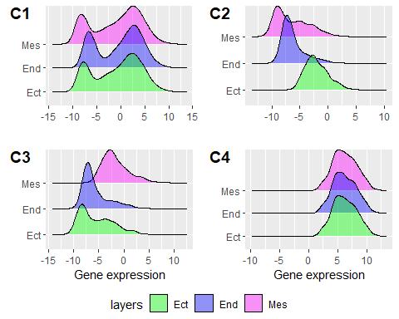

-Figure 4.B Distribution of chromatin accessibility difference in a window along chromosome 1.

-DAR density in 100bp window, Ect vs Mes, chr1 = Fig4.B

read_tsv("data_figures/da_win_pw_chr1.txt")->da_win

## Parsed with column specification:  
## cols(  
## diff_access = col_double()  
## )

#head(da_win)  
  
pDAR<- ggplot(da_win, aes(diff_access))+  
 #geom_bar(stat='identity')  
 geom_density(fill='grey')+  
 #ggtitle("Differential access,100bp win Ect vs Meso")+  
 theme_minimal(base_size = 14)+  
 ylab("density")+  
 xlab("differential access, frac")  
pDAR

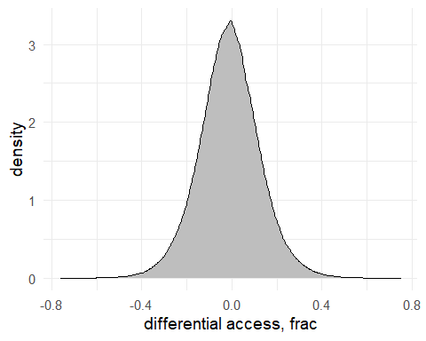 -Figure 4.C TSS histograms

read_tsv("data_figures/histTSS_DEG.txt")->histTSS_DEG

## Parsed with column specification:  
## cols(  
## TSS_vic = col_double(),  
## freqEct = col_double(),  
## type_Ect = col_character(),  
## freqMes = col_double(),  
## type_Mes = col_character(),  
## freqSEG = col_double(),  
## type_SEG = col_character(),  
## type_DEG = col_character(),  
## freqDEG = col_double()  
## )

head(histTSS_DEG)

## # A tibble: 6 x 9  
## TSS_vic freqEct type_Ect freqMes type_Mes freqSEG type_SEG type_DEG freqDEG  
## <dbl> <dbl> <chr> <dbl> <chr> <dbl> <chr> <chr> <dbl>  
## 1 -80000 0.37 highEct 0.32 highMes 0.04 highSEG highDEG 0.345  
## 2 -79000 0.39 highEct 0.31 highMes 0.04 highSEG highDEG 0.35   
## 3 -78000 0.44 highEct 0.31 highMes 0.04 highSEG highDEG 0.375  
## 4 -77000 0.49 highEct 0.290 highMes 0.04 highSEG highDEG 0.39   
## 5 -76000 0.47 highEct 0.3 highMes 0.04 highSEG highDEG 0.385  
## 6 -75000 0.43 highEct 0.31 highMes 0.04 highSEG highDEG 0.37

#-------------------histo SEG  
  
ps <- ggplot(histTSS_DEG, aes(x=TSS_vic, y=freqSEG, colour=type_SEG)) +   
 geom_line(size=1)+  
 scale_colour_manual(values=c("black","orange","yellow"))+  
   
 theme_minimal(base_size=15)+  
 ylim(0,0.6)+  
 #ylab("normalised chromatin access count")+  
 xlab(" ") +   
 ylab(" ")+  
 ylab(" Normalised chromatin access")+  
 #ylab("Normalised per gene Chromat Access count ")+  
 theme(legend.title = element_blank())  
   
 ps<-ps+scale_x_continuous(breaks=seq(-80000,80000,80000),labels=c("-80K", "TSS", "80K"))  
   
 #ps  
   
 #pp<-grid.arrange(pe, pm, ps, ncol=1)  
 #pp + theme(legend.title = element_blank())  
   
 #---------------------DEG TSS  
   
pm <- ggplot(histTSS_DEG, aes(x=TSS_vic, y=freqDEG, colour=type_DEG))+ geom_line(size=1)+  
 scale_colour_manual(values=c("black","blue","cyan"))+  
 #xlim(-80000,80000)+  
 theme_minimal(base_size=14)+  
 xlab(" ") +   
 ylab(" ")+  
 #ylab("Normalised Chromatin Access")+  
 scale_y_continuous(breaks=seq(-0,0.6,0.2))+  
 theme(legend.title = element_blank())  
#pm  
 pm<-pm+scale_x_continuous(breaks=seq(-80000,80000,80000),labels=c("-80K", "TSS","80K"))  
   
 #--------------------------together  
   
 pp<-grid.arrange(pm, ps, ncol=1)

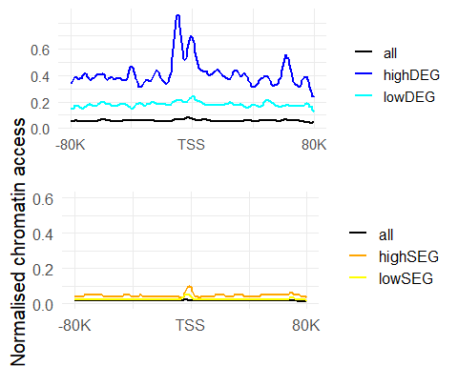

pp

## TableGrob (2 x 1) "arrange": 2 grobs  
## z cells name grob  
## 1 1 (1-1,1-1) arrange gtable[layout]  
## 2 2 (2-2,1-1) arrange gtable[layout]