Adaptive Tutor Bot
B — Conception
Team Lesinvincibles2 — Irina Kiseleva & Paulo-Rogerio Guimaraes-Filho

1. Project Overview
Adaptive Tutor Bot helps students review distributed systems topics: CAP theorem, saga pattern, consistent hashing, replication, idempotency, message queues. The bot reads the student's message and adjusts how deep the explanation goes. Say “I don't get it” and it simplifies. Say “too easy” and it goes further.
Two parts talk to each other over HTTP. The backend (Node.js/Express) exposes a small REST API and calls Groq's LLM API. The frontend (React) is what the student actually sees and clicks on.

2. System Architecture
No database here. Topics are hardcoded on the backend, and the chat history only lives in the browser tab — close it and it's gone. The diagram below shows the three pieces and how they talk to each other.
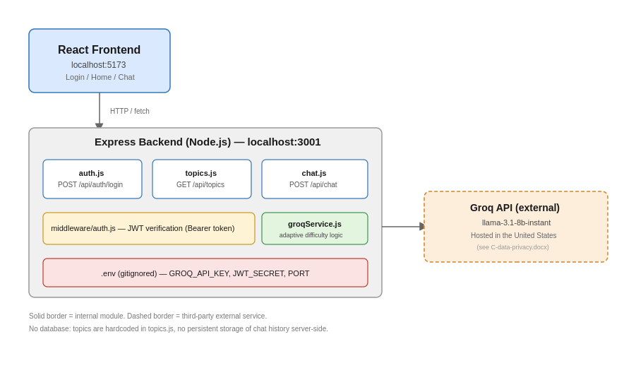

2.1 Components
- React frontend, port 5173. Three pages: Login, Home (topic list), Chat.
- Express backend, port 3001. Three route files (auth.js, topics.js, chat.js), a JWT middleware, and a Groq service module.
- Groq API, external, hosted in the US. Runs llama-3.1-8b-instant, which actually generates the tutor's replies.

2.2 Request flow
Below: a full session traced step by step — login, load the topics, send one chat message.
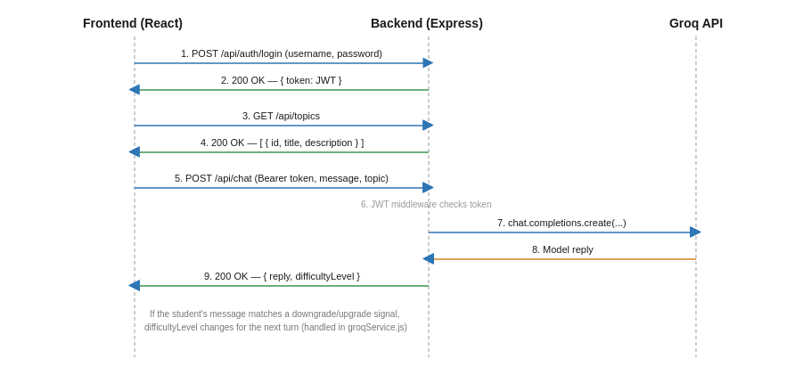

2.3 API summary
Method | Endpoint | Auth | Description
GET | /api/health | No | Health check
GET | /api/topics | No | List of available topics
POST | /api/auth/login | No | Login, returns a JWT token
POST | /api/chat | Yes (Bearer) | Send a message, get an adaptive reply

3. Frontend Structure
Small React app, built with Vite. Three pages, one shared file for API calls, routing handled by react-router-dom.
File | Responsibility
api.js | All the fetch calls in one place (login, getTopics, sendChatMessage). Saves having to fix the base URL or headers in three different files.
pages/Login.jsx | Username/password form, calls POST /api/auth/login, keeps the JWT token in memory, redirects to home once logged in.
pages/Home.jsx | Calls GET /api/topics on load, shows each topic as a clickable card. No token = redirect to /login.
pages/Chat.jsx | Calls POST /api/chat with the Bearer token, sends the message history along for context, shows the conversation and the current difficulty level.
App.jsx | Declares the three routes, guards / and /chat behind having a token.

The token stays in React state, not localStorage. Simplest option for a three-page prototype — downside is it disappears on refresh, which is fine here but would need fixing for anything real.

4. Work Organization
Two people on this team, so we kept it simple. Irina set up the repo and built the backend first. Once it was working, she sent a message listing four concrete tasks for the frontend side — clone the repo, build the three pages, write two of the docs, fill in the collaboration log. No board, just a clear handoff.

4.1 Role split
Team member | Scope
Irina Kiseleva | Backend (Express routes), GenAI integration (Groq), JWT auth, security doc, model benchmark.
Paulo-Rogerio Guimaraes-Filho | Frontend (React: Login, Home, Chat), this conception document, data privacy document.

4.2 Coordination tools
- GitHub repo as the single source of truth. Each person works on their own feature branch (e.g. feature/frontend) instead of pushing straight to main.
- Task list sent directly as a message once the backend was ready, instead of a GitHub Projects board — for two people and four tasks, a board felt like overkill.
- docs/collaboration-log.md, one table per person, filled in as we go: what we did, what we decided, and why.

4.3 Why no Kanban board
A board makes sense when several people juggle a lot of moving tasks at once. Here it was two people and a clean split: backend on one side, frontend plus docs on the other. A message with four bullet points covered it. The downside is obvious — this only works because the team is small. It would not hold up with five or six contributors.

