- Your name:

- Draw the result of running the following snippet of code. Assume background is white unless specified. Be precise!
- size(100,100);
line(0,0,width,height);
line(width,0,0,height);

- void setup(){
size(200,200);
}
void draw(){
fill(0);
rect(0,0,width/2,height/2);
rect(width/2,height/2,width/2,height/2);
}

- Translate from Processing into English. For go-getters: can you (slightly) improve the code? Is the condition x == y true or false ? Explain.
int x=1;
int y=2;
if(x == y){
fill(0,0,0);
rect(0,0,50,50);
}else{
fill(255,0,0);
rect(0,0,50,50);}

- Give short responses to the following questions:
  - what is camelCase?

  - What does x == y mean?

  - What does x = y mean?

  - What are 2 ways to say: set x to 1 less than its current value?

  - What are variables? Why do we need variables of different types? Give examples.

- Write out code that will produce this image. There are multiple ways to do this so approach it how you would like to.
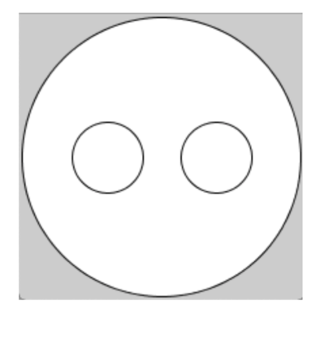

- Write a line of code to imitate a throw of a 12-sided die. The result must be an integer between 1 and 12 inclusive.
- What will be printed out?
boolean iLoveProgramming = true;
print("It is definitely "+ !(!(iLoveProgramming)) + " that I love programming!");

- Loops
  - Write a for() loop that will print all even numbers from 6 to 26 (including 26). Rewrite the code using a while() loop.

  - Given code
println("tick");
println("tock");
println("tick");
println("tock");
println("tick");
println("tock");

Rewrite using a loop.

- Variables —watch out, might be tricky!
  - What is a variable scope?

  - You wrote a snippet of code:
int x = 20;
void setup(){
size(200,200);
x = 200;
int y = 50;
}
void draw(){
println(x/y);
}
Will this code compile? If not, why? What will be printed to the console? Why?

c. You wrote a snippet of code:
int a=1;
a--; //what is a now?
a-=4; //what is a now?
int b=a;//what is b now?
Draw a memory diagram.

9. Calling a function
a. int p(int n){
int prod=1;
for(int i=0;i<n;i++){
prod*=2;
}
return prod;
}
What does the function above return if n=2? Show a memory diagram.
What does the function above return if n=4? Show a memory diagram.
Give a one-sentence "big picture" description of the function or express
the output as a function of n.
10. Arrays
Your first-year friend doesn't know what major to pick but they've narrowed down their choices.
//one of multiple ways to declare a String array
String[] majors ={"Math and CS", "Biology", "Graphic Design", "Creative Writing", "New Media", "Music: Performance", "Theatre and Performance"};
println(majors);
The above starter code prints the list of majors they are considering. - Now add a line of code to pick a major at random from their list and print it to the console. (Note: this is probably not a recommended way to pick a major.)

11. Write the condition that the mouse is in the black area; the gray area.
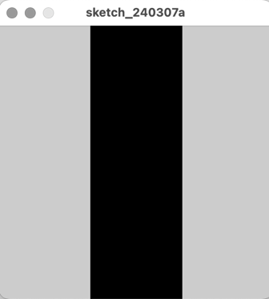
12. Consider a snippet of code. What will be printed on the console? Explain. Again, watch out, might be tricky!
int i;
for(i=10; i<14;i++);{
println(i);
}

13.(for go-getters) Consider a snippet of code. What will be printed to the console?
int []arr={1,2,3,4,5,6,3,2,1,0};
println(arr[4]);
println(arr[arr[4]]);
println(arr[arr[3]+arr[9]]);
println(arr[arr[3]]+arr[arr[5]]);

You added a line of code
println(arr[arr[3]+arr[5]]);
What will happen now?

