Assignment 1.1: Extracting Frequency Bands from Raw EEG Data (2%)
Due: September 28th, 2026, at 11:59 p.m.
You are a new trainee in a lab studying the neural circuits that regulate sleep and wakefulness. You are recording activity from three exploratory brain regions and aim to determine which sleep-wake states they regulate. The first step in your analysis is to create a function that extracts different frequency bands from the EEG recordings.
In this example, you are given a numeric list of raw EEG values labeled as REM_Baseline_Practice. The data was collected at 1024 Hz sampling rate.
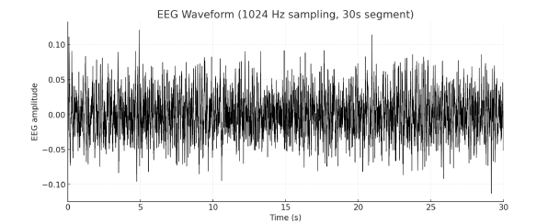
Figure 1: Example trace of EEG Recording during REM Sleep for one trial
Q1: What mathematical method would you use to extract frequency bands from these EEG signals? Why would you use this specific formula? Based on the information provided in the assignment, which frequency bands will you extract?
Q2: Create a Python function that:
- Takes the raw EEG signal and sampling rate as inputs
- Applies a mathematical method to transform the EEG signal into appropriate frequencies
- Return the frequency values and the corresponding power spectrum
Q3: Write a function that calculates the power of each frequency band. Your function should do the following:
- Takes the output from your function from part 2
- Selects only the values in the appropriate frequency range
- Calculate the total power in the appropriate range
- Return the frequency power as your output
Q4: What is the proportion of each frequency band power (in %) for this specific recording? Why do you think we report it as %?
To check if your function performs correctly, the theta proportion for REM_Baseline_Practice should be somewhere in between 40-45%
Once you got a correct value, you can move on to the next part:
Q5: In your Excel sheet, you have raw EEG data in Sheet 1 labeled as EEG. If you open the file, you will see that they are labeled accordingly. For example, "Trial1" refers to Laser trial 1 and so on.
As an output, you should create clean, analysis-ready DataFrames that store similar to the example below:
Your final output should look roughly like this (numbers are arbitrary)
Group Name | Power of Delta (%) | Power of Theta (%)
Trial 1 | 20 | 45
Trial 2 | 25 | 43
Trial 3 | 19 | 39
Keep in mind that you will have more frequencies that provided in this example table (see Assignment 1)
1) Load Excel files containing data into your Jupyter Hub:
- Inspect your data with .head() function and list the sheet names. What does the data represent? What does each column and row mean?
- Extract EEG signals for each trial
- Calculate total power for each frequency provided in Assignment 1 Description
- Summarize results into a clean DataFrame. (You should have 3 data frames per each unknown region
- Add a new column theta/delta where you divide column “power of delta”/”power of theta” for each trial
- Think how to modify your code if you have more than one mouse in Excel sheet.

Happy coding!

