DESIGN AND DEVELOPMENT OF A COMPUTER LABORATORY ISSUE REPORTING AND MONITORING SYSTEM
FINAL PROJECT DOCUMENTATION
AC COMPUTER PROGRAMMING
Prepared by: ______________________________
Section: _________________________________
Instructor: ______________________________
Submission date: _________________________
Document status: Revised with captured GUI screenshots and automated test evidence; manual testing remains partially unverified.

A. PROJECT DOCUMENTATION

1. Project Title
Design and Development of a Computer Laboratory Issue Reporting and Monitoring System

2. Background of the Problem
Computer laboratories support classroom instruction, research, and practical programming activities. Equipment or software faults such as malfunctioning keyboards, display problems, and unresponsive applications may interrupt laboratory sessions. When issues are communicated verbally or through informal messages, staff can find it difficult to locate existing reports, identify unresolved faults, and determine whether repairs have been completed.
The proposed system provides a simple computer-based process for submitting, tracking, and resolving laboratory issues. A staff account submits an issue report; an administrator acting as IT support reviews the report, marks it in progress, and records the action taken when it is resolved. The system operates offline on a single Windows computer and stores information using Python dictionaries backed by local JSON files.

3. Statement of the Problem
- How can laboratory staff record problems in an organized form?
- How can staff check the progress of issues they reported?
- How can the IT administrator identify unresolved problems and record corrective action?
- How can the system prevent incomplete reports and unauthorized changes?
- How can records remain available after the application is closed without requiring an SQL database?

4. General Objective
To design and develop an offline Computer Laboratory Issue Reporting and Monitoring System that records issues, supports role-based issue management, and preserves local records for subsequent review.

5. Specific Objectives
- Allow the administrator to create local staff accounts and authenticate users.
- Allow staff to report computer problems with a computer identifier and description.
- Generate a unique report ID, reporting date, and initial Pending status automatically.
- Allow staff to view and search the reports they submitted.
- Allow the administrator to review all reports, update statuses, and enter resolution notes.
- Provide a dashboard showing report counts and searchable, filterable records.
- Validate user input and preserve records in local JSON files.

6. Description of the Proposed System
The prototype is a Python desktop application built with Tkinter and ttk. At first launch, the user creates the initial administrator account. Administrators can create staff accounts. Staff users can submit issues and review their own reports; administrators can inspect reports from all staff, set Pending, In Progress, or Resolved status, enter resolution notes, reopen issues, and remove records after confirmation. All information is stored locally on the computer where the program runs.
The software does not send reports across a network. Staff and administrator users must access the same local computer and files, taking turns to sign in. It is a learning prototype rather than an enterprise service desk.

7. Target Users
- Laboratory staff or assigned staff reporters
- IT personnel or laboratory administrator acting as technical support

8. System Features and Functions
Feature | Function
Initial admin setup | Create first administrator on a fresh installation.
Login and logout | Identify the local user and apply staff/admin screens.
Staff account creation | Administrator creates staff credentials.
Issue submission | Staff enters PC number and issue description.
Search and filter | View matching records by keyword and status.
Status tracking | Administrator marks reports Pending, In Progress, or Resolved.
Resolution notes | Administrator records corrective action before resolution.
Delete report | Administrator removes a selected report after confirmation.
Local persistence | Save and reload dictionary records through JSON files.

B. SYSTEM DESIGN

1. Input-Process-Output (IPO) Chart
Input | Process | Output
Username and password | Validate credentials against stored hashed record | Login or error message
Admin registration details | Validate and save initial admin credentials | Administrator account created
Staff account details | Admin validates username, password and user role | Staff account created or validation error
Computer number and issue | Validate inputs; generate ID/date; save report | New Pending report
Search term/status | Filter visible report records | Matching table rows
Selected report and new status | Check admin role and update report | Updated report status
Selected report and repair notes | Store Resolved status and explanation | Resolution notes in report table
Delete selection and confirmation | Remove report from dictionary and JSON | Updated table and counts

2. Algorithm
- Start the desktop application and read local users.json and reports.json if available.
- If no users exist, display initial administrator registration; validate and save the account.
- Display the login form and authenticate submitted credentials.
- If authentication fails, display an error and allow another attempt.
- If role is Staff, display issue submission and only that user’s reports.
- If role is Admin, display all reports, staff account creation, and issue management buttons.
- When staff submit a report, validate required fields and computer format, allocate the next report ID, set date and Pending status, then save to JSON.
- When admin changes a report, validate selected record and status, request notes for Resolved, save changes to JSON, and refresh the display.
- For search/filter actions, loop through the dictionary, identify matches, and display results.
- Repeat available actions until the user logs out or closes the application.

3. Flowchart
Figure 1 presents the main role-based login and issue management path. Validation failures return to the relevant input screen.
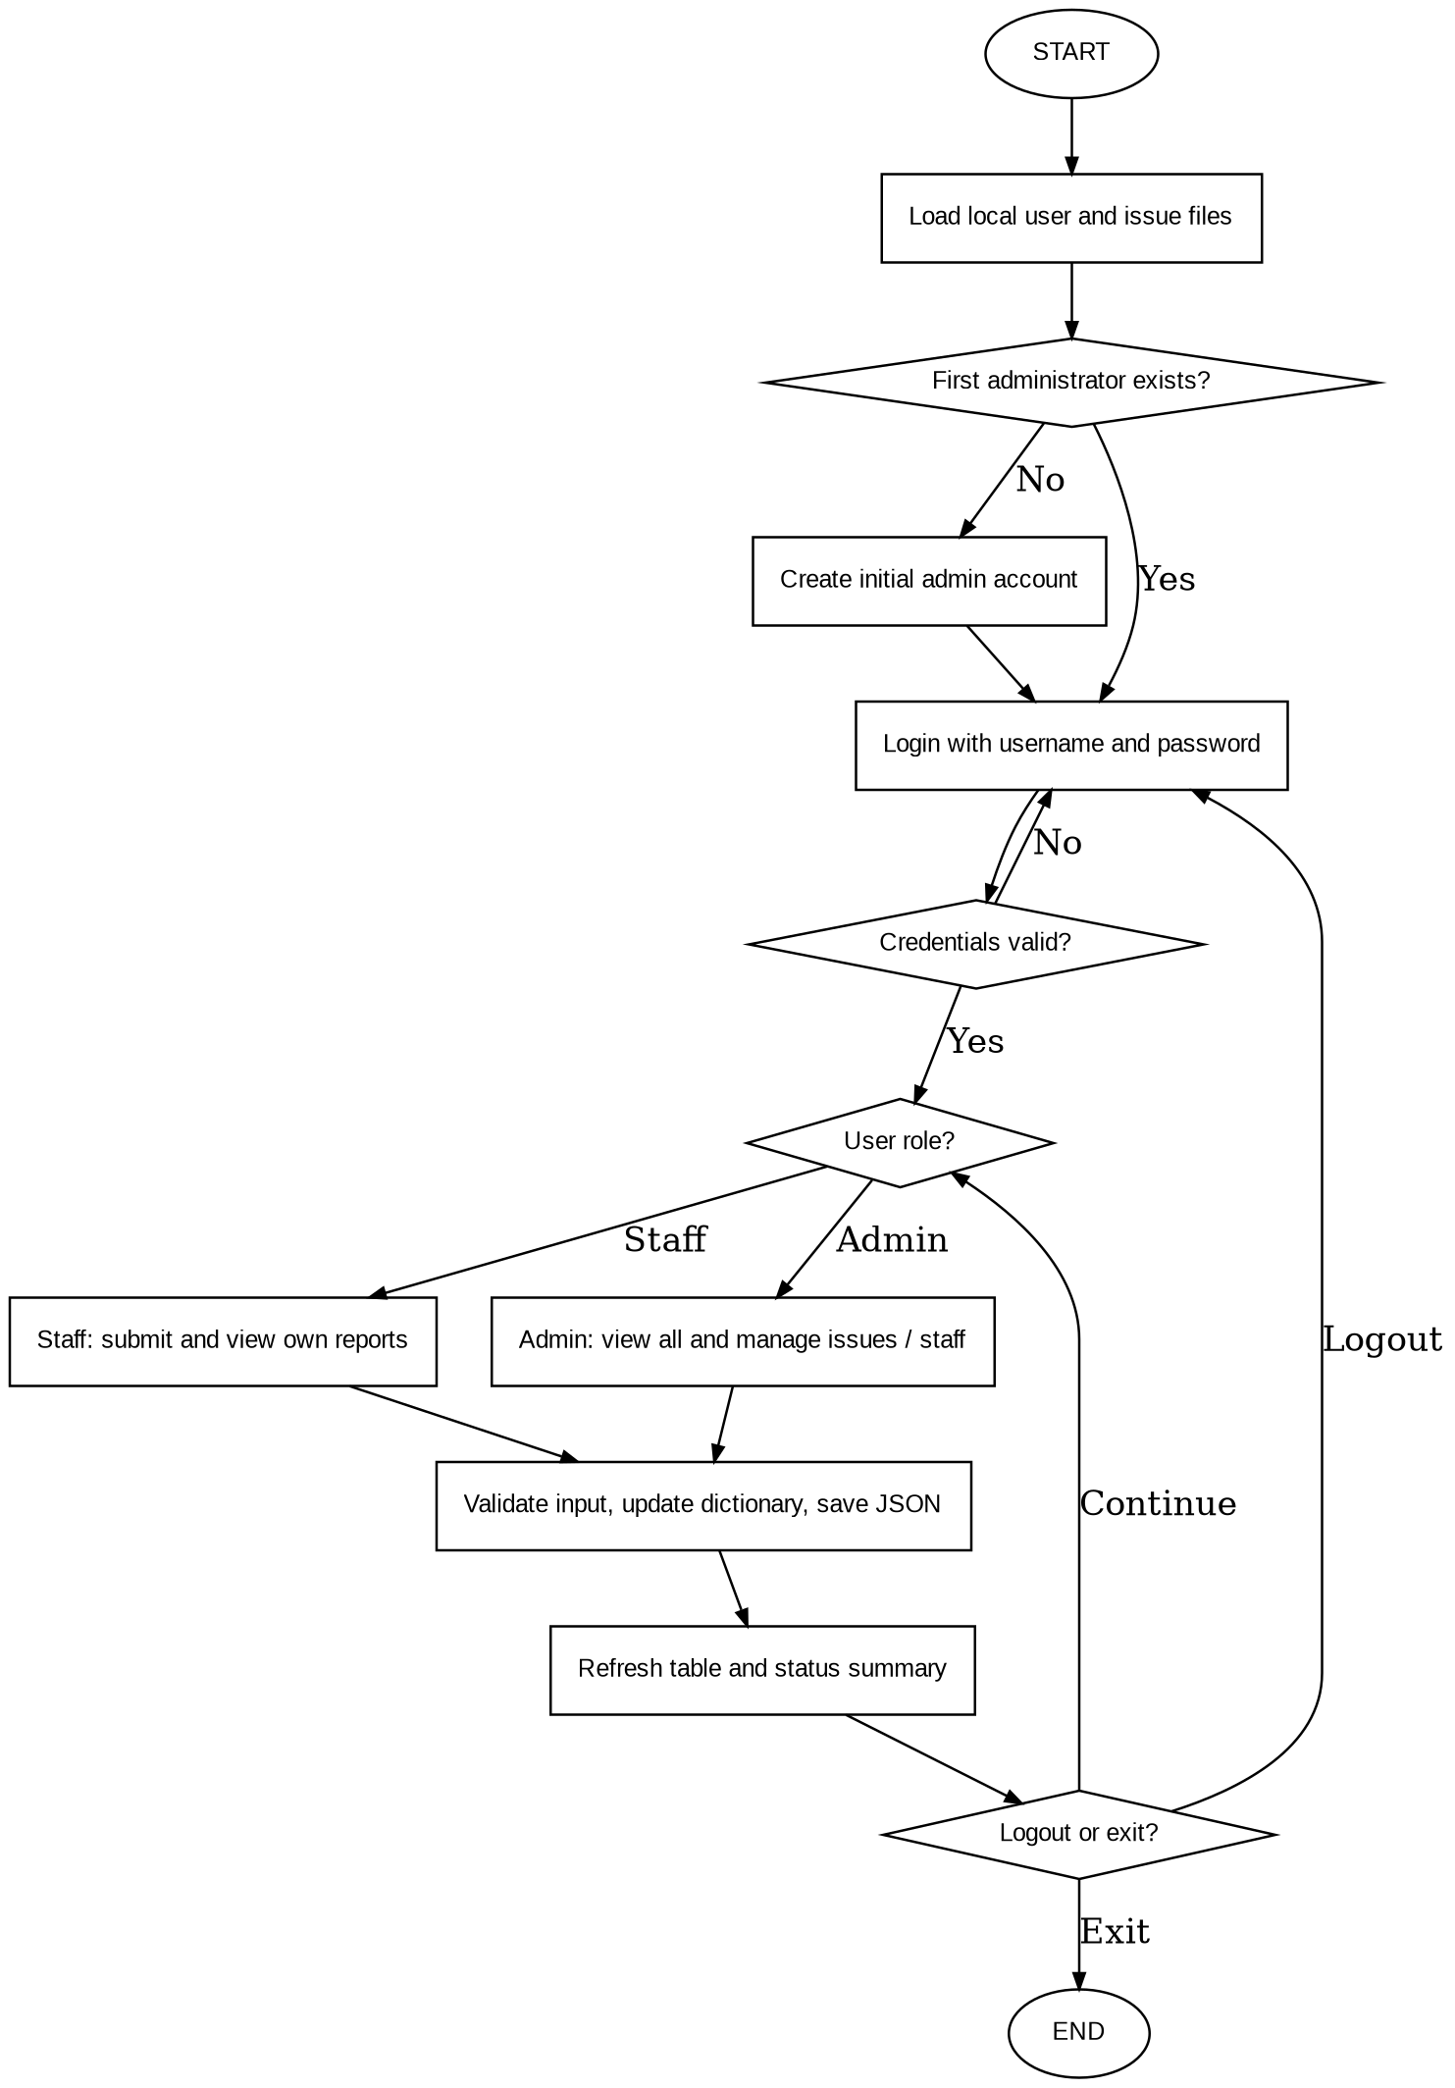

4. Pseudocode
START
LOAD local users and reports
IF no user account exists THEN
PROMPT for first administrator credentials
VALIDATE and SAVE account
END IF
REPEAT
PROMPT for username and password
IF credentials are invalid THEN SHOW error
ELSE
IF role = Staff THEN
DISPLAY own reports
IF report submitted THEN
VALIDATE computer and issue
CREATE report with Pending status
SAVE reports to JSON
END IF
ELSE IF role = Admin THEN
DISPLAY all reports
IF account creation requested THEN SAVE staff account
IF status change requested THEN
UPDATE report status
IF Resolved THEN REQUIRE resolution notes
SAVE reports to JSON
END IF
IF delete confirmed THEN REMOVE report and SAVE
END IF
REFRESH visible table and summary counts
END IF
UNTIL application exits

5. User Interface Design
Interface | Primary elements
First-run registration | Administrator username, password, confirmation and create button
Login screen | Username, password and login button
Staff dashboard | Issue form, own reports table, search, status filter and summary counts
Admin dashboard | All reports table, search/filter, Create Staff Account, status controls and delete confirmation

The following figures are screenshots captured from the functioning Python Tkinter application. The login screen and role-specific dashboards illustrate the system’s user interface and separation of responsibilities.
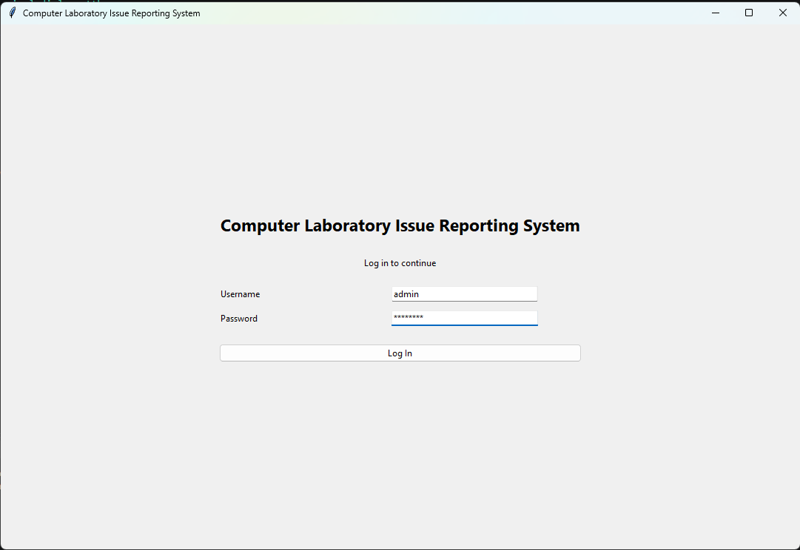
Figure 2. Local account login screen.
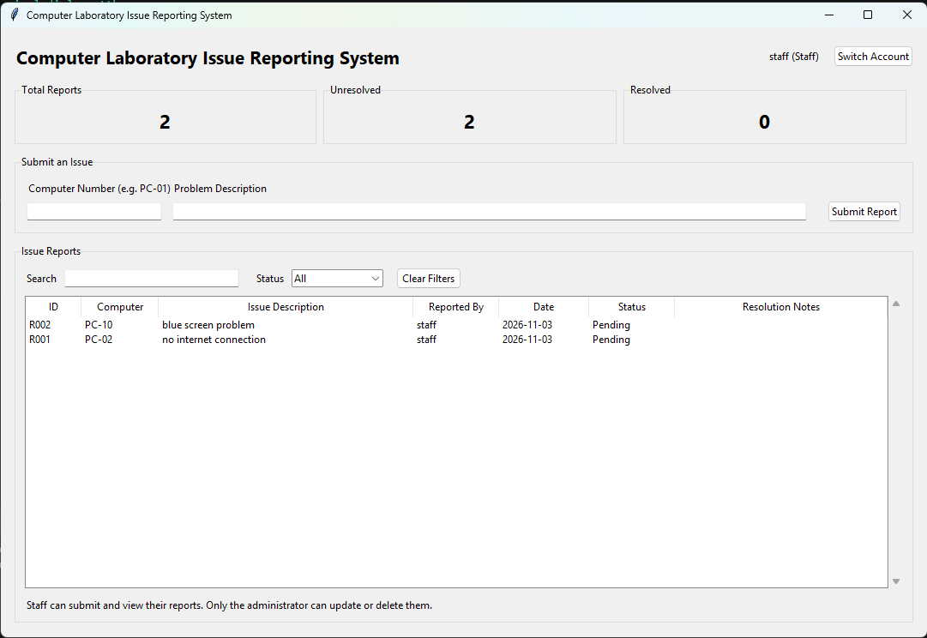
Figure 3. Staff dashboard with two submitted issue reports marked Pending.
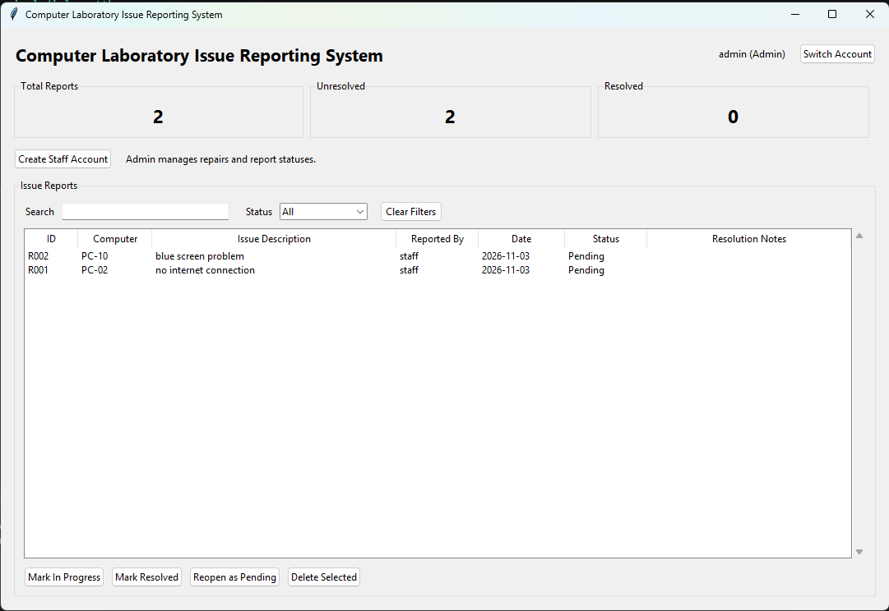
Figure 4. Administrator dashboard showing submitted issue reports and management controls.
Note: Figure 4 shows issues still Pending; it is not evidence of the administrator completing a resolution. The resolution workflow can be demonstrated separately during the final presentation.

C. SYSTEM DEVELOPMENT

1. Development Environment
Item | Specification
Language | Python 3.10 or newer
Editor | Visual Studio Code (optional; any compatible editor works)
GUI | Tkinter and tkinter.ttk from Python standard library
Data structures | Python dictionaries
Persistence | Local JSON files: reports.json and users.json
Authentication | Locally stored salted PBKDF2-HMAC-SHA256 password hashes
Connection | Offline; single computer

2. Programming Concepts Used
Concept | Application in the system
Variables | Username, selected role, computer number, issue, status and search term
Dictionaries | Report IDs map to issue records; usernames map to account records
Conditional statements | Role checks, login verification, validation and status rules
Loops | Record filtering, display refresh, summary counts and repeated GUI events
Functions/methods | Create account, authenticate, add report, search, update, delete and save
Operators | String comparisons, ID increment, count calculations
Error handling | Exceptions for invalid input, malformed JSON and save failures
GUI input/output | Tkinter Entry, Combobox, Button, Treeview and message boxes

3. Data Validation and Error Handling
- A report requires both a computer number and an issue description.
- Computer identifiers must follow the PC-number pattern used by the program (for example, PC-01).
- Staff accounts require a valid username and a password of at least eight characters.
- A selected existing report is required for administrator update and delete actions.
- A Resolved update requires an explanation in the interface.
- The program handles unreadable or malformed local data files by displaying a startup error rather than silently erasing records.
- Administrator functions are not presented on the staff interface.
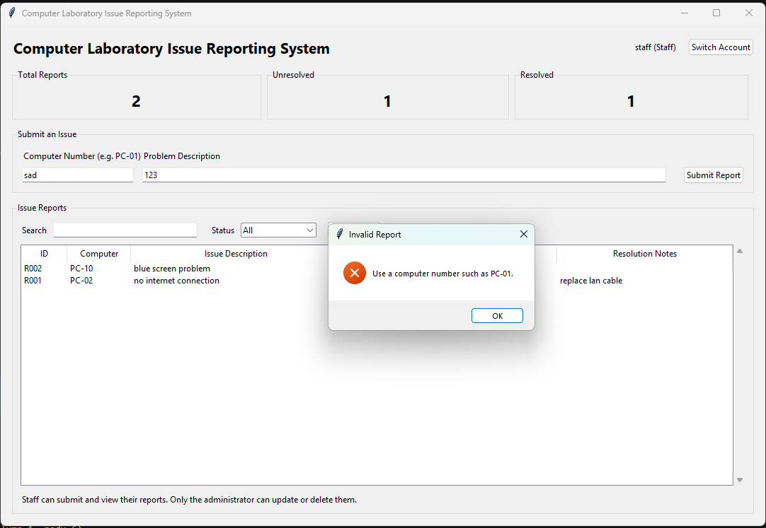
Figure 5. Input validation rejects an incorrectly formatted computer number.

4. Storage and Security Limitations
Report data are saved to reports.json. Account details, including salted password hashes rather than plaintext passwords, are saved to users.json. These files are excluded from Git tracking. The application assumes users access the same local device; it does not synchronize accounts or reports over the internet. A user with direct access to the local data files may bypass application-level role separation; therefore, the prototype should not be used for confidential or production service-desk information.

D. TESTING AND EVALUATION

1. Test Cases
The following table records manual test scenarios and the results supported by available screenshots. Scenarios without direct evidence are identified as not yet verified. The separate automated test suite completed 13 tests successfully.
ID | Test scenario | Expected result | Actual / Status
T01 | First launch: create valid admin account | Account is created and login screen appears. | Passed (indirect evidence) — Administrator account exists and login is successful (Figure 4).
T02 | Log in with incorrect password | Error appears; access is denied. | Not yet verified — Incorrect-password login was not demonstrated.
T03 | Admin creates staff account | New staff account can log in. | Passed (indirect evidence) — Staff account is operational and logged in (Figure 3).
T04 | Staff submits a valid PC-01 issue | New Pending report with ID and date appears. | Passed — Staff dashboard displays submitted Pending reports (Figure 3).
T05 | Staff submits blank issue text | Validation message; report not created. | Not yet verified — Invalid PC number was rejected (Figure 6), but blank issue input was not shown.
T06 | Staff searches own report | Matching own report is shown. | Not yet verified — Search feature was not demonstrated.
T07 | Admin marks report In Progress | New status is saved and displayed. | Not yet verified — In Progress status transition was not shown.
T08 | Admin resolves report with notes | Status is Resolved and notes are stored. | Passed (observed) — A Resolved report and repair note are visible on the Staff dashboard (Figure 5).
T09 | Staff attempts admin-only action | Staff interface does not provide update/delete actions. | Passed — Staff dashboard lacks administrator status and delete controls (Figure 3).
T10 | Close and reopen application | Accounts and issue reports remain available. | Not yet verified manually — JSON persistence passed automated testing; application restart was not documented.

2. Results of Testing
GUI evidence: The supplied screenshots show an authenticated Staff view with two Pending issue reports, an Administrator view of the same reports, and a validation dialog rejecting an invalid computer identifier. The later Staff screenshot additionally shows one issue resolved with a resolution note. This provides partial evidence of the role-based workflow, but does not replace an end-to-end manual test record.
Automated tests were executed in Windows PowerShell using python -m unittest discover -s tests -v. The supplied terminal screenshot records 13 tests completed with an OK result. The screenshot does not by itself verify all manual graphical-interface scenarios, which should be separately checked before final submission.
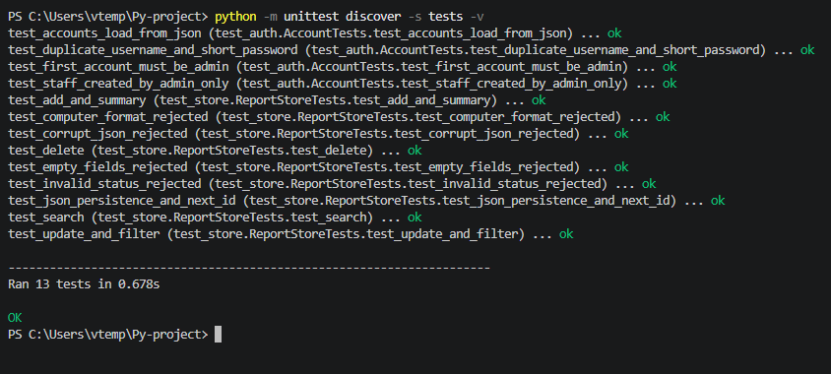
Figure 6. PowerShell output showing 13 automated tests completed successfully (OK).

3. Identified Errors and Corrections
Observed issue | Correction applied | Verification
Invalid computer number (e.g., “sad”) | Input check enforces the PC-number pattern and displays an error dialog. | Observed in Figure 5.
Automated test failures | No failing automated test is shown in the provided terminal output. | 13 automated tests passed; see Figure 6.

4. Suggested Improvements
- Provide a secure multi-computer deployment using a shared service or server.
- Allow the administrator to assign individual IT technicians to tickets.
- Add report timestamps and repair completion dates.
- Add richer report categorization and priority levels.
- Introduce secure backup/restore options and controlled account password resets.

E. FINAL PRESENTATION

1. Explanation of the Problem
The Computer Laboratory Issue Reporting System addresses difficulties associated with informal reporting of computer-related problems in school laboratories. Malfunctioning keyboards, monitors, network connections, and other equipment may disrupt academic activities. Reports communicated verbally can be overlooked, delayed, or left unresolved because there is no consistent record of the issue or action taken. The proposed system organizes reports, monitors their status, and records repair actions. It separates responsibilities between Staff, who submit and monitor their own reports, and the Administrator, who reviews issues and manages their resolution.

2. Discussion of How the System Works
The application begins with a login screen that requires a username and password. On its first launch, the system allows the creation of an initial administrator account. After successful authentication, it opens the dashboard corresponding to the user’s assigned role.
The Administrator can create Staff accounts and view reports submitted by Staff users. The administrator dashboard displays the total number of reports, unresolved issues, and resolved issues, together with search and status-filtering controls.
A Staff user submits an issue by entering a computer number, such as PC-01, and a description, such as “Keyboard not working.” The system validates the input, generates a unique report ID, records the current date, and assigns the Pending status to the new report.
The Staff dashboard displays the user’s submitted reports, including the report ID, computer number, description, reporter, date, and status. The search and filter features help locate specific reports. Staff users cannot modify repair statuses or delete reports.
The Administrator reviews submitted reports and may update an issue to In Progress while it is being investigated. After completing the corrective action, the Administrator can mark it Resolved and enter resolution notes describing the repair. If further work is needed, the Administrator can reopen the issue as Pending.
Staff users can subsequently sign in and view the updated status of their submitted reports. The separate user roles support a clear division between reporting problems and documenting the actions taken to resolve them.
Report information is held in Python dictionaries during program execution and saved to a local JSON file after changes. The saved information is reloaded when the application starts, allowing the system to operate offline without a database server.

3. Programming Concepts Demonstration
The system demonstrates variables, dictionaries, conditional statements, loops, functions, graphical user interface programming, and exception handling. Variables store computer numbers, issue descriptions, and user inputs. Dictionaries organize issue records under unique report IDs. Conditional statements validate entries, determine user permissions, and control issue status changes. Loops process records for searching, filtering, and display. Functions separate tasks such as report submission, status updates, and file saving. Tkinter provides the interface, while JSON enables local data persistence. The automated test run recorded 13 passing tests; manual interface results are documented separately where evidence is available.

4. Conclusion
The Computer Laboratory Issue Reporting System provides a simple offline approach to managing technical issues in school computer laboratories. Its role-based workflow allows Staff members to submit and monitor reports while the Administrator reviews, updates, and documents their resolution. The project demonstrates the application of Python programming, Tkinter interface development, dictionaries, input validation, and JSON file storage to a practical school management problem.

APPENDIX A. EVIDENCE CHECKLIST
- Included: Login screen (Figure 2).
- Included: Staff dashboard and submitted reports (Figure 3).
- Partially included: Administrator dashboard (Figure 4). A screenshot showing an actual completed resolution is still recommended.
- Included: Automated test command and 13 passing test results (Figure 6).
- Manual test results remain to be confirmed; the evidence provided establishes the automated tests and selected GUI operations.

