PROJECT REPORT

COLLEGE FEEDBACK INTELLIGENCE SYSTEM USING TF-IDF AND LOGISTIC REGRESSION

1.Title
College Feedback Intelligence System Using TF-IDF and Logistic Regression.

2. Problem Statement
Colleges collect feedback from students about different aspects of their academic and campus experience. Manually analysing a large number of feedback responses is time-consuming and makes it difficult to quickly identify common positive, neutral, and negative opinions.
The proposed College Feedback Intelligence System uses Natural Language Processing (NLP) to automatically analyse student feedback and classify it into Positive, Neutral, and Negative sentiment categories. The system uses TF-IDF (Term Frequency-Inverse Document Frequency) for converting textual feedback into numerical features and Logistic Regression for sentiment classification.
This system helps in understanding student opinions efficiently and can support colleges in identifying areas that require improvement.

3. Objectives
The main objectives of the project are:
- To analyse student feedback using Natural Language Processing techniques.
- To preprocess and clean textual feedback data.
- To convert text data into numerical features using TF-IDF.
- To classify feedback into Positive, Neutral, and Negative sentiments.
- To implement Logistic Regression for sentiment classification.
- To evaluate the performance of the classification model using standard evaluation metrics.
- To provide useful insights from student feedback.
- To demonstrate how NLP can be used for automated college feedback analysis.

4. Dataset

Dataset Name: Student Feedback Dataset

Dataset Source:
The dataset used in this project was obtained from Kaggle, a public platform that provides datasets and resources for data science and machine learning projects.

Dataset Size:
The original dataset contains 185 records and 12 columns.
The dataset contains feedback related to different aspects of the college experience. The feedback from six categories was combined for sentiment analysis, resulting in 1,110 feedback records.
After removing records with missing or invalid feedback or score values, 1,105 usable feedback samples were obtained and used for model training and evaluation.

Important Attributes / Fields:
The important fields used in the project are:
- Feedback Category – represents the area or aspect of the college for which the feedback was provided.
- Feedback Text – contains the textual feedback provided by students.
- Feedback Score – contains the numerical score associated with the feedback.
- Sentiment Label – represents the sentiment category assigned to the feedback.

The six feedback categories used in the project are:
- Teaching
- Course Content
- Examination
- Lab Work
- Library Facilities
- Extracurricular Activities

Target Variable:
The Sentiment Label is the target variable used for classification.
The labels are represented as:
- -1 – Negative
- 0 – Neutral
- 1 – Positive
Number of Classes / Categories
The project performs three-class sentiment classification:
- Negative
- Neutral
- Positive
Dataset Limitations
The dataset has some limitations:
- The dataset contains a relatively limited number of feedback samples.
- The feedback may represent only a particular student population and may not represent students from all colleges.
- Some feedback statements may be short, unclear, or ambiguous.
- The dataset may not cover every possible type of student opinion.
- The sentiment labels are based on feedback scores, and a numerical score may not always perfectly represent the sentiment expressed in the written feedback.
- The performance of the model may vary when it is applied to feedback from a different college or a different dataset.

4.Methodology
The overall methodology followed in the project is:
Student Feedback → Data Preparation → Text Preprocessing → Sentiment Labelling → Train-Test Split → TF-IDF Feature Extraction → Logistic Regression → Prediction → Evaluation

Step 1: Data Collection
The student feedback dataset was obtained from Kaggle and loaded into the Google Colab environment using Python.

Step 2: Data Preparation
The dataset was first loaded into Google Colab using Pandas. Feedback from the six categories was combined into a single dataset containing 1,110 feedback records. Missing and invalid feedback or score values were removed, resulting in 1,105 usable samples. The feedback scores were used to assign three sentiment labels: Negative (-1), Neutral (0), and Positive (1). The cleaned dataset was then divided into training and testing sets using an 80:20 ratio with stratification before applying TF-IDF feature extraction and Logistic Regression classification.

Step 3: Text Preprocessing
The textual feedback was cleaned before applying the machine learning model. Basic preprocessing operations were performed, such as handling missing values, removing unwanted characters, and preparing the text for feature extraction.

Step 4: Sentiment Labelling
The feedback score was used to assign sentiment labels to the feedback. The three sentiment classes were Negative, Neutral, and Positive.

Step 5: Train-Test Split
The cleaned dataset was divided into training and testing sets using an 80:20 split. Stratification was used to maintain the distribution of sentiment classes.

Step 6: TF-IDF Feature Extraction
TF-IDF was used to convert the textual feedback into numerical feature vectors. This technique gives importance to words based on their frequency in a particular document and their occurrence across the entire collection of documents.

Step 7: Logistic Regression
A Logistic Regression classifier was trained using the TF-IDF features. Logistic Regression was selected because it is a simple and effective machine learning algorithm for text classification problems.
Step 8: Model Evaluation
The trained model was tested using the test dataset. Its performance was evaluated using Accuracy, Precision, Recall, F1-score, and Confusion Matrix.

6. Implementation
The project was implemented using Python in Google Colab.
The main libraries used are:
- Pandas – for data loading and manipulation.
- NumPy – for numerical operations.
- Matplotlib – for data visualization.
- Seaborn – for graphical representation and confusion matrix visualization.
- Regular Expressions (re) – for text preprocessing.
- Scikit-learn – for TF-IDF feature extraction, Logistic Regression, train-test splitting, and evaluation metrics.
- OpenPyXL – for working with Excel dataset files.
- Pickle – for saving the trained model and TF-IDF vectorizer.
The TF-IDF vectorizer was configured with English stop-word removal and a maximum of 5,000 features. Logistic Regression was then trained using the extracted TF-IDF features.
The dataset was divided into 884 training samples and 221 testing samples.
The trained model and TF-IDF vectorizer were also saved so that they can be reused for future predictions.

7. Results
The performance of the Logistic Regression model was evaluated using the test dataset.
Evaluation Metric | Score
Accuracy | 79.64%
Precision | 77.96%
Recall | 79.64%
F1-Score | 76.20%
The model achieved an overall accuracy of 79.64%, indicating that it correctly classified a significant proportion of the student feedback into the appropriate sentiment categories.
The Precision, Recall, and F1-score also indicate that the model was able to identify sentiment patterns reasonably well.
A confusion matrix was generated to analyse the classification performance for the three sentiment classes. Graphical visualizations such as sentiment distribution and category distribution were also used to understand the dataset.

Sentiment Distribution Graph
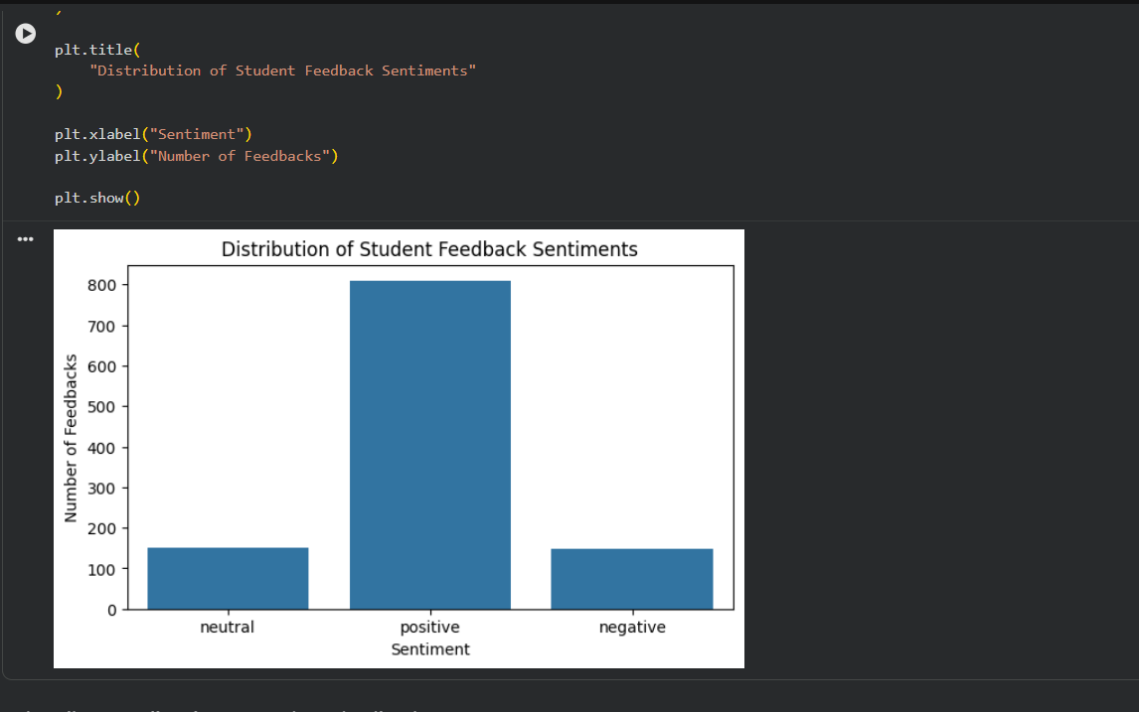
Category Distribution Graph
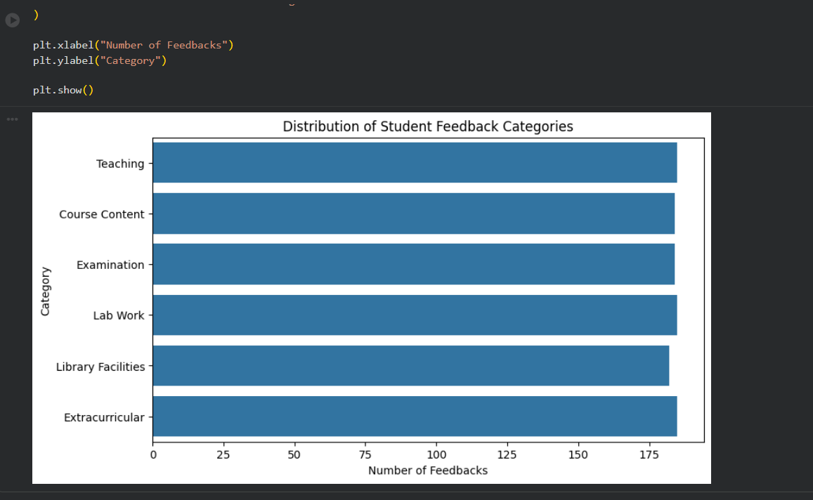

Model Evaluation Results
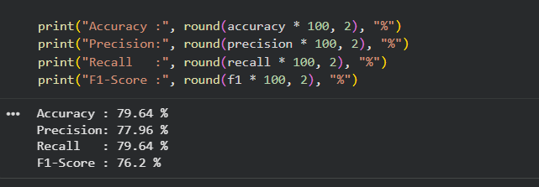
Confusion Matrix
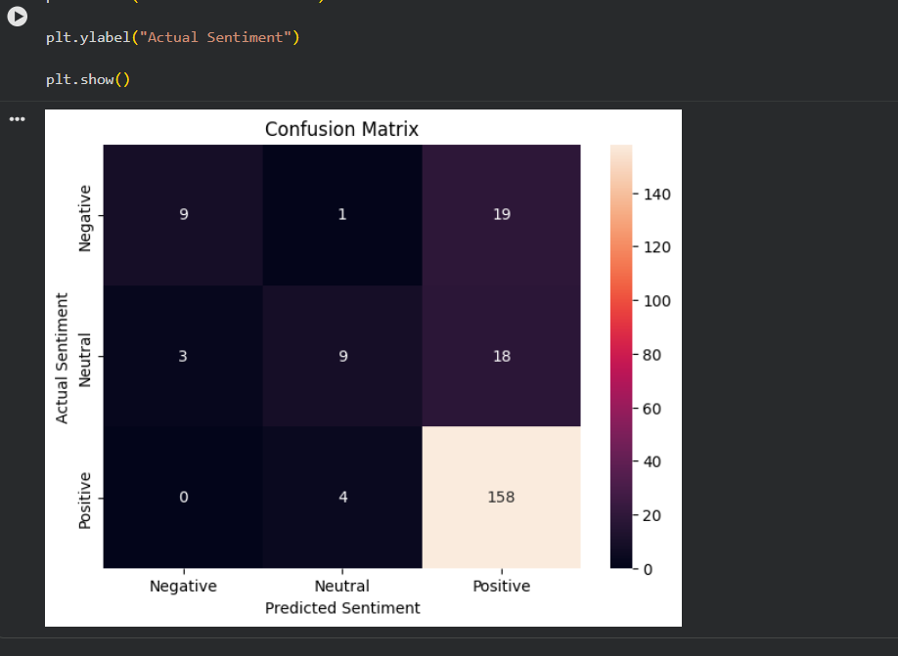

Sample Prediction
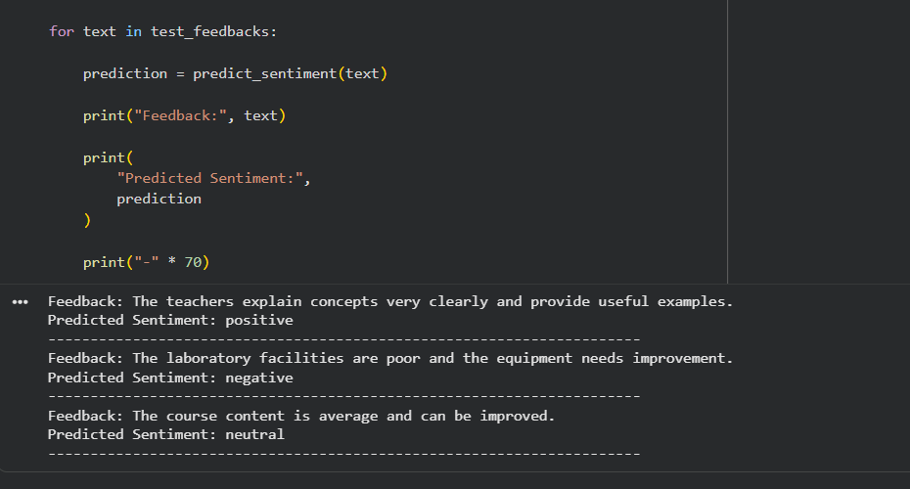
Final Output
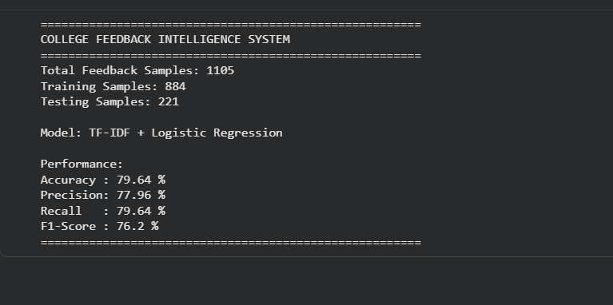

8. Limitations
The proposed system has some limitations:
- The model is trained using a relatively limited dataset.
- The dataset may not represent feedback from students of all colleges.
- Textual feedback can contain spelling mistakes, abbreviations, slang, or ambiguous expressions.
- Sarcasm and context-dependent statements may be difficult for the model to classify correctly.
- The sentiment labels are derived from numerical feedback scores and may not always accurately represent the actual emotion expressed in the text.
- Logistic Regression may not capture complex linguistic relationships as effectively as advanced deep learning models.

9. Future Scope
The project can be improved and extended in several ways:
- A larger and more diverse student feedback dataset can be used.
- Advanced NLP preprocessing techniques can be implemented.
- Other machine learning algorithms can be compared with Logistic Regression.
- Deep learning models such as LSTM, GRU, or Transformer-based models can be explored.
- The system can be developed as a web application for real-time feedback analysis.
- An interactive dashboard can be created to display sentiment trends and category-wise analysis.
- The system can identify frequently mentioned problems and important feedback topics.
- Automatic reports can be generated for college administrators.
- Multilingual feedback analysis can be added to support feedback written in different languages.

10. Conclusion
The College Feedback Intelligence System Using TF-IDF and Logistic Regression demonstrates how Natural Language Processing and machine learning can be used to automatically analyse student feedback.
The project combines feedback from different college-related categories, preprocesses the textual data, converts the feedback into numerical representations using TF-IDF, and classifies the feedback into Negative, Neutral, and Positive sentiments using Logistic Regression.
The model achieved an accuracy of 79.64%, showing that the proposed approach can effectively classify student feedback and provide useful insights.
The project demonstrates a practical application of NLP in the education domain and can be further improved using larger datasets, advanced NLP techniques, and deep learning models. It can ultimately be developed into an automated feedback analysis system that helps educational institutions understand student opinions and make data-driven improvements.

SUBMITTED BY : IRINE GEORGE
CLASS : III BCA A
REG NO : 24UBC132

