
http://ids-adi.org

POSC Caesar – FIATECH
Intelligent Data Sets - Accelerating Deployment of ISO15926
Realizing Open Information Interoperability

iRING User Document
Version 1.03.00

Revision History
Document Version # | Action Taken, Notes | Date | Name
1.03.00 | First release | 01 June, 2009 | Rohit Arora

Terms of License
Copyright (c) 2009, ids-adi.org
All rights reserved.

Redistribution and use in source and binary forms, with or without
modification, are permitted provided that the following conditions are met:
* Redistributions of source code must retain the above copyright
notice, this list of conditions and the following disclaimer.
* Redistributions in binary form must reproduce the above copyright
notice, this list of conditions and the following disclaimer in the
documentation and/or other materials provided with the distribution.
* Neither the name of the ids-adi.org nor the
names of its contributors may be used to endorse or promote products
derived from this software without specific prior written permission.

THIS DOCUMENT IS PROVIDED BY ids-adi.org ''AS IS'' AND ANY
EXPRESS OR IMPLIED WARRANTIES, INCLUDING, BUT NOT LIMITED TO, THE IMPLIED
WARRANTIES OF MERCHANTABILITY AND FITNESS FOR A PARTICULAR PURPOSE ARE
DISCLAIMED. IN NO EVENT SHALL ids-adi.org BE LIABLE FOR ANY
DIRECT, INDIRECT, INCIDENTAL, SPECIAL, EXEMPLARY, OR CONSEQUENTIAL DAMAGES
(INCLUDING, BUT NOT LIMITED TO, PROCUREMENT OF SUBSTITUTE GOODS OR SERVICES;
LOSS OF USE, DATA, OR PROFITS; OR BUSINESS INTERRUPTION) HOWEVER CAUSED AND
ON ANY THEORY OF LIABILITY, WHETHER IN CONTRACT, STRICT LIABILITY, OR TORT
(INCLUDING NEGLIGENCE OR OTHERWISE) ARISING IN ANY WAY OUT OF THE USE OF THIS
SOFTWARE, EVEN IF ADVISED OF THE POSSIBILITY OF SUCH DAMAGE.
Table of Contents

POSC Caesar – FIATECH Intelligent Data Sets - Accelerating Deployment of ISO15926 Realizing Open Information Interoperability 1
iRING User Document 1
1.0 ISO 15926 – Usage and Implementation Guide 4
2.0 iRING Overview 7
2.1 iRING Components 9
2.2 Camelot iRING Deliverables 11
2.3 iRING Contributors and Participants 11
2.4 iRING Layered Evolution 12
3.0 RDS WIP Editor 13
3.1 Reference Data Federation 17
4.0 Mapping Editor 20
5.0 Mapping Process 23
6.0 iRING Installation and Configuration 30
6.1 Prerequisites 30
6.1.1 InterfaceService Prerequisites 30
6.1.2 WCF Services and Silverlight Prerequisites 30
6.2 iRING Interface Service 30
6.3 iRING WCF Services and Silverlight Apps 31

ISO 15926 – Usage and Implementation Guide

Robin to provide content
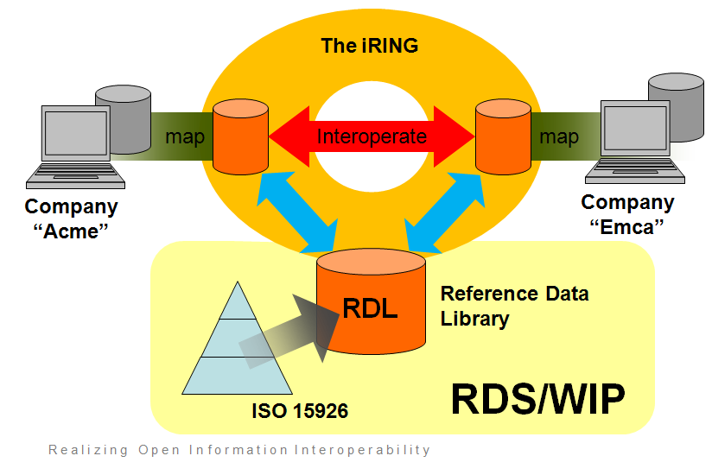

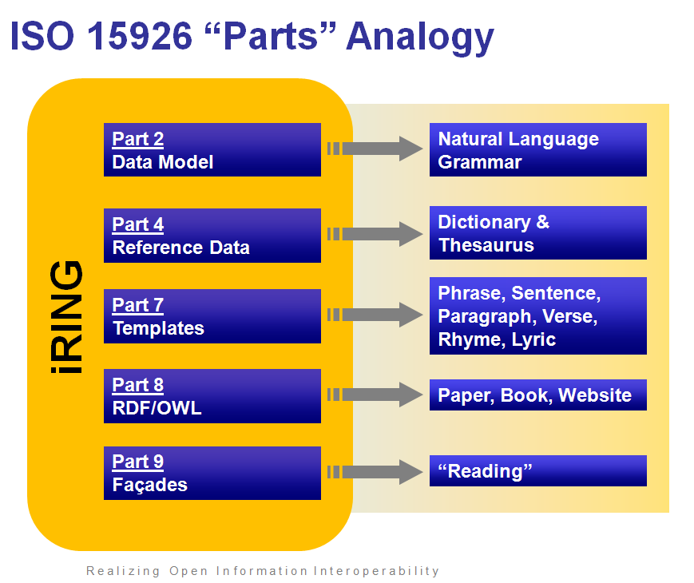

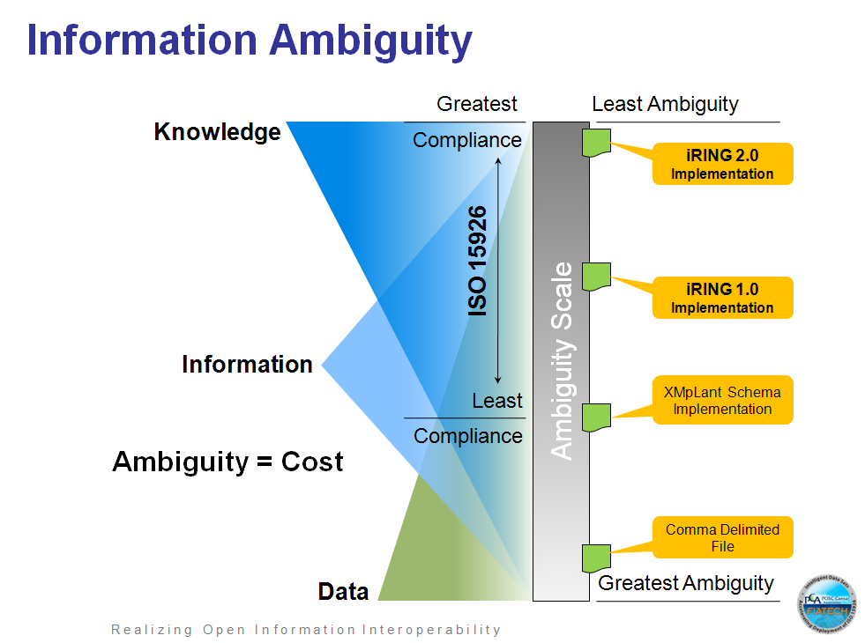

iRING Overview
The iRING, “ISO 15926 Real-time Interoperability Network Grid”, is an ISO 15926 infrastructure that will be deployed on the internet and will be accessible to any company to facilitate full specification ISO 15926 data exchanges. The base iRING is established by the deployment of iRING components at each company’s Firewall / DMZ. There is no central authority operating the iRING. The iRING is a peer to peer service.

The base iRING infrastructure deployment is built for “Red” category ISO 15926 compliance data exchange. The iRING will be extensible to allow for the inclusion of ISO 15926 Parts 8 (completed spec), Part 9, and Part 10 in the future. The iRING concept will allow these others specifications to operate as upper layers built on top of the base iRING.



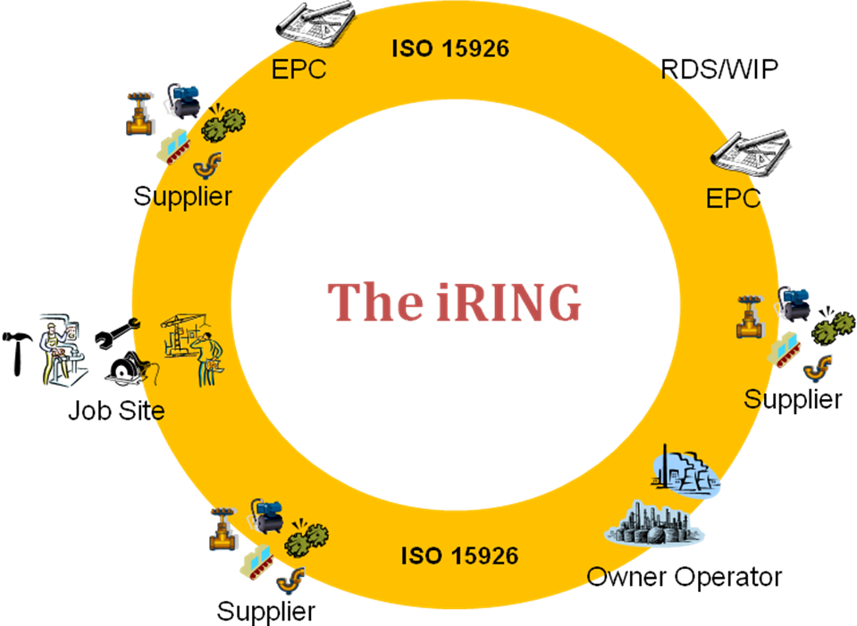

Figure 1: The iRING Concept
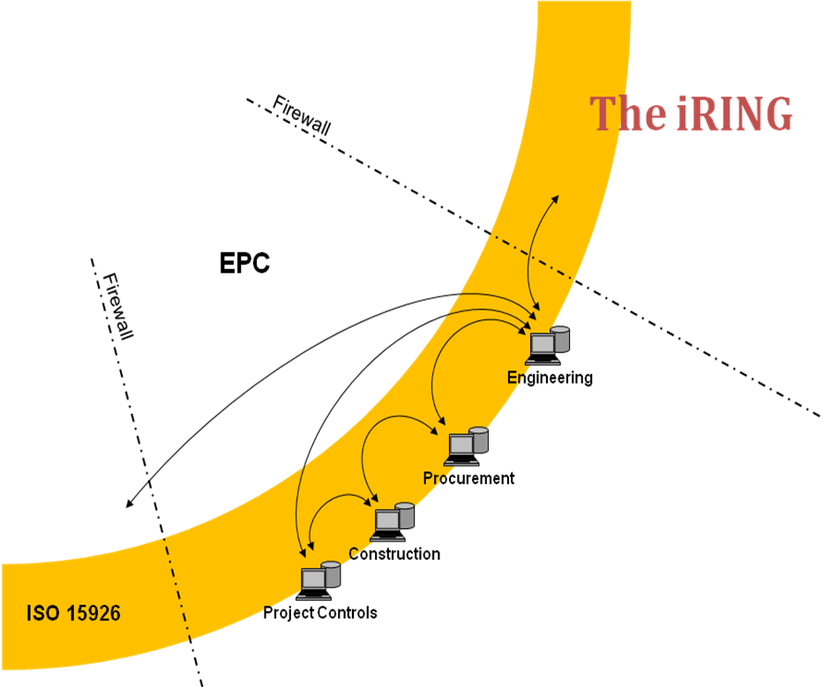

Figure 2: The iRING as an interoperability solution for both internal and external data exchanges

The iRING can also be deployed within a company to facilitate data exchanges between internal applications. The components are the same for both deployment domains. This approach will allow for a single approach to interoperate between a mix of internal and external applications.

iRING Components
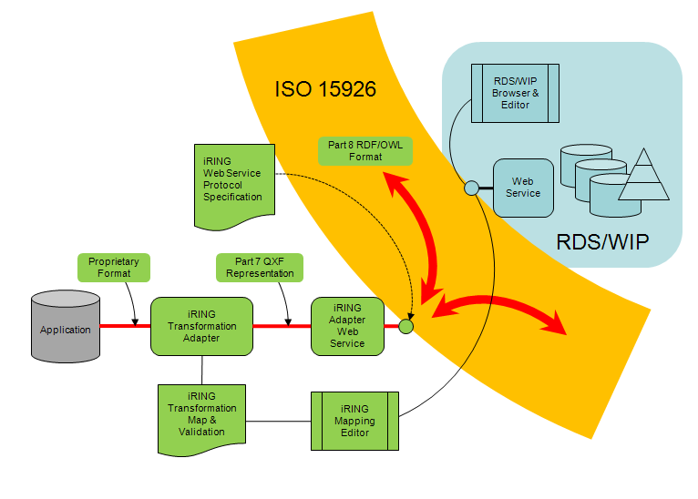
Figure 3: iRING Components

Following are the key components of iRING Infrastructure:

- RDS/WIP
- RDS/WIP browsers & editors
- Sandbox(es)
- Adapter web service
- iRING Mapping Editor
- iRING Reference Data Service
- iRING Interface Service
- iRING web service protocol specification

RDS/WIP
The RDS/WIP is a system for publishing definitions in ISO 15926 and related formalisms as a sort of collaboratively maintained library, using OWL/RDF and SPARQL for representing and querying the various volumes of data. Since the Reference Data Library (RDL) is extensible and managed, the content at any given time is often referred to as "WIP" or Work In Progress.

iRING RDS/WIP Editor
iRING RDS/WIP Editor is a software component that enables the users to browse the ISO 15926 Part4 and ISO 15926 Part 7 data existing in RDS/WIP as well as Sandbox(es). It also allows users to add new Classes and templates to the Sandbox.

Sandbox
Sandbox is a triplestore database to develop and host work-in-progress extensions to ISO 15926. The content in a Sandbox is considered volatile from a programmatic dependency point of view. Data may eventually move from Sandbox to RDS/WIP after approval workflows.

iRING Adapter Service
The iRING Adapter Service is made up of several abstraction modules that represent the legacy data into an ISO 15926, Part 7 form.

The role of the iRING Adapter Service is to:
- Get and update Manifest data to configure the adapter, and post QXF to the iRING Interface Service to enable refresh functionality. (Note: QXF is an XML format of Part 7 data)
- Use Manifest data to generate SPARQL queries to enable pull functionality.

iRING Interface Service
The iRING Interface Service is a proto “Façade” as defined by ISO 15926, Part 9. The role of the iRING Interface Service is to provide SPARQL Protocol access to a Proto Façade Triple Store. This core functionality will be provided by a Joseki server. The server will be configured to use a mySQL database as the data store. Additional functionality may be required to enable SPARQL update and the posting of ISO 15926, Part 8/RDF data.

iRING Mapping Editor
This application enables the users to define mappings between the source data schema (of Legacy Application) and the ISO 15926 model in RDS/WIP. This allows user to map Classes, Relationships and attributes. The output of Mapping editor is Mapping.xml file.

iRING Reference Data Service
The iRING Reference Data Service will provide picklists and editing functionality to the RDS/WIP Editor. The iRING Mapping Editor will also use the iRING Reference Data Service for picklists as well. The iRING Reference Data Service will be a WCF web service using the webHttpBinding. The interface is defined by WADL, but will be implemented as a C# interface as well.

Camelot iRING Deliverables

The Camelot deliverables are:
- Demonstration
- ISO 15926 Implementers Guide document
- Software Development Kit (SDK) – includes prototype tools, protocol specifications, and documentation
- Wiki site for prototype tools and documentation download

These deliverables together make up the base deployment of the “ISO 15926 Real-time Interoperability Network Grid” - The iRING.

iRING Contributors and Participants

Following companies participated in development of iRING Software Components for Camelot Project:

- Bechtel
- Consolidated Contractors Company (CCC)
- Hatch
- Tata Consultancy Services (TCS)
- Zachry

Following companies participated in Camelot Project for demonstration of several data exchange scenarios using iRING Components during “FIATECH 2009 Technology Conference and Showcase”, April 6th – 8th, 2009 in Las Vegas.

- Bechtel
- Bentley
- Chevron
- Consolidated Contractors Company (CCC)
- Dow
- DuPont
- Emerson Process Management
- Hatch
- Intergraph
- NRX Global

iRING Layered Evolution

The iRING components, that have been built and delivered by the Camelot project, are considered to have the base fundamental functionality. That functionality includes the ability to transform a data source into a full specification ISO 15926 representation, capability to declare mappings between the source data schema and the ISO 15926 model in RDS/WIP, and the functionality of a “Proto Façade” which will facilitate data exchange between endpoints on the internet. This scope is considered iRING 1.0.

More features will be added in subsequent iRING versions. The manner in which iRING versions will be built beyond iRING v1.0 is via the accepted industry practices for open source software.

Below is a breakdown of future scope for iRING components:
- iRING v1.0 – base functionality (Camelot scope)
- iRING v2.0 – fine grain access control and authentication
- iRING v3.0 – extension to facilitate ISO 15926 “Lifting” and “Lowering”

RDS WIP Editor

iRING RDS/WIP Editor is a software component that provides the users to browse the ISO 15926 Part4 and ISO 15926 Part 7 data existing in RDS/WIP as well as Sandbox(es). It also allows users to add new classes and templates to the Sandbox.

The RDS/WIP Editor consumes the Web Service Methods exposed by Reference Data Service to achieve its functionality. Some UI components of RDS/WIP Editor (In iRING2.0) will be re-usable and common with Mapping Editor.

The GUI of RDS/WIP Editor has been developed using Microsoft SilverLight 2.0. The underlying technology is Asp.Net 3.5 and WCF.

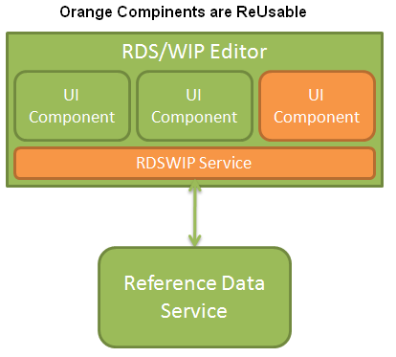

Layout of RDS/WIP Editor Homepage

RDS/WIP Editor home page has following components:
- A Search Field Box with various Search options like Contains/Exact and Cache/Refresh
- A pane on the left for Search results
- Two tabs Browse Templates and Browse Classes, which are elaborated in next sections

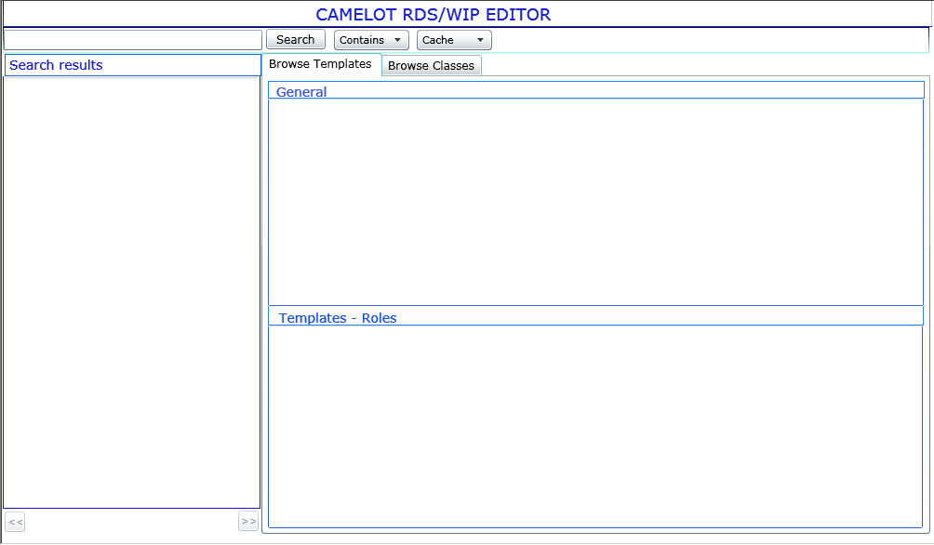

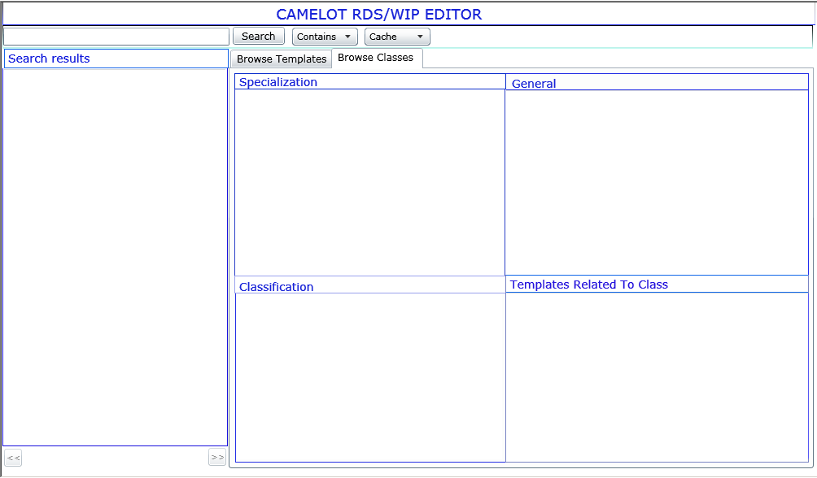
User enters search criterion in Search Field and can select Contains or Exact Search Option and also whether the results should be fetched from Cache or a fresh search. Based on search criterion; the search results pane on the left displays results in chunks of 20 with option to navigate to any other page of search results.

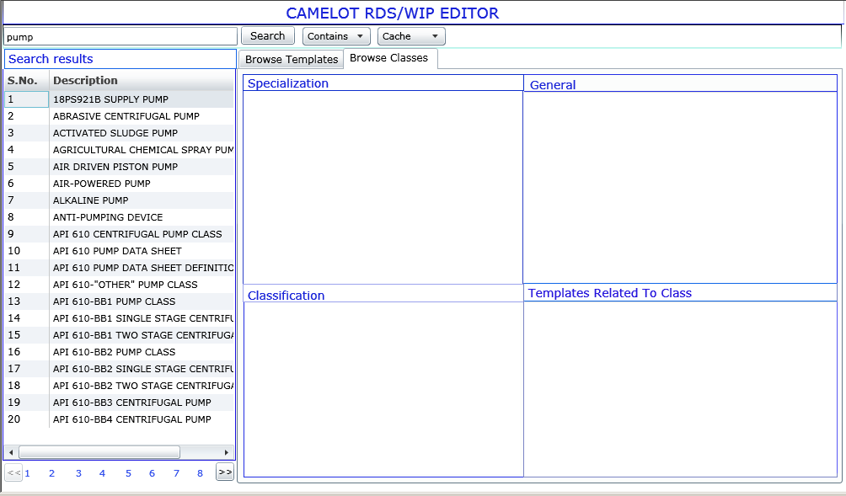

Based on the option selected by user, either Template or Class tab is selected, based on whether the option selected was a template or a class and the details of the selected value are displayed in the tab.

Class Tab
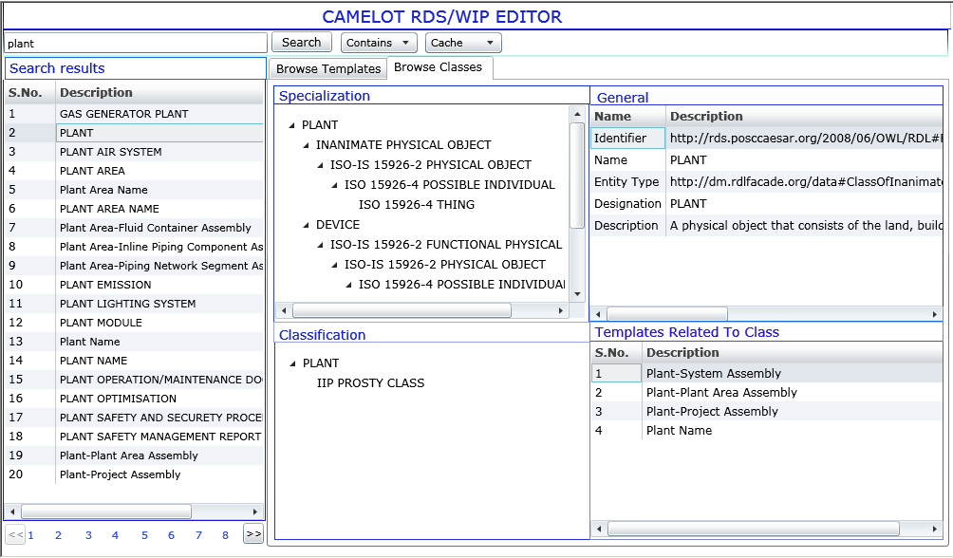

In Class Tab following details of the selected object are displayed:

- Specialization Tree: This represents the selected object in the class hierarchy of 15926 starting at the top from Thing and all the way down upto selected object

- General: This part of the pane displays properties of the selected Class and also its metadata

- Classification: This displays list of all the classes of which current class is a member. Please note that “member of” is different from Specialization (i.e. Sub/Super Class relationship)

- Templates related to a Class: This part of the Class tab displays both property and relationship templates related to selected class.

Template Tab
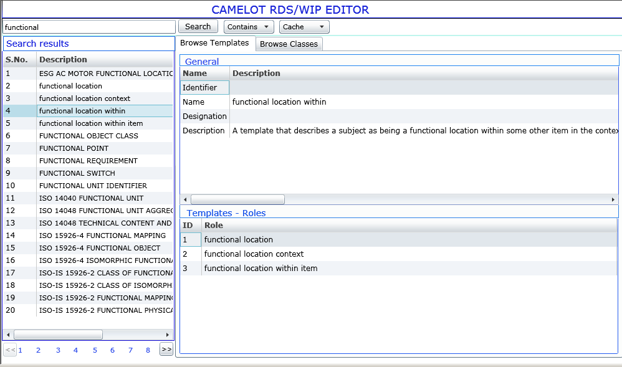

In Template tab, following details of the selected template are displayed
- General: This part of Template tab displays properties and metadata of the selected template.
- Template Roles: This part of the template tab displayed details of all roles associated with the template in a tabular form.

Reference Data Federation

The concept of Reference Data Federation will be implemented in future iRING (2.0 and 3.0) implementation. However the proposed implementation of Reference Data Federation is explained in this section.
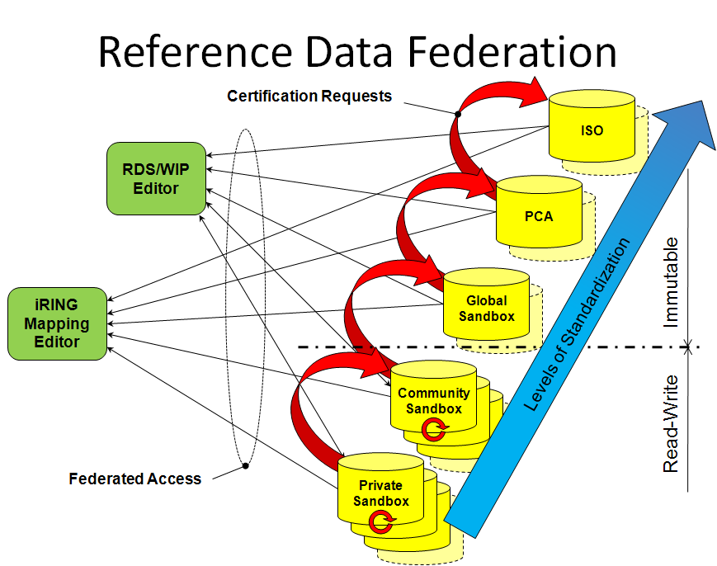

Architecture of the ISO 15926 WIP
The reference data repositories of the ISO 15926 WIP will consist of two types: one or more Community Sandboxes and a single Global Sandbox (Refer image above). The role of both of these Sandbox types is to host ISO 15926 reference data extensions. The key differentiator between these two types of Sandboxes is the access modes and access scopes. Note that the physical repositories that make up the ISO 15926 WIP are distributed and are not intended to be in a single data repository.
Community Sandbox
A Community Sandbox is created by one or more individuals or one or more companies needing a space to develop work-in-progress extensions to ISO 15926. The physical location of a Community Sandbox is determined by the owner(s) of the community. The lifetime of a Community Sandbox is determined by the community owner(s) but is considered temporary or non-enduring.
Communities are considered private with self managed membership for read-only and read-write access. Possible locations for a Community Sandbox are:
- Within a company’s network (behind the firewall)
- In a company’s DMZ (exposed to the internet)
- In a company’s DMZ and allowing public read-only access
- Hosted in the ISO 15926 WIP service
- Hosted in the ISO 15926 WIP service and allowing public read-only access
Community Sandboxes are inherently read-write to the community. The content in a Community Sandbox is considered volatile from a programmatic dependency point of view. The volatility is managed by the community.
A “trust” can be established between two or more communities. A trust is enabled by one community allowing public read-only access of its work-in-progress content and another community forms an interest or a dependency on its content. Due to the volatile nature of Community Sandbox content, it is recommended that trusts be used to discover work-in-progress extensions which would then form inter-community collaborations to promote the content to an immutable state.
Global Sandbox
A single Global Sandbox will exist in the ISO 15926 WIP service. The Global Sandbox content will have public read-only access and have read-write access to non-programmatic dependent aspects such as status and other metadata. This restriction establishes an immutable characteristic on the programmatically dependant aspects of the content. Content is entered into the Global Sandbox via a submission process and interface. Once the content is entered, the immutability mode applies.
The lifetime of the Global Sandbox is forever. At the discretion of the content owner, the content can be raised in standardization levels via requests for certification from authoritative bodies. Once content is in a lifecycle for certification and as soon as it appears in a certification body’s ISO 15926 compliant endpoint, the same content in the Global Sandbox will be terminated and statues accordingly. A certification request is subject to the ownership rules and policies of the certifying body.
If the owner of the content determines that a submission is in error or needs revision, the owner can status the content but cannot change the programmatic dependant aspects. Through the status and metadata properties associated to the content, the owner can form a relationship to a new submission which is considered to be the correction or revision of the content.
Each Sandbox type will include an instance of the RDS/WIP Editor and associated web services to manage both content and metadata. The RDS/WIP Editor will be extended to include submission and metadata management functionality.
Request for Certification
At any point in the lifetime of content, anyone can make a request for certification to various certification bodies. The licensing terms allow certification agencies to publish certification assessments in their own services or in this service at their own discretion. In either case, those certification assessments can be about definitions in this service, their services or other services. If certification assessments are published in this service, they fall under the licensing terms discussed above - in other words, certification assessments published in this service are treated no differently to any other content.

Mapping Editor

Layout of Mapping Editor Homepage

Mapping Editor home page has following components:
- A pane on the left top for Data Objects
- A pane on the right top for Information Model
- A pane on left bottom for showing details for whatever is selected from Data Objects pane, Information Model pane or Mapping pane.
- A pane on right bottom for Mapping coming from Mapping.xml

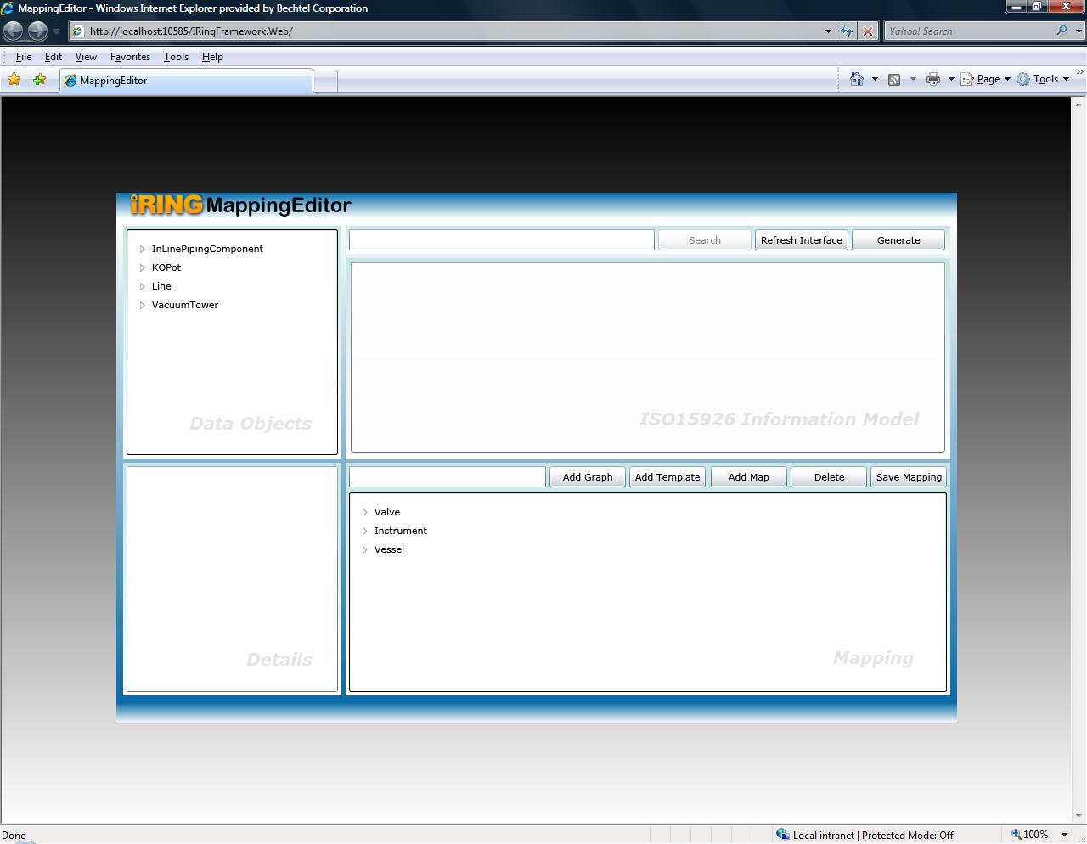

User can search for any class by entering search criterion in search field in Information Model as below
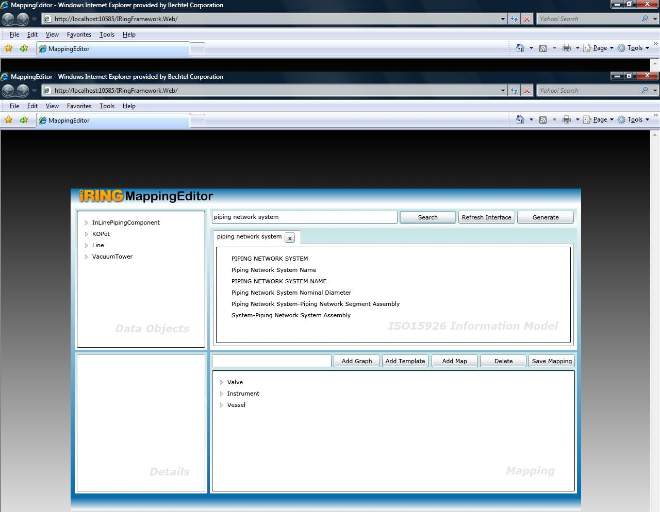
Based on search criterion; the information model pane displays results
On doing each search a new tab appears

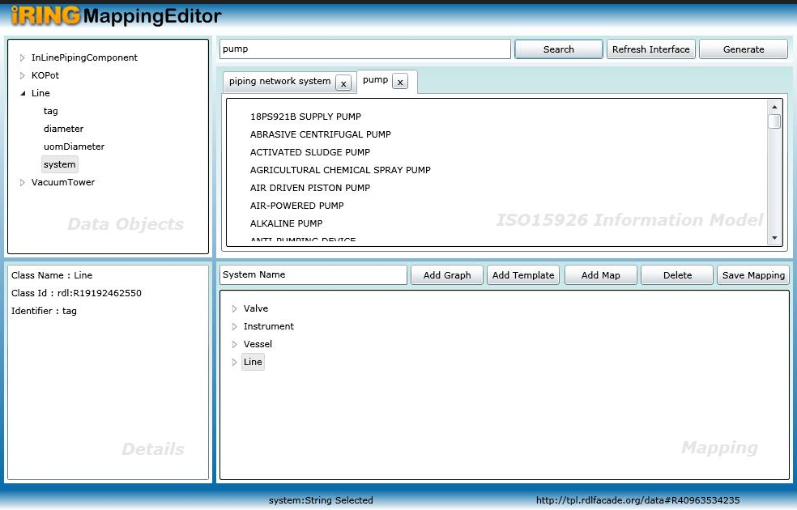

User can also perform following operation on Mapping Editor homepage

- Search: for searching data from all available endpoints
- Refresh Interface: for calling Refresh method of Adapter Service
- Generate: for auto-generating code by calling Generate in Adapter Service.
- Add Graph: for adding a graph in Mapping pane
- Add Template: for adding a template in Mapping pane
- Add Map: for performing map
- Delete: for deleting any node from mapping
- Save Mapping: for saving mapping.xml with the information added in Mapping pane

Details pane will be explained in more detail.
Points to add:WIP

Certain message boxes are shown when required nodes in various panes are not selected for the operation to be performed, you can detail them out, one example is below: Points to add:WIP
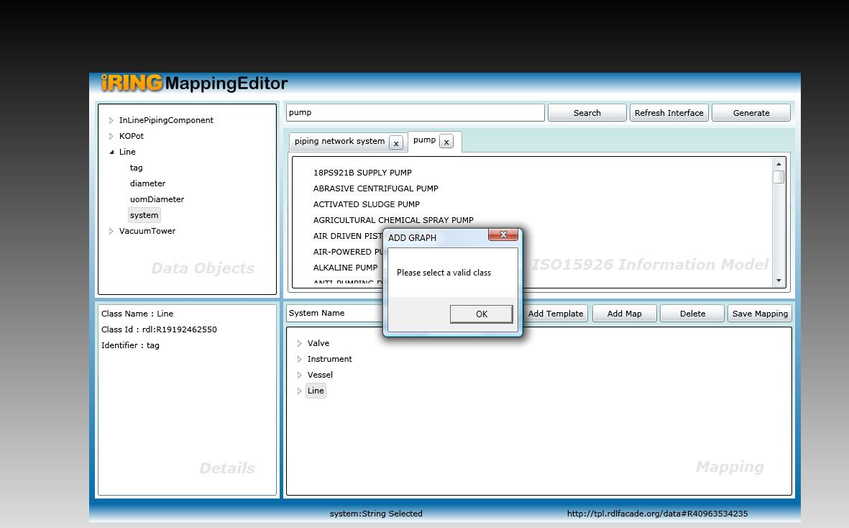
As can be seen, that no class has been selected from IM pane, so this message box have appeared.

Mapping Process
Need to review by ROB
Following are the steps for Mapping Process
- Give any search criterion in search field in Information Model as below
Based on search criterion; the information model pane displays results
- Now perform following steps for mapping legacy system data objects to a class in ISO 15926
  - Select Piping network system from Information Model,
  - Provide the graphname in textbox in Mapping pane,
  - Select identifier from Data objects pane

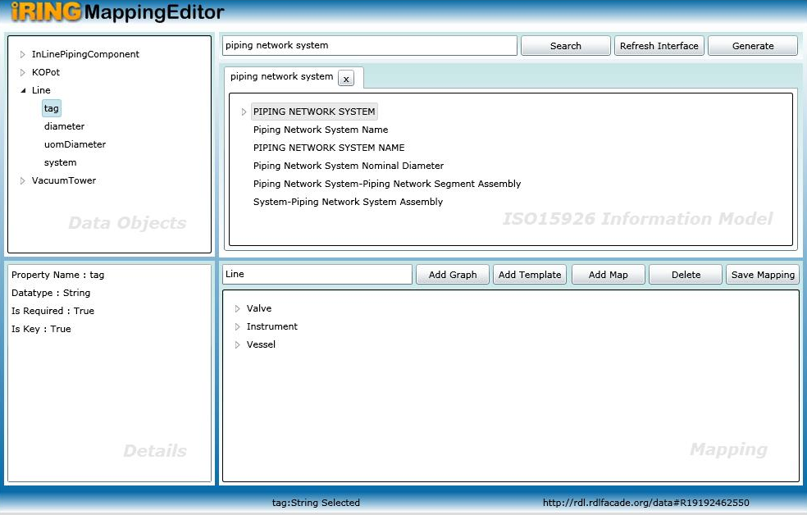

  - Click Add Graph. Graph will be added to Mapping.xml.

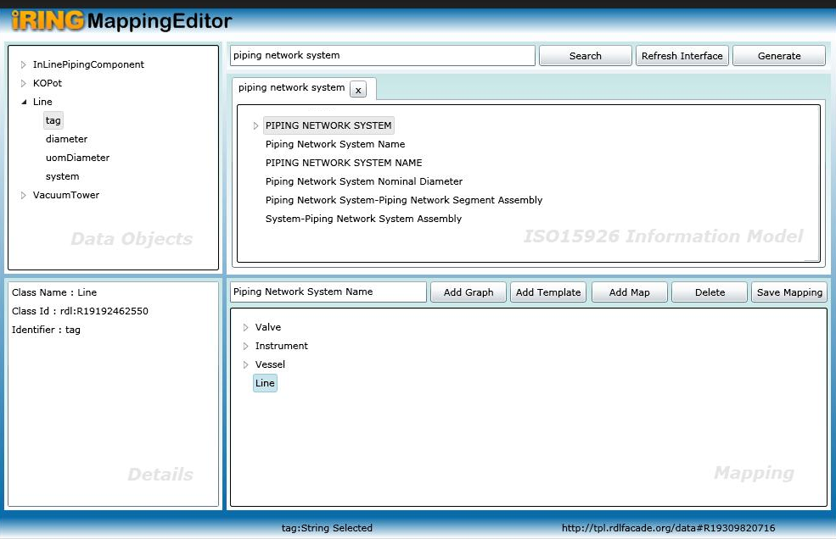

- Perform following steps for adding a template to graph in Mapping pane
  - Go to templates, select a template from Information Model,
  - Select graphmap from mapping, click Add template
The role - identifier under template will appear as unmapped.
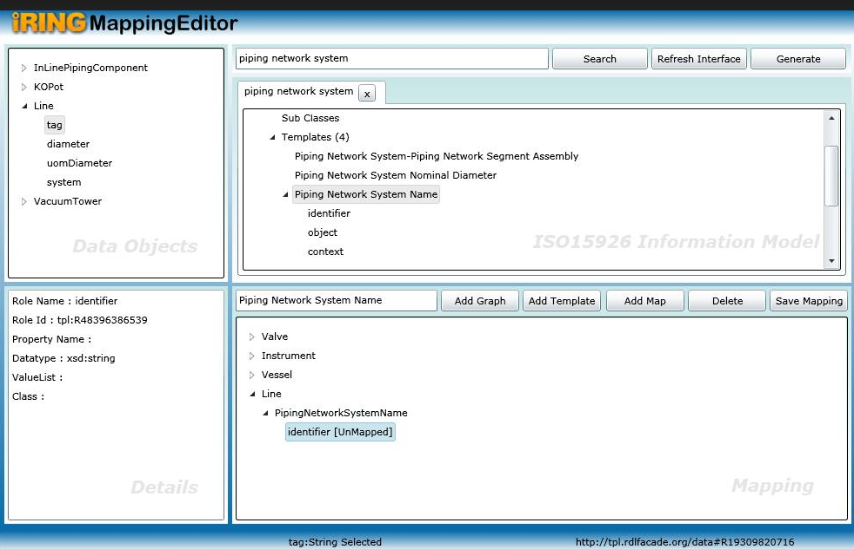
- Now we need to map it. Perform the following steps
  - Select role from Mapping, select property from data objects and click Add map

Unmapped will be removed.

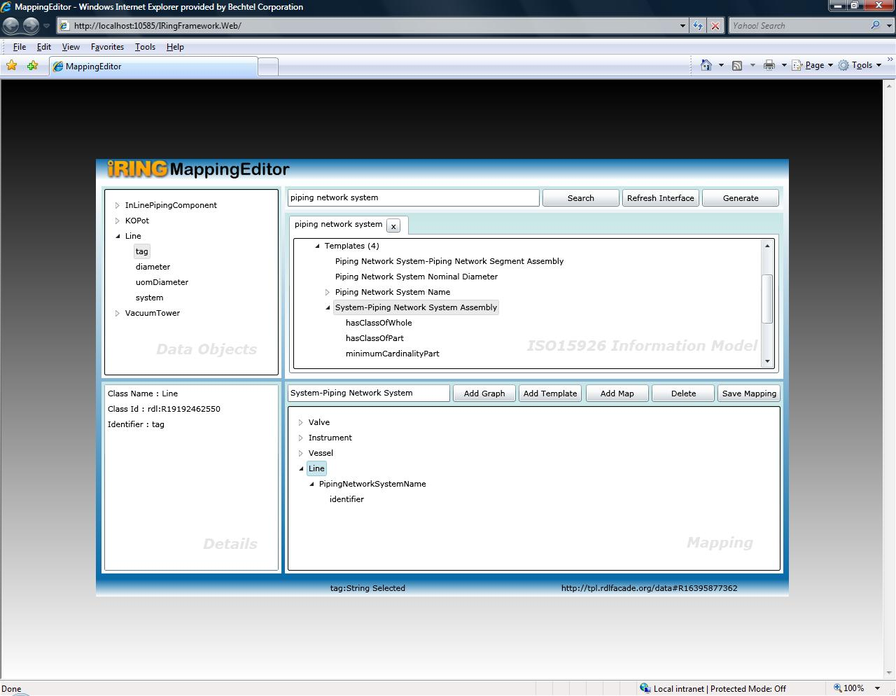

- Similarly another template can be added to mapped class in Mapping.xml

  - Select a template from IM and graphmap from mapping

  - Click Add template.
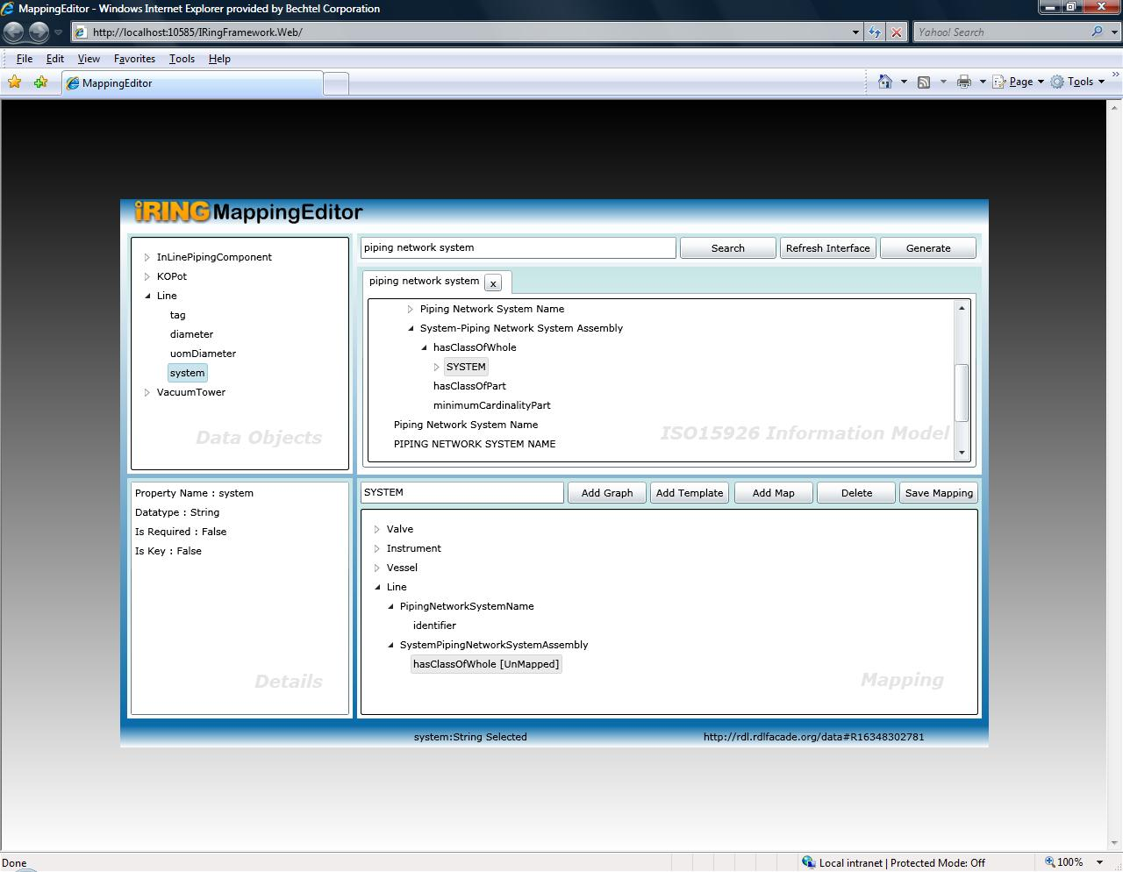
  - Select role hasClassofWhole from mapping. As it is a relationship template, so we will map it to class – SYSTEM in Information Model pane with system selected as identifier in Data Objects pane by clicking Add Map
  - Add template System Name under System
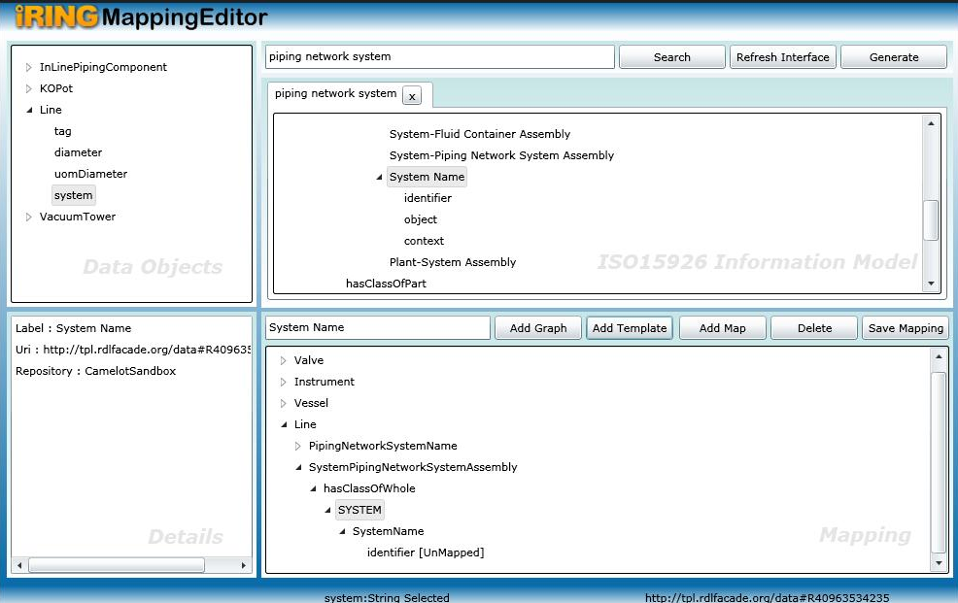
  - Select role – identifier in Mapping pane and map it to property system in data objects pane
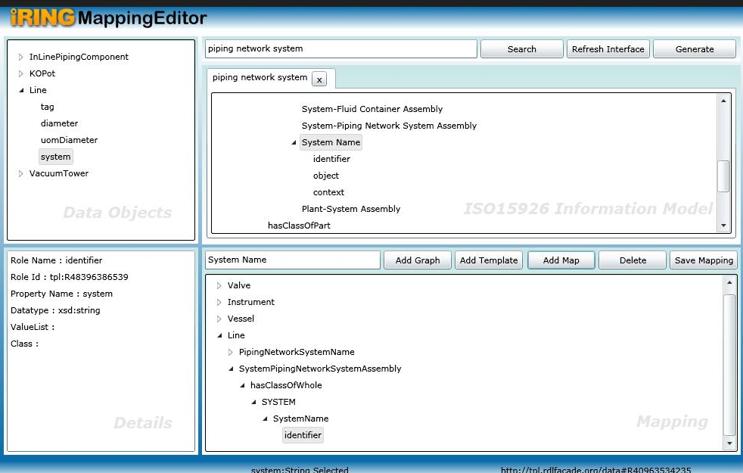
Now mapping is done. Click on Save mapping
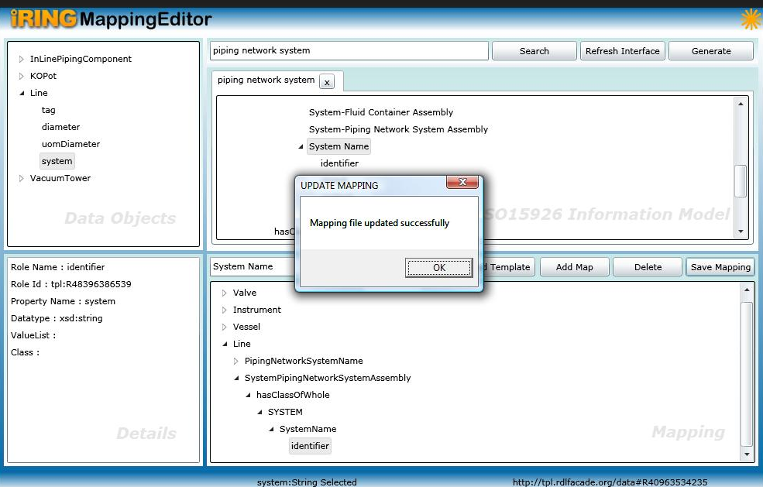

Snippet from mapping.xml for this new graph is shown below.
WIP

iRING Installation and Configuration

Prerequisites

InterfaceService Prerequisites
      - Java SE Runtime Environment 1.6.0_12
      - Joseki SPARQL Endpoint 3.3
      - MySQL Community Server 5.1.32
      - Recommended: MySQL GUI Tools 5.0 R17

WCF Services and Silverlight Prerequisites

      - Windows Server 2003 SP1 (recommended).
      - IIS 6.0 with:
        - ASP.NET installed
        - ASP.NET 2.0 registered (only do if neccessary)
        - Dynamic Content enabled
    - .NET Framework 3.5 SP1
    - ADO.NET Entity Framework Provider and approptiate client software for database of your legacy application.
(e.g. SQLServer workstation components
      - Test Application Requires:
        - SQLite 3.6.11 (select command line tool)
        - SQLite ADO.NET 2.0 Provider 1.0.60.0 (included)

iRING Interface Service
- Install Joseki into C:\Joseki-3.3.
- Set JOSEKIROOT environment variable to C:\Joseki-3.3
(Recommended - variation requires a change to %JOSEKIROOT%\webapps\joseki\WEB-INF\web.xml after running mod_joseki)
To set up the environment variable, follow steps below:
  - Open Control Panel and select System.
  - Go to the Advanced tab.
  - Click the Environment Variables button. Select the "new" button for the upper frame to create a new environment variable
  - Enter JOSEKIROOT as the Varible Name and C:\Joseki-3.3 as Variable Value
- Setup an "iring" schema and user account with password "camelot" in MySQL database and provide privileges.
To set up "iring" schema, follow steps below:
  - Go to MySQL Administrator and click on Catalogs.
  - In the window down below, right click and select Create New Schema.
To provide privileges to "iring" schema, follow steps below:
  - Go to MySQL Administrator and click on User Administration.
  - Select iring and assign all the Available priveleges to Assigned Privileges.
  - Click Apply changes.
- Run mod_joseki from InterfaceService directory
- From JOSEKIROOT
  - Modify setclasspath.bat according to your environment.
  - Run setclasspath to configure the java environment for the following commands.
  - Create the default graph in the MySQL database by running dbcreate data.
  - Create the Interface Service by running create-service.
  - Start the Interface Service by running net start josekisvc.
- Browse the following Uri: http://localhost:2020

iRING WCF Services and Silverlight Apps
- Create iRINGWeb folder on appropriate drive on the server.
- Copy AdapterService, MappingEditor, RDSWIPEditor, and ReferenceDataService folders into the iRINGWeb folder.
- Create an application for each subfolder of iRINGWeb from IIS Manager.
  - Select Read and Execute permission.
  - For IRINGFramework and RDSWIPEditor, add "application/x-silverlight-app" MIME Type for .xap file extension.
- Edit AppSettings in each Web.config.
  - AdapterService (http://localhost/AdapterService/Service.svc)
    - CSDLPath - This is the path of your CSDL file.
    - connectionStrings\add where name="Entities"
(actually not under appSettings.) - This is the Entity Framework connection string. It contains the ADO.NET connection string for your legacy database as well as the location of Entity Framework artifacts, including CSDL file.
  - MappingEditor (http://localhost/MappingEditor) (http://localhost/MappingEditor/Default.aspx)
    - AdapterServiceUri - Base URI of the AdapterService.
    - AdapterProxyCredentialToken - Credential token for AdapterService proxy server.
    - AdapterProxyHost - AdapterService proxy server name.
    - AdapterProxyPort - AdapterService proxy port number.
    - ReferenceDataServiceUri - Base URI of the ReferenceDataService.
    - ReferenceDataProxyCredentialToken - Credential token for ReferenceDataService proxy server.
    - ReferenceDataProxyHost - ReferenceService proxy server name.
    - ReferenceDataProxyPort - ReferenceService proxy port number.
  - RDSWIPEditor (http://localhost/RDSWIPEditor) (http://localhost/RDSWIPEditor/Service.svc)
    - OntologyServiceUri - This is the base Uri of the OntologyService being installed.
  - ReferenceDataService (http://localhost/ReferenceDataService/Service.svc)
    - ClassRegistryBase - URI of the RDSWIP part4 endpoint
(typically http://rdl.rdlfacade.org/data?query=).
    - TemplateRegistryBase - URI of the RDSWIP part7 endpoint
(typically http://tpl.rdlfacade.org/data?query=).
    - ProxyCredentialToken - Credential token for ReferenceDataService proxy server.
    - ProxyHost - ReferenceDataService proxy server name.
    - ProxyPort - ReferenceDataService proxy port number.

