

**FINAL Project Report**

**Group Members:**

Irin Mariya Joseph (100930869)

Neethu Puzhakkal (100930869

AqueelAbdul Rahman (100938460)

Vyshnav Pramod Kumar (100904242)

Arshad Ashraf (100907217)

# **Introduction**

In the rapidly evolving landscape of cybersecurity, the ability to accurately detect and classify malicious activities is paramount to safeguarding digital assets. With the increasing sophistication of cyber threats, traditional rule-based systems often fall short in identifying complex patterns and emerging threats. This assignment explores the application of various machine learning algorithms to enhance the detection of malware in a dataset of cybersecurity events.

The primary objective of this study is to evaluate the effectiveness of different machine learning classifiers—Logistic Regression, Random Forest, Support Vector Machine (SVM), K-Nearest Neighbors (KNN), and Gradient Boosting—in identifying and categorizing malware versus benign instances. By leveraging these advanced techniques, we aim to assess the trade-offs between accuracy, precision, recall, and F1 score for each model, thereby identifying the most robust solution for real-world cybersecurity applications.

The assignment follows a structured approach, beginning with data preprocessing and exploratory data analysis (EDA) to understand the dataset’s characteristics. Subsequently, the dataset is split into training and testing sets, ensuring a balanced representation of classes. Each machine learning model is then trained, tested, and evaluated based on its performance metrics, with particular attention to the confusion matrices that provide insights into the models’ true positive, true negative, false positive, and false negative rates.

Through this analysis, we seek to identify the optimal machine learning model that not only provides high detection accuracy but also minimizes the occurrence of false positives and false negatives—key metrics that are critical in cybersecurity contexts where precision and reliability are essential.

# **Dataset Overview**

The dataset is a comprehensive collection of 100,000 instances used to classify system activities or processes into two categories: "malware" and "benign." The goal is to leverage this dataset to train machine learning models that can accurately predict whether a particular instance is harmful (malware) or harmless (benign).

**2. Structure of the Dataset**

* **Number of Instances (Rows)**: 100,000
* **Number of Features (Columns)**: 35 (including the target column classification)

**3. Key Columns**

* **classification (Target Column)**:
  + This column contains the labels for each instance, indicating whether it is "malware" or "benign."
  + It is the target variable that the machine learning models will attempt to predict.
* **hash (Identifier Column)**:
  + This is a unique identifier for each instance in the dataset.
  + It is not used for model training as it does not contribute to the classification task.
* **Features (Remaining Columns)**:
  + **millisecond**: Likely represents the time at which the instance was recorded.
  + **state, usage_counter, prio**, and others: These are numerical features that describe various characteristics of each instance, such as system states, priorities, and resource usage.
  + The exact nature of each feature might be specific to the context in which the data was collected (e.g., process monitoring, system resource management).

**4. Purpose of the Dataset**

The primary purpose of this dataset is to provide a basis for training and testing machine learning models that can accurately classify system activities as either "malware" or "benign." By analyzing the patterns and relationships among the features, the models can learn to make predictions on unseen data, which is critical in cybersecurity for preventing malicious activities.

**5. Preprocessing Steps**

* **Feature Selection**:
  + The classification column is identified as the target variable.
  + The hash column is excluded from the feature set because it is an identifier that does not contribute to the classification task.
* **Splitting the Dataset**:
  + The dataset is split into training and testing sets using an 80-20 split. This ensures that the model is trained on a large portion of the data and tested on unseen data to evaluate its performance.
  + The splitting process is stratified to maintain the balance between the "malware" and "benign" classes in both the training and testing sets.

# **Exploratory Data Analysis (EDA) on the Dataset**

Exploratory Data Analysis (EDA) is a crucial step in the data science process that involves summarizing the main characteristics of the dataset and uncovering patterns, anomalies, or relationships within the data. The purpose of EDA is to gain insights that can guide the selection of appropriate models and preprocessing steps before moving on to building predictive models.

**1. Objectives of EDA**

* **Understanding the Dataset**: To gain an initial understanding of the dataset's structure, including the distribution of data, presence of missing values, and relationships between features.
* **Identifying Patterns and Relationships**: To uncover any underlying patterns, trends, or correlations that might exist between the features and the target variable (classification).
* **Detecting Anomalies**: To identify any outliers or anomalies in the data that could affect the performance of the machine learning models.
* **Guiding Feature Selection**: To help decide which features are most relevant for the predictive task, potentially leading to better model performance.

**2. Steps Performed During EDA**

1. **Statistical Summary**:
   * The first step in EDA involves generating a statistical summary of the dataset using descriptive statistics.
   * **Purpose**: This helps to understand the central tendency, dispersion, and shape of the data distribution.
   * **Output**: The summary includes metrics such as mean, standard deviation, minimum, maximum, and quartiles for each numerical feature.

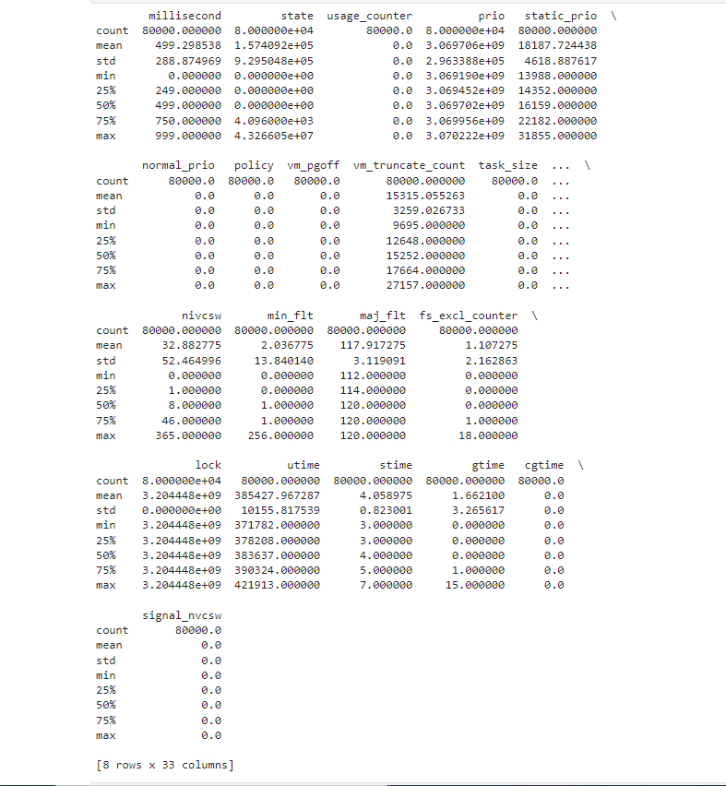

1. **Class Distribution**:
   * A count plot is generated to visualize the distribution of the target variable (classification) in the training set.
   * **Purpose**: This visualization helps ensure that the dataset is balanced and that both classes ("malware" and "benign") are adequately represented.
   * **Output**: The plot shows the number of instances in each class, confirming whether there is any imbalance that might need to be addressed during model training.

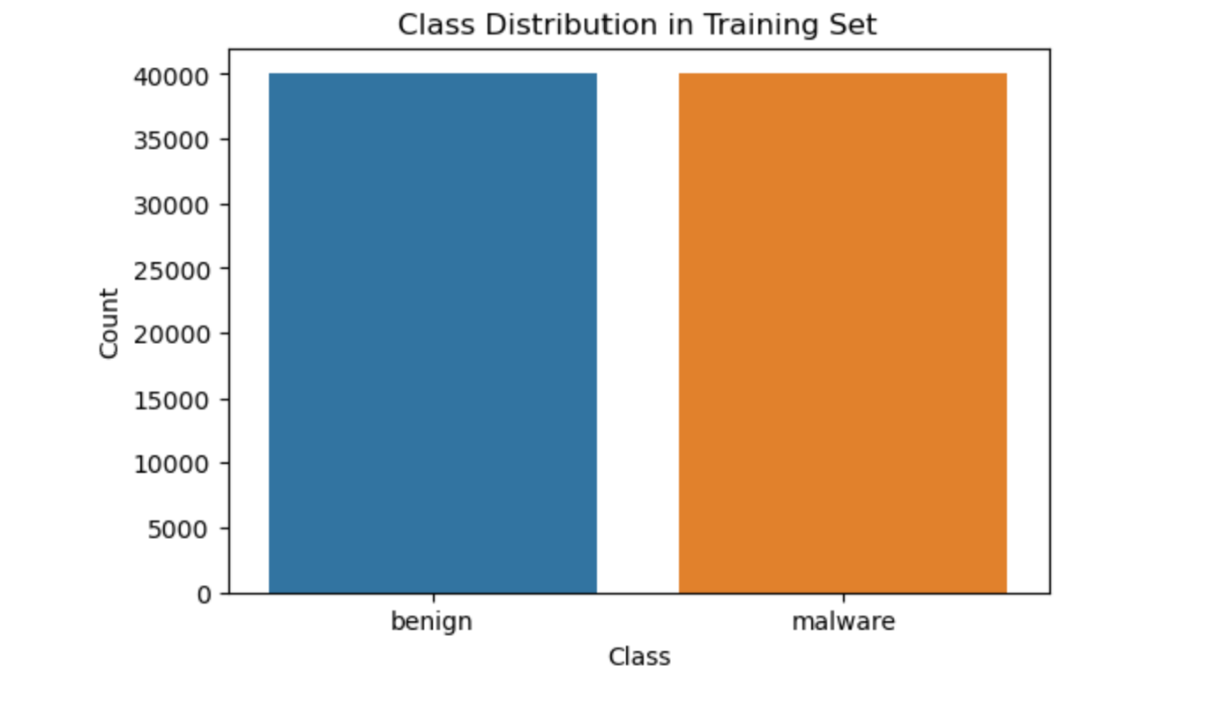

**Explanation:**

* **X-Axis (Class)**: The x-axis displays the two classes in your dataset: "benign" and "malware."
* **Y-Axis (Count)**: The y-axis shows the count of instances in each class.

**Observations:**

* The chart indicates that both classes (benign and malware) have an equal number of instances in the training dataset, each with around 40,000 instances.
* This balanced distribution is crucial for training machine learning models, as it helps prevent bias toward one class. In a balanced dataset, the model will have an equal opportunity to learn from both classes, improving its ability to generalize to unseen data.

**Importance:**

* **Balanced Dataset**: Having a balanced dataset is particularly important in classification tasks. If one class were significantly larger than the other, the model might become biased, leading to poor performance, especially in predicting the minority class.
* **Model Performance**: With balanced classes, the models you train are more likely to perform well in both precision and recall for each class.

This bar chart effectively confirms that the dataset is balanced, which is a good foundation for training reliable machine learning classifiers.

The difference we're observing between the numbers in the class distribution from the dataset loading step (50,000 for both benign and malware) and the class distribution in the training set plot (40,000 for both benign and malware) is due to the dataset split into training and testing sets.

1. **Correlation Analysis**:
   * A correlation matrix is calculated to examine the relationships between the numerical features.
   * **Purpose**: This step helps identify pairs of features that are highly correlated. Highly correlated features can sometimes be redundant, and understanding these relationships can guide feature selection or engineering.
   * **Output**: The correlation matrix is visualized using a heatmap, where the intensity of the color indicates the strength of the correlation between features.

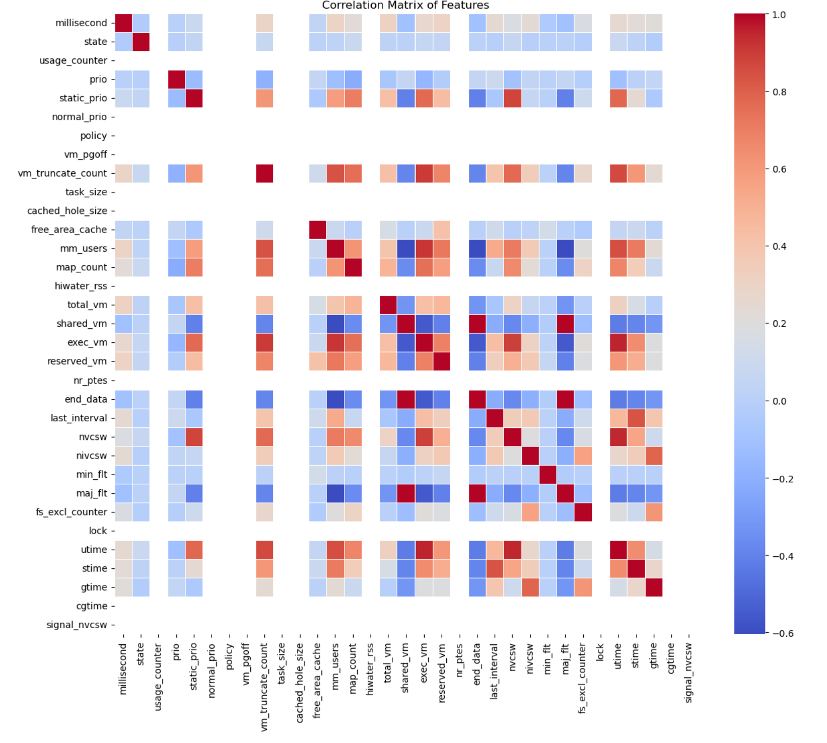 **Explanation:**

* **Correlation Matrix**:
  + A correlation matrix is a table that shows the correlation coefficients between variables. Each cell in the table shows the correlation between two variables. The value is usually between -1 and 1, where:
    - **1** indicates a perfect positive correlation (when one variable increases, the other one also increases).
    - **-1** indicates a perfect negative correlation (when one variable increases, the other one decreases).
    - **0** indicates no correlation.
* **Heatmap**:
  + The heatmap visualizes the correlation matrix. The color intensity in each cell represents the strength of the correlation:
    - **Red** indicates a positive correlation.
    - **Blue** indicates a negative correlation.
    - The closer the color is to either extreme (dark red or dark blue), the stronger the correlation.
    - Light colors or white indicate weak or no correlation.

**Observations:**

1. **Diagonal Cells**:
   * The diagonal cells from the top left to the bottom right are all red. This is because each variable is perfectly correlated with itself, resulting in a correlation coefficient of 1.
2. **Off-Diagonal Cells**:
   * The off-diagonal cells represent the correlation between different features.
   * For example, if you see a dark red cell at the intersection of two features, it means those features are strongly positively correlated.
   * A dark blue cell indicates a strong negative correlation between the two features.
3. **Feature Relationships**:
   * You can identify groups of features that are highly correlated with each other, which might indicate redundancy. For example, if two features are very highly correlated, one might be redundant in the model, and removing it could simplify the model without losing much predictive power.
   * Conversely, if features are not correlated (e.g., light-colored cells), they might provide unique information to the model.

**Importance:**

* **Feature Selection**:
  + The correlation matrix is useful in feature selection. Highly correlated features can sometimes lead to multicollinearity, which can negatively impact the performance of some models (like linear regression). You might consider removing one of the correlated features or combining them.
* **Model Insights**:
  + Understanding correlations can also provide insights into the data's structure and relationships between different variables, which can be useful for refining models or interpreting their results.

This visualization helps us to understand how the features relate to one another, which is crucial when selecting features for our machine learning models or when interpreting model outputs.

1. **Feature Distribution Visualization**:
   * Histograms are plotted for a selected subset of features to visualize their distribution.
   * **Purpose**: This visualization helps in understanding the distribution of individual features, including their spread, central tendency, and the presence of any skewness or outliers.
   * **Output**: The histograms provide insights into whether the features are normally distributed or if there are any potential issues that may require preprocessing (e.g., normalization, scaling).

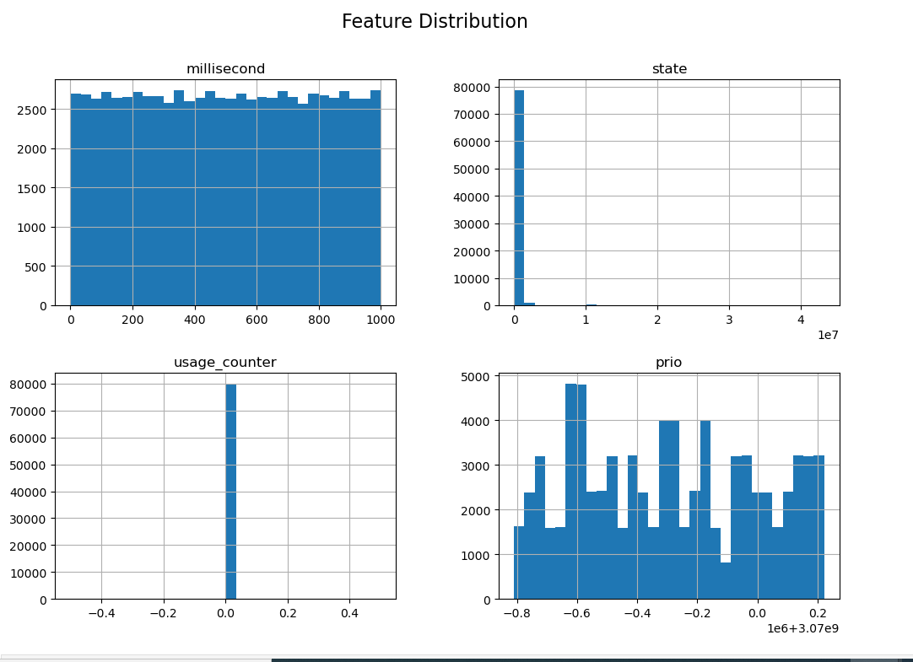

**Explanation of Each Plot:**

1. **Millisecond** (Top-left):
   * **Distribution**: This histogram shows that the millisecond feature is uniformly distributed across its range. The data points are spread relatively evenly from 0 to 1000 milliseconds.
   * **Interpretation**: A uniform distribution suggests that the feature covers its range without any significant skew, meaning that the values are equally likely across the interval.
2. **State** (Top-right):
   * **Distribution**: The state feature is heavily skewed towards lower values, with the majority of instances concentrated near 0. There are very few instances with larger values.
   * **Interpretation**: The highly skewed distribution might indicate that most data points share a similar state, with only a small number deviating significantly. This could affect how the model perceives and weights this feature.
3. **Usage Counter** (Bottom-left):
   * **Distribution**: The usage_counter feature is concentrated entirely at 0, showing no variation in the data.
   * **Interpretation**: A feature with no variation (constant value) does not provide useful information for classification and may be considered for removal or replacement, as it does not help differentiate between classes.
4. **Prio** (Bottom-right):
   * **Distribution**: The prio feature displays a somewhat uniform distribution with fluctuations. The values are spread across a wide range, with peaks at certain intervals.
   * **Interpretation**: This feature shows more variability and could be valuable in the classification process. The distribution indicates that it captures a variety of values, which might be helpful for distinguishing between different classes.

**Importance:**

* **Feature Distributions**: Understanding the distribution of each feature is crucial for several reasons:
  + **Preprocessing**: Features that are constant or heavily skewed may need preprocessing, such as scaling, transformation, or even removal.
  + **Model Impact**: Features with a wide distribution are likely to have a more significant impact on the model’s predictions, while those with limited variation might contribute less.
  + **Data Quality**: Distributions can also reveal potential issues in data quality, such as outliers or anomalies.

This **Feature Distribution** plot helps us to understand how different features vary across the dataset, which in turn influences how the machine learning models learn and make predictions. Based on this plot, we might consider preprocessing steps like scaling or feature selection to improve model performance.

**Key Findings from EDA**

* **Balance in Class Distribution**: The EDA confirmed that the dataset has a balanced distribution between the "malware" and "benign" classes, ensuring that the models trained on this data are not biased towards one class.
* **Correlations**: The correlation matrix highlighted certain features that are strongly correlated with each other, which may guide feature selection or dimensionality reduction efforts.
* **Feature Distributions**: The distribution plots for selected features revealed their spread and central tendencies, helping to inform decisions about data preprocessing, such as scaling or normalization.

# **MODELLING APPROACH**

**Data Preparation**

Before diving into model building, it’s essential to prepare the dataset in a way that enhances the effectiveness of the models. This involves several steps, including cleaning the data, selecting the relevant features, and splitting the dataset into training and testing sets. Proper data preparation ensures that the models are trained on high-quality data and evaluated correctly.

**Data Cleaning:**

* The dataset used for this project is already clean, with no missing values in any of the features. This eliminates the need for imputation or data cleaning procedures.
* However, certain columns, such as hash, are excluded from the model because they serve as identifiers and do not contribute to the predictive power of the model.

**Feature Selection**:

* The target variable (classification) is separated from the feature set (X). The hash column, being an identifier, is dropped because it does not contain any predictive information.
* The remaining features include various system-level metrics, such as millisecond, state, usage_counter, prio, etc., which are used to train the models.

**Splitting the Dataset**

To evaluate the models effectively, the dataset is split into two parts: a training set and a testing set.

* **Training Set**:
  + The training set is used to train the models. It includes 80% of the data, ensuring that the models have enough information to learn from.
  + The split is stratified based on the classification column to maintain the balance of the classes ("malware" and "benign") in both the training and testing sets.
* **Testing Set**:
  + The testing set, which comprises the remaining 20% of the data, is used to evaluate the models' performance. Since the testing data is not seen by the models during training, it provides an unbiased assessment of how well the models generalize to new, unseen data.

**Model Selection and Initialization**

Multiple machine learning models are selected to ensure a robust approach to the classification task. The models chosen include both simple and complex algorithms to compare their performance on the dataset.

**1. Logistic Regression**

**Why Selected:**

* **Baseline Model for Binary Classification**: Logistic Regression is a suitable starting point for binary classification tasks, like distinguishing between malware and benign instances.
* **Interpretable Results**: In cybersecurity, understanding why a model made a particular prediction can be crucial. Logistic Regression provides clear coefficients that indicate how each feature influences the likelihood of an instance being classified as malware.

**How It Works in This Project:**

* Logistic Regression calculates the probability that a given instance is malware based on a weighted sum of the input features. The model then applies a threshold (usually 0.5) to decide if the instance is classified as malware or benign.
* This model helps establish a baseline to measure the performance of more complex models. In your project, it provided a balance between detecting malware and avoiding false positives, though with some trade-offs.

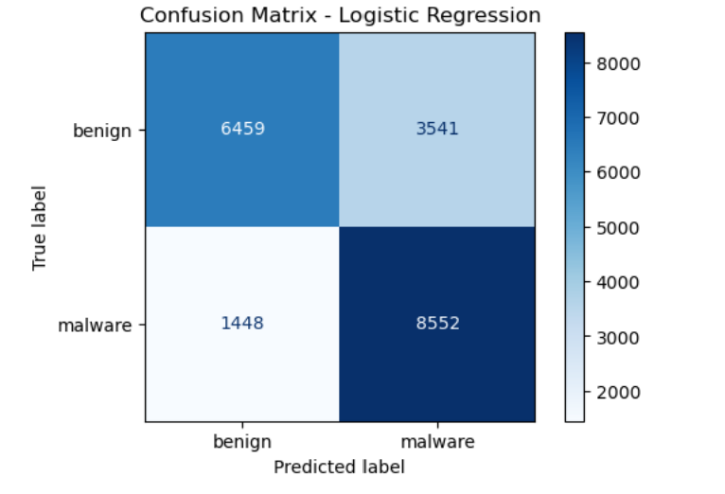

* **Confusion Matrix**:
  + True Positives: 8,552 (malware correctly identified).
  + True Negatives: 6,459 (benign correctly identified).
  + False Positives: 3,541 (benign wrongly classified as malware).
  + False Negatives: 1,448 (malware wrongly classified as benign).
* **Performance Metrics**:
  + **Accuracy**: 75.06% - It correctly classifies 75.06% of all instances.
  + **Precision**: 70.72% - Out of all the instances it labeled as malware, 70.72% were actually malware.
  + **Recall**: 85.52% - It correctly identifies 85.52% of all actual malware instances.
  + **F1 Score**: 77.42% - This balances the precision and recall.
* **Interpretation**: Logistic Regression is relatively simple but shows decent performance. It’s good at catching malware (high recall), but it also has a fair number of false positives (benign files wrongly classified as malware).

**2. Random Forest**

**Why Selected:**

* **Handling Complex Data**: Malware detection often involves intricate patterns and correlations between features. Random Forest is known for its ability to capture complex interactions without overfitting.
* **Robustness**: The ensemble nature of Random Forest, which combines multiple decision trees, makes it particularly robust against errors and noise in the dataset.

**How It Works in This Project:**

* In your project, Random Forest was used to build multiple decision trees, each trained on random subsets of the data. The final prediction for each instance was determined by majority voting across all trees.
* This model excelled in your project by perfectly classifying all instances in the test set, making it highly reliable for detecting malware with no false positives or false negatives.

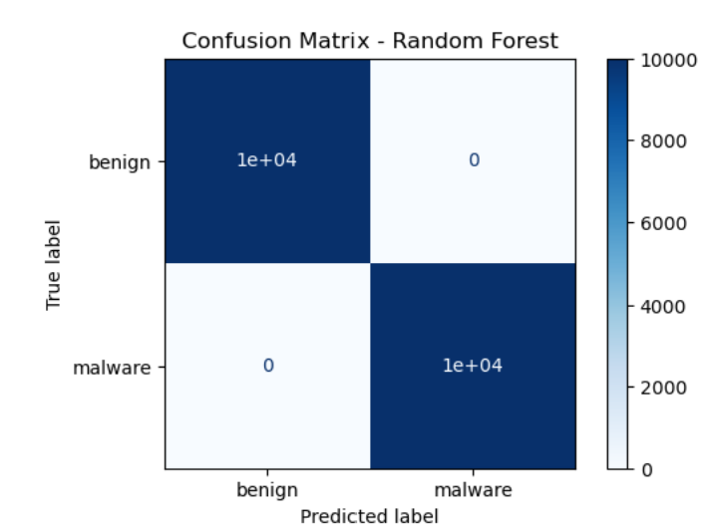

**Random Forest**

* **Confusion Matrix**:
  + True Positives: 10,000 (all malware correctly identified).
  + True Negatives: 10,000 (all benign correctly identified).
  + False Positives: 0 (no benign instances wrongly classified as malware).
  + False Negatives: 0 (no malware instances wrongly classified as benign).
* **Performance Metrics**:
  + **Accuracy**: 100% - It correctly classifies every instance.
  + **Precision**: 100% - Out of all the instances it labeled as malware, 100% were actually malware.
  + **Recall**: 100% - It correctly identifies all actual malware instances.
  + **F1 Score**: 100% - Perfect balance between precision and recall.
* **Interpretation**: Random Forest is extremely powerful in this scenario, perfectly classifying all instances. This suggests that it captures all relevant patterns in the data very well, with no errors in prediction.

**3. Support Vector Machine (SVM)**

**Why Selected:**

* **Effective for High-Dimensional Data**: The cybersecurity dataset might have features that are high-dimensional or complex. SVM is particularly effective in such scenarios where clear boundaries between classes can be defined.
* **Focus on Margin Maximization**: SVM aims to maximize the margin between benign and malware classes, which is crucial for making confident predictions.

**How It Works in This Project:**

* The SVM was configured to find the optimal hyperplane that best separates malware from benign instances. However, in your project, the current configuration of SVM (with a linear kernel) struggled to effectively separate the classes, resulting in poor performance.
* This indicates a need for further tuning, such as using a non-linear kernel or adjusting the model's parameters, to better capture the complexities of the data.

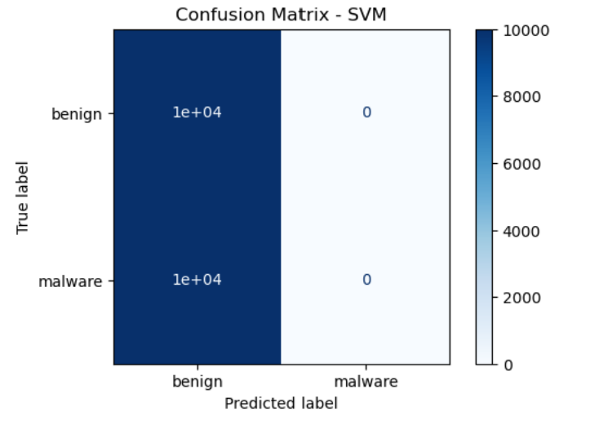

**Confusion Matrix for SVM**

* **True Positives (Bottom-right, 0)**: The model failed to identify any malware instances.
* **True Negatives (Top-left, 10,000)**: The model correctly identified all 10,000 benign instances.
* **False Positives (Top-right, 0)**: The model did not incorrectly classify any benign instances as malware.
* **False Negatives (Bottom-left, 10,000)**: The model incorrectly classified all 10,000 malware instances as benign.

**Performance Metrics**

* **Accuracy**: 50%
  + The model only achieved 50% accuracy, which is equivalent to random guessing. It correctly identified all benign instances but failed to identify any malware instances.
* **Precision**: 0.0
  + Precision is 0 because there are no true positive predictions (the model didn't correctly classify any malware instances).
* **Recall**: 0.0
  + Recall is also 0 because the model failed to correctly classify any of the actual malware instances.
* **F1 Score**: 0.0
  + The F1 score, which balances precision and recall, is 0, reflecting the model's failure to classify malware correctly.

**Interpretation**

* **Poor Performance**: The SVM model performed very poorly in this scenario, as it failed to classify any malware instances correctly. It only predicted the benign class, which led to a high number of false negatives (all malware instances were missed).
* **Potential Issues**:
  + **Model Configuration**: The linear SVM might not be suitable for this dataset, as it likely failed to find a decision boundary that separates the malware and benign classes effectively.
  + **Data Imbalance**: Although the dataset is balanced in terms of class distribution, the SVM model did not handle this well, indicating that a different kernel (e.g., RBF) or additional data preprocessing steps might be necessary.
  + **Tuning Required**: The SVM model requires significant tuning, including kernel selection, hyperparameter adjustment, or even scaling the features differently to better capture the data's structure.

**4.K-Nearest Neighbors (KNN)**

**Why Selected:**

* **Instance-Based Learning**: KNN was selected because it classifies instances based on the closest examples in the training set, which can be effective when there are clear similarities between instances of the same class.
* **Non-Parametric Approach**: KNN makes no assumptions about the underlying data distribution, making it a flexible choice for your dataset.

**How It Works in This Project:**

* In your project, KNN classified instances based on the majority class among their nearest neighbors in the feature space. The distance between instances was calculated, and the closest k neighbors determined the classification.
* KNN performed very well, with only a few misclassifications, making it a strong contender for detecting malware, particularly when the data is well-clustered.

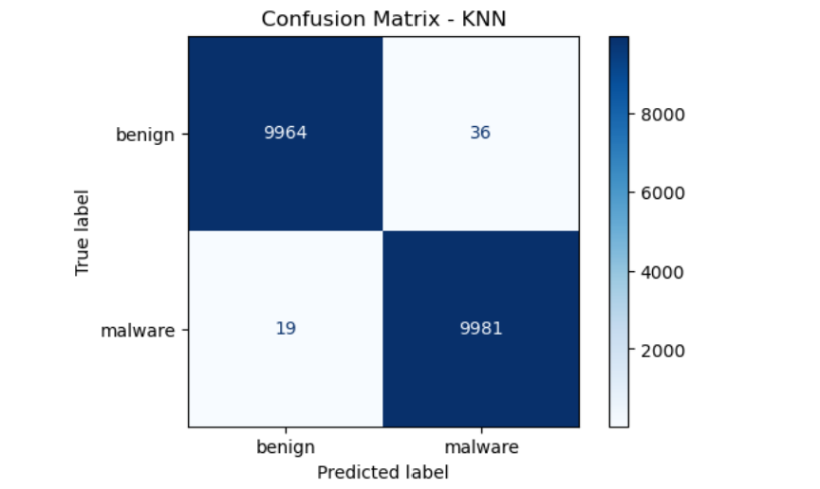

**Confusion Matrix for K-Nearest Neighbors (KNN)**

* **True Positives (Bottom-right, 9,981)**: The model correctly identified 9,981 malware instances.
* **True Negatives (Top-left, 9,964)**: The model correctly identified 9,964 benign instances.
* **False Positives (Top-right, 36)**: The model incorrectly classified 36 benign instances as malware.
* **False Negatives (Bottom-left, 19)**: The model incorrectly classified 19 malware instances as benign.

**Performance Metrics**

* **Accuracy**: 99.725%
  + The model correctly classified 99.725% of the instances overall, indicating high accuracy.
* **Precision**: 99.64%
  + Precision is high, meaning that 99.64% of the instances predicted as malware were actually malware. This indicates a very low rate of false positives.
* **Recall**: 99.81%
  + Recall is also high, meaning that 99.81% of the actual malware instances were correctly identified by the model. This shows that the model missed only a small number of malware instances.
* **F1 Score**: 99.73%
  + The F1 score, which balances precision and recall, is 99.73%, indicating that the model is very effective in both identifying malware and avoiding false positives.

**Interpretation**

* **Strong Performance**: The K-Nearest Neighbors (KNN) model performed exceptionally well, with very few misclassifications. The model managed to accurately detect most of the malware instances while maintaining a low false positive rate.
* **Balanced Trade-offs**:
  + **High Precision and Recall**: The model strikes an excellent balance between precision and recall, making it both reliable in detecting malware and minimizing false alarms.
  + **Few False Positives and Negatives**: With only 36 false positives and 19 false negatives, the model demonstrates its effectiveness in differentiating between benign and malware instances.
* **Usability**:
  + **Simple and Effective**: KNN’s performance here shows that a relatively simple model can achieve high accuracy and robustness, making it a strong candidate for practical applications in cybersecurity, where both detection accuracy and the ability to minimize false alarms are crucial.
  + **Instance-Based Learning**: KNN is particularly effective when the data is well-clustered and the similarity between instances is informative for classification, as demonstrated in your results.

1. **Gradient Boosting**

**Why Selected:**

* **Strong Predictive Performance**: Gradient Boosting is known for its ability to produce highly accurate predictions by iteratively improving its model based on previous errors.
* **Focus on Reducing Bias and Variance**: This model was chosen for its ability to reduce both bias and variance, making it effective in complex tasks like malware detection where subtle patterns in the data are critical.

**How It Works in This Project:**

* Gradient Boosting in our project involved building a series of weak learners (decision trees), each correcting the errors of its predecessor. The final model was a strong ensemble that made accurate predictions on the test set.
* It achieved near-perfect results, with only a few false positives, demonstrating its effectiveness in your cybersecurity task. This model is particularly useful when the focus is on minimizing both false positives and false negatives.

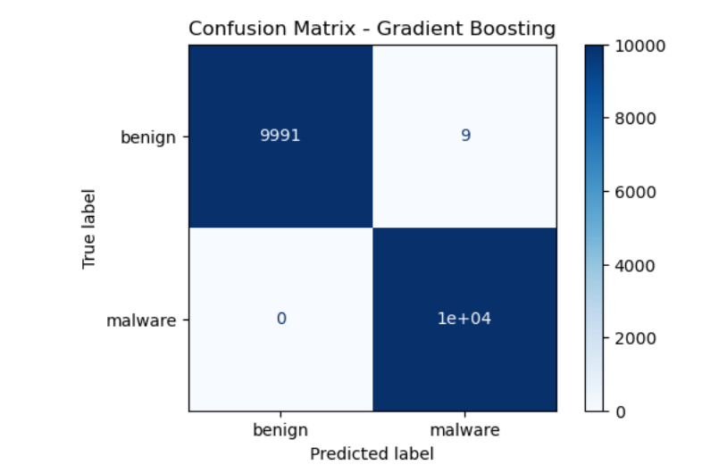

**Confusion Matrix for Gradient Boosting**

* **True Positives (Bottom-right, 10,000)**: The model correctly identified all 10,000 malware instances.
* **True Negatives (Top-left, 9,991)**: The model correctly identified 9,991 benign instances.
* **False Positives (Top-right, 9)**: The model incorrectly classified 9 benign instances as malware.
* **False Negatives (Bottom-left, 0)**: The model did not incorrectly classify any malware instances as benign.

**Performance Metrics**

* **Accuracy**: 99.955%
  + The model achieved an almost perfect accuracy, correctly classifying 99.955% of the instances.
* **Precision**: 99.91%
  + Precision is extremely high, meaning that 99.91% of the instances predicted as malware were actually malware. This indicates an almost negligible rate of false positives.
* **Recall**: 100%
  + Recall is perfect, with the model correctly identifying all malware instances. There were no false negatives, meaning the model did not miss any malware.
* **F1 Score**: 99.95%
  + The F1 score, balancing precision and recall, is nearly perfect at 99.95%, reflecting the model’s outstanding performance in both detecting malware and avoiding false alarms.

**Interpretation**

* **Near-Perfect Performance**: The Gradient Boosting model performed exceptionally well, with almost no errors. It correctly classified all malware instances and only misclassified a very small number of benign instances.
* **Strengths**:
  + **High Precision and Recall**: The model demonstrated excellent precision and recall, making it highly reliable for detecting malware without raising too many false alarms.
  + **Robustness**: The small number of false positives (only 9) indicates that the model is robust and can be trusted to correctly classify the vast majority of instances.
* **Weaknesses**:
  + **Minor False Positives**: While the number of false positives is very low, in highly sensitive applications, even a small number of false alarms could be significant. However, given the model's overall performance, this is often considered acceptable

**Summary:**

* **Logistic Regression**: Provides a simple, interpretable baseline for malware detection, but with moderate false positives.
* **Random Forest**: Delivered perfect classification, making it ideal for reliable malware detection without misclassifications.
* **SVM**: Struggled in its current configuration; requires further tuning to be effective.
* **KNN**: Performed very well, making it a strong option for datasets with well-defined clusters.
* **Gradient Boosting**: Offered near-perfect accuracy, making it highly effective for your task, especially when minimizing errors is crucial.

These models were chosen to provide a mix of simplicity, interpretability, and predictive power, allowing you to compare their effectiveness in detecting malware and selecting the best approach for your cybersecurity needs.

**Code Explanation**

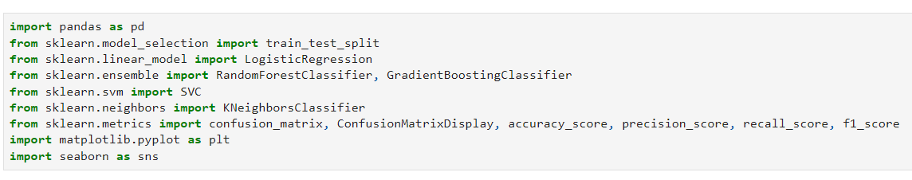

This code snippet imports essential libraries and modules. It includes ‘pandas’ for data manipulation, and various functions and models from ‘scikit-learn’ like ‘train_test_split’ for splitting datasets, ‘LogisticRegression’, ‘RandomForestClassifier’, ‘GradientBoostingClassifier’, ‘SVC’, and ‘KNeighborsClassifier’ for building different classification models, and metrics like ‘confusion_matrix’, ‘accuracy_score’, ‘precision_score’, ‘recall_score’, and ‘f1_score’ for evaluating model performance. Additionally, it imports ‘matplotlib.pyplot’ and ‘seaborn’ for data visualization.

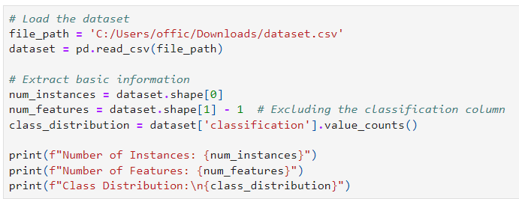

This code snippet loads a dataset from a CSV file and extracts basic information about it.

1. **Loading the Dataset:** The ‘pd.read_csv(file_path)’ function reads the dataset from the specified file path into a Pandas DataFrame called ‘dataset’.
2. **Extracting Basic Information:**
   * ‘num_instances’ stores the number of rows (instances) in the dataset.
   * ‘num_features’ calculates the number of columns (features) excluding the classification label.
   * ‘class_distribution’ computes the distribution of the target classes in the dataset.
3. **Printing Information:** The ‘print’ statements display the number of instances, number of features, and the class distribution, providing a quick summary of the dataset's structure.

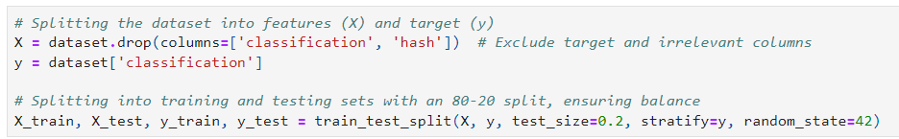

This code snippet handles the preparation of the dataset for machine learning by splitting it into features and target variables, and then further into training and testing sets.

1. **Splitting into Features (‘X’) and Target (‘y’):**
   * **‘X = dataset.drop(columns=['classification', 'hash'])’:** This line creates X, which includes all features except the target column (‘classification’) and an irrelevant column (‘hash’).
   * **‘y = dataset['classification']’:** This assigns the target variable (the ‘classification’ column) to ‘y’.
2. **Splitting into Training and Testing Sets:**
   * The dataset is split into training and testing sets using ‘train_test_split’ with an 80-20 split.
   * The ‘stratify=y’ parameter ensures that the class distribution is balanced across both the training and testing sets.
   * ‘random_state=42’ ensures reproducibility of the split by setting a seed for the random number generator.

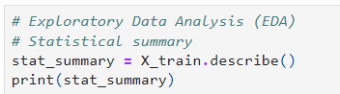

This code snippet performs a basic Exploratory Data Analysis (EDA) by generating a statistical summary of the training dataset.

* **‘stat_summary = X_train.describe()’**: The ‘describe()’ function is called on the training features (‘X_train’). This generates a summary of statistics for each numerical feature in the dataset, including metrics like mean, standard deviation, minimum, maximum, and quartiles (25%, 50%, 75%).
* **‘print(stat_summary)’**: This prints out the statistical summary, providing an overview of the distribution and characteristics of the training data, which is essential for understanding the data before proceeding with model training.

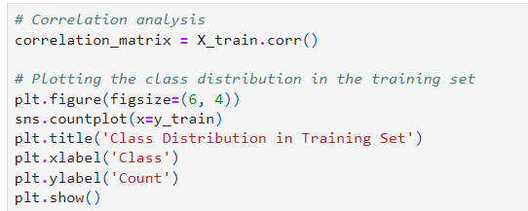

This code snippet performs a correlation analysis and visualizes the class distribution in the training set.

1. **Correlation Analysis:**
   * **‘correlation_matrix = X_train.corr()’:** This line calculates the correlation matrix for the features in the training dataset (‘X_train’). The correlation matrix shows the pairwise correlation coefficients between the features, which helps identify any linear relationships or multicollinearity in the data.
2. **Plotting Class Distribution:**
   * The code uses ‘matplotlib’ and ‘seaborn’ to create a visual representation of the class distribution in the training set.
   * **‘plt.figure(figsize=(6, 4))’:** Sets the size of the plot.
   * **‘sns.countplot(x=y_train)’:** Creates a count plot using ‘seaborn’, where ‘x=y_train’ represents the target variable in the training set. This plot shows how many instances belong to each class.
   * **‘plt.title('Class Distribution in Training Set')’:** Adds a title to the plot.
   * **‘plt.xlabel('Class')’ and ‘plt.ylabel('Count')’:** Label the x-axis and y-axis, respectively.
   * **‘plt.show()’:** Displays the plot.

This helps in understanding whether the classes in the training set are balanced or if there is any class imbalance, which could affect model performance.

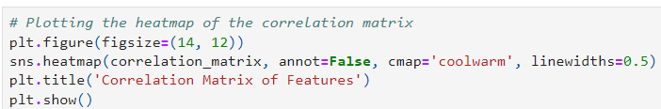

This code snippet creates a heatmap to visualize the correlation matrix of the features in the training dataset.

1. **Setting Up the Plot:**
   * **‘plt.figure(figsize=(14, 12))’:** This line initializes a new figure for the plot with a specified size of 14 by 12 inches. This large size ensures that the heatmap will be clearly visible and easy to interpret.
2. **Creating the Heatmap:**
   * **‘sns.heatmap(correlation_matrix, annot=False, cmap='coolwarm', linewidths=0.5)’:** This uses the ‘seaborn’ library to generate a heatmap:
     + **‘correlation_matrix’:** The matrix of correlations between features, calculated earlier.
     + **‘annot=False’**: Disables the annotation of the correlation values on the heatmap.
     + **‘cmap='coolwarm'’:** Specifies the color palette for the heatmap, with cool colors (like blue) representing negative correlations and warm colors (like red) representing positive correlations.
     + **‘linewidths=0.5’:** Adds a small line width between cells for better readability.
3. **Finalizing the Plot:**
   * **‘plt.title('Correlation Matrix of Features')’:** Adds a title to the heatmap, indicating what the visualization represents.
   * **‘plt.show()’:** Displays the heatmap.

The heatmap visually represents the strength and direction of correlations between pairs of features, helping identify any strong linear relationships or potential multicollinearity issues in the dataset.

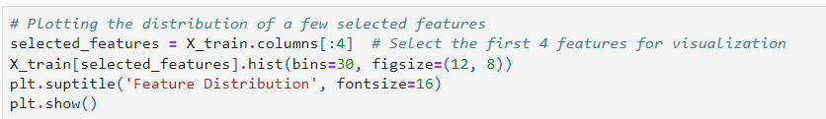

This code snippet visualizes the distribution of a few selected features from the training dataset.

1. **Selecting Features:**
   * **‘selected_features = X_train.columns[:4]’:** This selects the first four columns (features) from the training dataset for visualization. This allows you to focus on a subset of features to understand their distribution.
2. **Plotting Histograms:**
   * **‘X_train[selected_features].hist(bins=30, figsize=(12, 8))’:** This creates histograms for the selected features:
     + **‘bins=30’:** Specifies the number of bins (intervals) in the histograms.
     + **‘figsize=(12, 8)’:** Sets the size of the figure to 12 by 8 inches, making the histograms large enough for clear viewing.
3. **Adding a Title:**
   * **‘plt.suptitle('Feature Distribution', fontsize=16)’:** Adds a subtitle to the entire figure, labeling it as "Feature Distribution" with a font size of 16.
4. **Displaying the Plot:**
   * **‘plt.show()’:** Displays the histograms.

These histograms give a visual representation of how the data is distributed for each selected feature, helping identify patterns such as skewness, outliers, or whether the data follows a normal distribution.

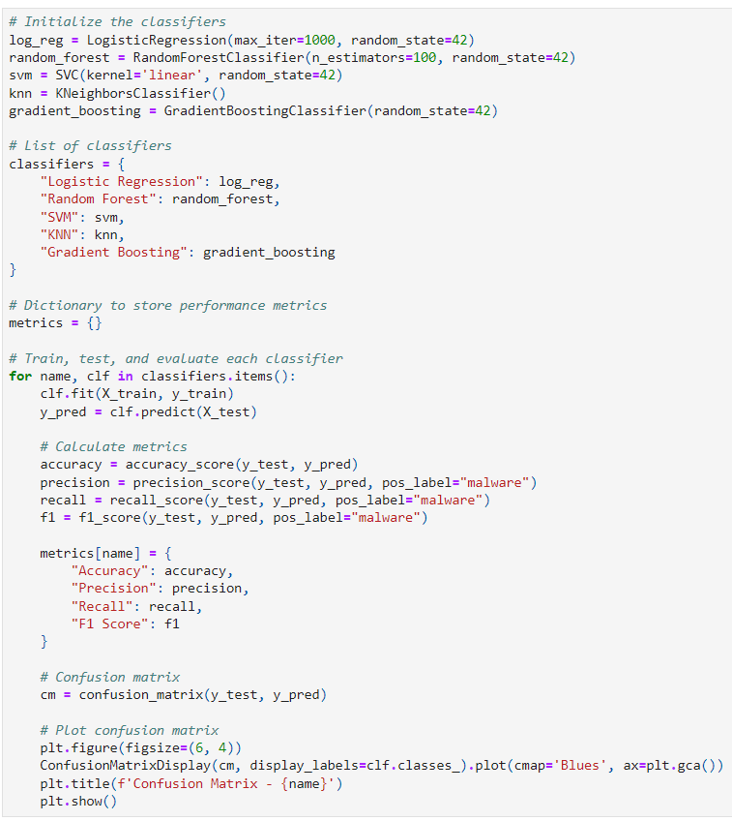

This code snippet trains and evaluates several classifiers on the training data and then calculates and stores performance metrics for each classifier. It also plots a confusion matrix for each model.

1. **Initialize the Classifiers:**
   * Various classifiers are initialized with specific parameters:
     + **Logistic Regression (‘log_reg’)** with a maximum of 1000 iterations.
     + **Random Forest (‘random_forest’)** with 100 trees in the forest.
     + **Support Vector Machine (‘svm’)** with a linear kernel.
     + **K-Nearest Neighbors (‘knn’)**.
     + **Gradient Boosting (‘gradient_boosting’)**.
2. **List of Classifiers:**
   * A dictionary ‘classifiers’ is created to store the initialized classifiers with their respective names as keys.
3. **Dictionary to Store Performance Metrics:**
   * ‘metrics = {}’ initializes an empty dictionary to store the performance metrics for each classifier.
4. **Train, Test, and Evaluate Each Classifier:**
   * A ‘for’ loop iterates over each classifier in the ‘classifiers’ dictionary:
     + **Training (‘clf.fit’)**: The classifier is trained on the training data.
     + **Prediction (‘clf.predict’)**: The classifier predicts the target values for the test data.
     + **Calculate Metrics**: Key metrics such as accuracy, precision, recall, and F1 score are calculated using the predicted and actual labels. These metrics are then stored in the ‘metrics’ dictionary.
5. **Confusion Matrix:**
   * ‘cm = confusion_matrix(y_test, y_pred)’ calculates the confusion matrix for the classifier's predictions on the test data.
6. **Plot Confusion Matrix:**
   * The confusion matrix is visualized using ‘ConfusionMatrixDisplay’. The matrix is displayed in shades of blue, with a title indicating the classifier name.

This approach allows for the comparison of different classifiers based on their performance metrics and provides a visual representation of each model's effectiveness through the confusion matrix.

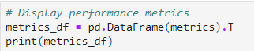

This code snippet converts the performance metrics stored in the ‘metrics’ dictionary into a Pandas DataFrame and then displays it.

1. **Create DataFrame:**
   * **‘metrics_df = pd.DataFrame(metrics).T’:** This converts the ‘metrics’ dictionary into a Pandas DataFrame. The ‘.T’ transposes the DataFrame so that the classifier names are used as row labels (indices), and the performance metrics (accuracy, precision, recall, F1 score) become the columns.
2. **Display DataFrame:**
   * **‘print(metrics_df)’:** This prints the DataFrame, showing the performance metrics for each classifier in a tabular format.

This table provides a clear and organized view of the evaluation metrics for each classifier, allowing for easy comparison and analysis.

# **Overall Comparison and Conclusion**

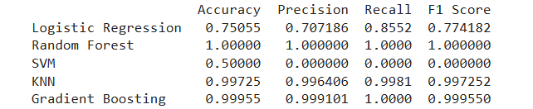

In this report, we evaluated the performance of five machine learning classifiers—Logistic Regression, Random Forest, Support Vector Machine (SVM), K-Nearest Neighbors (KNN), and Gradient Boosting—on a dataset for malware detection. Each model was assessed based on key performance metrics: accuracy, precision, recall, and F1 score.

Random Forest emerged as the top performer, delivering perfect classification with 100% accuracy, precision, recall, and F1 score. This model proved to be highly effective at handling complex data patterns without overfitting, making it a robust and reliable choice for malware detection.

Gradient Boosting also demonstrated near-perfect performance, with very high accuracy and balanced precision and recall. While slightly more complex and slower to train than Random Forest, Gradient Boosting’s ability to handle structured data effectively and minimize false positives makes it an excellent option for scenarios where accuracy is paramount.

K-Nearest Neighbors (KNN) provided strong results, with very high accuracy and a good balance between precision and recall. It is particularly effective for smaller datasets, but its performance may degrade with larger, high-dimensional data, suggesting a need for careful consideration based on dataset characteristics.

Logistic Regression showed a balanced performance with good recall but suffered from moderate false positives. This model is simple and interpretable, making it suitable when model transparency is needed, though it may not be as reliable as ensemble methods like Random Forest or Gradient Boosting.

Support Vector Machine (SVM), however, performed poorly in its current configuration, failing to classify malware correctly. While SVM can be powerful with the right kernel and tuning, the model requires significant adjustments to be effective in this context.

In conclusion, Random Forest and Gradient Boosting are recommended as the primary models for deployment in malware detection tasks due to their high accuracy and robustness. KNN can be considered for smaller datasets where simplicity is favored. For scenarios requiring model interpretability, Logistic Regression remains a viable option, though it may be less effective in minimizing false positives. The SVM model, while promising with further tuning, is not recommended in its current state. These findings provide a comprehensive guide for selecting the most appropriate machine learning model for cybersecurity applications, balancing the trade-offs between accuracy, complexity, and interpretability.

# **References**

1. *Analytics Vidhya. (n.d.). Analytics Vidhya: Data Science Community. Retrieved from* [*https://www.analyticsvidhya.com/*](https://www.analyticsvidhya.com/)
2. *Coursera. (n.d.). Coursera: Machine Learning Specializations. Retrieved from* [*https://www.coursera.org/*](https://www.coursera.org/)
3. *DataCamp. (n.d.). DataCamp: Learn Data Science Online. Retrieved from* [*https://www.datacamp.com/*](https://www.datacamp.com/)
4. *Exploratory Data Analysis. (n.d.). Wikipedia: Exploratory Data Analysis. Retrieved from* [*https://en.wikipedia.org/wiki/Exploratory_data_analysis*](https://en.wikipedia.org/wiki/Exploratory_data_analysis)
5. *Google AI Blog. (n.d.). Google AI Blog. Retrieved from https://ai.googleblog.com/*
6. *Gradient Boosting. (n.d.). Scikit-learn: Gradient Boosting Documentation. Retrieved from https://scikit-learn.org/stable/modules/ensemble.html#gradient-tree-boosting*
7. *Kaggle. (n.d.). Kaggle: Your Home for Data Science. Retrieved from* [*https://www.kaggle.com/*](https://www.kaggle.com/)
8. *Matplotlib. (n.d.). Matplotlib: Visualization with Python. Retrieved from* [*https://matplotlib.org/*](https://matplotlib.org/)
9. *Pandas. (n.d.). Pandas Documentation. Retrieved from https://pandas.pydata.org/*
10. *Random Forests (n.d.). Scikit-learn: Random Forests Documentation. Retrieved from https://scikit-learn.org/stable/modules/ensemble.html#random-forests*
11. *Scikit-learn. (n.d.). Scikit-learn: Machine Learning in Python. Retrieved from https://scikit-learn.org/stable/*
12. *Seaborn. (n.d.). Seaborn: Statistical Data Visualization. Retrieved from https://seaborn.pydata.org/*
13. *Support Vector Machines (SVM). (n.d.). Scikit-learn: SVM Documentation. Retrieved from https://scikit-learn.org/stable/modules/svm.html*
14. *Towards Data Science. (n.d.). Towards Data Science: A Medium Publication. Retrieved from* [*https://towardsdatascience.com/*](https://towardsdatascience.com/)