**Ahsanullah University of Science & Technology (AUST)**



**Department of Computer Science & Technology (CSE)**

**COURSE TITLE**:Microcontroller Based System

**COURSE NO**: CSE 3216

**SECTION**: C

**GROUP**: C1

**Digital Clock**

**Submitted to:**

**Mr. Sk. Murad Hassan Anik Mr. Sujan Sarker**

Lecturer Lecturer

B.Sc, CSE, AUST B.Sc, CSE, AUST

**Submitted by:**

SANJAnA KHAN | 15-01-04-113

FARHANA IRIN | 15-01-04-124

MASRURA UDDIN | 15-01-04-130

**Overview:**

Our project is basically a digital clock. Our clock has hour and minute. We have also kept the opportunity to change the time of the clock whenever one wants by pressing switch. There are four switches to increase and decrease the value of hour and minute.

**Instruments:**

* RTC
* 7 Segment Display
* Adaptor (12v & 2amp)
* Chip 7805(Converter)
* Breadboard
* Wires
* Arduino
* Switch(4)
* Resistance
* BCD

**Features** (Done)**:**

We have completed almost all the features of our project. Our clock can show the hour and minute. It can increase and decrease the value of hour and minute. Our clock can run using one source that is adaptor (12v and 2amp).

**Features** (Undone)**:**

We only didn’t complete the one part of our project. That is we didn’t show the second in our clock.

**Work Flow:**

At first we connected the SDA and SCL of our RTC (DS3231) to SDA and SCL of Arduino and the power and ground were also connected. Then four outputs from the Arduino pins as declared in our code will enter into our BCD as input. After that the 7 output from our BCD will be connected to a, b, c, d, e, f and g of our 1st hour digit of our seven segment display as per pin configuration. As our seven segment displays were quite big the 5 volt generated by Arduino wasn’t sufficient to power it on. So we supplied 12 V from external source. The whole process was repeated for our 2nd hour digit and two minute digits.

We should use resistance with the seven segment displays to keep it safe. The power and ground will have to be connected properly as per requirement.

**Circuit Diagram:**

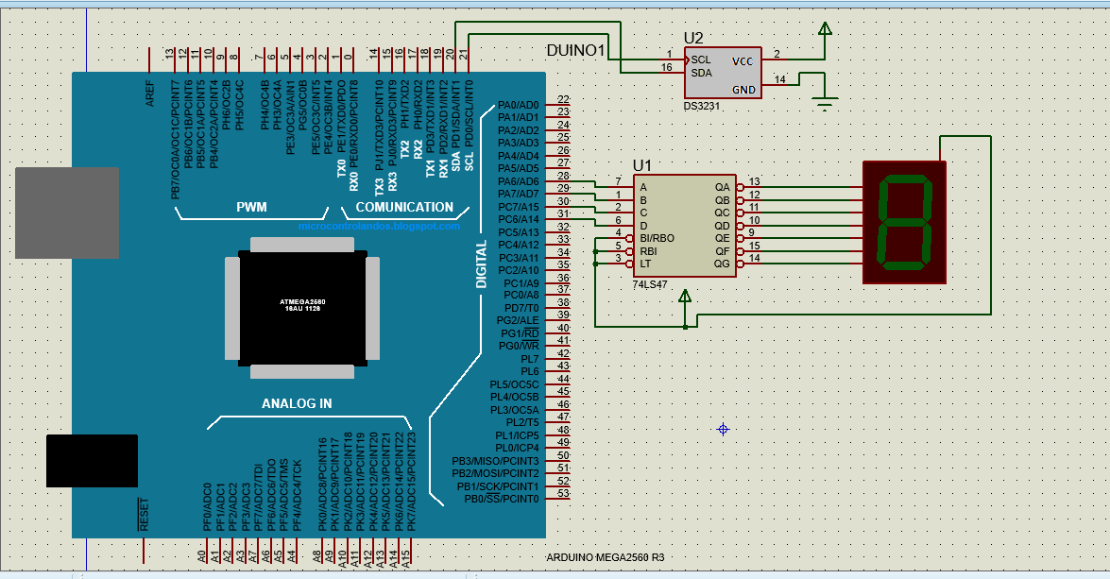

Figure: Circuit diagram of our project

**Screen Shot:**

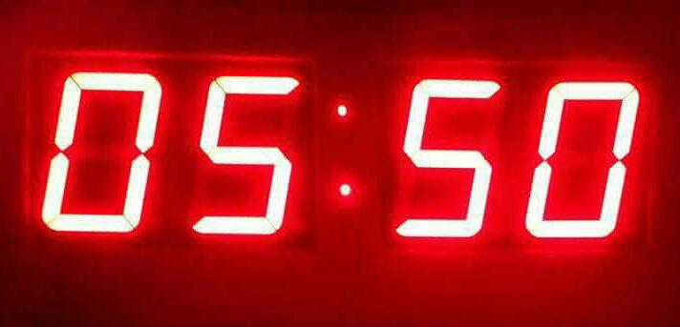

Figure: Screen shot of our project

**Conclusion:**

We want to add second in our clock. Our respected sir told us to hang our clock in our department. So we are working on it and we are hopeful that we will be able to hang it.