**Processing documentation**

First, I modify my focal data set *RTA_Fixed_Route_Ridership.xlsx* . I add a pivot table to the same sheet.

I go to *Insert* tab and choose *PivotTable*. As a new screen pops up, I choose the range of cells that I want to work with. After selecting all data I click *OK* button. Next I use *PivotTable Field List* to organize the data.

1. I use *Route* field for *Column Labels*
2. I use *Year* field for *Row Labels*
3. I add *Month* field to the *Row Labels* too
4. Field *RouteFixed_Route_Ridership* I use in *Values*, as I want to see ridership rate for all routes for each month.

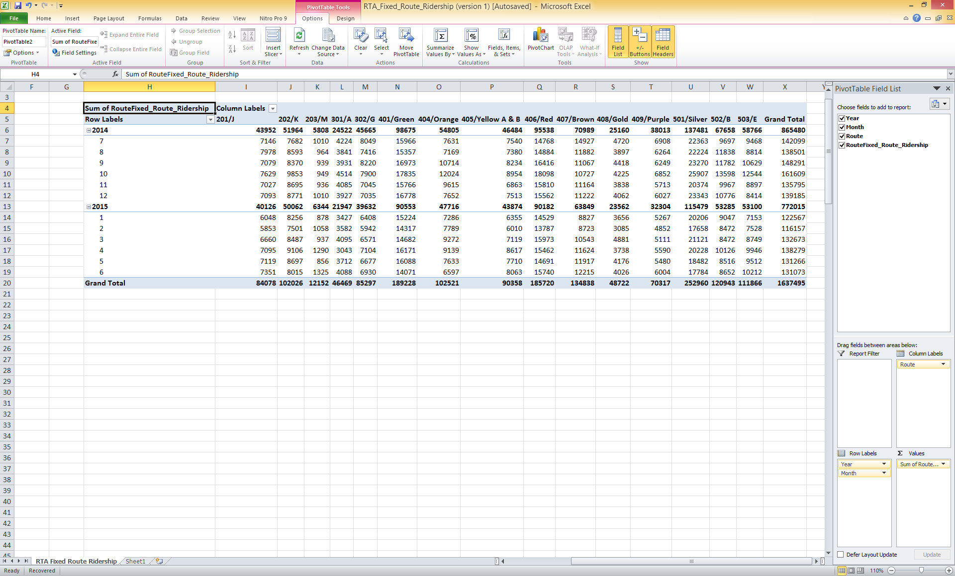

**Figare 1:** Resulting Pivot Table is presented.

For the next steps I use file *MTA_Rail_Ridership.xlsx*

1. I find the time frame for which I have data on Bus ridership – from July 2014 to June 2015.
2. To help myself work with the data, I first freeze the top row of this data set, and next highlight the time period with green.
3. I copy data from created *PivotTable* into *MTA_Rail_Ridership.xlsx*
4. I copy the cells containing all routes names and *Grand Total* field into the top row. Then I change the name for the *Grand Total* field to *Total RTA fixed routes*.
5. I copy values of ridership for all routes including *Grand Total* for all months in the year 2014, then insert copied values into the new table for the same months.

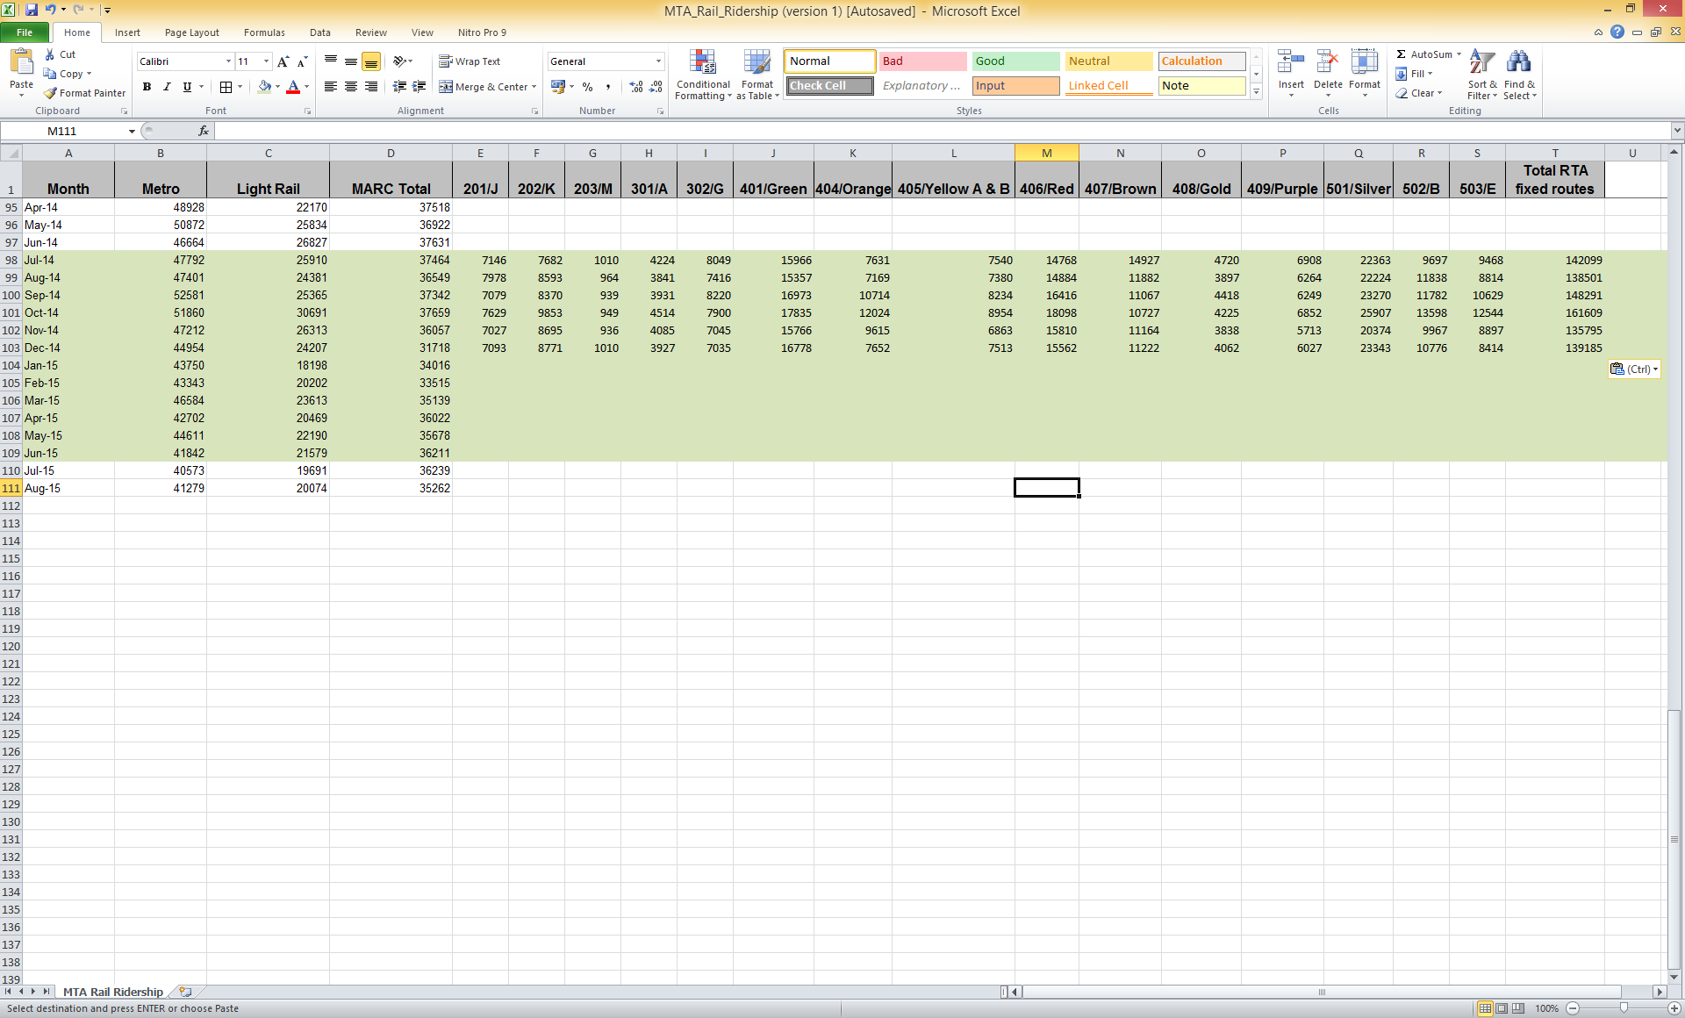

**Figare 2:** Merging two data sets.

1. I repeat the same for the months in 2015.
2. I save the new dataset with the name *MTA_Rail_and_RTA_Fixed_Route_Ridership_combined.xlsx*