PREPARATION
Seed Cards · Fronts
Print, cut and attach each front to its matching back. Replace placeholders with cropped details.
BORROWED EYES · CARD 1  Which visual fragment makes you most curious? | BORROWED EYES · CARD 2  Which visual fragment makes you most curious?
  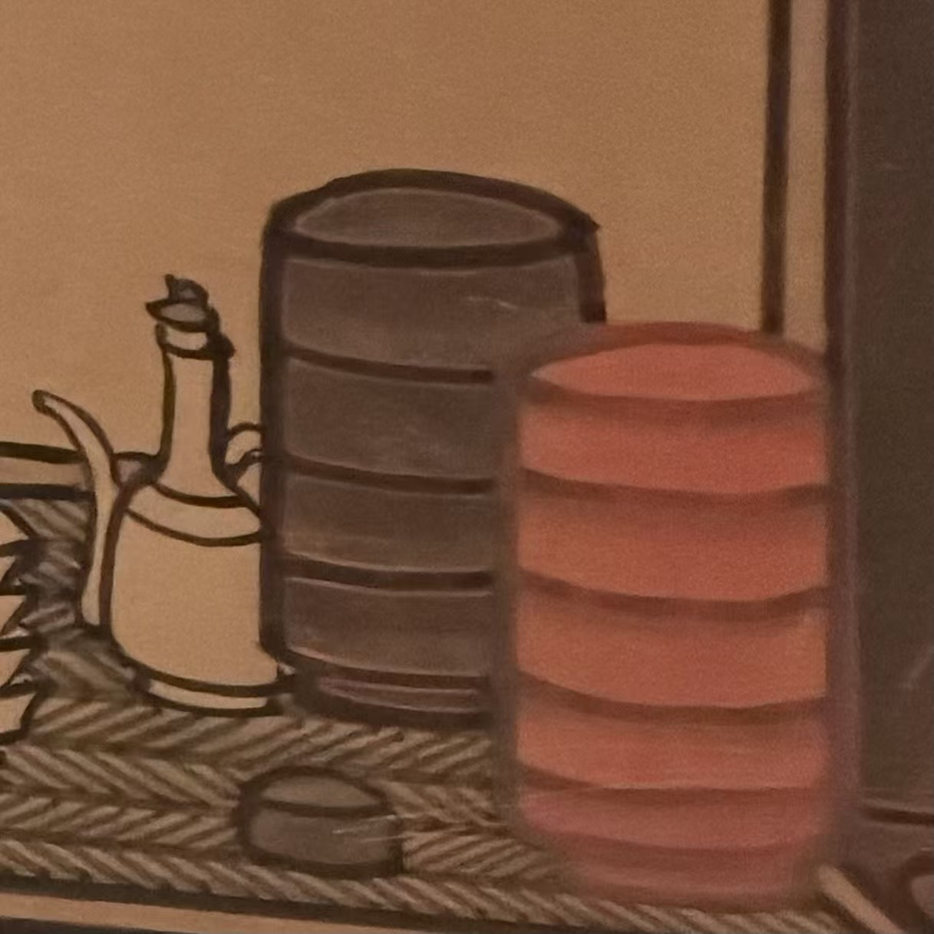
  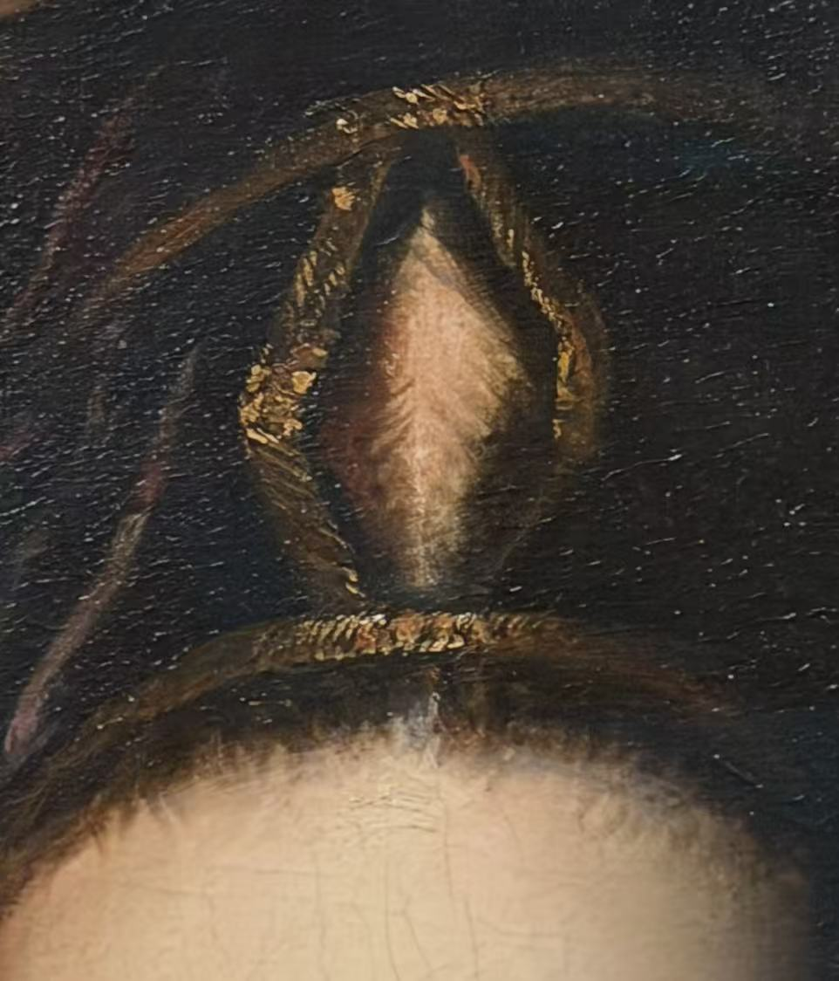
BORROWED EYES · CARD 3  Which visual fragment makes you most curious? | BORROWED EYES · CARD 4  Which visual fragment makes you most curious?
  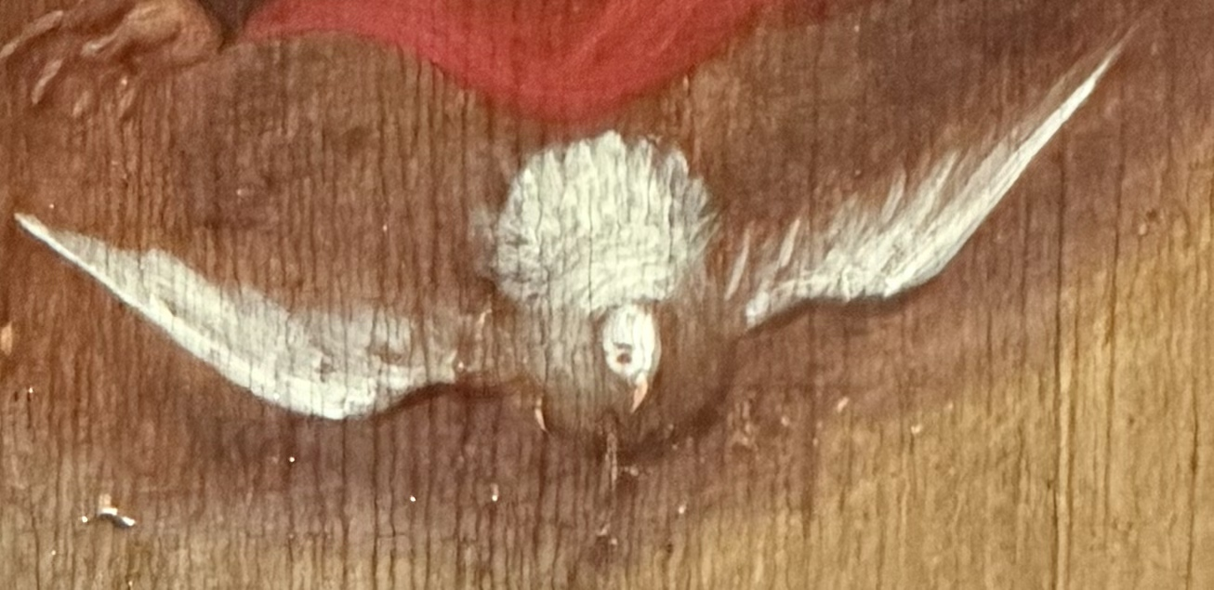
  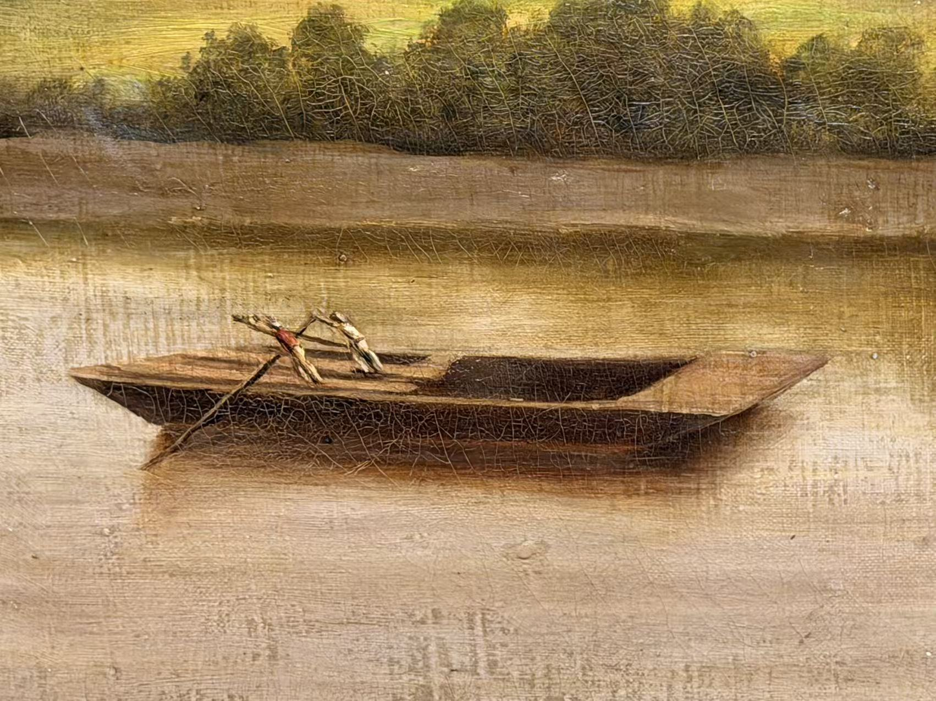

PREPARATION
Seed Cards · Backs
Use single words or short phrases. Add a second clue only when a participant is stuck.
CARD 1 · CLUE  Use short words or a short phrase. Do not reveal the title or exact location.  CLUE 1  __Look for a scene that feels like a quiet indoor moment.____  OPTIONAL CLUE 2 · reveal only if needed  ____Look closely at the objects near a seated person.____________________________________  Return to the facilitator when you think you have found it. | CARD 2 · CLUE  Use short words or a short phrase. Do not reveal the title or exact location.  CLUE 1  _______Beautiful woman____________  ___________________________________  OPTIONAL CLUE 2 · reveal only if needed  _________Look at her shoulder _______________________________  Return to the facilitator when you think you have found it.
CARD 3 · CLUE  Use short words or a short phrase. Do not reveal the title or exact location.  CLUE 1  ___ A small white figure appears above the main scene. _____________________  OPTIONAL CLUE 2 · reveal only if needed  ___ Look above the people, among flowers and fruit. ___________________________  Return to the facilitator when you think you have found it. | CARD 4 · CLUE  Use short words or a short phrase. Do not reveal the title or exact location.  CLUE 1  ____ Look above the people, among flowers and fruit. ________________________  OPTIONAL CLUE 2 · reveal only if needed  ___ This is a large landscape painting. Take a look at the lower left corner of it.__________  Return to the facilitator when you think you have found it.

PREPARATION
Seed Cards · Fronts
Print, cut and attach each front to its matching back. Replace placeholders with cropped details.
BORROWED EYES · CARD 5  Which visual fragment makes you most curious? | BORROWED EYES · CARD 6  Which visual fragment makes you most curious?
  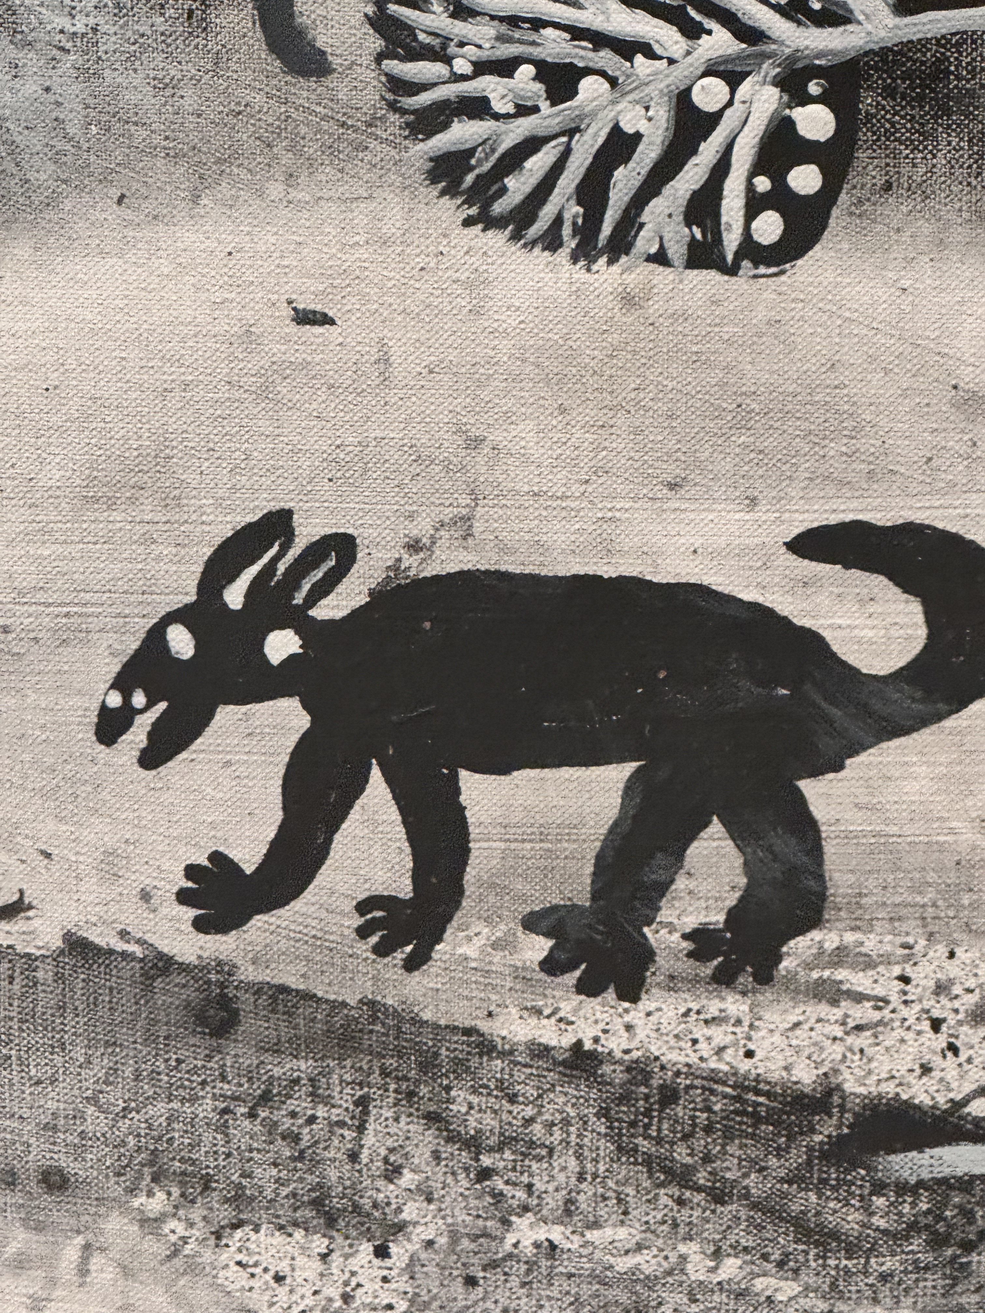
  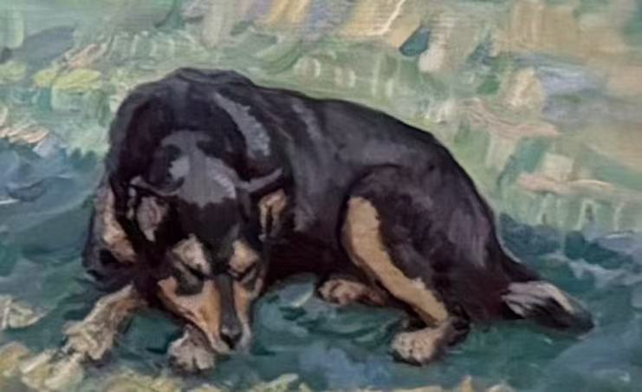
BORROWED EYES · CARD 7  Which visual fragment makes you most curious? | BORROWED EYES · CARD 8  Which visual fragment makes you most curious?
  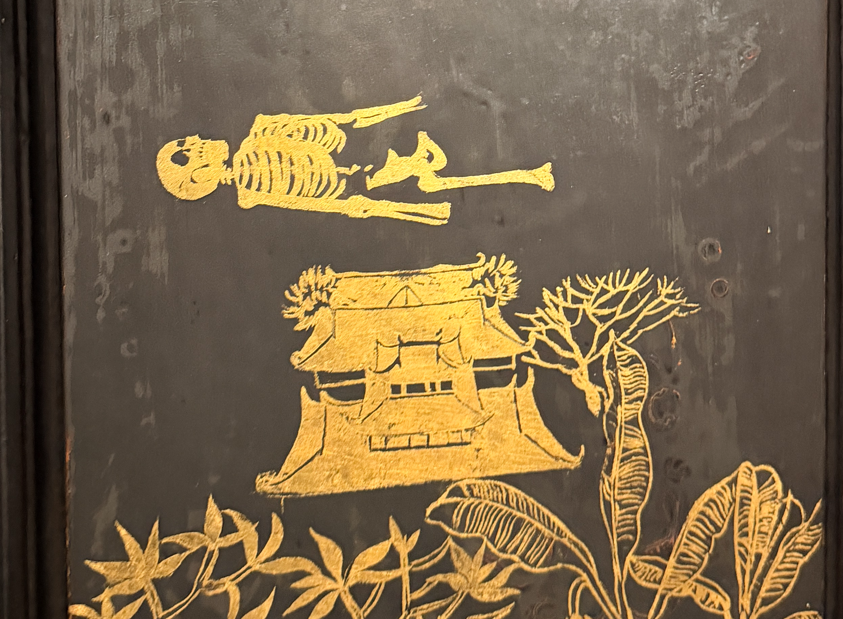
  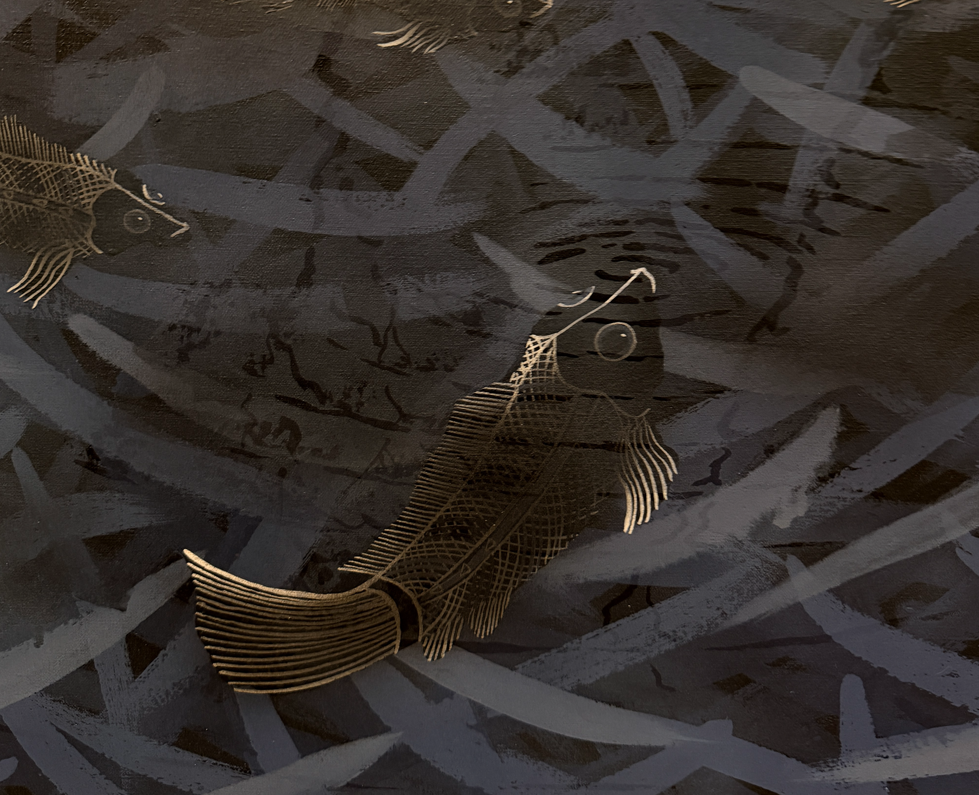

PREPARATION
Seed Cards · Backs
Use single words or short phrases. Add a second clue only when a participant is stuck.
CARD 5 · CLUE  Use short words or a short phrase. Do not reveal the title or exact location.  CLUE 1  _________Black and White ____________  OPTIONAL CLUE 2 · reveal only if needed  ___The only animal in the whole printing __  Return to the facilitator when you think you have found it. | CARD 6 · CLUE  Use short words or a short phrase. Do not reveal the title or exact location.  CLUE 1  ______A beautiful land_______  OPTIONAL CLUE 2 · reveal only if needed  _______people with_blue shirt__________  Return to the facilitator when you think you have found it.
CARD 7 · CLUE  Use short words or a short phrase. Do not reveal the title or exact location.  CLUE 1  ___Japanese folding screen_________________________________  OPTIONAL CLUE 2 · reveal only if needed  ________________________________________black wooden  ________________________________________  Return to the facilitator when you think you have found it. | CARD 8 · CLUE  Use short words or a short phrase. Do not reveal the title or exact location.  CLUE 1  ________________________________________  ________________________________________  OPTIONAL CLUE 2 · reveal only if needed  ________________________________________  ________________________________________  Return to the facilitator when you think you have found it.

ROUND 1 OR ROUND 2
Seed Cards · Fronts

BORROWED EYES · CARD 9  Which visual fragment makes you most curious? | BORROWED EYES · CARD 10  Which visual fragment makes you most curious?
  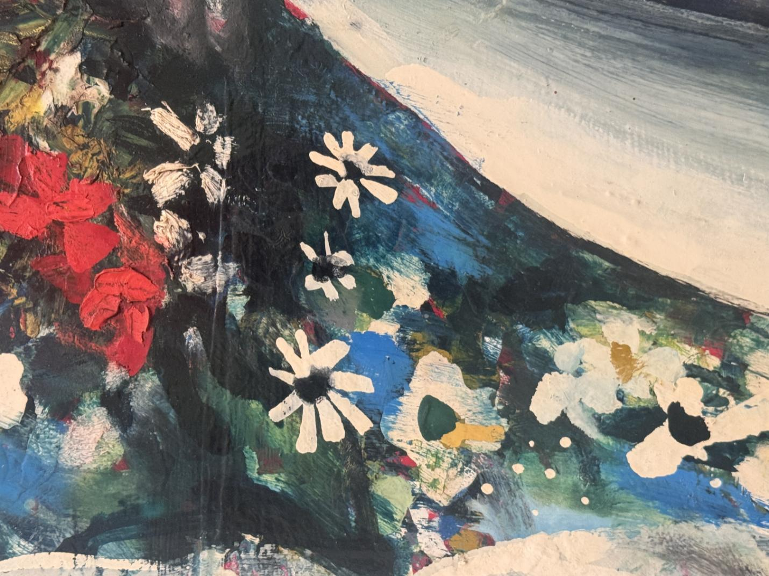
  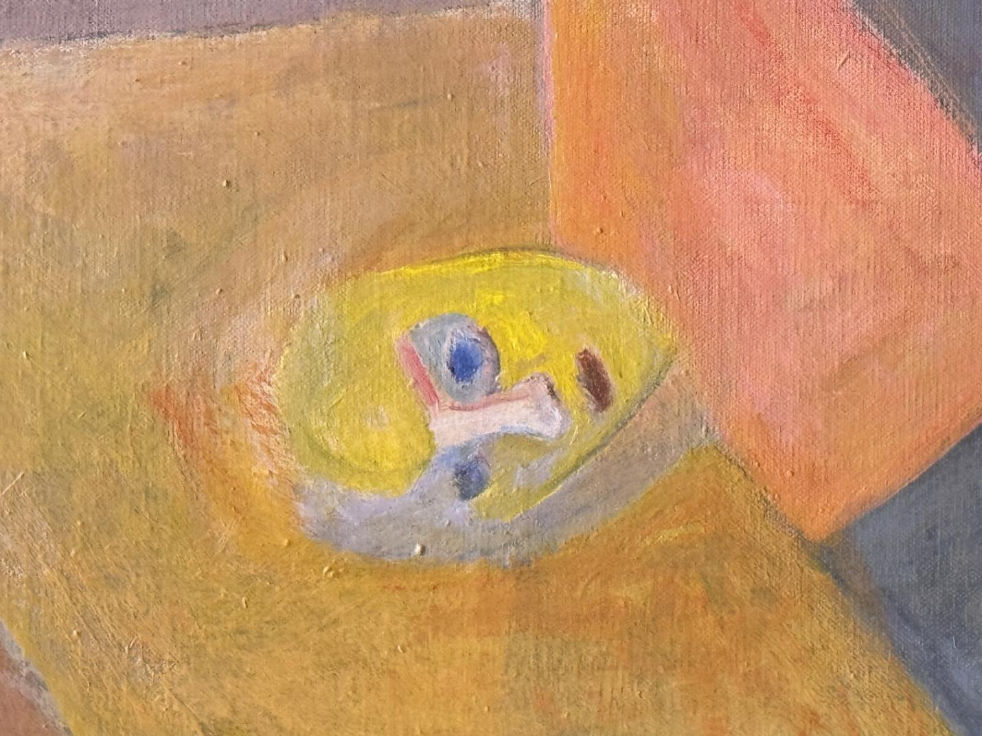

Seed Cards · Backs
CARD 9 · CLUE  Use short words or a short phrase. Do not reveal the title or exact location.  CLUE 1  ___A peaceful sleeping girl__________________________  OPTIONAL CLUE 2 · reveal only if needed  ________________________________________cold color  ________________________________________  Return to the facilitator when you think you have found it. | CARD 10 · CLUE  Use short words or a short phrase. Do not reveal the title or exact location.  CLUE 1  _________Abstract_______________________________  ________________________________________  OPTIONAL CLUE 2 · reveal only if needed  ________________________________________  ____________obscure boy____________________________  Return to the facilitator when you think you have found it.

