Kaggle_G2F_visulisation

Iris Chow

2025-03-12

# load libraries

setwd("C:/Users/botch/Downloads/genomes-to-field-corn-hybrid-prediction")  
library(readr)  
G2F_data <- read_csv("G2F_data.csv")

## Rows: 3302 Columns: 77  
## ── Column specification ────────────────────────────────────────────────────────  
## Delimiter: ","  
## chr (4): Hybrid, Env, Win_YN, field_location  
## dbl (73): moisture, test_weight, root_lodging, stalk_lodging, plant_height, ...  
##   
## ℹ Use `spec()` to retrieve the full column specification for this data.  
## ℹ Specify the column types or set `show_col_types = FALSE` to quiet this message.

library(ggplot2)

str(G2F_data)

## spc_tbl_ [3,302 × 77] (S3: spec_tbl_df/tbl_df/tbl/data.frame)  
## $ Hybrid : chr [1:3302] "PB80/PHZ51" "WF9/H95" "LH212HT/LH195" "B73/PHM49" ...  
## $ Env : chr [1:3302] "GAH2_2017" "ARH2_2017" "IAH3_2017" "SCH1_2019" ...  
## $ Win_YN : chr [1:3302] "N" "Y" "Y" "N" ...  
## $ moisture : num [1:3302] 15.2 17.7 19 16.7 24.4 ...  
## $ test_weight : num [1:3302] 913 731 763 731 667 ...  
## $ root_lodging : num [1:3302] 3 0 0 0 0 32.5 0 12.5 0 11.5 ...  
## $ stalk_lodging : num [1:3302] 2 2 2 1.5 0.4 1.75 1.5 2.5 5.5 2 ...  
## $ plant_height : num [1:3302] 235 229 229 210 256 ...  
## $ ear_height : num [1:3302] 130 110 110 80 135 ...  
## $ silk : num [1:3302] 58.5 65 65 56 67.7 64.5 86.5 55 68 56.5 ...  
## $ pollen : num [1:3302] 56 64 64 57 66.1 62.5 86.5 53 67.5 56 ...  
## $ Rain_1 : num [1:3302] 5.22 2.79 4.15 3.52 2.73 ...  
## $ Rain_2 : num [1:3302] 2.59 15.83 4.48 3.03 5.45 ...  
## $ Rain_3 : num [1:3302] 0.877 4.776 3.405 1.832 6.112 ...  
## $ Rain_5 : num [1:3302] 6.98 2.85 2.21 3.16 4.75 ...  
## $ Rain_6 : num [1:3302] 36.666 1.143 0.784 1.497 3.655 ...  
## $ Rain_7 : num [1:3302] 11.69 5.65 2.63 2.44 1.04 ...  
## $ Rain_8 : num [1:3302] 2.77 3.91 1.89 1.84 2.53 ...  
## $ Rain_10 : num [1:3302] 6.72 2.44 2.33 1.72 3.7 ...  
## $ Rain_11 : num [1:3302] 5.24 4.69 1.79 2.16 2.61 ...  
## $ AccPrecip_1 : num [1:3302] 161.7 89.3 132.9 109.2 84.8 ...  
## $ AccPrecip_2 : num [1:3302] 18.1 110.8 67.2 18.2 32.7 ...  
## $ AccPrecip_3 : num [1:3302] 11 61.6 54 19.9 82.9 ...  
## $ AccPrecip_5 : num [1:3302] 219.5 89 78.3 97.9 167.6 ...  
## $ AccPrecip_6 : num [1:3302] 69.63 3 1.57 2.85 8 ...  
## $ AccPrecip_7 : num [1:3302] 116.6 52.4 28 21.9 12.6 ...  
## $ AccPrecip_8 : num [1:3302] 77.6 105.2 71.9 50.9 113.8 ...  
## $ AccPrecip_10 : num [1:3302] 33.59 13.34 19.05 9.48 40.74 ...  
## $ AccPrecip_11 : num [1:3302] 162.4 145.3 54.7 67 78.9 ...  
## $ Radn_1 : num [1:3302] 18.6 17.1 16.1 18.2 20.4 ...  
## $ Radn_2 : num [1:3302] 21 19.1 17.8 19.2 18.3 ...  
## $ Radn_3 : num [1:3302] 22 20.9 18.9 19.8 21.3 ...  
## $ Radn_5 : num [1:3302] 18.5 19.7 22.1 19.9 20.4 ...  
## $ Radn_6 : num [1:3302] 14.3 19.8 20.5 17.8 19.5 ...  
## $ Radn_7 : num [1:3302] 17.8 19.1 21 20.9 19 ...  
## $ Radn_8 : num [1:3302] 19.8 18.8 19.8 19.9 17.8 ...  
## $ Radn_10 : num [1:3302] 18.9 19.7 17.2 20.2 14.2 ...  
## $ Radn_11 : num [1:3302] 17.6 17.5 15.6 17.7 10.1 ...  
## $ MaxT_1 : num [1:3302] 25.9 23.7 15.8 24.1 15.5 ...  
## $ MaxT_2 : num [1:3302] 24.2 24.6 15.5 27.6 26.5 ...  
## $ MaxT_3 : num [1:3302] 30.5 25.4 21.4 26.9 25.4 ...  
## $ MaxT_5 : num [1:3302] 29.3 29 27.7 30.3 27.3 ...  
## $ MaxT_6 : num [1:3302] 29.5 32.4 28.5 30.2 28 ...  
## $ MaxT_7 : num [1:3302] 29.7 30.8 29.9 31.8 27.2 ...  
## $ MaxT_8 : num [1:3302] 32.7 31.8 27.7 32.9 25.8 ...  
## $ MaxT_10 : num [1:3302] 32.1 32.8 25.6 31.8 21.8 ...  
## $ MaxT_11 : num [1:3302] 30.8 30.2 25.1 32.3 14.7 ...  
## $ MinT_1 : num [1:3302] 12.17 12.07 4.42 10.72 3.11 ...  
## $ MinT_2 : num [1:3302] 9.94 12.16 4.14 15.89 15.19 ...  
## $ MinT_3 : num [1:3302] 16.15 12.71 9.78 14.79 12.31 ...  
## $ MinT_5 : num [1:3302] 18.1 18 13.6 18.3 15.1 ...  
## $ MinT_6 : num [1:3302] 20.4 21.8 16.1 20.5 16.1 ...  
## $ MinT_7 : num [1:3302] 19.5 20.2 16.6 19.5 16.3 ...  
## $ MinT_8 : num [1:3302] 21.2 21.9 14.8 21.2 13.2 ...  
## $ MinT_10 : num [1:3302] 20.86 22.26 12.75 19.17 9.93 ...  
## $ MinT_11 : num [1:3302] 19.96 20.26 11.28 20.17 4.43 ...  
## $ ThermalTime_1 : num [1:3302] 11.91 10.84 5.82 10.63 5.29 ...  
## $ ThermalTime_2 : num [1:3302] 10.39 11.22 5.62 13.88 13.28 ...  
## $ ThermalTime_3 : num [1:3302] 15.46 11.89 9.39 13.27 11.7 ...  
## $ ThermalTime_5 : num [1:3302] 15.8 15.6 13.3 16.4 13.6 ...  
## $ ThermalTime_6 : num [1:3302] 17 19.1 14.4 17.3 14.3 ...  
## $ ThermalTime_7 : num [1:3302] 16.6 17.5 15.4 17.6 14 ...  
## $ ThermalTime_8 : num [1:3302] 18.9 18.8 13.7 19 12.3 ...  
## $ ThermalTime_10: num [1:3302] 18.47 19.28 11.9 17.49 9.66 ...  
## $ ThermalTime_11: num [1:3302] 17.41 17.25 11.29 18.16 5.63 ...  
## $ TempStress_1 : num [1:3302] 1 0.992 0.569 0.967 0.572 ...  
## $ TempStress_2 : num [1:3302] 0.986 1 0.57 1 1 ...  
## $ TempStress_3 : num [1:3302] 1 0.973 0.88 1 1 ...  
## $ TempStress_5 : num [1:3302] 1 1 1 1 1 ...  
## $ TempStress_7 : num [1:3302] 1 1 1 1 1 1 1 1 1 1 ...  
## $ TempStress_8 : num [1:3302] 1 1 1 1 0.966 ...  
## $ TempStress_10 : num [1:3302] 1 1 1 1 0.88 ...  
## $ TempStress_11 : num [1:3302] 1 1 0.979 1 0.561 ...  
## $ latitude : num [1:3302] 33.7 35.7 42 34.6 44.1 ...  
## $ longitude : num [1:3302] -83.3 -90.1 -92.2 -82.7 -89.5 ...  
## $ year : num [1:3302] 2017 2017 2017 2019 2020 ...  
## $ field_location: chr [1:3302] "GAH2" "ARH2" "IAH3" "SCH1" ...  
## - attr(*, "spec")=  
## .. cols(  
## .. Hybrid = col_character(),  
## .. Env = col_character(),  
## .. Win_YN = col_character(),  
## .. moisture = col_double(),  
## .. test_weight = col_double(),  
## .. root_lodging = col_double(),  
## .. stalk_lodging = col_double(),  
## .. plant_height = col_double(),  
## .. ear_height = col_double(),  
## .. silk = col_double(),  
## .. pollen = col_double(),  
## .. Rain_1 = col_double(),  
## .. Rain_2 = col_double(),  
## .. Rain_3 = col_double(),  
## .. Rain_5 = col_double(),  
## .. Rain_6 = col_double(),  
## .. Rain_7 = col_double(),  
## .. Rain_8 = col_double(),  
## .. Rain_10 = col_double(),  
## .. Rain_11 = col_double(),  
## .. AccPrecip_1 = col_double(),  
## .. AccPrecip_2 = col_double(),  
## .. AccPrecip_3 = col_double(),  
## .. AccPrecip_5 = col_double(),  
## .. AccPrecip_6 = col_double(),  
## .. AccPrecip_7 = col_double(),  
## .. AccPrecip_8 = col_double(),  
## .. AccPrecip_10 = col_double(),  
## .. AccPrecip_11 = col_double(),  
## .. Radn_1 = col_double(),  
## .. Radn_2 = col_double(),  
## .. Radn_3 = col_double(),  
## .. Radn_5 = col_double(),  
## .. Radn_6 = col_double(),  
## .. Radn_7 = col_double(),  
## .. Radn_8 = col_double(),  
## .. Radn_10 = col_double(),  
## .. Radn_11 = col_double(),  
## .. MaxT_1 = col_double(),  
## .. MaxT_2 = col_double(),  
## .. MaxT_3 = col_double(),  
## .. MaxT_5 = col_double(),  
## .. MaxT_6 = col_double(),  
## .. MaxT_7 = col_double(),  
## .. MaxT_8 = col_double(),  
## .. MaxT_10 = col_double(),  
## .. MaxT_11 = col_double(),  
## .. MinT_1 = col_double(),  
## .. MinT_2 = col_double(),  
## .. MinT_3 = col_double(),  
## .. MinT_5 = col_double(),  
## .. MinT_6 = col_double(),  
## .. MinT_7 = col_double(),  
## .. MinT_8 = col_double(),  
## .. MinT_10 = col_double(),  
## .. MinT_11 = col_double(),  
## .. ThermalTime_1 = col_double(),  
## .. ThermalTime_2 = col_double(),  
## .. ThermalTime_3 = col_double(),  
## .. ThermalTime_5 = col_double(),  
## .. ThermalTime_6 = col_double(),  
## .. ThermalTime_7 = col_double(),  
## .. ThermalTime_8 = col_double(),  
## .. ThermalTime_10 = col_double(),  
## .. ThermalTime_11 = col_double(),  
## .. TempStress_1 = col_double(),  
## .. TempStress_2 = col_double(),  
## .. TempStress_3 = col_double(),  
## .. TempStress_5 = col_double(),  
## .. TempStress_7 = col_double(),  
## .. TempStress_8 = col_double(),  
## .. TempStress_10 = col_double(),  
## .. TempStress_11 = col_double(),  
## .. latitude = col_double(),  
## .. longitude = col_double(),  
## .. year = col_double(),  
## .. field_location = col_character()  
## .. )  
## - attr(*, "problems")=<externalptr>

library(ggplot2)  
  
# Subset the data to include columns 1-11 and 74-77  
visualised_col_df <- G2F_data[, c(1:11, 74:77)]  
  
# Loop through each column of the subset  
for (i in 1:ncol(visualised_col_df)) {  
 column_name <- colnames(visualised_col_df)[i]  
 current_col <- visualised_col_df[[column_name]]  
 num_missing <- sum(is.na(current_col))  
   
 # Check if the column is numeric  
 if (is.numeric(current_col)) {  
 # Create histogram for numeric columns  
 p <- ggplot(visualised_col_df, aes(x = .data[[column_name]])) +  
 geom_histogram(fill = "skyblue", bins = 30, na.rm = TRUE) +  
 labs(title = paste0("Distribution of ", column_name),  
 x = column_name)  
 } else {  
 # Create bar plot for categorical columns  
 p <- ggplot(visualised_col_df, aes(x = .data[[column_name]])) +  
 geom_bar(fill = "salmon", na.rm = TRUE) +  
 labs(title = paste0("Distribution of ", column_name),  
 x = column_name)  
 }  
   
 print(p)  
}

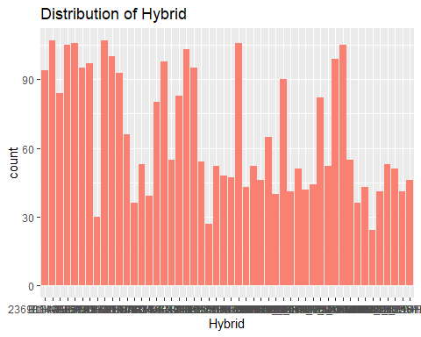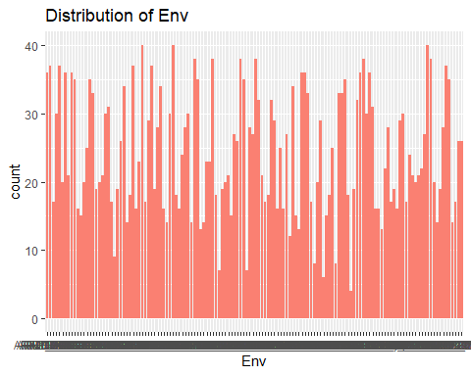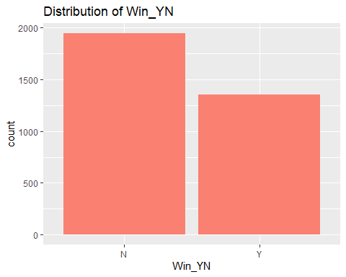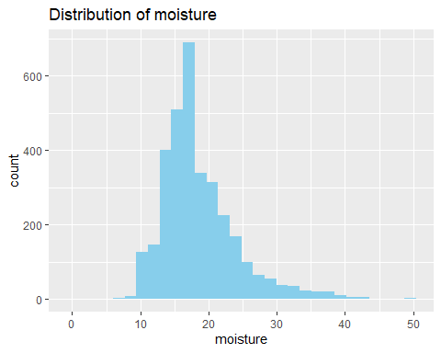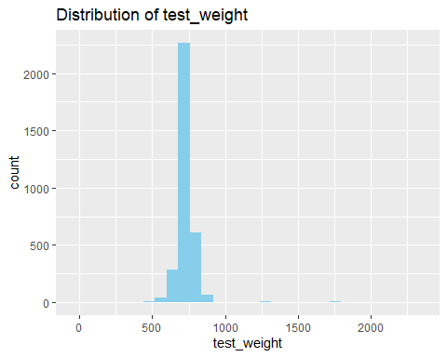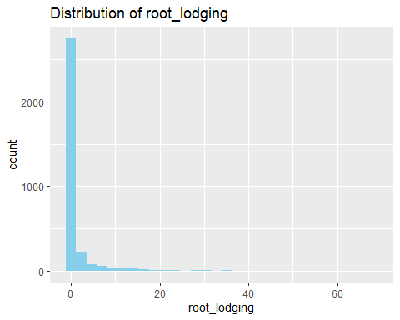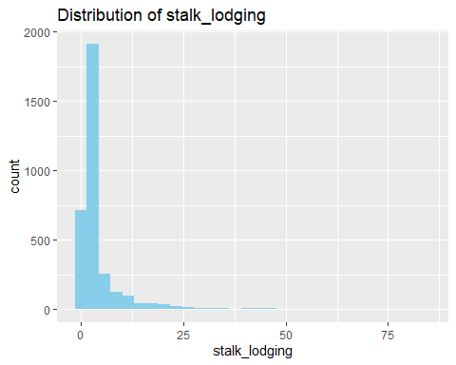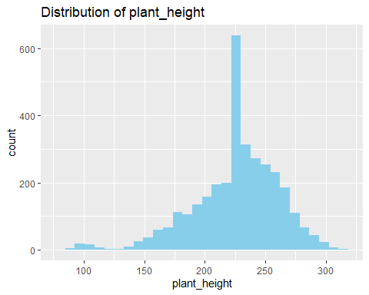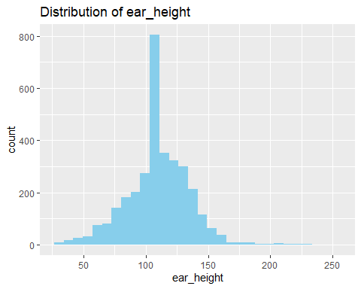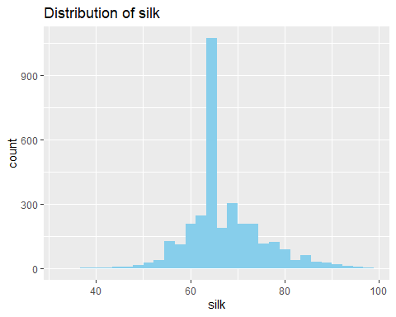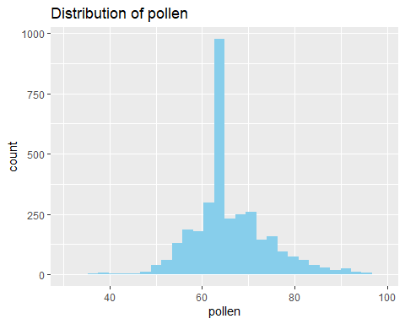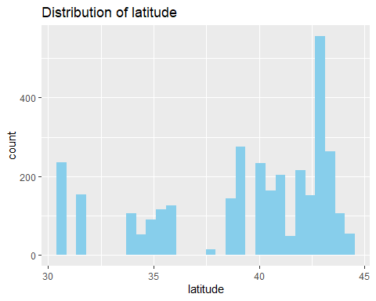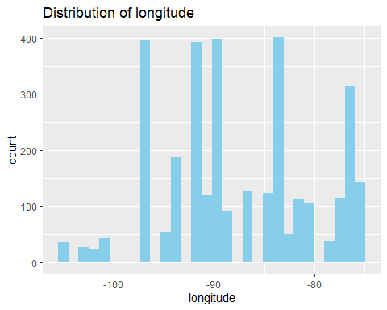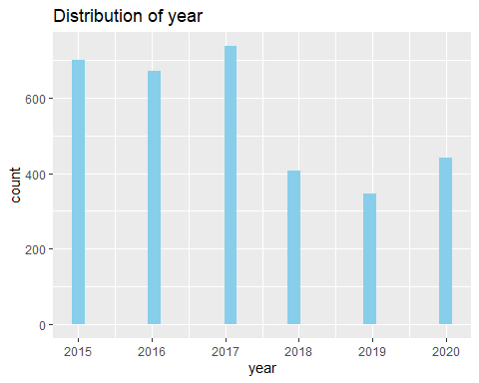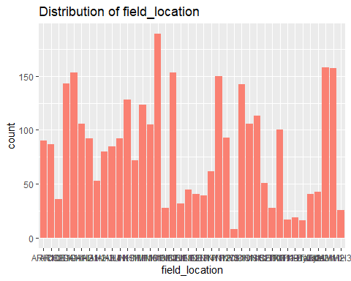 # make plot one by one to adjust labels and axis

# Hybrid  
# arrange in descending order by count  
library(forcats) # Load forcats for factor reordering  
  
ggplot(G2F_data, aes(x = fct_infreq(Hybrid))) +  
 geom_bar(fill = "salmon", na.rm = TRUE) +  
 labs(title = "Distribution of Hybrid", x = "Hybrid") +  
 theme(axis.text.x = element_text(angle = 90, vjust = 0.5, hjust = 1))

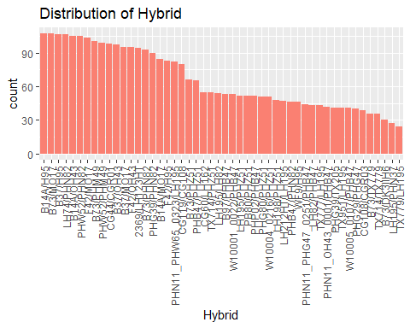

# Environment  
ggplot(G2F_data, aes(x = fct_infreq(Env))) +  
 geom_bar(fill = "salmon", na.rm = TRUE) +  
 labs(title = "Distribution of Environment",  
 x = "Environment")+ theme(axis.text.x = element_text(angle = 90, vjust = 0.5, hjust=1))

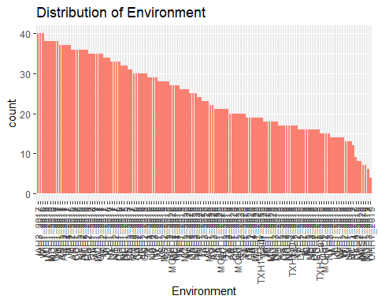

# add percentage of proportion in the piechart  
ggplot(G2F_data, aes(x = "", fill = Win_YN)) +  
 geom_bar(width = 1, na.rm = TRUE) +  
 coord_polar("y") +  
 labs(title = "Distribution of Win_YN", fill = "Win_YN") +  
 scale_fill_manual(values = c("salmon", "skyblue")) +  
 theme_void() +  
 geom_text(aes(label = scales::percent(..count../sum(..count..))),  
 stat = "count",  
 position = position_stack(vjust = 0.5))

## Warning: The dot-dot notation (`..count..`) was deprecated in ggplot2 3.4.0.  
## ℹ Please use `after_stat(count)` instead.  
## This warning is displayed once every 8 hours.  
## Call `lifecycle::last_lifecycle_warnings()` to see where this warning was  
## generated.

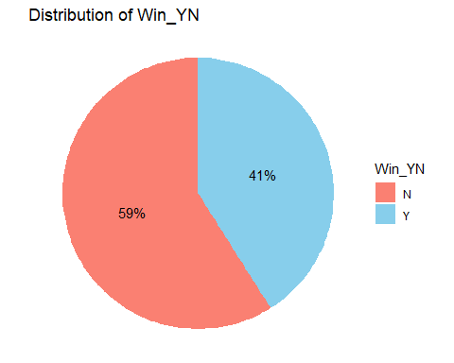

# moisture  
ggplot(G2F_data, aes(x = moisture)) +  
 geom_histogram(fill = "skyblue", bins = 30, na.rm = TRUE) +  
 labs(title = "Distribution of Moisture",  
 x = "Moisture") + xlim(5,45)

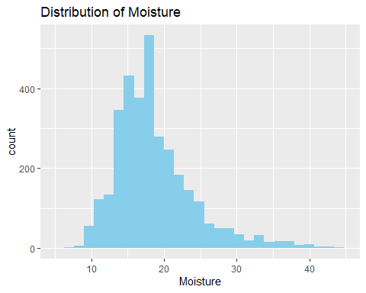

max(G2F_data$moisture, na.rm = TRUE)

## [1] 49.6

# test weight  
ggplot(G2F_data, aes(x = test_weight)) +  
 geom_histogram(fill = "skyblue", bins = 30, na.rm = TRUE) +  
 labs(title = "Distribution of Test Weight",  
 x = "Test Weight")

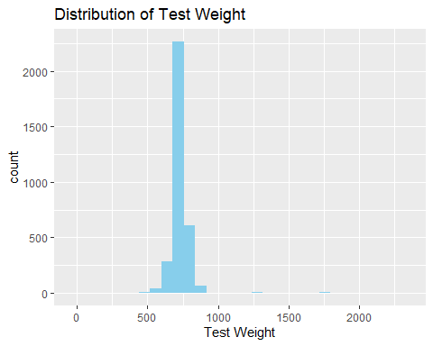

# set x-axis from 400 to 1000  
ggplot(G2F_data, aes(x = test_weight)) +  
 geom_histogram(fill = "skyblue", bins = 30, na.rm = TRUE) +  
 labs(title = "Distribution of Test Weight",  
 x = "Test Weight") +  
 xlim(450, 900)

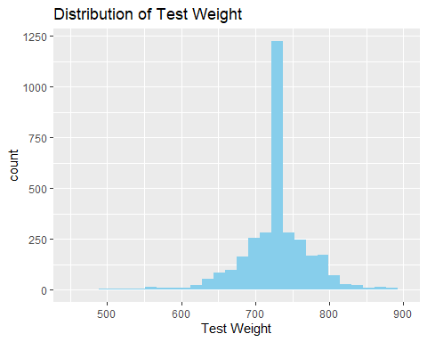

#root_lodging  
ggplot(G2F_data, aes(x = root_lodging)) +  
 geom_histogram(fill = "skyblue", bins = 30, na.rm = TRUE) +  
 labs(title = "Distribution of Root Lodging",  
 x = "Root Lodging") + xlim(0,20) + ylim(0, 300)

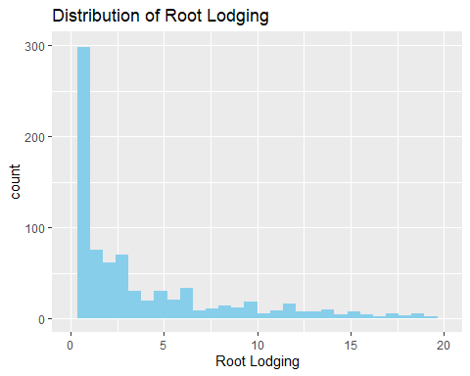

#stalk_lodging  
ggplot(G2F_data, aes(x = stalk_lodging)) +  
 geom_histogram(fill = "skyblue", bins = 30, na.rm = TRUE) +  
 labs(title = "Distribution of Stalk Lodging",  
 x = "Stalk Lodging") + xlim(0,25)

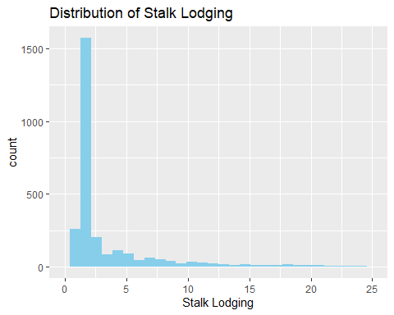

# convert year to a factor variable  
G2F_data$year <- as.factor(G2F_data$year)  
# Make histogram for year  
ggplot(G2F_data, aes(x = year)) +  
 geom_bar(fill = "salmon", na.rm = TRUE) +  
 labs(title = "Distribution of Year",  
 x = "Year")

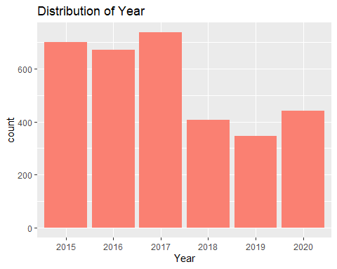

# field_location  
ggplot(G2F_data, aes(x = fct_infreq(field_location))) +  
 geom_bar(fill = "salmon", na.rm = TRUE) +  
 labs(title = "Distribution of Field Location",  
 x = "Field Location") + theme(axis.text.x = element_text(angle = 90, vjust = 0.5, hjust=1))

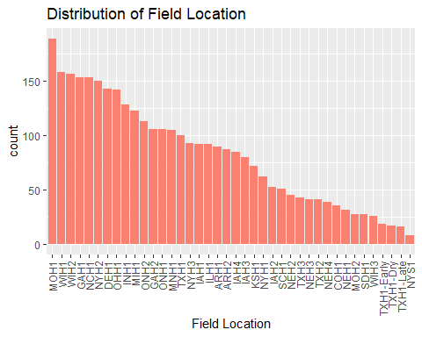

summary(G2F_data)

## Hybrid Env Win_YN moisture   
## Length:3302 Length:3302 Length:3302 Min. : 0.00   
## Class :character Class :character Class :character 1st Qu.:15.00   
## Mode :character Mode :character Mode :character Median :17.70   
## Mean :18.63   
## 3rd Qu.:20.98   
## Max. :49.60   
## test_weight root_lodging stalk_lodging plant_height   
## Min. : 0.0 Min. : 0.000 Min. : 0.00 Min. : 81.0   
## 1st Qu.: 711.6 1st Qu.: 0.000 1st Qu.: 1.50 1st Qu.:208.5   
## Median : 731.1 Median : 0.000 Median : 2.00 Median :229.0   
## Mean : 733.7 Mean : 1.567 Mean : 3.95 Mean :226.5   
## 3rd Qu.: 749.8 3rd Qu.: 0.500 3rd Qu.: 3.00 3rd Qu.:249.0   
## Max. :2312.1 Max. :68.000 Max. :84.00 Max. :315.0   
## ear_height silk pollen Rain_1   
## Min. : 28.00 Min. :33.00 Min. :31.50 Min. : 0.1232   
## 1st Qu.: 97.75 1st Qu.:63.50 1st Qu.:62.00 1st Qu.: 2.4353   
## Median :110.00 Median :65.00 Median :64.00 Median : 3.1042   
## Mean :110.45 Mean :67.34 Mean :66.02 Mean : 3.4867   
## 3rd Qu.:125.00 3rd Qu.:71.50 3rd Qu.:70.00 3rd Qu.: 4.3945   
## Max. :250.00 Max. :97.50 Max. :97.50 Max. :12.6266   
## Rain_2 Rain_3 Rain_5 Rain_6   
## Min. : 0.000 Min. : 0.001709 Min. :0.3608 Min. : 0.0000   
## 1st Qu.: 1.296 1st Qu.: 1.604943 1st Qu.:2.4303 1st Qu.: 0.6066   
## Median : 3.519 Median : 3.079374 Median :3.5180 Median : 2.1076   
## Mean : 3.940 Mean : 3.552634 Mean :3.8200 Mean : 3.9375   
## 3rd Qu.: 5.730 3rd Qu.: 4.753615 3rd Qu.:5.1648 3rd Qu.: 5.0550   
## Max. :16.140 Max. :14.670995 Max. :9.0954 Max. :36.6657   
## Rain_7 Rain_8 Rain_10 Rain_11   
## Min. : 0.05556 Min. : 0.2581 Min. : 0.05781 Min. :0.1559   
## 1st Qu.: 1.63275 1st Qu.: 2.2679 1st Qu.: 1.47467 1st Qu.:2.1722   
## Median : 3.01524 Median : 3.1235 Median : 2.48514 Median :3.0220   
## Mean : 3.58580 Mean : 3.5178 Mean : 3.11680 Mean :3.3123   
## 3rd Qu.: 5.07040 3rd Qu.: 4.3589 3rd Qu.: 4.11797 3rd Qu.:4.1405   
## Max. :13.09008 Max. :13.0623 Max. :11.31935 Max. :9.3947   
## AccPrecip_1 AccPrecip_2 AccPrecip_3 AccPrecip_5   
## Min. : 3.82 Min. : 0.00 Min. : 0.02905 Min. : 12.29   
## 1st Qu.: 73.06 1st Qu.: 9.68 1st Qu.: 20.30118 1st Qu.: 80.44   
## Median : 97.20 Median : 32.03 Median : 44.70364 Median :117.16   
## Mean :109.18 Mean : 33.35 Mean : 46.61186 Mean :130.24   
## 3rd Qu.:136.95 3rd Qu.: 49.05 3rd Qu.: 61.04857 3rd Qu.:172.84   
## Max. :404.05 Max. :112.98 Max. :163.68600 Max. :328.21   
## AccPrecip_6 AccPrecip_7 AccPrecip_8 AccPrecip_10   
## Min. : 0.000 Min. : 0.45 Min. : 11.18 Min. : 0.5863   
## 1st Qu.: 1.018 1st Qu.: 15.88 1st Qu.: 78.71 1st Qu.:11.8831   
## Median : 4.263 Median : 31.84 Median :110.04 Median :19.0843   
## Mean : 7.608 Mean : 36.79 Mean :116.39 Mean :23.2614   
## 3rd Qu.: 9.844 3rd Qu.: 52.23 3rd Qu.:139.44 3rd Qu.:30.3286   
## Max. :69.630 Max. :148.22 Max. :378.07 Max. :77.3100   
## AccPrecip_11 Radn_1 Radn_2 Radn_3   
## Min. : 4.648 Min. :13.38 Min. :10.10 Min. :13.74   
## 1st Qu.: 66.170 1st Qu.:17.82 1st Qu.:17.72 1st Qu.:18.84   
## Median : 91.792 Median :18.88 Median :19.65 Median :20.45   
## Mean :101.474 Mean :18.61 Mean :19.58 Mean :20.26   
## 3rd Qu.:128.354 3rd Qu.:19.80 3rd Qu.:21.76 3rd Qu.:21.77   
## Max. :287.315 Max. :23.14 Max. :27.31 Max. :25.99   
## Radn_5 Radn_6 Radn_7 Radn_8   
## Min. :16.62 Min. :14.34 Min. :16.20 Min. :13.81   
## 1st Qu.:19.79 1st Qu.:18.67 1st Qu.:18.85 1st Qu.:17.70   
## Median :20.48 Median :19.57 Median :19.59 Median :18.53   
## Mean :20.57 Mean :19.65 Mean :19.69 Mean :18.48   
## 3rd Qu.:21.31 3rd Qu.:21.20 3rd Qu.:20.64 3rd Qu.:19.53   
## Max. :25.02 Max. :24.39 Max. :24.00 Max. :20.64   
## Radn_10 Radn_11 MaxT_1 MaxT_2   
## Min. :11.15 Min. : 7.416 Min. : 9.772 Min. :12.63   
## 1st Qu.:14.95 1st Qu.:12.220 1st Qu.:16.003 1st Qu.:19.24   
## Median :17.15 Median :15.141 Median :18.347 Median :23.66   
## Mean :16.88 Mean :14.574 Mean :18.724 Mean :23.04   
## 3rd Qu.:18.86 3rd Qu.:16.955 3rd Qu.:21.207 3rd Qu.:26.27   
## Max. :21.62 Max. :20.143 Max. :27.807 Max. :32.65   
## MaxT_3 MaxT_5 MaxT_6 MaxT_7   
## Min. :18.67 Min. :24.80 Min. :25.17 Min. :25.23   
## 1st Qu.:23.18 1st Qu.:27.19 1st Qu.:28.20 1st Qu.:28.51   
## Median :25.24 Median :28.13 Median :29.91 Median :30.01   
## Mean :25.14 Mean :28.32 Mean :29.87 Mean :29.90   
## 3rd Qu.:26.99 3rd Qu.:29.31 3rd Qu.:31.09 3rd Qu.:31.31   
## Max. :32.30 Max. :34.21 Max. :36.80 Max. :35.70   
## MaxT_8 MaxT_10 MaxT_11 MinT_1   
## Min. :22.03 Min. :18.11 Min. : 9.55 Min. :-2.427   
## 1st Qu.:27.00 1st Qu.:24.73 1st Qu.:20.41 1st Qu.: 3.356   
## Median :28.67 Median :28.22 Median :25.41 Median : 5.964   
## Mean :29.06 Mean :28.09 Mean :25.35 Mean : 6.329   
## 3rd Qu.:31.90 3rd Qu.:32.11 3rd Qu.:30.57 3rd Qu.: 8.655   
## Max. :34.62 Max. :35.04 Max. :35.63 Max. :14.199   
## MinT_2 MinT_3 MinT_5 MinT_6   
## Min. : 2.045 Min. : 5.264 Min. :11.61 Min. :11.62   
## 1st Qu.: 8.531 1st Qu.:11.282 1st Qu.:14.79 1st Qu.:16.75   
## Median :10.490 Median :12.998 Median :16.05 Median :18.29   
## Mean :10.884 Mean :13.039 Mean :16.16 Mean :18.34   
## 3rd Qu.:14.145 3rd Qu.:14.967 3rd Qu.:17.49 3rd Qu.:19.94   
## Max. :19.218 Max. :19.359 Max. :20.32 Max. :22.96   
## MinT_7 MinT_8 MinT_10 MinT_11   
## Min. :13.63 Min. :10.39 Min. : 6.865 Min. : 1.636   
## 1st Qu.:16.61 1st Qu.:14.84 1st Qu.:12.716 1st Qu.: 8.593   
## Median :18.18 Median :16.93 Median :15.568 Median :12.574   
## Mean :18.34 Mean :17.52 Mean :16.309 Mean :13.789   
## 3rd Qu.:20.26 3rd Qu.:20.79 3rd Qu.:21.191 3rd Qu.:20.165   
## Max. :23.22 Max. :23.01 Max. :25.714 Max. :24.535   
## ThermalTime_1 ThermalTime_2 ThermalTime_3 ThermalTime_5   
## Min. : 2.851 Min. : 4.201 Min. : 6.895 Min. :11.56   
## 1st Qu.: 5.558 1st Qu.: 8.125 1st Qu.:10.602 1st Qu.:13.53   
## Median : 6.887 Median :10.488 Median :11.827 Median :14.44   
## Mean : 7.432 Mean :10.399 Mean :11.922 Mean :14.54   
## 3rd Qu.: 8.690 3rd Qu.:12.107 3rd Qu.:13.071 3rd Qu.:15.40   
## Max. :13.326 Max. :16.994 Max. :17.725 Max. :18.78   
## ThermalTime_6 ThermalTime_7 ThermalTime_8 ThermalTime_10   
## Min. :11.95 Min. :11.98 Min. : 9.763 Min. : 7.368   
## 1st Qu.:14.64 1st Qu.:14.74 1st Qu.:13.357 1st Qu.:11.660   
## Median :16.27 Median :16.02 Median :15.006 Median :14.215   
## Mean :16.17 Mean :16.20 Mean :15.533 Mean :14.720   
## 3rd Qu.:17.35 3rd Qu.:17.68 3rd Qu.:18.237 3rd Qu.:18.472   
## Max. :20.37 Max. :20.24 Max. :20.094 Max. :21.470   
## ThermalTime_11 TempStress_1 TempStress_2 TempStress_3   
## Min. : 3.453 Min. :0.1671 Min. :0.4033 Min. :0.8099   
## 1st Qu.: 8.731 1st Qu.:0.6095 1st Qu.:0.8812 1st Qu.:0.9839   
## Median :11.924 Median :0.7497 Median :1.0000 Median :1.0000   
## Mean :12.783 Mean :0.7395 Mean :0.9226 Mean :0.9830   
## 3rd Qu.:17.348 3rd Qu.:0.9138 3rd Qu.:1.0000 3rd Qu.:1.0000   
## Max. :20.905 Max. :1.0000 Max. :1.0000 Max. :1.0000   
## TempStress_5 TempStress_7 TempStress_8 TempStress_10   
## Min. :0.9860 Min. :0.9913 Min. :0.9292 Min. :0.7776   
## 1st Qu.:1.0000 1st Qu.:1.0000 1st Qu.:0.9969 1st Qu.:0.9667   
## Median :1.0000 Median :1.0000 Median :1.0000 Median :1.0000   
## Mean :0.9991 Mean :0.9999 Mean :0.9947 Mean :0.9746   
## 3rd Qu.:1.0000 3rd Qu.:1.0000 3rd Qu.:1.0000 3rd Qu.:1.0000   
## Max. :1.0000 Max. :1.0000 Max. :1.0000 Max. :1.0000   
## TempStress_11 latitude longitude year   
## Min. :0.2893 Min. :30.54 Min. :-105.00 2015:699   
## 1st Qu.:0.8300 1st Qu.:35.67 1st Qu.: -92.24 2016:671   
## Median :0.9758 Median :40.48 Median : -89.33 2017:737   
## Mean :0.9048 Mean :39.32 Mean : -87.46 2018:407   
## 3rd Qu.:1.0000 3rd Qu.:42.73 3rd Qu.: -81.88 2019:347   
## Max. :1.0000 Max. :44.21 Max. : -75.43 2020:441   
## field_location   
## Length:3302   
## Class :character   
## Mode :character   
##   
##   
##